
Skills for the Workplace
Module Assignment Submission
Student Name: | Alin Chirila
Student Number: | 2008838
Module No: | BMSK5001
Module Title: | Developing Workplace Critical Thinking

Statement of Confirmation of Authenticity
By the act of making this submission, the student declares that this is the work of the student named above. The work has not, in whole or in part, been knowingly presented elsewhere for assessment, or where assessment has been built on a previous assessment, this has been identified. Where materials have been used from other sources it has been properly acknowledged. If this statement is untrue, the student acknowledges that an assessment offence has been committed.
Attention is drawn to the plagiarism and unfair practice policies of both the University and of ILM.
Table of Contents

Introduction 3
Evaluating beliefs, attitudes, and values about hybrid work. 3-4-5
The effect that attitudes have on your own work behaviour 5-6
How values affect your own workplace behaviour. 7
The impact that beliefs have on your own workplace behaviour. 8
Business theories and how they align with your own workplace beliefs, attitudes, and values…… ……9-10-11
Conclusion. 11-12
References. 13-14-15-16-17
Appendix 1- Country Comparison - Hofstede Insights 18-19-20
Appendix 2 – Jobs that can be done at home typically earn higher wages 21
Appendix 3 –SWOT analysis 22

Introduction.

The purpose of this study is to analyze the impact of hybrid work on return to work to determine the benefits and impact on a person's belief, value, and attributes. The outcome of this case study shows the increase in job satisfaction and new implementations of diverse types of work in particular hybrid work. This analysis shows that hybrid work is restricted to businesses that do not have offices.

Evaluating beliefs, attitudes, and values about hybrid work.

Following the COVID-19 pandemic, to what extent hybrid work should be implemented in every business to improve productivity and work-life balance. According to Elton Mayo's (1949) Hawthorne experience, employee satisfaction is likely to influence employee behavior when it comes to influencing employer productivity. The working from home concept was first time mentioned by Nilles (1988), he predicted that in the future work would be in any house with the help of technology, known as “telework” (Messenger and Gschwind 2016). While working conditions are not always ideal for remote working, allowing to work flexible and to be applicable to the maximum extent possible according to Vyas and Butakhieo (2021) they studied the culture of working from home before the outbreak of the pandemic and focused primarily on motivation. Another study done by Dingel, JI, Neiman, B (2020), conducted in the United States reveals "that 37% of employment in the United States can be done entirely at home, with significant variations between cities and industries". Furthermore, in the United Kingdom, according to the ONS-Office for National Statistics in April 2020, "46.6% of those in employment worked at home" ONS (2020). Prior to the COVID-19 pandemic, Anderson and Kelliher (2009) found that flexible work hours positively impact the employee and employer by increasing job satisfaction. However, to achieve this, it is necessary to implement a flexible working policy.

In August 2021, following the time spent working from home during the pandemic, Department for Work and Pension has adopted a hybrid work approach divided into four types of working which they call “Personas”. One of them is the hybrid worker, where the role is not in person and most contacts are mostly by telephone or electronically. The proposal is that 60% of work time to be at home and 40% of work time to be at the office (3 days at home and 2 days at the office). Hybrid work it offers great flexibility of work for employers, the freedom to choose any location to work for part of the week and in the office the rest. According to Jillian Smith (2021), the hybrid model preferred by 48% and more than 41% are willing to accept employment with lower wages if the hybrid work model proposed. Before the pandemic, another study by Bloom et al. (2015) performed in a call center with volunteer employees for nine months to work, either at home or in the office, as with hybrid work. The research found that performance increased by 13%, primarily due to the reduction in the number of brakes and sick days, as well as more calls per minute, mainly because of the quieter environment of the house. In addition, job satisfaction is also improving, on the other hand the conditional promotion rate has decreased. Due to the successful experiment, the business introduces the option throughout the business for people to choose where they want to work, at home or in the office.
Based upon Senge and Sterman (1992), increasing flexibility through lower hierarchies, increasing local decision-making responsibility and individual incentives, and rewarding innovation autonomy has led to managerial anarchy, except where managers consider interconnections. Managers must adjust as they learn and become ‘systems thinkers.
In 1959 Frederick Irving Herzberg wrote: "We can expand... by stating that the job satisfiers deal with the factors involved in doing the job, whereas the job dissatisfiers deal with the factors which define the job context”, According to the two factors' theory Herzberg (Yusoff, et al. ,2013). hybrid work is included as a hygiene factor in working conditions and purpose, but also on the motivational factor of responsibility and recognition, which provides employees with the opportunity to choose their preferred location for their work. However, according to McGregor's theory X and Y, employees can be viewed from two angles, namely a pessimistic perspective called theory X persons on this axis, they oppose changes , on this category are individuals who prefer to work in the office, the second axis a more optimistic perspective called Y theory, people who are open to change and who work in a relaxed manner to achieve their objective and improve their performance, these individuals prefer hybrid work, offering the opportunity to work in their own way McGregor (2013).
Hybrid work will not apply to all businesses, most businesses that may offer this opportunity are businesses that are not face-to-face and are office businesses., e.g., IT, technology, insurance, government, telephony and more. Does the hybrid work model apply to everybody? Most large corporations have already implemented hybrid work in recent years, since the beginning of the pandemic. Studies indicate that positive aspects outweigh negative aspects Sam Cooper (2021), including, no commuting, leading to a reduction in carbon emissions, choose the flexibility to work by choosing when to begin and end, increased work-life balance, as well as increased productivity, profitability, and cost savings.
A study conducted in the United Kingdom by Pierce et al. (2020) found that “for some people with elevated levels of socioeconomic security, the suspension of commuting, changes to education and work activities, and increased time with family potentially could have reduced stress and increased mental health and wellbeing”
While the hybrid working model is not for everyone or every business, it is open a more flexible approach to a contemporary style of patent works, provide a range of benefits for both the employee and the employer. But that is the way it should be for you?

The effect that attitudes have on your own work behaviour.

“Attitudes can be considered the response that individual has to other actions and external situations, ways of conduct that peoples have learned having certain beliefs and values.” (Moise,2014)
Nowadays, most businesses offer flexible/hybrid/remote work and employees adopt a cheerful outlook in this regard. Are we really prepared to work without supervision, to have the right attitude to achieve our gold by working in a blend of home/office environment? Employees pay attention to the work environment, how they are treated and the relationships between colleagues, all of which influence positive attitudes at work. Positive attitudes at work are associated with self-esteem, locus of control, consciousness (Judge & Bono, 2001) and emotional stability (Zimmerman, 2008). According to Chris Lilly (2022), his research has shown that the attitude of employees working from home toward flexible or hybrid work is overwhelmed by the positives. Employees prefer to work from home because they are more productive and less distracted, allowing them to save more time, more money, and less pollution. On the other hand, there is a negative attitude toward flexible/hybrid work from home, employees are struggling with loneliness, feeling isolated. Another study from Andrew Fennell (2022), attitudes toward flexible/hybrid/distance work were found to be higher among young people aged 25 to 34, with only 2% more women than men choosing to work from home.
“The project conceived in 1929 by Gardner Murphy and the writer aimed first to present a wide array of problems having to do with five major "attitude areas"—international relations, race relations, economic conflict, political conflict, and religion.” Likert, R. (1932). “The attitudes of individuals and organizations and their economic behaviour are strongly affected by what they perceive to be the way to win. “Porter, M.E. (2000). The distinction between work-life balance and job satisfaction according to Morganson et al. (2010), have a similarly prominent level of support, allowing the employee to choose their workplace flexibly, which has a positive impact. The authors propose various practices for the effective implementation of alternative working methods Should hybrid work be promoted as the new standard and allow the employee to decide where, when and how they work? On the other hand, working from home can have a negative impact because people can be distracted mainly because they are not micro-managed or checked. With time, the attitude toward work may change because people tend to do less without specific rules, such as not getting used to working in pyjamas, try to do the same routine you do before working in an office: dressed proper, washing, brushing, and many more. Moreover, take regular breaks as it is easy to get lost in the job without realizing that time has flown. To avoid feeling lonely a regular daily contact through the Microsoft Teams or other social media, with colleagues or a team meetings or short daily meetings. Procrastination has been identified as the leading cause of mortality for productivity Steel (2007). Kühnel et al., (2016) suggest that procrastination is worse for home-based employees. Employees tend to spend more time on social media or non-work-related activities, as opposed to work-related tasks and long breaks. Such distractions can cause underperformance. The promotion of a positive attitude may reduce this distraction by routine and self-motivation. Companies should introduce a flexible approach to working from home in different patents, such as hybrid work that is the combination of office work combined with working from home. Additionally, a flexible approach to the beginning and end of time. Develop rules and policies to reduce distractions and promote employee wellbeing. Even though some businesses and employees cannot promote hybrid/remote work, considering a flexible approach that enables employees to adopt a positive attitude to improve their well-being and satisfaction in the workplace.
How values affect your own workplace behaviour.

“Values express attributes of the reality surrounding us, regarding essential qualities like honesty, integrity, openness seeing as main values. (Moise,2014)
Schwartz (1992, 1994) argues that the relationship between labour value and labour performance is particularly important for companies and employees. Some people enhance their well-being by bringing their own value to the work environment (Meglino et al., 1989; Sagiv & Schwartz, 2000). Both studies found that managers who have a positive influence and are aligned with the value of the business influence employees who see a positive impact on workplace engagement.
The value is constantly changing, assuming that, since our birth, we are influenced by the belief that creates an attitude and behaviour’s, however, some of them remain unchanged, e.g.: love, freedom, etc., and some value can be negotiated such as wages, employment, etc. Values are transferable from one person to another, learned by looking at other people or through the experience of life through experimentation. Values, attitudes, and beliefs are the foundation upon which we are and how we do things, how we see the world that surrounds us and its influence, how we see others and vice versa, how we decide. Value and belief affect our attitude, how we perceive things, like or dislike things, colleagues, friends, most of the time everything around us. Everything you do daily is a matter of attitude and works as an impulse that helps us to make decisions faster, see the overview when you connect with others on similar values and beliefs. Rokeach (2008)
De Bono (2011) demonstrates that values are present in every field of thought, behaviour, and decision-making. De Bono introduces a value system to rate them gold, silver, steal, glass, wood, copper. The value triangle is how you help and establish priorities.
Different values influence our judgement, the most important value is the family, the people you love and care for, the second place is work providing income and stability, without this, most people find it difficult to live because the quality of life will be close to zero. Values are shaped by a particular belief, depend on the individual or societies. The values are different for each one, but a certain value you must accept when you start a new job or to adapt. today values are influenced by communities or culture Hofstede (2001), one of the leading influencers of the twenty-first century is social media, Heinrichs et al (2011).
The impact that beliefs have on your own workplace behaviour.

"You can analyse the past, but you need to design the future."
Dr Edward de Bono

Hybrid work introduced as a new standard by most companies worldwide, to succeed, most employees must make a leap of faith and engage in new ways of working. Every employee has personal beliefs, sometimes this can be limited by what people can ask about "you", being stuck in the past by believing without asking themselves or thinking critically: Why are these changes occurring? How is that belief helping me? What impact does that have on others? And what if I lose that argument? Is that argument inductive, inferential, or abductive? Is this too good to be real? Are there values that guide me in life? If yes, what are the values? Am I still faithful to those values? “Beliefs represent mainly assumptions that everyone makes about himself, about others and about different phenomena that are occurring in their own environment.” Widespread belief represents all the information gathered throughout life transforming every individual concept about things that are. Is a sentiment which tends something is true despite irrational or unproven, dividing beliefs into two categories: core and dispositional belief. (Moise, 2014). The way in which hybrid work is implemented, such as the factors that employer attitudes influence the belief of people who develop positive or negative beliefs. Gardner and Jones (1999) found that managers and subordinates share similar beliefs.
When people have been working from home for over 2 years due to the pandemic, they will begin to rely on their place of residence to work from home, and when the time comes to return to work, there will be problems. Returning to work too quickly can be overwhelming or too long, making full return to the workplace difficult. As an alternative is hybrid work, it provides the possibility for people to work in a mixed form from home or workplace. Research done by Tan et al. (2020) reveals that managers need to be aware of the magnitude and factors associated with PTSD symptoms, stress, anxiety, depression, and insomnia among workers returning to work immediately after quarantine and lockdown during the COVID-19 pandemic.

Business theories and how they align with your own workplace beliefs, attitudes, and values.

Dose your own leadership style influence and impact your own beliefs, attitudes, and values? Managers play a vital role in the organization's success in achieving its goals and objectives. Managers are continually evolving these days, must adapt and be open-minded and attentive to the alternatives and be a critical thinker. The critical thinker cares about dignity and their true creed, they hold a stand to be honest and clear to all people, Ennis (1996).
These days, business theories are necessary and reliable for all organizations. By understanding these theories, provide an opportunity to apply and introduce motivation to the employee, and improve productivity, but also to help managers become more effective in their duties. On the other hand, traditional management theories are treated more on productivity and not interested in employee needs, resulting in behavioural management theories. These theories affect employee behaviour with respect to productivity, with an emphasis on employee motivation and job satisfaction.
Elton Mayo is one of the most influential behavioural theorists, his contributions came through the Hawthorne studies, a series of experiments revealed that labour productivity increased as lighting levels decreased. (Mayo, E., 1949)
Abraham Maslow (1954), Hierarchy of Needs -developed based on human needs, his hypotheses are based on the need to motivate the need for satisfaction, people are never satisfied.

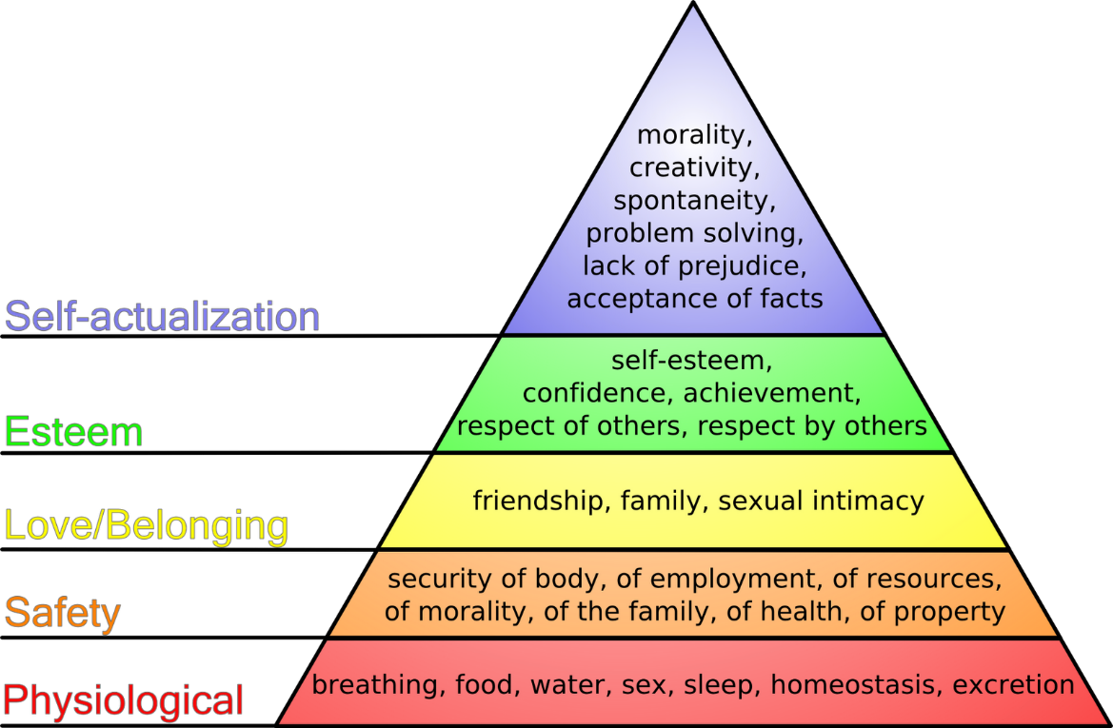

Douglas McGregor Theory X and Y- describing two opposing management styles, representing managers' perceptions of their employees, not outside their workplace, behaviours while working in the organization. Theory X presupposes that all employees are lazy and will avoid working as much as they can. This management style must closely oversee employees. They will have less interest if there are no incentives. On the other hand, Theory Y presupposes that the employee will commit to achieving goals and objectives. Management has the primary task of maximizing their commitments. Hattangadi (2015)
Working for the government as a public servant brings with it a great responsibility for care with dedication and commitment, and especially important for the core values of the public service: integrity, honesty, objectivity, and impartiality.
Most civil servants are included in the theory of Douglas McGregor Y, have an unobstructed vision of their task and employment, able to assume responsibilities and an elevated level of motivation.
Working for one of the UK's biggest companies gives you great satisfaction, makes you proud and gives you excellent value at work. Working in such a big government organization and coming from diverse backgrounds and cultures has a significant impact on my beliefs and values. An important value at work is stability, which is for both employers and businesses. Another aspect of the beliefs is integrity and honesty perfectly correspond to my original culture. There is great satisfaction in being able to help others. The value of work flexibility Department for Work and Pension currently offers me the possibility of having a great work-life balance. The introduction of hybrid work starts with a new chapter on working patterns. Work flexibility is based on the various patents started between 08:00 a.m. and 6:30 p.m., with three tempos per week, a late shift until 6:30 p.m., two mornings from 8:00a.m. or 9:00 a.m., and an evening until 5:00 p.m. For example, if you have a tempo of 5:00 p.m., you cannot finish before., but you can start late in the morning and vice versa if the tempo is 8:00 a.m. If you use flexible hours to finish earlier, that the hours you need to recover on other days. You can establish flexible hours. Another introduction is the hybrid work 60% working from the home and 40% working in the office. The only disadvantage is that you cannot just ask to work from home only. This should make it possible for people to choose how they work and where they work. My personal beliefs were inculcated in me from an incredibly early age, living in a communist era until the age of fourteen when people revolted in 1989. Influence me to value the Democracy, Rule of Law, Respect & Tolerance, Individual Liberty, and to migrate to different country who values those, which are the most significant values in British culture, Crawford (2017).

Conclusion.

Hybrid work is not something new, however, COVID-19 is accelerating. Before the pandemic period, we could not imagine that it would be achievable. The need to work during the pandemic in lockdown has opened this possibility that is not available to all industries. We had applications, but we never used them on that scale, such as Microsoft Teams, Skype, Facebook, LinkedIn, and more. Two years later, the government lifted the restrictions and people must go back to work. But there has been a significant shift as companies try to get people back into the workplace, but at the same time, keep people at a distance, the solution is to approach hybrid work, sometimes working in the workplace and sometimes at home.
The companies could not accommodate all the people back at the office as most of them need more space to fit the 2metre distance between people recommended by the World Health Organization according to Setti et al (2020). Hybrid work not only increases job satisfaction, offers great flexibility and, if properly implemented and not abused, people would benefit from increased well-being. Research has shown that people are more positive when hybrid work is applied. Hybrid work should be promoted by any business everywhere without restriction, so that businesses let employees decide where and when to work, although they choose 100% at home as at present exist to work 100% at the office. Companies should adopt a positive attitude to encourage these changes and, at the same time, adopt good practices to improve productivity and job satisfaction. Moreover, a work life balance for employees as corresponding to work between personal life and not the other way around. This is just the start of a new way of working from home, it has begun to thrive, but in the future will be introduced as much as possible by companies, also with more options, including various schedules, and why not night-time to work from home for people with health issues. What we have learned from the COVID-19 pandemic is that companies must adapt and be more flexible than in the past. Contingency plans are in place but not followed through the pandemic or not implemented or designed for such a disaster. For those who commuted daily for over an hour in one direction, returning to work is a shock after almost two years of working from home, a significant impact will have the financial aspect (more money to spend in gasoline), personal (less free time) and emotional/mental (due to no work in a quiet place or stuck in traffic).
The last point is the recommendations. Hybrid work should move to the next level for people to decide how they would like to do their job, not just a strict patent on shifts. By enabling their preferences, job satisfaction and productivity will be higher than static hybrid work according to Mayo (1949) when people are offered better working conditions. Even though people choose to work only from home, an option should be introduced for people to choose. As the Internet evolves, the relationship between home and place of work is also expected to evolve. Nowadays, most computers help people do the same job from any place in the world. Employers should always be given the opportunity to choose where they wish to work, by providing this option, businesses could save money by reducing building rents and enhancing the productivity of satisfied employees.

References.

Anderson, D. and Kelliher, C. (2009), "Flexible working and engagement: the importance of choice", Strategic HR Review, Vol. 8 No. 2, pp. 13-18. [online] Available at: https://doi.org/10.1108/14754390910937530 . Accessed: 24/03/2022
BBC (no date) Why it is wrong to look at work-life balance as an achievement. [online] Available at: https://www.bbc.com/worklife/article/20210302-why-work-life-balance-is-not-an-achievement . Accessed: 20/03/2022
Bloom, N., Liang, J., Roberts, J., and Ying, Z.J., 2015. Does working from homework? Evidence from a Chinese experiment. The Quarterly Journal of Economics, 130(1), pp.165-218. [online] Available at: https://doi.org/10.1093/qje/qju032 . Accessed: 22/03/2022
Bono, E., (no date) We provide tools to change the future. [online] Available at: https://www.debono.com/ Accessed: 22/03/2022
Chung, H., van der Horst, M. (2020). Flexible Working and Unpaid Overtime in the UK: The Role of Gender, Parental and Occupational Status. Soc Indic Res 151, 495–520. [online] Available at: https://doi.org/10.1007/s11205-018-2028-7 . Accessed: 24/03/2022
Civil Service (March , 2015) The Civil Service code, [online] Available at: https://www.finder.com/uk/working-from-home-statistics . Accessed: 24/03/2022
Cooper, S., (October 2021) 6 Benefits of Hybrid Working: Transform Your Organisation. [online] Available at : https://www.changingsocial.com/hybrid-working/#:~:text=1%20No%20commute.%20One%20of%20the%20main%20advantages,has%20on%20work-life%20balance%20has%20been%20well%20documented. Accessed: 20/03/2022
Crawford, C.E., (2017). Promoting ‘fundamental British values’ in schools: a critical race perspective. Curriculum Perspectives, 37(2), pp.197-204. [online] Available at: https://doi.org/10.1007/s41297-017-0029-3 . Accessed: 24/03/2022
De Bono, E., (2011). The six value medals. Random House.
Dingel, JI, Neiman, B (2020) How many jobs can be done at home? Journal of Public Economics 189: 104235. [online] Available at: https://doi.org/10.1016/j.jpubeco.2020.104235 . Accessed: 21/03/2022
EduPRO. (2021). What are terminal values? [online] Available at: https://edupro.cc/examples/what-are-terminal-values . Accessed: 20/03/2022
Elliott, B., (January 2021) Hybrid rules: the emerging playbook for flexible work. [online] Available at: https://slack.com/intl/en-gb/blog/transformation/emerging-hybrid-playbook-flexible-work . Accessed: 20/03/2022
Ennis, R.H., (1996). Critical thinking dispositions: Their nature and assessability. Informal logic, 18(2).
Fowell, T., (February 2002) Hybrid work: what is hybrid work and why do employees want it? [online] Available at : https://envoy.com/blog/what-is-a-hybrid-work-model/#:~:text=%20The%20value%20of%20hybrid%20work%20%201,any%20given%20time.%20For%20some%20companies%2C...%20More%20 Accessed: 20/03/2022
Gardner, M.J. and Jones, E., (1999). Problematic communication in the workplace: beliefs of superiors and subordinates. International Journal of Applied Linguistics, 9(2), pp.185-203.
Gawel, J.E., (1996). Herzberg's theory of motivation and Maslow's hierarchy of needs. Practical Assessment, Research, and Evaluation, 5(1), p.11. [online] Available at https://doi.org/10.7275/31qy-ea53 : Accessed: 22/03/2022
Hattangadi, V., (2015). Theory x & theory y. International Journal of Recent Research Aspects, 2(4), pp.20-21.
Heinrichs, J.H., Lim, J.S. and Lim, K.S., (2011). Influence of social networking site and user access method on social media evaluation. Journal of Consumer Behaviour, 10(6), pp.347-355.
Herzberg, F., (2017). Motivation to work. Routledge.
Hofstede, G., (1984). Culture's consequences: International differences in work-related values (Vol. 5). sage.
Hofstede, G., (2011). Dimensionalizing cultures: The Hofstede model in context. Online readings in psychology and culture, 2(1), pp.2307-0919. [online] Available at: http://mchmielecki.pbworks.com/w/file/fetch/64591689/hofstede_dobre.pdf .Accessed: 24/03/2022
Janet A. Simons, Donald B. Irwin and Beverly A. Drinnien (1987) Abrham Maslow's Hierarchy Of Needs: [online] Available at : http://mindpower365.blogspot.com/2010/10/abrham-maslows-hierarchy-of-needs.html Accessed: 20/03/2022
Judge, T.A. and Bono, J.E., (2001). Relationship of core self-evaluations traits—self-esteem, generalized self-efficacy, locus of control, and emotional stability—with job satisfaction and job performance: A meta-analysis. Journal of applied Psychology, 86(1), p.80.
Kuehnel, J., Bledow, R. and Feuerhahn, N., (2016). When do you procrastinate? Sleep quality and social sleep lag jointly predict self‐regulatory failure at work. Journal of Organizational Behavior, 37(7), pp.983-1002. [online] Available at: https://doi.org/10.1002/job.2084 . Accessed: 24/03/2022
Likert, R. (1932). A technique for the measurement of attitudes. Archives of Psychology, 22 140, 55.
Lilly, C. (February 2022). Working from home (WFH) statistics [online] Available at: https://www.finder.com/uk/working-from-home-statistics . Accessed: 24/03/2022
Lina Vyas & Nantapong Butakhieo (2021) The impact of working from home during COVID-19 on work and life domains: an exploratory study on Hong Kong, Policy Design and Practice, 4:1, 59-76, [online] Available at https://doi.org/10.1080/25741292.2020.1863560 . Accessed: 21/03/22
Mayo, E., (1949). Hawthorne and the western electric company. The social problems of an industrial civilisation, pp.1-7.
McGregor, D., (1960). Theory X and theory Y. Organization theory, 358(374), p.5.
Meglino, B.M., Ravlin, E.C. and Adkins, C.L., (1989). A work values approach to corporate culture: A field test of the value congruence process and its relationship to individual outcomes. Journal of applied psychology, 74(3), p.424. [online] Available at: https://doi.org/10.1037/0021-9010.74.3.424 Accessed: 24/03/2022
Messenger, J.C. and Gschwind, L., (2016). Three generations of Telework: New ICT s and the (R) evolution from Home Office to Virtual Office. New Technology, Work and Employment, 31(3), pp.195-208. [online] Available at: https://doi.org/10.1111/ntwe.12073 Accessed: 24/03/2022
Minkov, M., (2007). What makes us different and similar: A new interpretation of the World Values Survey and other cross-cultural data. Sofia, Bulgaria: Klasika i Stil Publishing House. [online] Available at: https://doi.org/10.1177/0022022108321313 Accessed: 24/03/2022
Moise, C., (2014). Importance of Beliefs, Attitudes and Values in the Frame of Human Resource Motivation. Annals of Spiru Haret Economic Series, 14(2).
Morganson, V.J., Major, D.A., Oborn, K.L., Verive, J.M., & Heelan, M.P. (2010). Comparing telework locations and traditional work arrangements: Differences in work‐life balance support, job satisfaction, and inclusion. Journal of Managerial Psychology, 25(6), 578–595. [online] Available at: https://doi.org/10.1108/02683941011056941 Accessed: 24/03/2022
Nilles, J.M., (1988). Traffic reduction by telecommuting: A status review and selected bibliography. Transportation Research Part A: General, 22(4), pp.301-317. Available at: https://doi.org/10.1016/0191-2607(88)90008-8 .Accessed: 24/03/2022
ONS Office for National Statistics , (July , 2020), Coronavirus and homeworking in the UK: April 2020 , [online] Available at: https://www.ons.gov.uk/employmentandlabourmarket/peopleinwork/employmentandemployeetypes/bulletins/coronavirusandhomeworkingintheuk/april2020 . Accessed: 24/03/2022
Pierce, M., Hope, H., Ford, T., Hatch, S., Hotopf, M., John, A., Kontopantelis, E., Webb, R., Wessely, S., McManus, S., and Abel, K.M., (2020). Mental health before and during the COVID-19 pandemic: a longitudinal probability sample survey of the UK population. The Lancet Psychiatry, 7(10), pp.883-892. Available at: https://doi.org/10.1016/S2215-0366(20)30308-4 .Accessed: 24/03/2022
Porter, M.E., (2000). Attitudes, values, beliefs, and the microeconomics of prosperity. Culture Matters. New York: Basic Books, 2000, pp.14-28.
Ro, C. , (August , 2020) Why the future of work might be ‘hybrid’ [online] Available at : https://www.bbc.com/worklife/article/20200824-why-the-future-of-work-might-be-hybrid . Accessed: 20/03/2022
Rogers, P., & Meehan, P. (2007). Building a winning culture. Business Strategy Series, 8(4), 254-261. [online] Available at:https://doi.org/10.1108/17515630710684420 . Accessed: 24/03/2022
Rokeach, M., (2008). Understanding human values. Simon and Schuster.
Sagiv, L. and Schwartz, S.H., (2000). Value priorities and subjective well‐being: Direct relations and congruity effects. European journal of social psychology, 30(2), pp.177-198. [online] Available at: https://doi.org/10.1002/(SICI)1099-0992(200003/04)30:2<177::AID-EJSP982>3.0.CO;2-Z Accessed: 24/03/2022
Schein, E.H., (1991). What is culture. Newbury Park, CA: Sage, pp.243-253.
Schwartz, S.H., (1992). Universals in the content and structure of values: Theoretical advances and empirical tests in 20 countries. In Advances in experimental social psychology (Vol. 25, pp. 1-65). Academic Press. [online] Available at https://doi.org/10.1016/S0065-2601(08)60281-6 : Accessed: 24/03/2022
Schwartz, S.H., (1994). Are there universal aspects in the structure and contents of human values? Journal of social issues, 50(4), pp.19-45.
Senge, P.M. and Sterman, J.D., (1992). Systems thinking and organizational learning: Acting locally and thinking globally in the organization of the future. European journal of operational research, 59(1), pp.137-150. [online] Available at: https://doi.org/10.1016/0377-2217(92)90011-W . Accessed: 22/03/2022
Setti, L., Passarini, F., De Gennaro, G., Barbieri, P., Perrone, M.G., Borelli, M., Palmisani, J., Di Gilio, A., Piscitelli, P. and Miani, A., (2020). Airborne transmission route of COVID-19: Why 2 meters/6 feet of inter-personal distance could not be enough. International journal of environmental research and public health, 17(8), p.2932. [online] Available at: https://www.mdpi.com/1660-4601/17/8/2932# Accessed: 20/03/2022
Sharma, A., (2020). Persuasive/Serious Games: Agents of Change in Individual Beliefs (Doctoral dissertation, Dissertation]. Breda: Breda University. [online ] Available at : https://www.researchgate.net/publication/342282910_PersuasiveSerious_Games_Agents_of_Change_in_Individual_Beliefs . Accessed: 24/03/2022
Slack Team ( April ,2020) Report: Remote work in the age of Covid-19 [online] Available at : https://slack.com/intl/en-gb/blog/collaboration/report-remote-work-during-coronavirus .Accessed: 20/03/2022
Smith, J., (March ,2021) Envoy survey finds employees want companies to embrace hybrid work and mandate COVID vaccines. [online] Available at: https://envoy.com/blog/envoy-survey-finds-employees-want-companies-to-embrace-hybrid-work-and-mandate-covid-vaccines/ Accessed: 20/03/2022
Steel, P. (2007). The nature of procrastination: A meta‐analytic and theoretical review of quintessential self‐regulatory failure. Psychological Bulletin, 133(1), 65–94. [online] Available at: https://doi.org/10.1037/0033-2909.133.1.65 Accessed: 24/03/2022
Tan, W., Hao, F., McIntyre, R.S., Jiang, L., Jiang, X., Zhang, L., Zhao, X., Zou, Y., Hu, Y., Luo, X. and Zhang, Z., (2020). Is returning to work during the COVID-19 pandemic stressful? A study on immediate mental health status and psychoneuroimmunity prevention measures of Chinese workforce. Brain, behaviour, and immunity, 87, pp.84-92. [online] Available at: https://doi.org/10.1016/j.bbi.2020.04.055. Accessed: 24/03/2022
Willits, F.K., Theodori, G.L. and Luloff, A.E., (2016). Another look at Likert scales. Journal of Rural Social Sciences, 31(3), p.6. [online] Available at: https://egrove.olemiss.edu/jrss/vol31/iss3/6/ Accessed: 20/03/2022
Yusoff, W.F.W., Kian, T.S. and Idris, M.T.M., (2013). Herzberg’s two factors theory on work motivation: does its work for today’s environment. Global journal of commerce and Management, 2(5), pp.18-22.
Zimmerman, R.D., (2008). Understanding The Impact of Personality Traits on Individuals ‘turnover Decisions: A Meta‐Analytic Path Model. Personnel psychology, 61(2), pp.309-348. [online] Available at: https://doi.org/10.1111/j.1744-6570.2008.00115.x .Accessed: 22/03/2022

Appendix 1- Country Comparison - Hofstede Insights (hofstede-insights.com)

Country Comparison - Hofstede Insights (hofstede-insights.com)
• Romania
• United Kingdom
• United States

WHAT ABOUT THE UK?
If we explore the British culture through the lens of the 6-D Model©, we can get a good overview of the deep drivers of British culture relative to other world cultures.
POWER DISTANCE
This dimension deals with the fact that all individuals in societies are not equal – it expresses the attitude of the culture towards these inequalities amongst us. Power Distance is defined as the extent to which the less powerful members of institutions and organisations within a country expect and accept that power is distributed unequally.
At 35 Britain sits in the lower rankings of PDI – i.e., a society that believes that inequalities amongst people should be minimized. Interestingly is that research shows PD index lower amongst the higher class in Britain than amongst the working classes. The PDI score at first seems incongruent with the well-established and historical British class system and its exposes one of the inherent tensions in the British culture – between the importance of birth rank on the one hand and a deep-seated belief that where you are born should not limit how far you can travel in life. A sense of fair play drives a belief that people should be treated in some way as equals.
INDIVIDUALISM
The fundamental issue addressed by this dimension is the degree of interdependence a society keeps among its members. It has to do with whether people´s self-image is defined in terms of “I” or “We.” In Individualist societies people are supposed to look after themselves and their direct family only. In Collectivist societies people belong to ‘in groups’ that take care of them in exchange for loyalty.
At a score of 89 the UK is amongst the highest of the Individualist scores, beaten only by the commonwealth countries it spawned i.e., Australia and the USA. The British are a highly Individualist and private people. Children are taught from an early age to think for themselves and to find out what their unique purpose in life is and how they uniquely can contribute to society. The route to happiness is through personal fulfilment. As the affluence of Britain has increased throughout the last decade, with wealth also ‘spreading North,’ a much-discussed phenomenon is the rise of what has been seen as rampant consumerism and a strengthening of the ‘ME’ culture.
MASCULINITY
A high score (Masculine) on this dimension indicates that the society will be driven by competition, achievement, and success, with success being defined by the winner/best in field – a value system that starts in school and continues throughout organisational life.
A low score (Feminine) on the dimension means that the dominant values in society are caring for others and quality of life. A Feminine society is one where quality of life is the sign of success and standing out from the crowd is not admirable. The fundamental issue here is what motivates people, wanting to be the best (Masculine) or liking what you do (Feminine).
At 66, Britain is a Masculine society – highly success oriented and driven. A key point of confusion for the foreigner lies in the apparent contradiction between the British culture of modesty and understatement which is at odds with the underlying success driven value system in the culture. Critical to understanding the British is being able to ‘’read between the lines’’ What is said is not always what is meant. In comparison to Feminine cultures such as the Scandinavian countries, people in the UK live to work and have a clear performance ambition.
UNCERTAINTY AVOIDANCE
The dimension Uncertainty Avoidance has to do with the way that a society deals with the fact that the future can never be known: should we try to control the future or just let it happen? This ambiguity brings with it anxiety and diverse cultures have learnt to deal with this anxiety in diverse ways. The extent to which the members of a culture feel threatened by ambiguous or unknown situations and have created beliefs and institutions that try to avoid these reflected in the score on Uncertainty Avoidance.
At 35 the UK has a low score on Uncertainty Avoidance which means that as a nation they are quite happy to wake up not knowing what the day brings and they are happy to ‘make it up as they go along’ changing plans as added information becomes known. As a low UAI country the British are comfortable in ambiguous situations – the term ‘muddling through’ is a very British way of expressing this. There are not too many rules in British society, but those that are there are adhered to (the most famous of which of course the British love of queuing which has also to do with the values of fair play).
In work terms this results in planning that is not meticulous – the end goal will be clear (due to high MAS) but the detail of how we get there will be light and the actual process fluid and flexible to appearing and changing environment. Planning horizons will also be shorter. Most importantly the combination of a highly Individualist and curious nation is an elevated level of creativity and strong need for innovation. What is different is attractive! This appears throughout the society in both its humour, heavy consumerism for new and innovative products and the fast highly creative industries it thrives in – advertising, marketing, financial engineering.

LONG TERM ORIENTATION
This dimension describes how every society must maintain some links with its own past while dealing with the challenges of the present and future, and societies prioritise these two existential goals differently. Normative societies. which score low on this dimension, for example, prefer to maintain time-honoured traditions and norms while viewing societal change with suspicion. Those with a culture which scores high, on the other hand, take a more pragmatic approach: they encourage thrift and efforts in modern education to prepare for the future.
With an intermediate score of 51 in this dimension, a dominant preference in British culture cannot decided.
INDULGENCE
One challenge that confronts humanity, now and in the past, is the degree to which small children are socialized. Without socialization we do not become “human.” This dimension defined as the extent to which people try to control their desires and impulses, based on the way they raised. Weak control called “Indulgence” and relatively strong control is called “Restraint.” Cultures can, therefore, described as Indulgent or Restrained.
A high score of 69 shows that the British culture is one that classified as Indulgent. People in societies classified by a high score in Indulgence exhibit a willingness to realise their impulses and desires about enjoying life and having fun. They own a cheerful outlook and have a tendency towards optimism. In addition, they place a higher degree of importance on leisure time, function as they please and spend money as they wish.

Appendix 2 – Jobs that can be done at home typically earn higher wages

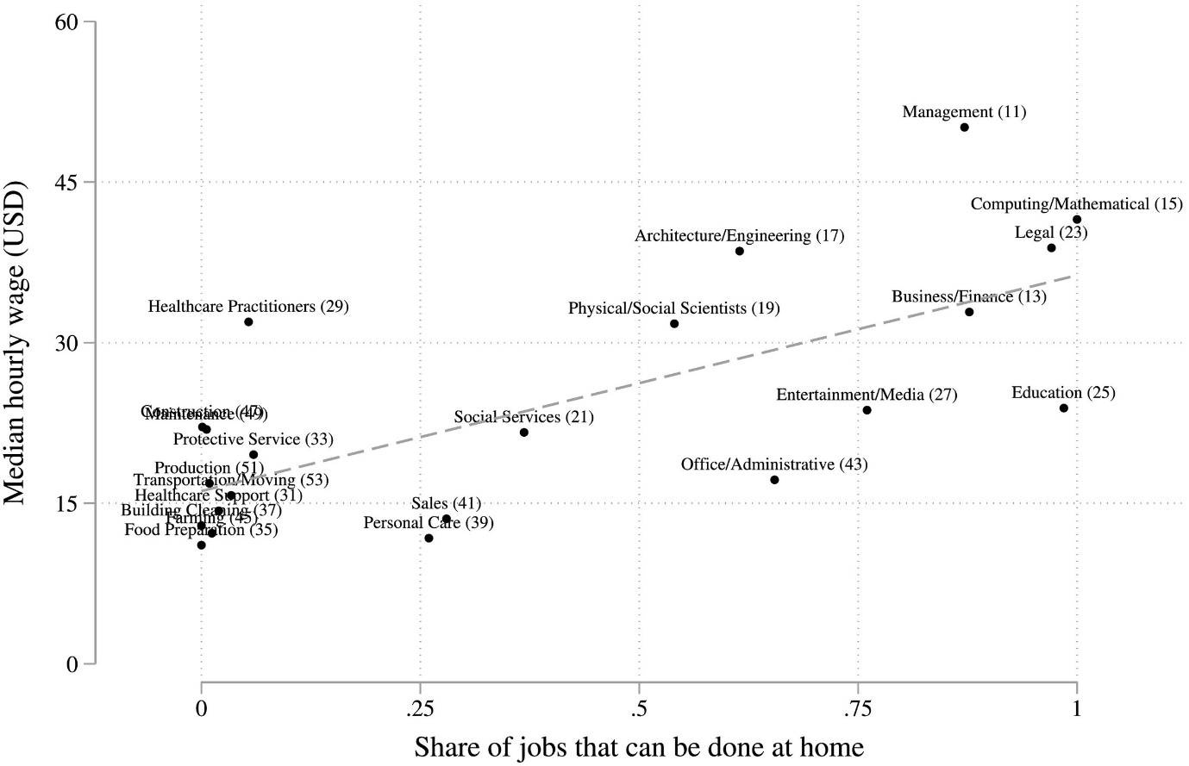

Appendix 3 – SWOT analysis.



