BA (HONS) BUSINESS MANAGEMENT
Module: Data Handling and Business Intelligence
Module code: LCBB5000
Lecturer Name: Dr Ejike Udeogu
Student Name: Md Abidur Rahman
Student ID:1815081
A dataset describing terms such as price, sqft living, sqft lot, bedrooms, and bathrooms is provided to us. Price, bedrooms, baths, square footage of the living room and lot, floors, view, year of construction, and location are all included in the dataset. A variety of factors determine the property's pricing. Therefore, we are unable to comprehend it with just one. I would examine the entire data set using Microsoft Excel. Here are the findings of our analysis of the data using Microsoft Excel.
This result is based on Price:
- Mean: 553,062.88
- Median: 460,000
- Mode: 0
- Standard Deviation: 583,686.45
- Sample Variance: 3.41 × 10¹¹
- Range: 26,590,000
553,062.88 is the average price of the properties. However, because of the high standard deviation, extreme values (outliers) may have a significant impact on this mean.

This Median indicates that half of the properties are priced below 460,000 and the other half are priced above it. This is the midway value of the price distribution. When the median is less than the mean, it frequently indicates that there are some expensive outliers distorting the distribution.

A mode of 0 may suggest that a sizable portion of the dataset's attributes contain inaccurate or missing pricing information (such as entries in which the price was not recorded).

A huge variety in property values is shown by the high standard deviation, which means that some properties are quite expensive while others are relatively inexpensive.

There is a significant disparity between the highest and least costly prices, indicating a rather wide price range.

This result is based on sqft living:
- Mean: 2,143.64 sq. ft.
- Median: 1,980 sq. ft.
- Mode: 1,720 sq. ft.
- Standard Deviation: 957.48 sq. ft.
- Sample Variance: 916,771.05
- Range: 9,670 sq. ft.
The living area is 2,143.64 square feet on average. This implies that the residences in this dataset are often of a moderate size. Although the mean is a useful measure of overall size, extreme values (extremely big or very small characteristics) may have an impact.
There are 1,980 square feet in the median. This indicates that half of the residences in the dataset have a living area of 1,980 square feet or less, while the other half have more.
The most common living space size in the sample is 1,720 square feet, which is also the mode. This implies that a sizable fraction of the dataset's residences are grouped together in an area of 1,720 square feet.
The standard deviation is 957.48 square feet. With the majority of residences falling within 957 square feet of the mean. This indicates that the living space sizes in this dataset are fairly dispersed.
The difference between the largest and smallest dwelling areas in the sample is 9,670 square feet. This implies a broad range of property sizes, which probably means that both tiny and extremely large homes are included in the dataset.
This result is based on sqft lot:
- Mean: 14,697.64 sq. ft.
- Median: 7,676 sq. ft.
- Mode: 5,000 sq. ft.
- Standard Deviation: 35,876.84 sq. ft.
- Sample Variance: 1,287,147,514 sq. ft.²
- Range: 1,073,580 sq. ft.
The distribution is skewed to the right due to a few particularly big lots that pull the mean up from the average lot size of 14,698 square feet.
The skew is confirmed by the median lot size of 7,676 square feet, which is significantly less than the mean and indicates that half of the residences are on smaller lots.
The 5,000 square foot mode indicates that 5,000 square feet is the most common lot size, which may be indicative of smaller residential properties or typical suburban areas.
There is significant variation in lot sizes, as seen by the wide standard deviation of 35,876.84 square feet. The significant dispersion is caused by the fact that some properties have relatively large lots, even while many have smaller ones.
There are both tiny urban lots and enormous estate-sized lots in the dataset, as evidenced by the stark contrasts between the smallest and largest homes, which span 1,073,580 square feet.

The results are based on bedrooms:
- Mean: 3.40
- Median: 3
- Mode: 3
- Standard Deviation: 0.90
- Sample Variance: 0.82
- Range: 8

The majority of residences are probably three or four bedrooms, as the typical number of bedrooms is 3.4.
Bedroom counts are grouped around the median and mode of 3, which indicate that three-bedroom dwellings are the most prevalent in the sample.
The majority of the dwellings in the sample had bedroom counts near three, as indicated by the standard deviation of 0.90, which shows minimal diversity in bedroom counts.
Although there are a few properties with more than three or four bedrooms, as indicated by the range of eight, bedroom counts typically do not vary substantially throughout the dataset.

This result is based on bathrooms:
- Mean: 2.16
- Median: 2.25
- Mode: 2.5
- Standard Deviation: 0.78
- Sample Variance: 0.62
- Range: 6.75

Given that the mean number of bathrooms is 2.16, most households likely have two to three bathrooms on average.
More than half of the properties in the sample have somewhat more than two bathrooms, as indicated by the median number of bathrooms of 2.25.
The most prevalent number of bathrooms is 2.5, indicating that many households have two full bathrooms and a half-bathroom, which is typical in larger homes.
Some homes have somewhat more or less bathrooms than others, but the range is not very large, according to the standard deviation of 0.78, which shows that bathroom numbers are concentrated rather tightly around the mean.
With certain residences having a disproportionately high number of bathrooms compared to the rest of the dataset, the range of 6.75 indicates a significant variation in bathroom counts and the presence of larger luxury or estate homes.

2. Now we will visualize house price and numbers of bedrooms.
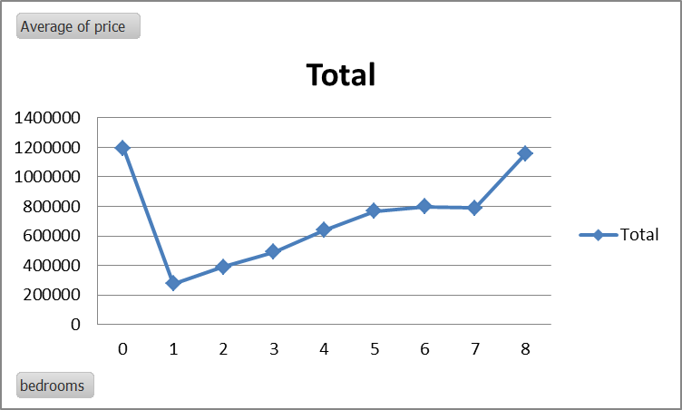
Visualization of the relationship between price and bathrooms.
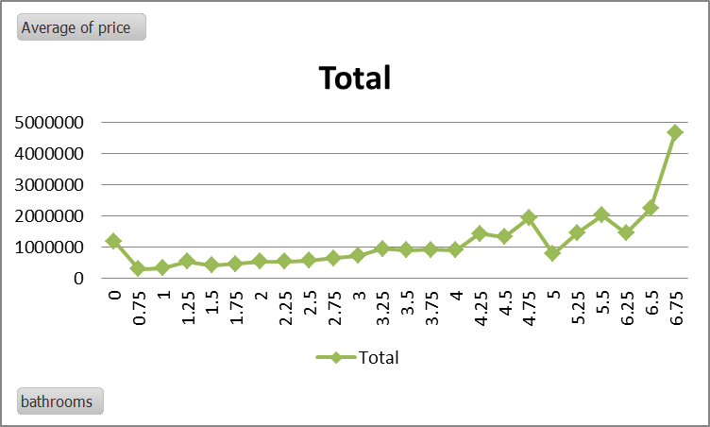

Visualization of the relationship between price and sqft living.
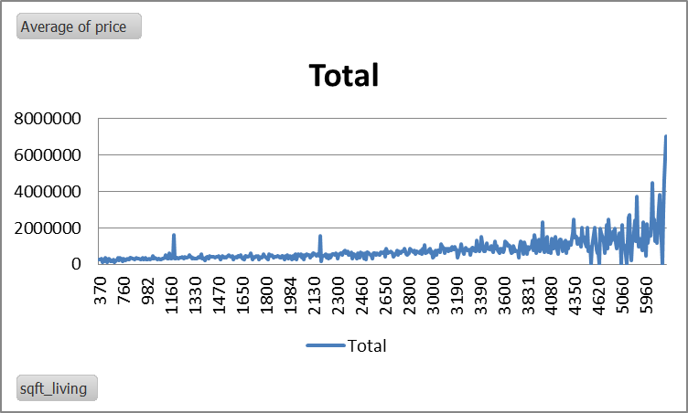

Visualization of the relationship between price and year of built
.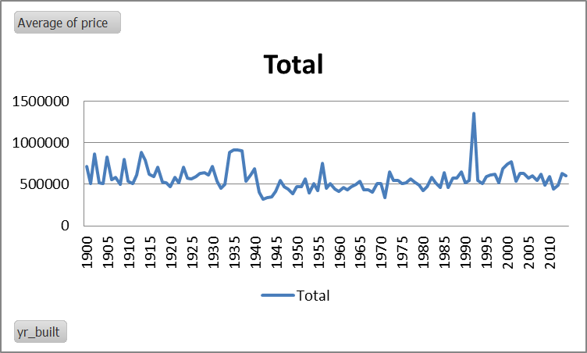

3. Correlation analysis:
Discuss the advantages and disadvantages of using SPSS or Excel using relevant practical examples. You should choose only one of these tools and look into that.

In the world of globalization and industrialization, the Statistical Package for Social Science is a very crucial tool in software packages broadly used in academia and industry for the analysis of data (Anlesinya et al., 2023). On the other hand, for common-purpose tasks, Excel is versatile, while Statistical Package for Social Science is tailored to monitor complicated statistical analyses, making it a very preferred choice for data analysts as well as researchers.
Advantages of using Statistical Package for Social Science
Comprehensive Statistical Analysis | Diverse Statistical Tests and Advanced Data Manipulation: Statistical Package for Social Science generally offers several types of statistical tests such as t-tests, factor analysis, ANOVA, and regression analysis which enables data analysts and researchers to pursue several statistical relationships as well as uncover meaningful in-depth from data (Anlesinya et al., 2023). Statistical Package for Social Science gives strong tools for data clearing, restructuring, as well as transformation. It streamlines raw data preparation for analysis.
User-Friendly Interface | Intuitive Design and Guided Analysis: The point-and-click interface and menu-driven eases the process of selecting and operating several statistical tests (Wojtkowski et al., 2023). The users with limited statistical know-how can better perform analyses effectively and Statistical Package for Social Science features gradually directs for operating analyses which decline errors and give advocate for users unknown with advanced statistical ideas.
Automation and Accountability | Syntax-Based Analysis and Batch Processing: Statistical Package for Social Science permits the users to automate repetitive works as well as regenerate analyses with the help of its scripting characteristics which is known as syntax. Syntax confirms more consistency around different databases as well as analyses. Besides this, SPSS advocates batch processing to enable users to perform analyses on multiple databases.

Disadvantages of using Statistical Package for Social Science
Steep Learning Curve | Complicated functionality and Personalized Boundaries: Mastering advanced characteristics for example scripting and complicated statistical tools and techniques needs critical endeavor when the interface is friendly and Statistical Package for Social Science is less flexible than open source programming tools such as R or Python (Tsui et al., 2023). It also offers wider options for personalization and exploratory data analysis.
Costs | Licensing Fees; Statistical Package for Social Science is industrial software including robust licensing costs and it can make it less penetrable to small companies and personal users compared to free tools such as Excel, R, or Python (Wojtkowski et al., 2023).

The Real-life Example: Analysis Survey Data
Data Import

Data Clearing
inferential analysis

Data visualization

Descriptive analysis

With the help of the Statistical Package for Social Science, the researcher can more efficiently analyze the data survey to address patterns as well as proven-based recommendations. Statistical Package for Social Science has advanced capabilities making it the superior choice for more complicated analyses, while Excel may suffice for simpler works (Wojtkowski et al., 2023).
However, Statistical Package for Social Science stands out as a strong user-friendly tool for statistical analysis. Making it more inevitable for researchers as well as analysts who work with complicated datasets, the tool offers in-depth and comprehensive statistical tests, reliable automation characteristics and intuitive data manipulation.

b) Explain the meaning and importance of the Data Mining Cycle with examples.
The Data Mining Cycle which is also known as the Knowledge Discovery in Databases process is a well-designed structure for extracting meaningful in-depths and insights from vast datasets (Du et al., 2023). Confirming precious and relevant outcomes, ranging from problems to actionable know-how development, Data Mining comprises an effective series of systematic steps.

Key Steps Used in the Data Mining Cycle

Business Understanding
Define the Problem and Setting Goals: The process starts by addressing the several challenges and opportunities to identify. With high buying feasibility, a retail company may goal to address consumer groups (Bharadiva et al., 2023). The company establishes clear, measurable goals to direct the data mining process. For example; Optimizing market campaigns, increasing customer satisfaction, and declining costs
Data Understanding
Data Collection, Data Description, and Data Exploration: From several sources like weblogs, databases, and spreadsheets, relevant data is gathered (Wojtkowski et al., 2023). The collected data is tested to understand its core structure, types, and problems for example missing values or outliers and initial patterns and trends unboxed using statistical systems and visualization techniques.
Data Preparation
Data clearing, Data Integration, and Data Transformation: To improve data quality, the missing values, inconsistencies and outliers are identified and the data from several sources is amalgamated into a single and unified dataset (Kayadella et al., 2023). Besides this, Data is simplified and translated into proper formats for analysis for example categorical variables might be transformed into numerical values.
Modelling
Model Selection and Model Building: Based on the issues and data types like classification, clustering, regression, and association rule mining, Appropriate data mining methods are selected (Wojtkowski et al., 2023). The chosen models are properly trained on the prepared data to produce predictions.
Evaluation
Model Evaluation and Model Selection: To determine the effectiveness of the models, the models are assessed using several metrics such as accuracy, recall, F1-score and precision. For implementation, the more effective model is chosen (Kayadella et al., 2023).
Development
Model Integration and Model Monitoring: Continuous monitoring of the selected model ensures the model performs according to expected with periodic updates which are needed (Wojtkowski et al., 2023).

The Importance of the Data Mining Cycle
The Data Mining Cycle plays a crucial role in leveraging data for functional and actionable insights. For example;
- Improving Decision-Making
- Enriched Customer Understanding
- Increased Efficiency
- Risk combat
- Competitive Advantage

An Example like Customer Segmentation
To segment customers based on buying behaviour, preference, and demographics, a retail company can use the Data Mining Cycle (Wojtkowski et al., 2023). This process might include the following steps:
- Defining the Problem: Address high-potential customer segments
- Collect Data: Collect data on purchase history, preferences and demographics.
- Prepare Data: Process, clean, and integrate the data for analysis.
- Model Data: To group customers with similar features, applying clustering techniques.
- Evaluate Model: Evaluate the quality and relevance of the customer segment
- Deploy Models: To tailor marketing campaigns as well as product offerings, use the segments.

References
Anlesinya, A. and Dadzie, S.A., 2023. Technology and the Conduct of Bibliometric Literature Reviews in Management: The Software Tools, Benefits, and Challenges. In Advancing Methodologies of Conducting Literature Review in Management Domain (pp. 57-78). Emerald Publishing Limited.
Wojtkowski, M., Bartoszewski, M., Buchwald, W., Joachimczyk, K., Kawala, A. and Romaniuk, R.S., 2024. Students’ view of Quantum Information Technologies, part II. International Journal of Electronics and Telecommunications, 70.
Kavadella, A., Da Silva, M.A.D., Kaklamanos, E.G., Stamatopoulos, V. and Giannakopoulos, K., 2024. Evaluation of ChatGPT’s real-life implementation in undergraduate dental education: mixed methods study. JMIR Medical Education, 10(1), p.e51344.
Tsui, K.L., Chen, V., Jiang, W., Yang, F. and Kan, C., 2023. Data mining methods and applications. In Springer handbook of engineering statistics (pp. 797-816). London: Springer London.
Du, Y., Yang, C., Zhao, B., Hu, C., Zhang, H., Yu, Z., Gao, J., Zhao, W. and Wang, H., 2023. Optimal design of a supercritical carbon dioxide recompression cycle using deep neural network and data mining techniques. Energy, 271, p.127038.
Bharadiya, J.P., 2023. A comparative study of business intelligence and artificial intelligence with big data analytics. American Journal of Artificial Intelligence, 7(1), p.24.

