11/21/2025
University of Wales Trinity Saint David
London campus
E-Portfolio Link: https://editor.wix.com/html/editor/web/renderer/edit/a7a3007f-11ec-4721-974c-99e2d462ca6e?metaSiteId=dceab8d9-4493-4e6c-a825-d0f10f3f9aff
Module Name: Learning In the Digital Era
Module Code: ACCA 4025

Student Name: Dayana Balandra
Student ID: 2442006
Group: 2

Lecturer’s Name: Koushik Modak

LDE Assignment 1
E-Portfolio
Table of Contents
Introduction 2
Main Body 2
Task 1: Essential Academic and Employment Skills for the future career Path 2
Task 1 (a): Report on Essential Academic and Employment Skills 2
Task 1 (b): Evaluation of Task 1 (a) based on Similarity report 2
Task 2: Collaborative Mind Map and Individual Poster 2
Mind Map (Collaborative) 2
Poster (Individual) 2
Task 3: Virtual Collaboration and RefWorks 2
Report on Virtual Collaboration 2
Step-by-step process of using RefWorks with visuals 2
Task 4: E-Portfolio Creation and Evaluation 2
Task 4 (a): E-Portfolio Creation 2
Task 4 (b): Illustrative Review of E-Portfolio tool Selection 2
Conclusion 2
References 2
Task 1 References: 2
Task 3 References: 2

Introduction
In this assessment, I present the work completed for the Level 4 assessment ask 1: In this task, I produce a written summary of essential academic and employment skills, supported by credible sources using the IEEE referencing style. I then submit the work to Turnitin, review my similarity score, and write a brief reflection on the result and the mark I would award myself.
Task 2: Here, I create an academic A3 poster that explains the importance of teamwork for academic and professional success. I also participate in a group activity to develop an online mind map about effective teamwork, using collaborative digital tools. Both the poster and the mind map will be included in this portfolio.
Task 3: In this section, I explore the use of an automatic referencing tool, such as RefWorks. I summarise a topic from Unit 3 on virtual collaboration and add citations generated by the tool. I also provide screenshots as practical evidence of how the referencing manager was used.
Task 4: Finally, I build the complete online e-portfolio using a digital platform, ensuring that all tasks are clearly presented and accessible. I also include a reflective review of the tool used to create the portfolio, along with screenshots of each page.

Main Body
Task 1: Essential Academic and Employment Skills for the future career Path
Task 1 (a): Report on Essential Academic and Employment Skills
Essential Academic and Employment Skills is a practical guide aimed at helping students, particularly those studying business and management, to develop the key skills required for success at university and in future employment. The books integrate academic, personal, and professional development by showing how learning strategies and employability competencies are interconnected. The authors encourage students to become reflective, self-directed learners who can transfer their knowledge and abilities effectively into real-world contexts.
The text covers a wide range of topics such as independent learning, communication, research techniques, teamwork, creativity, and wellbeing. It highlights the importance of understanding how one learns, managing time efficiently, and maintaining balance between academic work and personal life. Also places strong emphasis on developing emotional intelligence and critical awareness as foundations for lifelong learning. From these sources, three important skills stand out and they are explained below.
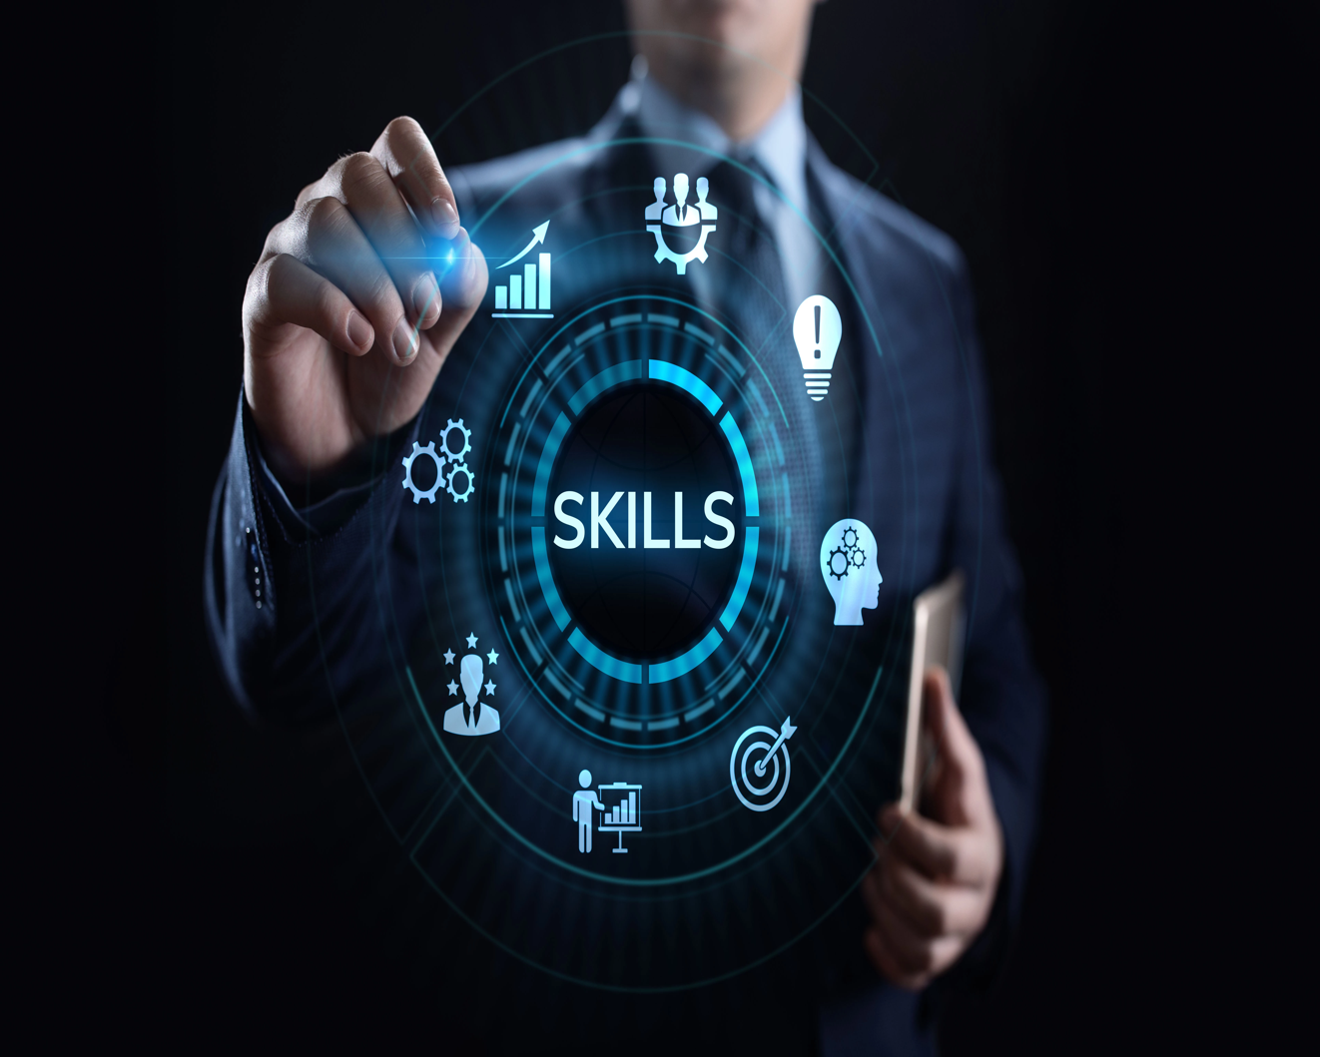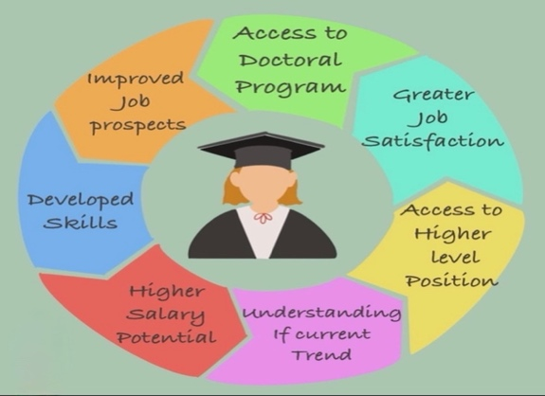
Figures: Essential Skills for future career path.
[1]
Effective Communication: The ability to convey ideas clearly and professionally, both orally and in writing, and to adapt one's style to different audiences. This skill frequently appears as a priority for employers and in academic development. [2]
Time Management and Self organisation: Setting realistic goals, prioritising tasks, and balancing workloads to achieve consistent academic and professional performance. [3]
Critical Thinking and Problem Solving: Questioning assumptions, evaluating evidence objectively, and generating innovative solutions, which are essential capabilities in modern workplace.
Overall, the book serves as both a study companion and a career preparation tool, guiding students towards becoming competent, adaptable, and employable graduates. [4]
Moreover, these skills enable individuals to share previously acquired knowledge clearly and professionally in front of others, which is essential in meetings, group work, and academic discussions. Developing these abilities not only enhances communication and collaboration but also strengthens one’s professional presence, increasing opportunities for success in both academic and workplace environments. [5]
Task 1 (b): Evaluation of Task 1 (a) based on Similarity report
Given my mark, I believe that my document may not have been fully assessed as intended, as I initially drafted several sections and then refined them in my Word document. I have included all of my supporting sources throughout. The only issue highlighted in red relates to the template, as I had created a new one, whereas the lecturer instructed us to use the template he had originally provided. For this reason, I simply copied the content from my previous document and pasted it into the correct template. Regarding the links, I had placed the references at the top of the document, although they were meant to appear at the end. I therefore copied and moved them to the appropriate section. In conclusion, for the next assessment, if I make an error, I will need to redo the entire document from the beginning to avoid similar issues. I will take this into consideration.
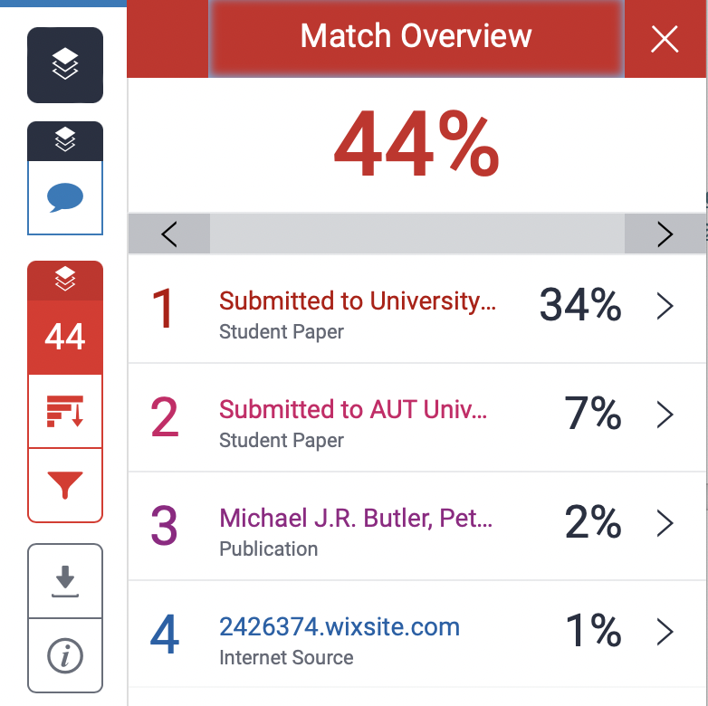
Task 2: Collaborative Mind Map and Individual Poster
Mind Map (Collaborative)
Life Is a Team Sport suggests that, just like in team sports, life is better when we collaborate with others. It emphasizes the importance of mutual support, communication, trust, and empathy to achieve both personal and group goals. It also highlights that everyone has a role to play sometimes we lead, sometimes we follow, but we always contribute to the team. The central message is that success, resilience, and growth increase when we don’t act alone, but alongside people who share our values and goals.
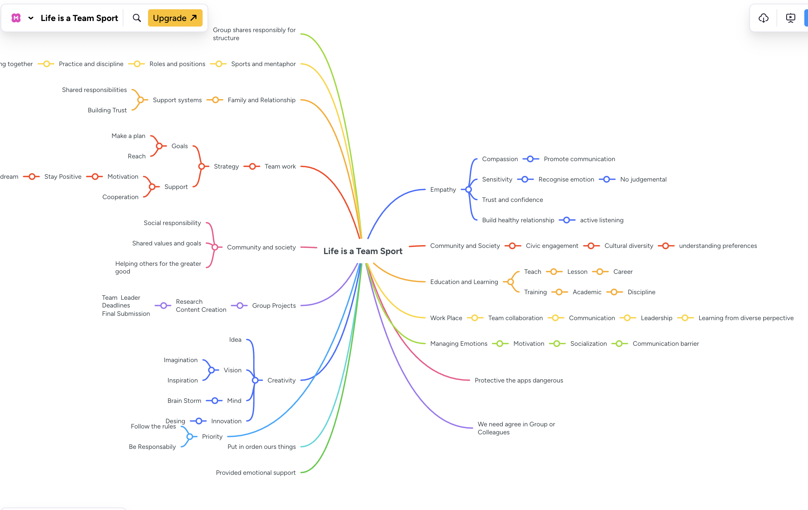
https://mm.tt/map/3845109854?t=SaMYlrstz7

Poster (Individual)
Here I have created my academic poster based on the Essential Academic and Employment Skills.
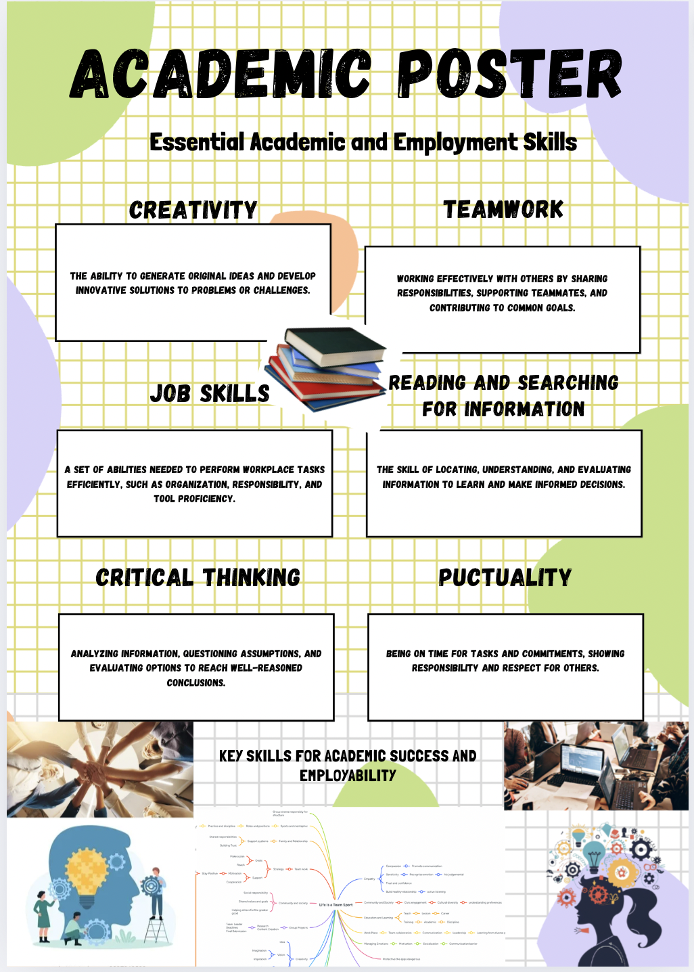
https://www.canva.com/design/DAG2_penoKY/vlUd3QfjtBBW6WiCFWImBA/edit?utm_content=DAG2_penoKY&utm_campaign=designshare&utm_medium=link2&utm_source=sharebutton

Task 3: Virtual Collaboration and RefWorks

Report on Virtual Collaboration
The topic I chose is Forming a team
Forming a Team” within the context of virtual collaboration refers to the process of creating, organizing, and preparing a group of individuals who will work together remotely using digital tools. In virtual environments, the formation of a team is not just about bringing people together; it involves intentionally shaping the conditions that allow effective cooperation despite the physical distance. This process includes selecting members who have the right skills, expertise, and availability to contribute meaningfully to the shared goals of the group. Since team members do not interact face-to-face, it becomes especially important to clearly define roles and responsibilities from the beginning so that everyone understands their tasks, areas of ownership, and expectations. [6]
Another essential aspect of forming a virtual team is establishing common objectives that help align all members toward a shared purpose. By agreeing on what the team intends to achieve and how success will be measured, it becomes easier to coordinate efforts and maintain motivation throughout the project. [7]
Communication norms also play a central role. Unlike traditional in-person work, virtual collaboration relies heavily on digital platforms such as Zoom, Teams, Slack, or shared cloud drives. The team must decide which tools will be used, how frequently members are expected to communicate, what response times are reasonable, and what standards should guide online interactions. [8]
Building initial trust is also a key component of forming a virtual team. In remote settings, trust does not develop naturally through everyday interactions, so it must be created through intentional activities, early conversations, and opportunities for members to get to know each other. This sense of connection contributes significantly to cohesion and team morale. Additionally, forming a team involves preparing the digital environment by ensuring that everyone has access to the necessary accounts, platforms, and shared workspaces, as well as establishing workflows that support efficient collaboration. [9]
This process is especially important in virtual collaboration because remote teams require clearer structures, more explicit communication, and well-defined processes from the start. Without these elements, virtual teams are more likely to experience misunderstandings, coordination problems, and reduced productivity. By carefully forming a team, organizations can create a solid foundation that enables members to collaborate effectively, maintain clarity, and achieve their objectives despite the challenges inherent to working remotely. [10]

Step-by-step process of using RefWorks with visuals
Step 1. Click on Create account or sign up.
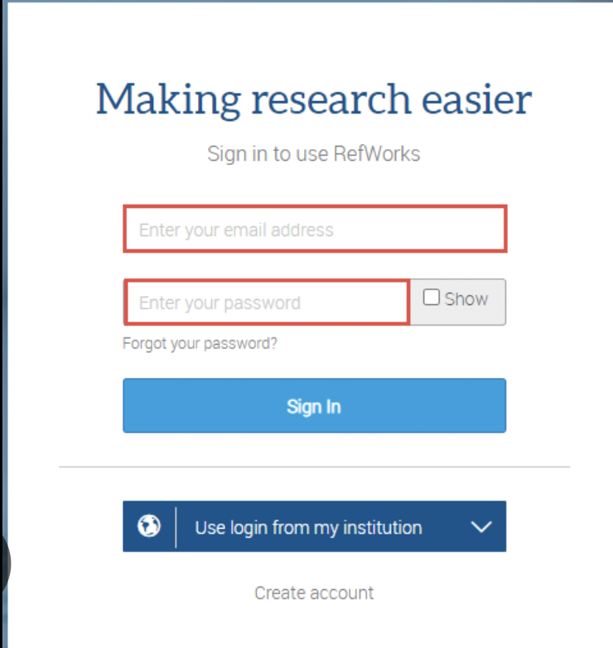
Step 2. Check your university email for an activation link and follow the instructions to complete your profile and log in.
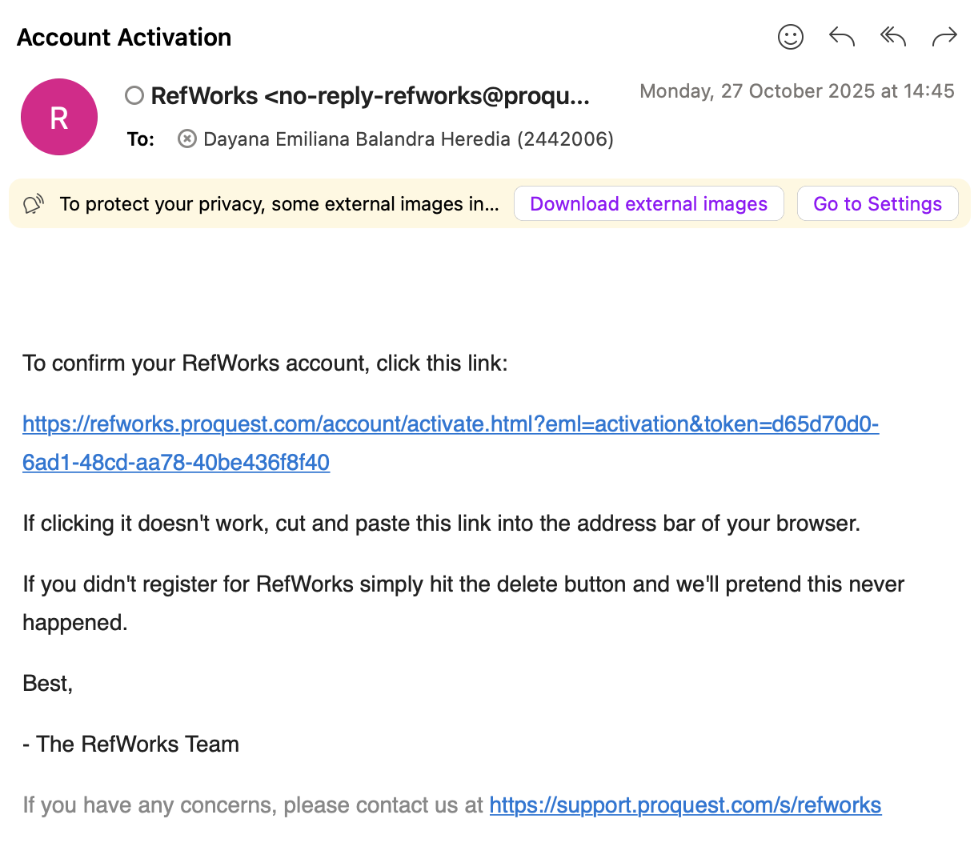
Step 3. Once you’ve created the account and filed in all the required Information, you can start creating folders and naming them however you like.
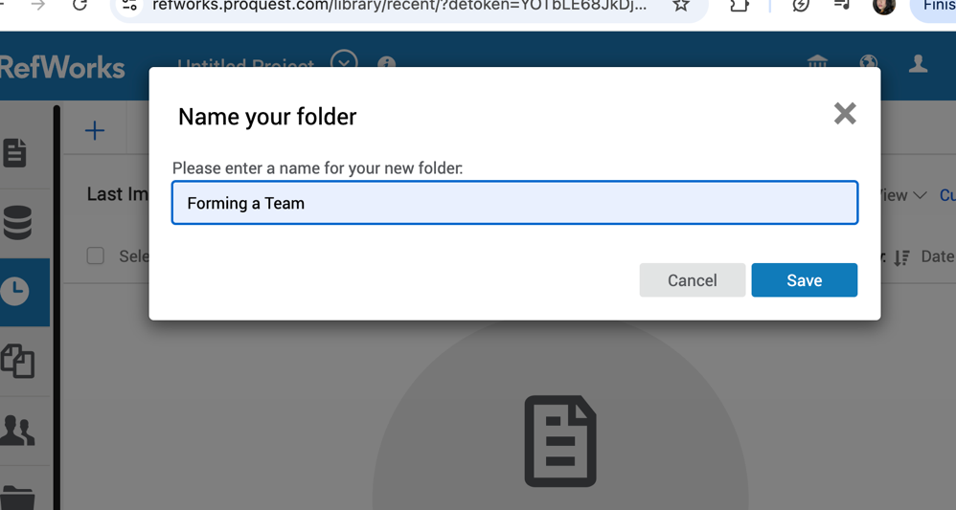
Step 4. Creating citation using RefWorks.
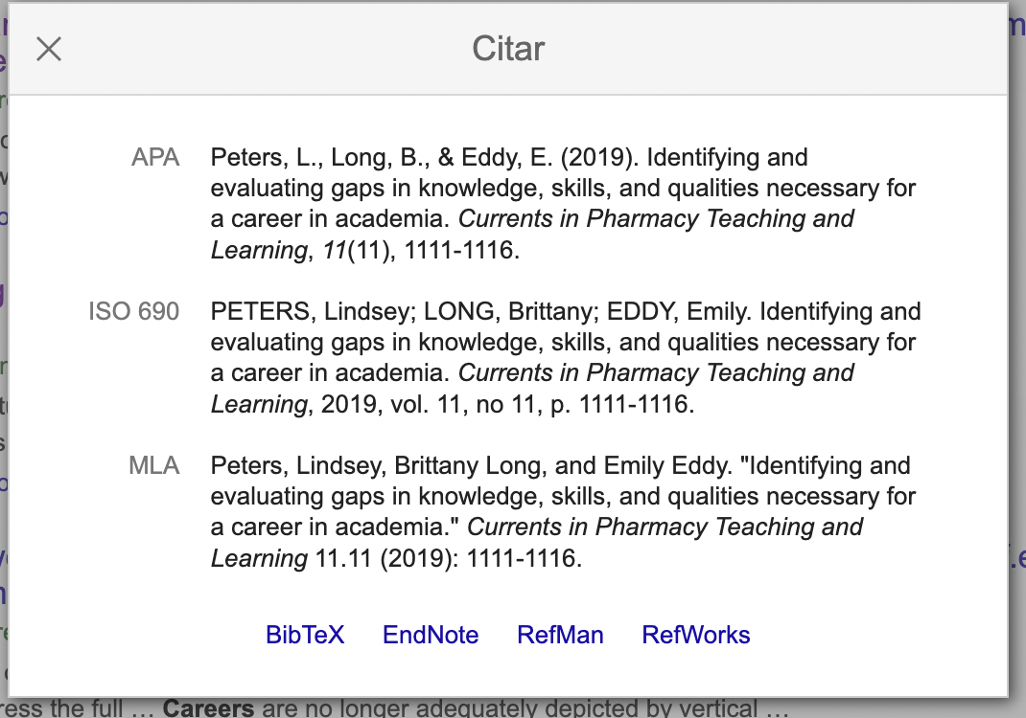
Step 5. Once all sources have been uploaded, select them to generate the RefWorks reference list. When the process is complete, copy the generated references to the clipboard.
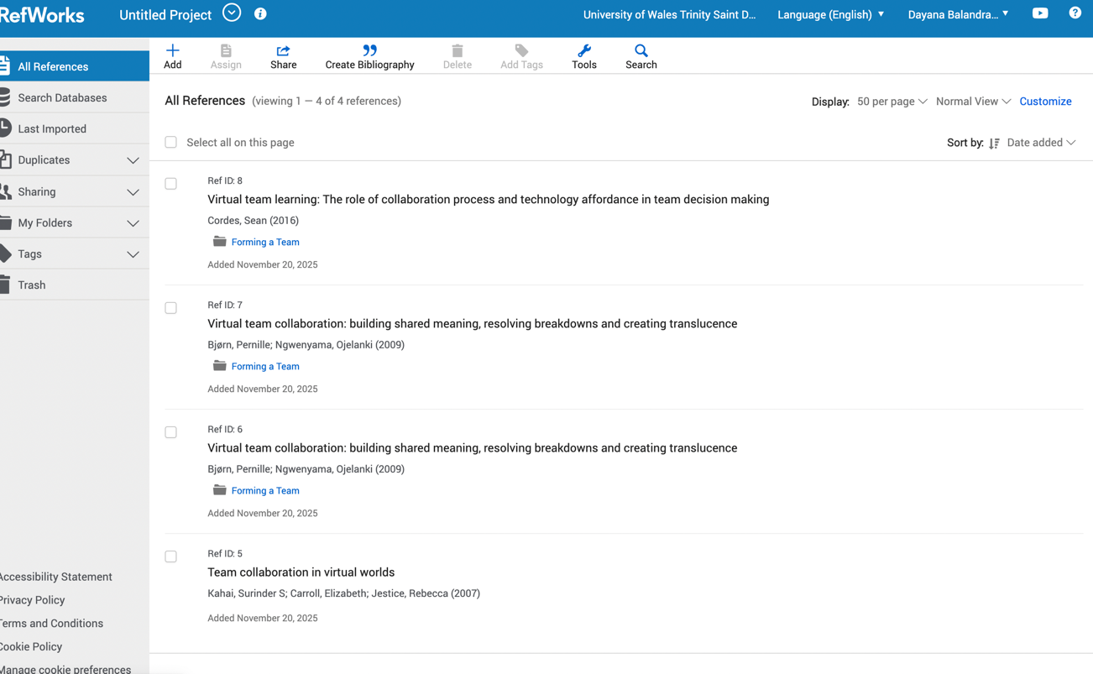
Task 4: E-Portfolio Creation and Evaluation
Task 4 (a): E-Portfolio Creation
Task 4 (b): Illustrative Review of E-Portfolio tool Selection
The initial step is to create and select an appropriate template. Subsequently, I will outline the steps following the order in which I completed them. This portfolio is based on all the work I produced in response to the previous questions in this assignment.
1. We begin by creating a new site
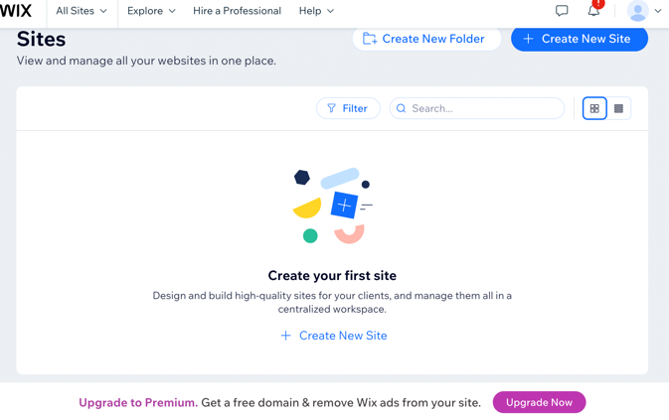
2. Next, we select the option without AI
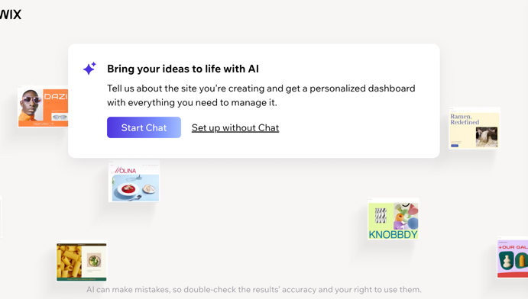
3. Once in the dashboard, select Design Site.
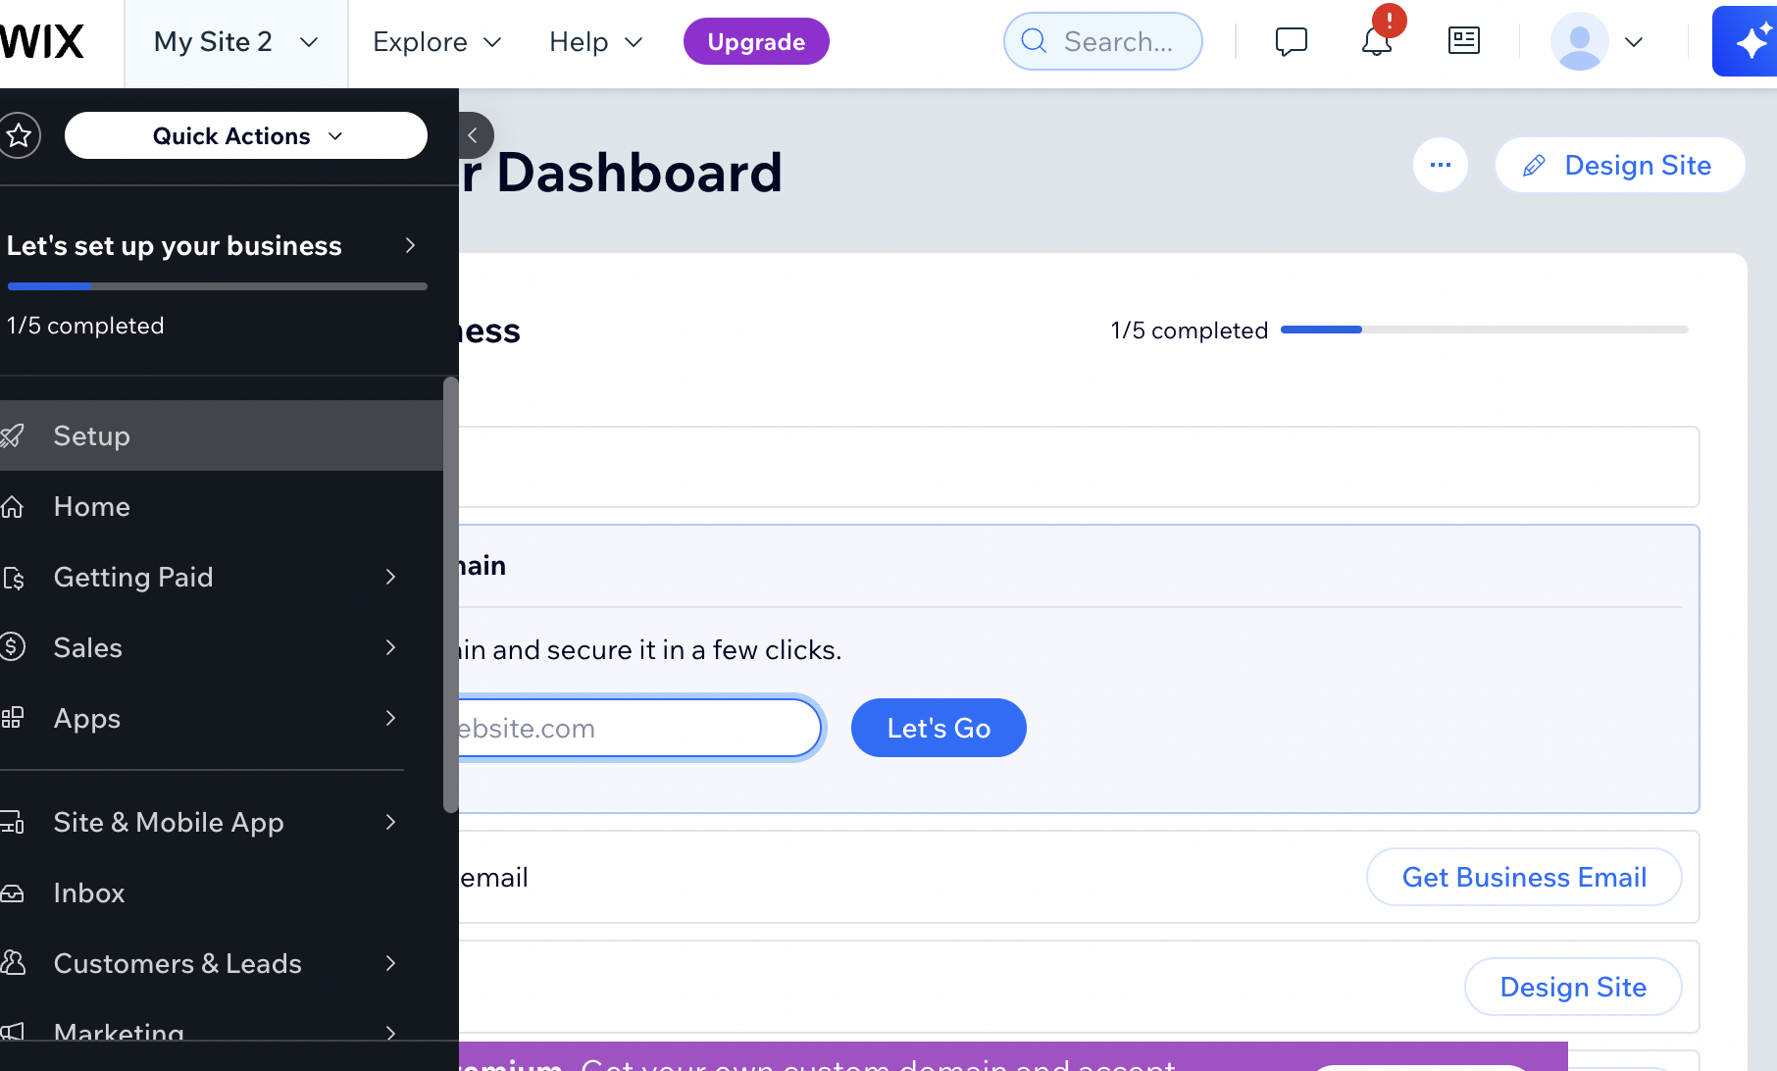
4. Then, choose a template
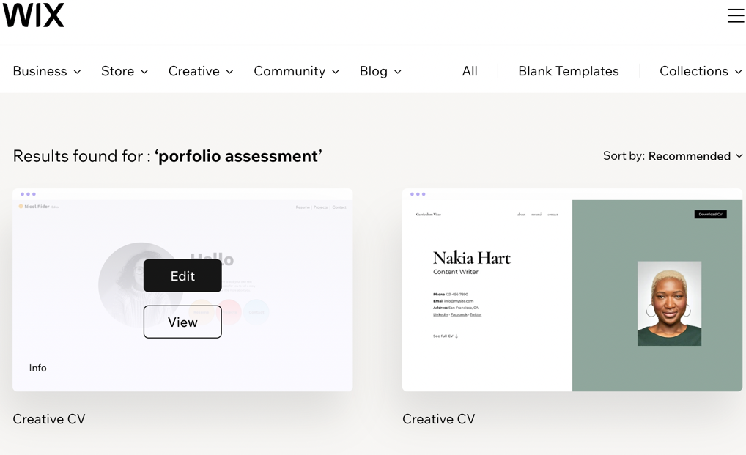
5. We then edit every detail according to your preferences.
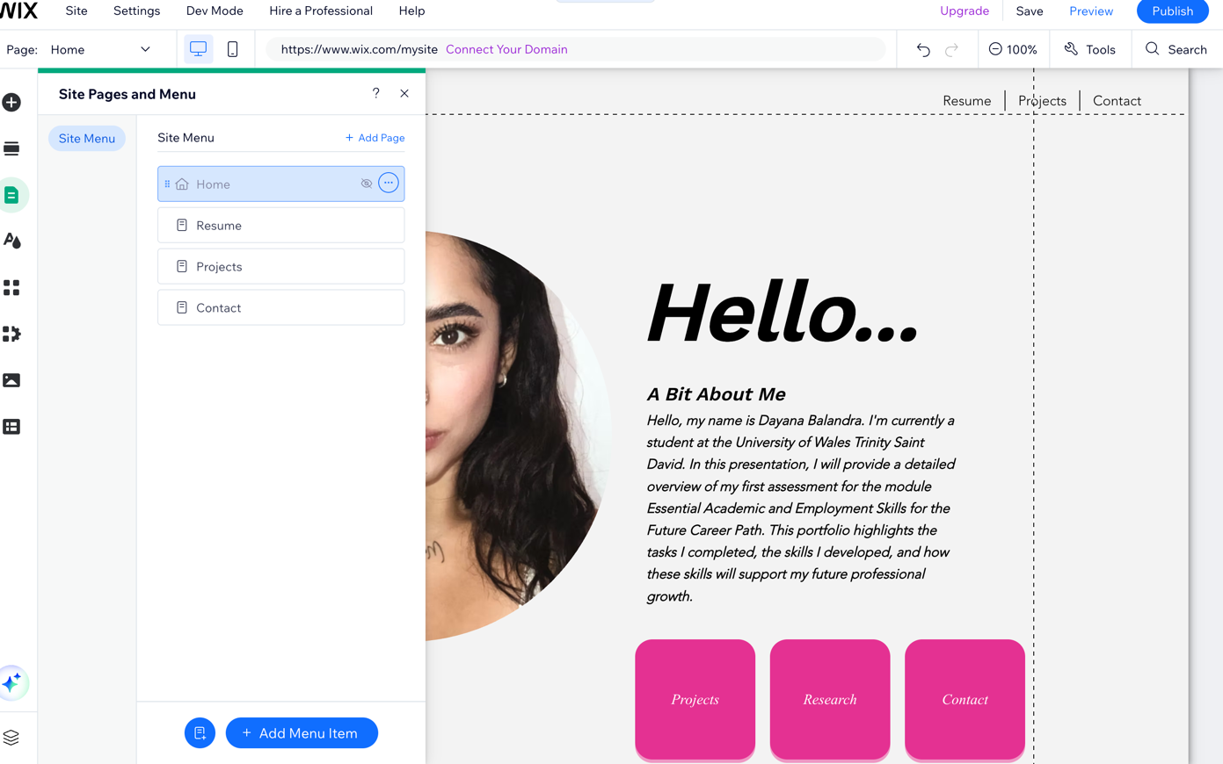
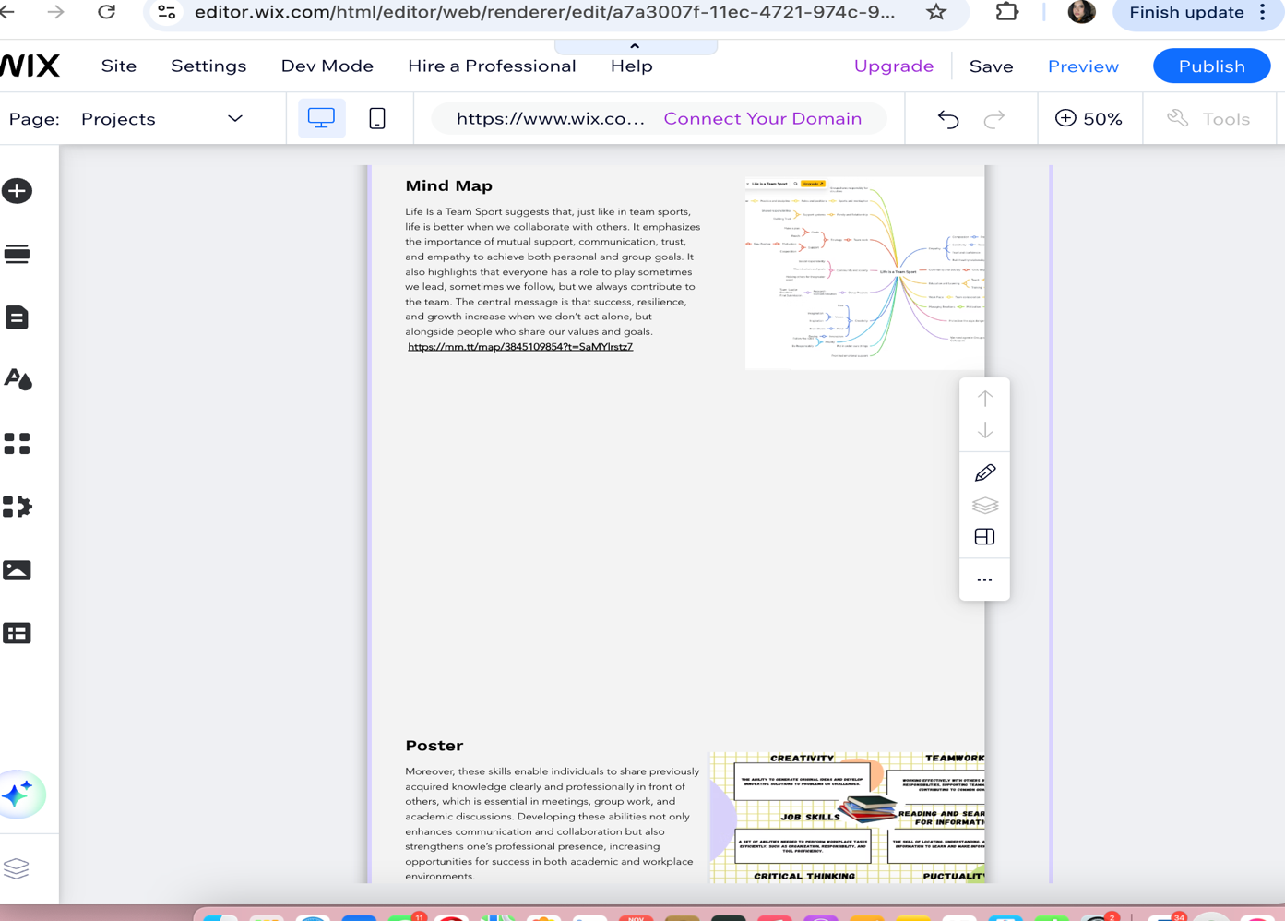 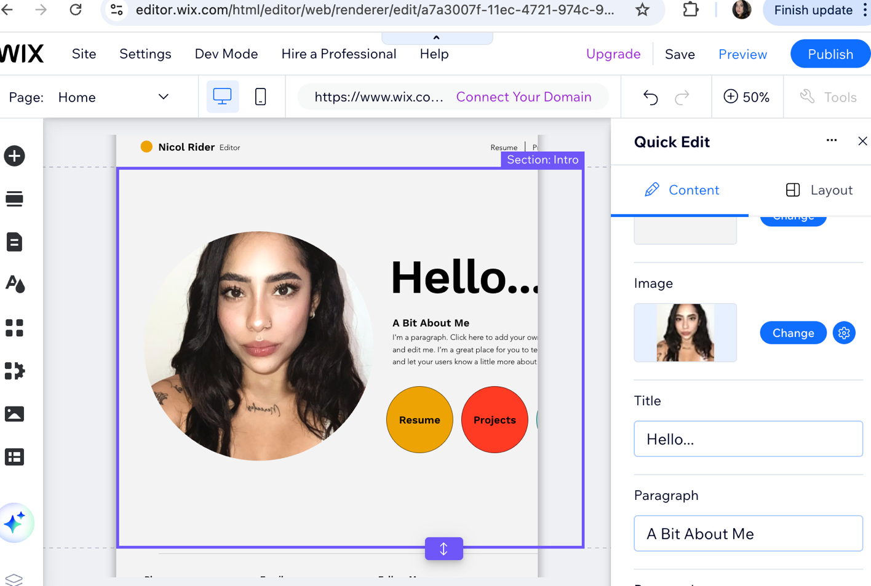
https://editor.wix.com/html/editor/web/renderer/edit/a7a3007f-11ec-4721-974c-99e2d462ca6e?metaSiteId=dceab8d9-4493-4e6c-a825-d0f10f3f9aff

Conclusion
In conclusion, developing essential academic and employment skills is key to building a strong career path. These competencies allow individuals to adapt to changes, meet market demands, and take advantage of new opportunities, ensuring continuous growth and successful performance in the future.

References

Task 1 References:

[1] | A. Awate, “Amruta Awate,” 2023.
[2] | A. B. a. W. Locke, “The Early Career Paths and Employment Conditions of the Academic Profession in 17 Countries,” European Review, pp. S7-S33, 18.
[3] | R. Bridgstock, “The graduate attributes we’ve overlooked: enhancing graduate employability through career management skills,” Higher Education Research & Development, vol. 28, no. 1, pp. 31-34.
[4] | “Sobiya Syed and Andrea Duncan,” The Open Journal of Occupational Therapy, vol. 7, no. 1, 2019.
[5] | E. Dunne, “Skill development in higher education and employment,” 2000.

Task 3 References:

[6] | E. C. a. R. J. S. S. Kahai, “Team collaboration in virtual worlds,” The Data Base for Advances in Information Systems, vol. 38, no. 4, pp. 61-68, 2007.
[7] | L. J. Gressgård, “Virtual team collaboration and innovation in organizations,” vol. 17, no. 1-2, pp. 102-119, 2011.
[8] | P. B. a. O. Ngwenyama, “Virtual team collaboration: Building shared meaning, resolving breakdowns and creating translucence,” Information Systems Journal, vol. 19, no. 3, pp. 227-253, 2009.
[9] | S. J. a. J. P. B. . Meluso, “Making Virtual Teams Work: Redesigning Virtual Collaboration for the Future,” 2020.
[10] | R. V. C. S. S. a. S. W. H. S. Sarker, “Understanding Virtual Team Development: An Interpretive Study,” Journal of the Association for Information Systems (J Assoc. Inf. Syst.), vol. 4, no. 1, 2003.
[11] | K. Gallagher, “Essential Study and Employment Skills for Business and Management Students.,” p. 370, 2022.
[12] | A. Taylor, J. Nelson, S. O’Donnell, E. Davies and J. Hillary, “The Skills Imperative 2035: What Does the Literature Tell Us About Essential Skills Most Needed for Work,” p. 59, 2022.
[13] | M. C. Schools, “Information, Grade 9 Employability Skills,” Not specific .
[14] | N. B. a. C. C. Elisabeth Dunne, “Skill development in higher education and employment,” Differing Visions of a Learning Society, Volume 1: Research Findings, pp. 105-138, 2000.
[15] | L.-E. Datta, “Chapter VII: Employment-Related Basic Skills,” Adult Education Quarterly (Vol. 83, Issue 6), 1982.
[16] | A. B. a. W. Locke, “The Early Career Paths and Employment Conditions of the Academic Profession in 17 Countries,” European Review, vol. 18, pp. S7-S33.

