Mr Ionut Tudureanu
Student number: 1917144
Programme: BA Business Management Level 4
Module title: Community Engagement
Module code: LCBB4002
Assignment Title: Assessment 1- Community Engagement
Module Lecturer: Rula Alousi

LONDON MARATHON
Report
Community Engagement
Assessment1

Table of contents

- Introduction…………………………………………………………………………3
- London Marathon ………………………………………………………………….4
  - Findings………………………………………………………………………4
  - The London Marathon main aim within community……………………..5
  - The London Marathon community aims and strategy…………………..5
  - Objectives……………………………………………………………………6
  - London Marathon grants and projects…………………………………….7
- Analysis………………………………………………………………………………8
  - Community engagement techniques………………………………………9
  - London Marathon project difficulties ……………………………………...9
- Conclusion………………………………………………………………………….10
- References………………………………………………………………………….11

- INTRODUCTION
London Marathon started its activity from 1981. Nowadays, the organisation still has its own focus on raising funds in order to help London sports facilities and to inspire people in living a healthy lifestyle. The London Marathon Trust is offering financial support raised from every year’s marathon and it enables many kids and adults to lead healthy lifestyles for the rest of their days. The organisation’s main focus is on maintaining and increasing their involvement in exercise at the moment. The key is providing facilities for everybody in London, of all ages, who wishes to be or needs to improve their health. Across the UK, the organisation wants to take on ambitious initiatives that will combat the imbalance in opportunity and physical activity: children and young people, ethnic minorities, people from lower socio-economic circumstances, and the elderly. The foundation supports the London Marathon because it emulates their philanthropic values. Over the past 30 years, the trust has given over one hundred million pounds to projects in the city and beyond (LMCT,2021). This report will focus on London’s Marathon community engagement process, the implemented community engagement techniques in order to keep the community informed and engage more and more people into their social projects.

- LONDON MARATHON
  - Findings

Chris Brasher and John Disley created the London Marathon in 1981, their initial goals was to raise funds for London's sports and leisure facilities. Their vision was that all proceeds from the London Marathon and future activities organized by London Marathon Events Ltd will be permanently donated to The Trust (London Marathon, 2021).
The organisation is focusing on trust in continuous growth and innovation for their sports operations, the participants have raised funds for charities, and have made an impression on future participants to inspire people to participate in other mass-led activities. The London Marathon Charitable Trust offers funds to support people as they strive to become and maintain a healthy lifestyle, as well as challenge barriers to others (LMCT, 2021).
London Marathon was brought by LMEL and has proven to be an effective programme in organizing high-scale athletic competitions, which in turn has given them the opportunity to hold world-class ones. Ever since it was established, the London Marathon has served as a vehicle for mobilizing millions of others to become involved. The Trust is a shareholder of the L.M.M.E.L. and all The LMEL makes a financial contribution to The Foundation. Both of the Foundation's funds are used for charitable purposes (LMCT, 2021).
Donations of the surpluses have been made to The London Marathon Trust after all the expenses have been paid These funds are awarded to organizations and programs that help individuals to break through the barriers to physical activity by helping them to maintain their personal and societal health (LMCT, 2021).
As well as that, the Prudential RideLondon festival is supported by the Mayor of London and his authorities, it is also organized by the London & Surrey Cycling Partnership (LSP). 50% of the shares and profits are held by London Marathon Holdings, a wholly owned subsidiary of London Sporting Events Ltd Entrance fees are specifically not allotted to participants who fail to qualify for the sportive in the LSCP contest. Additionally, all profits generated from London Marathon Events are donated to The Trust.
  - The London Marathon main aim within community

John Disley and Chris Brasher had drafted six improving areas within the London Marathon project, they launched it.
- Enabling British marathoners to run faster and with a more prestigious field.
- To demonstrate on occasions, the human race should meet on the ground of mutual respect and cooperation
- To improve the social amenities in London
- To develop the city's tourism industry
- When Britain does it very well when it comes to planning large-scale operation The London Marathon, in particular, is proud of its work for charity. A high percentage of those who take on the event of completing it set out to use it as a way to earn money for a good cause. There have been over $955 million in donations received to London Marathon charities since the first one started in 1981 (LMCT, 2021).
Since it sets a world record every year, the London Marathon is the largest single day charity event of its kind. The 2018 Virgin Money London Marathon set a new world record for annual single-day fundraising event for an unprecedented 12th year in a row, raising a total of £63.7 million for charity (Virgin money. 2021).
Prudential RideLondon has donated more than £53 million to charity since its first year in 2013. At 2017's case, we raised $12.75 million, breaking our own previous record of $12 million.to make one's life more cheerful and productive in a troubled world of chaos.
  - The London Marathon community aims and strategy
The idea of community involvement is to make a cohesive collection of procedures and implement programs to nurture the members' potential. The community's involvement generates deeper partnerships and loyalty, which increases lifetime value (G.Stuart, 2016).

Although people share a mutual interest, the culture is more than the sum of its parts; each community consists of a unique experiences, desires, and outcomes. Community-based approach refers to the need to community and includes community involvement (G.Stuart, 2016).
In order to make the community to engage with the social project the London Marathon is stating all the organisation’s principles, purpose and future goals. The foundation’s vision consists in a world in which everyone is healthy and involved, improving their quality of life by doing something that is socially beneficial (London Marathon,2021).
The mission of the foundation is to expand the range of possibilities to allow diverse people to join and marginalized people in and continuous physical activity regardless of age, gender, skill, or race, and for all citizens, residents who face geographical, economic, personal, or physical challenges, maintain and build, renovate, or expand facilities to accommodate such initiatives to value education (LMCT, 2021).
The foundation attempt to conduct their activities with aplomb and with the purpose of leaving a legacy of accomplishment, making efforts to make an impression on others so they remember who the foundation is for the rest of their lives ( G. Grimes, 2021).
  - Objectives
The foundation is expressing the wish of bringing together the people and create a big community focusing on putting inclusion, accessibility, equity, and diversity at the core of all the foundation’s activities in order to ensure that all UK citizens and societies will benefit from the operation, the foundation must make sure that everybody has fair access to it (G. Grimes, 2021).
Furthermore, the foundation is focusing on enabling and inspiring groups to serve as partners in running for a common cause. Although no one enjoys sitting around doing nothing and being inactive, and the foundation recognise that there are a number of barriers that hinder people from getting enough exercise and that the foundation is trying to help people to everyone overcome them so that everybody can get the greatest possible physical activity (LMCT,2021). Also, the foundation is making clear the respect over the community choice and commitments.

  - London Marathon grants and projects
The program's grants in London and Surrey concentrate on improving services to promote the health and independence of men, women, the elderly, and persons with disabilities. Facilities and programs that would have a positive effect on community participation in physical activity are more than simply paid for; the foundation is also funded with donations which help those which truly pursue the noble goals of such an organisation initiative. Below can be illustrated the Facilitates and the Grants that the foundation is offering and the criteria of approving the grants (LMCT, 2021).
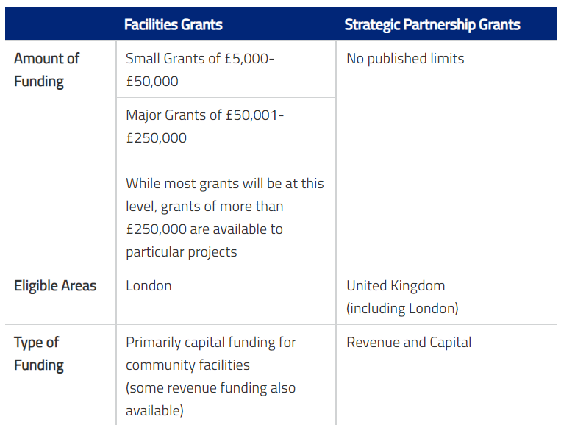

Fig.1: London Marathon Grants and Facilities
Source: London Marathon, 2021
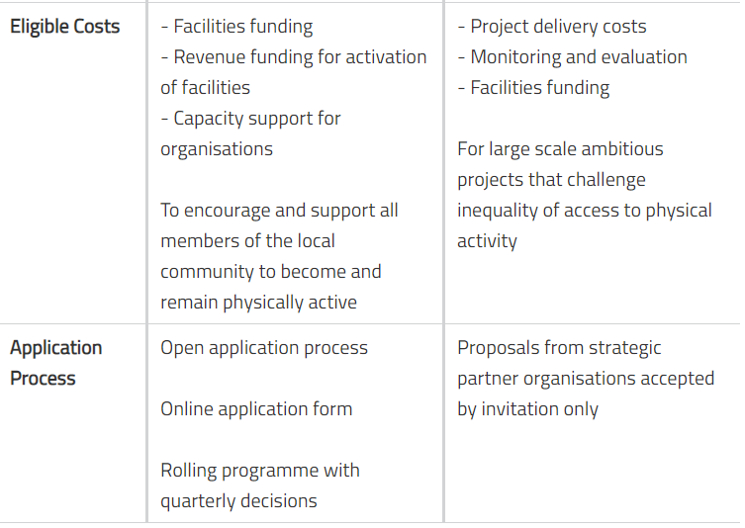

Fig.2: London Marathon Grants and Facilities criteria
Source: London Marathon, 2021

- ANALYSIS
Community engagement describes the mechanism by which a common vision is brought about and implemented in order to support a given community (K. Hodgson, 2011). The London Marathon is referred to as the community since they all the residents and businesses are located in close proximity to each other. All events that London Marathon is having are focusing on gather trust for helping other projects. The impact that this foundation has is huge.
According to the London Marathon (2021), the foundation has accorded source of funding of $55 in grants given to 55 different sports and activities. Every London borough was given a small amount of discretionary funds from which they could do what they wanted. Since 2018, the organization has granted over £11.4 million to 29 strategic partners, all of which were used to support all the elements of Inspire Operation in the UK. Since 2012, several charities have benefited from nearly £7 million in total funding, much of which was for the Legacy Ventures, such as the London Marathon Community Track and Lee Valley Velo Park, both in the Olympic Park.
To help finance over 200 children's playground programs, the trust was allocating £3.8 million to help expand recreational facilities, the organization was the only one that was awarding money to provide these amenities to other children. Additionally, money has been set aside for the maintenance of 46 permanent playing fields (or 335 hectares) throughout the country (LMCT, 2021).
  - Community engagement techniques
The foundation seems to keep the community engaged and informed using tv channel BBC, newspapers the online platform also is giving all information needed about the foundation trust, main goals, the foundation further projects and missions. The foundation partnership with Virgin in enlarging the community (LMCT, 2021).
The foundation wants to include everyone, not just athletes, during the engagement process young people, and working parents, retired people, all nationalities, cultures, women and men. The involvement of all these groups is crucial to the success of the society (K. Hodgson, 2011). It is possible to increase the opportunities for participation, to make participation more enjoyable, and more successful, by expanding the scope of the existing marathons.
  - London Marathon project difficulties
London Marathon declared the postponement of the event for Sunday, which was to take place on April 26th, 2020. Fearing that many customers will miss the Race in October, organizers added more dates for the event in October of Sunday, December 3rd, February 17th, June, July, and September 17th in the year 2021. In order to solve the difficulties that COVID19 has brought to London Marathon, the foundation came with a solution: the Bump will be available to 100 professional athletes and 1- and 500 event organizers to let them know when they come into contact with each other. However, they must not be worn when racing because of course; however, in the athletes can take them off before they step on the starting line. The Bump has an RFID system that lets you monitor people within a few feet of the item, allowing for easy location and can expand the footprint (BBC,2020). Those that have been in close contact with the positive person will be told if they have been infected, as well as others in the two-week period before them. Thas is a robotics firm, which is located in the Blyth Northumberland area of England. All these strategies used helped in maintaining the community engagement and loyalty (BBC,2020).
- CONCLUSION

According to all data gathered in this report, London Marathon is playing a significant role in United Kingdom. The foundation is organising sportive gatherings with charitable scope, in order to help other sportive projects to thrive. The foundation mission is to help the community introducing physical activity to everyone doesn’t matter the age or if the person has any disability. For this the foundation is organising different types of marathons for professional athletes, for beginners and here everyone is allowed to come and for people in wheelchair. The idea of gathering together to accomplish the same goal has brought the community engagement. The information that the foundation is releasing in order to keep the community engaged and informed is always updated. The communication channels are very diversified as: through TV channel (BBC), newspapers, through their official site and social media platform. The foundation ideal is to help and with the community engagement and loyalty London Marathon is one of the strongest charity foundations.

- REFERENCES

D. Dawson & P. Triola, (2020), “Everything You Need to Know About the 2020 London Marathon”, Available at: https://www.runnersworld.com/races-places/a27207762/london-marathon-faq/ , Accessed: 28.04.2021.
VirginMoney, (2021), “Our Community”, Available at: https://www.virginmoneylondonmarathon.com/training/community , Accessed: 20.04.2021.
G.Grimes, (2021), “How the London Marathon Works”, , Available at: https://adventure.howstuffworks.com/outdoor-activities/running/events/london-marathon.htm , Accessed: 20.04.2021.
LMCT, (2021), “London Marathon Charitable Trust Grants”, Available at: https://www.lmct.org.uk/about/lmct-grants/index.html , Accessed: 21.04.2021.
CSE, (2013), “Community engagement: Developing a strategy”, Available at: https://www.cse.org.uk/local-energy/download/community-engagement-developing-a-strategy-255 , Accessed: 23.04.2021.
LMCT, (2021), “About us”, Available at: https://www.lmct.org.uk/info-hub/lmct-40-campaign/index.html , Accessed: 22.04.2021.
BBC, (2020), “London Marathon 2020: Athletes to wear social-distancing tech”, Available at: https://www.bbc.co.uk/news/technology-54354528 , Accessed: 22.04.2021.
LOROS,(2021), “London Marathon 2021”, Available at: https://www.loros.co.uk/support-us/events/2021/10/03/london-marathon-2021 , Accessed: 22.04.2021.
K. Hodgson, (2011), “Community Engagement”, Available at: https://planning-org-uploaded-media.s3.amazonaws.com/publication/download_pdf/How-Arts-Cultural-Strategies-Enhance-Community.pdf , Accessed: 25.04.2021.

