
Assignment 2: T-Test
Data Analysis and Visualisation
ACCA4002
University of Wales Trinity Saint David, Birmingham
Student Name: Cristian-Constantin Paraschiv
Student ID: 2026077
Contents
T-Test 3
References 11

T-Test

Significance levels or hypothesis tests may be found in abundance in scientific publications. T.Dahjru (2008) pointing out that doctors and scientists often state if their testing for hypotheses was important nor semi, and several investigators become ecstatic if those who uncover a “statistically relevant” result before fully comprehending what else it implies more details in [1]. Furthermore, discussed, researchers also go over statistical techniques and see what the T-Test entails.
The researchers ( https://www.kdnuggets.com/2015/08/statistics-understanding-levels-measurement.html ) reflect on understanding relevant parameters would be approach in undertaking statistically for insights. Every element that must be quantified or who amount fluctuates across the community is referred to someone as a variability. Thus instance, if we want to determine the average pay of US citizens, we may either go out and record the salaries of this or any other member to obtain the mean, select a representative selection first from total society while using hypothesis testing to make inferences again for sample frame,[2] provides more information.
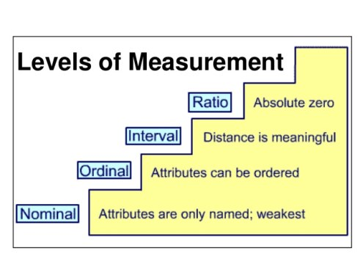
The nominal subcategories paradigm, through its different specialisations as well as modifications, provides a vast family of functions suited for statistical description of individualized qualitatively action in relation to specified cues, according to the author R. Darrell Bock. As a function of stimulus features and human qualities, those level method overall probabilities of such a person's personal reply in a slew of completely rare and highly exhausting classes as represented in picture below, [3] gives additional information.
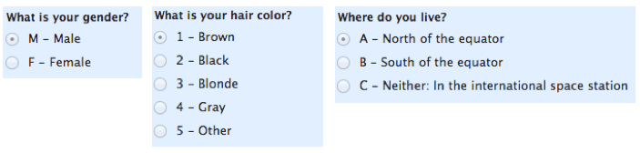
As an example, consider nominal subcategories. Origin: https://www.mymarketresearchmethods.com/types-of-data-nominal-ordinal-interval-ratio/
The authors N. Cliff and J. A. Keats (2003) highlights that the elements that make up a gauge ought to be independently exclusionary structured in enable for something to be there at ordinal response variable. The availability of an alternative neutral level as well as an optional calculation method that really is consistent across the spectrum are usual extra prerequisites for an interval data. However, determining the gauge kind is difficult, as shown in the illustration, explored in further detail in [4].
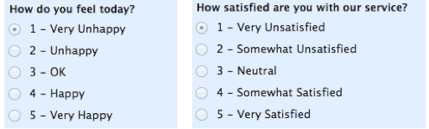
Ordinary image as an example. Citation: https://www.mymarketresearchmethods.com/types-of-data-nominal-ordinal-interval-ratio/
Richard J. Larsen and Morris L. Marx (2012) reflect on how to use basic summary analysis on databases that include intervals instead of plan presented. It summarises the side is called of such numbers as a component of survey needs and colour of the intervals throughout the information (level of commonality, length but also consistency of thicknesses, etc.) as well as explains methodologies to quantify different mechanisms, the growth rate(median) and other decile, fluctuation, standard deviations, instances, standard errors, and perhaps other play vital roles. It also looks at the possibilities for studying these data sources using hypothesis testing approaches like sentiment analysis and explanatory variables, additionally to see on [5].
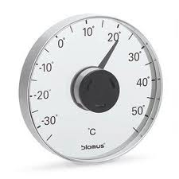
Illustration of an interval as an example: https://www.mymarketresearchmethods.com/types-of-data-nominal-ordinal-interval-ratio/
High sample mean of an occurrence is calculated as the ratio, further detailed in [6]; handful of words an incident happens divided by the total of instances same test has already been done. The comparative interpretation of possibility should be used when the multitude of days a research project is frequent encounters spacetime and the central tendency of the venue reaches a restriction due to measurement coherence. Observe that it's all a scientific theory limitation never genuinely occur because the number of incidents a physiological test is being performed can be very vast, yet it is ultimately limited.


Illustration Ratio sample picture. Origin: https://www.mymarketresearchmethods.com/types-of-data-nominal-ordinal-interval-ratio/
Furthermore, proper statistics need the usage of mean, median, mode, and range, as previously mentioned. Experts think the three most common "estimates" in facts and numbers are the three that are most ready to impose throughout our post courses if the topic is ever brought up. This same "mean" is the same as the "average" commonly understood, which is calculated by adding all values together and dividing by the total digits of digits. In a sequence of names, the "median" element was also the "centre" element. Because values must be sorted in ascending order from smallest to largest in order to get the median, the collection must be modified until the median is discovered. Although "mode" is probably the most often used supply function, there seems to be no pattern for both the collection and the column when no integer is duplicated. The range is the distance between the largest and smallest entry in a list of numbers, further information may be found on (https://www.purplemath.com/modules/meanmode.htm?fbclid=IwAR1ratzxWagWR_99C70XNwWWWPueExlHDek892qhwIbFku0exaAVxeq63m8).
The author highlights detailed in [7], that standard deviation quantifies a dataset's separation from its own average value. By calculating each data point's departure from the mean, standard deviation is computed as the squared of variation. There is still a greater variance inside the information source unless the variables are farther from mean; therefore, then the spaced out everyone's information, then larger the quality variation.
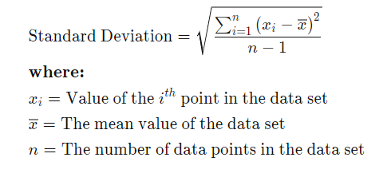
Standard deviation illustration. Origin:https://www.investopedia.com/terms/s/standarddeviation.asp
The author (L. Van Valen, 2005) describe mathematical assessment of the dispersion among values in such an information gathering is known as variance; nevertheless, expresses how much each value within collection deviates again from average, and therefore from just about every integer throughout the subset. Thus, the symbol is often used to represent variation: σ². Researchers and shopkeepers like to evaluate currency fluctuations and safety, concise in [10].
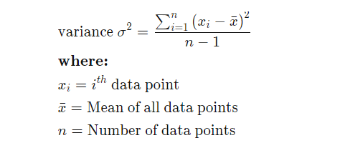
Origin: https://www.investopedia.com/terms/v/variance.asp

H. Kranzler (2018) pointed out that technique adds that has been used to see whether there is a substantial distinction of different parts that are linked in some way it is illustrated as t-test, concluded better in [8]. It's most often employed whenever metrics, such as those obtained by rolling the dice, are expected to abide by rules and seem to have uncertain eccentricities. Also, t-test seems to be a factor analysis technique that can be used to evaluate a statement that is relevant to a community. To assess predictive value, a t-test examines the t-statically, uptime, and coefficients. Quantitative frequency analysis would be used to perform a testing involving multiple or much more variables. The formula for the two-sample t-test (also known as the independent t) is given below, according to the writers of the site (https://www.scribbr.com/statistics/t-test/). Calculation for such T-test t stands for t-value, x1 as well as x2 represent for the dividing it into two subgroups getting examined, s2 stands for the combined error range of both the two different groups, as well as n1, n2 represent for the set of measurements inside each category. Higher t-value indicates also that variation in grouping differences is bigger than just the aggregate error range, implying a rather more differential expression. You may check if their computed t-value is higher than what's being anticipated by coincidence by comparing it all to the numbers in an upper critical graphic. If this is the case, you may rule out the invalid theory also that two sides are distinct, illustrated more in (https://www.scribbr.com/statistics/t-test). Nevertheless, we show how to use T-test and how it works using a table that we have on Moodle.
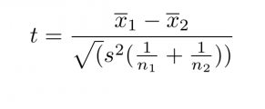
Illustration T-test equation. Illustration origin: https://www.scribbr.com/statistics/t-test
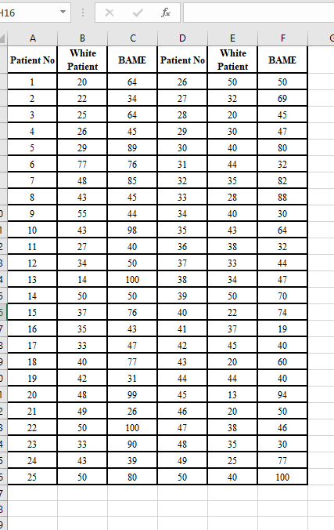

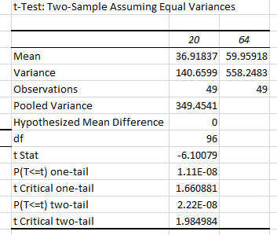
C. Hesse and J. Ofosu (2017) detailed the statistics assumption as the same exam consisted of two hypotheses being considered. Both null and alternative hypothesis are two types of assumption, origin and detailed in [9]. Those theories include conflicting opinions; nevertheless, null hypothesis is represented by H0: declaration that there's no distinction among independent samples or ratios, and that of a sampling meaning or ratio and the overall average or percentage. To put it another way, the variance is zero. Thus, alternate theory is as follows: community assertion that contradicts H0, because that is what we come until when dismiss H0. Because the null/alternative form theories are mutually exclusive, you should analyse the information to prove when you have sufficient fail to deny the null assumption. Also, proof comes in the shape of data sample; decide upon determining whichever assumption the evidence favours. A choice may be made between two alternatives. Therefore, collection data supports the alternate theory, either were “deny H0,” “will not deny H0,” or “collapse to refute H0.” Unless the population evidence is inadequate to deny null assumption, those who get “will not deny H0” or “collapse to deny H0.” As a result, we demonstrate how null and alternative assumptions operate.
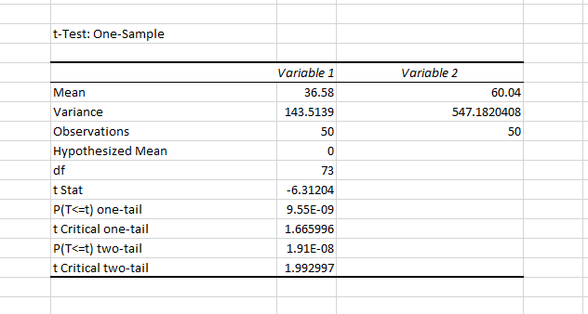H₀ ≤ 0, H_{a}>0
Deny H₀ ≤ 0, if t > 1,665996
T= -6.31204
P-value = 9.6
Because t=-6.31204 > 1.666
Deny H₀
Considering the p-values p=0,10, p=0,01 and p=0,02 a p-value is below 0,05, it is statistically meaningful; nevertheless, data frame p=0,10 is not statistically meaningful since it is higher above 0,05, indicating solid support for such null assumption. Thus, implies that the null assumption is retained, and the alternative assumption is denying; it is important to remember that the null assumption could not be accepted; either deny it or disconfirm it. In the case of data set p=0.01, a p-value of less than 0.05 shows firmness prove facing the null assumption, because there was within a 5% chance the null assumption is true. As a result, the null assumption is rejected, and the alternative assumption is accepted. Furthermore, the p-value is only about 0,05, the null may be rejected, and it does not imply that the alternative theory has a 95% basis in truth, as in the light of data setting p=0.02; p-value is dependent on the null having truthful, yet it has nothing to do with whether the alternate theory is accurate or not, webpage raised issues (https://www.simplypsychology.org/p-value.html).
To summarise, statistics are really utilised to assist us in improving on a large size information collection and dealing with it in a more efficient way. As a result, statistics include the examination and outright fraud, as well as methods for gathering, reviewing, analysing, and drawing insights from collection; can help you make more educated financing and industry choices.

References

[1] T. Dahiru, “P - value, a true test of statistical significance? A cautionary note,” Ann Ib Postgrad Med, vol. 6, no. 1, pp. 21–26, Jun. 2008, doi: 10.4314/aipm.v6i1.64038.

[2] https://www.kdnuggets.com/2015/08/statistics-understanding-levels-measurement.html
[3] R. D. Bock, “The Nominal Categories Model,” in Handbook of Modern Item Response Theory, W. J. van der Linden and R. K. Hambleton, Eds. New York, NY: Springer New York, 1997, pp. 33–49. doi: 10.1007/978-1-4757-2691-6_2.
[4] N. Cliff and J. A. Keats, Ordinal measurement in the behavioral sciences. Mahwah, N.J: Lawrence Erlbaum Associates, 2003.
[5] Richard J. Larsen and Morris L. Marx, INSTRUCTOR'S SOLUTIONS MANUAL AN INTRODUCTION TO MATHEMATICAL STATISTICS AND ITS APPLICATIONS FIFTH EDITION. Pearson Education, Inc. Publishing as Prentice Hall, 75 Arlington Street, Boston, MA 02116, 2012.
[6] A. Grami, Probability, random variables, statistics, and random processes: fundamentals and applications. Hoboken, NJ: John Wiley & Sons, 2020.
https://www.purplemath.com/modules/meanmode.htm?fbclid=IwAR1ratzxWagWR_99C70XNwWWWPueExlHDek892qhwIbFku0exaAVxeq63m8
https://www.mymarketresearchmethods.com/types-of-data-nominal-ordinal-interval-ratio/
https://www.investopedia.com/terms/s/standarddeviation.asp
https://www.scribbr.com/statistics/t-test
https://www.simplypsychology.org/p-value.html
[7] C. Leys, C. Ley, O. Klein, P. Bernard, and L. Licata, “Detecting outliers: Do not use standard deviation around the mean, use absolute deviation around the median,” Journal of Experimental Social Psychology, vol. 49, no. 4, pp. 764–766, Jul. 2013, doi: 10.1016/j.jesp.2013.03.013.
[8] J. H. Kranzler, Statistics for the terrified, Sixth edition. Lanham: Rowman & Littlefield,
2018
.
[9] C. Hesse and J. Ofosu, “Statistical Methods for the Social Sciences,” 2017.

[10] L. Van Valen, “The Statistics of Variation,” in Variation, Elsevier, 2005, pp. 29–47. doi: 10.1016/B978-012088777-4/50005-3.

