APPLICATION FOR ETHICAL APPROVAL

RESEARCH STUDENTS
This form is to be completed by the student within SIX months for full-time students and TWELVE months for part time students, after the commencement of the research degree or following progression to Part Two of your course.

Once complete, submit this form via the MyTSD Doctoral College Portal at (https://mytsd.uwtsd.ac.uk).

This document is also available in Welsh.

RESEARCH STAFF ONLY
All communications relating to this application during its processing must be in writing and emailed to pgresearch@uwtsd.ac.uk , with the title ‘Ethical Approval’ followed by your name.

STUDENTS ON UNDERGRADUATE OR TAUGHT MASTERS PROGRAMMES should submit this form (and receive the outcome) via systems explained to you by the supervisor/module leader.

In order for research to result in benefit and minimise risk of harm, it must be conducted ethically. A researcher may not be covered by the University’s insurance if ethical approval has not been obtained prior to commencement.

The University follows the OECD Frascati manual definition of research activity: “creative work undertaken on a systematic basis in order to increase the stock of knowledge, including knowledge of man, culture and society, and the use of this stock of knowledge to devise new applications”. As such this covers activities undertaken by members of staff, postgraduate research students, and both taught postgraduate and undergraduate students working on dissertations/projects.

The individual undertaking the research activity is known as the “principal researcher”.

Ethical approval is not required for routine audits, performance reviews, quality assurance studies, testing within normal educational requirements, and literary or artistic criticism.

Please read the notes for guidance before completing ALL sections of the form.

This form must be completed and approved prior to undertaking any research activity. Please see Checklist for details of process for different categories of application.

SECTION A: About You (Principal Researcher)
1 | Full Name: |  | Ffion Alice Jones
2 | Tick all boxes that apply: |  | Member of staff: | ☐ | Honorary research fellow: | ☐
 | Undergraduate Student | ☒ | Taught Postgraduate Student | ☐ | Postgraduate Research Student | ☐

3 | Institute/Academic Discipline/Centre: | Yr Athrofa: Psychology and Counselling
4 | Campus: | Swansea
5 | E-mail address: | 2100534@student.uwtsd.ac.uk
6 | Contact Telephone Number: | 07479467614
 | For students:
7 | Student Number: | 2100534
8 | Programme of Study: | BSc Psychology and Counselling
9 | Director of Studies/Supervisor: | Dr Judith Marshall

SECTION B: Approval for Research Activity
1 | Has the research activity received approval in principle?  (please check the Guidance Notes as to the appropriate approval process for different levels of research by different categories of individual) |  | YES | ☒ | NO | ☐
 |  |  |  |  | Date
2 | If Yes, please indicate source of approval (and date where known): Approval in principle must be obtained from the relevant source prior to seeking ethical approval | Research Degrees Committee |  | ☐
2 |  | Institute Research Committee |  | ☐
2 |  | Other (write in) Dr Judith Marshall (Dissertation Supervisor) |  | ☐ | 07/08/2023

SECTION C: Internal and External Ethical Guidance Materials
 | Please list the core ethical guidance documents that have been referred to during the completion of this form (including any discipline-specific codes of research ethics, location-specific codes of research ethics, and also any specific ethical guidance relating to the proposed methodology). Please tick to confirm that your research proposal adheres to these codes and guidelines. You may add rows to this table if needed.
1 | UWTSD Research Ethics & Integrity Code of Practice | ☒
2 | UWTSD Research Data Management Policy | ☒
3 | UWTSD Student Code of Conduct | ☒
4 | UWTSD Data Protection and Storage Protocol | ☒
5 | BPS Code of Ethics and Conduct (December 2021) | ☒
6 | BPS Code of Human Research Ethics (April 2021) | ☒
7 | BPS Data Protection Regulation – Guidance for Researchers (2018) | ☒
8 | BPS Ethics Guidelines for Internet-mediated Research (June 2021) | ☒

SECTION D: External Collaborative Research Activity
If there are external collaborators then you should gain consent from the contact persons to share their personal data with the university. If there are no external collaborators then leave this section blank and continue to section E.
1 | Institution
2 | Contact person name
3 | Contact person e-mail address
4 | Is your research externally funded? |  | YES | ☐ | NO |  | ☐
5 | Are you in receipt of a KESS scholarship? |  | YES | ☐ | NO |  | ☐
6 | Are you specifically employed to undertake this research in either a paid or voluntary capacity? | Voluntary | YES | ☐ | NO | ☐
7 |  | Employed | YES | ☐ | NO | ☐
8 | Is the research being undertaken within an existing UWTSD Athrofa Professional Learning Partnership (APLP)? | If YES then the permission question below does not need to be answered. | YES | ☐ | NO |  | ☐
9 | Has permission to undertake the research has been provided by the partner organisation? | (If YES attach copy)  If NO the application cannot continue | YES | ☐ | NO |  | ☐

Where research activity is carried out in collaboration with an external organisation
10 | Does this organisation have its own ethics approval system? | YES | ☐ | NO | ☐
 | If Yes, please attach a copy of any final approval (or interim approval) from the organisation (this may be a copy of an email if appropriate).

SECTION E: Details of Research Activity
1 | Indicative title: | A qualitative exploration of perceptions of portrayal of schizophrenia, and people with schizophrenia in the media.
2 | Proposed start date: | November 2023 | Proposed end date: | May 2022
Introduction to the Research (maximum 300 words per section)
Ensure that you write for a Non-Specialist Audience when outlining your response to the points below:
- Purpose of Research Activity
- Proposed Research Question
- Aims of Research Activity
- Objectives of Research Activity
Demonstrate, briefly, how Existing Research has informed the proposed activity and explain
- What the research activity will add to the body of knowledge
- How it addresses an area of importance.
3 | Purpose of Research Activity  The purpose of this study is an investigate perceptions of schizophrenia as a cluster of mental illnesses, and people with schizophrenia, are portrayed in the media.  Mental illnesses is a vast area of research which is contstanly expanding. Mental illness, according to the American Psychiatric Association [APA], (2022), is defined as a health condition which involves changes in an individual such as emotion, thinking and/or behaviours. These changes can lead to distress and/or problems functioning in social, work, or family activities. Scizophrenia is a mental illness often classified as a type of psychosis (NHS, 2023). It affects how individual interpret reality and causes a variety of different psychological symptoms, inclusing hallucinations, delusions and disorganised thinking, which can lead to issues in all areas of life such as personal, family, social, educational, and work (Mayo Clinic, 2020; World Health Organisation, 2022).  Societal factors can also have an impact upon individuals with schizophrenia, such as how others view and behave towards them. Research conducted by Cadge et al., (2019), exploring university students understanding and perceptions of schizophrenia found that there was lack of knowledge and a misconception that schizophrenia caused multiple personalities and is a dangerous illness. Perceptions of schizophrenia are often negative, with individuals with schizophrenia being viewed as highly dangerous and feared by many (Angermeyer & Matschinger, 2003). It has been found that stigma and discrimination towards individuals with mental illnesses can have a seriously harmful effect such as an increase in psychiatric symptoms, individuals less likely to stick to treatment, increased difficulty with work and social relationships (Borenstein, 2020). Information that is provided to the public by easily accessed news media can promote stigmatised views of schizophrenia and people diagnosed with it. However, such easily accessed information can also help to challenge perceived stereotypes and related stigma. The ways in which articles related to schizophrenia are presented and interpreted can play an important role in how members of the general public understand and respond to related issues and people. Therefore it is important to explore how people make sense of different presentations.  In todays society, the most common method for people to consume information is through the use of media sources, such as; the news, social media, television, journals, the radio, podcasts, the internet, books, etc. While a number of these sources may be reliable and correctly inform people about methal illnesses, Wahl (2003), states that it is more common for negative media sources to be published. These sources exaggerate, stating vulnerable individuals are dangerous, likely to partake in criminal activity, and tend to be unpredictable (Stuart, 2006). In a study conducted by Owen (2012), where movies featuring at least one main character with schizophrenia were analyzed, it was found that a majority of these characters displayed violent behaviour, either towards themselves or others.  Therefore, the research question for this study is an exploration of the ways in which university students perceive news media portrayals of schizophrenia and people diagnosed with schizophrenia as positive, negative and neutral perceptions, and how they perceive potential effects on the public and people with schizophrenia.  References  American Psychiatric Association. (2022, November). What is mental illness?. Psychiatry.org - What is Mental Illness? https://www.psychiatry.org/patients-families/what-is-mental-illness  Angermeyer, M. C., & Matschinger, H. (2003). Public beliefs about schizophrenia and depression: Similarities and differences. Social Psychiatry and Psychiatric Epidemiology, 38(9), 526–534. https://doi.org/10.1007/s00127-003-0676-6  Borenstein, J. (2020). Stigma, Prejudice and Discrimination Against People with Mental Illness.  Cadge, C., Connor, C., & Greenfield, S. (2019). University students’ understanding and perceptions of schizophrenia in the UK: A qualitative study. BMJ Open, 9(4). https://doi.org/10.1136/bmjopen-2018-025813  Mayo Foundation for Medical Education and Research. (2020, January 7). Schizophrenia. Mayo Clinic. https://www.mayoclinic.org/diseases-conditions/schizophrenia/symptoms-causes/syc-20354443  NHS. (2023, April 13). Schizophrenia. NHS choices. https://www.nhs.uk/mental-health/conditions/schizophrenia/overview/  Owen, P. R. (2012). Portrayals of schizophrenia by entertainment media: A content analysis of contemporary movies. Psychiatric Services, 63(7), 655–659. https://doi.org/10.1176/appi.ps.201100371  Stuart, H. (2006). Media portrayal of mental illness and its treatments. CNS Drugs, 20(2), 99–106. https://doi.org/10.2165/00023210-200620020-00002  Wahl, O. F. (2003). News media portrayal of mental illness. American Behavioral Scientist, 46(12), 1594–1600. https://doi.org/10.1177/0002764203254615  World Health Organization. (2022, January 10). Schizophrenia. World Health Organization. https://www.who.int/news-room/fact-sheets/detail/schizophrenia  (this box should expand as you type)
4 | Research Question  An exploration of the ways in which students perceive news media portrayals of schizophrenia and people diagnosed with schizophrenia as positive, negative and neutral perceptions, and how they perceive potential effects on the public and people with schizophrenia.  (this box should expand as you type)
5 | Aims of Research Activity  The aim of this research study is:  - To identify from the participants’ discussions what dominant views of schizophrenia are recognised.  - To understand university students perceptions of news media portrayals of mental illnesses, specifically schizophrenia.  - To understand from the talk of university students how news portrayals of schizophrenia could influence the ways in which dominant views and social representations are perpetuated and challenged.  (this box should expand as you type)
6 | Objectives of Research Activity  The objective of this study is to contribute to existing literature by identifying current recognised social representations of schizophrenia and how these are interpreted as being supported or challenged by mainstream news media.  (this box should expand as you type)
Proposed methods (maximum 600 words)
Provide a brief summary of all the methods that may be used in the research activity, making it clear what specific techniques may be used. If methods other than those listed in this section are deemed appropriate later, additional ethical approval for those methods will be needed. You do not need to justify the methods here, but should instead describe how you intend to collect the data necessary for you to complete your project.
7 | The study will be conducted in a classroom at the SA1, Swansea campus.  Participants will be recruited through the use of the University of WalesTrinity Saint David (UWTSD) Psychology Department’s Experiment Management System (EMS), which allows eligible students to volunteer to take part in the study in exchange for credits.  After signinging up for the study, participants will be asked to click on a link which will present them with an information sheet (see appendix 1) outlining what the study is about, their right to withdraw from the focus group at anytime, and that the researcher will ensure they remain anonymous.  When participants arrive at the specified location, they will be greeted by the researcher and welcomed in. The researcher will then hand them a consent form (see appendix 2) which they will be required to read and sign, stating they understand what participation in the study will entail, and that they still wish to take part in the study and consent to be recorded on an audio recording device, before the study can commence. After completion of consent forms, participants will be asked to complete a demographics questionnaire, in which they will be asked their age and gender.  During the focus group session, participants will have a number in front of them on a piece of paper which they will be asked to read out before questions start in order for researcher to be able to identify voices of each participants when transcribing. A set of focus group questions (see appendix 3), based on related literature will be used for data collection to ensure that the discussion between participants remains on track and relevant to the research questions.  Media articles will be spread out on the table by the researcher before the focus groups start. Participants will be invited to look over the articles before discussion starts as a number of the questions will be asking them to engage with the articles to answer. The participants will be encouraged to comment freely on aspects of the articles such as headlines, images, use of language, ect. Participants will be told they can refer at anytime during the discussion, not only for questions where they are directed to. Media articles were selected to represent a small but diverse range of perceptions of schizophrenia and people with schizophrenia. Articles that related both to the study questions and prior literature were prioritised to stay within the scope of the study.  Once the session has ended, participants will be given a debrief sheet (see appendix 4) informing them of the aim and purpose of the study, as well as the contact information of the researcher and research supervisor. The researcher will ensure that they talk them through the form, explaining more about the purpose of the research, inviting any questions they may have, and telling them that they can withdraw their data up to two weeks from the date of the focus group session.  After completion of focus groups, researcher will transcribe all audio recordings, before deleting the audio files from the recording device. The researcher will ensure recordings are kept confidential, participants are kept anonymous through the use of participants numbers, read out at the start of the recording and later changed to pseudonames during transcription, and any factors that could lead to identification of participants are changed or removed.  The data collected from the focus group sessions will be analysed through thematic analysis, which allows the researcher to identify and organise key themes that can emerge in the data (Braun & Clarke, 2006).  It is important to understand how media content is understood, and how social representations are constructed, supported and challenged, therefore focus groups will allow for analysis of how media reporting of issues surrounding schizophrenia are discussed during social interactions. Therefore this method is expected to illustrate the different ways in which information can be evaluated and discussed by different people.  References  Braun, V., & Clarke, V. (2006). Using thematic analysis in psychology. Qualitative Research in Psychology, 3(2), 77–101. https://doi.org/10.1191/1478088706qp063oa  (this box should expand as you type)
Location of research activity
Identify all locations where research activity will take place.
8 | Reseach study will take place in a classroom at the SA1 Swansea campus of the University of Wales Trinity Saint David.  (this box should expand as you type)
Research activity outside of the UK
If research activity will take place overseas, you are responsible for ensuring that local ethical considerations are complied with and that the relevant permissions are sought. Specify any local guidelines (e.g. from local professional associations/learned societies/universities) that exist and whether these involve any ethical stipulations beyond those usual in the UK (provide details of any licenses or permissions required). Also specify whether there are any specific ethical issues raised by the local context in which the research activity is taking place, for example, particular cultural and/or legal sensitivities or vulnerabilities of participants. If you live in the country where you will do the research then please state this.
9 | (this box should expand as you type)

10 | Use of documentation not in the public domain: Are any documents NOT publicly available? | NO | ☒
10 |  | YES | ☐
11 | If Yes, please provide details here of how you will gain access to specific documentation that is not in the public domain and that this is in accordance with the current data protection law of the country in question and that of England and Wales.  (this box should expand as you type)

 | Does your research relate to one or more of the seven aims of the Well-being of Future Generations (Wales) Act 2015? | YES | NO
12 | A prosperous Wales | ☐ | ☒
13 | A resilient Wales | ☐ | ☒
14 | A healthier Wales | ☐ | ☒
15 | A more equal Wales | ☐ | ☒
16 | A Wales of cohesive communities | ☐ | ☒
17 | A Wales of vibrant culture and thriving Welsh language | ☐ | ☒
18 | A globally responsible Wales | ☐ | ☒
19 | If YES to any of the above, please give details:
 | (this box should expand as you type)

SECTION F: Scope of Research Activity
 | Will the research activity include: | YES | NO
1 | Use of a questionnaire or similar research instrument? | ☐ | ☒
2 | Use of interviews? | ☐ | ☒
3 | Use of focus groups? | ☒ | ☐
4 | Use of participant diaries? | ☐ | ☒
5 | Use of video or audio recording? | ☒ | ☐
6 | Use of computer-generated log files? | ☐ | ☒
7 | Participant observation with their knowledge? | ☐ | ☒
8 | Participant observation without their knowledge? | ☐ | ☒
9 | Access to personal or confidential information without the participants’ specific consent? | ☐ | ☒
10 | Administration of any questions, test stimuli, presentation that may be experienced as physically, mentally or emotionally harmful / offensive? | ☐ | ☒
11 | Performance of any acts which may cause embarrassment or affect self-esteem? | ☐ | ☒
12 | Investigation of participants involved in illegal activities? | ☐ | ☒
13 | Use of procedures that involve deception? | ☐ | ☒
14 | Administration of any substance, agent or placebo? | ☐ | ☒
15 | Working with live vertebrate animals? | ☐ | ☒
16 | Procedures that may have a negative impact on the environment? | ☐ | ☒
17 | Other primary data collection methods. Please indicate the type of data collection method(s) below. | ☐ | ☒
 | Details of any other primary data collection method:  (this box should expand as you type) | ☐ | ☒
If NO to every question, then the research activity is (ethically) low risk and may be exempt from some of the following sections (please refer to Guidance Notes).

If YES to any question, then no research activity should be undertaken until full ethical approval has been obtained.

SECTION G: Intended Participants
If there are no participants then do not complete this section, but go directly to section H.

 | Who are the intended participants: | YES | NO
1 | Students or staff at the University? | ☒ | ☐
2 | Adults (over the age of 18 and competent to give consent)? | ☒ | ☐
3 | Vulnerable adults? | ☐ | ☒
4 | Children and Young People under the age of 18? (Consent from Parent, Carer or Guardian will be required) | ☐ | ☒
5 | Prisoners? | ☐ | ☒
6 | Young offenders? | ☐ | ☒
7 | Those who could be considered to have a particularly dependent relationship with the investigator or a gatekeeper? | ☐ | ☒
8 | People engaged in illegal activities? | ☐ | ☒
9 | Others. Please indicate the participants below, and specifically any group who may be unable to give consent. | ☐ | ☒
 | Details of any other participant groups:  (this box should expand as you type) | ☐ | ☒

Participant numbers and source
Provide an estimate of the expected number of participants. How will you identify participants and how will they be recruited?
10 | How many participants are expected? | There will be approximately 12 participants. The study will use two focus groups, consisting of 6 participants each.  (this box should expand as you type)
11 | Who will the participants be? | Participants will be undergraduate students, aged 18 or older, studying a psychology related course at UWTSD  (this box should expand as you type)
12 | How will you identify the participants? | Participants will be recruited though the Psychology departments EMS, in exchange for EMS credits.  (this box should expand as you type)

 | Information for participants: | YES | NO | N/A
13 | Will you describe the main research procedures to participants in advance, so that they are informed about what to expect? | ☒ | ☐ | ☐
14 | Will you tell participants that their participation is voluntary? | ☒ | ☐ | ☐
15 | Will you obtain written consent for participation? | ☒ | ☐ | ☐
16 | Will you explain to participants that refusal to participate in the research will not affect their treatment or education (if relevant)? | ☒ | ☐ | ☐
17 | If the research is observational, will you ask participants for their consent to being observed? | ☒ | ☐ | ☐
18 | Will you tell participants that they may withdraw from the research at any time and for any reason? | ☒ | ☐ | ☐
19 | With questionnaires, will you give participants the option of omitting questions they do not want to answer? | ☒ | ☐ | ☐
20 | Will you tell participants that their data will be treated with full confidentiality and that, if published, it will not be identifiable as theirs? | ☒ | ☐ | ☐
21 | Will you debrief participants at the end of their participation, in a way appropriate to the type of research undertaken? | ☒ | ☐ | ☐
22 | If NO to any of above questions, please give an explanation
 | (this box should expand as you type)

 | Information for participants: | YES | NO | N/A
24 | Will participants be paid? | ☐ | ☒ | ☐
25 | Is specialist electrical or other equipment to be used with participants? | ☐ | ☒ | ☐
26 | Are there any financial or other interests to the investigator or University arising from this study? | ☐ | ☒ | ☐
27 | Will the research activity involve deliberately misleading participants in any way, or the partial or full concealment of the specific study aims? | ☐ | ☒ | ☐
28 | If YES to any question, please provide full details
 | (this box should expand as you type)

SECTION H: Anticipated Risks

Outline any anticipated risks that may adversely affect any of the participants, the researchers and/or the University, and the steps that will be taken to address them.

If you have completed a full risk assessment (for example as required by a laboratory, or external research collaborator) you may append that to this form.
1 | Full risk assessment completed and appended? |  | Yes | ☐
1 |  |  | No | ☒
2 | Risks to participants  For example: sector-specific health & safety, emotional distress, financial disclosure, physical harm, transfer of personal data, sensitive organisational information
 | Risk to participants:  - Partcipants may become emotional or distressed during the focus group discussion.  - Participant may have concerns regarding the usage and storage of audio recordings collected during the focus group.  - Anonymity and Confidentiality  - Risk of data leakage  (this box should expand as you type) | How you will mitigate the risk to participants:  - Following providing information and gaining consent, the focus groups schedule will be piloted on 2-3 volunteers, any issues or suggested changes will be understaken and reported in methods chapter. This study is not intened to exclude participants with schizophrenia, or those with close experiences with schizophrenia, however clear warning of potential content will be made clear. The study is open for any students on EMS if they so choose. It is not possible to know partcipants personal circumstances surrounding schizophrenia, however potential participants will be strongly advised if they believe they will find the content distressing to not take part. Before any data collection, an information sheet will be provided to participants via EMS, outlinng the nature of they study. It will be advised on EMS that participants should not sign up for or take part in the study if they believe that they may find the content distressing. The researcher will ensure to remind participants when they turn up for the study and before they sign the consent form, that the content of the study, schizophrenia and mental illness in general, can be very triggering and if they wish to, they are free to leave the focus group before it begins. Should a participant become distressed, the researcher will pause the focus group and take the distressed participants out of the room. The participants will be offered an opportunity to withdraw from the study, as well as, an opportunity to return to the focus group session once they feel more comfortable. When the participants has calmed down and the researcher feels comfortable they can be left alone, the researcher will return to the focus group to continue. The supervisor or other member of the Psychology and Counselling staff will be sought out if the researcher feels it is necessary.  - The researcher will ensure that the information sheet informs participants that audio recordings will be kept confidential, and any information on the recordings that could lead to identification of the participants will be deleted immediately after transfering onto a password protected device. Researcher will also inform participants that a pseudonym will be used in place of the participants name.  - The researcher will ensure that there is anonymity by using psedonames in place of participants actual names, and changing or removing other factors that could lead to identification of participants. However, it cannot be completely guaranteed that there will be anon ymity and confidentiality, due to the data being collected in a group setting. A statement will be added to the consent form, stating that participants will maintain anonymity of other participants and confidentiality of discussion, to maximise the adherence to expected standards.  Numbers will be used during focus group, howver these will be changed to pseudonyms, to further anonymise after focus group, and allow participants to have a name rather than a number.  - The researcher will minimise risk of data leakage by ensuring that audio recording is deleted immediately after transcription. The reseacther will keep any paper consent forms and paper transcripts collected through the study in separate lockable drawers at their home so that data is not able to be matched to named participants. Electronic data, such as audio recordings and savied transcripts will be stored on password protected OneDrive cloud storage via UWTSD, on a password protected device.  (this box should expand as you type)
3 | If research activity may include sensitive, embarrassing or upsetting topics (e.g. sexual activity, drug use) or issues likely to disclose information requiring further action (e.g. criminal activity), give details of the procedures to deal with these issues, including any support/advice (e.g. helpline numbers) to be offered to participants. Note that where applicable, consent procedures should make it clear that if something potentially or actually illegal is discovered in the course of a project, it may need to be disclosed to the proper authorities
 | (this box should expand as you type)
4 | Risks to the investigator  For example: personal health & safety, physical harm, emotional distress, risk of accusation of harm/impropriety, conflict of interest
 | Risk to the investigator:  - Researcher may be accused of harm/impropriety if any particpants become distressed during the focus group.  - Risk to researchers well being if participant is distressed due to the discussion taking place and turn hostile.  - Researcher may receive negative emails from particpants who, after leaving the session, may feels distressed with what was previously discussed.  (this box should expand as you type) | How you will mitigate the risk to the investigator:  - The BPS Code of Human Research Ethics (2021) and UWTSD Research Ethics & Integrity Code of Practice will be followed by the researcher throughout the study. Reserahcer will maintain a professional manner while interacting with participants and ensure they are aware they are free to withdraw from the focus group if they become too uncomfortable. Audio recordings from the focus group session can help to ensure that there are no unwarranted accusations made.  - The researcher will ensure to observe all particpants for signs of distress throughout the session, and will remove themselves and other participants from the situation before going to get help, if necessary, from a releveant member of staff. If such an incident were to occur, the researcher will report it to the study supervisor.  - Participants will be provided with researchers university student email, ensuring no personal contact details are available. If researcher recieves any undesirable emails from participants, they will be reported to the dissertation supervisor.  (this box should expand as you type)
5 | University/institutional risks  For example: adverse publicity, financial loss, data protection
 | Risk to the University:  - There is a potential risk to the universities reputation and integrity if the researcher does not adhere to ethical codes and search protocols.  - Reputational damage due to the researcher not maintaining standards. Data collected during the study may be exposed, leaked or used in a way that is not intended by the study.  (this box should expand as you type) | How you will mitigate the risk to the University:  - Throughout the study the researcher will follow the BPS Code of Ethics (2021) and UWTSD Researcher Ethics & Integrity Protocol. The researcher will debrief particpants after completeion of the focus group and ensure they still consent to have the data collected during their discussion used.  - The reserahcer will follow UWTSD Research Data Management Policy. Any data collected will only be used as intened for the study. The reserahcer will ensure collected data is stored in an anonymised form that is password protected.  (this box should expand as you type)
6 | Environmental risks  For example: accidental spillage of pollutants, damage to local ecosystems
 | Risk to the environment:  N/A  (this box should expand as you type) | How you will mitigate the risk to environment:  (this box should expand as you type)

 | Disclosure and Barring Service
 | If the research activity involves children or vulnerable adults, a Disclosure and Barring Service (DBS) certificate must be obtained before any contact with such participants. | YES | NO | N/A
7 | Does your research require you to hold a current DBS Certificate? | ☐ | ☒ | ☐
8 | If YES, please give the certificate number. If the certificate number is not available please write “Pending”; in this case any ethical approval will be subject to providing the appropriate certificate number.

SECTION I: Feedback, Consent and Confidentiality

1 | Feedback  What de-briefing and feedback will be provided to participants, how will this be done and when?
The researcher will debrief the participants at the end of the study, detailing the aim and purpose, as well as informing them that they are still able to withdraw from the study, up to two weeks from the date of the focus group session if they wish to. The participants will then be provided with a paper copy of the debrief for them to keeps, which will include contact information of the researcher and dissertation supervisor incase they want to contact them about an issue regarding the study or what was discussed. The researcher will also allow participants the opportunity to ask any questions or raise concerns at the end of they study.

(this box should expand as you type)
2 | Informed consent  Describe the arrangements to inform potential participants, before providing consent, of what is involved in participating. Describe the arrangements for participants to provide full consent before data collection begins. If gaining consent in this way is inappropriate, explain how consent will be obtained and recorded in accordance with prevailing data protection legislation.
Participants will be asked to read and sign a consent form before taking part in the study. Researcher will also reiterate to participants before starting the discussion that they are being recorded and inform they everything said will remain confidential and anonymised by the researcher. The researcher will also ensure participants must maintain anonymity about other participants and confidentiality in regard to the discussion during the focus group session.

(this box should expand as you type)
3 | Confidentiality / Anonymity  Set out how anonymity of participants and confidentiality will be ensured in any outputs. If anonymity is not being offered, explain why this is the case.
The researcher will ensure that there is anonymity by placing cards with a number on them in front of participants during the focus group and using psedonames in place of participants actual names, and changing or removing other factors that could lead to identification of participants in the transcripts. However, it cannot be completely guaranteed that there will be ano ymity and confidentiality, due to the data being collected in a group setting. A statement will be added to the consent form, stating that participants will maintain anonymity of other participants and confidentiality of discussion, to maximise the adherence to expected standards.

All data collected from participants will remain confidential throughout the study. Confidentiality may be broken if it is disclosed that the participant or someone else may be at risk, this would be reported to the dissertation supervisor. Participants names will be replaced with pseudonyms when audio recordings are transcribed to ensure they remain anonymous.

(this box should expand as you type)

SECTION J: Data Protection and Storage

 | Does the research activity involve personal data (as defined by the General Data Protection Regulation 2016 “GDPR” and the Data Protection Act 2018 “DPA”)? | YES | NO
1 | “Personal data” means any information relating to an identified or identifiable natural person (‘data subject’). An identifiable natural person is one who can be identified, directly or indirectly, in particular by reference to an identifier such as a name, an identification number, location data, an online identifier or to one or more factors specific to the physical, physiological, genetic, mental, economic, cultural or social identity of that natural person. Any video or audio recordings of participants is considered to be personal data. | ☒ | ☐
 | If YES, provide a description of the data and explain why this data needs to be collected:
2 | Participants age and gender will be collected and kept securely, separate from the transcripts.  Audio recordings of the focus group discussions will be retained only on OneDrive until the exam board decision.  (this box should expand as you type)
 | Does it involve special category data (as defined by the GDPR)? | YES | NO
3 | “Special category data” means sensitive personal data consisting of information as to the data subjects’ –  (a) racial or ethnic origin,  (b) political opinions,  (c ) religious beliefs or other beliefs of a similar nature,  (d) membership of a trade union (within the meaning of the Trade Union and Labour Relations (Consolidation) Act 1992),  (e) physical or mental health or condition,  (f) sexual life,  (g) genetics,  (h) biometric data (as used for ID purposes), | ☐ | ☒
 | If YES, provide a description of the special category data and explain why this data needs to be collected:
4 | (this box should expand as you type)

 | Will data from the research activity (collected data, drafts of the thesis, or materials for publication) be stored in any of the following ways? | YES | NO
5 | Manual files (i.e. in paper form)? | ☐ | ☒
6 | University computers? | ☐ | ☒
7 | Private company computers? | ☐ | ☒
8 | Home or other personal computers? | ☐ | ☒
9 | Laptop computers/ CDs/ Portable disk-drives/ memory sticks? | ☒ | ☐
10 | “Cloud” storage or websites? | ☒ | ☐
11 | Other – specify: | ☐ | ☐
12 | For all stored data, explain the measures in place to ensure the security of the data collected, data confidentiality, including details of backup procedures, password protection, encryption, anonymisation and pseudonymisation:
All electronic data collected will be stored on the OneDrive cloud storage with password protection, as well as on a device that is password protected.

Paper copies of consent forms and transcripts will be stored at the researchers home, in seperate lockable drawers.

Anonymisation and pseudonymisation will be ensured by participants receiving numbers during the recorded session to read out so the researcher can identify their voices to be able to transcribe the discussion.

(this box should expand as you type)

 | Data Protection
 | Will the research activity involve any of the following activities: | YES | NO
13 | Electronic transfer of data in any form? | ☒ | ☐
14 | Sharing of data with others at the University outside of the immediate research team? | ☐ | ☒
15 | Sharing of data with other organisations? | ☐ | ☒
16 | Export of data outside the UK or importing of data from outside the UK? | ☐ | ☒
17 | Use of personal addresses, postcodes, faxes, emails or telephone numbers? | ☐ | ☒
18 | Publication of data that might allow identification of individuals? | ☐ | ☒
19 | Use of data management system? | ☐ | ☒
20 | Data archiving? | ☐ | ☒
21 | If YES to any question, please provide full details, explaining how this will be conducted in accordance with the GDPR and Data Protection Act (2018) (and any international equivalents, where appropriate):
Audio recordings will be transferred from audio recording device to a password protected device, once this has been completed data will be deleted from the audio recording device.

(this box should expand as you type)
22 | List all who will have access to the data generated by the research activity:
Ffion Jones (researcher) and Dr Judith Marshall (dissertation supervisor).
Possibility that examiner may request acces to data.

(this box should expand as you type)
23 | List who will have control of, and act as custodian(s) for, data generated by the research activity:
Ffion Jones (researcher)

(this box should expand as you type)
24 | Give details of data storage arrangements, including security measures in place to protect the data, where data will be stored, how long for, and in what form. Will data be archived – if so how and if not why not.
Audio recordings will be stored on the cloud under password protection, as well as on a devices that requires a password. Once data is transcribed audio recordings will be deleted. Transcription will be stored on the cloud under password protection, and on a device that requires a password. This will be stored until Psychology Empirical Project has been confirmed by external examiners, where it will then be deleted.

(this box should expand as you type)
25 | Please indicate if your data will be stored in the UWTSD Research Data Repository (see https://researchdata.uwtsd.ac.uk/ ). If so please explain. (Most relevant to academic staff)
Data will not be stored in the UWTSD Research Data Repository.

(this box should expand as you type)
26 | Confirm that you have read the UWTSD guidance on data management (see https://www.uwtsd.ac.uk/library/research-data-management/) | YES | ☒
27 | Confirm that you are aware that you need to keep all data until after your research has completed or the end of your funding | YES | ☒

SECTION K: Declaration
The information which I have provided is correct and complete to the best of my knowledge. I have attempted to identify any risks and issues related to the research activity and acknowledge my obligations and the rights of the participants.

In submitting this application I hereby confirm that I undertake to ensure that the above named research activity will meet the University’s Research Ethics and Integrity Code of Practice which is published on the website: https://www.uwtsd.ac.uk/research/research-ethics/
1 | Signature of applicant: |  | Date:  11.11.2023

For STUDENT Submissions:
2 | Director of Studies/Supervisor: | 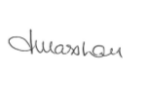 | Date:  11.11.2023
3 | Signature: |  | Date:  11.11.2023

For STAFF Submissions:
4 | Academic Director/ Assistant Dean: |  | Date:
5 | Signature: |  | Date:

Checklist: Please complete the checklist below to ensure that you have completed the form according to the guidelines and attached any required documentation:
☒ | I have read the guidance notes supplied before completing the form.
☒ | I have completed ALL RELEVANT sections of the form in full.
☒ | I confirm that the research activity has received approval in principle
☐ | I have attached a copy of final/interim approval from external organisation (where appropriate)
☐ | I have attached a full risk assessment (where appropriate) ONLY TICK IF YOU HAVE ATTACHED A FULL RISK ASSESSMENT
☒ | I understand that it is my responsibility to ensure that the above named research activity will meet the University’s Research Ethics and Integrity Code of Practice.
☒ | I understand that before commencing data collection all documents aimed at respondents (including information sheets, consent forms, questionnaires, interview schedules etc.) must be confirmed by the DoS/Supervisor, module tutor or Academic Director.

RESEARCH STUDENTS ONLY
Once complete, submit this form via the MyTSD Doctoral College Portal at (https://mytsd.uwtsd.ac.uk).

RESEARCH STAFF ONLY
All communications relating to this application during its processing must be in writing and emailed to pgresearch@uwtsd.ac.uk , with the title ‘Ethical Approval’ followed by your name.

STUDENTS ON UNDERGRADUATE OR TAUGHT MASTERS PROGRAMMES should submit this form (and receive the outcome) via systems explained to you by the supervisor/module leader.

Appendix

Appendix 1
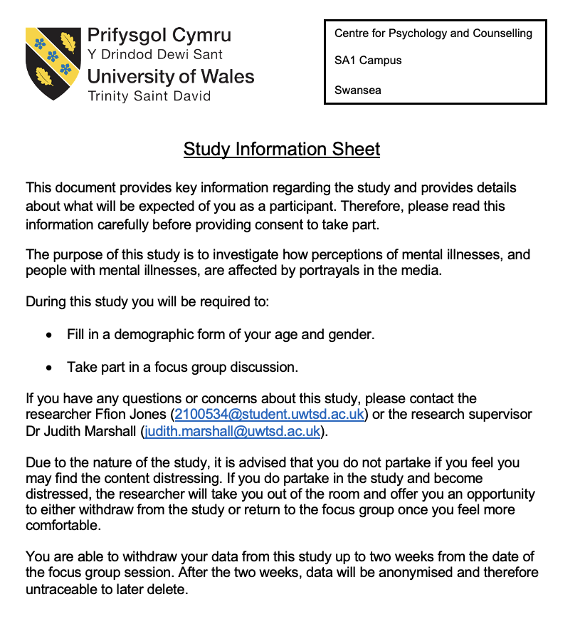

Appendix 2
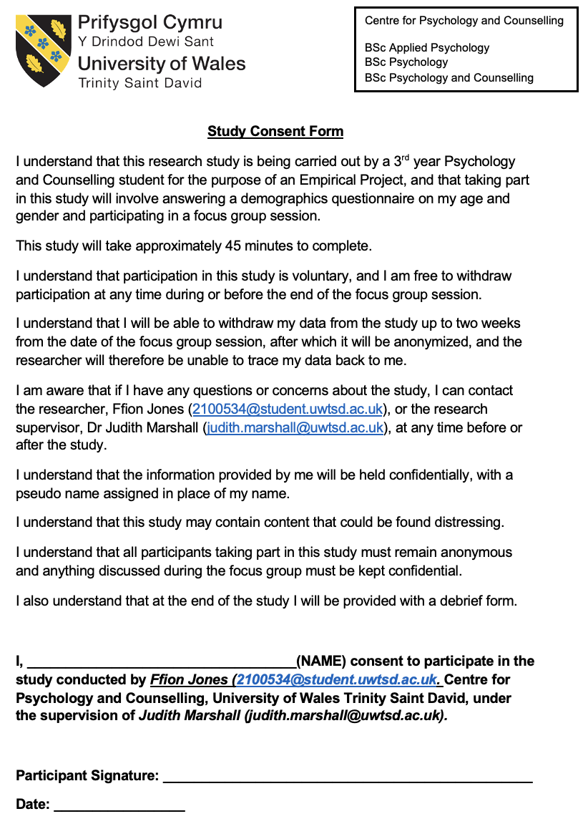

Appendix 3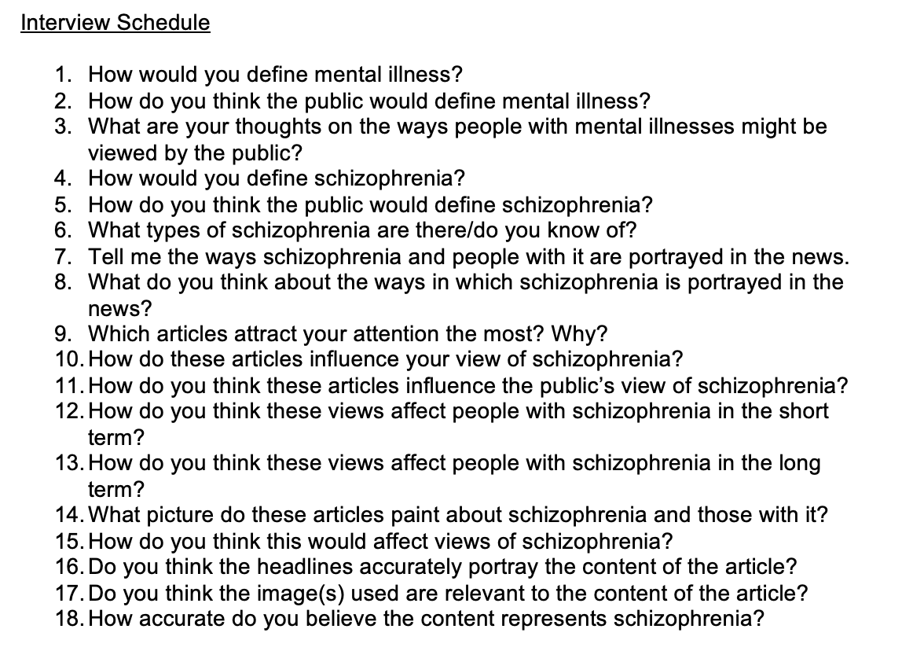

Appendix 4
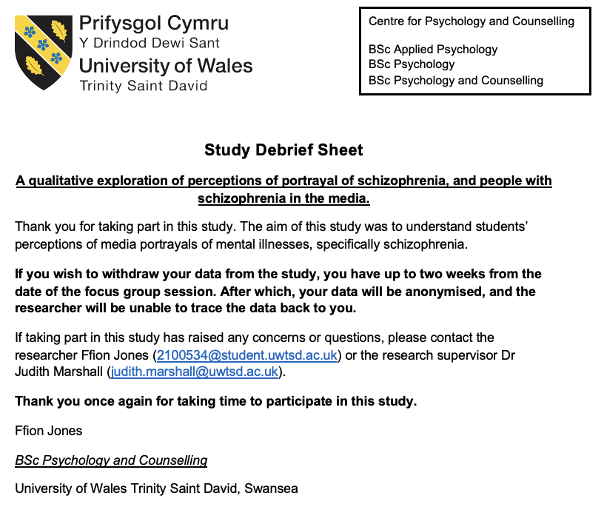

Articles
https://www.independent.co.uk/news/uk/crime/zara-radcliffe-wales-stabbing-guilty-manslaughter-pen-y-graig-john-rees-b1159410.html


https://www.bbc.co.uk/news/uk-england-norfolk-63139154
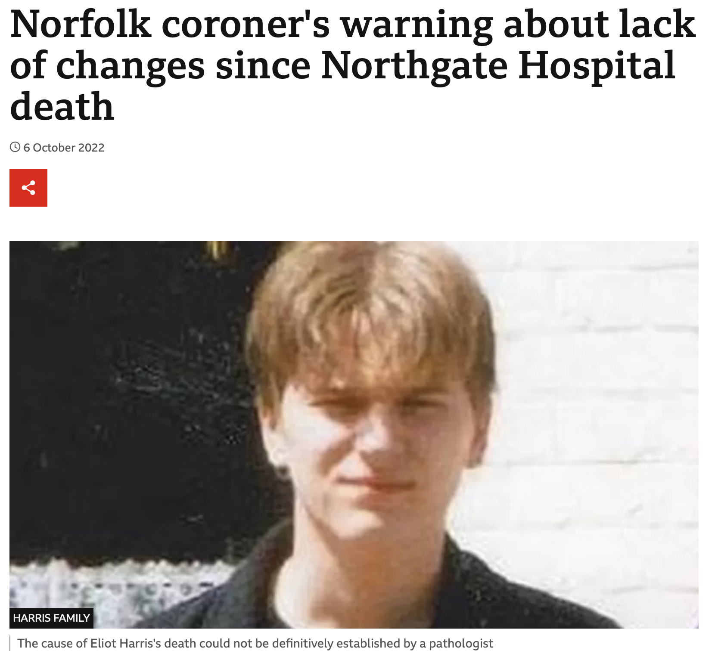

https://www.bbc.co.uk/news/uk-england-bristol-63096568
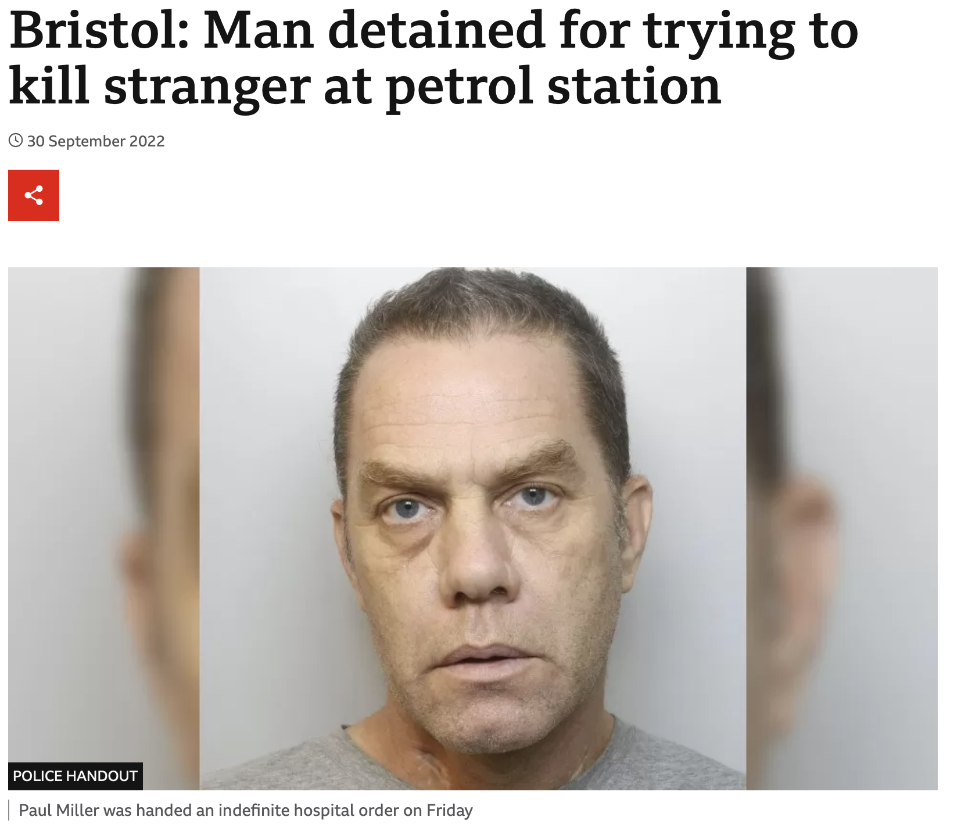

https://www.bbc.co.uk/news/articles/cd1qp077vx1o
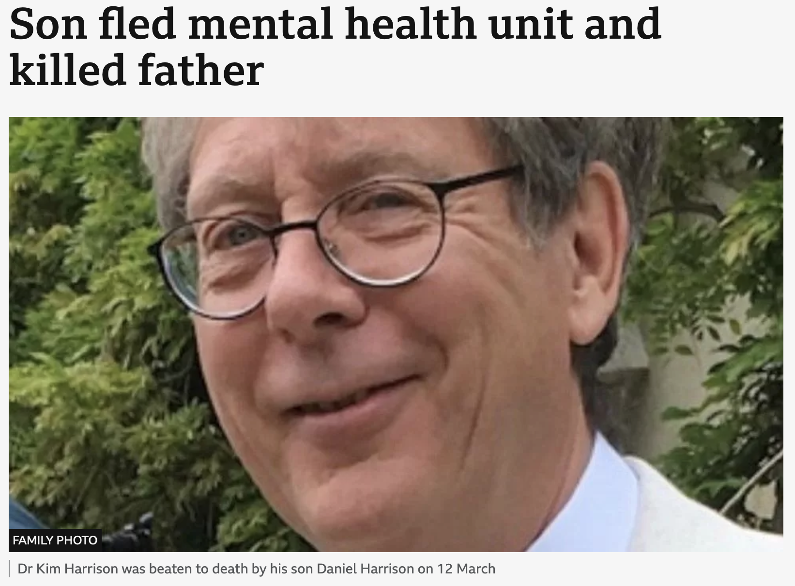

https://www.bbc.co.uk/news/uk-england-essex-60781954
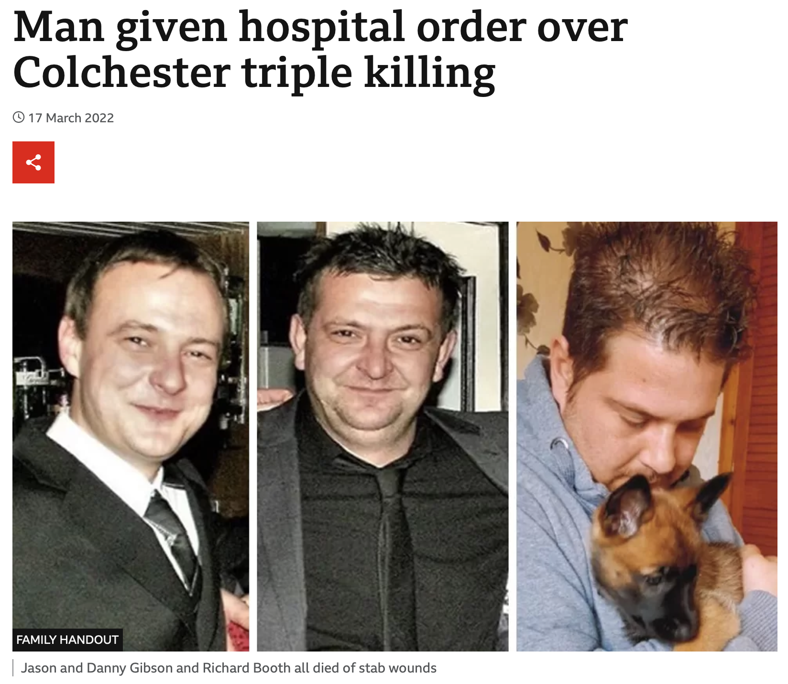

https://www.bbc.co.uk/news/uk-scotland-glasgow-west-51383193
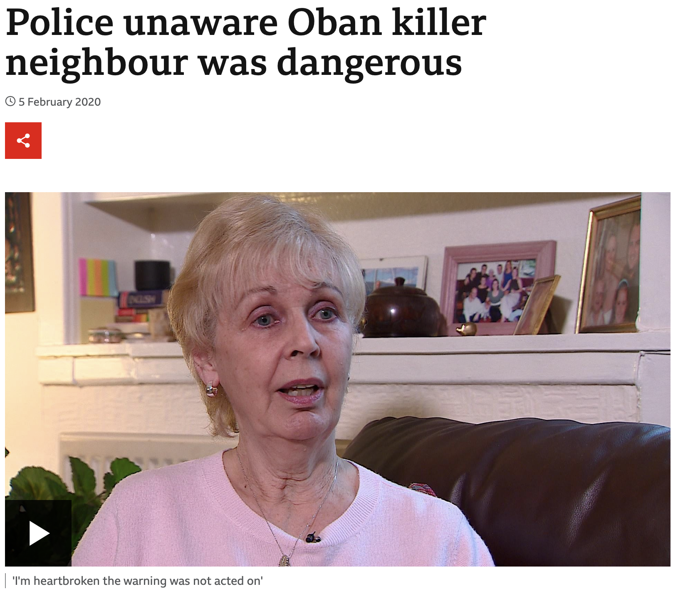

https://www.theguardian.com/society/2018/mar/06/nhs-trusts-accused-of-cover-up-over-attack-on-hospital-ward


