Experimental Data Analysis

Student Name – Gareth Evans
Student Number – 1810612
Module – Data Analysis & Visualisation
Module Code – ACBA4002

Contents
Introduction 1
1. The Scenario 2
1.1 Selecting a hypothesis 2
1.2 How will the hypothesis be tested? 3
2. The Experiment 4
2.1 Establishing the facts 5
2.2 The results 6
3. Outliers and other factors 6
3.1 Outliers 7
3.2 Other factors to consider 8
Conclusion 8
Bibliography 8

Introduction

Analysing and visualising data sets can provide real life solutions to a hypothesis. Once a hypothesis is specified, it can be tested against a specific level of significance. The P value must also be found, this indicates if the variance is down to chance. This can help find if any variance in a data set is down to chance or if there is a correlation. This report will look at a real-life scenario and provide:
- A testable hypothesis
- A suitable test that can test the hypothesis
- Test the hypothesis to different significance levels
- Establish any outliers and other factors that may have affected the results

The Scenario

An online retail company has decided to make changes to its website, aiming to see if it will have an impact on their sales. Using A/B testing, each visitor to the website will either be directed to the old or new website. To encourage people to visit their website, the company are offering a 15% discount on all orders made through both the old and new website. The number of sales was recorded across a 40-day period through the old and new website. The company would like to know whether they should move to the new website design or keep their old one. The data set is shown in figure 1 below.

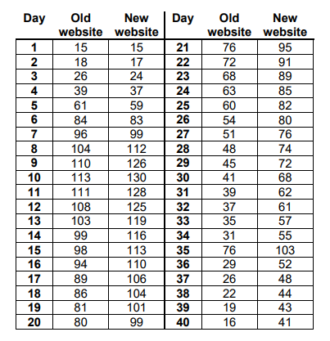
Figure 1 Sales across a 40-day period

Initial impressions from the data suggest that the new website will generate more sales than the older website. The first few days show very little variance in sales, however as data approaches day 9, the variance begins to increase. Both website versions show a similar trend of a steep increase in the first 10 days, followed by a gradual decrease over time until day 40. There is an anomaly at day 35 which shows a sharp increase in sales, the data then returns to its normal trade after this.

Selecting a hypothesis

To create a hypothesis, the independent and dependant variable must first be established. The dependant variable is the output that will be measured, in this scenario this will be the number of sales. The independent variable is what is changed to cause a change in the dependant variable. In this case, the website version will be the independent variable, being the old website design and the new one. A null and an alternative must be stated. Ideally, the null hypothesis will be rejected.

If the null hypothesis can be rejected, the alternate hypothesis can be accepted. The hypotheses will be stated in the experiment section of this report.

How will the hypothesis be tested?

To test the above hypothesis, a T-test must be carried out. A T—test is used to determine if there is a significant difference between the mean average of two sets of data. The T-test carries uses relevant formulas to calculate values, allowing for the null hypothesis to be accepted or rejected. If the null hypothesis is rejected, it indicates that there is likely a correlation between the variables [1]. In this scenario, a T-test for independent samples will be used. This is because the two data sets are not paired. A Two tailed test will analyse the outcome of the experiment to show if one samples mean is higher than the other. This test will be used to test the positive or negative differences of the independent variable [2]. Figure 2 below shows an example of how a T-test works.
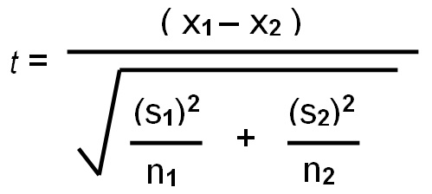
Figure 2 T Test equation [3]
The formula aims to find the value of t. To find this, the following data must first be found:
- X1 (mean of data set 1)
- X2 (mean of data set 2)
- N1(sample size of data set 1)
- N2(sample size of data set 2)
- S1(Standard deviation of data set 1)
- S2(Standard deviation of data set 2)

The value of t will then be compared to the critical value. Comparing against the critical value checks to see if it is statistically significant by comparing against the level of significance. To calculate the critical value, the degree of freedom must be known. This is then cross referenced with the level of significance. See figure 3 below for the table that explains the above.

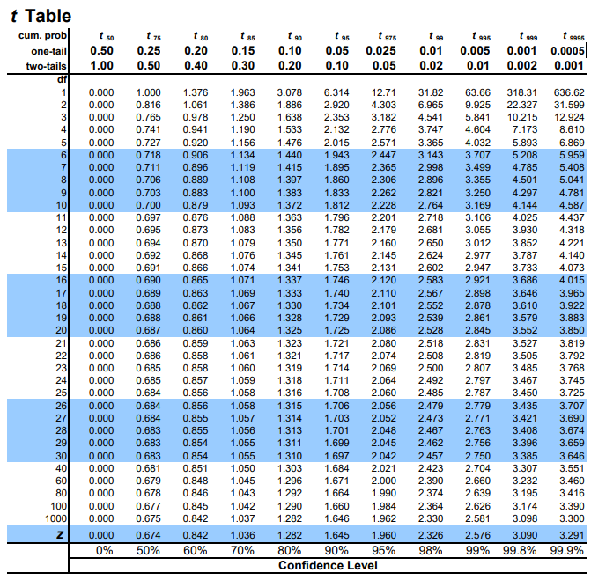
Figure 3 Finding the critical value [4]

The hypotheses will be tested to significance levels of 0.10, 0.05 and 0.01. It will then be decided which hypothesis can be accepted, the null or the alternate.

The Experiment

The hypothesis for this experiment will be:
Null Hypothesis – The old website design will have equal to or greater than sales compared to the new website design
Alternate hypothesis – The new site will generate a higher number of mean sales per day than the old site

Establishing the facts

To be able to accept one hypothesis, this is the order that must be taken in the analysis of the data:
- Calculate the mean of the two data sets
- Calculate the standard deviation (SD) of the two data sets using excel (STDEV.p(**:**))
- Carry out the t-test
- Calculate the degrees of freedom and cross reference with the table in figure 3
- Compare the value of t to the degree of freedom to reach a conclusion

Table 1 below is a table that shows the output from excel. The data was obtained by using the “t-Test: Two-Sample Assuming Equal Variances” tool.

Table 1 Data sets
Website Version | Old Version (x) | New Version (y)
Mean number of sales | 63.08 | 80.03
Number of samples (n) | 40.00 | 40.00
Standard deviation (SD) | 31.04 | 31.58

Figure 4 below show the final calculations once the numbers have been put into the equation seen in figure 2. -16.95 is the sum of the mean of x minus the mean of y (63.08 – 80.03). 1.25 is the result of calculating the square root of the sum of SDx plus SDy, then dividing this by the number of samples.
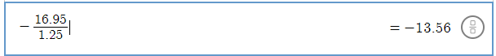
Figure 4 - Final calculation

When running the command in excel, our value for t for a two-tail test is -13.56. Now, the critical value must be found. The equation to this is n-2, meaning the number of samples (80) minus 2. The critical value therefore is 78. This must now be cross referenced with the table seen in figure 3.

As the degree of freedom is 78, excel will be used to calculate the t critical value. Table 2 below is the value at the significance levels used for this experiment:

Table 2 Significance level VS t value
Significance level | T critical value
0.10 | 1.66
0.05 | 1.99
0.01 | 2.64

The results

The value of t is now known to be -13.56, however when accepting or rejecting the hypotheses, the symbol before the number is ignored. Therefore, it will be treated as a positive number. This means that in each case of the three levels of significance, the null hypotheses can be rejected. The alternate hypothesis has been accepted, meaning that the new site will generate a higher number of means sales per day when compared with the old site. Testing the results using the levels of significance confirms the integrity of data and that the results were not due to chance.

Outliers and other factors

Data is likely to contain anomalies, something that goes against the trend that may have an affect on the results of an experiment. These anomalies must be considered and even removed to see if this has an impact on the experiment. Consider figure 5 below, it is a graph of the data gathered. It is clear that the data gathered from the two different website versions follow the same trend of a sharp rise in the first 10 days, followed by a gradual decline. Over the decline, the variance in sales seems to slightly increase but it is miniscule. This is the case up until day 35, where a very sharp increase suddenly appears in the data, breaking the trend of a steady decline. What could have caused this decline? What impact could it have had on the final results of the experiment?
Figure 5 Graph of data set

Outliers

Removing the data collect in last 6 days will get rid of the anomaly seen, this can then be tested against the same levels of significance to see if there is a different outcome. Table 3 shows the figures that will go in the equation when the outliers are removed.

Table 3 New figures without outliers
Website Version | Old Version (x) | New Version (y)
Mean number of sales | 68.68 | 84.41
Number of samples (n) | 34 | 34
Standard deviation | 29.17 | 31.02

The value of t once the outliers are removed is -11.83. This means that the null hypotheses can again be rejected at a significance level of 0.5, 0.01 and 0.05, therefore it is known the anomalies do not influence which hypotheses will be accepted.
What could have caused the outlier seen at day 35? Up until this point, the data was seeing a consistent decline for both the old and new version of the website. Why would day 35 see almost double the amount of sales compared to day 34 and 36? It is known that the company had a 15% discount on all orders made through the website, however this had been available throughout the test period. It cannot have caused this outlier. One theory could be that day 35 synced up with customers being paid, causing a sudden influx in sales as people come into more money. It could also be that the retail company received more stock and was initially sold out. These could explain the anomaly; however it is known that the anomaly does not impact the results of the experiment.

Now that the null hypothesis can be rejected, with or without outliers, the alternate hypothesis can be accepted, meaning that the new version of the website has generated a higher mean of sales than the old website.

Other factors to consider

The retail company introduced a discount to encourage online sales, causing the sharp increase in sales in the first 10 days. If a future experiment were to be done, perhaps the results should only be measured from the day the data starts to decrease. This would give an insight into how the website would perform after the initial high levels of sales caused by the discount.

Conclusion

It is now known that the newer version of the website will generate a higher number of sales than the older version. The variance between the number of sales seems to stay consistent throughout the test period, even during anomalies. The test was performed in a controlled environment, limiting external factors resulted in one anomaly that did not spoil the results.

Bibliography

[1] | W. Kenton, “T-test,” Investopedia, 22 March 2020. [Online]. Available: https://www.investopedia.com/terms/t/t-test.asp. [Accessed April 2020].
[2] | Statistic solutions, [Online]. Available: https://www.statisticssolutions.com/should-you-use-a-one-tailed-test-or-a-two-tailed-test-for-your-data-analysis/. [Accessed April 2020].
[3] | “Biology for Life,” [Online]. Available: https://www.biologyforlife.com/t-test.html. [Accessed April 2020].
[4] | “T-Table,” [Online]. Available: https://www.sjsu.edu/faculty/gerstman/StatPrimer/t-table.pdf. [Accessed April 2020].

