Module: Professional Career Development
Module code: BMSW4005
Task 2- Report
Contents
Introduction 3
Recruitment and selection 4
Skills and knowledge required to work effectively 6
Skills to work effectively 6
Knowledge to work effectively 6
My readiness for employment as a digital marketing manager 6
Personal strength and areas of further development 7
My SWOT analysis 8
My employment goal 8
Short-term employment goal 8
Medium-term goal 8
Long-term goal 9
Personal development plan 10
Conclusion 12
Reference List 13
Appendix: 15
Appendix-1: Questions in the role play 15
Appendix-2: Job description 16
Appendix-3: Application for digital marketing manager 17

Introduction
Employers always search for competent employees to ensure better performance of the organization and to keep ahead within the market. To make oneself a competitive candidate one needs to go through several tasks to accomplish (Olson et al., 2021). In this study, such required activities have been discussed. Personal reflection is the first functionality discussed for this purpose where one can learn himself deeply. This accurate investigation and judgement process enhances awareness among a person. This action support development deadlines for employment in future. In this paper to support readiness, analysis has also been conducted along with personal reflection. The reason behind this action was to find out the areas where a candidate needs to work more and which area can support that candidate for developing in career. Professional development is not a temporary thing. One needs to conduct the above-mentioned functionality to ensure.

Recruitment and selection
Personal reflection is about understanding own self. This is the beginning of the process of self-awareness. In this process observation and analysis in conducted about own to know the way of thinking, reaction tendency, and pattern of action. This activity is treated with importance because it accelerates personal growth. From self-reflection, it is easier to find out the field of interest and where curiosity lies (Ramos-Mejía et al., 2019). In personal development activities, this activity is also suggested and preferable to many for some reasons. Emotional stability is developed from this function as one becomes aware of himself, then accepts that and finally directs himself in a productive way. Apart from this self-respect, decision-making ability, and efficiency get improve within a person by practising this function (Stachová et al., 2019). To conduct personal reflection several models are available. Kolb's reflective cycle is a helpful tool for this function. This model helped to learn from this interview in 2 phases. In the first phase, the experience was observed and in the second phase, knowledge was gathered from that experience in a process.
Stages of learning:
Concrete experience: In this phase, I have got a direct experience from the interview but only participating and watching the actions is not enough. As direct involvement is required, I need to reimagine the experience which will help to acquire some advanced knowledge (Bulle, 2016).
Reflective observation: according to this phase, if I involve in communication about an interview I will come to know more information about this experience. The point of view of others will help to enhance the stock of words and provide a solid review of the experience.
Abstract Conceptualization: In this phase, a transition occurs. Here, I can compare the experience with already established ideas, past knowledge or established theory or with new ideas and then observations turn into a conceptualization.
Active Experimentation: This phase will help to imply the learnings gained from the previous cycle to the new experience (Kannan and Li, 2017). At this time during the experience, the interviewee will have some predictions and can analyse the situation.

Learning styles:
Diverging: This can be applied to the first two stages of learning. As this learning process is creative (Olson et al., 2021), applying this process to the interview experience I can enjoy the whole task. At the same time, it will improve brainstorming and collaboration skills as well as create more opportunities to explore.
Assimilating: This learning process can also be applied in the first two stages (Robins, Elliott and Pattison, 2001). From this process, I can conduct reasoning during the interview and this will enhance my ability of reasoning and assessment. Besides, I will know the whole picture better.
Converging: This style can be implied in the last two stages. As this style provides knowledge through problem-solving if I apply this style in the experience gained from interviews I will be able to improve my decision-making ability and application ability and help in finding the solution.
Accommodating: This is also a style to imply for the last two stages. If I apply this style it will improve my skill because this style creates ways to learn from trial and error. Besides, the provided guidelines help to learn how to respond to changing situations (Chomsky, 2021).
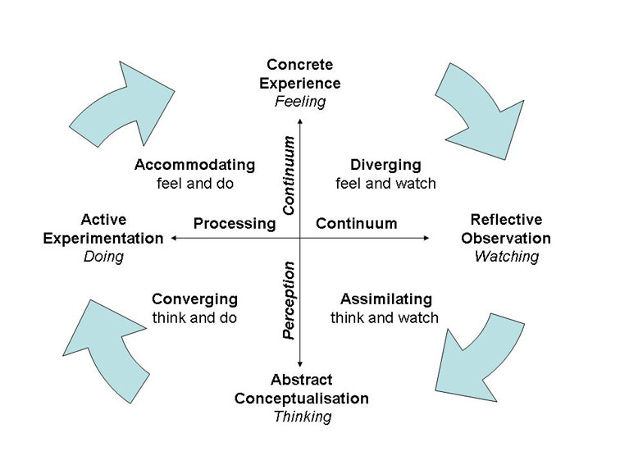
Figure 1 Kolb’s reflective cycle Source: (Ramos-Mejía et al., 2019)
Skills and knowledge required to work effectively
Skills are necessary as it assists to pursue any work accordingly. Skills help one to ensure a better establishment for both the employee himself and the organization. This is the reason for requiring skills for every type of job. Skills can cover the limitations and gaps of the rivals and ensure success (Kanagavalli, Seethalakshmi and Sowdamini, 2019). Having skills is not enough to bring success proper knowledge about work is also important. Knowledge helps to find out the solution faster so it is important along with skills.
Skills to work effectively
In the competitive world to keep ahead of their rivals employers always look for such employees who have the competencies and skills to conduct the task smartly. It has been observed that employees with skills earn better than those who have fewer skills or no skills. As skills help to respond to changes and adapt faster in changing situations. As a digital marketing manager, I need to plan, develop and conduct digital marketing strategies (Stachová et al., 2019). To conduct this role properly I need to have strategic thinking ability, analytical ability, SEO strategy and other related skills.
Knowledge to work effectively
The environment where business conduct changes very faster. This situation requires continuous learning as employers search for an employee who is the most suitable to pursue work in a continuously changing environment (Kumar Sharma and Shilpa Jain, 2013)t. As a digital marketing manager, I need to gather knowledge about visual marketing. Apart from this, knowledge needs to be gathered in some other fields such as social media marketing, social advertising, email marketing, knowledge about software etc. These are required to keep updated and compete in the changing market.
My readiness for employment as a digital marketing manager
Readiness is considered an essential requirement currently. It has been observed that when a candidate is cautious, confidence automatically comes into her. Skills and confidence, both are required for success. Candidates who have undergone training are considered as having readiness and have a high chance of getting hired (Ramos-Mejía et al., 2019). I have also tried different times to gather some skills to ensure job readiness and I hope these skills will help me to get a competitive advantage over other candidates.
Communication  - Capacity to work in a group  - Fluency in three languages  - Attended public speaking and written course. | Problem-solving  - Identifying facts from earlier challenges.  - Finding solutions from previous data  - Listening skills and detecting problems.
Teamwork  - Conflict resolving skill  - Positive mindset | Work ethic  - Conducting task list  - Using opportunities for improvement  - Strong self-discipline
Time management  - Setting alarms  - Following schedule daily | Adaptability  - Flexibility  - Fast learner

Personal strength and areas of further development
As a digital marketing manager, I need to use my full potential. I already have some readiness but this is not enough for the continuously changing business environment. I need to find out the weakness too and work on them to furnish them. In this case, analysis for strength weakness, opportunities and threats are very helpful to achieve the motive. After conducting a SWOT analysis it has been found that I have some strengths to perform well in this post. Such as punctuality will help in achieving the objectives on time (Benzaghta et al., 2021). Creativity and acceptability will help to adapt to changing environment.
Some weaknesses have also come out after conducting analysis where some effort is needed to perform better for this job. Poor leadership skills can slow down the speed and even may cause failure in achieving goals (Abdel-Basset, Mohamed and Smarandache, 2018). So this should get a concern. Even having communication skills I do have not sufficient social capital. So, more involvement is required in responsibilities.

My SWOT analysis:
Strength  - Punctuality  - Creativity  - Empirical  - Accepting  - Direct  - Communication | Weakness  - Unmotivated  - Poor leadership skills  - Insufficient social capital
Opportunity  - Opportunity for further study  - Career opportunities  - Training and mentoring | Threats  - Brexit  - Change in technology  - Market changes

My employment goal
Short-term employment goal:
- I am to specify the roles and requirements I want from an employee before hiring a digital marketing manager.
- Arranging a discussion with someone familiar who has conducted his own business.
- Goals and objectives need to be set.
- Structured leadership need to be ensured.
- Timelines need to be set to achieve the goals.
Medium-term goal:
- I have decided to provide training to the selected candidates.
- This will help to resolve the personal problems which lie within selected candidates.
- After training the performance of the hired candidates will be improved and in the long term, this action will help to capture more market share (Abdel-Basset, Mohamed and Smarandache, 2018).
- The employees also get job satisfaction and remain motivated.
Long-term goal:
- In the long term, organizations need to establish a unique brand value and capture much of the market share.
- To ensure this goal the performance should be measured from time to time and compared with the standards (Stachová et al., 2019).
- Modification needs to be applied where needed. Within the targeted time these actions will help to achieve the goal.

Personal development plan
Required Skills | Importance of the skill | Plan to improve | Date
Leadership skill | Though this is a management role, this skill is essential for achieving any objective. Apart from this, it helps in optimizing productivity. | Involving myself in more projects and learning from the experience will be very helpful. Apart from this, some leadership theories will also support such as transactional theory and the theory of transformation. | 30 March 2023
Social skill | This skill is essential in the business world. It supports communication in any environment (Herhausen et al., 2020). This helps to grow a group of skills such as empathy, listening capacity, interpersonal skill etc at the same time which provide support in professional life. | Engaging with others will be helpful to achieve social skills. Apart from this observation, eye contact, spending more time on this purpose, joining events etc will be helpful. Social learning theory along with the previously mentioned functions will be very helpful. | 31 June 2023
Time management | Proper time management can Daniela PavelDaniela Pavelmotivate one (Klima Ronen, 2020). In the long term, time management brings efficiency and successful completion of tasks. At the same time, the quality of work also gets improved. | Time can be managed most constructively by using some techniques. Such as creating a list of work, prioritising them, planning time regarding how to spend, avoiding multitasking, and setting limits for them. Pickle Jar Theory will be helpful for | 1 March 2023
Creativity | Currently, the business world values creativity much. The problems faced by businesses are very different from the past which can not be solved using old models and theories. For this reason, creativity is appreciated and welcome in any organization. It is also supportive of problem-solving. | Thinking about every possible way boost creativity. Besides, continuing imagination, thinking from different sides and giving shapes to ideas are helpful to improve creativity. Psychoanalysis theory of creativity will help in achieving creativity. | 15 July 2023

Conclusion
To gather some ideas about professional world role play support well. This encourages one to take an initiative in the areas where improvement is required. As a digital marketing manager ensuring some abilities are the responsibility of the post. As a digital marketing manager, I need to develop and implement a marketing strategy. For this purpose, I need to ensure the required skills. I need to keep well knowledge of the current market and at the same time ensure a proper team management system. To achieve this motive, personal reflection as well as career development planning work as a support system.

Reference List
Abdel-Basset, M., Mohamed, M. and Smarandache, F. (2018) ‘An extension of neutrosophic AHP-SWOT analysis for strategic planning and decision-making’, Symmetry, 10(4). doi: 10.3390/sym10040116.
Benzaghta, M. A. et al. (2021) ‘SWOT analysis applications: An integrative literature review’, Journal of Global Business Insights, 6(1), pp. 55–73. doi: 10.5038/2640-6489.6.1.1148.
Bulle, N. (2016) ‘A Method of Measuring Inequality Within a Selection Process’, Sociological Methods and Research, 45(1), pp. 69–108. doi: 10.1177/0049124114562611.
Chomsky, N. (2021) ‘Linguistics Then and Now: Some Personal Reflections’, Annual Review of Linguistics, pp. 1–11. doi: 10.1146/annurev-linguistics-081720-111352.
Herhausen, D. et al. (2020) ‘The digital marketing capabilities gap’, Industrial Marketing Management, 90, pp. 276–290. doi: 10.1016/j.indmarman.2020.07.022.
Kanagavalli, G., Seethalakshmi, R. and Sowdamini, T. (2019) ‘A systematic review of literature on recruitment and selection process’, Humanities and Social Sciences Reviews, 7(2), pp. 1–9. doi: 10.18510/hssr.2019.721.
Kannan, P. K. and Li, H. ‘Alice’ (2017) ‘Digital marketing: A framework, review and research agenda’, International Journal of Research in Marketing, 34(1), pp. 22–45. doi: 10.1016/j.ijresmar.2016.11.006.
Klima Ronen, I. (2020) ‘Action research as a methodology for professional development in leading an educational process’, Studies in Educational Evaluation, 64. doi: 10.1016/j.stueduc.2019.100826.
Kumar Sharma, M. and Shilpa Jain, M. (2013) ‘Leadership Management: Principles, Models and Theories’, Global Journal of Management and Business Studies, 3(3), pp. 2248–9878. Available at: http://www.ripublication.com/gjmbs.htm.
Olson, E. M. et al. (2021) ‘Business strategy and the management of digital marketing’, Business Horizons, 64(2), pp. 285–293. doi: 10.1016/j.bushor.2020.12.004.
Ramos-Mejía, M. et al. (2019) ‘Cycles of action and reflection as the basis of transformative innovation’, Management Research Review, 42(1), pp. 141–154. doi: 10.1108/MRR-02-2018-0063.
Robins, G., Elliott, P. and Pattison, P. (2001) ‘Network models for social selection processes’, Social Networks, 23(1), pp. 1–30. doi: 10.1016/S0378-8733(01)00029-6.
Stachová, K. et al. (2019) ‘An effective selection process is the key to quality job positions occupation conditional for long-term competitiveness’, Production Engineering Archives, 24(24), pp. 5–9. doi: 10.30657/pea.2019.24.02.

Appendix:

Appendix-1: Questions in the role play
- What intrigued you to apply for this Job?
- What skills do you have that fit this position?
- What experience did you get in this field?
- How do you think this role aligns with your future career?
- What is your expectation from this job?

Appendix-2: Job description
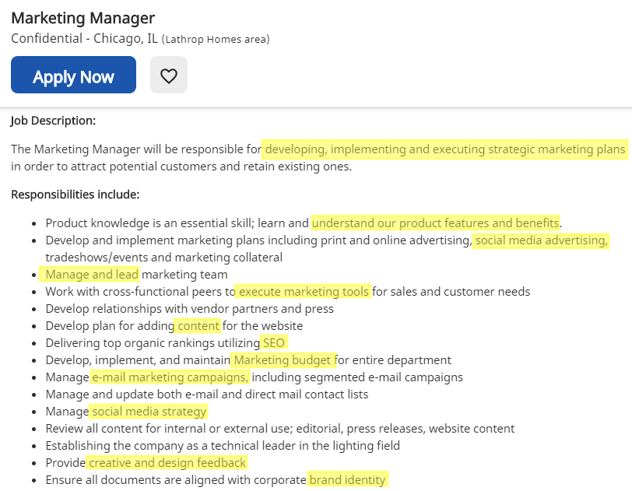
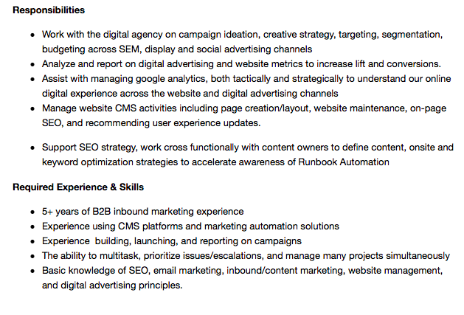

Appendix-3: Application for digital marketing manager
Name: Daniela Pavel
Education:
- Bachelor’s in marketing management.
- Received training on digital marketing strategy.
- Received training on teamwork and conflict management at workplace.

Qualifications:
- I have strong academic achievements.
- I worked as junior marketing executive in a reputed organization which provided me some knowledge and experience regarding job responsibilities.
- I have strong sense of responsibility and other interpersonal skills.
- I have analyzing and problem-solving capacity.
- Strong grip in using digital marketing.

Employment history:
Employer name: N/A
Job title: Junior marketing executive
Time: 30 hours in a weak
Reason for leaving: Career advancement
Duties:
- Setting marketing strategies for the business with a team.
- Executing marketing programs, positioning, identifying target audiences, leveraging internal support and driving collaboration.
- Analyze customer insights, consumer trends, market analysis, and best marketing practices to build successful strategies and ensure that paid customers generate revenue.
Right to work in the UK
Yes
Reference
N/A
Memorandum
I certify that the provided information on this form is accurate according to my knowledge, and I acknowledge that intentionally giving incorrect information could lead to my termination.

Name: Daniela Pavel
Signature:Daniela Pavel
Date:04-01-2023

