WORKSHEET 5 – TESTING (Treasure Hunt)

For this worksheet, there are several possible approaches to the problem.
Create your own test set to show the strengths and/or limitations of your solution. Use as many of the boxes below as you need.

Test: Test to see if 0 is a valid input

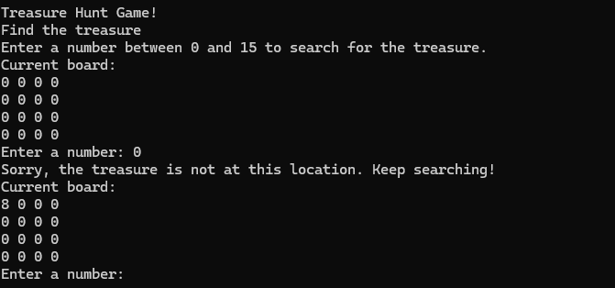
Result: Did the programme behave as expected ie syntactically and logically correct?
YES

Test: Test to see if 15 is a valid input

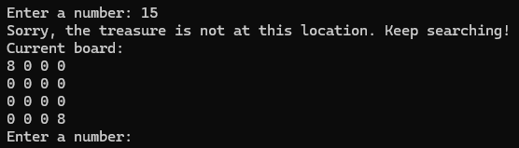
Result: Did the programme behave as expected ie syntactically and logically correct?
YES

Test: Test to see if 27 is a valid input

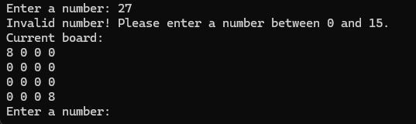
Result: Did the programme behave as expected ie syntactically and logically correct?
YES

Test: Test to see if -8 is a valid input

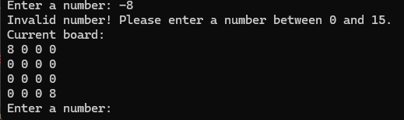
Result: Did the programme behave as expected ie syntactically and logically correct?
YES

Test: Test to see if A is a valid input

Result: Did the programme behave as expected ie syntactically and logically correct?
No

My code does not give a valid error to the user it just closes the program down.

Test: Test to see if B is a valid input

Result: Did the programme behave as expected ie syntactically and logically correct?
No

My code experienced the same problem as When I tried inputting the letter and gave the same error

Test: Test to see if @ is a valid input

Result: Did the programme behave as expected ie syntactically and logically correct?
No

My code experienced the same problem as when I tried inputting the letters. It just closes and shows the lines where the problem is.

Test: Test to see if £ is a valid input

Result: Did the programme behave as expected ie syntactically and logically correct?
No

My code experienced the same problem as when I tried inputting the @ symbol.

Final code:
using System;// used to make the code more readable and simpler to understand

class TreasureHuntV2
{
static char[,] board = new char[4, 4]; // Game board
static int treasureX, treasureY; // This declares two strings that hold the location of the treasure X and Y location

// Place the treasure at a random location on the board
static void PlaceTreasure()// This "static void PlaceTreasure" places the treasure randomly on a X and Y axis
{
Random rand = new Random();// This generates a random numbers
treasureX = rand.Next(0, 4);// This gernerates a random for the X axis
treasureY = rand.Next(0, 4);// This gernerates a randon for the A axis
}

// Initialize the game board
static void InitializeBoard()
{
for (int i = 0; i < 4; i++)// this line starts a loop for the rows on the board
{
for (int j = 0; j < 4; j++)// this line starts a loop for the columns
{
board[i, j] = '0'; // '0' represents an empty space on the board
}
}
}

// Display the game board
static void DisplayBoard(bool revealTreasure = false)// this shows wherever the treasure should be revealed
{
Console.WriteLine("Current board:");// this Shows what the board currently looks like
for (int i = 0; i < 4; i++)//if "i" is greater than 4 increment by 1
{
for (int j = 0; j < 4; j++)//if "j" is greater than 4 increment by 1
{
if (!revealTreasure && board[i, j] == '1') // If the treasure has not be shown then show a 0
Console.Write('0' + " ");// this hides the treasure from the user
else
Console.Write(board[i, j] + " ");// this lines shows either a 0 or a 1 to the user if the conditions have not been met
}
Console.WriteLine();
}
}

// Main method to run the game
static void Main(string[] args)// this is the entry point for the program
{
InitializeBoard();// this starts the treasure game
PlaceTreasure();// this line places the treasure

Console.WriteLine("Treasure Hunt Game!");// this line welcomes the user
Console.WriteLine("Find the treasure");// this prints to the user asking them to find the treasure
Console.WriteLine("Enter a number between 0 and 15 to search for the treasure.");// this lines asks the user to enter a number between 0 and 15

int turns = 0;// this counts the number of turns the user has taken to find the treasure

while (true)// this starts and infinite loop until the user finds the treasure
{
DisplayBoard();// this shows the board to the player in its current state

Console.Write("Enter a number: ");// prompts the user to enter a number
int guess = int.Parse(Console.ReadLine());// this converts the user input to a integer
turns++;// this adds to the player count

int row = guess / 4; // Calculate row index
int column = guess % 4; // Calculate column index

if (row < 0 || row >= 4 || column < 0 || column >= 4)// this checks if the users inputs are valid and are not greater than the board
{
Console.WriteLine("Invalid number! Please enter a number between 0 and 15.");// this outputs a error message to the user if they have not entered a number that is within the range of the board
continue;//if the user enters an error this line of code skips any remaining lines of code and goes straight back to the beginning of the loop
}

if (row == treasureX && column == treasureY)// This checks to see if the location the user enter is where the treasure is located
{
Console.WriteLine("Congratulations! You found the treasure!");// if the user has entered the right location then it prints a message to the user
board[treasureX, treasureY] = '1'; // Mark the found treasure with '1'
DisplayBoard(true); // Reveals the treasure to the user on the board
break;// when the user has found the treasure it then breaks out of the loop and ends the game
}
else
{
Console.WriteLine("Sorry, the treasure is not at this location. Keep searching!");// if the user does not guess the right location of the treasure then it promts the user with a message
board[row, column] = '8'; // Mark the searched location with '8'
}
}

Console.WriteLine("Game Over! It took you " + turns + " turns to find the treasure.");// this shows the amount of turns it took the user to find the treasure
}
}

