Narcisa-Daniela Trifanov 1812758
UNIVERSITY OF WALES TRINITY SAINT DAVID

MANAGING PROJECTS IN ORGANISATIONS

Raising awareness for cancer patients needs

Table of Contents
1. Introduction 2
2. Project life cycle 2
2.1 Project Initiation Stage 2
2.2 Project Planning Stage 3
2.3 Project Execution Stage 4
2.4 Project Closure Stage 6
3. Conclusion and Recommendations 7
4. References 7

- Introduction

It is considered that a project can be defined by multiple actions that require resources to be completed in order to achieve a main objective (Whelton, Ballard, Tommelein, 2002). Moreover, the projects can be done individually or as a team, and the project variables can constantly change, but what does not change is the main objective of the project, otherwise, the project is cancelled as there it no need for it (Whelton, Ballard, Tommelein, 2002).
According to Kerzner (2017), a successful project must be backed by a strong project management, which represents all the knowledge, skills and tools that are applied to the project to ensure its effectiveness. While the project manager is the person that must ensure that the project management is giving favourable results, in the successful companies, the project management has been adopted by every member of the staff and it is viewed as part of a company’s culture (Kerzner, 2001).
The report will look at the effectiveness of the project management, especially to the application of project management tools to the group project of Raising awareness for cancer patients needs, which, according to the definition above, it can be considered a project because it has a main objective, and it required multiple resources to be completed, such as human resources and time.

- Project life cycle
Pinto and Slevin (1988) argued that the most important tool in project management is represented by the project life cycle. This tool is popular between project managers because it allows them to clearly view the stages of the project, but more importantly, they are able to allocate resources based on the actions that are happening in each phase of the project (Pinto, Slevin, 1988). Moreover, it is argued that the project life cycle provides a great overview of the possible conflicts of each stage and allows the project managers to come up with actions that will minimise or end the conflicts based on the stage of the project (Pinto, Slevin, 1988). There are four phases in the project life cycle, each with its own characteristics and its own role.
  - Project Initiation Stage
Initiation is the first step in project management and project life cycle (Radu, Nistor, 2013). This is the stage where the majority of the details are established, which will be later analysed in the next stage (Radu, Nistor, 2013). However, the most important aspect of this stage is to clearly establish the project’s objective and to choose the best people that can help in achieving that objective by forming a highly effective team (Radu, Nistor, 2013). On the other hand, Pinto and Slevin (1988) argue that the most important aspect of this stage is establishing the feasibility of the project based on the need and based on the resources allocated to the project.
In order to create an effective team, the most used tool is the Belbin’s team roles theory and questionnaire (Fisher, Hunter, Macrosson, 2002). Belbin has identified that an effective team must have nine roles filled by the members of the team, where their strengths and weaknesses are complementary and the team is at the highest level of performance and lowest level of conflicts (Prichard, Stanton, 1999).
  - Project Planning Stage
After the need of the project has been established and the team formed, it is now time to carefully plan the activities of the project and to allocate the main resources (Pinto, Slevin, 1988). Although this is the most important part of the project, it is also the most neglected stage of the project as the majority of the project managers are looking forward to executing and implement the project, and do not carefully analyse and plan what is necessary for the project to be successful (Chatzoglou, Macaulay, 1996).
The most important tools that the project managers can use within this stage are the Quad Chart and the Stakeholders Analysis.
The Quad Chart represents a project management framework which can be customised by the project manager to reflect the main four concerns of the project, for a better understanding of what must be done and to offer a summary of the project’s objective (Ford, Wei, 2015).
For the project of raising awareness for cancer patients needs, the Quad Chart has been customised to show the purpose of the project, the customers, the desired end results and the measure of success. The tool has been successfully applied to the project for the reason that the team has been able to correctly identify the factors of each quadrant and was able to create a clear view of the project’s details.
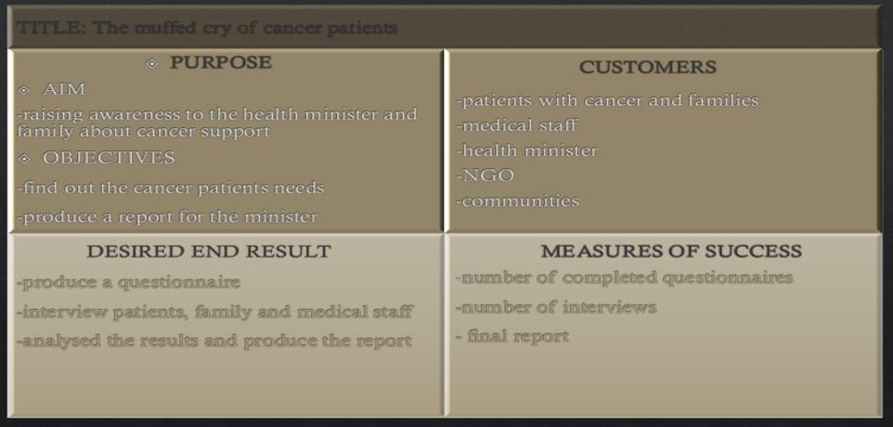
As the purpose of the project has been clear since the Initiation stage, the rest of the quadrants will be analysed within the report, but at this stage, only the second quadrant will be analysed using the Stakeholders Analysis.
The Stakeholders Analysis represents a successful project management tool that is being used to identify all the people that can be interested in the project, involved in the project, and for which the project is made, and offers the opportunity to understand the perspective and expectations of each of the stakeholders, as well as creating a list of activities with the purpose of implement them to ensure that the stakeholders’ perspective and expectations are met (Matuleviciene, Stravinskiene, 2015). The stakeholders can be external or internal and can have any of the three roles: supporters, represented by the stakeholders directly involved in the project, observants, represented by the stakeholders that are not involved in the project, but they are interested in its outcome, and drivers, which are the stakeholders that decide if the project achieved its target or not (Matuleviciene, Stravinskiene, 2015).
This tool have been implemented for the project, as the team has been able to identify the stakeholders, accordingly, have determined their priority and their role, as well as managed to spot their perspective and to create actions that will help the team in the future to satisfy their stakeholders. The research was proven to be extensive and the team possessed a very good understanding of the stakeholders of the projects, which means that the foundation of the project is very solid within the team.

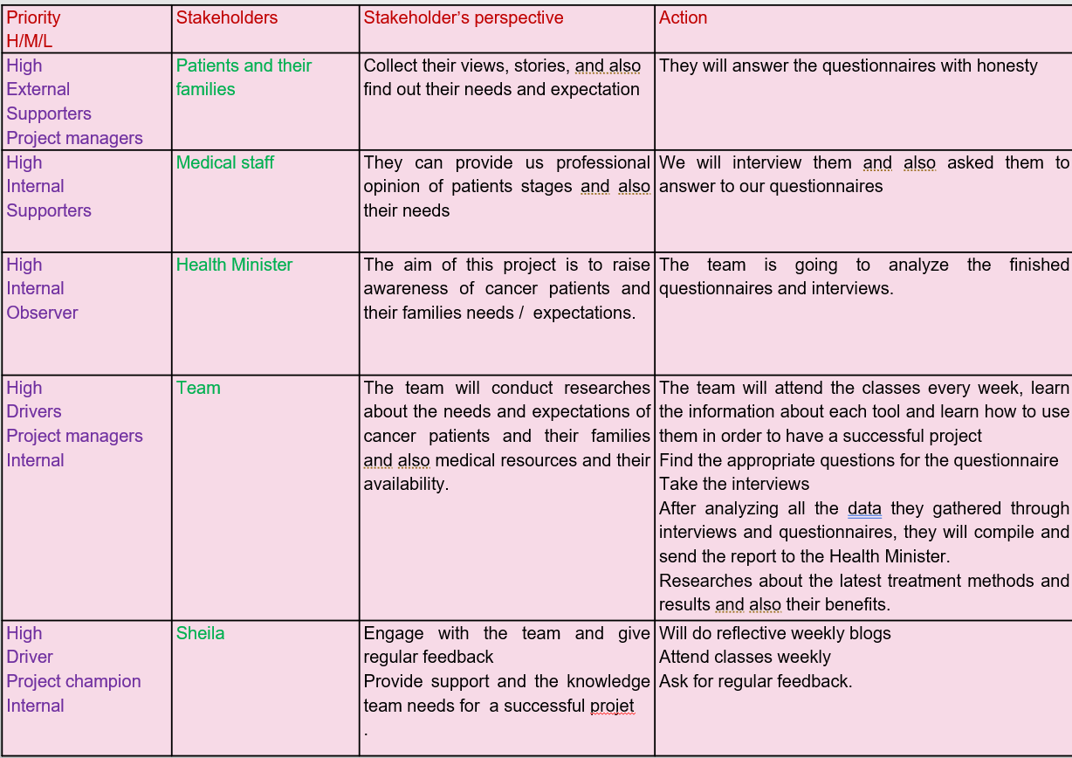
  - Project Execution Stage
The execution stage of the project refers to the doing actual activities that are meant to complete the project with success (Melendez, Malvacias, Almeida, 2018). Thus, there are critics that are arguing that if the planning stage is not correctly completed, the execution stage will face many difficulties as here there is not enough time to act without a plan, and during this stage the pressure is very present within the team to make everything perfect (Melendez, Malvacias, Almeida, 2018).
During this stage, the team applied two project management tools to ensure that the tasks are correctly identified and scheduled.
The main tool used here by the team was the Work Breakdown Structure or WBS, which is a common project management tool used to divide the main objective of the project within multiple smaller tasks (Satrio, Latief, 2018). The WBS enables the project manager to keep track of the tasks that must be completed, and this makes it easier for the project manager to delegate the work within the team (Satrio, Latief, 2018). The only issue of the tool is that many consider it to be incomplete, as it lacks the resources needed for each tasks and the time frame in which the tasks must be completed (Satrio, Latief, 2018). In addition, this stage is connected with the third quadrant of the Quad Chart as it accumulates all the activities needed to achieve the desired results.
The team has been able to split the work in 10 smaller tasks to help them raise awareness for cancer patients needs. The team found no challenges when using this tool, as it is very simple to use and very effective. However, what the team noticed was that certain tasks are duplicates, which reduced the number of the actual tasks that the team must complete.
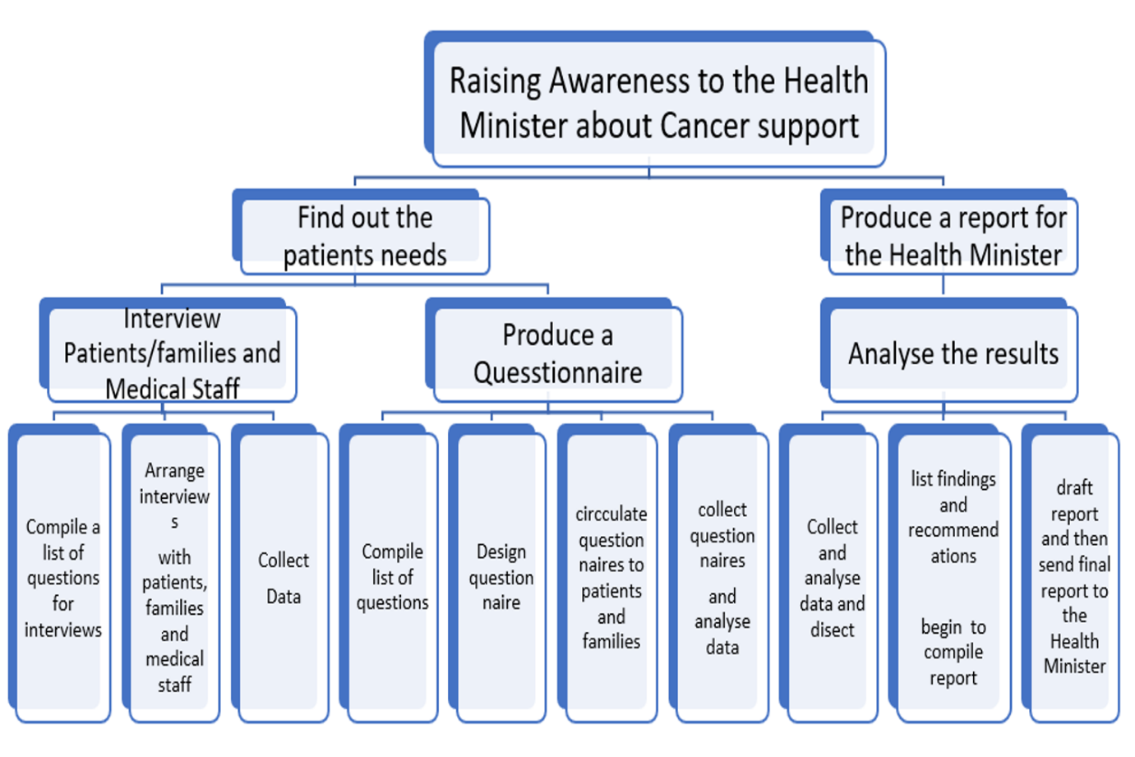
As the issue of the WBS is that is considered to be an incomplete tool, this required to use another tool that was able to provide the means that are lacking in the WBS. The Gantt Chart is considered to be the best project management scheduling tool, as it provides the proper framework for delegating the work and to set up time frames for each activity (Geraldi, Lechter, 2012). The Gantt Chart and the WBS are usually used together because they both complete each other (Geraldi, Lechter, 2021).
As well as the WBS, the Gantt Chart has been successfully applied to the project of raising awareness for cancer patients needs, because the team has been able to delegate the work correctly and to set up different time frames for each activity, which made it easier for the team to monitor the project. However, the team has been having trouble to complete each activity, as the majority of them required urgent attention to be completed.
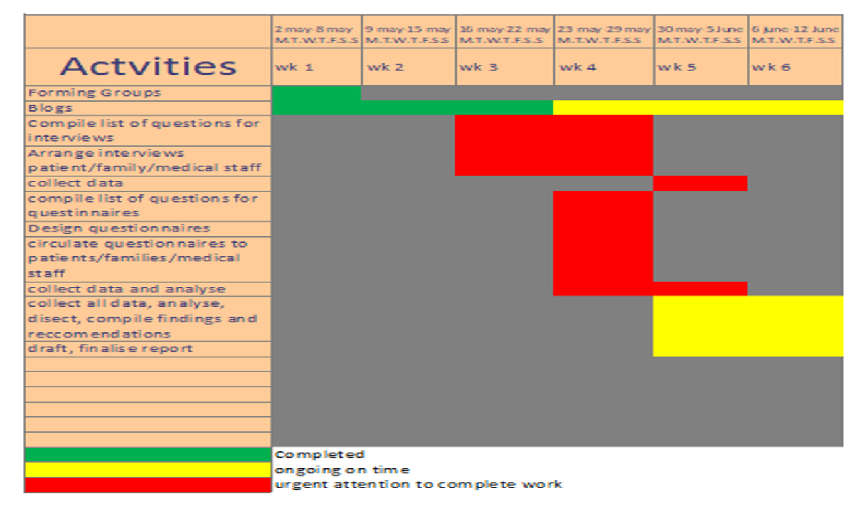

  - Project Closure Stage
This is the last stage of the project life cycle, and it is represented by the ending of the project and its evaluation (Ding, 2015). What is important to argue within this stage is the fact that the end of the project’s activities does not mean that the project has been successful, and the completion of this stage does not represent the accomplishment of the project’s main objective (Ding, 2015). This stage contain the measured of success of the Quad Chart, as this is the stage where the Project Evaluation occurs, which is the tool that helps to examinate the measures of success of the project.
Within this stage, the team has implemented the Risk Assessment tool and the Project Evaluation Tool.
The Risk Assessment is the project management tool which enables the user to discover the risks of the project, to assess their importance and the probability of happening, but the most important, it offers the possibility to come up with a set of activities to minimise the risks or to completely avoid them (Junkes et al., 2015). Used correctly, this tool can offer an advantage to the user, because it will be prepared in case of interferences with the project and will be able to continue the activities without disruptions (Junkes et al., 2015). However, if it is not used correctly and the risks are not all identified or their impact is being underestimated, the project might be negatively impacted (Junkes et al., 2015).
This tasks have been not implemented accordingly to the process, as there is a lack of mitigating actions for the risks, and not enough information about the potential risks, and the entire application of the risk assessment is vague.
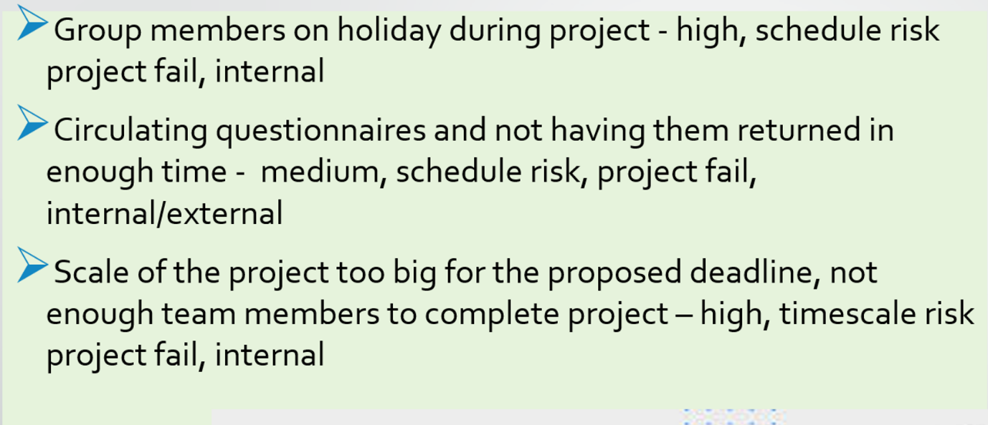

The last tool that has been applied to the project has been the Project Evaluation, which is the tool used to analyse if the project has achieved its goal or not (Squire, 1989). The tools analyses two types of outcomes, hard outcomes, which are the measurable goals, and the soft outcomes, which are the intangible goals (Squire, 1989).
The team have achieved the hard outcome, as 22 people responded to the questionnaire, and also the soft outcome regarding feedback, as the feedback has been given through questionnaires. Moreover, all the measures of success included in the last box of the Quad Chart have been obtained, as well as two of the desired outcomes, apart from the interview.
- Conclusion
The team was able to show deep understanding of the project and they have implemented the correct tools in every stage of the project life cycle. Moreover, the team has been able to keep each deadline imposed by the lecturer, with the help of the Gantt Chart. Each member of the team took responsibility for utilising certain project management tools, and each have been leading the team in a correct way. The team communicated well throughout the project, and was able to compile each of the tasks needed for the project to be successful, meaning that the team have been highly effective.
In conclusion, the project was meant to raise awareness for the cancer patient needs, and the team successfully achieved the main objective, even with the difficulties that appeared throughout the project.

- References
Chatzoglou, P.D., Macaulay, L.A. (1996) A review of existing models for project planning and estimation and the need for a new approach. International Journal of Project Management, Vol. 14, Issue 3, pp. 173-183.
Ding, R. (2015) Project Closure Aiming for Maximum Value. Available at: https://link.springer.com/chapter/10.1007/978-3-662-47731-1_16 (Accessed: 01.07.2022).
Fisher, S.G., Hunter, T.A., Macrosson, W.D.K. (2002) Belbin’s team role theory: for non‐managers also? Journal of Managerial Psychology, Vol. 17, Issue 1, pp. 14-20.
Ford, J.D., Wei, T. (2015) Quad Charts in the Classroom to Reinforce Technical Communication Fundamentals. Journal of Technical Writing and Communication, Vol. 45, Issue 3, pp. 275-284.
Geraldi, J., Lechter, T. (2012) Gantt charts revisited: A critical analysis of its roots and implications to the management of projects today. International Journal of Managing Projects in Business, Vol. 5, Issue 4, pp. 578-594.
Junkes, B., Tereso, A.P., Afonso, P.S.P.S. (2015) The Importance of Risk Assessment in the Context of Investment Project Management: A Case Study. Procedia Computer Science, Vol. 64, pp. 903-909.
Kerzner, H. (2001) Strategic Planning for Project Management Using a Project Management Maturity Model. New York: John Wiley & Sons, Inc., pp. 5-11.
Kerzner, H. (2017) Project Management: A Systems Approach to Planning, Scheduling, and Controlling. Twelfth Edition. Hoboken, New Jersey: John Wiley & Sons, Inc., pp. 4-6.
Matuleviciene, M., Stravinskiene, J. (2015) The Importance of Stakeholders for Corporate Reputation. Available at: https://www.inzeko.ktu.lt/index.php/EE/article/view/6921 (Accessed: 01.07.2022).
Melendez, J.R., Malvacias, A.M., Almeida, A. (2018) Importance of the participation of the employee in the execution of projects: Management perspectives. Available at: https://www.revistaespacios.com/a18v39n14/18391421.html [Accessed: 01.07.2022).
Pinto, J.K., Slevin, D.P. (1988) Critical success factors across the project life cycle: definitions and measurement techniques. Project Management Journal, Vol. 19, Issue 3, pp. 67-75.
Prichard, J.S., Stanton, N.A. (1999) Testing Belbin’s team role theory of effective groups. Journal of Management Development, Vol. 18, Issue 8, pp. 652-665.
Radu, M., Nistor, R. (2013) PROJECT INITIATION AND PROJECT MANAGEMENT APPROACH – AN EXPENSIVE CONNECTION. Managerial Challenges of the Contemporary Society. Proceedings, Vol. 6, pp. 67-70.
Satrio, G., Latief, Y. (2018) Development of Risk-Based Standardized WBS (Work Breakdown Structure) for Safety Planning of Cable Stayed Bridge Project. Available at: http://ieomsociety.org/ieom2018/papers/188.pdf (Accessed: 01.07.2022).
Squire, L. (1989) Chapter 21 Project evaluation in theory and practice. Handbook of Development Economics, Vol. 2, pp. 1094-1100.
Whelton, M., Ballard, G., Tommelein, I.D. (2002) A KNOWLEDGE MANAGEMENT FRAMEWORK FOR PROJECT DEFINITION. Available at: http://citeseerx.ist.psu.edu/viewdoc/download?doi=10.1.1.13.9126&rep=rep1&type=pdf (Accessed: 01.07.2022).

