Managing Projects in the Organisation
  - Towards sustainability: To design and implement the intelligent power control system to reducing carbon emission and enhancing efficiency for Land Rover, UK

Table of Contents
Introduction 4
Project management techniques and tools 4
Techniques 4
Classical techniques 4
Waterfall techniques 5
Agile project management 5
Programme review and evaluation 5
Critical path 6
Tools 6
Organising and planning 6
Communications 6
Scheduling and Time management 6
Financial tools 7
Project management approach 7
PMBOK 7
Agile 8
PRINCE2 8
Implementation plan of the project 9
Project Title 9
Project deliverables, constraints, and assumption 9
Project deliverables 9
Project constraints 10
Project assumption 10
Project Milestones 10
Project planning and implementation plan 10
Project scope 11
Stakeholder analysis 11
Project communication plan 13
Risks management and register strategy 14
Project appraisal techniques 16
WBS and Gantt chart 18
WBS 19
Gantt chart 19
Project budget 20
Own project management skills evaluation 21
SMART objects 21
Strength and weaknesses identification 21
Weaknesses 21
Personal development plan 21
Conclusion and recommendation 23
Reference 24

Introduction
The project management tools technique and approaches are important for the completion of successful projects. Sustainability is one of the important aspects in new project management. In this report business case study of Land Rover UK has been selected to discuss the implementation of intelligent power control system which will enable the feature to control the carbon emission effectively and contribute to the overall sustainable mobility process. This report has been developed by focusing important areas like assessment of project management techniques and tools, implementation of plan of project management and the final personal reservation and development Plan formulation.

Project management techniques and tools
There are different Tools and techniques that are used for the project management processes has been discussed in the section below in a separate manner by understanding their usefulness and applicability within a given project and organisational context.

Techniques

Classical techniques
This is one of the simplest techniques of managing a project. In this technique the project is assessed in terms of its work requirement and then talks are planned and performed, allocation of resources at done, getting and providing feedback to the team along with the monitoring and control process (Too and Weaver, 2014). But this kind of project management technique is most useful when the project is simple and a small team is working to complete a project. Land Rover is a large organisation and the projects especially in the product development segment are not simple enough and a large development team work to fulfil certain goals and objective. Therefore this kind of simply approach is not suitable and in most cases is not used in the organisation.

Waterfall techniques
This technique of project management is advancement on the classical approach of project management. In this method the types of a given project are done in a methodical and sequential manner. The project is planned in advance and completion of one step of stage begins the new stage of project work. In this method the Gantt chart is developed to have a better visualisation of the project stages. Pace technique is useful for a more controlled approach of project management but the process is much more rigid. Completion of one stock can only lead to the next task or level within a project. In Land Rover the projects especially in the product development section are highly technical and need much more flexibility and open nest to come up with some creative innovative solutions (Too and Weaver, 2014). Therefore this kind of project management techniques is also rarely used within the organisation. This technique is used in case of very simple and highly predictable project requirements in in different sections of organisational operation.

Agile project management
This technique of project management break the project work and Delivers project works using short sprints. This approach after delivery makes the project management technique highly flexible and highly focused on values. In Land Rover the goal is to develop innovations two benefit not only the customer but also should produce later societal good. The projects are highly technical and complex in nature which makes it difficult to predict. This technique of project management therefore uses the continuous development more adaptable approach job project work management (Turner, 2016). The teams of the organisation are highly skilled and have high level of expertise. This technique the ability to self organise the teamwork and also at the same time able to deliver highest value with high level of collaboration. Considering this flexibility, open, value centred approach and scope for regular improvement this kind of technique in high use in Land Rover.

Programme review and evaluation
This PERT technique helps in developing Complex task based project planning with higher support of visual tracking system. This kind of project management approaches is useful for the non-routine, long-term and large requirement based project management. In Land Rover one of the long-term projects directed to sustainability is the reduction of waste, emission and recycling of materials in the production process (Heagney, 2016). This kind of challenging but non-routine tax oriented long term projects managed through this technique.

Critical path
This technique is a supporting technique of the above p e r t technique where an algorithm is developed to identify the critical task based longest path. Highly complex projects are managed with the help of this tool where the aim of the project remains the greater control, high level of attention and perfectly meeting the project deadline (Turner, 2016). This technique of project management is highly used in Land Rover considering the highly complex product development process and time targeted requirement.

Tools
There are different project management tools that are used to complete project task effective in a more effective way by following the above techniques of project management.

Organising and planning
The project work has diverse types of requirement and needs effective planning process along with following a specific technique of project management. MS project is one of such tool that is used for managing to workflow and also greater planning process of the project (Turner, 2016). This tool is helpful not only developing the project sequential task and their completion against their specific time but also helps in allocating resources managing risk and control process.

Communications
Large and complex projects have different stakeholders who are directly or indirectly related to that project. This stakeholder has different level of interest and also power to influence the project work. Therefore an effective communication plan is required to manage the Expectations of this important stakeholder. Land Rover is a large organisation and many of their projects have such implications (Heagney, 2016). Use of current communication tools may be formal or informal in types are used in this communication process. Different types of stakeholder’s requirements are assessed and tools for communication are done accordingly.

Scheduling and Time management
Different it Software Solutions are used as important tools for scheduling a project. This tool is helpful in not only scheduling with project work but also resource allocation process. There are multiple projects happening in a given point of time in Land Rover. This scheduling tool is helpful and managing the greater program of the business by also focusing individual projects in a more effective way.

Financial tools
The financial resources use and the project return on development assessment need some important financial tools for this assistance. Financial and accounting software are helpful in budgeting process which letter helps in monitoring the planned expenses against the actual expenses. Apart from this planning and monitoring help these financial tools are also used in projecting the future project cash flow and profitability situation. Based on these imports given project is accepted or rejected or can be compared with other such viable projects. Land Rover multiple solutions are assessed in terms of their financial viability and appropriate decisions are made (Heagney, 2016). In recent time the organisation has been witnessing difficult profitability situation along with amount of business debt for the process of investment. Considering this kind of situation this financial tool becomes highly important for the management of current cost cutting measures and also completing new projects within the business.

Project management approach
The project management approaches are the project management methods that are useful for different kind of projects. Some of the important methods or approaches have been discussed in the section below.

PMBOK
The full form project management body of knowledge. As the name suggests this is more of a guideline and standard terminological support for any kind of project management. There are no clear methodological approach that has been described under this approach but provide some more general requirement for any kind of projects (Meredith et al., 2017). There are 5 key processes that have been extensively discussed in this approach. The approaches are initiation of a project which deals with the starting phase of a project, planning of project that helps in defining the objective scope of a given project, execution of project work which is the actual work done during the project, controlling and monitoring activity that deals with tracking and performance management, the closing of the project which is the last phage formalities (Kerzner, 2017). This approach easy to understand and have relevance in wider range of project types in Land Rover. The organisational culture of Land Rover is transparent type with high level of focus on excellence and innovation. This kind of approaches understanding the overall requirement of a project and makes the overall project requirement accessible to kind of employees because of ease of understanding.

Agile
The Agile technique has already discussed about section of this report. This mythology has for important values for different kind of projects. The values are priority of introduction and individual over the tools and processes for the project management. The comprehensive documentation is not given high amount of priority but working software has that significance (Meredith et al., 2017). Customer collaboration and customer focus approach is given greater importance in comparison to negotiation of the project contracts. The Change management process has a higher priority against the normal Persuasion of a project plan. Important principles of this approach are high level of customer satisfaction achievement , changing requirement accommodation , frequent delivery, different stakeholders collaboration and negotiation, people management , scope of face to face communication , software driven project progress management , management of consistent development , technical details attention , simplicity delivery , encouraging team to self organised and regular reflection for better outcome management (Meredith et al., 2017). This kind of project management approach is more useful for highly technical and software project management. The Land Rover cars have become much more connected to provide higher luxury value and for this kind of development is project management approach is highly useful today liver high level of customer satisfaction and effectiveness.

PRINCE2
There are 7 core principles of this management approach. First approaches the justification from the business point of view which is followed by team specific learning requirement. Clear roles and responsibility delegation, planed stage based working process, management by exception approach based project board formation, quality focus project delivery and ability to use this approach for different types of project with minor modification are some of the other important principles (Kerzner, 2017). Different projects in Land Rover are adopted considering the long term business goals and objective. Therefore business case justification makes this approach highly suitable for the organisation. On the other hand Land Rover operates as a responsible business organisation. Therefore specific documentation support of this process helps them fulfilling the regulatory documentation requirements effectively. The process based approach of this method has in achieving relative amount of flexibility for large projects. In recent times the projects related to the renewable energy based manufacturing process development has been used of this methodology for a large and complex project by delegating the roles and responsibility in an effective manner (Kerzner, 2017). The managers of the organisation are highly skilled and have higher level of experience that makes them eligible enough to implement this Complex approach.

Implementation plan of the project
In the project management process project implementation phase is considered effective steps and helps managers to implement projects within the workplace in proper ways. The project initiation plan in the PRINCE2 project management approach is indented to successfully articulate the steps as well as the purpose of all processes involved in the project idea. The initiation plan in project management is mainly involved, project scope, objective, deliverable, assumption, and project constraint (Maylor, 2010). PID also includes the communication methods, stakeholder analysis plan, risks assessment plan, budget plan, and Gantt chart.
Project Title: To design and implement the intelligent power control system to reducing carbon emission and enhancing efficiency for Land Rover, UK

Project deliverables, constraints, and assumption

Project deliverables
The overall purpose of the undertaken project is to implement an intelligent control system within the organization and helps businesses to reduce greenhouse gases emission and improve effectiveness. Thus the main deliverable of this project is to successfully develop WBS and Gantt chart that helps to improve time management (Cooke, Tate, and Cooke, 2011). Additionally, the project manager needs to implement better budget techniques and communication plans that improve the reliability of the project. The manager needs to utilize a better risk management approach that helps to reduce the risks associated with the project.

Project constraints
- The main constraints associated with the planning and implementation of an intelligent control system is the time and budget.
- Resource including human resource management, materials, and other resources also includes main issues for business.
- Lack of skills of employees and project manager significantly impacted the project performance

Project assumption
- The main assumption that is considered in this study is that all employees are well qualified and knowledgeable
- The resource and budget in this project are easily available (Wysocki, 2011).

Project Milestones
The milestones associated with the undertaken project i.e. successfully implementation of the intelligent control system at the workplace is explained below;
- First milestones: Appointment of the well qualified and skilled workers and find out the feasibility and reliability of the project.
- Second Milestones: The second milestone of the project mainly involves the selection of the IT and electrical engineers that aids them to establish an intelligent control system at the workplace.
- Third Milestones: Designing and implementation of the intelligent system at the workplace and also compared the performance with the existing system (Chapman, and Ward, 2011).
- Four Milestones: This is the stage where all members are performed evaluation and monitoring stage.
- Five Milestones: These are the milestones where all employees are awarded.

Project planning and implementation plan
Project aim and objective: The main aim of the present project management is to implement an intelligent power control system in organizational existing system. Furthermore, the project aims to improve efficiency and reduce carbon emission for Land Rover, UK.
The objective of the present project is illustrated below;
- To improve the sustainability approach within Land Rover through the implementation of an intelligent power control system
- To help the business to reduce carbon emission and improve efficiency
- To provide an effective recommendation that helps to encourage organization towards sustainability approach

Project scope
The scope associated with the present project management process is that it helps the organization to improve efficiencies and achieve a substantial approach through the reduction of carbon dioxide and greenhouses gas emission. Apart from that development of the intelligent control system helps the business to achieve competitive benefits and improve the quality of products and services. Furthermore, the implementation of the intelligent control system within the organization can smooth organizational activities and contribute to improving financial health performance.

Stakeholder analysis
According to Harrison, and Lock, (2017), stakeholders of an organization or project is the person or group who vested interest towards organization success as well as the environment in which business function. Larson, and Gray, (2013), stated that stakeholder’s analysis is the process to determine and evaluate the key important people of a project that may have directly or indirectly impact on project performance. According to Harrison, and Lock, (2017), project management of the organization needs to find out the key stakeholders mapping that helps to determine the kind of power and interest. The stakeholders mapping plays a key role in helping the implementation of an intelligent power system project. The stakeholder's analysis of the undertaken project is illustrated in the table;
Lists of stakeholders | Roles and responsibilities | Level of Importance (L/M/H) | When will they engage | Maximum Frequency
Project manager | To complete the tasks according to the plan and assign roles and responsibilities to employees. | High | project manager engage all phases of the project cycle | Daily
Business manager | To solve escalated issues and involve in technical analysis | High | Planning and designing phase | Weekly
Project team members | Responsible for completing and executing jobs. | Medium | Involve in implementation and planning phase | daily
Project sponsor | Responsible for project results and implementation of guidance and regulation | High | Planning and evaluation stage | yearly
Government | Responsible for monitoring that organization uses government policies and procedures within the organization or not. | LOW | All phase in the project lifecycle | Yearly

Project communication plan
A communication plan in project management is a tool and technique that helps the project manager to communicate effectively with customers, shareholders, and clients. The objective of the communication strategies for the undertaken project is to improve the coordination process among team members and reduce conflict problems (Larson, and Gray, 2013). An effective communication plan provides a clear guideline for how data is shared and also accountable for the requirement of each project communication. The project communication plan for planning and implementation of an intelligent power control system is illustrated in the below table;
Communication | Methods | Frequency | Objective | Owner | Audiences
Project status report | Email communication methods | Weekly basis | The main objective is to receive project status as well as project closer report | Project manager | Project sponsors, project team members, and project management
Team build-up | Meeting | Daily basis | Responsible for the making of the roles and responsibilities of members in a daily manner | project manager | project team
Review of project | Meeting | At milestones | Represent the project deliverables, collection of feedback | Project manager | the project sponsor and project team
Post-meeting | Meeting | End of project | Assess and evaluate what work is done and what did not work and implement considerable approach and action | Project manager | Project team
Tasks update | Team Gantt | Daily | Share information on a regular manner | project manager | Project team

Source [Gray, (2013), Harrison, and Lock, (2017)]

Risks management and register strategy
Risk management strategies is the methods that help the project manager to easier manage the risks associated with the project. The risks management strategies of the undertaken project are illustrated in the below table;
POTENTIAL RISKS MANAGEMENT STRATEGIES AND MITIGATION STRATEGIES OF INTELLIGENT CONTROL MANAGEMENT SYSTEM
SI NO | POTENTIAL RISKS | IMPACT | LIKELIHOOD OF OCCURRENCE | PROBABILITY | MITIGATION PLAN
1 | Lack of time estimation and budget planning | 3 | 3 | 9 | This can be reduced through the implementation of effective investment appraisal techniques and time management strategies.
2 | Lack of communication plan | 4 | 3 | 12 | This can be migrated by the project manager through a better communication plan
3 | Lack of staff’s skills and knowledge | 4 | 4 | 16 | Implementation of better tainting and development approach reduces these issues
4 | Project scope creep and unclear project objective | 5 | 4 | 20 | To define a project plan and objective effectively and involves customers and management during planning
5 | Unrealistic project time estimation | 4 | 5 | 20 | Continuously review and monitor the project performance
6 | Lack of quality control l | 3 | 2 | 6 | This can be migrated by making sure that project stakeholders are involved in deliverables
7 | Natural disasters i.e. External unforeseen circumstance | 2 | 2 | 4 | This cannot be resolved but project managers need to continuously monitor the weather news
8 | Business insolvency i.e. internal unforeseen circumstance | 2 | 3 | 6 | This can be managed by the project manager and if any insolvency occurred then the project is terminated

Source [Harrison, and Lock, (2017), Cooke, Tate, and Cooke, (2011), (Larson, and Gray, 2013)]

Project appraisal techniques
The project management utilizes the project appraisal techniques (including internal rate of return, payback period, and net present value) for purpose of assessing and evaluating the project's financial feasibility (Fazilah Abdul Samad., and Gurcharan, 2009). The positive value of the net present value indicates that the project is profitable and benefited for business.
Year | Cash flow(m) |  | Present Value(m)
0 | -£5,500.00 |  | -5500.00
1 | £2,000.00 |  | 2000.00
2 | £20,000.00 |  | 20000.00
3 | £2,000.00 |  | 2000.00
4 | £2,000.00 |  | 2000.00
5 | £2,000.00 |  | 2000.00
Interest Rate |  | 2%
Net Present Value NPV |  |  | £3,926.92
Internal Rate of Return (IIR) |  |  | 24%
Payback Period (PBP) |  |  | 2.7 years

The above calculation indicates that the implementation of the present project is benefited for the organization as the project is associated with the positive net present values i.e£3,926.92. On the other hand value of the payback period of the present project is indicated 2.7 years that signifies that the organization needs to total 2.7 years to resolve their initial outflow. Therefore from the evaluation and analysis, it is said that implementation of the appraisal techniques is effective for organizations and helps in project evaluation and planning process in better ways.

WBS and Gantt chart
WBS NO | TASKS | STARTING | ENDING | TIME COMPLETION
1 | Successfully Planning And Implementing The Intelligent Power Control System To Reducing Carbon Emission And Enhancing Efficiency For Land Rover, Uk | 7/15/2020 | 1/20/2021 | 136 days
1.1 | Intelligent Power Control System Planning And Initiation: {Milestone1} | 7/15/2020 | 7/29/2020 | 11 days
1.1.1 | To create project scope, purpose, and objective | 7/15/2020 | 7/21/2020 | 5 days
1.1.2 | To create communication and risks plan | 7/22/2020 | 7/23/2020 | 2 days
1.1.3 | To create stakeholders plan | 7/24/2020 | 7/27/2020 | 2 days
1.1.4 | To create WBS, Gant chart and Budget plan | 7/28/2020 | 7/29/2020 | 2 days
1.2 | Intelligent Power Control System Designing Phase {Milestone2} | 7/30/2020 | 8/19/2020 | 15 days
1.2.1 | To design a power control system prototype | 7/30/2020 | 8/12/2020 | 10 days
1.2.2 | To test the functionalities of the control system | 8/13/2020 | 8/19/2020 | 5 days
1.3 | Intelligent Power Control System Implementation And Execution Phase{Milestone3} | 8/20/2020 | 10/14/2020 | 40 days
1.3.1 | To review and analysis the exiting system | 8/20/2020 | 9/2/2020 | 10 days
1.3.2 | To analyze the hardware and software system | 9/3/2020 | 9/16/2020 | 10 days
1.3.3 | To implement hardware and software system | 9/17/2020 | 9/30/2020 | 10 days
1.3.4 | To test and integrate the functionalities | 10/1/2020 | 10/7/2020 | 5 days
1.3.5 | To implement the power control system | 10/8/2020 | 10/14/2020 | 5 days
1.4 | Intelligent Power Control System Monitoring And Controlling Phase{Milestone4} | 10/15/2020 | 12/16/2020 | 45 days
1.4.1 | To implement CCTVs camera to monitor function | 10/15/2020 | 11/4/2020 | 15 days
1.4.2 | To install a monitoring system | 11/5/2020 | 12/2/2020 | 20 days
1.4.3 | To review and analysis the performance | 12/3/2020 | 12/16/2020 | 10 days
1.5 | Project Closure Phase {Milestone5} | 12/17/2020 | 1/20/2021 | 25 days
1.5.1 | To create a documented plan for the power control system | 12/17/2020 | 12/23/2020 | 5 days
1.5.2 | To update all document | 12/24/2020 | 12/30/2020 | 5 days
1.5.3 | To submit a document to management | 12/31/2020 | 1/6/2021 | 5 days
1.5.4 | To collect information from respondents | 1/7/2021 | 1/13/2021 | 5 days
1.5.5 | Sign off | 1/14/2021 | 1/20/2021 | 5 days

WBS
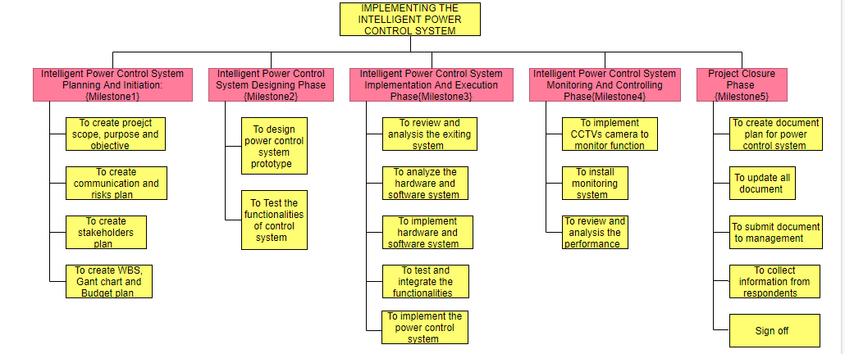

Gantt chart
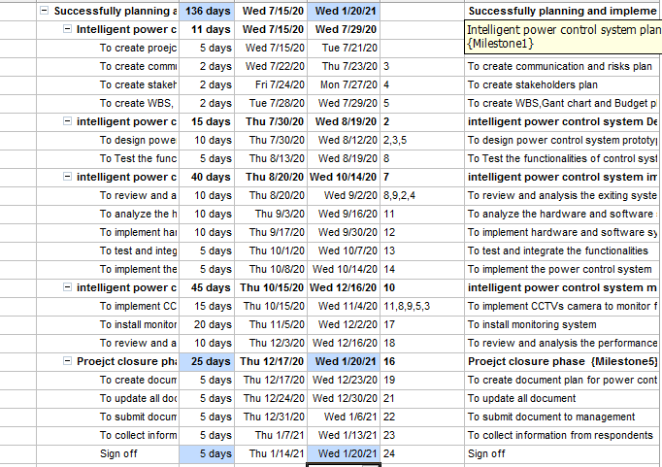

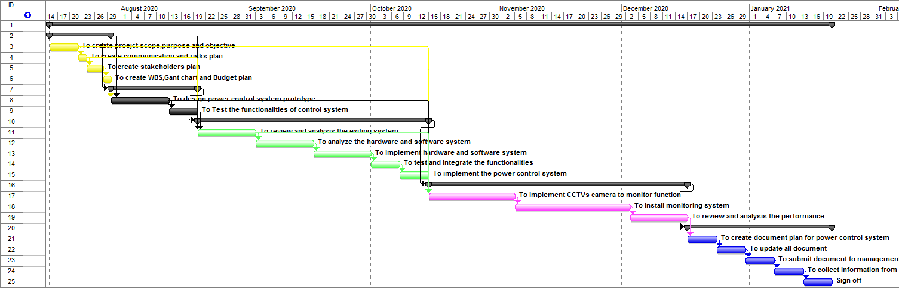

Project budget

Tasks | Employees costs | Total equipment costs | Training costs | Total transport costs | Total
Project planning and initiation | £ 2,200.00 | £ 25,000.00 | £ 5,000.00 | £ 1,500.00 | £ 33,700.00
Project designing | £ 1,800.00 | £ 5,000.00 | £ 4,000.00 | £ 1,700.00 | £ 12,500.00
Project implementation | £ 3,200.00 | £ 3,500.00 | £ 9,000.00 | £ 1,600.00 | £ 17,300.00
Project execution | £ 3,500.00 | £ 5,500.00 | £ 1,100.00 | £ 1,200.00 | £ 11,300.00
Testing | £ 2,000.00 | £ 6,500.00 | £ 6,000.00 | £ 5,000.00 | £ 19,500.00
Contingency plan i.e. 10% |  |  |  |  | £ 9,430.00
Total expenses | £ 12,700.00 | £ 45,500.00 | £ 25,100.00 | £ 11,000.00 | £ 12,700.00

Own project management skills evaluation

SMART objects
To understand the strength and weakness of project management skill
To understand future opportunity and threat working in the project manager job role
To develop the new skills as per requirement within 6 month time period

Strength and weaknesses identification
Strength in the project management process some of the most important the strength of mine are ability to plan meticulously coma development of communication plan coma understanding the constraint of project management coma assessing the weeks and ability to mitigate risk coma effective monitoring and controlling process development coma high level of Technical understanding for a particular project coma ability to show leadership capability and delegation of roles and responsibility so and so forth.

Weaknesses
The feedback process has help in understanding the development need within me. One of the important weaknesses that I have understood from my personal analysis is the lack of understanding of accounting and Finance subject. Therefore I feel and comfortable at the time of using accounting and financial tools for the project budgeting and return on investment analysis. On the other hand the feedback as shown that I need to improve my negotiation skills to manage any large project related activity. These two weakness need to be improved through a well developed plan.

Personal development plan
Development need | Actions | Resource | Evaluation criteria | time
Accounting and financial skills and knowledge | - Studying the accounting principles and the financial management theories  - Solving problems from the text books  - Learning to develop financial statement preparation, budgeting, investment appraisal  - Studying case of actual projects financial statements | Books, computers and financial accounting software, old project report documents | Assessing knowledge through online test, successfully solving problems, developing financial and accounting statements successfully for various kind of projects | 3 month time period
Negotiation sills | - Studying the negotiation process, technique, and different variables  - Studied different negotiation case study  - Participating in negotiation role playing activates | Books, computers and internet, old project report documents, negotiation case studies | Clearly demonstrate different negotiation situation variables and strategising for those.  Successfully performing in a negotiation role playing.  Confidently deal in future small scale negotiating processes. | 3 month time period

Conclusion and recommendation
The above analysis reflects that project management methodologies help the project manager to execute project planning successfully. Furthermore, finding also shows that project management tools including Gantt chart, WBS, Communication plan, risk assessment plan, and investment appraisal techniques help the manager to determine the project feasibility and reliability in a better manner. It is recommended that business management needs to implement the above solution in their existing system that not only helps them to improve efficiency but also promotes a sustainable approach.

Reference
Chapman, C., and Ward, S., 2011. How to manage project opportunity and risk.
Cooke, H., Tate, K., and Cooke, H. (2011). Project management. 1st ed. New York: McGraw-Hill
Harrison, F., and Lock, D., 2017. Advanced project management: a structured approach. Routledge.
Heagney, J., 2016. Fundamentals of project management. Amacom.
Ika, L. A. (2009). Project success as a topic in project management journals. Project Management Journal, 40(4), 6-19.
Kerzner, H., 2017. Project management: a systems approach to planning, scheduling, and controlling. John Wiley & Sons.
Larson, E. W., and Gray, C. (2013). Project management: The managerial process with MS project. McGraw-Hill.
M. Fazilah Abdul Samad., and Gurcharan, P. (2009). Corporate finance. 1st ed. Singapore: Cengage Learning Asia Pte Ltd.
Maylor, H. (2010). Project management. 1st ed. Harlow, England: Financial Times Prentice Hall
Meredith, J.R., Shafer, S.M. and Mantel Jr, S.J., 2017. Project Management: A Strategic Managerial Approach. John Wiley & Sons.
Too, E.G. and Weaver, P., 2014. The management of project management: A conceptual framework for project governance. International Journal of Project Management, 32(8), pp.1382-1394.
Turner, R., 2016. Gower handbook of project management. Routledge.
Wysocki, R. K. (2011). Effective project management: traditional, agile, extreme. John Wiley and Sons.

