Assignment 1
“A critical evaluation and the identification of next teaching and learning steps focusing on a case study of an individual learner or a group of learners, based on an observed critical incident.”
In this essay, I will be critically evaluating and identifying the next teaching and learning steps whilst focusing on a case study of a group of learners based on my observation of a critical incident (to ensure continuous learning). For the purpose of this essay, I have observed three critical incidents (see Appendices 1, 2 and 3) that took place within the classroom, however, I am going to focus on one main incident (see Appendix 1). In order to ensure confidentiality and anonymity, the name of the PTE school will not be disclosed within this essay. A methodology will be included in order to hypothesize what will happen within this scenario with an explanation as to how the observation took place and what specific method was best used. Also, the critical incident will be linked to Donaldson’s Four Purposes of Learning in order to provide a thorough investigation between how they’re connected. A strong literature review will be completed as evidence as to how literature illustrates the connection and to also provide context to the assignment. A reflection will be undertaken in order to improve in all aspects for future references along with how things could differ for the future. A critical incident analysis may be tools which can facilitate the integration of theory and practice.
The main purpose of observing critical incidents in the context of reflective practice of teaching is to reflect on teaching strategies and methods. So, as to engage in a process of continuous learning and to inform future practice and create a sense of professional awareness. Calderhead (1989) defines a critical analysis as trying to identify the underlying issues which aggravated a specific feeling about a particular teaching situation which lead the teacher to reflect upon oneself thus leading to consider possibilities for future teaching actions. One example of a highly significant event of a critical incident would be a child not completing homework with a teacher reacting, that is one kind of incident which ought to be included for professional reflection in a critical incident (Tripp, 2011).

The school in which the observations for this essay took place, is a Welsh Medium Primary School based in South Wales. Since September 2020, the school has admitted pupils up to Year 6 (10/11 years of age). Within the school, 30% of pupils are eligible for free school meals (FSM), which is higher when compared to the national average (Estyn 2016). Within this school, 14% of pupils have additional learning needs (ALN) and there are a minority of pupils that speak Welsh as a first language at home. Due to the global pandemic (COVID-19), there was an effect on how the observations were undertaken. Consequently, only one class was able to be observed on the single day when participating. In accordance with Health and Safety, a two-metre distance was kept at all times from all staff and pupils within the school. The anonymity guidelines of BERA (2018) have been adhered to throughout this essay.
Within this section, I will be discussing an examination of the research methods that were conducted within the study as well as what type of method was used throughout. A clear justification as to why this type of approach was used, relating to the literature, critiquing this method yet stating the specific positives, will also be considered within this section. The methodology used for the research was a case study, using structured observations which will be non-participant. Gillham, B (2008) argues that observing what people do is arguably a more valid method than relying on what they say they do. A case study is about examining the phenomena within its context. According to Cohen, Manion & Morrison, (2007), using observations allows the researcher to gather information and data based on the physical settings, thus being the surroundings of the environment, the human setting, being the group of children or child’s natural behavior in the ‘live’ setting, the program setting. Which is the curriculum style and the pedagogical style, lastly the interactional setting, therefore being the different interactions, which had taken place e.g. informal or was it planned Cohen, Manion & Morrison, (2007). Gerring J (2006) defines a case study as examining an individual or a group of people or an organization which rests implicitly on the existence of a micro-macro link in social behavior. Interpretation also seems appropriate for the creation and analysis of critical incidents in teaching because of its associations with what is often called the interpretive approach in the sociology of education. Interpretive sociology aims to produce micro-analytic accounts of the everyday in terms of how participants, receive, perceive, create and negotiate their reality (Tripp, 2011). The rationale for using a case study as a method of research is it provides an in-depth investigation which allows more detail but also has an emphasis on reality. One critique to this method of study is that it is significantly difficult to define what a ’case study’ is due to it being a broad concept and topic as well as being difficult to generalise the findings. Structured observations were used throughout in order to gain a first-hand response to the findings yet it being as ‘real’ as possible. Using observations as a choice of method is a systematic yet highly important way of being able to watch a group of learns, to listen throughout and notice the natural behaviors of the learners without interrupting or prompting and therefore being the most appropriate method to use in order to collect data (Kumar, 2014). The case becomes an in-depth yet more importantly a holistic approach to the aspect of what needs to be found out (Kumar, 2014). This approach allows the researcher to see exactly what is taking place at that given point and ensuring validity and reliability (Cohen & Manion & Morrison, 2007). Richards and Farrell (2010) highlight that fundamentally, a critical incident is an unplanned event that occurs during a situation which assists in developing a certain aspect of teaching and also learning. Thus, practitioners would learn from this incident if it was a success or be used as a critique.
The aim of Donaldson’s ‘Successful Futures (2015)’ is to promote the spiritual, moral, cultural, mental and physical development of pupils in school, and to prepare them for the opportunities, responsibilities and experiences of later life. Practitioners stated they want a more in-depth focus on life skills, such as building personal confidence, health and well-being and basic skills within the curriculum to shape a child’s successful future (Welsh Government, 2015). Also, children need to develop a wide range of the necessary skills for future references. Donaldson’s ‘Successful Futures’ defines the four learning purposes as ‘ambitious, capable learners ready to learn throughout their lives, ethical informed citizens ready to be citizens of Wales and the world, healthy confident individuals ready to lead fulfilling lives as valued members of society and enterprising, creative contributors ready to play a full part in life and work. Each child and young person in Wales should be able to benefit from the curriculum and assessment that will meet their present needs, yet grow as a capable, healthy, well-rounded individual who can thrive in the face of the unknown. The previous culture of the classroom curriculum was fundamentally based around a static curriculum, now the culture can be developed around an understanding of our learners. The critical incident chosen from the observations (see Appendix A) were taken during a mathematics lesson. During this lesson, Pupil A, which was situated towards the back of the classroom, was off task, not concentrating and was distracted by many different elements within the classroom, whilst all other pupils were engaged with the teacher. The teacher had chosen Pupil A to answer the question in order to gain the pupils attention which was immediately gained as the pupil looked up at the teacher. Although the teacher had to repeat the question, the individual answered correctly, in Welsh. Following this, the teacher had praised the child for answering correctly by providing a sticker. The child began to listen to the teacher after this, sitting up correctly with a positive body language. Linking this with Donaldson’s ‘Successful futures (2015)’, the child will eventually become an ‘ambitious capable learner ready to learn throughout their life’, due to the use of questioning and therefore enjoy solving problems through the teacher using praise. This creates motivation for the child and thus making them want to work hard and succeed for next time. An overlap is inevitable with Donaldson’s purposes, as in this instant an overlap with ‘healthy, confident individuals who are ready to lead fulfilling lives as valued members of society as the child will face and overcome challenges. In order to develop knowledge and understanding of the topic, research becomes a vital aspect when finding the gap and important connections between a critical incident and an evaluation/theory. Research is not only a set of skills, but also a way of thinking. Kumar (2014) states that this framework makes you question what you are observing, then making an attempt to further the research. Therefore, leading to understanding and creating a more in-depth explanation of the specific observation, then drawing together a conclusion in order to develop the skills practiced and the knowledge with in.
The development of a child’s social and emotional well-being is vital for them in order to succeed for the future. Yates (2008) states that emotional and social well-being is to form secure yet close relationships with adults and peers, through various experiences and being able to express emotions in culturally and social ways by exploring different environments by learning. Although Landy (2009) states that positive social-emotional development is an important aspect of success in school and in life for young children, thus every early childhood professional must enter the field ready to support children's social and emotional health. During the critical incident, the child was not paying attention to the teacher as he was completely off task and disengaged. The teacher had called the child for their immediate attention and the child looked up. This has a strong connection with Bronfenbrenner’s (2015) theory and research of ‘The Development Ecology’ theory, whereby Bronfenbrenner believed that a person’s development was affected by everything in their surrounding environment. This theory is specific to how humans gain knowledge from their everyday actions. The children/child’s experience at home may have an effect on their learning at school due to the surrounding environment. An example of this would be, if a child’s parent was busy with their work at home and would not play with their child at that moment due to the parent having more work, this would result in an increase in conflict with less interaction with the child. This would become a factor of disengagement for the individual at school. Bronfenbrenner’s theory is important for educators to understand because it allows the educator to build fundamental relationships with their students and create a communication rich classroom that involves the parents (Christensen, 2016). Also, the use of Erikson’s (1950) 8 stage model for psychosocial development is used within classrooms for teachers (figure 1.0), as it is important to ensure that all students will eventually attain mastery of each stage. Erik Erikson (1902–1994) who took Freud’s psychosexual theory, which was controversial thus being modified, the theorist then made it his own, creating the eight-stage psychosocial theory of development. As seen below in figure 1.0, the age observed of the child was 5-13 thus the two conflicting ideas of psychosocial crisis is industry vs inferiority.

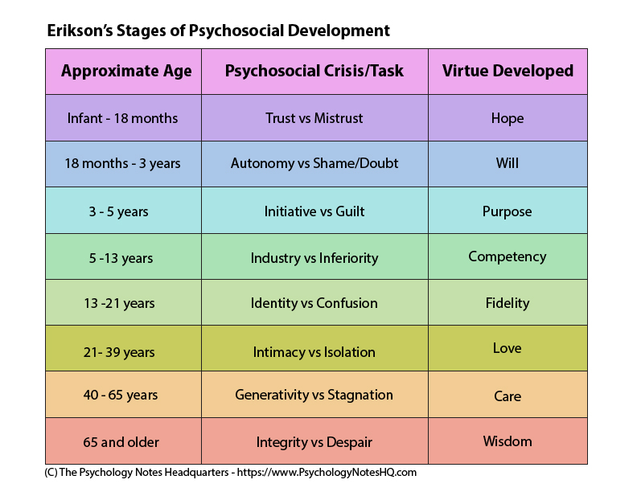
Figure 1.0 Erikson’s Stages of Psychosocial Development

Research has clearly shown that children’s emotional and behavioural adjustment is important for their chances of early school success, yet the emphasis on cognitive and academic preparedness often overshadows the importance of children’s social and emotional development (Raver, 2002). Although Erikson’s theory shows the developmental stages throughout an individual’s life, not all children or young adults will develop at the same time and access each stage at once, with the same ease of difficulty. Thus, as educators, we must see Erikson’s theory as milestones to analyse not as a series of steps that each child must achieve before they move onto the next (Levine, 1988).
During my observations, I had the opportunity to observe three critical incidents (see appendices). From these observations, I was able to identify an incident to focus on which I was able to connect the gap between theory and practice. The traditional approaches to discipline often mean that suppression or transformation of the symptoms of underlying problems that may be preventing learning is actually seen as successful classroom management (Christensen, 2016). Due to the teacher prompting the child with the question again, the child answered correctly. The teacher praised the child and they had received a sticker as an award and praise and verbal communication through applying positive reinforcement. Using positive reinforcement is one of the most important ways to motivate a child. Using non-verbal and verbal reinforcement is an important factor to motivate a child yet should always be accompanied by praise of the specific change in behaviour e.g. “well done for answering correctly” (Schmidt & Heybyrne, 2004). Although Bear, (2010) argues that rewards makes children question as to why certain behaviours are more important irrespective of external factors e.g. sticker.
Although using punishment may be the more appropriate principle to use in a certain situation, researchers established that this sort of approach had little effect on children when encouraging them to perform (Maag, 2001). The theory of behaviourism is used due to learning occurred thus due to the change in behaviour which was proposed by Skinner within his operant conditioning theory. Using Skinners (1953) operant conditioning theory of reinforcing a behaviour by rewarding it or discouraging a behaviour by punishing, it has a connection with the critical incident chosen as the practitioner believed that reinforcing the child to answer correctly was a successful approach instead of punishement. Thus, keeping the child’s motivational levels high would be the end goal. Researchers believe that when learners are extrinsically motivated, they become more independent, autonomous and become more successful (Ahmad, 2018). The practitioners main aim would be to ensure all students sustain their motivational levels using interesting activities which creates the desire to learn (Ahmad, 2018). Within Donaldson’s ‘Successful futures’, it is stated that the new curriculum has more of a focus on lessons being fun and interesting, rather than predominantly based around assessments and the pressures of high grades. Again, knowing that your student will be motivated due to there being a reward at the end will change the behaviour of the student naturally (Rumfola, 2017). The child began to listen to the teacher after this, sitting up correctly with positive body language. This prompts positive behaviour but also using this technique motivates the child to want to succeed again instead of punishing the child for being off task initially. Linking this with Skinners research and theory of behaviourism, positive reinforcement, but also based on his research of Thorndike’s (1898) law of effect, that different behaviour which followed by a pleasant action is likely to be repeated. The behaviourism theory proposed by Skinner (1953) is an important principle for practitioners to learn and investigate further in order to understand and develop their knowledge further in order to understand that each positive action is likely to be repeated. Thorndike’s theory (1898) is one of the most recognised theories within psychology yet also education. Thordike (1898) introduced this theory to investigate different aspects of behaviour. Linking this theory with the critical incident chosen, due to the child’s behaviour changing after receiving praise and a sticker, Watson (2013) reinforces this theory that behaviour is shaped by using positive reinforcement or negative reinforcement as the learner starts fresh. Skinner (1953) highlights that behaviour is fundamentally the actions followed by good outcomes are likely to reoccur, thus meaning the child will likely repeat these actions and concentrate in order to receive a sticker and praise in the future. It is vital to create an environment where learning can flourish and develop constantly yet set boundaries where children can feel the achievement of success. Within Donaldson’s ‘Successful futures’, it is stated that the new curriculum has more of a focus on lessons being fun and interesting, rather than predominantly based around assessments and the pressures of high grades. Again, knowing that your student will be motivated due to there being a reward at the end will change the behaviour of the student naturally (Rumfola, 2017).
The aim of this essay was to reflect on my learning and to personally identify areas of reflection in order to inform my own teaching practices and for myself to develop and improve even further. A practitioner’s self-reflection is highly important after the delivery of a lesson in order to improve in all aspects for future references. The Centre for the Healing, Arts and Science (2018) highlights that the importance of building one’s self- awareness of self-reflection by taking time to ask yourself the vital and important questions. According to Gibbs’ Reflective cycle (1988) about learning from different experiences, it is vital when developing teaching practice, to be able to plan and learn from positive and negative teaching experiences. Due to the model being in different stages, it enables the individual to engage critically especially with my own learning experience. The principles of this model assist with developing personal experiences in order to progress for future references, thus I will be referring to Gibbs’ model throughout this section. Reflection is a vital step and regarded as an important aspect used by all practitioners in order to gain a better understanding of practice-based learning. After a critical incident has occurred, it enables practitioners to reflect but also create and understand new learning but also form new ideas and learn from it (Burrows, 1995).
When observing this critical incident, it became clear what to observe and became apparent to investigate further by reading and creating important connections between different theories of practise. When analysing a critical incident, trying to verify a suspected hypothesis is the end goal, but also using analysis can confirm a completely new topic (Tripp, 2012, p.43).
I believe by the teacher using the positive reinforcement instead of punishment when the child wasn’t listening but answered correctly, in fact increased the child’s confidence. This made me question different aspects of teaching due to this technique succeeding. Before the critical incident occurred, I believed that if a child was not engaged to use punishment or use the child’s name. During the incident, I wasn’t convinced that using this approach would help the child’s behavior, I had asked myself the question of “how will not punishing the child for their bad behavior help their learning?”. In order to inform my own teaching practice, I will use the technique the teacher used of praising and rewarding the child for answering the question correctly, using positive reinforcement, instead of punishing for being off task. The child will remember being rewarded for answering correctly and want to answer correctly again thus being engaged more often. Otero (2015) stated that being engaged academically throughout is connected to stronger behavior for well-functioning classroom.
Within the investigation into the literature, it was apparent that Thorndike’s (1898) ‘law of effect’ that that different behaviour which is followed by a pleasant action is likely to be repeated, had a connection with the critical incident chosen as this technique is what the practitioner used yet also the technique was a success due to the child commenced being back on task after being rewarded with a sticker. I believe using this theory for my own teaching practice for future references will be a vital step within my continuous learning.
Ensuring complete inclusion and engagement throughout to succeed with the children’s learning and my own teaching. The experience provided greater knowledge and more in depth of this specific topic which will inform and better my own teaching experience for future references. For further steps, ensuring all children are engaged throughout would be a vital step. I would suggest ensuring the activity/lesson the teacher has created is appropriate for all due children developing at their own time in order to ensure complete engagement throughout and more importantly, inclusion. Karten (2010) states that the majority of teachers are sceptical because when it comes to inclusion, there isn’t a certain template or a specific guide to follow. Karten (2010) stated that inclusion is a way of life, it prepares all individuals for adulthood in order for future references. Inclusive pedagogy for teachers is vital thus believing that every child’s learning capacity can change (Hart, 2004). If this specific situation arose again, I believe using praise and positive reinforcement would be an important principle to use as increasing the child’s confidence and preparing them for their own physical literacy journey is the ultimate goal.
In conclusion, connecting theory to practice is a vital way for teachers/student-teachers or practitioners to inform and progress with their teaching practices due to it being a continuous learning cycle. When referring to the Professional Standards for Teaching and Leadership handbook (Welsh Government, 2017), practitioners are constantly self-reflecting in order to keep progressing with their teaching to achieve to the best of their ability and develop their teaching pedagogy thus using Gibbs’ model of reflection as a framework. After taking in the considerations of the learning, along with the literature found, developing further knowledge into the gap between theory and practice is an essential way for a practitioner to develop their teaching practises. Within the findings of the research, it is important to remember that all children are on their own physical literacy journey, thus developing at their own pace is highly important. To critique this, research within education has consistently shown the importance of challenging students in order to prevent boredom and to stimulate learning (Heilbronner, Connel, and Reis 2010; Marra and Palmer 2004; Noble and Childers 2008; Weiss 2003). It is vital to provide appropriate challenges for students within pedagogical literature for teachers. Throughout the essay, it has become apparent different connections that different literature had on practice and how they reinforce one another. Limitations to this study are, if the child had not known the answer, the practitioner had used punishment or the child had responded in the wrong way, the theories stated above would be wrong.
References
- Bangladesh Research Foundation Journal [ISSN 2224-8404 (Print), 2305-1566 (Online)], Vol. 7, No.1, January 2018

- Bear, G (2010). School Discipline and Self-discipline: A Practical Guide to Promoting Prosocial Student Behavior. United Kingdom: Guilford Press. 110.

- Belanger, P (1953). Theories in Adult Learning and Education. USA: Verlag Barbara Budrich. P.p.18.

- British Educational Research Association (BERA, 2018) Ethical Guidelines for Educational Research, fourth edition, London. https://www.bera.ac.uk/publication/ethical-%20guidelines-for-educational-research-2018

- Burrows, D. E. (1995). The nurse teacher's role in the promotion of reflective practice. Nurse Education Today, 15(5), 346-350.

- Calderhead, J. (1989). ‘Reflective teaching and teacher education’. Teaching and Teacher Education, 5(1), 43–51.

- Christensen, J. (2016). A CRITICAL REFLECTION OF BRONFENBRENNER ́S DEVELOPMENT ECOLOGY MODEL. PROBLEMS OF EDUCATION. 69 (1), 22.

- Cohen, L & Manion, L & Morrison, K (2007). Research Methods in Education . 6th ed. United Kingdom: Burrows, D. E. (1995). The nurse teacher'srole in the promotion of reflective practice. Nurse Education Today, 15(5), 346-350.. 396.

- Estyn (2020) Estyn Report. [Available online] https://www.estyn.gov.wales/system/files/2020-08/Ysgol%2520Gymraeg%2520y%2520Cwm%2520eng.pdf (last accessed 22/10/2020)

- Gerring, J (2006). Case Study Research: Principles and Practices. London: Cambridge University Press. 1.

- Gillham, B (2008). Observation Techniques: Structured to Unstructured. USA: Bloomsbury Academic. 112.

- Government (2015) Donaldson’s Successful Futures [Available online] https://gov.wales/sites/default/files/publications/2018-03/succesful-futures-a-summary-of-professor-graham-donaldsons-report.pdf (last accessed 22/10/2020)

- Hart et all (2004). Learning Without Limits. Maidenhead: Open University Press.

- Heilbronner, N. N., E. E. Connel, and S. W. Reis. 2010. “The ‘Stepping Stone Phenomenon’: Exploring the Role of Positive Attrition at an Early College Entrance Program.” Journal of Advanced Academics 21 (3): 392–425.

- Karten, T (2010). Inclusion Strategies That Work: Research-Based Methods for the Classroom. USA: Corwin. pp.2-3.

- Kumar, R. (2014) Research Methodology. London: SAGE.

- Landy, S. (2009). Pathways to competence: Encouraging healthy social and emotional development in young children (2nd ed.). Paul H Brookes Publishing.

- Levine, C. (1988). A critical examination of the ego identity status paradigm. Developmental Review. 8 (2), 147-184.

- Maag, J. W. (2001). Rewarded by punishment: Reflections on the disuse of positive reinforcement in schools. Exceptional children, 67(2), 173-186.

- Otero, Tiffany L., Haunt, Jillian M. (2015). Differential Effects of Reinforcement on the Self-Monitoring of On-Task Behavior: American Psychological Association. 91-103.

- Raver, C. (2002). Emotions matter: Making the case for the role of young children’s emotional development for early school readiness. Social Policy Report of the Society for Research in Child Development, 16 (3), 1-20.

- Richards, J. C., & Farrell, T. S. C. (2010). Professional development for language teachers. Cambridge: CUP.

- Rumfola, L, "Positive Reinforcement Positively Helps Students in the Classroom" (2017). Education and Human Development Master's Theses. 786.

- Schmidt, C & Heybyrne, B (2004). Autism in the School-Aged Child: Expanding Behavioral Strategies and Promoting Success. USA: Autism Family Press. 396.

- The Cenre for the Healing, Arts and Science (2018) The Importance of Self-Reflection [Available Online] https://www.thecenterforhas.com/the-importance-of-self-reflection/ (Last accessed 14/9/2020)

- Tripp, D. (2012) Critical incidents in teaching: developing professional judgement.London : Routledge.

- Yates, T. (2008). Research Synthesis on Screening and Assessing Social-Emotional Competence. Research Synthesis. 1 (1), 22.

Appendices

Appendix 1


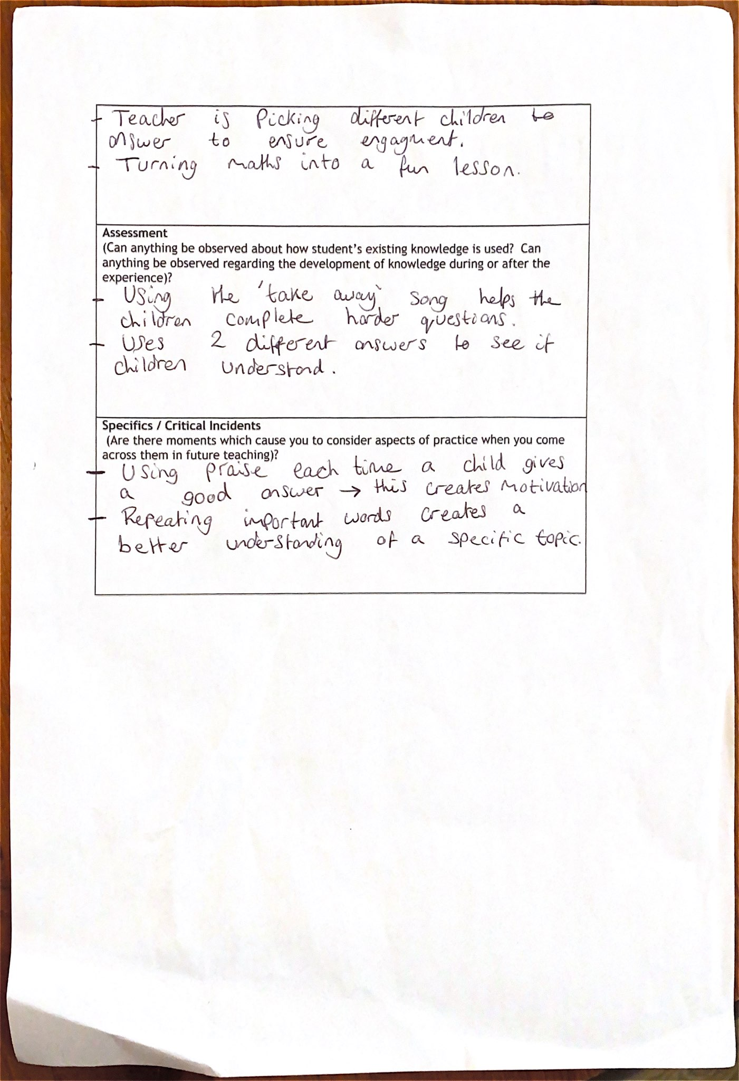



Appendix 2

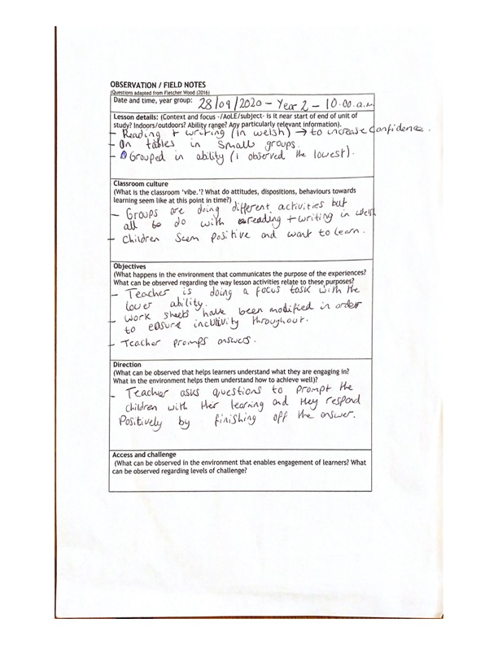

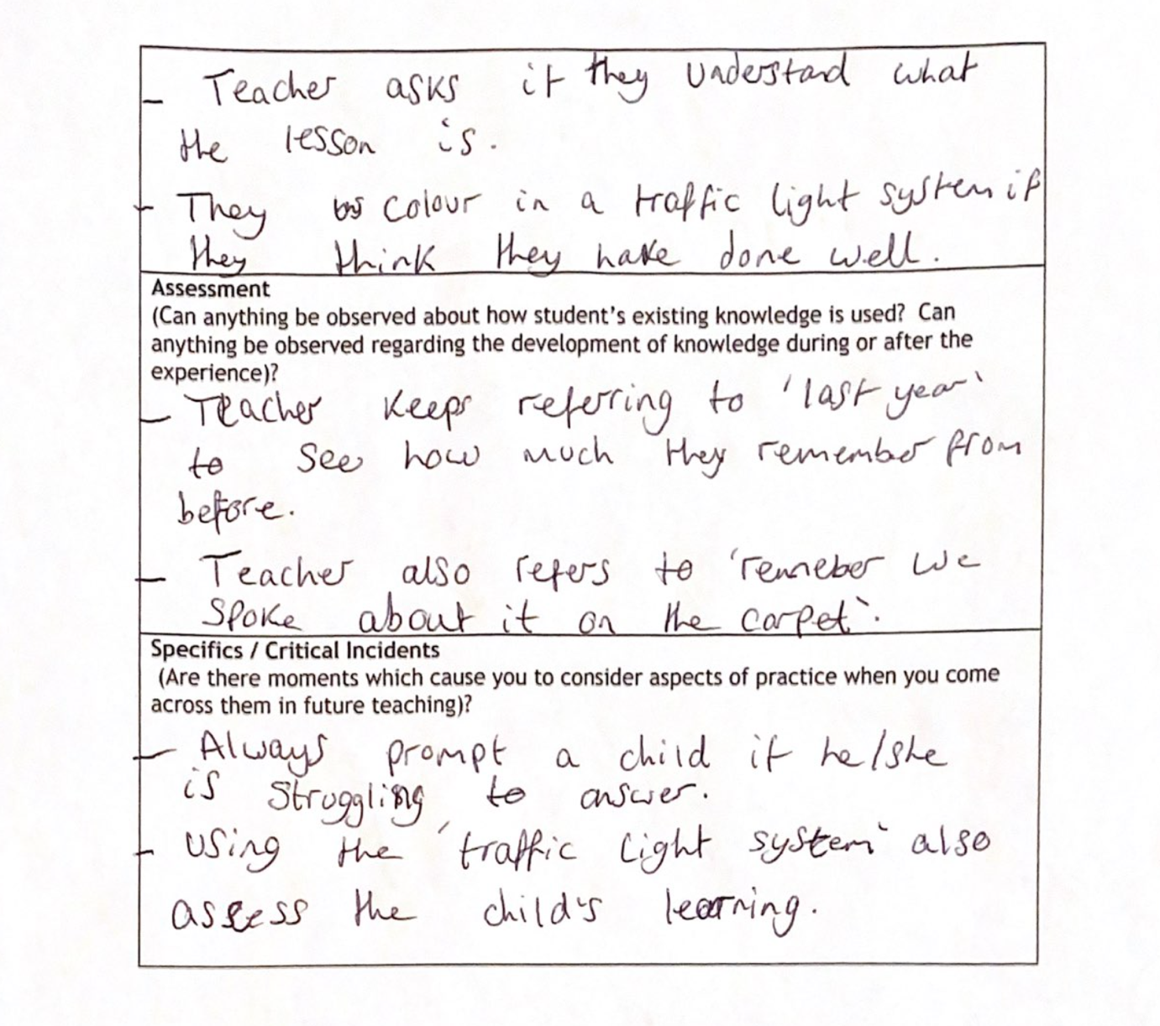



Appendix 3







