Hospitality and guest services

Name of student: Penka Ilieva
Student number: 1816778
Module Title: Hospitality and Guest Service Management
Assignment Title: Guest Service Assignment Part 1
Lecture name: Dale Clarke
Module number M4X01915_LON

Contents:
1. Introduction… ……… …………… …………… ...... ........... ...... ..... ....... …. …..... ...3
2. Hotel’s services that provide… …… ……….… ……… …….. …….. …… …... .…… ...4
3. How the hotel adapts to changing consumer preferences.... ... ....... ... .. ...5
4. How the changes impact the guest service management... ... ... ....... .... ….6
5.Conclusion. ….. ……. ……… …. … … … … …… … . . ………….. …… …….. ...…… … ….7
6. References…………… ……… … … ………… …… ……… …… … ……… ………...….. …… 8

Assignment brief:
Evaluative report, based on a hotel organisation of your choice. In your report, you will discuss the service provided in the chosen hotel, quality management (Continuous improvement), how the hotel adapts to changing consumer preference and how these changes impact guest service management.

- Introduction:

In this assignment today I will talk about the services that are provided in the hospitality industry and how to adapts to customer changing preferences and how these changes impact the guest services management. Assignment purpose is to look deeper in the hospitality and guest services.
UK Hospitality industry represent all the hotels, bars, restaurants, leisure complexes- all the companies providing hospital services. According to Langhorn 2004 the service provider is “part of the product itself”. For the satisfaction of the guest, he needs to feel valued and respected. (Tandfonline.com,2020)

.Hospitality - The hospitality is a process of welcoming and satisfying guests need and wants, to make them feel comfortable in relation to accommodation or foods and drinks.
“Hospitality is the relationship between the guest and the host, or the act or practice of being hospitable. Specifically, this includes the reception and entertainment of guests, visitors, or strangers.” (Definitions.net,2020)
Guest services is the action of host delivering the experience, before, in the moment of purchasing the goods or services and after that.
In guest service is very important the attitude of the employee to the customer. Main rule is that one company is not selling goods or services, it sells experience.

2.Hotel’s services that provide
The guest service in a hotel is extra services provided to the guests like
concierge, cleaning of the room, morning newspaper, drinks etc.
The guest service in a restaurant is the meal experience, the good friendly attitude, being available and quickly to respond to guest’s needs. Same as bars.
The hotel is chosen to talk about is Fleming Mayfair Hotel located at Green Park. This is a five-star luxury hotel in the centre of Mayfair. It’s part of the group SLH - Small Luxury Hotels of the world.
The hotel disposes with cosy rooms, drawing room-afternoon tea lounge, Manetta’s bar, private dining meeting rooms and Ormer Mayfair restaurant. It provides every service that I mention above.
- From the side of housekeeping every accommodation is serviced with daily - and turndown(night) cleaning.
- From the side of reception they deliver welcoming friendly attitude and register and process guests at their accommodation.
- From the side of hotel concierge, they are doing restaurant and spa reservations, transportation booking, assisting client’s guests, provide information about local shopping centres or restaurant, help guests with their luggage, deliver every morning a newspaper.
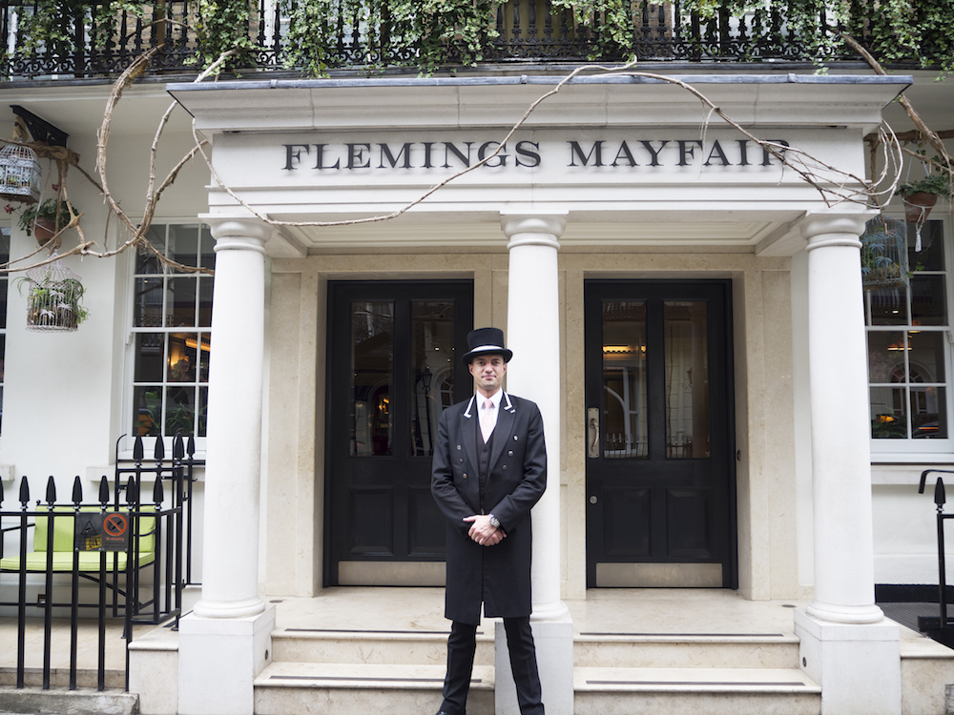
Figure 1: Flemings Mayfair (Luxnomade,2020)
There are five components for delivering best customer service:
- Great customer experience
- Highest level of knowledge
- Friendliness
- Promptness
- First-call resolution

3.How the hotel adapts to changing consumer preferences
The consumer preferences for hotels are changing consistently so to satisfy one guest’s needs and wants is becoming harder and harder. The solution - new innovative technology and methods helps to create a desirable experience at all. To avoid complaining and disappointed guests, falling from the competitors and to be successful overall the hotels need to adapt to change.
There are at total four segments of hospitality industry.
- Food and beverages -biggest segment in the industry, providing food and customer service.
- Travel and Tourism-part of the travel industry as well, helping moving people from point A to B.
- Lodging -providing a place to sleep/ accommodation
- Recreation-activity related with rest, relaxation; spa
The hotels are in the lodging industry.
To avoid complaining and disappointed guests, falling from the competitors and to be successful overall the hotels need to adapt to change.
These changes require more resources. This can be extra staff or extra finance.

As customers’ interests and needs in hotels evolve, so too the hotel industry must adapt and find a way to sustain itself, it’s a bit like Darwin’s idea of natural selection: if the industry can’t change to suit the consumer then new options will open up that the consumer will ultimately prefer.(M by Montcalm Blog,2020)

4.- How the changes impact the guest service management
Nowadays the infrastructure of all the modern luxury hotels is changed from the way they used to be. In the previous big hotels there was one manager running more than one different departments, now there is different manager for different department.
All the different management operation services like front desk, housekeeping, reservations, concierge etc. are main important thing for the development of the hotel and they needs to be a policy, a practice or procedure linking to standards of effectiveness in terms of meeting the expectations of the end consumer. The tools that can be used are total quality management tools, including tools for generating ideas, and in order to achieve objectives related to consumer changes can be used tools like flow diagrams. Flow charts are used to look at the ways that things can be done to improve in the future. Histograms can be used to frequency occurrences or variables over time. In terms of problems, management team can identify the most frequently occurring thing that’s happening and try and go to the heart of what is happening and look deeper in terms of the issues and try them to sort them out so to rectify them and satisfy customers to meet their expectation.
Technology in the hospitality industry is playing a huge role in the transformation. In order to make themselves competitors in their own changing industry, hotels need to gather information on trends that could affect their industry including technological and cultural advances. Similarly, they should work to collect data not only on what their competitors are doing, but what other industries are doing in general to serve the interests of their consumers to see if it can be adapted for their own model. (M by Montcalm Blog,2020)
But the improve in guest service can’t be achieve only through improving the data and technology.
The focusing on the high value quick wins can play a good role in improving the hotel in a certain way to get the guests attention. This can help to adapt quickly to customers changing preferences. Starting with the small will help do a better guest service and leave a great customer experience, make easy the changing process and measure results.
It’s very important in the hospitality industry the management team to know few rules:
• Guests don’t buy service, what they buy is experience.
• Guests don’t buy service quality, what they buy is memories for the place, attitude and the experience.
• Customers don’t buy just food and drinks, what they buy is the meal experience and all the impressions that brings
And the management team needs to have strategies like:
- Know what their product is – what service are they offering; in which sector is it: Food and Beverage, Lodging, Travel and Tourism, Recreation or Entertainment, what is the intangibility of their product, know the external environment.
- Know who is there client- understand the guests/customers and their needs and wants; to develop a relationship with guests and to act professional at the same time, know what are their motives, what is their language, what is their culture, what are their desires.
- Know who you are- this is for understanding yourself ,your own abilities, to understand what is all your negative sides and to put them away , to try to give the desired best customer service with the help from few qualities: greeting, politeness, eye contact, response, gesture, facial expression .
- Summarize all the goals to achieve the best customer service-this is for merging the guests’ goals, company’s goals, personal goals, hospitality industry goals and environmental goals.
All these strategies are integral part of achieving the great customer service and satisfied guests.
The 21st-century customer has high expectations for not only the product or service they’re buying, but most importantly for the experience they have while purchasing it. (Ferenczuk,2018)

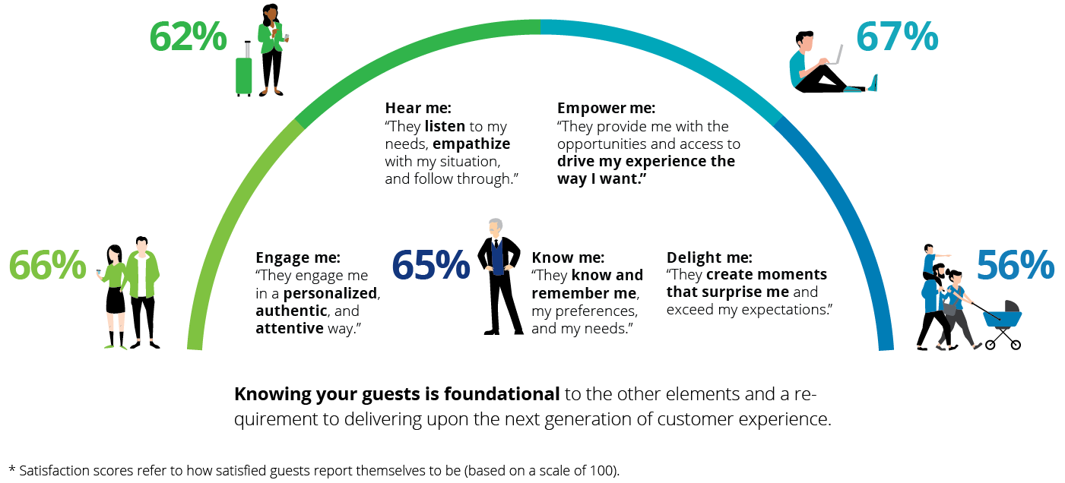
Figure 2: Guest score satisfaction in hotel industry (Deloitte United States,2020)

5. Conclusion:
The hotel industry Is changing continuously. Customer service now is not what is was before and it is the most important for the success of one business company and for the customers relations. Now guests want the fast answers to any of their questions. They are expecting their problem to be resolved as quickly as possible.
Guests are ruled nowadays by emotions. They pick up a place to go to stay a night or two or pick up a place to eat and drink based on reviews in internet.
So, the companies need to fulfil customers’ expectations, to deliver best customer service and to bring the success of the company no matter what.
Here is where the social media is taking place and here is where the hospitality industry has changed.
Companies need to have their own website, easy access via smartphones, social media profiles, chat boxes etc. The old fashion automatic responses are not useful and enough anymore.
Modern customers are also more aware of their surroundings. That has a few implications. They care about the environment and search for more sustainable products and services, including ways to travel. Finding ways to make your hotel more environmentally friendly may help you increase your revenue.(Ferenczuk,2018)
So, the one thing which is old and not changed in hospitality industry is that the customer is always right and is the one who has the advantage of satisfying all his needs before anyone else.
The management team of one company need to listen to the customers need and want, suggest and provide them the best offers that can give, facilitate access to all services for the purpose to be sure that the business will be successful in the industry.

6. References:

Tandfonline.com. (2020). [online] Available at: https://www.tandfonline.com/doi/pdf/10.1080/15332840802156873 [Accessed 5 Jan. 2020].
Definitions.net. (2020). What does Hospitality mean? [online] Available at: https://www.definitions.net/definition/Hospitality [Accessed 5 Jan. 2020].
M by Montcalm Blog. (2020). What Exactly Is Changing in The Hotel Industry - M by Montcalm Blog. [online] Available at: https://www.mbymontcalm.co.uk/blog/what-exactly-is-changing-in-the-hotel-industry/ [Accessed 5 Jan. 2020].
L U X N O M A D E. (2020). Hotel Guide: Flemings Mayfair, London. [online] Available at: http://www.luxnomade.com/2017/09/27/hotel-guide-flemings-mayfair-london/ [Accessed 5 Jan. 2020].
M by Montcalm Blog. (2020). What Exactly Is Changing in The Hotel Industry - M by Montcalm Blog. [online] Available at: https://www.mbymontcalm.co.uk/blog/what-exactly-is-changing-in-the-hotel-industry/ [Accessed 5 Jan. 2020].
Ferenczuk, K. (2018). Customer expectations for hospitality in 2018 - Insights. [online] Insights. Available at: https://insights.ehotelier.com/insights/2018/02/18/customer-expectations-hospitality-2018/ [Accessed 8 Jan. 2020].
Deloitte United States. (2020). Hotel Guest Experience Measurement and Strategy | Deloitte US. [online] Available at: https://www2.deloitte.com/us/en/pages/consumer-business/articles/hotel-guest-experience-strategy.html [Accessed 8 Jan. 2020].
Ferenczuk, K. (2018). Customer expectations for hospitality in 2018 - Insights. [online] Insights. Available at: https://insights.ehotelier.com/insights/2018/02/18/customer-expectations-hospitality-2018/ [Accessed 8 Jan. 2020].

