Research Proposal
For MBA Sustainability Leadership Dissertation
(BMSP7005D)

Melanie Schumm
Student ID: 2012474
Word Count: 1923

Introduction
With the rise of sustainability as a global concern, businesses have been compelled to reassess their practices. This shift in focus can be traced back to key events such as the UN’s Agenda 21 in 1992 and the Paris Agreement in 2016. However, it was the emergence of Greta Thunberg's Fridays For Future movement in 2018 that truly galvanised society's attention towards sustainability. This heightened awareness has led to a more sensitive consumer base, increasing demands on businesses to demonstrate ethical and environmentally responsible practices.
I propose to investigate the attitudes towards sustainability in the Real Estate Sector (RES). The answer to this question will contribute to current research by investigating areas beyond operational resource and material management. The study will also contribute to sustainability practice by highlighting, on the one hand, areas where sustainability is embedded in RES operations. On the other hand, practitioners will benefit from understanding which areas of the RES process, from design over construction and use to decommissioning, can be improved.
The research will take a holistic view of sustainability, addressing all three pillars: economic, social, and environmental.
This research proposal is structured thus. First, a review of relevant literature on sustainability and the RES is presented to provide a framework and the setting for the research. The current state of research and research gaps are identified. Second, a brief discussion on relevant research methodology is presented including a detailed proposal for data collection and analysis. Finally, a research plan with phases and dates concludes the proposal.

Literature Review
Sustainability is the continuous coexistence of humans and other species within a shared, protected, and thriving ecosystem. In this system, the needs of humans are carefully balanced against the welfare and health of the natural environment as a whole (Costanza and Patten, 1995, Hodge, 1997, Giddens and Sutton, 2013).
There are three pillars of sustainability that businesses have to consider in their day-to-day business operations. These are the environmental, economic and social pillars of sustainability. Concerning environmental sustainability, businesses must mitigate their negative impact on the environment, for example, by reducing consumption of natural resources, CO2 emissions and waste generation (Elkington, 1998).
Profitability will achieve economic sustainability, which is enhanced through corporate governance, transparent operations, compliance, integrity, and accountability, as well as risk management and meeting consumer needs.
Finally, businesses can contribute to social sustainability. For example, they can support the communities within which they operate and ensure that their supply chain operates ethically and environmentally responsibly. They can also provide fair and equal treatment and empowerment of employees and good working conditions (e.g., offering appropriate benefit packages, the possibility to work remotely, training and payment, and sustainable company buildings) (Alhaddi, 2015).

Four root causes for unsustainability
We are constantly increasing the amount of natural resources such as oil, gas, coal and minerals we extract from the Earth’s lithosphere. Thereby, for example, we actively increase erosion and pollute soils and water, consequently destroying wildlife habitats and decreasing the overall quality of living conditions for and health of those living in there (AABMCI, 2009). We pollute the natural environment through emissions caused by producing goods and through toxic waste. Further, we inhibit, for example, through deforestation, Earth to run its cycles, which are essential for regeneration. Finally, we hinder people from meeting their basic needs, for example, when we buy goods produced in countries where employees are not protected by labour law, have no job security, work in harmful and often hazardous workplace conditions and do not earn their cost of living (Heinrich Böll Stiftung, 2021).

Megatrend urbanisation – importance of RES
There is no single definition of the term urbanisation (Britannica, 2024, Dijkstra et al., 2021). Some disciplines, for example, consider the process of rural areas around cities becoming urban areas due to urban sprawl as urbanisation. Other disciplines define urbanisation as the growing population density of an area or the phenomenon of people leaving rural areas and moving to cities. Further, the availability of urban services is a characteristic to define urbanisation (Dijkstra et al., 2021, Kok and Collinson, 2006).
It is projected that the number of people living in cities will increase from today’s about 56% to around 68% in 2050 (Worldbank, 2023, Reuters, 2018). Considering further the expected growth of population from 8 billion in 2022 to 9.7 billion by 2050 and extreme weather causing floods, draughts and wildfires due to climate change, these projections present sustainability challenges for the RES (Coady, 2020, Worldbank, 2023, United Nations, 2022).

The Real Estate Sector
The Real Estate Sector (RES) encompasses the various industries that offer services and products associated with real estate (i.e., land and the built assets on it), such as development, including construction, infrastructure, property management, architectural services, urban planning, and governments (Cambridge University, 2021).

Issues/risks
The issues and risks that the RES is facing are manifold. The RES is responsible for 40% of global GHG emissions and resource consumption (Coady, 2020, Sayce et al., 2023, Designing Buildings, 2022). The GHG emissions contribute to climate change, exacerbating the risk of storms, floods, and heatwaves and challenging the resilience of the built environment. Further, climate change exacerbates resource scarcity (Hartenbeger et al., 2023). The RES highly depends on natural resources such as water, minerals, timber, and fossil fuels (Cambridge University, 2021).

Findings of SLRs
In recent years, the number of studies concerning sustainability in the RES has increased. Recent SLRs revealed several predominant topics of interest in the literature. On the other hand, some areas need to be explored more to develop broader knowledge about the RES’ sustainability issues and solutions (Kiani Mavi et al., 2021, Lima et al., 2021).

Main Research Areas
The main focus of current sustainability in the RES literature is on construction materials, project management, sustainability evaluation, energy and drivers for sustainability. Whereby most studies concentrated on environmental issues (Kiani Mavi et al., 2021, Lima et al., 2021). Further, the main stages of a building’s life cycle that are regarded in the literature are the design and construction phases. The other stages: pre-construction (resource extraction), use, and demolition and disposal of material (Design Buildings, 2021) are not consistently covered.

Research Gaps
Lima et al. (2021) identified in their systematic literature review several areas that have not yet been sufficiently addressed. For example, they found that future research should explore social sustainability issues in the RES. This includes organisations’ approach to sustainability (Martinsuo et al., 2020, Meglio and Di Paola, 2021) and understanding of financial and other risks involved in neglecting sustainability (Hussain and Nguyen, 2022). Furthermore, more research could be conducted concerning the two life-cycle phases: operation and maintenance, as well as demolition and disposal of buildings. Stakeholders’ sustainability preferences present another research gap. Kiani Mavi et al. (2021) found that studies are needed concerning the relationship between sustainability and compensation packages.

Methodology
I want to discover how the stakeholders involved in RES projects decide whether, how, and how frequently they consider environmental, social, and economic sustainability beyond governmental regulations.
The research question is: “How is sustainability considered in Real Estate Sector projects by stakeholders in the UK?” To answer the research question, I plan to apply a qualitative research approach. I further plan to gather research data by applying the qualitative method of deep, semi-structured interviews.

Data Collection and Analysis
To answer the research question, I will look for data in the literature to find out whether similar studies have already been conducted that can contribute to answering it. For this, I will use Google Scholar to find appropriate scientific journals. Additionally, I will use Google to find relevant white papers from consultancies such as Deloitte and McKinsey. To scan the cutting-edge literature, I plan to use special software such as VOSviewer, which is used for textual analysis and visualising co-occurrence systems of literature.

Participant Selection
Most importantly, I will further have to identify which parties/stakeholders are involved in RES projects and, therefore, be able to provide information about the decision-making in those projects. To get that information, I will try to get access to people who occupy those identified stakeholder roles and are regularly involved in RES projects. Therefore, I will contact peers I know from the course “Sustainable Real Estate: Creating a Better Built Environment” at the University of Cambridge Institute for Sustainability Leadership, where I took part.

Data Collection
To gather information about the stakeholders' actual experiences, I will have to prepare a questionnaire and interview them. I will conduct deep, semi-structured interviews with open-ended questions. The questions must lead the participants to speak about their personal experiences rather than reciting their employing companies’ CSR reports and website proclamations to get insight into their daily jobs in the RES projects. This will enable me to collect data about what is really happening in the RES to understand how sustainability is considered in RES projects.

Data Analysis
I plan to conduct the interviews via Microsoft Teams, which provides a transcription function. I will interpret the participants' statements to extract the deeper meaning of the interviews. To analyse the collected interview data, I plan to use qualitative data analysis software such as NVivo to aid my coding process.
I will create a table or a diagram to visualise which sustainability areas and issues the participants are most concerned with. I will summarise these data and apply concepts of the literature to draw conclusions.
From the data, I will understand:
- what reasons do stakeholders have to consider or disregard sustainability
- if stakeholders consciously try to contribute to sustainability
- if they aim to mitigate issues in urban areas, e.g. air and noise pollution, flooding due to paved surfaces and less green spaces, etc.
- how often and how prominent is sustainability considered
- what it would take to make RES stakeholders always consider sustainability in their decision-making
From my understanding of the data, I will either be able to create a framework for the decision-making process within RES projects or derive the barriers and drivers for sustainability in the RES.

Ethical considerations
To ensure the ethical integrity of my research approach, I have thoroughly reviewed both the UWTSD Research Ethics & Integrity Code of Practice and the UWTSD Research Data Management Policy. Additionally, I sought and have already obtained ethical approval from the University for my research methodology.
In considering ethical implications, I am committed to transparently informing participants about the research's objectives, scope, and procedures, ensuring they clearly understand what to expect and how their information will be utilised. It is paramount that participants feel at ease during interviews, particularly regarding potential implications in their professional contexts. To safeguard their anonymity, I will utilise pseudonyms, preventing identification by employers, colleagues, or clients.
All interviews will be conducted via Microsoft Teams and recorded to substantiate proper protocol. Transcripts and recordings will be securely stored and accessible only to myself, ensuring confidentiality. Adherence to the UWTSD’s Research Integrity and Ethics Code of Practice is fundamental to upholding the University's reputation.
Furthermore, I will send every participant a “participant agreement form” and outline the interview procedures, data handling, and anonymity protocols before their engagement. This upfront communication aims to foster trust and transparency throughout the research process.

Research Plan
The research timeline is built around an anticipated completion of a part-time MBA in one year. The first three months are allocated to research planning; the subsequent phases of preparation, data collection, analysis and write-up are split over 12 months.
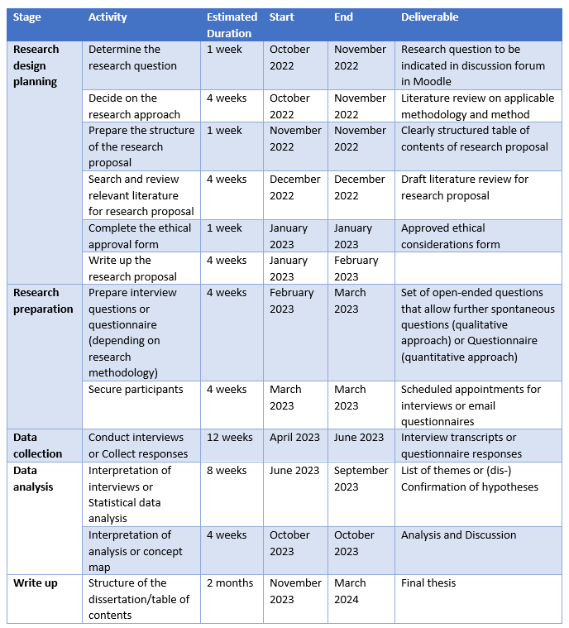
The approximate times account for breaks in the projects for seasonal holidays and a summer break.

Resources
The following resource requirements are anticipated:
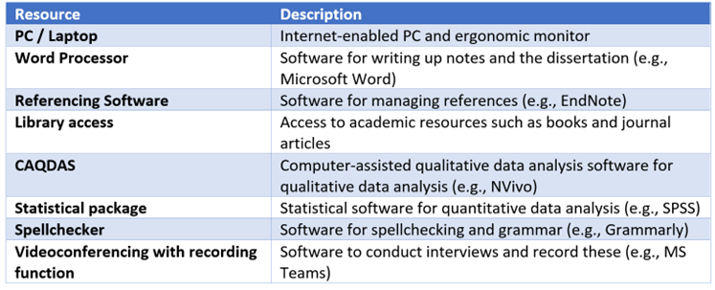

References
AABMCI, O. Our use of the world’s natural resources. Working Committee “Forum mineralische Rohstoffe” of the Austrian Association for Building Materials and Ceramic Industries, Austria, 2009.
ALHADDI, H. 2015. Triple bottom line and sustainability: A literature review. Business and Management studies, 1, 6-10.
BRITANNICA, T. E. O. E. 2024. Urbanization | Definition, History, Examples, & Facts | Britannica [Online]. Online: Encyclopedia Britannica. Available: https://www.britannica.com/topic/urbanization [Accessed March 2024].
CAMBRIDGE UNIVERSITY, I. 2021. Cambridge Sustainable Real Estate: Creating a Better Built Environment. Online: University of Cambridge, Institute for Sustainability Leadership.
COADY, T. 2020. Rebuilding Earth : designing ecoconscious habitats for humans, Berkeley, California, North Atlantic Books.
COSTANZA, R. & PATTEN, B. C. 1995. Defining and predicting sustainability. Ecological economics, 15, 193-196.
DESIGN BUILDINGS. 2021. Life cycle in the built environment [Online]. online. Available: https://www.designingbuildings.co.uk/wiki/Life_cycle_in_the_built_environment [Accessed December 2022].
DESIGNING BUILDINGS. 2022. Consumption in the construction industry [Online]. Available: https://www.designingbuildings.co.uk/wiki/Consumption_in_the_construction_industry [Accessed September 2022].
DIJKSTRA, L., FLORCZYK, A. J., FREIRE, S., KEMPER, T., MELCHIORRI, M., PESARESI, M. & SCHIAVINA, M. 2021. Applying the degree of urbanisation to the globe: A new harmonised definition reveals a different picture of global urbanisation. Journal of Urban Economics, 125, 103312.
ELKINGTON, J. 1998. Accounting for the triple bottom line. Measuring business excellence, 2, 18-22.
GIDDENS, A. & SUTTON, P. 2013. Sociology (7 Edit.). Cambridge, England: Polity Press.(in English).
HARTENBEGER, U., SAYCE, S. & TOTH, Z. 2023. Financing retrofits. Resilient Building Retrofits - Combating the Climate Crisis. Abingdon: Routledge.
HEINRICH BÖLL STIFTUNG 2021. Plastik, Müll & ich, Berlin, Heinrich Böll Stiftung.
HODGE, T. 1997. Toward a conceptual framework for assessing progress toward sustainability. Social indicators research, 40, 5-98.
HUSSAIN, N. & NGUYEN, D. K. 2022. Call for Papers “Determinants and Consequences of Climate Risk Disclosure”. Journal of Economics, 16, 39.
KIANI MAVI, R., GENGATHAREN, D., KIANI MAVI, N., HUGHES, R., CAMPBELL, A. & YATES, R. 2021. Sustainability in construction projects: A systematic literature review. Sustainability, 13, 1932.
KOK, P. & COLLINSON, M. 2006. Migration and urbanisation in South Africa, Statistics South Africa.
LIMA, L., TRINDADE, E., ALENCAR, L., ALENCAR, M. & SILVA, L. 2021. Sustainability in the construction industry: A systematic review of the literature. Journal of Cleaner Production, 289, 125730.
MARTINSUO, M., TEERIKANGAS, S., STENSAKER, I. & MEREDITH, J. 2020. Call for papers: Managing strategic projects and programs in and between organizations. International Journal of Project Management, 38, 464-467.
MEGLIO, O. & DI PAOLA, N. 2021. Innovation and entrepreneurship for well-being and sustainability. MDPI.
REUTERS. 2018. Two-thirds of world population will live in cities by 2050, says UN [Online]. The Guardian. Available: https://www.theguardian.com/world/2018/may/17/two-thirds-of-world-population-will-live-in-cities-by-2050-says-un [Accessed February 2024].
SAYCE, S., WILKINSON, S., ARMSTRONG, G. & ORGAN, S. 2023. Resilient Building Retrofits: Combating the Climate Crisis, Abingdon, Taylor & Francis.
UNITED NATIONS, U. N. 2022. World population to reach 8 billion on 15 November 2022 [Online]. Online: UN. Available: https://www.un.org/en/desa/world-population-reach-8-billion-15-november-2022 [Accessed December 2022].
WORLDBANK. 2023. Urban Development [Online]. Worldbank. Available: https://www.worldbank.org/en/topic/urbandevelopment/overview [Accessed February 2024].

