Practices in context

‘Student name: Laura Sadler
Student P number: P152177
Module code: ADAD5001
Programme of study: Illustration

Children’s books play a vital role in a child’s development. Reading books, along with being an important part of their educational wellbeing, also helps children to make sense of the world around them. Whilst the words on the page are an important part of reading children’s books, the illustrations within the book play a pivotal role. Images help children to understand and identify things they come across in daily life. This understanding begins in advance of the child being able to make sense of the text. Children also look to images that they can relate to so they can have a sense of their identity and place within the world.

Keywords
Representation, tokenism, responsibility

We live in a diverse society yet there is a lack of acceptance for people from minorities. In 2017 it was reported that less than 4% of children’s books published represented diversity. With the knowledge that children learn from a young age through literature about the world and our society, could the lack of diversity and representation within these books be a factor for lack of empathy and acceptance towards people who are different?

I am going discuss the responsibility and challenges illustrators and artists face to be inclusive and the importance of diversity representation within art and illustrations.

The first keyword I will be discussing is representation.
“You can’t be what you can’t see” (Marian Wright Edelman)
This is true for all of us we rely on examples of others to identify with and see what we can become in our own lives.
An American or European black male child of school age will already have an understanding that he is a minority. Based on knowledge learned from images in popular culture, or from being told by family members preparing him for experiences he is likely to face in society.
“He will be told anything is possible, but he has to work twice as hard as his white counterparts in order to succeed and be worthy of acceptance. Many will take this message on board and will strive for academic excellence in a pressured education system. Others, seeing black role models in sport , music or some other art form hoping that their talent will enable them to overcome discrimination and other obstacles to success.” (Sarpong2019)
However this isn’t always the reality many Black men can strive for success and do everything ‘right’ and are unable to break through the discriminations and prejudices of society. Representation goes further than telling someone what they can be, you need to tell others what they can be as well.
“It’s very common among BAME (Black, Asian and minority ethnic) children to imagine and dream themselves in another skin colour. This is because the ideal ‘type’ in the books they read are portrayed as White.” (Delaram Ghanimifard 2018)
It’s important for children to see themselves within popular culture as people with potential and living a normal life, and to see others living normal lives. This teaches them how to be tolerant of other people and creates healthier values towards others. Representation helps children envision their own potential and helps them become the best possible version of themselves.

It all sounds very simple in theory, more representative books equates to a more accepting, tolerant happier society.
The Arts Council England found that of 9,115 children’s books published in 2017, only 391 - 4% featured a BAME character. Yet the department of Education reported that in 2017 32.1% of pupils of compulsory school age were of an ethnic minority. Which shows a large imbalance of representation within children’s literature.

One illustrator striving for inclusiveness within children’s literature is Jessica love who wrote and illustrated Julian’s mermaid. The story is about a gender questioning child who sees women dressed as mermaids and copies their look when he goes home. Inspired by a transgender friend to write and illustrate the story.

“Talking to him and thinking about his journey got me curious about what kind of literature there is out there for kids who might be asking themselves these questions, and I started reading blogs of families who had children who were questioning their gender,” (Love 2019)
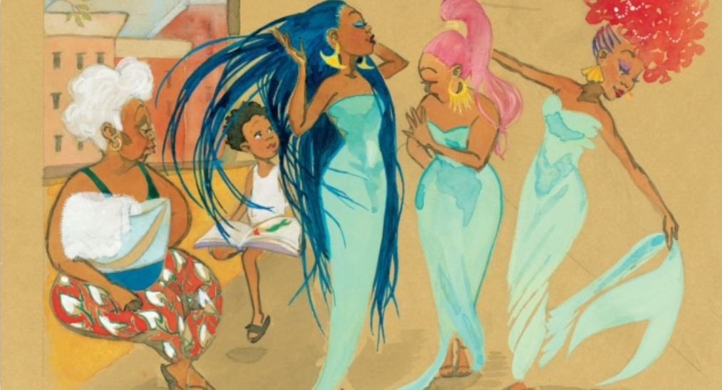
Julian’s mermaid illustrated by Jessica Love

Not only are the illustrations representative of a male child breaking the stereotypes of gender, they are also representative of BAME children. The illustrations are not token illustrations and are beautifully inclusive and non stereotypical. This type of positive image can not only help a child similar to the protagonist but help children who do not relate become open minded and accepting of differences.

My second keyword that I will be discussing is Tokenism. There is a fine line between diversity and Tokenism. Tokenism is the effort to appear diverse and inclusive by using selected underrepresented minorities to act as a voice for the larger society. To give the appearance of equality. It is like a person proving they are not racist or prejudice by pointing out one of their friends is black, gay, disabled etc.
Tokenism within Children’s illustrations for example would be making a supporting character black or disabled to tick off a box of appearing to be diverse . These often feel added as an after thought. An example of this could be the Biff, Chip and Kipper books, where the protagonists of the story are white kids and they have occasional appearances from their ethnic friends.

The dangers of tokenism is it creates an illusion of inclusiveness and masks real issues. Tokenism makes organisations and individuals feel like they are doing enough to tackle diversity but it’s an empty gesture and does little in the way of tackling the bigger issues of inclusiveness. Tokenism also does little to combat stereotypical portrayals of people. When tokenism is such a common place in popular culture it creates an increase of stereotypical views from both majority and minority groups towards each other. When individuals either from a minority or majority group have little exposure to the opposite, they have no choice but to accept the stereotypical representations presented to them.

The issues illustrators and artists face with tokenism is that even if their work is intended to be inclusive it could still be perceived as tokenism.
Aisha Oxley discusses. Seeing an advertisement for the Taylor Wessing Photographic Portrait Prize exhibition housed in the national portrait gallery. The advertisement features a print of a black woman dressed in yellow with a stylised Afro smiling into the distance. Aisha describes not seeing images of black women featured often within galleries and was hopeful that the advertisement for this exhibition would represent ‘the overall racial makeup within the exhibition’. Aisha describes her disappointment to find the image of the woman on the advertisement was one of a few tucked into an inconspicuous corner. ‘I questioned the purpose of placing a black woman on an advertisement for mainly a white portrait show, challenging myself not to attribute it to tokenism.” (Oxley 2015)
Aisha interviewed the photographer of the image that drew her into the exhibition, Hayley Benoit, who revealed she felt discouraged after submitting the image to the contest and felt it was a waste of time.
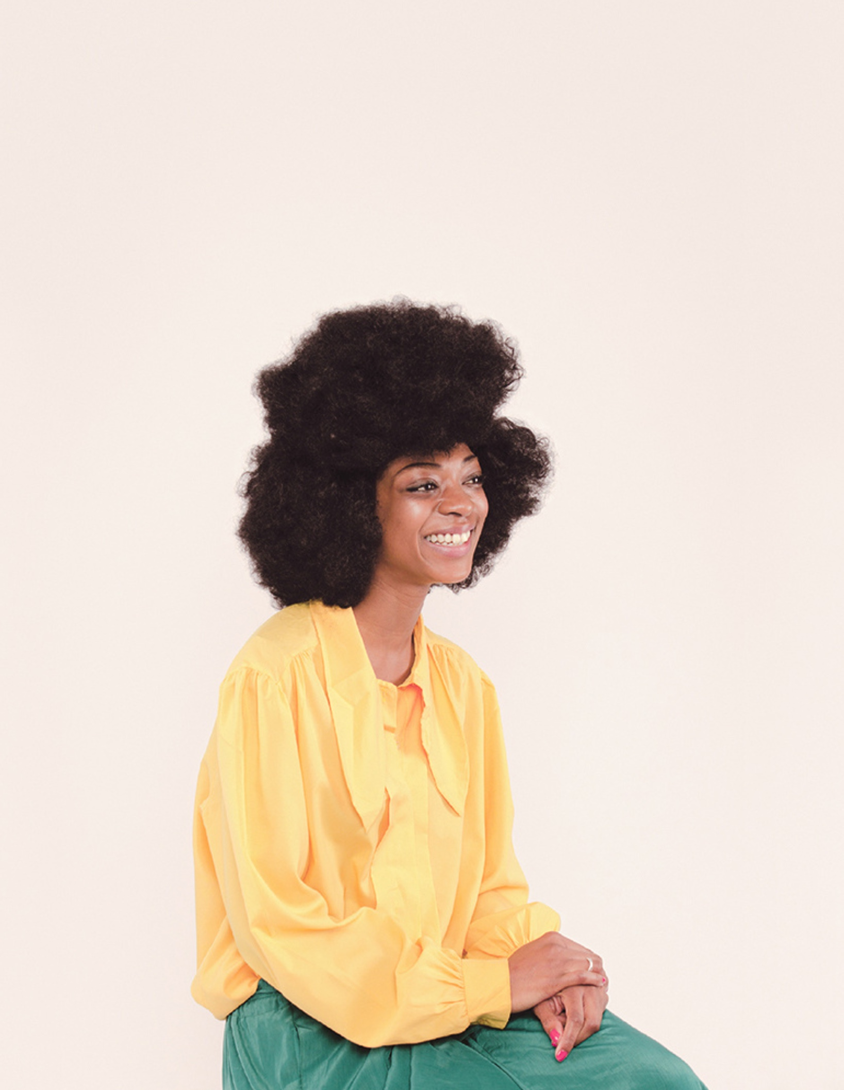
Untitled portrait by Hayle Benoit

Artists and illustrators don’t always have full control of where their work ends up or how their images are displayed. In this example the photograph was a created as an inclusive piece of art and had it been displayed in the appropriate context with portraits of a similar nature it could have been perceived as beautiful display of representation for black women/ people. Aisha who then viewed the exhibition could have felt represented and empowered rather than questioning if the photograph was a token portrait.

When you add these factors outside of an artists control into being inclusive within their work, it can be intimidating especially for artists who are not from a minority. To try to be inclusive and sensitive within their work but for the work to end up being perceived as a token effort can be deflating and prevent artists from trying.

The third and final keyword I will be discussing is responsibility.
Artists and illustrators who venture into representing cultures and minorities that are not familiar to them, have a responsibility to be sensitive to the particular issues that those minorities face. Of which they can have little empathy for as they will not have experienced the suffering of that minority.
When looking at issues of race representation for example, this can can be challenging as to not appropriate that culture, and to be sensitive to the oppressions they may have dealt with.

In 1955 Emmett Till a 14 year old, African American boy, from Chicago, was visiting family in Mississippi. Emmett was brutally murdered after it was falsely claimed he had been flirting with a white woman four days prior to his death.
The men who murdered him were the white woman's husband and her brother. According to history sites they made Emmett carry a 75lb cotton gin fan to the bank of the Tallahatchie river. They forced him to strip naked, beat him severely, gauged out his eye, shot him multiple times and threw his bullet ridden body tied to the cotton gin fan with barbed wire into the river. Three days later his body was recovered and was so disfigured could only be identified by an initialled ring.

The authorities wanted this to be hushed over and wanted his body buried quickly but Emmett’s mother Mamie Till requested his body be sent home to Chicago.
Emmett’s mother after seeing his mutilated remains decided to have an open casket funeral and allowed photographs to be taken to show the world what these racist murderers had done to her son. ‘Let the world see what I have seen” was her brave response.
Emmetts murderers, less than two weeks after his funeral, were acquitted of murder by an all white jury who deliberated for less than an hour.
This is a tragic story about white supremacy. So when white artist Dana Schutz painted an abstract painting ‘open casket’ in 2016 from the photographs of Emmett Till's disfigured corpse it was naturally going to cause some controversy.
Maurice Berger writes for the New York Times “unlike the original Photograph, “Open Casket” is inscrutable and even grotesquely decorative. It lives outside of historical context. We live in another wrenching time, when young black men continue to be endangered. But insensitivily appropriating a complicated photograph with multiple layers of meaning from another era does justice to neither the image nor its historic role.” (Maurice Berger,2017)
The controversy around this painting was so great and many artists and members of the black community were extremely upset by this painting even calling for it to be destroyed.
At the center of the debate is the argument ‘It is not acceptable for a white person to transmute black suffering into profit and fun, though the practise has been normalised for a long time.”
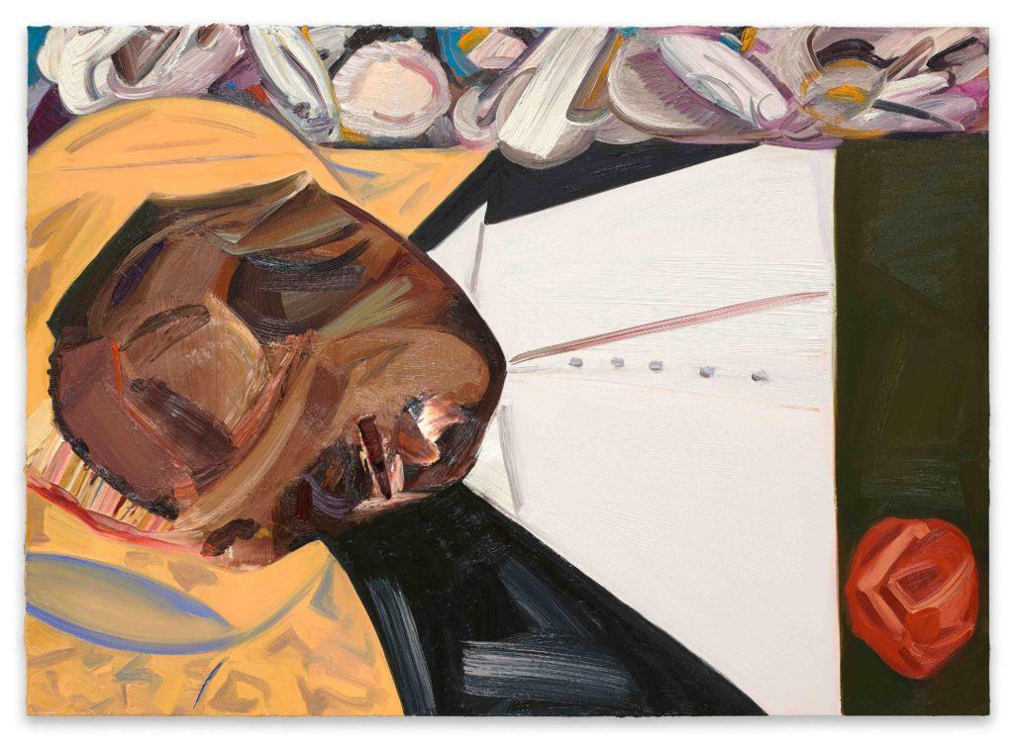
The open casket by Dana Schutz

Schutz defended her painting by stating “ I do not know what it is like to be black in America but I know what it is like to be a mother. Emmett Till was Marie’s only son. The thought of anything happening to your child is beyond comprehension.” (Schutz 2016) She felt that race is irrelevant that she has created another relationship with the subject matter as a mother. But one could argue that Schutz would never know even as a mother what it is like to fear or to lose your child in a racially motivated attack.

Although the arguments surrounding the controversy are regarding the fact that the artist is white and the subject matter is a victim of white supremacy. The real issues are more to do with the execution of the painting and how responsible the artist has been with the subject matter. There is almost a censorship of Emmet’s disfigured face within the painting, and it I feel it softens the brutality of his death which contradicts the wishes of Emmett's mother to open the casket and allow the photos. Although titled open casket Schutz almost closes the casket and thus having a negative impact on the black community and their suffering.

In conclusion after considering my three keywords and looking at the roles of representation, tokenism and responsibility there are many questions that go unresolved.
Do the issues regarding lack of representation within art and illustration stem from the fact that the art world is a place of white privilege, cis gender, male dominated, able bodied industry?
Art and illustration is a way of communication and telling a story. Is the fact that representing minorities seen as telling someone else’s story? Does the fact when people try to represent or tell the story of a minority as the case of the ‘open casket’ put people off being representative when they see negative effects from what can happen if it goes wrong? Is adding a token minority worse than excluding a minority all together and if so is this contributing to children’s literature being exclusive rather than inclusive what they do they Which leads to the question for the basis of my dissertation How can illustrators and literature for children promote a more diverse and representive society?

For my dissertation I would like to build on these sub questions and relate them to my own practice in illustration and become more inclusive as an illustrator. which leads me to the question how can illustrators and creators of literature for children sensitively and responsibly promote a more inclusive and representative society?

Bibliography
Aisha Oxley. 2019. Isis. [Online] . [28 April 20199]. Available from : http://isismagazine.org.uk/2015/06/tokenism-or-representation-people-of-colour-in-the-uk-arts-scene/
Maurice berger.2017. Lens Blog. [Online]. [2 May 2019]. Available from: //lens.blogs.nytimes.com/2017/04/05/controversy-contexts-using-emmett-tills-image/

Pinknewscouk. 2019. PinkNews. [Online]. [8 May 2019]. Available from: https://www.pinknews.co.uk/2019/02/17/trans-kids-book-julian-is-a-mermaid-awards

Sarpong, J.U.N.E (2019). Diversify. London: Harper Collins publishers1.

Spikeartmagazinecom. 2017. Spike Art Magazine. [Online]. [8 May 2019]. Available from: https://www.spikeartmagazine.com/en/articles/dana-schutzs-open-casket-controversy-around-painting-symptom-art-world-malady

Standardcouk. 2018. Evening Standard. [Online]. [8 May 2019]. Available from: https://www.standard.co.uk/lifestyle/books/best-childrens-books-diversity-a3974701.html

