  Food Delivery Data Analysis Report  Data Handling and Business Intelligence - LCBB5014 | By Alexandra Chistol  Student ID 2319949

Table of Contents
- Introduction…………………………………………………... Page 2
- Data Cleaning and Preparation……………………………...…Page 3
- Descriptive Statistics and Summary…………………………. Page 6
- Trend Analysis and Visualization……………………………. Page 9
- Statistical Analysis using SPSS………………………………. Page 11
- References……………………………………………………. Page 15

Introduction

The goal of this study is to analyse a dataset about food delivery operations utilizing data analysis techniques in Microsoft Excel and IBM SPSS Statistics. The dataset includes information about delivery workers, such as age, ratings, delivery times, weather, traffic density, and vehicle kinds. The analysis seeks to find patterns and relationships that influence delivery performance.
This paper focuses on several important goals. First, Excel is used for data preparation and cleaning to make sure the dataset is correct and ready for analysis. Second, to summarize important variables, descriptive statistics are computed. Thirdly, to find trends in delivery performance, trend analysis is carried out using visualizations. Additionally, statistical analysis with SPSS is used to investigate correlations between variables and evaluate hypotheses. Lastly, conclusions are presented along with suggestions and perspectives.
Businesses can increase productivity and performance by using data analysis in their decision-making processes (Davenport and Harris, 2017). Analysing operational data in the context of food delivery services might offer insightful information about variables influencing customer satisfaction and delivery speed (Provost and Fawcett, 2013). Businesses need to use data-driven tactics to stay competitive as the demand for online meal delivery keeps rising.
Furthermore, business intelligence technologies help organizations turn unprocessed data into insights that can be used to improve planning and resource allocation (Chaffey, 2015). This research shows how these technologies can be used to improve delivery operations in a practical setting. The research offers a thorough grasp of the dataset's performance drivers by combining descriptive and inferential statistical techniques.

Data Cleaning and Preparation

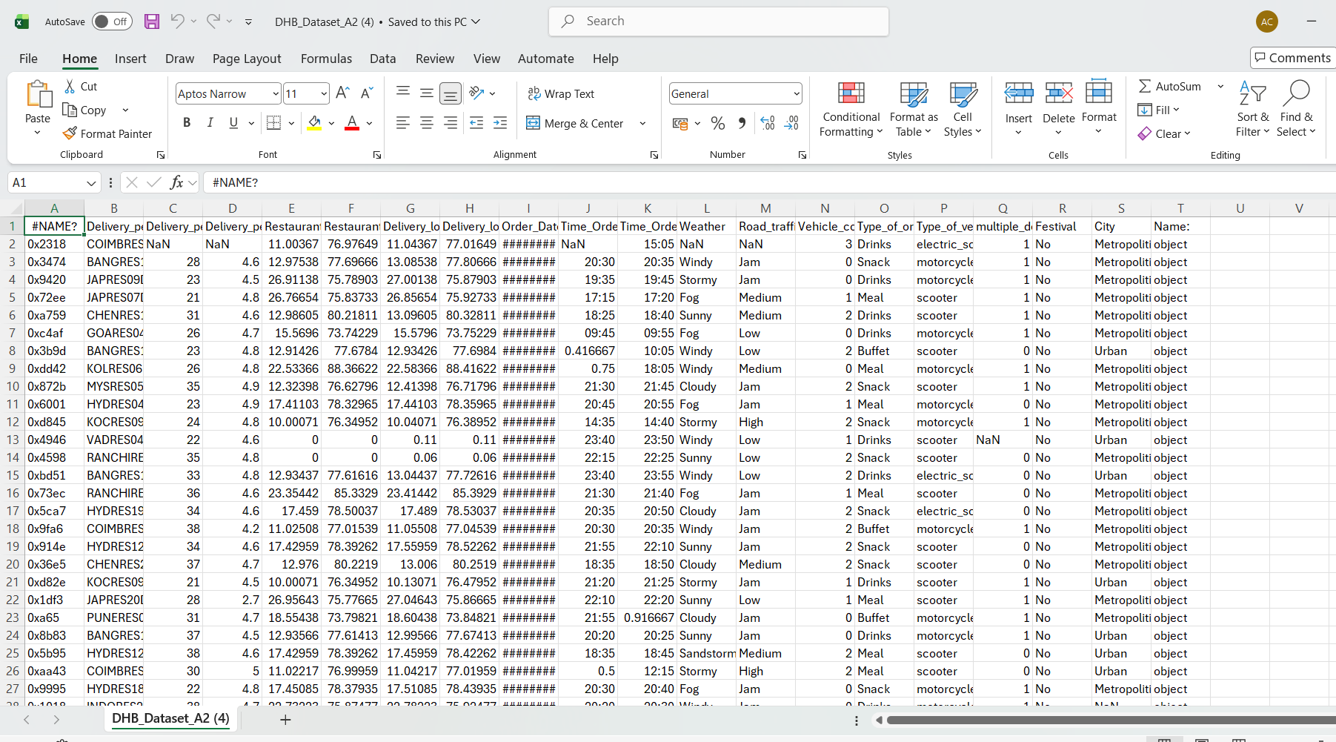
Microsoft Excel was used for data cleaning to make sure the dataset was reliable, consistent, and appropriate for analysis. Poor data quality can have a major impact on results and result in incorrect conclusions; hence data preparation is an essential phase in the data analysis process (Kelleher and Tierney, 2018). Initially, filtering techniques were used to identify missing values (NaN), enabling a methodical study of incomplete records.
Figure 1: The original dataset before cleaning.

Numerical variables such as delivery personnel age and ratings contained missing and invalid values, including zeros, which are not realistic in this context.
Before proceeding with the cleaning process, I have replaced the column #NAME with Order_ID, and I deleted the last column Name as it looks incorrect. Next, I have selected Data and then Filter to identify all the NaN values that need to be replaced in the Data set. After selection and identification, all the non-values will be replaced with the average value for each numerical column as in Age, Ratings, Delivery time, but for the categorical ones like weather, traffic, city we will use Mode(the most common).

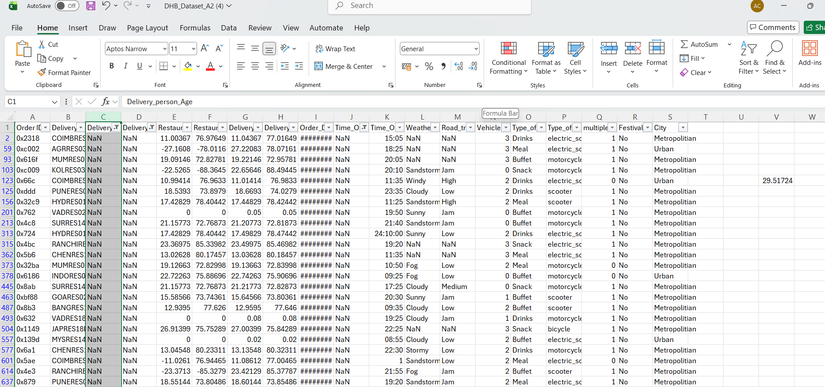
By following the same steps for all the columns that require cleaning. We have obtained the following average values and common values.
Figure 2: Starting the Cleaning Process

Figure 3: Calculating Delivery_Person_Age Average
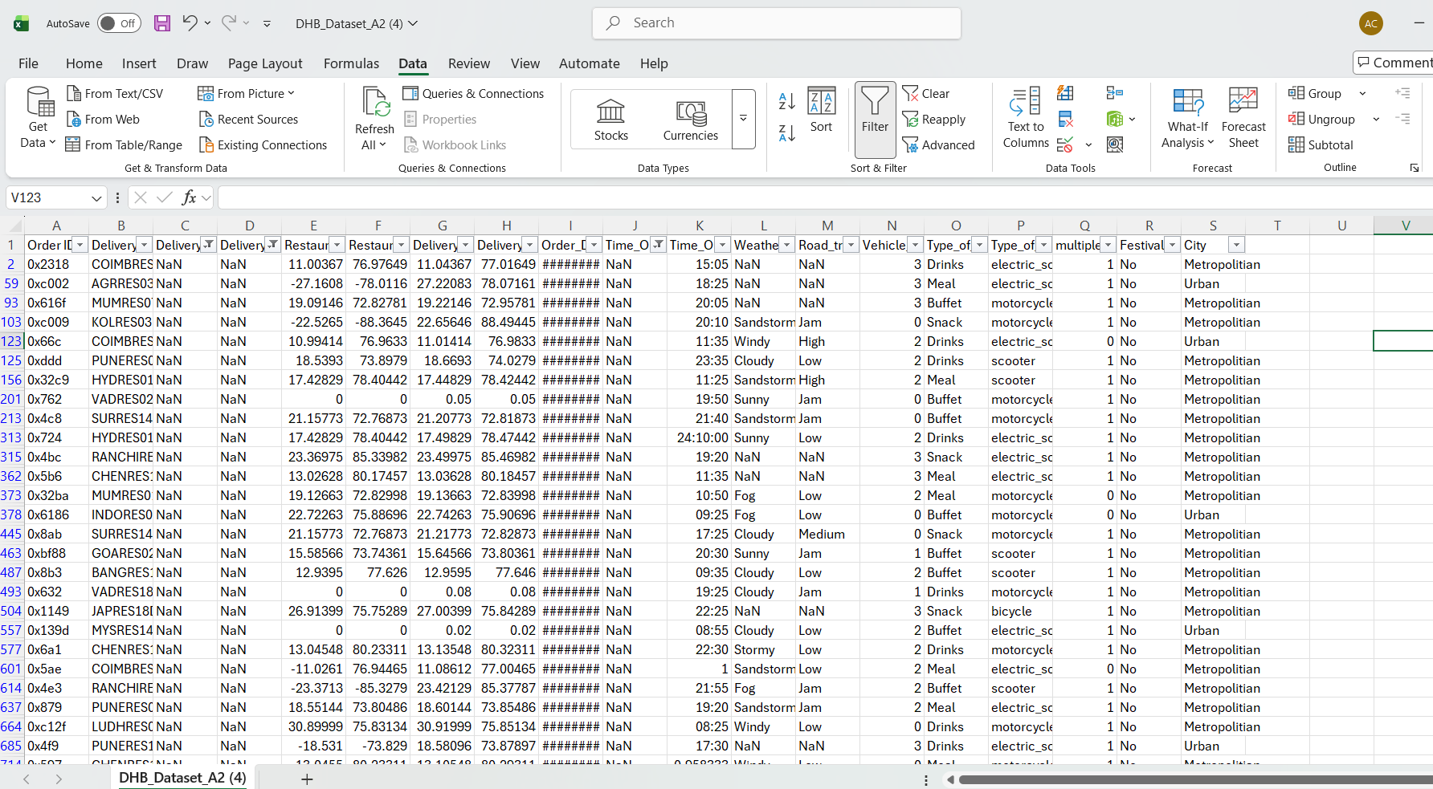
Delivery_Person_Age – 29.52
Delivery_person_Ratings → 4.63
multiple_deliveries → 0.75
And for the categorical ones we have used the most common values from the dataset:
Weather → Sunny
Road_traffic_density → Low
Type_of_vehicle → motorcycle
City → Metropolitian
Festival → No
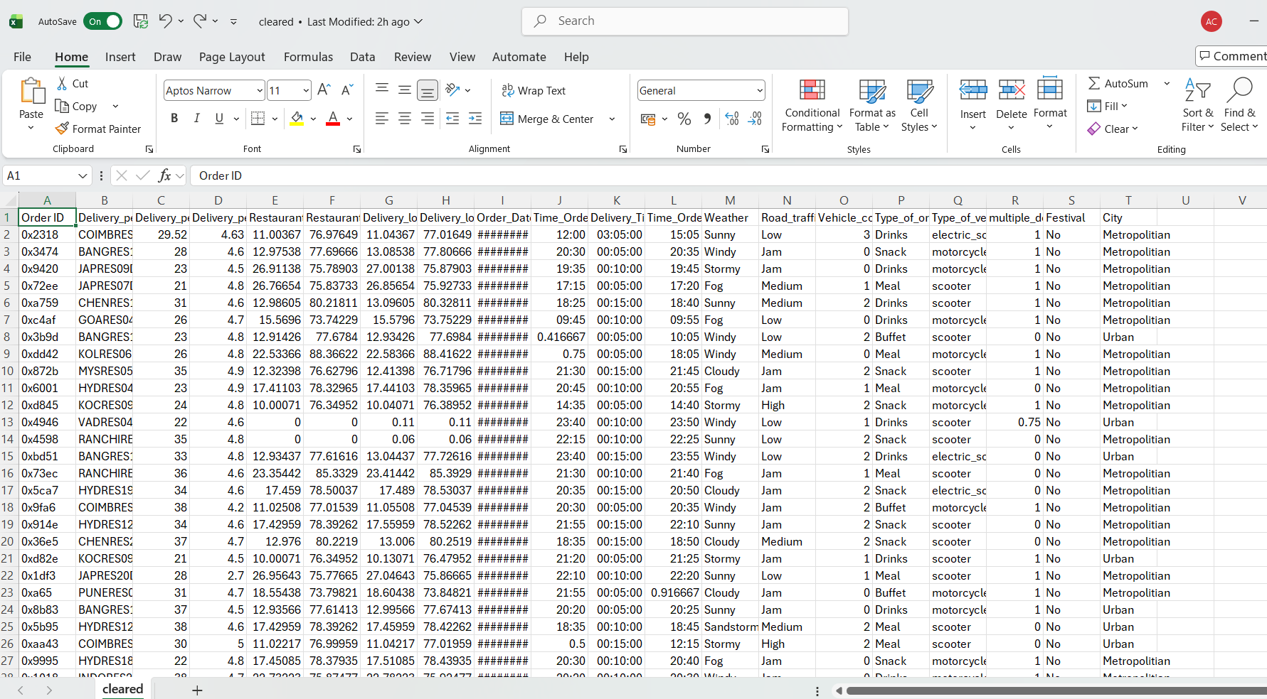
Missing values in numerical variables were replaced using the mean (e.g. age = 29.52, ratings = 4.63), while categorical variables were replaced using the mode (e.g. weather = Sunny, traffic = Low). This ensured data completeness while maintaining the integrity of the dataset.
Figure 4: Clean Dataset including new variable Delivery_Time
Categorical variables such as weather conditions, traffic density, and vehicle type also contained missing values. These were replaced using the most frequent category (mode), which is commonly used for categorical data to preserve consistency and avoid introducing bias (Pallant, 2020). This approach ensures that the dataset remains representative of typical conditions.
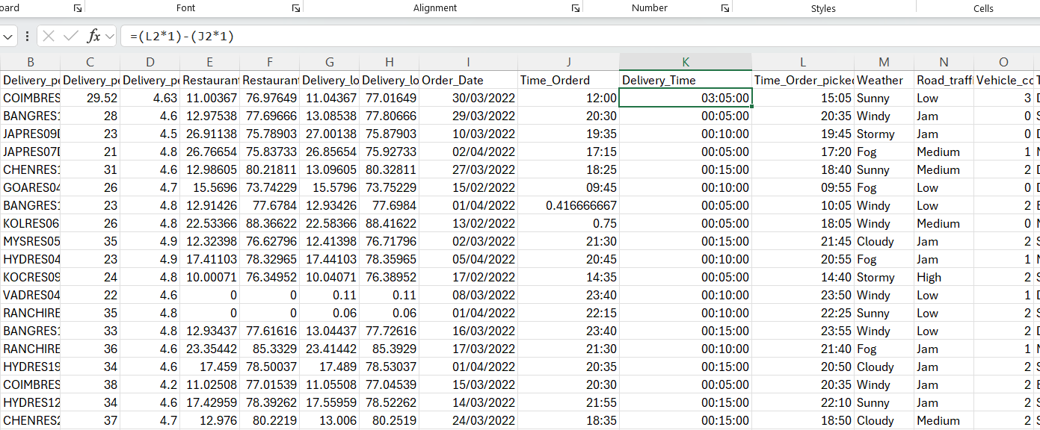
Time-related variables required particular attention due to their importance in calculating delivery duration. Rows with missing time values were removed, as accurate time data is essential for meaningful analysis. A new variable, Delivery_Time, was created by calculating the difference between order and pickup times, with adjustments made to account for overnight deliveries.
Figure 5: Creating new variable Delivery_Time

Overall, these data cleaning steps ensured that the dataset was reliable, consistent, and ready for further statistical analysis, improving the validity of the results.

Descriptive Statistics and Summary
Both IBM SPSS Statistics and Microsoft Excel were used to provide descriptive statistics that summarized the dataset's salient features. Before applying more sophisticated approaches, descriptive analysis is a crucial first step in data analysis since it offers a clear picture of the data (Field, 2018).
By using pivot tables and charts we have obtained the following analysis:
Most delivery personnel are young, average age ~ 29.52 and perform consistently average rating ~ 4.6.
The range of ratings indicates a few lower-performing deliveries that may need attention.
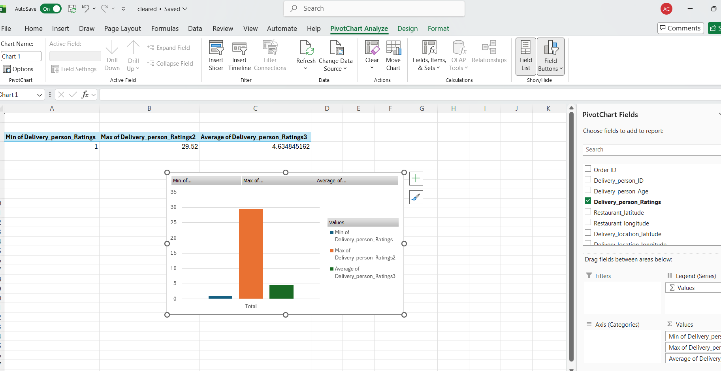
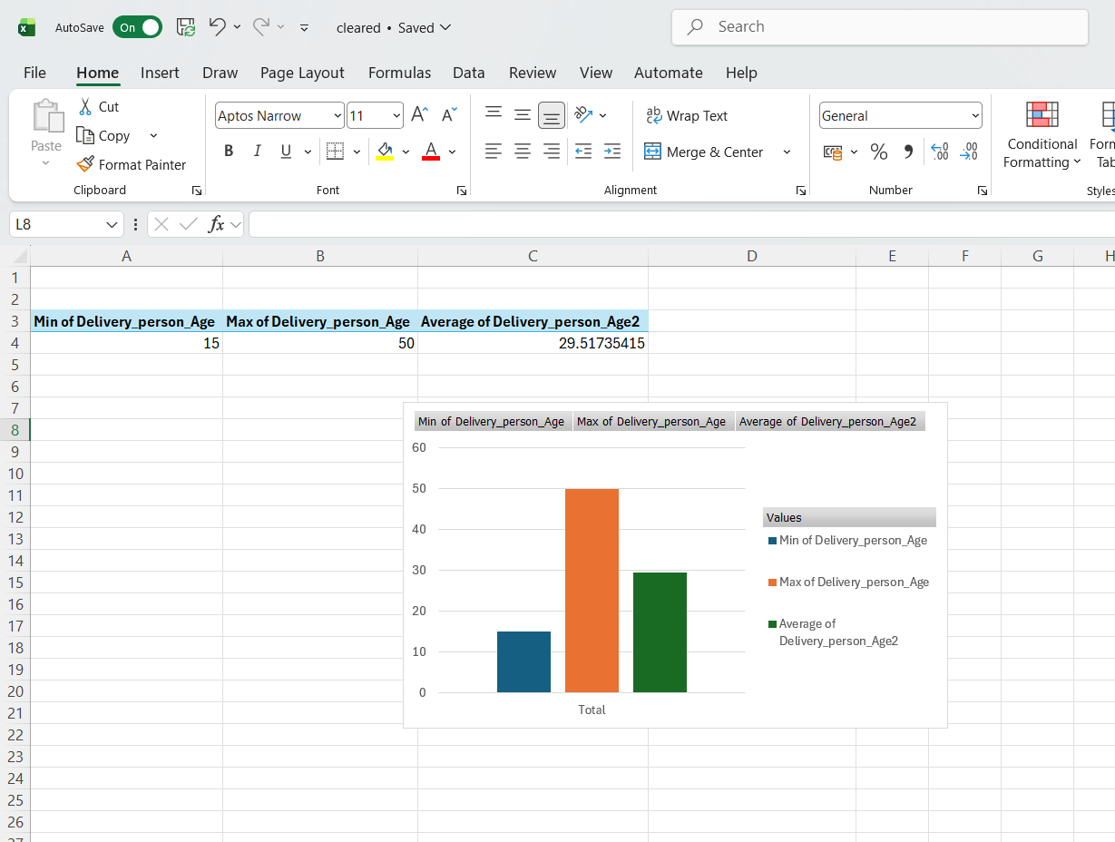
Figure 7: Delivery person rating min, max and average, chart and pivot table.
Figure 6: Delivery person average, min and max age pivot table and chart.

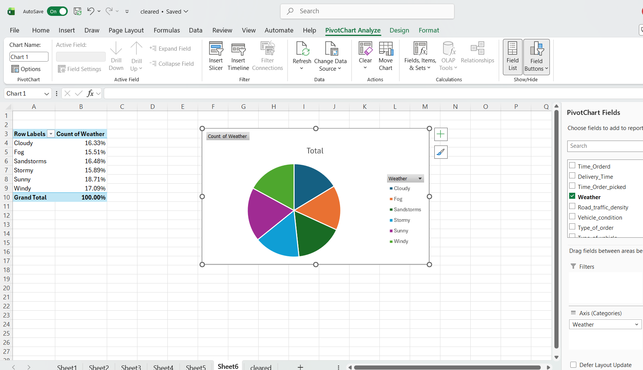
Most deliveries happen in Sunny or Medium traffic conditions, suggesting these are optimal conditions.
Figure 8: Weather pivot table and chart
Fewer deliveries during Rainy weather or High traffic, which may affect delivery speed and customer satisfaction.
The analysis showed that the average age of delivery personnel was approximately 29.5 years, indicating a relatively young workforce. This may reflect the nature of delivery work, which often requires physical activity and flexible working hours. Delivery ratings were generally high, with a mean of around 4.63, suggesting strong customer satisfaction levels and consistent service quality.
Delivery time varied depending on operational and environmental factors. The range of delivery times indicated variability in performance, which justified further analysis through trend and statistical techniques. Measures such as minimum and maximum values provided insight into the best and worst delivery scenarios within the dataset.
Categorical variables were also analysed to understand their distribution. Weather conditions were predominantly sunny, which may influence the overall performance results. Traffic density was mostly low to medium, although instances of high congestion were present and likely contributed to longer delivery times. Vehicle type distribution showed that motorcycles were the most used, followed by scooters and cars, highlighting their efficiency in urban delivery environments.
Visualisation tools such as charts and pivot tables were used to present these findings clearly. These tools are widely used in business intelligence to communicate data insights effectively and support decision-making (Chaffey, 2015). Tables and graphs allowed for easier comparison between categories and improved the interpretability of results.
Overall, the descriptive statistics provided a comprehensive overview of the dataset, identifying key characteristics and patterns that informed the subsequent analysis stages.

Trend Analysis and Visualization
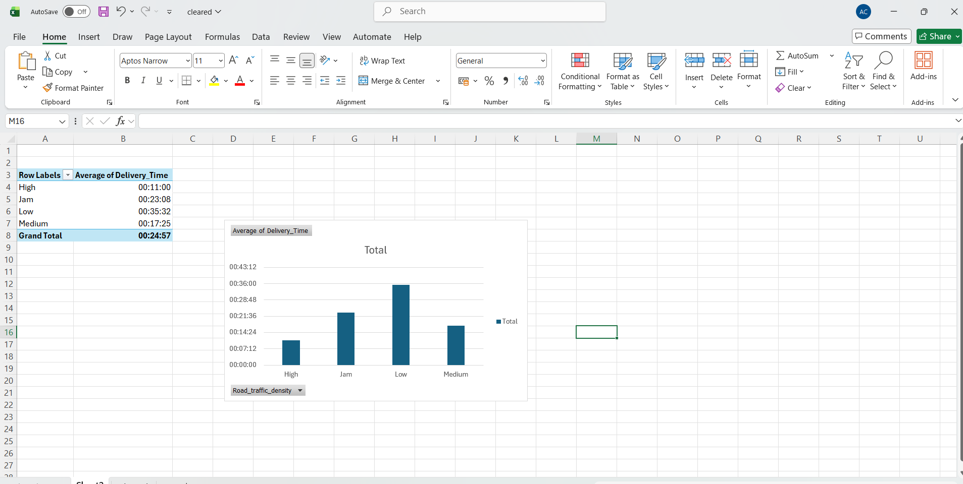
Microsoft Excel was used for trend analysis to find trends in delivery performance and investigate correlations between variables. To spot trends and present complicated data in an intelligible way, visualization techniques are essential (Davenport and Harris, 2017).
The analysis's primary focus was on the connection between delivery time and road traffic density. To determine the average delivery times for every traffic category, a pivot table was built. Delivery times rose as traffic density increased, according to the statistics. The longest delivery durations were linked to traffic jams, underscoring the substantial effect of congestion on operational effectiveness.
Figure 9: Pivot table and chart of road traffic density and average delivery time
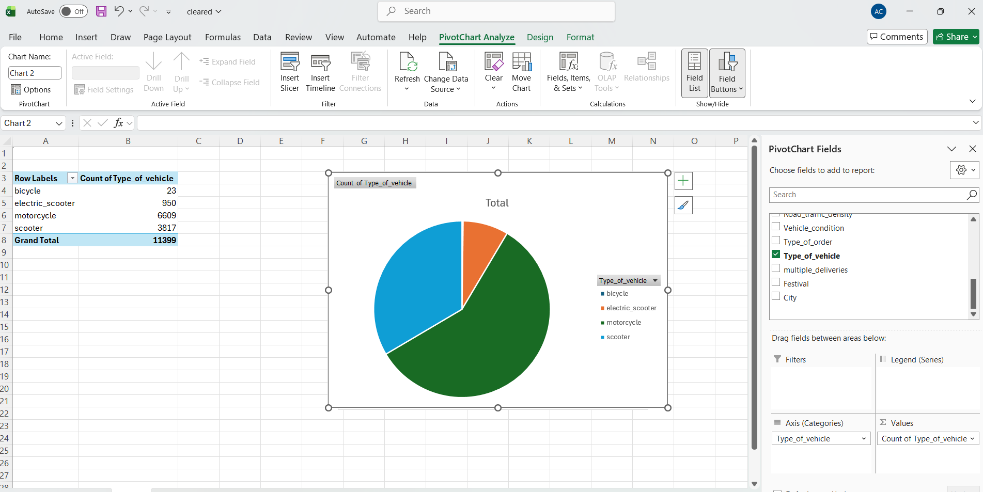
Weather conditions were also analysed in relation to delivery time. The findings indicated that adverse weather conditions, such as rain or storms, were associated with slightly longer delivery times compared to sunny conditions. Although the impact of weather was less significant than traffic, it still represents an important operational consideration.
Figure 10: Weather and type of vehicle, pivot table and chart.

Vehicle type distribution was analysed using a pie chart, which showed that motorcycles dominate delivery operations. This reflects their ability to navigate congested roads more efficiently than larger vehicles, making them a preferred choice for urban delivery services. This insight supports strategic decisions regarding fleet composition.
Scatter plots were used to examine relationships between variables such as delivery distance and delivery time. While some patterns were observed, not all relationships were strong, indicating that multiple factors influence delivery performance.
Overall, the trend analysis demonstrates that external factors such as traffic density and weather conditions significantly influence delivery efficiency. These findings are consistent with existing research in data analytics, which emphasises the importance of environmental factors in operational performance (Provost and Fawcett, 2013). The use of visual tools enhances understanding and supports effective communication of insights.

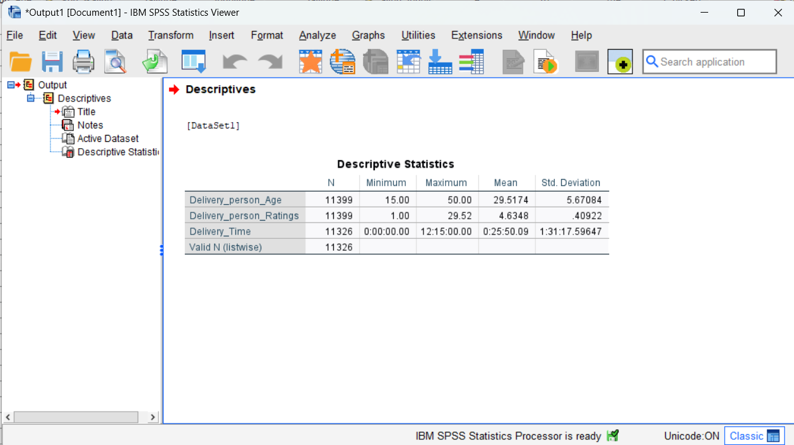
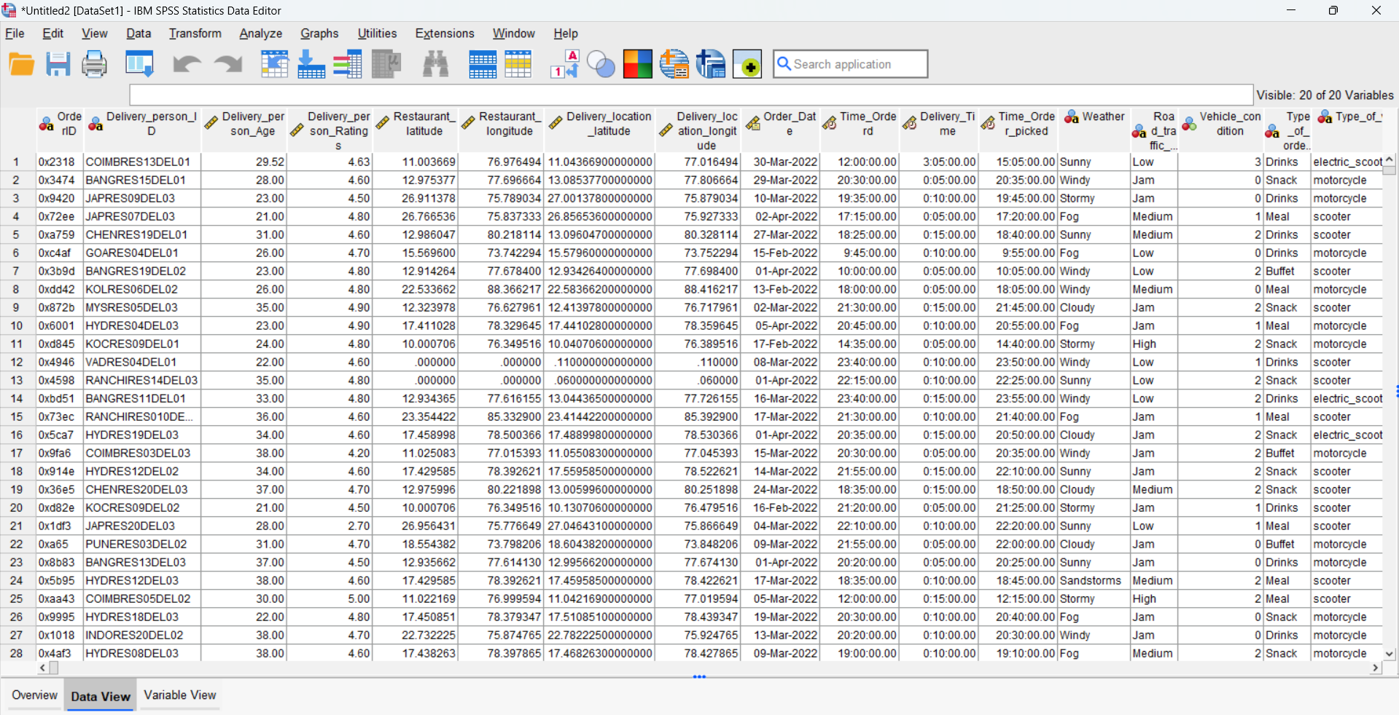
Statistical Analysis using SPSS
Figure 10: The dataset was imported in SPSS
Figure 11: Descriptive Statistics in SPSS.

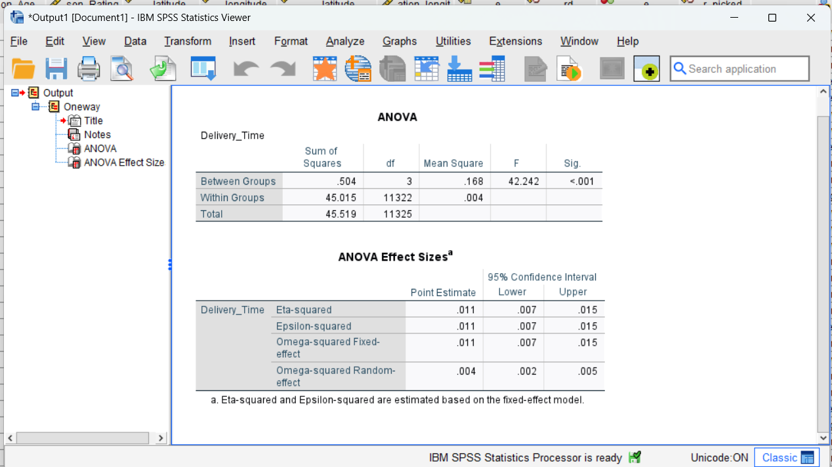
Figure 12: ANOVA Analysis
Statistical analysis was conducted using IBM SPSS Statistics to test hypotheses and examine relationships between variables. A one-way ANOVA test was used to determine whether road traffic density significantly affects delivery time. ANOVA is a widely used statistical method for comparing means across multiple groups and identifying significant differences (Field, 2018).
The results showed a statistically significant difference in delivery time across different traffic conditions (F = 42.242, p < 0.001). Since the p-value is less than 0.05, the null hypothesis was rejected. This indicates that traffic density has a significant effect on delivery time. The effect size (η² = 0.011) suggests a small but meaningful impact, indicating that while traffic influences delivery time, other factors may also play a role (Pallant, 2020).
A Pearson correlation analysis was conducted to examine relationships between delivery personnel age, ratings, and delivery time. The results showed a very weak negative correlation between age and ratings (r = -0.046, p < 0.001). This suggests that as age increases, ratings slightly decrease, although the strength of the relationship is extremely weak and may not have practical significance (Hair et al., 2019).
No significant relationships were found between delivery time and age (p = 0.702), or delivery time and ratings (p = 0.799). This indicates that delivery performance is not strongly influenced by individual characteristics, but rather by external operational factors. These findings align with previous research emphasising the importance of environmental variables in service performance (Davenport and Harris, 2017).
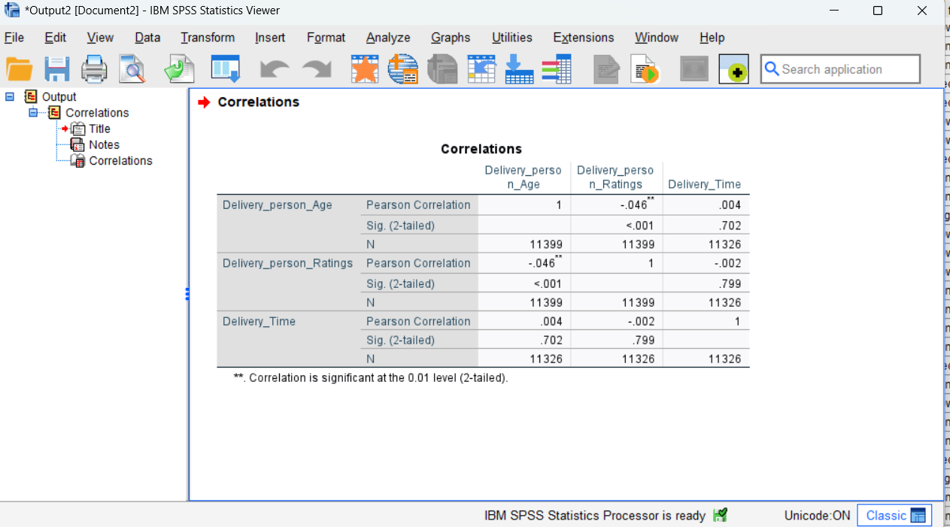
Figure 13: Correlation SPSS analysis
Overall, the statistical analysis confirms that traffic density is a key factor affecting delivery efficiency, while individual attributes have minimal impact.

Insights and Recommendations
This research offers several significant delivery performance insights. The most important conclusion is that delivery time is strongly and statistically significantly impacted by traffic density. This emphasizes how crucial it is to control outside operational elements to increase productivity.
Following these findings, various recommendations might be made. Companies should first create route optimisation technologies that use real-time traffic data. This would enable delivery drivers to bypass busy regions, reducing delays. Second, motorcyclists should be prioritized in high-traffic areas since they can move through traffic more efficiently than larger vehicles.

Additionally, companies should consider implementing flexible delivery scheduling during adverse weather conditions. Although weather has a smaller impact compared to traffic, it still affects delivery performance and should be accounted for in operational planning. Investing in training and support for delivery personnel may also help improve overall efficiency and service quality.
According to the findings, individual attributes such as age and ratings have no influence on delivery time. As a result, operational plans should focus on external factors rather than personal characteristics. However, maintaining high customer happiness remains critical to corporate success.
A limitation of this study is that the dataset may not include all relevant variables, such as driver experience or precise delivery distances. Future research could incorporate additional factors and apply more advanced analytical techniques, such as regression modelling, to gain deeper insights.
Overall, the findings demonstrate the value of data-driven decision-making in improving delivery operations and enhancing business performance (Provost and Fawcett, 2013).

References
Bryman, A. (2016). Social Research Methods. Oxford University Press.
Chaffey, D. (2015). Digital Business and E-Commerce Management. Pearson.
Davenport, T. & Harris, J. (2017). Competing on Analytics. Harvard Business Review Press.
Field, A. (2018). Discovering Statistics Using IBM SPSS Statistics. Sage.
Hair, J. et al. (2019). Multivariate Data Analysis. Cengage.
Kelleher, J. & Tierney, B. (2018). Data Science. MIT Press.
McKinney, W. (2017). Python for Data Analysis. O’Reilly.
Pallant, J. (2020). SPSS Survival Manual. McGraw-Hill.
Provost, F. & Fawcett, T. (2013). Data Science for Business. O’Reilly.
Saunders, M. et al. (2019). Research Methods for Business Students. Pearson.

