
Module Name: Academic Skills in the Arial Digital Era
Module Code: BMSW4013
Assessment 1: E-Portfolio
Student Name: Alicia west
Student Number:2508273
Lecturer: Scott James
Deadline: Friday 21st November 23rd 00:59

I confirm that I have not presented any AI generated materials as my own work.
I confirm that I have copies of my drafts, notes, and other resources I used, which I may be asked to provide in evidence.

Component 1 – Research and Planning (around 500 words)
Planning and Research Approach
To keep my research structured and dependable, I set specific aims for each study session. I used a technique—working in 25-minute blocks followed by short breaks which helped me stay focused and prevented burnout. I also made a checklist for selecting credible sources, ensuring I relied on academic materials such as reviewed studies rather than unverified blogs or social media posts.
During the research process, I searched using terms like “digital distractions,” “technology and focus,” and “illness affecting concentration.” This led me to three valuable sources that offered a range of insights. One examined how social media and constant notifications interrupt attention (Pérez-Juárez et al., 2023). Another discussed how conditions such as meningitis can influence memory and concentration (Christie et al., 2017). The third outlined practical techniques for reducing distractions, including time-management methods and apps designed to improve self-regulation (Martin et al., 2025).
I also compared these findings with my own experiences. I know firsthand how quickly I can drift into scrolling or checking messages, especially when I’m stressed or low on energy. Connecting academic research with my personal habits helped me understand the topic more deeply.
At the end of this process, I plan to share my findings through a short PowerPoint presentation. It will cover the causes of concentration issues, strategies to manage them, and the key lessons I’ve taken from the research. Overall, my aim is to improve my understanding of how to control distractions, handle concentration challenges related to health, and develop daily routines that support better focus and productivity.

Component 2 – Answering the Question (around 800 words)
Key Challenge for Students
One major challenge student face today is staying focused when using digital devices. Even though phones, tablets, and laptops are meant to help with schoolwork, they can easily pull our attention away. Apps like Instagram, TikTok, and YouTube are designed to keep us scrolling, and notifications make it hard to stay on task.
For example, when I try to study, I often get distracted by messages or alerts, and before I realize it, I’ve stopped working completely. Research also shows that multitasking between different apps makes learning harder and reduces the quality of our work because our brains can’t fully concentrate when we keep switching tasks (Pérez-Juárez et al., 2023).
Another challenge is staying focused when dealing with health issues. After recovering from meningitis, I noticed that my memory and attention weren’t as strong as they used to be. Studies have found that people who have had meningitis can experience long-term problems with concentration and processing information (Christie et al., 2017). This can make focusing feel tiring and frustrating.
When digital distractions and health-related concentration problems happen at the same time, staying focused becomes even harder. A single notification or a moment of fatigue can interrupt work completely. This challenge matters because it doesn’t just affect school performance — it can also make it difficult to keep up in future jobs where focus and productivity are important skills.
Key Opportunity for Students
A positive opportunity that technology gives students is the ability to use digital tools to improve focus and stay organised. Instead of only being a distraction, technology can actually support better learning when used properly. For example, using structured study methods like timed work sessions or focus tools can help students stay disciplined. Research shows that these strategies can lower digital distractions and improve school performance (Martin et al., 2025).
The article also mentioned tools that block social media or limit screen time, and I’ve found these helpful too. Apps that track how long you spend online can be a wake-up call, and planners or digital calendars make it easier to organise tasks and reduce stress.
This opportunity is important because every student learns in a different way. Some learn best by watching videos, others by reading or listening, and some by using interactive tools. Technology gives us a range of options so we can choose the methods that work best for us. Instead of treating technology as something that only distracts us, students can turn it into a tool that supports focus, learning, and better study habits.

Planning Your Report
For Component 2, the focus will be on strategies to improve focus and build employability skills, because both academic performance and workplace readiness are important. It needs to be highlighted that while grades matter, developing concentration and self-discipline is equally valuable for the future.
In the report, the plan is to include practical strategies like setting small goals, taking regular breaks, turning off notifications, using focus apps such as Forest or RescueTime, and organising notes. These strategies are useful for students and also support long-term employability by improving time management, self-discipline, and resilience.
The report will follow this structure:
Introduction → Challenges to Focus → Strategies to Improve Focus → How These Skills Build Employability → Conclusion.
This structure will make the ideas clear, logical, and easy to follow.
Task | Date/ Deadline
Finish research | 26th October 2025
Draft first section | 7th November 2025
Complete first draft | 14th November 2025
Final editing | ^{19th} November 2025
Understanding Introduction
Digital tools like laptops, tablets, and smartphones have changed how students learn, but they also bring challenges. Staying focused can be difficult with constant notifications, social media updates, and other online distractions. Even short breaks to check your phone can easily turn into half an hour of lost time. On top of this, personal health challenges, like recovering from meningitis, can make concentration and memory more difficult. Many students experience similar struggles, making this a relevant topic for both education and personal development.
This report explores how technology and health issues can affect concentration. It also highlights opportunities digital tools provide and offers practical strategies students can use to adapt. Understanding both the advantages and challenges of technology helps students use it more effectively, manage distractions, and develop skills that are valuable for school and future employment.

Challenges Students Face
One major challenge students face today is staying focused while using digital devices. Although phones, tablets, and laptops are intended to support learning, they can easily distract students. Social media apps such as Instagram, TikTok, and YouTube are designed to keep attention for long periods, while notifications interrupt focus.
For example, when I try to study, I often get sidetracked by messages or alerts, and before I know it, I’ve stopped working entirely. Research also shows that multitasking between different apps reduces learning outcomes because the brain cannot fully concentrate when switching tasks constantly (Pérez-Juárez et al., 2023).
Another significant challenge is dealing with health-related concentration problems. After recovering from meningitis, I noticed that my memory and attention were not as strong as before. Studies indicate that people who have had meningitis may experience long-term difficulties with focus and information processing (Christie et al., 2017).
When digital distractions and health-related focus issues combine, maintaining attention becomes even harder. Even a single notification or moment of fatigue can disrupt work. This challenge matters because poor concentration affects not only school performance but also future employability, where attention to detail and productivity are essential skills.

Opportunities Digital Tools Provide
Despite these challenges, technology offers valuable opportunities for students to improve focus and organisation. When used correctly, digital tools can support structured study and better learning habits. For example, techniques like timed work sessions or focus apps help students maintain discipline, and research shows these methods can reduce distractions and enhance academic performance (Martin et al., 2025).
Tools that block social media or track screen time are also useful. For instance, apps that monitor time spent online can encourage students to manage their habits, while planners and digital calendars help organise tasks and reduce stress.
This opportunity is important because every student learns differently. Some benefit more from videos, others from reading or listening, and some from interactive learning tools. Digital resources provide multiple ways to learn, allowing students to choose approaches that work best for them. When used wisely, technology can enhance understanding, engagement, and academic success.

How Students Can Adapt
To succeed in the digital era, students need to develop strategies that balance technology use and focus. Practical approaches include:
- Setting small goals: Breaking larger tasks into smaller steps makes work feel more manageable and reduces overwhelm.
- Taking regular breaks: Short pauses prevent burnout and give the brain time to recharge.
- Turning off notifications: Minimising interruptions helps maintain continuous focus.
- Using focus tools: Apps like Forest or RescueTime track progress, block distractions, and support self-discipline.
- Organising notes: Reviewing and structuring notes improves understanding and memory.
For students managing health challenges, listening to the body and pacing work is also crucial. Fatigue or stress can make concentration more difficult, so resting and managing workloads effectively is key.
These strategies are not only beneficial for schools but also help build employability skills. Employers value individuals who can stay organized, meet deadlines, and manage distractions effectively. Practicing these approaches trains concentration and resilience, showing self-discipline, and improving overall productivity.

Conclusion
This research has shown that concentration is influenced by both technology and personal health, but it is also a skill that can be developed. By understanding how digital distractions, notifications, and health-related challenges affect focus, students can make intentional choices to manage their learning more effectively. Strategies such as setting goals, taking regular breaks, turning off notifications, and using focus tools help improve concentration and organisation.
Reflecting on my own habits, I have learned that improving focus is about balance rather than perfection. Awareness of personal distractions and energy levels allows for better planning and productivity. Overall, developing strong focus not only supports academic success but also builds valuable employability skills, including self-discipline, time management, and resilience. By applying these strategies, students can use technology as a tool to enhance learning rather than letting it become a source of distraction.

Component 3 –slide
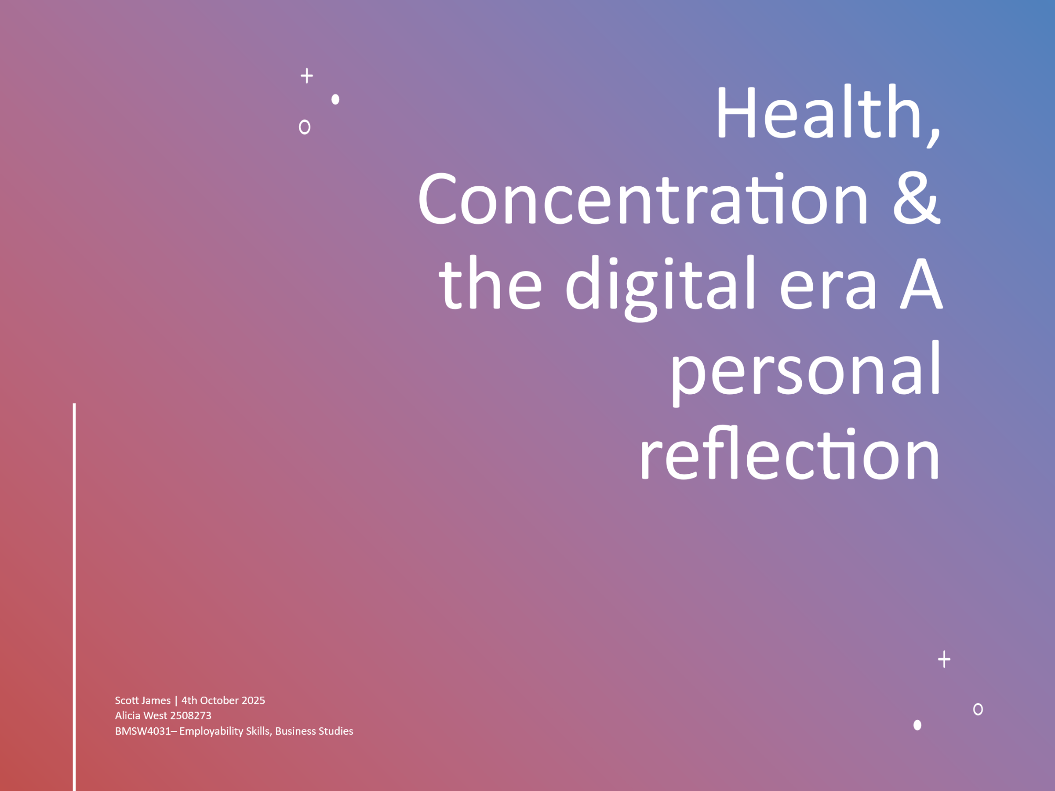
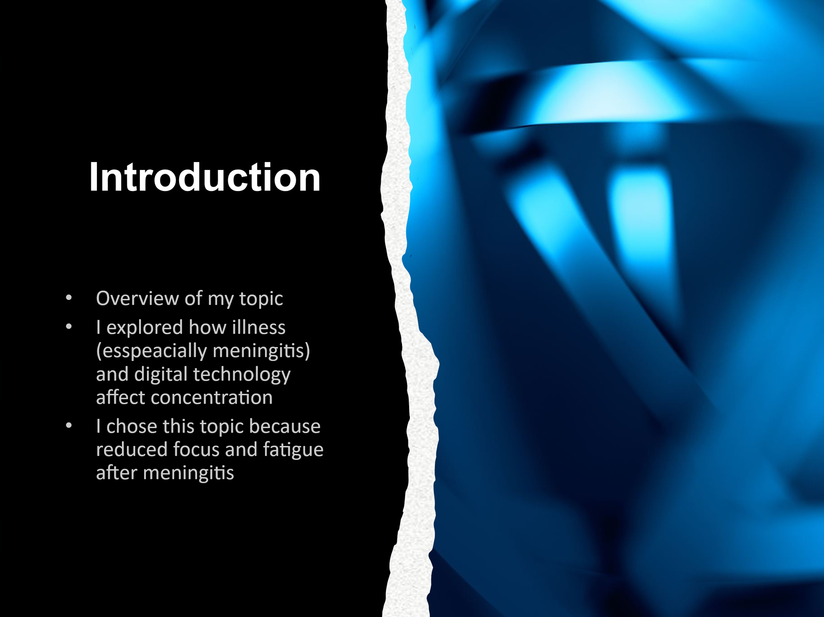
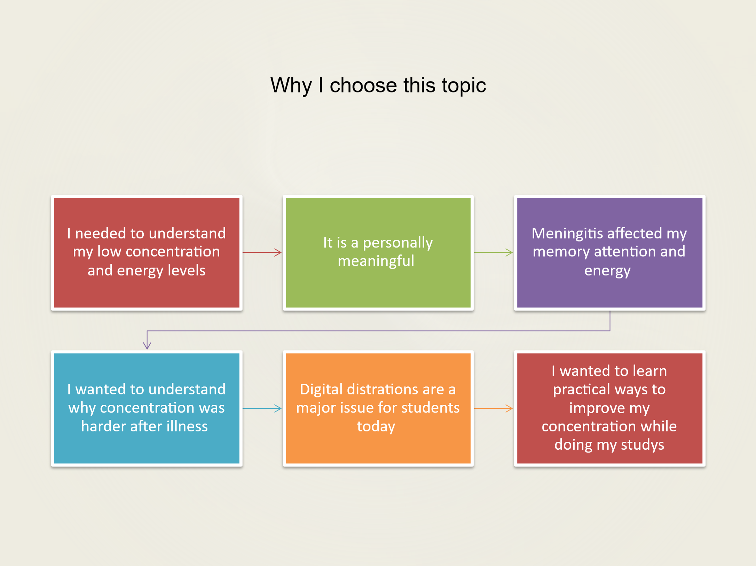
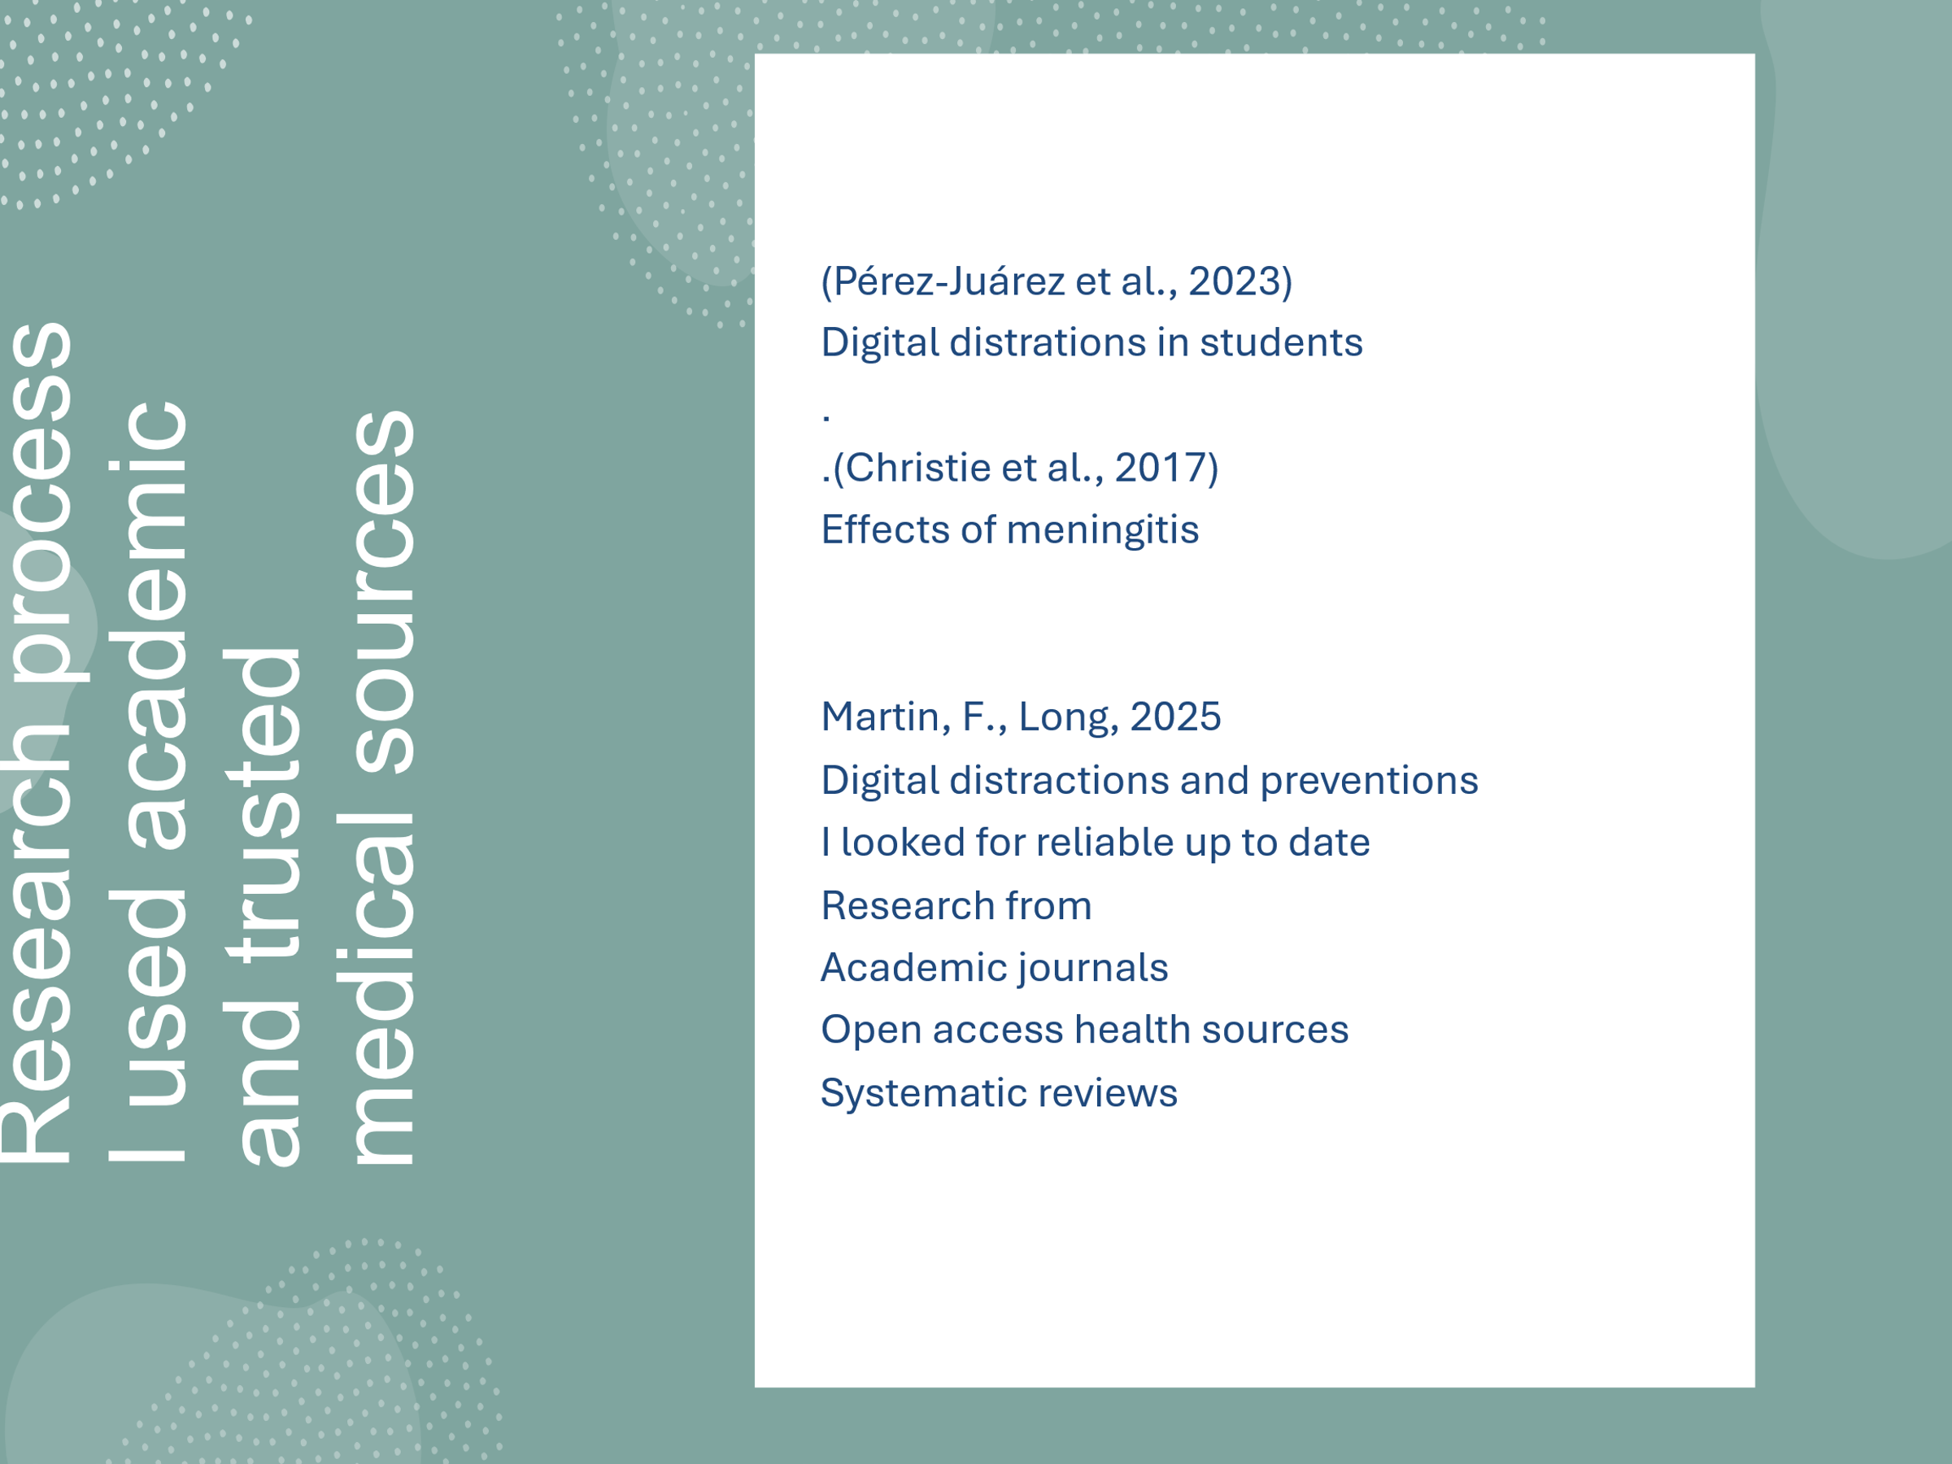
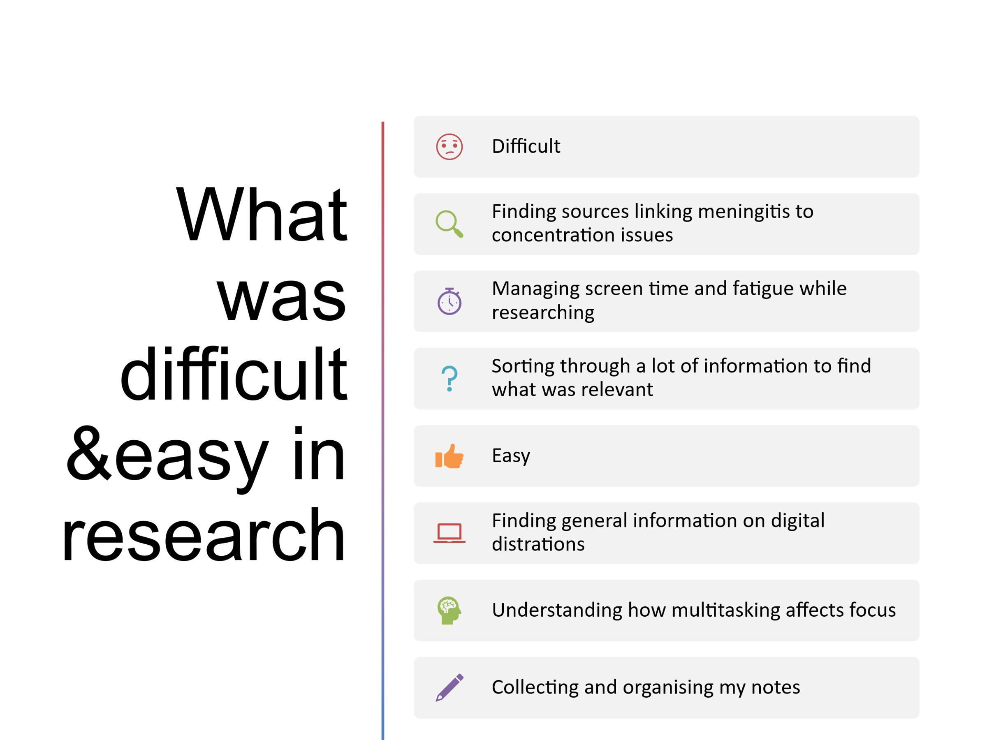
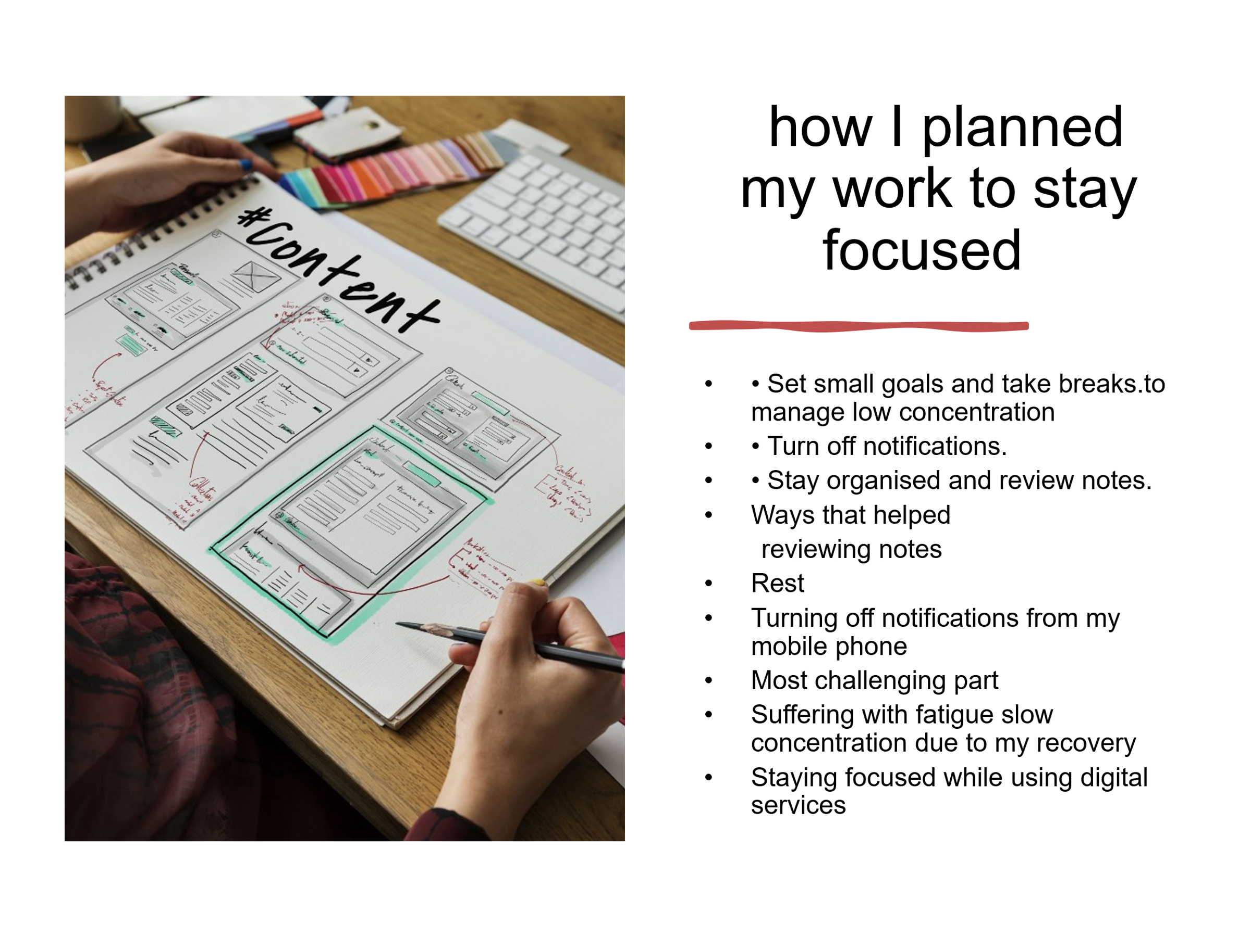
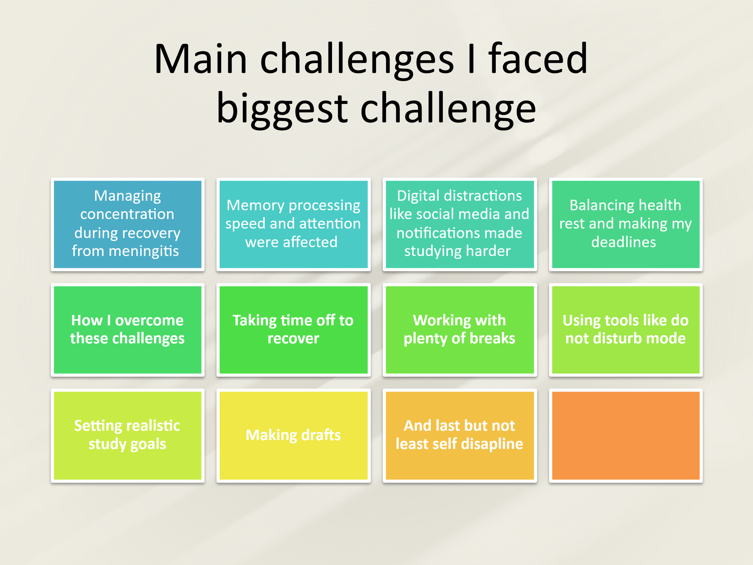
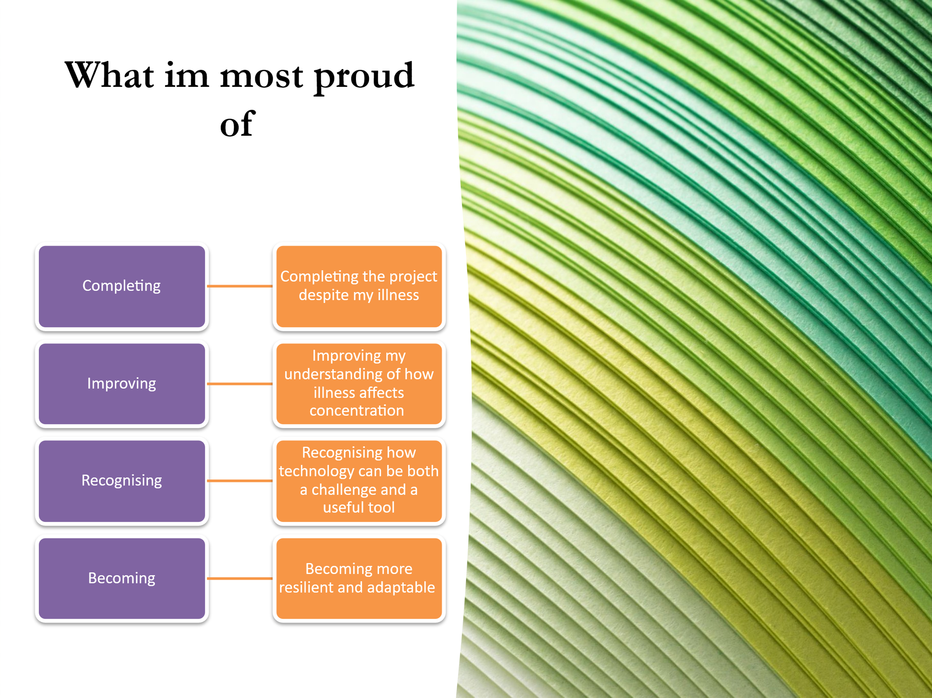
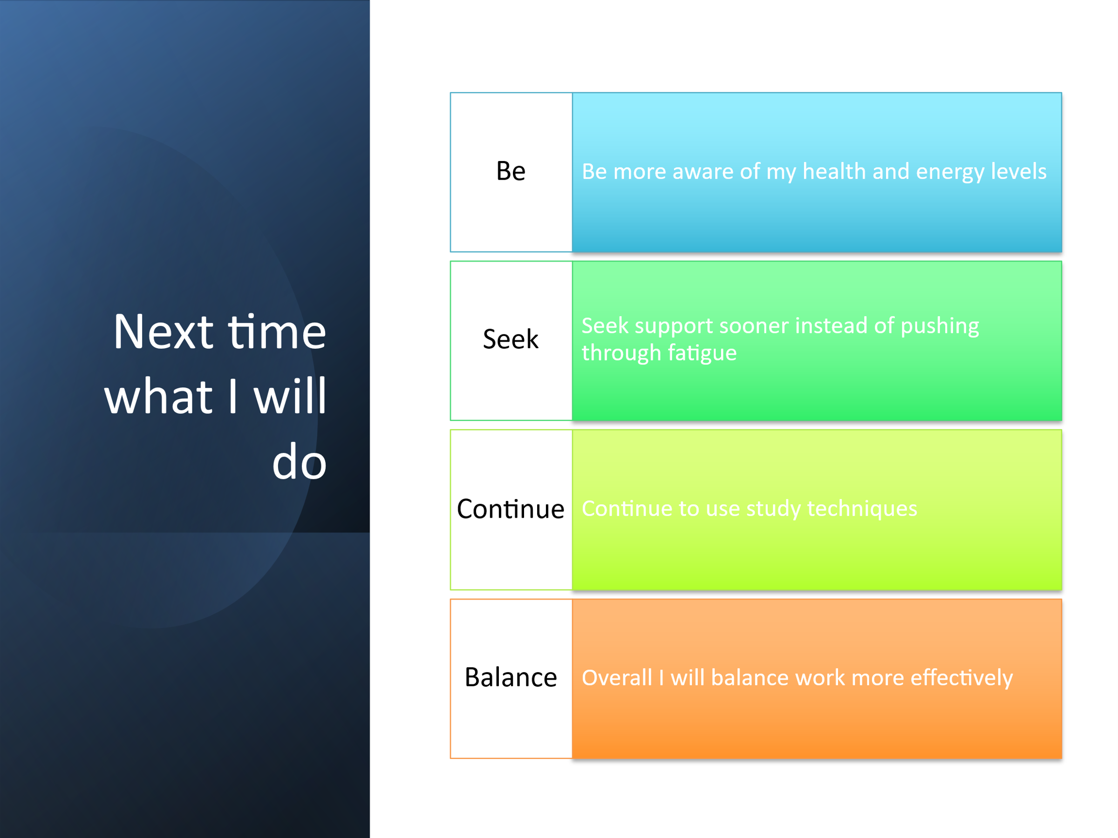
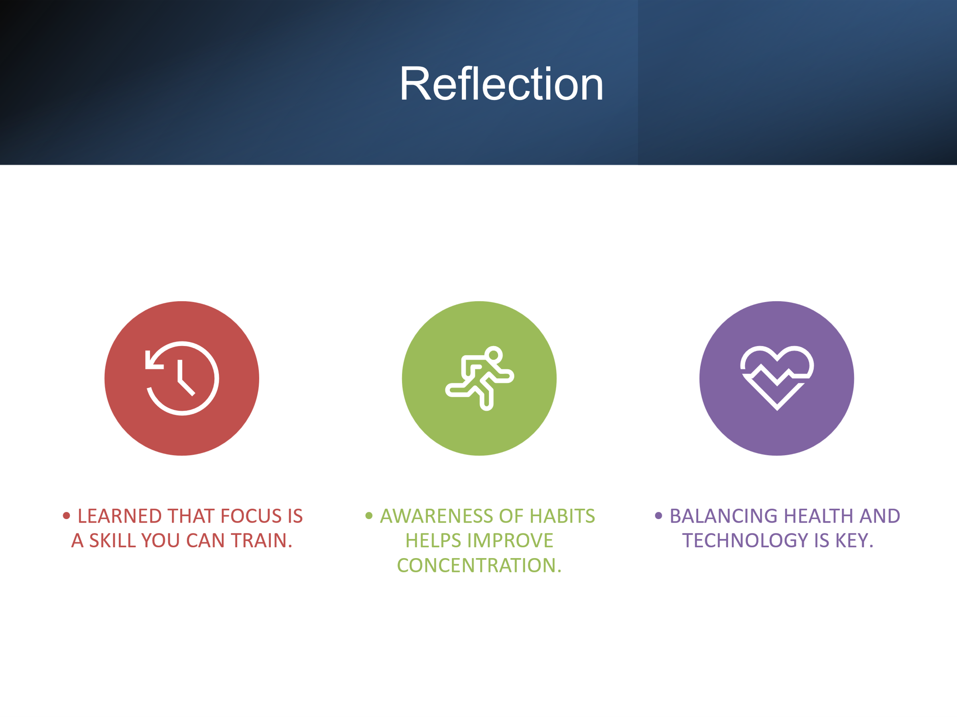
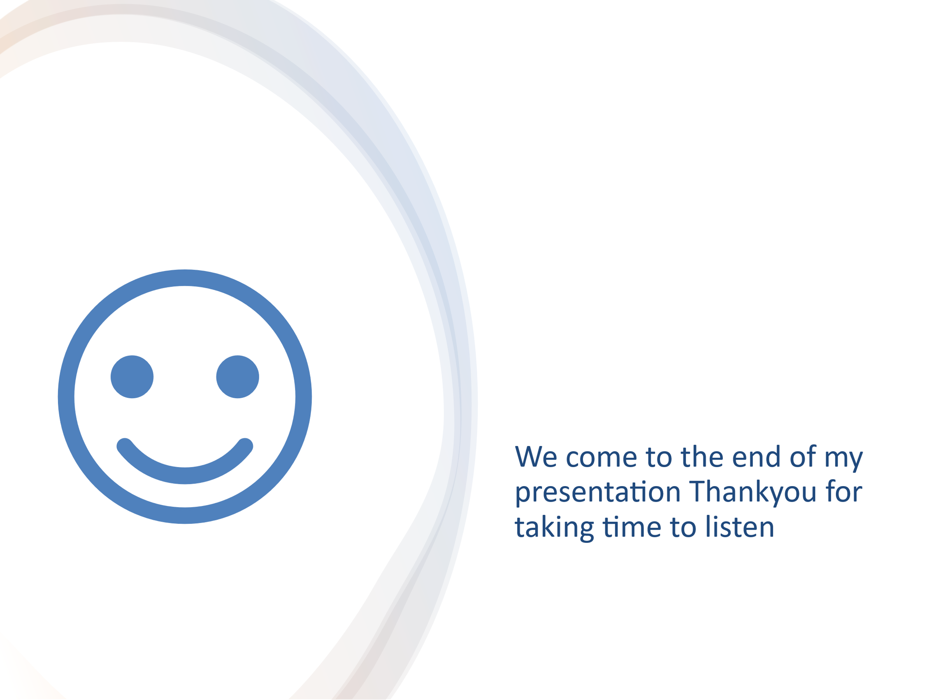

Source 1: Digital Distractions
Reference: Pérez-Juárez, M. Á., González-Ortega, D., & Aguiar-Pérez, J. M. (2023). Digital Distractions from the Point of View of Higher Education Students. Sustainability, 15(7), 6044. [DOI: https://doi.org/10.3390/su15076044]
Explanation: This peer-reviewed article explores how multitasking and constant notifications reduce learning efficiency. It supports my section on digital distractions and matches my own experiences of losing focus while studying. The study’s findings helped me understand why even short interruptions can lower productivity and make studying more stressful.
Source 2: Illness Impact
Reference: Christie, D., Rashid, H., El-Bashir, H., Sweeney, F., Shore, T., Booy, R., & Viner, R. M. (2017). Impact of meningitis on intelligence and development: A systematic review and meta-analysis. PLOS ONE, 12(8), e0175024. [DOI: https://doi.org/10.1371/journal.pone.0175024]
Explanation: This article shows how bacterial and viral meningitis can affect memory and concentration. It provided strong evidence for the section on illness-related challenges and connected directly to my own recovery experience, making my analysis more personal and credible.
Source 3: Focus Tools
Reference: Martin, F., Long, S., Haywood, K., & Xie, K. (2025). Digital distractions in education: A systematic review of research on causes, consequences and prevention strategies. Educational Technology Research and Development. [DOI: https://doi.org/10.1007/s11423-025-10550-6]
Explanation: This recent review highlighted how digital tools can be used positively to manage distractions. It supported my discussion about time-management techniques and focus apps, giving evidence for how structure and technology can work together to improve concentration.
Working on this project has helped me understand how both technology and health influence concentration in daily life. It’s been interesting to learn about meningitis and how people recovering from it manage fatigue while rebuilding focus. Reading about the strategies they use—like pacing, setting small goals, and practicing self-discipline—made me think more deeply about how I handle distractions myself. I’ve realized that focus isn’t just about effort; it’s also about patience and adapting to personal limits. I’ve also learned that while technology can easily distract us, it can be used to stay organized and motivated if managed properly. Overall, this research has shown me how self-awareness, resilience, and adaptability are key to success in learning, recovery, and future employment.

