1702463
Business & I.T Management
BSc Business Information Technology
Runa Bibi
09/01/2018

Table of Contents

1. Introduction 4
2. Business Strategy & PEST Analysis 4
2.1 Business Strategy 5
2.1.1 SMART Objectives 5
2.2 PEST/SLEPT Analysis 7
2.2.1 Political Factors 7
2.2.2 Legal Factors 7
2.2.3 Economic Factors 8
2.2.4 Social and Customer Factors 8
2.2.5 Technological Factors 8
2.2.6 Environmental Factors 9
2.2.7 Ethical and Legal Issues 9
3. Organisation Structure 9
3.1 Functional Departments 14
3.1.1 I.T Department 14
3.1.2 HRM Department 14
3.1.3 Marketing Department 14
3.1.4 Finance Department 15
3.1.5 Production Department 15
3.1.6 Research and Development Department 15
4. E-business Information Systems 15
4.1 E-business Solutions 15
4.2 Functional Specific Solutions 17
4.3 Enterprise Resource Planning 19
4.4 Testing 20
5. Conclusions 26
5.1 Conclusions 26
5.2 Recommendations 26
6. References 27

Table of Figures
Figure 1 4
Figure 2 4
Figure 3 5
Figure 4 6
Figure 5 10
Figure 6 11
Figure 7 12
Figure 8 12
Figure 9 16
Figure 10 17
Figure 11 17
Figure 12 18
Figure 13 19
Figure 14 20
Figure 15 20
Figure 16 21
Figure 17 21
Figure 18 22
Figure 19 22
Figure 20 22
Figure 21 23
Figure 22 23
Figure 23 23
Figure 24 24

1. Introduction
The purpose of this report is to analyse business strategy and organisation structure in order to recommend the best viable e-business solutions for organisations to use that would meet their needs. It will also include testing of a current e-business solution to highlight its benefits and any downsides.

2. Business Strategy & PEST Analysis
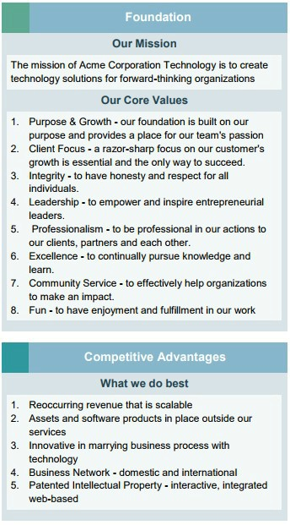
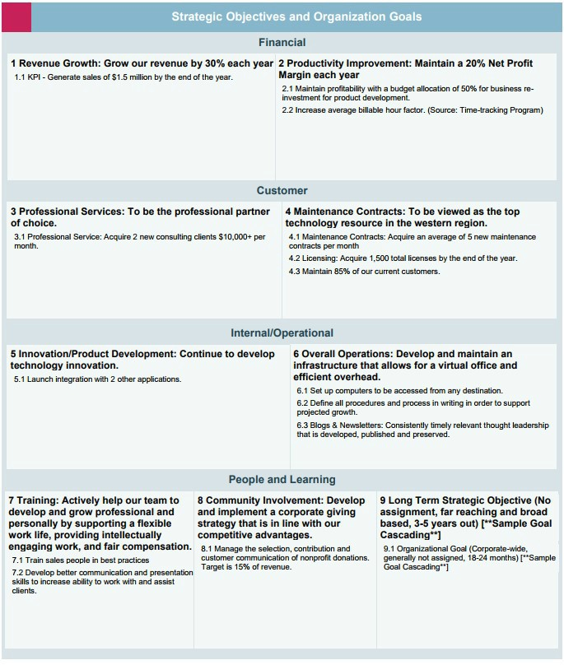
Business strategy is an organisation’s plan to attain its goals with a set structure they use to prioritise what they want to achieve in order to compete against their competition [1]. While forming a strategy a business will use a strategic plan which is a written/online document including their goals, what they need to carry out to achieve them as well as other essentials [2]. Below is an example of a company’s (ACME’s Corporation Technology) strategic plan [3]:
Figure 1
Figure 2

2.1 Business Strategy
Strategic planning is when an organisation forms a plan to achieve their long-term goals [4]. Part of this planning involves deciding on the organisation’s vision statement, mission statement and its values. A vision statement is what the organisation decides will be its mid-term and long-term goals [5]. An example of this is the Human Rights Campaign which is “Equality for everyone.” A mission statement is an organisation’s central purpose and their main reason for existing [6]. American Heart Association’s mission statement is “To build healthier lives, free of cardiovascular diseases and stroke.” An organisation’s values are a guide to how they wish to run as a company. Some values of American Express include customer commitment, teamwork, good citizenship and personal accountability [7].
The strategy pyramid is used to show the structure of how an organisation wants to meet its vision and missions through specific strategies which meet broad goals that also follow their values [8].
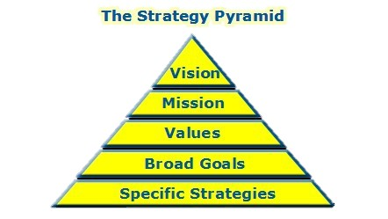
Figure 3

2.1.1 SMART Objectives
Businesses use SMART objectives to ensure the goals they make are measurable. SMART stands for Specific, Measurable, Achievable, Realistic and Time-Oriented [9]. An example of a SMART objective is starting with the goal of expanding your business and then taking into consideration each piece of SMART criteria and ending up with the SMART goal “I will acquire three new clients for my consulting business within two months by asking for referrals, launching a social media marketing campaign, and networking with local businesses. This will allow me to grow my business and increase my revenue. [10]” This gives it a time-scale of two months, with a measurable way of keeping track of its progress i.e. the number of new clients that come in and a specific task of getting three clients that is relevant as this will expand the business.
Also, when devising their business strategy, organisations need to consider their social responsibility which is the notion that they need to contribute to society while making profit and build a strong relationship with the society they have built themselves in [11]. A corporate social responsibility is a further consideration for organisations with regards to their stakeholders. This contributes benefits such as environmental, social and economic to stakeholders [12]. A stakeholder is any group, person or organisation that has interest in a given organisation [13]. Organisations use the balanced scorecard system when planning their strategy. The following is an example of a scorecard system [14]:
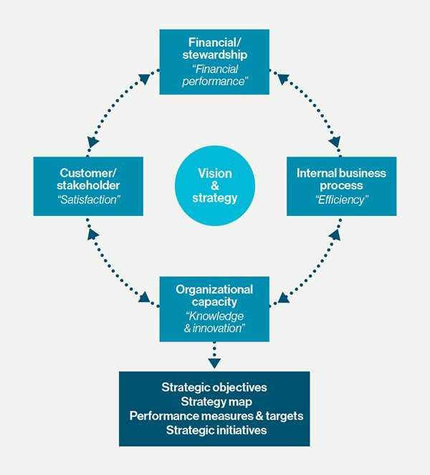
Figure 4

This system is used to keep track and measure progress towards targets, prioritise services, products and projects, communicate what they wish to achieve and align the daily tasks that the employees do with the organisation’s strategy [15].

2.2 PEST/SLEPT Analysis
PEST stands for Political, Economic, Social and Technological. Businesses assess how these external factors will affect the running of the business long-term [16]. To show how it works, a PEST analysis for Samsung has been included here. Some of Samsung’s key products are printers, PCs, mobile phones, televisions, refrigerators and microwave ovens [17].

2.2.1 Political Factors
Samsung have faced external political factors that affect them due to being based in South Korea which has always faced tensions with North Korea, so they have had to deal with the possible threat of war in the Korean Peninsula as well as political instability [20].

2.2.2 Legal Factors
Samsung has faced many lawsuits from Apple over the patent for who has ownership of rounded phones as well as other things. They have been sued for over $1 billion in 2012 which has since decreased to $400 million. This has gone to trial again due to an appeal from Samsung [18].
The new trial has been decided on by the judge Lucy Koh who has been the judge for this case since 2011. Apple charged Samsung for stealing their design for their iPhone patent with the rounded edges, rectangular screen and a black screen with colourful icons. Samsung had to pay Apple based on its sales for every smartphone that infringed this patent, but Samsung argued they should only have to pay for specific components that infringed it [19].

2.2.3 Economic Factors
A major economic factor that affected Samsung is Korean currency. Decline of profits in the second quarter of 2014 by 25% is said to be because of Won appreciation. The global economic and financial crisis of 2007- 2009 is also said to have affected Samsung’s profit at the time, as their profits were halved in 2008 during the third quarter. Tax rates are another economic factor that has affected Samsung. Korea’s tax regulations mean that Samsung paid 67% of tax in Korea in 2016 [21].

2.2.4 Social and Customer Factors
Samsung social and customer factors involve Samsung’s Hope for Children. This is a program for children in need of better education and health opportunities. Samsung [22] explain how this program is designed for customer involvement where they hope to make a change in communities by implementing their program long-term. It also involves employees who can volunteer and make these children’s lives better. This program will also be integrated into Samsung products that will improve children’s health and education opportunities. Samsung are also working on programs that will allow consumer involvement who can also help to make big differences in these children’s lives. Another program designed by Samsung to help children who need better education is Samsung SMART school, which provided 224,753 students from disadvantaged areas with education in 2015 [23].

2.2.5 Technological Factors
The biggest external technological factor that Samsung face is competing to provide the best technology and be ahead of its rivals [20]. While this has often been the case as discussed earlier Samsung have fallen foul of imitating Apple’s patented design. Some of Samsung’s key competitors are Apple, Huawei, Sony, Lenovo and HTC [25].

2.2.6 Environmental Factors
With regards to environmental factors, Samsung ensure their products are eco-certified by several governments including the US, Europe and Korea and also standard associations like the Canadian Standards Association. 2,054 models were given the eco-label certification by the end of 2016. Many of their electrical appliances are also carbon labelled to keep track of their carbon emissions, so Samsung can improve their carbon footprint. They have also won many awards for their green products [24].

2.2.7 Ethical and Legal Issues
Managers now face more ethical issues as consumers are now more concerned about sustainable practices and are more likely to invest in a product if the materials have been made from recyclable products and the production of the products is done by ethical means i.e. not in sweatshops [26]. Any negative publicity could affect the sales of a business, so managers need to be aware of any ethical ramifications of their actions. Samsung have been checked for their policy on conflict minerals by Ethical Consumer [27]. These are minerals mined in places with abuse of human rights and armed conflict. Samsung have said to be part of the Conflict-Free Sourcing Initiative, but Ethical Consumer have found their continued sourcing from a DRC region (which provide conflict minerals) to be implied.
Legal issues that managers in the UK need to consider include laws such as the Data Protection Act 1998 [28], Health and Safety at Work Act 1974 [29], discrimination law, import and export laws and trade control [30].

3. Organisation Structure
Organisational structure is a hierarchy used to identify jobs and their functions within the organisation. It allows an organisation to achieve its long-term goals [31]. A scalar chain and span of control help determine an organisation’s structure type. A scalar chain is one which has all the supervisors from the highest management to the lowest ranking person in the organisation [32]. The span of control is the number of subordinates that are controlled by a superior [33]. There is constant debate on what is the ideal span of control, with modern experts saying 15-20 subordinates is ideal per superior and more traditional experts claiming 5 to 6 is the best option [34]. There is no right answer as it all depends on the type of organisation and how many employees are needed.
There are many different types of organisational structure. One of them is tall organisational structures. This has a lot of levels of hierarchy with many managers, usually these managers have a small number of people they are in. This is typically found in more complex organisations and can mean that the organisation take longer to follow what the latest market changes are telling them. Executives take charge of the larger decisions. Tall structures are easier to grow as you can add new layers and not disrupt the layers already in place. Tall structures became popular during the 20th century as communication was easier to control. Although now wireless communication and the Internet mean a lot of tall structure organisations reduced the number of people working and gave the managers a higher span of control [35]. The image below shows an example of a tall hierarchy [36].
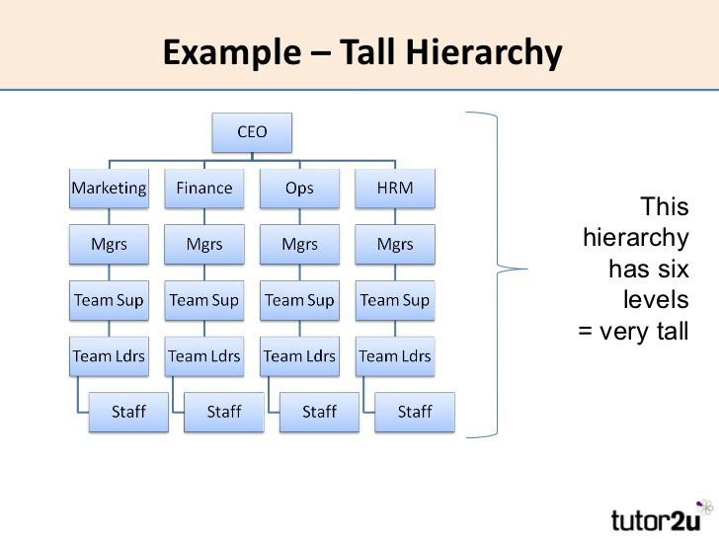
Figure 5
Flat structures are another type of organisational structure. They work by focusing more on employees’ talents with less management levels. These structures work through problems using collaboration. Compared to tall structures, there are more employees who excel and reach the top of their level. This structure makes communication easier and means it is easier to adapt to changes. Tall structures can take much longer to make decisions if they get too tall as communication will take longer to reach all levels. Managers can sometimes end up with a bigger workload as decisions are made quicker [37]. An example of a flat hierarchy is shown below [38].
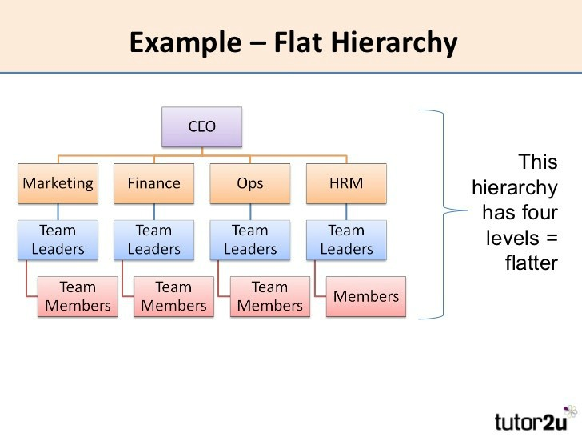
Figure 6
Another organisational structure is a mechanistic structure. This contains a vigilant chain of command and heavily relies on management to take charge. It consists of a series of highly specialised jobs comprised from fine division of labour [39]. An organic structure is one with little supervision, not many layers of management and distributed decision making [40]. The most common organisational structure is a functional structure. Employees are grouped based on similar roles and this structure is less likely to change as it is hard to respond to market changes [41]. Matrix organisational structures are ones where employees report to two people as these relationships are in a matrix design [42] as shown below [43].
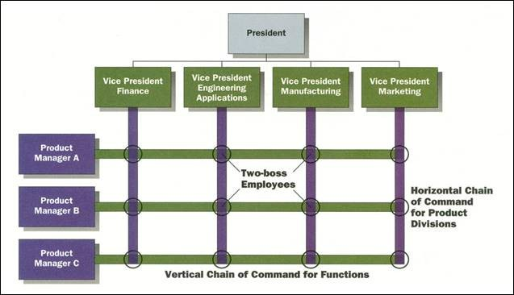
Figure 7
A more modern organisational structure is a virtual organisation. This works online usually by groupware or e-mail where people who live apart from each other collaborate while seeming as though they are in a physical location as a united organisation [44]. Below is an example of what a virtual organisation looks like [45].
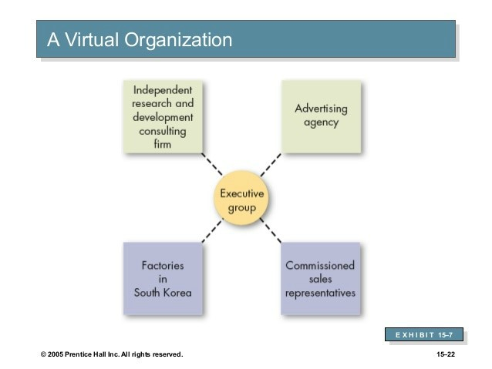
Figure 8

3.1 Functional Departments
A business function is a process an organisation carries out routinely to complete a mission set out by the organisation [45]. Some functional departments within organisations include the IT department, human resources management, marketing, finance, production and research and development.

3.1.1 I.T Department
Activities that the IT department could provide include maintaining the company’s website, ensuring the employee’s emails are running smoothly and networking the organisation’s computers as well keeping them running and protected [46]. They can also be in charge of maintaining any documents held digitally and help maintain the organisation’s communication tools e.g. video conferencing systems [47].

3.1.2 HRM Department
Mooney [48] states that the Human Resources Management department provide such activities as recruitment, safety, compensation and benefits, training and development and payroll. As part of recruitment they post job offers, find possible candidates and interview them, work with the managers during hiring and make the final decision for who will be employed. HR also provide workplace safety training and keep logs of any workplace injuries as part of law. With regards to compensation, HR evaluate competitive pay prices and compensation structures are set. HR also give new employees extensive training, so they can assimilate to the new working environment. They may also give them training towards professional development and leadership. The processing of payroll in terms of guaranteed pay and variable pay is dealt with by HR.

3.1.3 Marketing Department
The marketing department provides marketing strategy, market research to understand better what the customer wants, product development where they work with development teams on new products or improving ones that already exist, communications where they develop communications to promote the company’s products and release things such as press releases. They also provide sales support where they work with sales department to improve sales by providing them with customer responses [49].

3.1.4 Finance Department
The finance department provides budget and forecasting which relates the business to the outside world and provides it with data on staff demands, what raw materials are needed and what needs to be expanded in the business. It also handles bookkeeping, which is when the organisation’s journals and subsidiary ledges are summed up. They also provide external reports which focus on how the public, shareholders and banks relate to the organisation. Finally, they deal with any money that comes in and goes out of the business [50].

3.1.5 Production Department
The production department oversee the creation of new products from raw supplies. They also work on improving the production line in order to meet the management’s targets and provide the best possible products they can. They also confirm how much raw materials they need and schedule the production processes. They ensure the final products meet at least the minimum of quality standards [51].

3.1.6 Research and Development Department
The research and development department carry out thorough research before a company creates a new product. They also evaluate any existing products to ensure they still adhere to company standards and help the company to stay ahead and aware of its competition [52].

4. E-business Information Systems

4.1 E-business Solutions
Information systems are the gathering of human and technological resources that give the distribution, storage, communication and computing for any information that the enterprise needs [53]. One type of information system is Customer Relationship Systems which help customers to provide feedback to companies on products and allows the business to keep track of any product faults, customer questions and purchasing trends. It also allows for collaboration with business partners [54].
A Transaction Processing System retrieves, collects and modifies any transaction data [51]. An example of a transaction processing system would be an airline ticket booking system. Customers will pick out which seats they want on which flight as input, the system will process this by removing the chosen seats from seats available and it will output tickets and a bill [55]. Management Information Systems compile information from an array of sources and present it in a way that is readable. It creates reports that managers can use to make effective decisions as it allows them to analyse the information presented [56].
An executive information system is one which helps senior executives make decisions by giving them access to graphical data which assist in achieving an organisation’s strategic goals [57]. Business Intelligence (BI) is technologies used for the analysis, gathering, and displaying data from organisations. Decision making is also made easier using this technology [58]. It can also display data using data visualisation software and analyse data by merging a host of data analysis applications such as SAAS BI software, cloud BI software and enterprise reporting [59]. An example of BI software is Sisense [60]. Sisense allows users to display data in a visually pleasing way and share with business partners and colleagues and helps them make better decisions and devise improved strategies.
Businesses could also use digital dashboards to visual certain elements of business. Digital dashboards can keep track of Key Performance Indicators as well as several other vital data and metrics involved in a business [61]. This simplifies any complex data the business wants to portray.
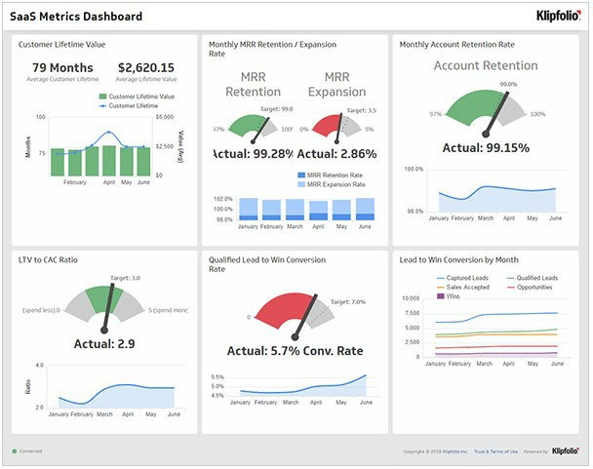
Figure 9

4.2 Functional Specific Solutions
Google has many different departments that could use functional specific solutions to assist their day-to-day running. Their Engineering and Technology department could use OpenGL. This is a 2D and 3D graphics API that is used extensively in the industry. It works independently from a window-system and operating system and allows software developers for supercomputing hardware, workstation and PC to create graphics software applications involved in CAD, game development and medical [62].
They could also use DirectX 12 which uses all the cores in your multicore CPU at once, so any work is done in less time. It also lets your GPU to do many tasks at the same time so receive more frames per second, reduce inactivity and shorten the time it takes to render. Asynchronous shaders and multi-threaded command buffer recording allow this all to work [63].
The sales department could use Conga [64] which provides a variety of sales functions as shown below:
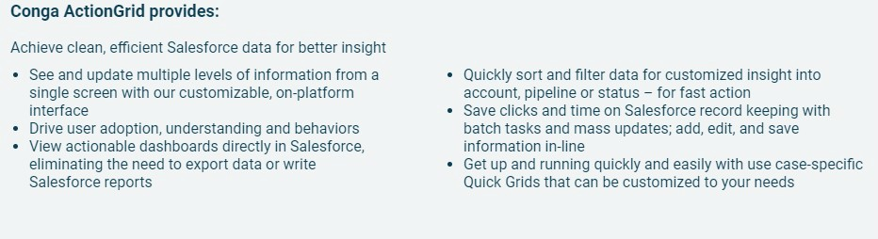
Figure 10
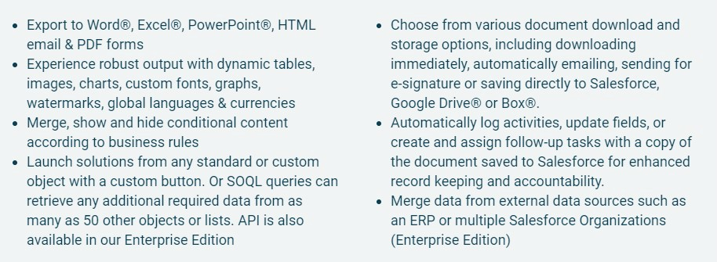
Figure 11
They could also use Veelo for sales which provides functions from all ends of the sale. Its functions include training and ongoing sales enablement [65].
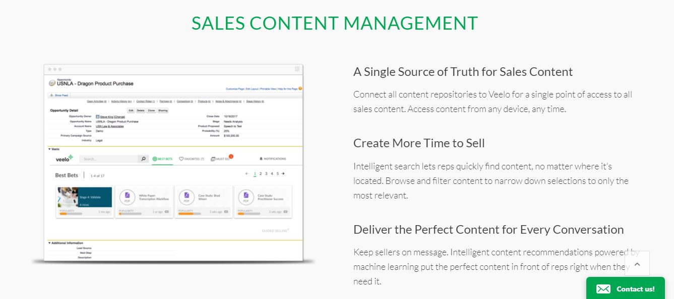
Figure 12
The marketing and communication department could use Alliance Tech which provides solutions for backup, cloud solutions, data storage products, network security, data networking, disaster recovery and wireless media [66]. They could also use Owler which provides three email products called Weekly Showdown, Instant Insights and Daily Snapshot. Weekly Showdown gives benchmarks between competitors and your employees based on press coverage and web traffic etc. Instant Insights sends any changes in leadership, funding and purchases to your inbox. Daily Snapshot accumulates blog posts and the top news stories for users [67].
The finance department can use Payoneer which provides numerous ways for international clients to pay you [68].

4.3 Enterprise Resource Planning
Enterprise Resource Planning or ERP systems combine many business systems into one platform, so data can be consistent and shared from multiple sources [69]. ERP systems usually share a database which contains different applications including CRM and e-commerce [70]. Some benefits of using ERP systems include efficiency as ERP’s will get rid of processes that repeat and enable businesses to gather data from any department, they save money as rather than buying many functional specific solutions, a company can use an ERP system which combines them, they also help with making reports easier to create without needing I.T and they can also be custom-made for a business rather than having a rigid structure [71]. There are also disadvantages to ERP systems such as the costs which includes planning, testing, customisation and implementation, it requires thorough user training to ensure its success and ERP systems are typically hard to learn to use, it can be impossible to assimilate any functional specific solutions with ERP systems and it can take several years to implement [72].
One popular ERP system that organisations could use are Sage X3 which provides functionality for sales, distribution, business intelligence, financial management and inventory [73]. Netsuite is another available option, it also provides business intelligence as well as customer relationship management, human resources and cloud software [74]. ECount is an ERP system that provides services for payroll, accounting, inventory, logistics and production [75]

4.4 Testing
An example of a new technology that businesses can use to support operations is Shopify [76]. Below are screenshots showing tests of its use.
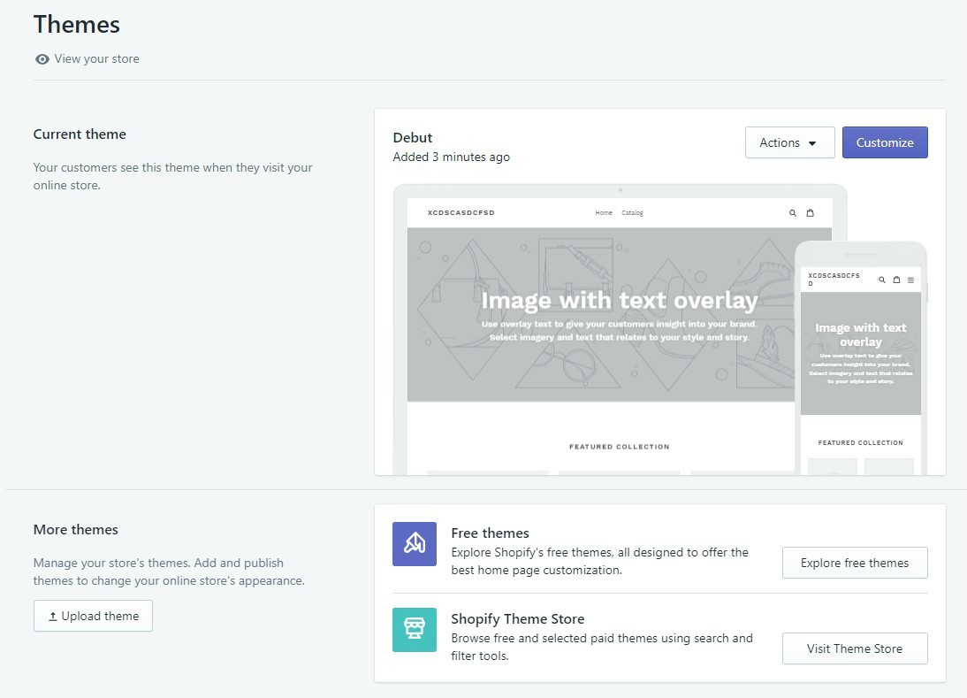
Figure 13
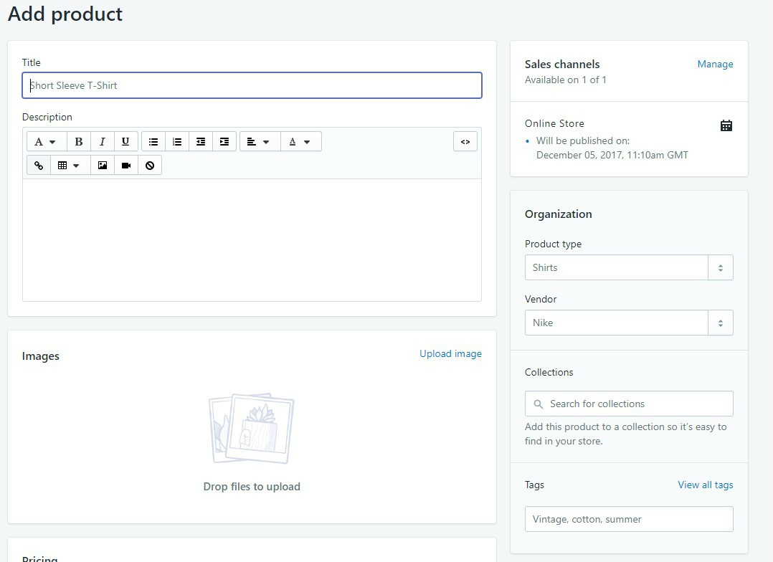
Figure 14
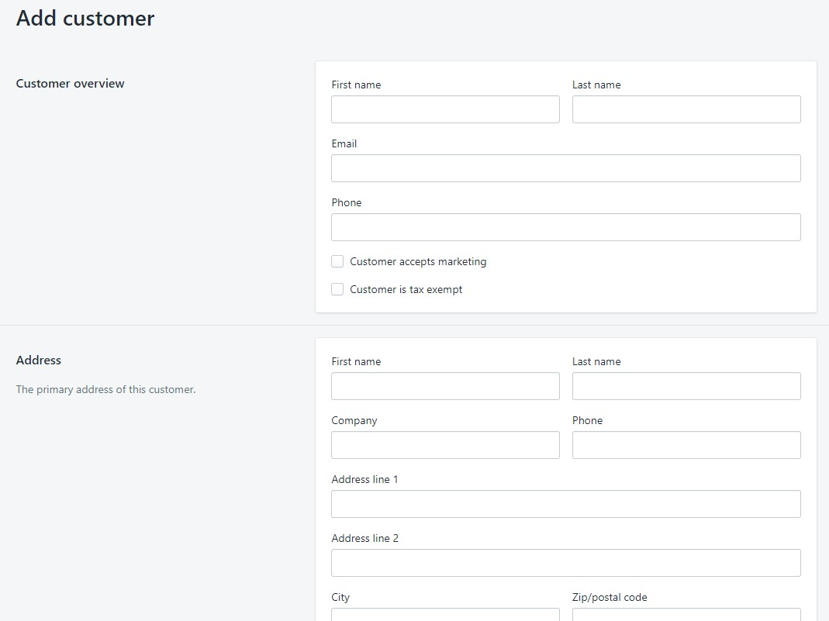
Figure 15
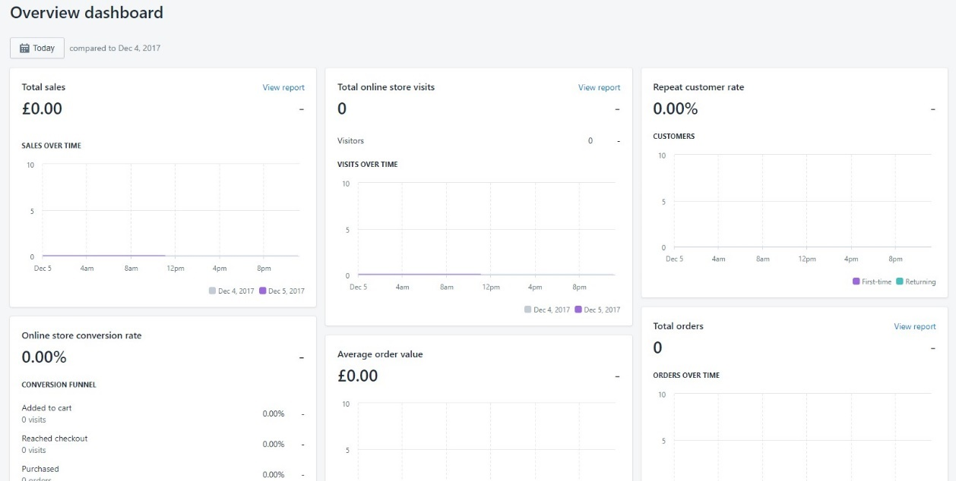
Figure 16
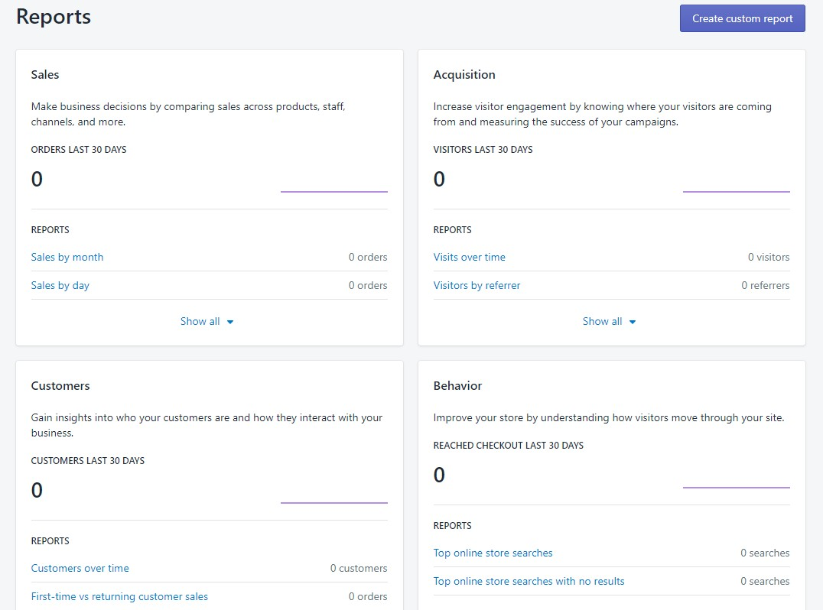
Figure 17
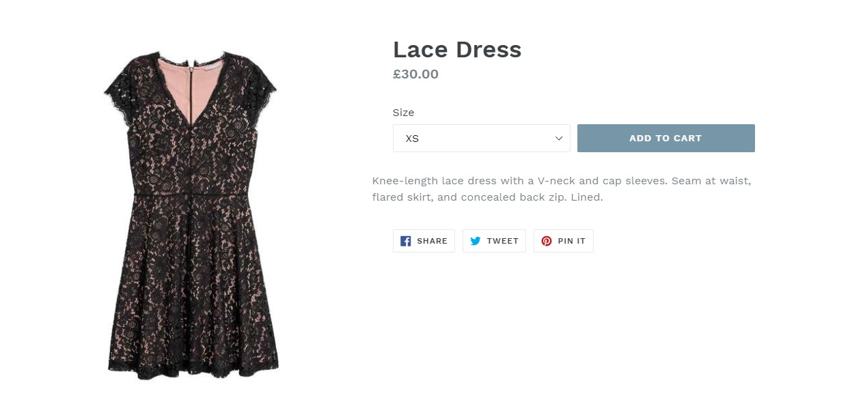
Figure 18
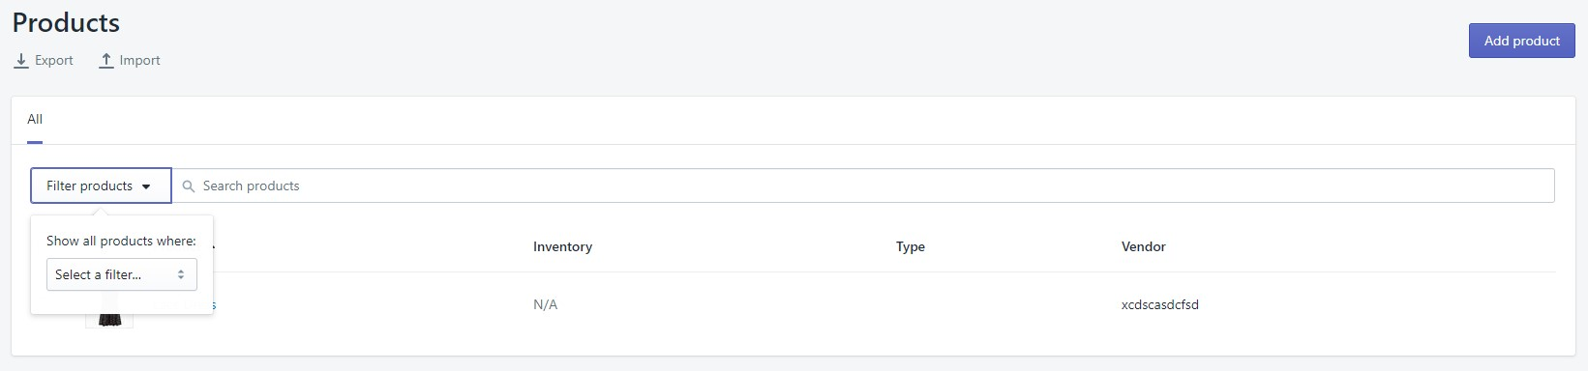
Figure 19

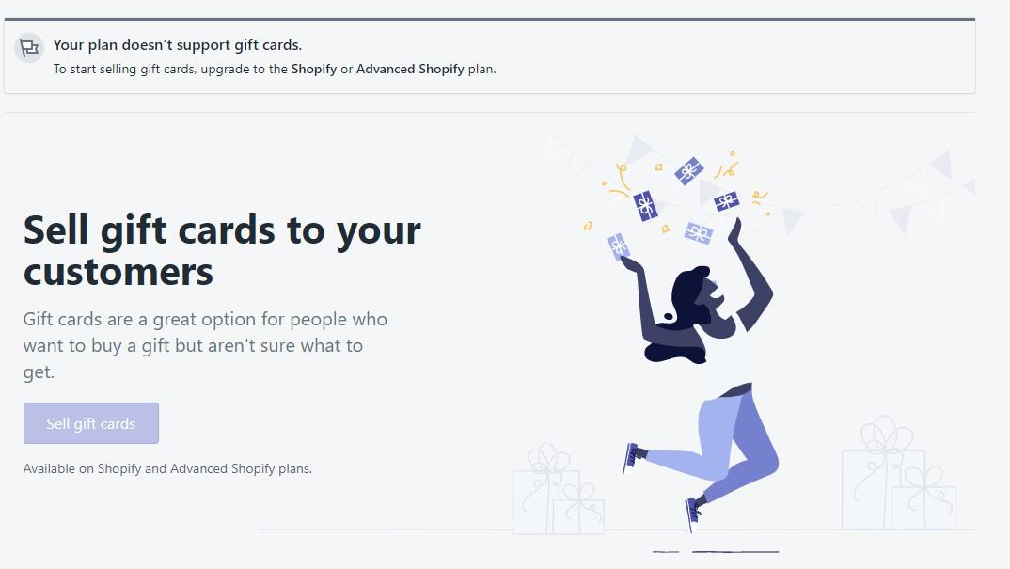
Figure 20
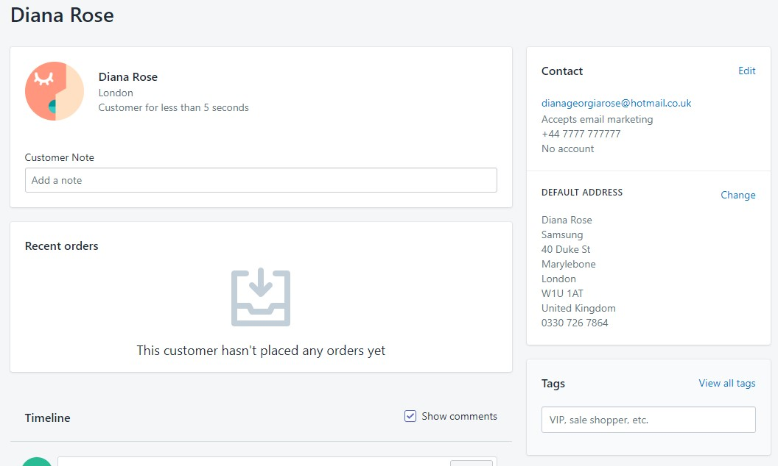
Figure 21
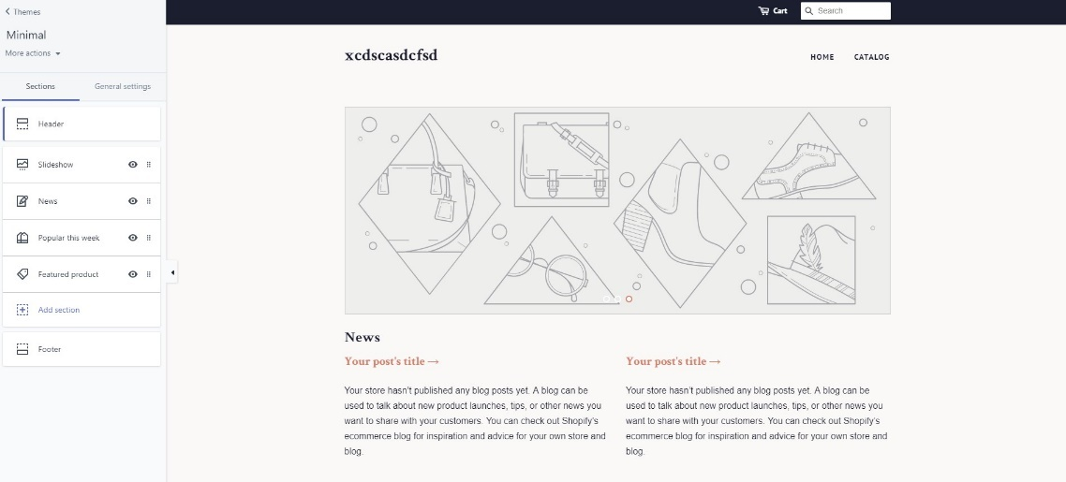
Figure 22
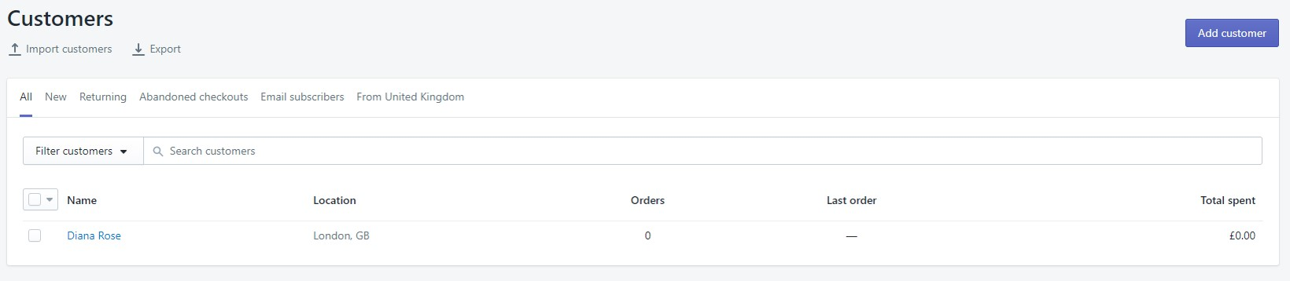
Figure 23
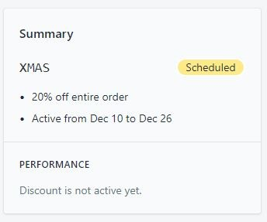
Figure 24

5. Conclusions

5.1 Conclusions
In conclusion it is important for any type of business to have a strategy and keep in mind any external factors that will affect them reaching their goal. They need to be conscious of their social impact and how their business partners and suppliers act and whether it is in fair practice. Each functional department plays a key role in business and contribute to the day-to-day running and help the business achieve their goals and vision.

5.2 Recommendations
There is a variety of business solutions available for business success. It all depends on what your business needs to meet its goals. It may be wise to use an ERP if you need a variety of solutions in a combined software which will make it easier to communicate and present data in a similar format throughout your organisation. If you have a smaller business with specific needs, you can use more functional specific solutions like Shopify which is also customisable and easy to use whereas ERP systems are more complex and require user training.

6. References

[1] | 2017 Solution Matrix Ltd, "Business Strategy, Model, Strategic Framework," [Online]. Available: https://www.business-case-analysis.com/business-strategy.html. [Accessed 14 November 2017].
[2] | Balanced Scorecard Institute, "Balanced Scorecard Basics," [Online]. Available: http://www.balancedscorecard.org/BSC-Basics/About-the-Balanced-Scorecard. [Accessed 14 November 2017].
[3] | ACME Corporation Technology, "ACME CORPORATION TECHNOLOGY: STRATEGIC PLAN," [Online]. Available: https://onstrategyhq.com/wp-content/files/SampleReports/AcmeCorporationTechnology.onepageplan.04042012.pdf). [Accessed November 14 2017].
[4] | Study.com, "What Is the Strategic Planning Process? - Model, Steps & Examples," [Online]. Available: https://study.com/academy/lesson/what-is-the-strategic-planning-process-model-steps-examples.html. [Accessed 14 November 2017].
[5] | M. Rouse, "Vision Statement," July 2013. [Online]. Available: http://whatis.techtarget.com/definition/vision-statement. [Accessed 14 November 2017].
[6] | S. Ward, "Mission Statement," 27 October 2016. [Online]. Available: https://www.thebalance.com/mission-statement-2947996. [Accessed 14 November 2017].
[7] | H. R, "190 Brilliant Examples of Company Values," [Online]. Available: https://inside.6q.io/over-100-examples-of-company-values/. [Accessed 14 November 2017].
[8] | Scenarios to Strategy Inc., "Strategy," [Online]. Available: http://www.scenarios2strategy.com/docs/strategy.html. [Accessed 15 November 2017].
[9] | Wayne LEADS, "S.M.A.R.T Objectives," [Online]. Available: https://hr.wayne.edu/leads/phase1/smart-objectives. [Accessed 14 November 2017].
[10] | A. Gray, "SMART Goal Examples," 29 September 2017. [Online]. Available: https://www.thebalance.com/smart-goal-examples-2951827. [Accessed 14 November 2017].
[11] | Investopedia, [Online]. Available: http://www.investopedia.com/terms/s/socialresponsibility.asp#ixzz4vlFo9Vab. [Accessed 14 November 2017].
[12] | Financial Times, "Definition of corporate social responsibility (CSR)," [Online]. Available: http://lexicon.ft.com/Term?term=corporate-social-responsibility--(CSR). [Accessed 14 November 2017].
[13] | Business Dictionary, "Stakeholder," [Online]. Available: http://www.businessdictionary.com/definition/stakeholder.html. [Accessed 14 November 2017].
[14] | TechTarget, "Balanced Scorecard," [Online]. Available: http://searchcio.techtarget.com/definition/balanced-scorecard-methodology. [Accessed 14 November 2017].
[15] | Balanced Scorecard Institute, "Balanced Scorecard Basics," [Online]. Available: http://www.balancedscorecard.org/BSC-Basics/About-the-Balanced-Scorecard. [Accessed 14 November 2017].
[16] | PESTLEanalysis, "Understanding Pest Analysis with Definitions and Examples," 23 December 2013. [Online]. Available: http://pestleanalysis.com/pest-analysis/. [Accessed 15 November 2017].
[17] | Samsung, "Samsung," [Online]. Available: https://www.samsung.com/us/. [Accessed 15 November 2017].
[18] | J. Vincent, "Samsung drags Apple back to court for a retrial over $400 million patent damages," 23 October 2017. [Online]. Available: https://www.theverge.com/2017/10/23/16519546/apple-samsung-patent-lawsuit-damages-retrial-october. [Accessed 15 November 2017].
[19] | J. Rossignol, "Apple vs. Samsung Lawsuit to Drag Into Eighth Year With Retrial Scheduled Next May," 26 October 2017. [Online]. Available: https://www.macrumors.com/2017/10/26/apple-vs-samsung-retrial-may-2018/. [Accessed 15 November 2017].
[20] | Management Study Guide, "PESTLE Analysis of Samsung," [Online]. Available: https://managementstudyguide.com/pestle-analysis-of-samsung.htm. [Accessed 15 November 2017].
[21] | J. Dudovskiy, "Samsung PESTEL Analysis," 4 October 2017. [Online]. Available: Samsung PESTEL Analysis. [Accessed 15 November 2017].
[22] | Samsung, "Social Contribution," [Online]. Available: http://www.samsung.com/us/aboutsamsung/sustainability/socialcontribution. [Accessed 15 November 2017].
[23] | J. Dudivskiy, "Samsung Corporate Social Responsibility," 12 October 2017. [Online]. Available: https://research-methodology.net/samsung-corporate-social-responsibility/. [Accessed 15 November 2017].
[24] | Samsung, "Sustainability Reports," [Online]. Available: http://www.samsung.com/us/aboutsamsung/sustainability/sustainabilityreports/). [Accessed 15 November 2017].  [25] H. Bhasin, "Top 21 Samsung Competitors – Competitor analysis of Samsung," 20 December 2017. [Online]. Available: https://www.marketing91.com/samsung-competitors/. [Accessed 17 December 2017].
[26] | S. Mack, "Social Factors Affecting Retail Business," [Online]. Available: http://smallbusiness.chron.com/social-factors-affecting-retail-business-71662.html. [Accessed 15 November 2017].
[27] | Ethical Consumer, "Samsung Electronics Co Ltd - Workers' Rights," [Online]. Available: http://www.ethicalconsumer.org/companystories.aspx?CompanyId=215964&CategoryId=421. [Accessed 15 November 2017].  [28] Margaret Rouse, “U.K. Data Protection Act 1998 (DPA 1998),” [Online]. Available: http://whatis.techtarget.com/definition/UK-Data-Protection-Act-1998-DPA-1998. [Accessed 15 November 2017]  [29] Healthy Working Lives, “Health and Safety Legislation,” [Online] Available: http://www.healthyworkinglives.com/advice/Legislation-and-policy/Workplace-Health-and-Safety/health-safety-legislation. [Accessed 16 November 2017]  [30] PestleAnalysis, “Political Factors Affecting Business,” [Online] Available: http://pestleanalysis.com/political-factors-affecting-business/. [Accessed 16 November 2017]
[31] | L. Friend, "What Is the Meaning of Organizational Structure?," [Online]. Available: http://smallbusiness.chron.com/meaning-organizational-structure-3803.html. [Accessed 16 November 2017].
[32] | The Economic Times, "Definition of 'Scalar Chain'," [Online]. Available: https://economictimes.indiatimes.com/definition/scalar-chain. [Accessed 16 November 2017].
[33] | Inc.com, "Span of Control," [Online]. Available: https://www.inc.com/encyclopedia/span-of-control.html. [Accessed 16 November 2017].
[34] | ERC, [Online]. Available: https://www.yourerc.com/blog/post/Span-of-Control-How-Many-Employees-Should-Your-Supervisors-Manage.aspx. [Accessed 16 November 2017].
[35] | L. Magloff, "Tall Organizational Structure," [Online]. Available: http://smallbusiness.chron.com/tall-organizational-structure-3835.html. [Accessed 16 November 2017].
[36] | LinkedIn Corporation, [Online]. Available: https://www.slideshare.net/tutor2u/hrm-organisational-structure. [Accessed 16 November 2017].
[37] | D. Griffin, "Tall Vs. Flat Organizational Structure," [Online]. Available: http://smallbusiness.chron.com/tall-vs-flat-organizational-structure-283.html. [Accessed 15 November 2017].
[38] | S. Johnson. [Online]. Available: http://smallbusiness.chron.com/mechanistic-organizational-structure-58785.html. [Accessed 16 November 2017].
[39] | Study.com, "Organic Organizational Structure: Definition & Examples," [Online]. Available: http://study.com/academy/lesson/organic-organizational-structure-definition-examples-quiz.html. [Accessed 16 November 2017].
[40] | J. Davoren. [Online]. Available: http://smallbusiness.chron.com/functional-structure-organization-strength-weakness-60111.html. [Accessed 16 November 2017].
[41] | Study.com, [Online]. Available: http://study.com/academy/lesson/matrix-organizational-structure-advantages-disadvantages-examples.html. [Accessed 16 November 2017].
[42] | N. M. Ataev, "Matrix Organization Structure: Advantages and Disadvantages," [Online]. Available: http://mirznanii.com/a/165406/matrix-organization-structure-advantages-and-disadvantages. [Accessed 16 November 2017].
[43] | M. Rouse, "Virtual Organization," September 2005. [Online]. Available: http://whatis.techtarget.com/definition/virtual-organization. [Accessed 16 November 2017].
[44] | LinkedIn Corporation, [Online]. Available: https://www.slideshare.net/AshishGupta21/c-15foundations-of-organization-structure. [Accessed 16 November 2017].
[45] | BusinessDictionary, [Online]. Available: http://www.businessdictionary.com/definition/business-function.html. [Accessed 16 November 2017].
[46] | S. Ashe-Edmunds, "Primary Business Functions," [Online]. Available: http://smallbusiness.chron.com/primary-business-functions-43477.html. [Accessed 17 November 2017].
[47] | C. MacKechnie, "Information Technology & Its Role in the Modern Organization," [Online]. Available: http://smallbusiness.chron.com/information-technology-its-role-modern-organization-1800.html. [Accessed 17 November 2017].
[48] | L. Mooney, "Seven Major Categories of HR Management Activities," [Online]. Available: https://yourbusiness.azcentral.com/seven-major-categories-hr-management-activities-6406.html. [Accessed 17 November 2017].
[49] | I. Linton, "Responsibilities of Marketing Department," [Online]. Available: http://smallbusiness.chron.com/responsibilities-marketing-department-69931.html. [Accessed 17 November 2017].
[50] | D. Griffin, "Role of Finance in a Business," [Online]. Available: http://smallbusiness.chron.com/role-finance-business-290.html. [Accessed 17 November 2017].
[51] | bizfluent, "What Are the Duties of the Production Department?," [Online]. Available: https://bizfluent.com/list-6765198-duties-production-department-.html. [Accessed 17 November 2017].
[52] | Chron.com, [Online]. Available: http://smallbusiness.chron.com/function-descriptions-research-development-department-37150.html). [Accessed 17 November 2017].
[53] | M. Rouse, "IS (information system or information services)," [Online]. Available: http://whatis.techtarget.com/definition/IS-information-system-or-information-services. [Accessed 17 November 2017].
[54] | J. Davoren, "Types of Information Systems in an Organization," [Online]. Available: http://smallbusiness.chron.com/types-information-systems-organization-43097.html. [Accessed 17 November 2017].
[55] | Techopedia, "Transaction Process System (TPS)," [Online]. Available: https://www.techopedia.com/definition/707/transaction-process-system-tps. [Accessed 16 November 2017].
[56] | D. Ingram, "What Is a Management Information System?," [Online]. Available: http://smallbusiness.chron.com/management-information-system-2104.html. [Accessed 17 November 2017].
[57] | Techopedia, "Executive Information System (EIS)," [Online]. Available: https://www.techopedia.com/definition/1016/executive-information-system-eis. [Accessed 17 November 2017].
[58] | Olap.com, "Business Intelligence," [Online]. Available: http://olap.com/learn-bi-olap/olap-bi-definitions/business-intelligence/). [Accessed 17 November 2017].
[59] | Margaret Rouse, "business intelligence (BI)," [Online]. Available: http://searchbusinessanalytics.techtarget.com/definition/business-intelligence-BI. [Accessed 17 November 2017].
[60] | FinancesOnline, "What Is the Purpose of Business Intelligence in a Business?," [Online]. Available: https://financesonline.com/purpose-business-intelligence-business/. [Accessed 17 November 2017].
[61] | Klipfolio, [Online]. Available: https://www.klipfolio.com/resources/articles/what-is-digital-dashboard. [Accessed 17 November 2017].
[62] | Khronos Group, [Online]. Available: https://www.khronos.org/opengl/. [Accessed 17 November 2017].
[63] | Advanced Micro Devices, Inc, "AMD DirectX® 12 Technology," [Online]. Available: http://www.amd.com/en-us/innovations/software-technologies/directx12. [Accessed 17 November 2017].
[64] | Conga, [Online]. Available: https://getconga.com/. [Accessed 17 November 2017].
[65] | Veelo Inc., [Online]. Available: https://veeloinc.com/. [Accessed 17 November 2017].
[66] | LinkedIn, "Alliance Technology Group," [Online]. Available: https://uk.linkedin.com/company/alliance-technology-group. [Accessed 18 November 2017].
[67] | Owler, "What Is Owler?," [Online]. Available: https://www.owler.com/about/what-is-owler. [Accessed 18 November 2017].
[68] Payoneer, Payoneer Inc., [Online]. Available: https://www.payoneer.com/main/. [Accessed 18 November 2017].
[69] Oracle UK, “What is ERP?,” [Online]. Available: https://www.oracle.com/uk/applications/erp/what-is-erp.html. [Accessed 18 November 2017]
[70] Visual Next, “WHAT DOES ERP STAND FOR AND WHAT DOES IT DO FOR BUSINESSES TODAY?,” [Online]. Available: https://www.visualnext.com/news/what-does-erp-stand-for/. [Accessed 18 November 2017]
[71] WorkWiseSoftware, “TOP 15 BENEFITS OF IMPLEMENTING ERP SOFTWARE,” [Online]. Available: https://www.workwisellc.com/erp-software/15-benefits-implementing-erp-software/. [Accessed 18 November 2017]
[72] ExcITingIP.com, “Advantages & Disadvantages of ERP (Enterprise Resource Planning) Systems,” [Online]. Available: http://www.excitingip.com/2010/advantages-disadvantages-of-erp-enterprise-resource-planning-systems/. [Accessed 18 November 2018]
[73] Sage, [Online]. Available: https://www.sage.com/en-gb/products/sage-x3/. [Accessed 18 November 2017]
[74] Netsuite, [Online]. Available: http://www.netsuite.co.uk/portal/uk/products/erp.shtml. [Accessed 18 November 2017]
[75] Software Advice, “ECOUNT Software,” [Online]. Available: https://www.softwareadvice.com/uk/inventory-management/ecount-profile/. [Accessed 18 November 2017]
[76] Shopify, [Online]. Available: https://www.shopify.co.uk/. [Accessed 18 November 2017].

