Emergent Leadership Skills
in the Workplace
BMSW6101



Rahela Begum (1818336)
May 2023
Dr Sujeewa Herath

Contents Page:
Introduction..............................................................................................3
Management V Leadership.................................................................................................4
Effective Leadership Skills..............................................................5,6,7,8
Leadership Styles............................................................................9,10,11
Strengths and Weakness Comparison Chart....................................................................................................12,13
McGregor’s Theory X and Y……………………………..………………....14
Tackling Barriers to Leadership...................................................15,16,17
Ethics in Leadership...............................................................................................18
Conclusion...............................................................................................19
References..........................................................................................20,21
Appendix..............................................................................................22,23
Reflective Report..................................................................................................24,25

Introduction
Leadership skills in the workplace combine various types of leadership styles and skills. This report will discuss the potential skills and traits required to make an effective leader a great one. Within the report there will be a critical analysis on Leadership skills, Leadership styles, how to tackle barriers to leadership and ethical leadership. Emergent Leadership is a revolutionary management system that allows leaders to emerge organically within an organisations objectives and goals.
This contrasts with the traditional practise of management, to control a collection of individuals to achieve a specified object and leadership, the ability to influence, motivate and enable others to add to organisational success.

Management Vs Leadership

One of the key differences between management and leadership is how the two professions assist individuals and organisations to achieve their objectives. Managers rely on their authority to execute tasks. They assign assignments to team members according on what must be completed and expect them to carry out their responsibilities.
On the other side, leaders appeal to, inspire, and influence people. They strive to maximise each person's potential by aligning their own goals with those associated with the project and the organisation in general. ‘Managers use a push approach where leaders use a pull approach’ state (Podsakoff and Podsakoff,2019).
The content within this report is focused on Leadership in the workplace.

Effective Leadership Skills in the Workplace

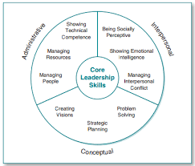
Source: Model of Leadership Skills

Strong and effective Leadership skills are essential to successfully influence and support a team or group of people within the workplace to encourage productivity.
Administrative, Interpersonal and Conceptual are three categories of leadership skills.
Several skills build the core of each category.
Administrative Skills
A leader who is influential and determines organization purposes and goals must have administrative skills Kason, Aswar and Fiman,(2019). These competencies are broken down into three categories: People management, resource management, and technical competency. .
Managing People
An effective leader communicates with people and knows the tasks that must be completed, the talents needed to complete them, as well as the working atmosphere. Amongst the abilities they are helping people operate as a team Crowley, (2022), inspiring them to accomplish their best, establishing satisfying relationships amongst employees and meeting their demands. The leader should additionally make time to deal with pressing personnel issues. Staff issues are a daily occurrence for any leader; employees seek counsel from the leader on how to handle problems, and the leader must respond correctly.
In addition, paying attention to recruitment and employee retention. Leaders also need to communicate effectively with directors, stakeholders within the organization and any external constituents which may have a conflict of interest.

Managing Resources
A leader is frequently expected to devote significant time to resolving resource issues. People, money, materials, and anything else needed to run a business are examples of an organization's resources. To properly manage resources, a leader must be proficient in both acquiring and allocating them according to Grint (,2020). Finding resources can involve a range of actions, such as finding workspace, locating money, negotiating, and ordering equipment, are all examples of resource operations.
The leader may also be required to allocate funding for new workers and incentive training programmes in addition to all of this. A leader may frequently enlist the assistance of staff to assist in resource management, but the ultimate responsibility rests with the leader.

Showing Technical Competence
Technical competence entails possessing specialised knowledge about the work we undertake or delegate to others. It entails comprehending the complexities of how an organisation operates. A technically skilled leader comprehends the complexities of how the organisation operates. They are more effective when subordinates apply their knowledge when asked to complete a task.
Functional competence denotes a person's ability to function in a specific field. Not every leader possesses the necessary skills to be technically proficient in every situation.

Technical competence entails possessing specialised knowledge about the work we undertake or delegate to others. It entails comprehending the complexities of how an organisation operates according to Falloon, (2020). A technical competent leader understands the complex aspects of how the organization runs. They are more effective when the knowledge is implemented by the subordinates when asked to perform a task.
Functional competence means a person can function in a particular area. Not all leaders have the required skills to be technically competent in every situation.

Interpersonal Skills
Communication
Communication Skills are the most imperative skills of a leader, a soft and tangible skill Vasanthakumari,(2019). They define the goals and vision of team members clearly. It is essential to communicate distinctly with your subordinates to avoid any sort of misunderstandings. Therefore, the process is exchanged from one recipient to another through several communication channels such as emails, telephone conversations, meetings etc.
Motivation
Motivational skills for leaders are the qualities that allow them to encourage and empower their team members to improve performance overall in the work environment.
Speaking clearly with confidence can instigate inspiration in others. Speaking about personal achievements can motivate the team to achieve their own personal goals. A learning questionnaire by EI-Adi and Alkharusi,(2020) revealed that intrinsic motivation positively motivated students to achieve their goals and aspirations.
Emotional Intelligence
Empathy helps leaders to understand the situation and sentiments of their team listening to any issues they may be encountering. With empathy you can build solid relationships and improve performance. Leaders can promote wellbeing activities. Having empathy can present you as an approachable leader in the workplace.
Defusing conflict. Developing these skills is essential to mediate and bring in a resolution. Asking thoughtful questions to both parties, remaining calm and professional, remaining objective to the two parties involved in conflict. Treating with integrity and respect. Finally, being flexible and coming up with a solution that works for everyone involved by putting accountability into conflict resolution and following up regularly in the early stages of resolution.
In differences will always be an issue in the workplace and can have a dramatic negative effect on the workforce productivity. Conflict resolution skills can turn a good leader into an outstanding one (Chandolia and Anastasiou,2020).

Conceptual Skills


Soft skills are under the category of conceptual skills. The capacity to recognise issues and find answers, as well as the capacity to comprehend complex situations better. These abilities give leaders the flexibility to tackle challenging workplace issues in a variety of ways.
Akdere and Egan, (2020) stated ‘As Leaders, they look for a deeper grasp of how to guide employee growth towards quantifiable, significant organisational objectives as they explore for methods to better their personal future and that of their organisation’, through:
Strategic Planning – Set priorities, focus energy, resources and work towards common goals.
Problem-solving – Process of removing barriers that prevent reaching targets.
Creating Vision – Inspiration, aspiration and achievement. Strong leadership visions support companies’ overall goals.

Leadership Styles

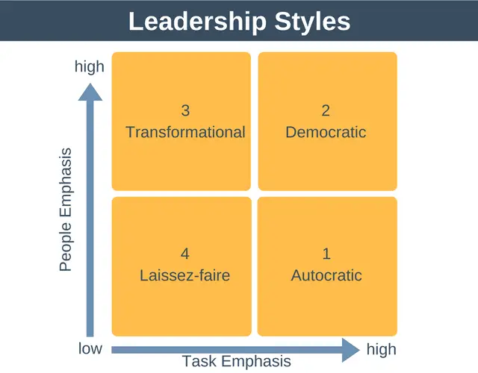
Source: (Denis G,2023) Expert Program Management

Skills alone do not make leaders, behaviour and styles also contribute.
Autocratic, Democratic, Transformational and Laissez-Faire are the four major leadership styles within the workplace.

Autocratic Leadership
An authoritarian leader is conscious of his position and having little faith or trust in his staff. Authority resides in a single person and centres around the leader. Autocratic characteristics include being demanding and believing that they must dictate to their employees for them to perform. Autocratic rulers, in general, prefer to reserve the right to make choices.
They also believe that paying an employee in advance for work is a fair transaction, and that an employee can only be driven by rewards. Personal control over staff decisions and little feedback differentiates this leadership style.
These leaders emphasize loyalty and devotion while adhering to tight company laws. The decision-making process is centralized and based on their own judgments; they accept full responsibility for their final decisions and control the performance of their followers. In times of crisis, the autocratic leader may be useful. Autocratic leadership can be effective in situations (for example, when unpopular decisions must be made) and (for example, in paramilitary organizations), (Caillier,2020).

Democratic Leadership
Democratic leadership style, also known referred to as participative leadership, entails obtaining feedback from the workforce and team members so that everyone can contribute to the decision-making process. Democratic leaders continue to make the final decisions, but their approach allows people to have a sense of belonging and investment in the outcome. They thrive at inspiring, Subordinates are encouraged to innovate, and efforts benefit from constructive contributions from all parties. This boosts employee morale. Creates a creative environment, a coherent group, and a high degree of production from a high efficiency group.
Clarity, trust and communication in both directions are essential. Because of their desire for a participatory environment, they are outstanding, subordinates and communicators generally find them approachable. (Tedla,2022).
This type of leadership style works best when the leader's dialogue skills are strong, as well as when employees are relatively skilled.

Transformational Leadership
Transformational leadership entails creating a grand vision and uniting employees around it. The team is eager to develop and evolve, both personally and professionally--in order to achieve the overall aim. with the corporation and its personnel in sync. Transformational leaders are committed to a single cause and are willing to invest effort, time, and energy. While trying to achieve their purpose, employees remain loyal, productive and employee trust Purwanto et al., (2019). This produces a harmonious workplace since everyone is working together and the lines of communication between leadership and employees are always open. Reflecting on lower employee attribution or turnover rate.
Transformational leaders know their followers well, develop a vision that is captivating packed with values, and foster a culture of no blame since the emphasis is on problem solving rather than who caused the problem.

Laissez-faire Leadership
Laissez-faire leadership style, letting people do as they choose’ approach but rather empowering your employees, taking a step back and relying on them to complete the task at hand without questioning or micromanaging them. Laissez-faire leaders delegate decision-making to their staff while remaining ready to give feedback as needed. According to Lewin, they exhibit four common behaviours and results: complete freedom to individuals, without any participation. Clear instructions that information would be supplied only if asked. Complete nonparticipation. Infrequent comments on activities, no attempt to join in or interfere with the course of events.
These leaders are excellent delegators and install confidence in employees while assigning them tasks without any oversight. Employees can make decisions without seeking approval. Workers are fully competent.
According to, Ahmed et al., (2021), If followers are highly talented and motivated, the laissez faire method can be quite effective. It removes bureaucratic restraints and should be addressed with caution and evaluated objectively.

Strengths (+) and Weaknesses (-) for Leadership Styles
Table 1.
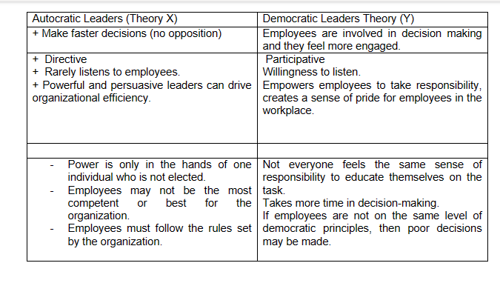
Comparison of Autocratic and Democratic leadership styles

Table 2.
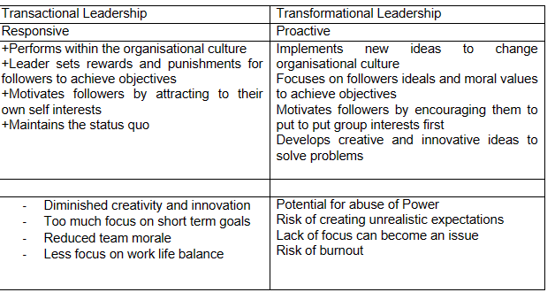
Strengths and weaknesses of transactional and transformational leadership.

Table 3.
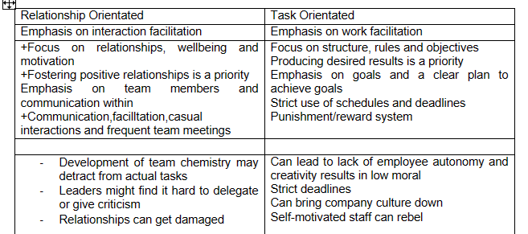

Relationship Orientated V Task Orientated, advantages and disadvantages chart.

Most common leadership styles in the modern workplace. Along with Orientation, leaders may rely on to complete certain objectives.

McGregor's Theory X and Y Model
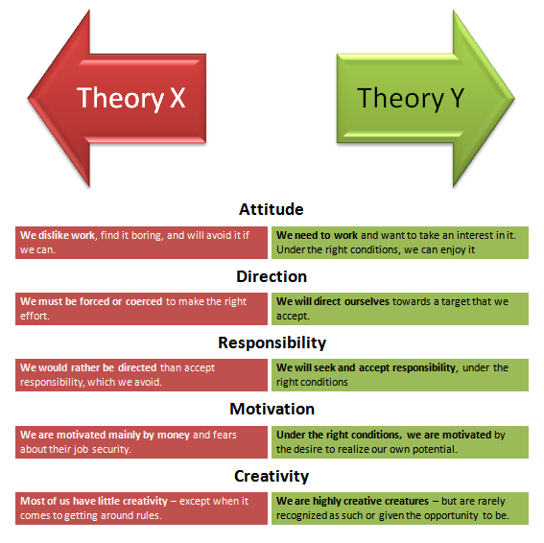
Source:( Dokum, 2018). LinkedIn
Theory X Leadership Style: Theory Y Leadership Style:
Autocratic Transformational/ Democratic
Lassie Faire

Regarding control, Theory X works on the idea of punishing people to keep the work going. This can fail as it does not consider human motivation and its needs. Control and direction are useless methods of motivating people unless psychological and safety needs are satisfied. Theory Y promotion, rewards, and recognition play a major part. The downfall can be, leaders ‘were simply engaged in a seductive form of manipulation,’ implied (Gurjev and Triesman,2020).

Tackling the Barriers to Leadership
In times like these, there is volatility and uncertainty, necessitating quick, high-impact judgements with minimal information. To keep organisations operating, leaders must manage these factors, acquiring fresh lessons and contribute to the development of different creative problem-solving methods (Kaul and Shah,2020).
Those in strategic leadership roles play a significant part. Leaders need to become more agile and flexible. Supporting their teams to do the same. An agile leader recognises a challenge or opportunity and efficiently responds to it (Attar and Abdul Karim,2020). Four options to overcome these are:

Recommendations to overcome these are as follows:
- Hierarchical structure- Is the most critical factor in leadership of any organisation and is crucial to its effectiveness in functioning and ongoing development. Flexible networks, open communication methods, leaders with a creative, constructive mindset and happy spirit have a beneficial influence on employees' feelings and increase creativity and fluidity. Importance of leaders contributions and development may be viewed as an acute issue that has a significant impact on staff morale and effective performance, given that a highly hierarchical system may negatively affect incentives to exert effort as well as the efficiency of communication channels. Research by Zhang and Parker, (2019) suggests that employees are not always empowered to make their own judgements on the front lines. When an organisation asks its staff to embrace uncertainty, trust becomes an especially pressing issue.
- Short-term, bottom-line focus - Another challenge to organisational leadership is the tension between long-term performance and the immediate profit and loss balance. Firms are now concerned with performance; sustainability and the ethical dimensions of decision making and are incorporating relevant measurements into their value frameworks and behaviours. In practise, however, the message that certain employees may be receiving via performance management methods and informal components of organisational culture could be reinforcing the importance of in terms of short-term bottom-line priorities above 'how' things are carried out. Across organisations, where there are behavioural frameworks in place to support sustainable leadership behaviours, people know they would primarily be evaluated on how well they meet their objectives. ‘A certain ‘halo’ effect acts as a shield’ stated Kim, oh and Ham, (2022) around strong achievers who are unlikely to be penalised for their weaknesses.
- Individualism - In many firms, incentive and advancement paths are related to an employees process creating and meeting a group of individual goals. However, that approach does not always properly integrate with the larger organisational objectives, resulting in departmental agendas clashing. In the absence of specificity about how performance affects the larger vision, culture of blame and bias rewards may refocus individuals' attention on what is most likely to benefit their individual performance. Rather than focusing on long-term and corporate goals, focus on objectives and penalties. One of the reasons managers may adopt a directive leadership style rather than empowering and mentoring their personnel is a focus on individual performance. When confronted with time-sensitive jobs, individuals are more inclined to take a hands-on approach to meeting short-term objectives.
- Finally, for businesses, leaders, and managers must embrace worker diversity. Diversity includes not just variances in people's demographic attributes (gender, language, culture, etc.), but also work styles and perspectives. Even though diversity has been proved to give significant benefits to firms in the form of increased people management processes (such as lengthy and tightly enforced behavioural frameworks) can accidentally prefer sameness over the desired level of variability in local teams and across the organisation. Organisational policies and processes aimed at ensuring fairness may have grown unduly prescriptive. The blanket policy that should be implemented to all employees to ensure compliance, and the individual policies also should be applied to each employee.
Leaders need to set a good example and exhibit conscientious behaviour. It's crucial to recognise and honour team accomplishments in uncertain climates and maintain motivation (Armstrong and Taylor,2020).
Collaborating Transactional and Transformational Leadership skills are essential. Summed up as follows: Transactional Leadership looks to get things done. Transformational Leaderships look at how to motivate people to do things. Combing both can enhance effective leadership.

Effective Key Barriers in the Organisations
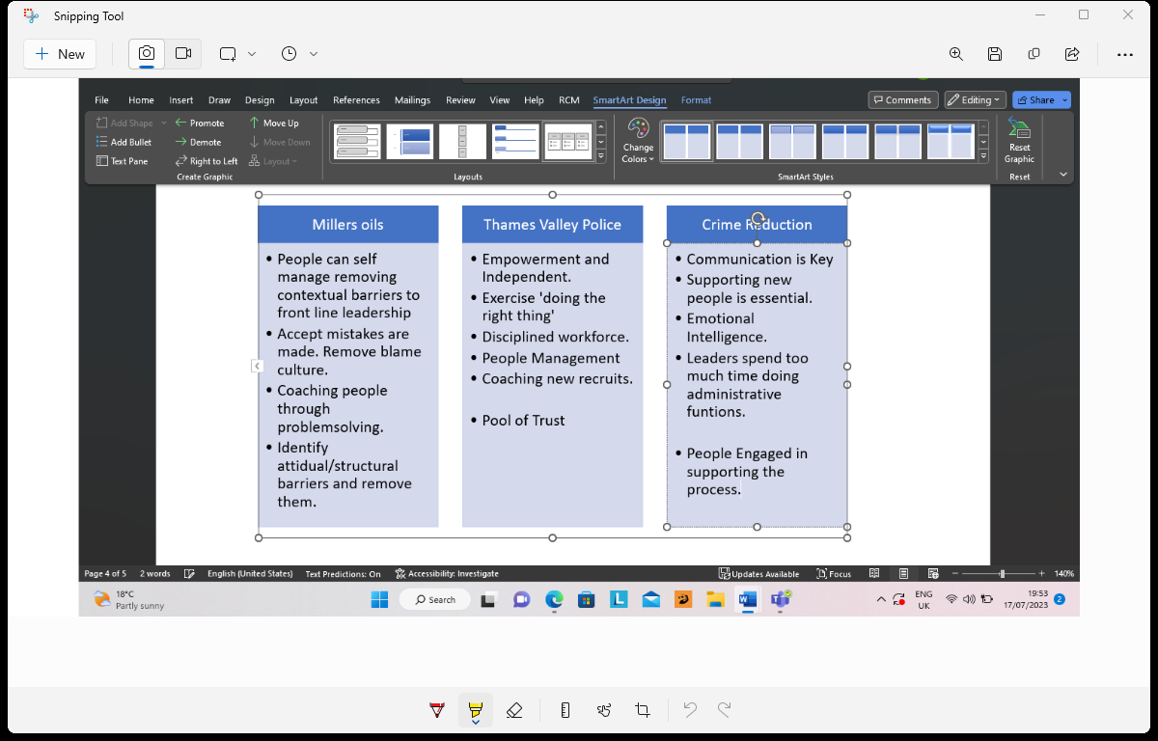

Above are the other organizations practices from CPID report, the transformational people management approach is crucial to intellectually challenge the people you manage, attentively analyse each of their unique ideas, inspire them, and act as a positive role model a style adopted by many organisations (Naido,2019).

Ethics in Leadership
An ethical leader must uphold others' rights and dignity, as well as the rule of law (Ren, Tang, and Jackson,2021).
Traits of an Ethical Leader:
- Fairness
Fairness is a crucial attribute of ethical leadership. The concept of fairness is centred around how humans interact with one another and expect to receive fair treatment. Our expectations include receiving fair treatment and reciprocating it with others.
- Favouritism
Nowhere, is it appropriate because everyone's circumstances are the same, and justice is also tied to how you discipline someone. If two people make the same mistake, they should receive the same punishment.

- Accountability
Being held responsible for inadequate decisions is a beneficial virtue; it is also a vital feature of ethical leadership. Some of us make errors and prefer to move on quickly, while others like to point fingers. However, accepting responsibility for a mistake demonstrates your maturity.

- Trust
You cannot have a great team without trust running through it. Trust is a fundamental component of our lives and work, we want others around us to trust us to build high-performing teams within organizations.
- Honesty
The advantage of being honest is that people will trust you. If a leader is truthful people know they can be relied on. They will be comfortable following instructions and tasks because they know they won't be deceived.

- Equality
Everyone is created with value; people deserve to be treated respectfully regardless of gender, colour or disability. Treating people equally by valuing each member.

Conclusion
In summary, leadership is a process in which the group or organisation chooses the leader rather than being assigned to the position. This form of leadership offers various advantages, including the ability to bring new perspectives and creativity to the table. Creating stronger bonds with followers and encouraging staff. Individuals who take up leadership roles when the occasion calls for them are more adaptive and flexible. Emergent leaders are individuals who rise to prominence during times of transition or catastrophe. Because they have earned their position of authority, these leaders are more likely to be revered by their followers. This increases their motivation to achieve their best to lead their group to victory.
Effective leadership is heavily influenced by good leadership traits and styles. Effective leadership is defined by results rather than qualities, such as delivering speeches or being loved.
To achieve the best results in any organisation, every administrator must have the necessary leadership qualities.
Leaders partner both Transactional and Transformational leadership approaches to produce a positive outcome.
Ethical Leaders must be honest and trustworthy, care about people and society, and provide a good ethical example for those they lead. Integrity is everything and an essential trait that is required by a leader.

Reference List:
Ahmed Iqbal, Z., Abid, G., Arshad, M., Ashfaq, F., Athar, M.A. and Hassan, Q.,( 2021). Impact of authoritative and laissez-faire leadership on thriving at work: The moderating role of conscientiousness. European journal of investigation in health, psychology and education, 11(3), pp.667-685.
Akdere, M. and Egan, T.,( 2020). Transformational leadership and human resource development: Linking employee learning, job satisfaction, and organizational performance. Human Resource Development Quarterly, 31(4), pp.393-421.
Attar, M. and Abdul-Kareem, A.,( 2020). The role of agile leadership in organisational agility. In Agile business leadership methods for industry 4.0 (pp. 171-191). Emerald Publishing Limited.
Armstrong, M. and Taylor, S.,( 2020). Armstrong's handbook of human resource management practice. Kogan Page Publishers.
Caillier, J.G.,( 2020). Testing the influence of autocratic leadership, democratic leadership, and public service motivation on citizen ratings of an agency head’s performance. Public Performance & Management Review, 43(4), pp.918-941.
Chandolia, E. and Anastasiou, S., (2020). Leadership and conflict management style are associated with the effectiveness of school conflict management in the Region of Epirus, NW Greece. European Journal of Investigation in Health, Psychology and Education, 10(1), pp.455-468.
Crowley, M.C., (2022). Lead from the heart: Transformational leadership for the 21st century. Hay House, Inc.
Denis, G. (2023). Expert Program Management: Minute Tools.
El-Adl, A. and Alkharusi, H., (2020). Relationships between Self-Regulated Learning Strategies, Learning Motivation and Mathematics Achievement. Cypriot Journal of Educational Sciences, 15(1), pp.104-111.
Falloon, G., (2020). From digital literacy to digital competence: the teacher digital competency (TDC) framework. Educational Technology Research and Development, 68, pp.2449-2472
Grint, K., (2020). Leadership, management and command in the time of the Coronavirus. Leadership, 16(3), pp.314-319.
Guriev, S. and Treisman, D., (2020). A theory of informational autocracy. Journal of public economics, 186, p.104158.
Kaso, N., Aswar, N., Firman, F. and Ilham, D.,( 2019). The Relationship between Principal Leadership and Teacher Performance with Student Characteristics Based on Local Culture in Senior High Schools. Kontogianis: Journal Ilmiah Management, 7(2), pp.87-98.
Kaul, V., Shah, V.H. and El-Serag, H.,( 2020). Leadership during crisis: lessons and applications from the COVID-19 pandemic. Gastroenterology, 159(3), pp.809-812.
Kim, J., Oh, H.J. and Ham, C.D., (2022). The Impact of the CSR-Embedded Crisis Response: The Role of Values Congruence between Leadership Styles and CSR Motives. Management Communication Quarterly, 36(1), pp.92-123.
Naidoo, P., (2019). Perceptions of teachers and school management teams of the leadership roles of public-school principals. South African Journal of Education, 39(2).
Pedersen, K.Z. and Roelsgaard Obling, A.,( 2019). Organising through compassion: The introduction of meta‐virtue management in the NHS. Sociology of Health & Illness, 41(7), pp.1338-1357.
Podsakoff, P.M. and Podsakoff, N.P., (2019). Experimental designs in management leadership research: Strengths, limitations, and recommendations for improving publishability. The Leadership Quarterly, 30(1), pp.11-33.
Ren, S., Tang, G. and Jackson, S.E.,( 2021). Effects of Green HRM and CEO ethical leadership on organizations' environmental performance. International Journal of Manpower, 42(6), pp.961-983.
Tedla, B.A., (2019). An essence of leadership, its styles: A review and personal account commentary. International Journal of Health Sciences, (II), pp.175-183.
Vasanthakumari, S.,( 2019). Soft skills and its application in workplace. World Journal of Advanced Research and Reviews, 3(2), pp.066-072.
Zhang, F. and Parker, S.K., (2019). Reorienting job crafting research: A hierarchical structure of job crafting concepts and integrative review. Journal of organizational behavior, 40(2), pp.126-146.

Appendix:
The score for Ethical Questionnaire
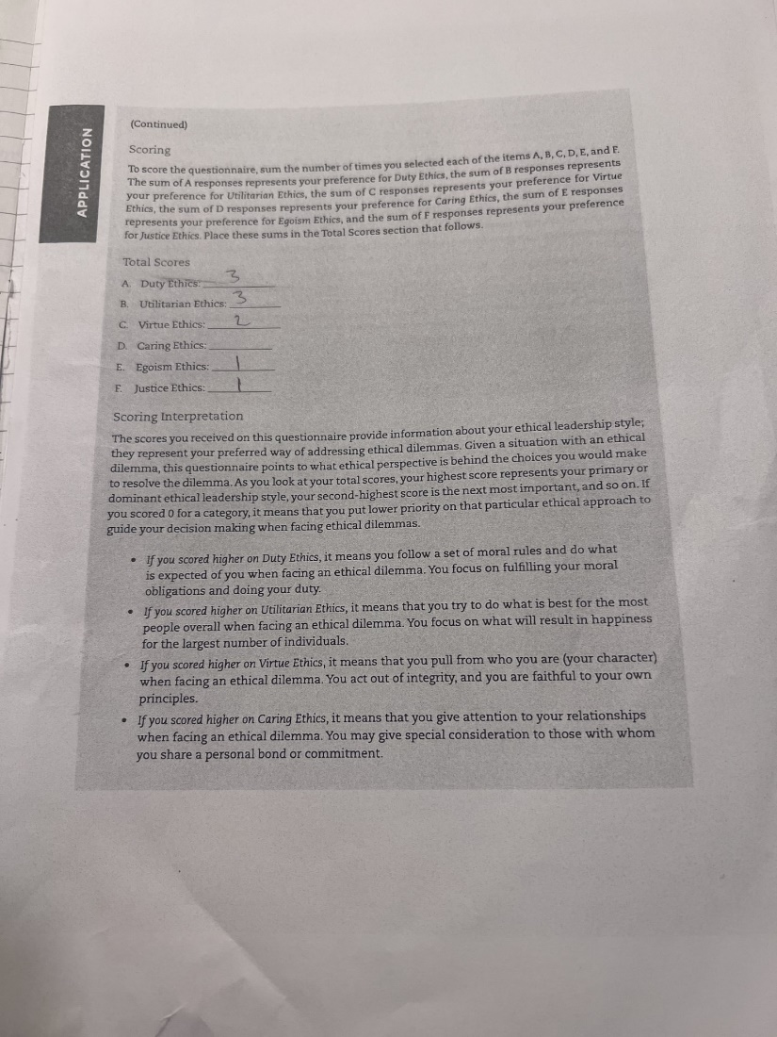

Leadership Style Questionnaire results:

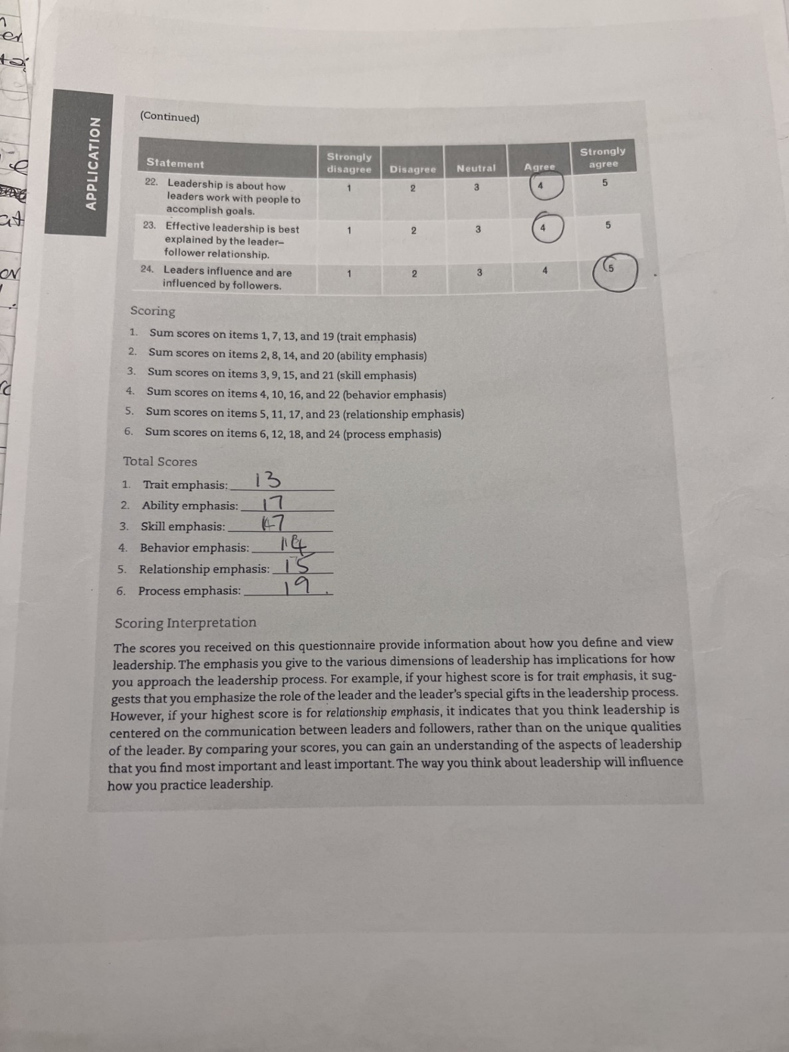
Reflection

Introduction
My personal reflections on how Emergent Leadership Skills will help me in the workplace and in life. Skills that I have learned and will practice. Which style of leadership I should apply to the different settings at work.
Reflection
Throughout the course, the study of Emergent leadership skills in the Workplace gave me a deep insight into the roles and responsibilities of a leader. I now have a clear knowledge of the various styles of leadership, and I've begun to critically evaluate myself. Upon completing a questionnaire, I was not surprised to see the result: Process emphasis suggested that I put my personal interests aside for the interest of the larger group, empowering and motivating everyone involved Aldaihani, (2020). I have demonstrated and learned the attributes of a leader at work, where I have leadership responsibilities, and my co-workers look to me for guidance for successful task completion. Children during play look forward to being directed on objectives that they find challenging. My primary strengths are my openness and flexibility. I tend to go with the flow even if it is stressful.
Moving forward, as a leader, I will empower people via encouragement while building a vision that encompasses all. Through my acts and words, both verbal and written, I will inspire others to act. I will constantly attempt to challenge myself and grow into a great leader, while also encouraging my coworkers to do the same.
Transformational leadership theory underpins my strategy. As a leader, I will remain proactive in achieving my future goals of Special Educational Needs teaching and will continually analyse my progress throughout. I have comprehended leadership styles need to adapt to the situations as called for example, during intervention classes the Transformational Leadership approach is necessary.
My ethics questionnaire was spot on: Duty and Utilitarian. I do have high moral standards and have implemented these standards to my children, Moral philosophy, in fact, makes it easier to evaluate and reconsider any given practise Bietti, (2020). In the workplace I fulfil my moral obligations to complete my work duties and try to do my best to advocate actions that foster happiness. I try my best to promote and help the people around me. I always look beyond my own interests and consider impartially the interests of others.
I will continue to use my Leadership skills to create my vision and thoughtful decision making and will continue to inspire others to do the same.

References:
Aldaihani, S.G., (2020). Administrative empowerment among Kuwait University staff and its effect on their job satisfaction. Journal of Applied Research in Higher Education, 12(2), pp.210-229.
Bietti, E., (2020), January. From ethics washing to ethics bashing: a view on tech ethics from within moral philosophy. In Proceedings of the 2020 conference on fairness, accountability, and transparency (pp. 210-219).

