BSc Applied Psychology
ECAP6003 Forensic Psychology and the Criminal Mind:
Rehabilitative Proposal

Proposal title:
The Rehabilitation of Young Offenders Engaged in Knife Crime: A Cognitive Behavioural Therapy Appoach
Proposal theme:

In the year ending March 2022, the UK witnessed a surge in knife crimes committed by children, reaching 3,500 incidents. Tragically, 13 young lives under the age of 16 were lost due to these knife crimes. To address this issue, the proposed rehabilitation initiative is dedicated to transforming the behaviour of young offenders aged 10-18 involved in knife crimes. The primary objective is to equip them with essential skills and facilitate a successful reintegration into society. The RNR model serves as the framework for assessing their eligibility for the program. CBT will be tailored to each individual, spanning between 6 to 20 sessions based on the severity of their offenses. The SAVRY and EARL-20B/21G assessments will track their progress throughout the program. A visual representation in the form of a Gantt chart outlines the intended duration of the initiative.

Background literature review:

‘Knife crime’ refers to criminal activities involving the use of knives or sharp-edged instruments and can include stabbings, threats, robbery, possession, and gang-related violence. It encompasses a range of offenses where such weapons are used to cause harm, intimidate, or commit crimes (Allen, 2018). Since 2013, there has been a continual increase in violent crimes and offenses involving sharp instruments, more commonly known as knife crimes, among young people in major UK cities such as London, Manchester and Birmingham as highlighted by Haylock (2020). However, these offences and knife crimes are not just a prevalent issue within the UK but also globally. It has been found that interpersonal violence and homicide from knife crime rank as the third leading cause of death for individuals aged 15–19 (Haylock, 2020). Despite the recognition of this as a major and escalating issue, effective strategies to reduce youth violence have yet to be prioritised and implemented. The severity of the problem is underscored by the alarming number of young people involved in violence who are losing their lives due to sharp instruments, emphasising the urgency for comprehensive and targeted interventions (Harding, 2020).
According to the Office for National Statistics (2022), there were 282 murders involving a knife or bladed instrument in England and Wales between March 2021 – March 2022. Out of the 282 victims, 99 were young people under the age of 25 and 13 were under the age of 16. In the UK alone during the year ending March 2022, there were 3500 knife offences committed by children under the age of 18. In 51% of these cases, the young offenders were given a community sentence, with 6% being taken immediately into custody and serving a custodial sentence. Unfortunately, juvenile recidivism rates in the UK are alarmingly high, with 31.2% of children aged 10-17 and 23.7% of 18–20-year-olds reoffending. This highlights a significant challenge in breaking the cycle of reoffending among young individuals.
One psychological model that has shown to be effective in reducing recidivism in juvenile offenders is the Risk, Need, Responsivity model [RNR model] proposed by Bonta and Andrews (2007). The RNR model is a framework used in criminal justice and rehabilitation which consists of three key principles: Risk, where the interventions should be tailored to the individual's level of risk, with higher-risk individuals requiring more intensive interventions. Need, where interventions should target criminogenic and/or non-criminogenic needs, addressing specific factors contributing to criminal behaviour, such as the need for stimulation, lack of familial and social support, substance abuse or the fear of being attacked and needing protection, which is prevalent in knife crimes for example. Finally, the responsivity Principle where interventions should be responsive to an individual's learning style, abilities, and motivation, ensuring tailored approaches for maximum effectiveness (Bonta & Andrews, 2007). The RNR model aims to reduce recidivism by addressing individual risk factors and needs while adapting interventions to the unique characteristics of each offender.
According to Brogan et al. (2015), despite the RNR model being designed for adult offenders, the RNR model can also be a crucial tool in reducing recidivism among juvenile offenders due to its facilitation of more targeted resource allocation. By targeting these resources towards moderate- and high-risk juvenile offenders, the model prevents the unnecessary involvement of lower-risk cases in intensive and potentially counterproductive correctional services such as incarceration (Brogan et al., 2015). On an individual level, the RNR model is particularly effective for juveniles by tailoring treatments to each juvenile offender’s unique risk and needs profile. This individualised approach increases the likelihood of a positive response to treatment., steering youths toward prosocial pursuits and away from criminal activities (Brogan et al., 2015).
In addition to the RNR model being used to identify the risks, needs and responsivity of the young offender, which creates the base of the rehabilitation, a psychological intervention should also be used to rehabilitate the individual. One psychological intervention that has been shown to reduce recidivism rates in knife crimes in general, regardless of age, is cognitive behavioural therapy [CBT] (Blattman et al., 2022). According Hollin (2019), CBT is a valuable rehabilitative approach for young offenders engaged in knife crime, offering a tailored and multifaceted strategy for addressing the psychological factors contributing to their actions. Through CBT, therapists will guide individuals in identifying and challenging distorted thought patterns associated with their criminal behaviour, replacing them with constructive alternatives. The therapy includes comprehensive skills training, focusing on impulse control, effective communication, conflict resolution, and anger management. Prosocial behaviours are actively encouraged, with therapists working to help young offenders develop and pursue positive alternatives to violence. CBT sessions may incorporate exercises to foster empathy toward potential victims, reinforcing a sense of responsibility and encouraging the consideration of the impact of their actions on others. Family involvement plays a crucial role, strengthening support systems and creating a more holistic understanding of the factors influencing knife crime. Goal setting, progress monitoring, and integration with other rehabilitation programs ensure a comprehensive and contextually relevant approach to breaking the cycle of violence and promoting positive change and reduced recidivism rates among young offenders (Hollin, 2019).
The rationale for this rehabilitative proposal is underscored by the recognition of the multifaceted nature of knife crime among young offenders. The incorporation of the RNR model to identify their risk level, criminogenic needs and responsivity to treatment alongside cognitive-behavioural therapy as an intervention reflects a commitment to targeted and evidence-based strategies, addressing the psychological aspects of criminal behaviour. This is why the RNR model and CBT will be used in this rehabilitative proposal. Beyond the immediate goal of mitigating knife crimes amongst the youth population, the proposal aims to break the cycle of recidivism and fostering successful reintegration into society. This not only empowers young offenders to overcome their circumstances but also positions them as potential contributors to their communities, thereby positively influencing the wider social structures around them. Emphasising human morals and principles, the proposal aligns with the ethos of providing individuals with an opportunity for positive transformation, acknowledging the complex challenges they may face. Ultimately, this rehabilitative approach represents a comprehensive and forward-thinking endeavour to address the root causes of knife crime, offering a pathway towards lasting personal growth and societal contribution.

Proposed methodology:

The rehabilitative intervention design:

Young offenders engaged in knife crimes will meet with a psychologist or therapist once a week to undergo cognitive behavioural therapy. Prior to the first session, a Structured Assessment of Violence Risk in Youth [SAVRY] (Borum et al., 2010) will be completed by the professional for offenders aged between 12-18, and an Early Assessment Risk List for Boys [EARL-20B] or Early Assessment Risk List for Girls [EARL-21G] (Augimeri et al., 2005) will be carried out for those ages 10 and 11. Each young offender will access a minimum of 6 CBT sessions and a maximum of 20 depending on the severity of their crimes and the results of the SAVRY or EARL-20B/21G. The sessions will include learning effective communication and anger management amongst others (See Procedure). Every 6 sessions, an additional SAVRY or EARL-20B/21G will be carried out to record the individuals progress and identify the need to further CBT sessions or alternative interventions. In the instance of an individual completing 20 sessions and the need for further intervention persists, additional CBT sessions may be considered or the referral to alternative interventions such as social skills training for example to target specific areas of their behaviour.

The target population and recruitment:
This rehabilitation intervention is designed for young offenders aged 10-18 in the UK who have a history of involvement in knife crime. Participants will include those currently in a probation program or incarcerated for their offenses. Probation and prison workers will communicate details of this initiative to eligible offenders. Whether they have committed a single knife crime or multiple offenses, all eligible offenders must express a genuine desire to change. It's important to note that participation in this rehabilitation program is entirely voluntary, and no one will be compelled to take part. This approach ensures that those who engage in the program do so willingly, fostering a more positive and cooperative environment for their rehabilitation journey. By focusing on this age group, the intervention aims to address the specific challenges associated with youth involvement in knife crime, leveraging the potential for rehabilitation and redirecting individuals away from a trajectory of criminality.

Materials/measures:

- Consent form
- Information leaflet
- SAVRY
- EARL-20B
- EARL-21G

In this rehabilitation intervention, the materials will consist of a consent form, where their voluntary engagement will be confirmed through their signature or, for those under 18, the signature of their parent/guardian. Additionally, verbal assent will be obtained 3 times from participants below the age of 18 prior to treatment. This process ensures that individuals are actively choosing to undergo the intervention and are expressing a genuine desire for positive change. All participants will also be provided with an information leaflet outlining what to expect from the treatment. For the assessment component, a SAVRY, along with an EARL-20B and EARL-21G, will be required for this rehabilitative intervention.
Procedure:

Step 1:
Firstly, recruitment will be facilitated through communication by probation and prison workers to eligible participants who are currently in probation programs or incarcerated for their offenses. The RNR model will be used to identify their eligibility for this programme. All eligible offenders, regardless of the number of offenses committed, must express a genuine desire to change. Participation in the rehabilitation program is entirely voluntary.

Step 2:
Next, participants, or their parent/guardian if under 18, will be required to sign a consent form confirming their voluntary engagement in the intervention. Additionally, verbal assent will be obtained three times from participants below the age of 18 prior to treatment. This ensures that individuals actively choose to undergo the intervention.
Step 3:
Then, all participants will be provided with an information leaflet outlining what to expect from the treatment. This document aims to enhance understanding and set expectations for the rehabilitation process.
Step 4:
After that, for offenders aged 12-18, a SAVRY will be conducted by a qualified psychologist or therapist, which aims to evaluate violence risk factors within this age group. As the SAVRY is only intended for use in those aged 12-18, the EARL-20B or EARL-21G will be carried out on those under the age of 12. These assessments are designed to identify early risk indicators among younger participants, offering a proactive approach to addressing potential risk factors associated with their involvement in knife crime. The insights gained from these assessments will inform the tailored intervention plans and contribute to a more effective and targeted rehabilitation process.
Step 5:
Next, young offenders will meet with a psychologist or therapist alone once a week for CBT sessions which will last 1 hour. Each participant will access a minimum of 6 and a maximum of 20 sessions, depending on the severity of their crimes and the assessment results (SAVRY or EARL-20B/21G). CBT sessions will cover skills training, effective communication, anger management, impulse control and conflict resolution. Alongside these, prosocial behaviours will be encouraged throughout the sessions to help young offenders develop positive alternatives to violence. CBT sessions will also incorporate exercises to increase empathy toward victims, reinforcing a sense of responsibility and encouraging the consideration of the impact of their actions on others. Individuals will also partake in goal setting exercises (See Gantt Chart).
Step 6:
Then, after every 6 CBT sessions, a follow-up SAVRY or EARL-20B/21G assessment will be conducted to track individual progress and identify the need for further CBT sessions or alternative interventions. In the instance of an individual completing 20 sessions and the need for further intervention persists, additional CBT sessions may be considered or the referral to alternative interventions, such as anger management or social skills training, targeting specific areas of their behaviour.
Step 7:
Finally, upon completion of the rehabilitation intervention CBT programme, a final SAVRY or EARL-20B/21G will be conducted to identify the overall effectiveness of the programme and to identify the progress of the individual. This will enable professionals to conduct a further analysis or prediction of the individuals risk level and the risk of recidivism. After 6 months has passed after completing treatment, additional testing can be carried out to identify long-term benefits of the intervention.

Ethical considerations:

The process of obtaining informed consent will be clearly communicated. Participants, and their parents/guardians if under 18, will be provided with an information leaflet which will provide a comprehensive understanding of the nature of the CBT intervention, potential risks and benefits. The consent process will be voluntary, and all offenders have expressed the desire to change. All individuals will be aware that they can withdraw from the intervention at any stage without facing consequences. Written consent will be gained by the individual or the parents/guardians if they are under 18. Where there is a child involved, verbal assent will be gained on 3 occasions to ensure the child is aware of what they are consenting to.

Due to the sensitive nature of CBT, there may be the potential for the participant to feel some distress or become uncomfortable with what they are discussing. The use of gradual exposure, teaching coping strategies, and providing regular check-ins will allow for a systematic approach to addressing sensitive topics while enabling participants to manage their emotions. Offering alternatives to verbal expression and allowing breaks caters to diverse comfort levels, recognising that not everyone (especially children) expresses themselves verbally. Additionally, having crisis intervention protocols in place will help to mitigate this, following ethical guidelines set out by the British Psychological Society (2021) code of ethics. If the professional feels that the individual is not ready or mentally stable enough for the rehabilitation, then treatment will be stopped.

Planned analysis:

The SAVRY or EARL-20B/21G assessments will be completed both prior to the initiation of the treatment and upon the completion of the intervention program. For individuals undergoing more than 6 treatment sessions, additional SAVRY or EARL-20B/21G assessments will be conducted every 6 weeks or sessions during the intervention. This regular assessment schedule enables professionals to monitor progress and identify the need for further or alternative treatments.

Following a 6-month period, a subsequent SAVRY or EARL-20B/21G assessment will be carried out by a psychologist or therapist to evaluate the long-term benefits of the intervention program on the individual. This comprehensive assessment aims to provide insights into the impact and effectiveness of the intervention over an extended period of time.
What are the expected outputs from this project?

The rehabilitation intervention is designed with a holistic approach to bring about positive transformations in various aspects of young offenders' lives. The rehabilitative programme seeks to improve their mental well-being by promoting emotional resilience and addressing underlying psychological challenges. Simultaneously, a key focus lies in diminishing levels of anger through targeted sessions that equip participants with effective anger management strategies. Social skills improvement is also a central objective, aiming to provide crucial communication skills, empathy, and interpersonal abilities that facilitate positive interactions with both peers and the societies around them. Furthermore, the intervention strives to provide practical coping mechanisms, enabling individuals to navigate life's challenges and make positive decisions. Ultimately, the program aspires to prepare these young offenders for successful reintegration into society, providing them with the necessary tools and skills to contribute positively to their communities and build a foundation for a constructive future.
Timescales for project completion
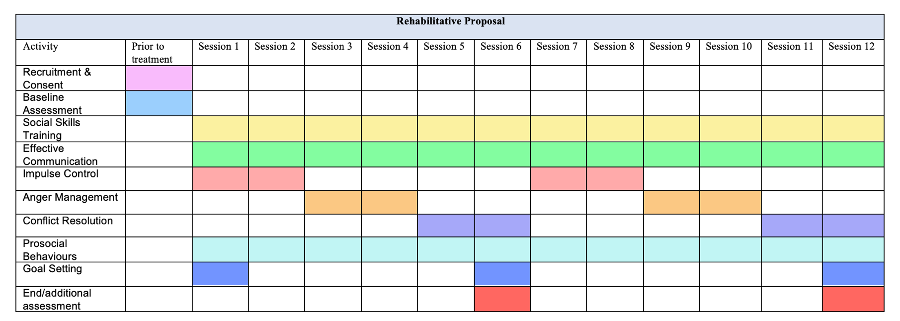
Gantt Chart of proposed timescale:

Gantt Chart continued:
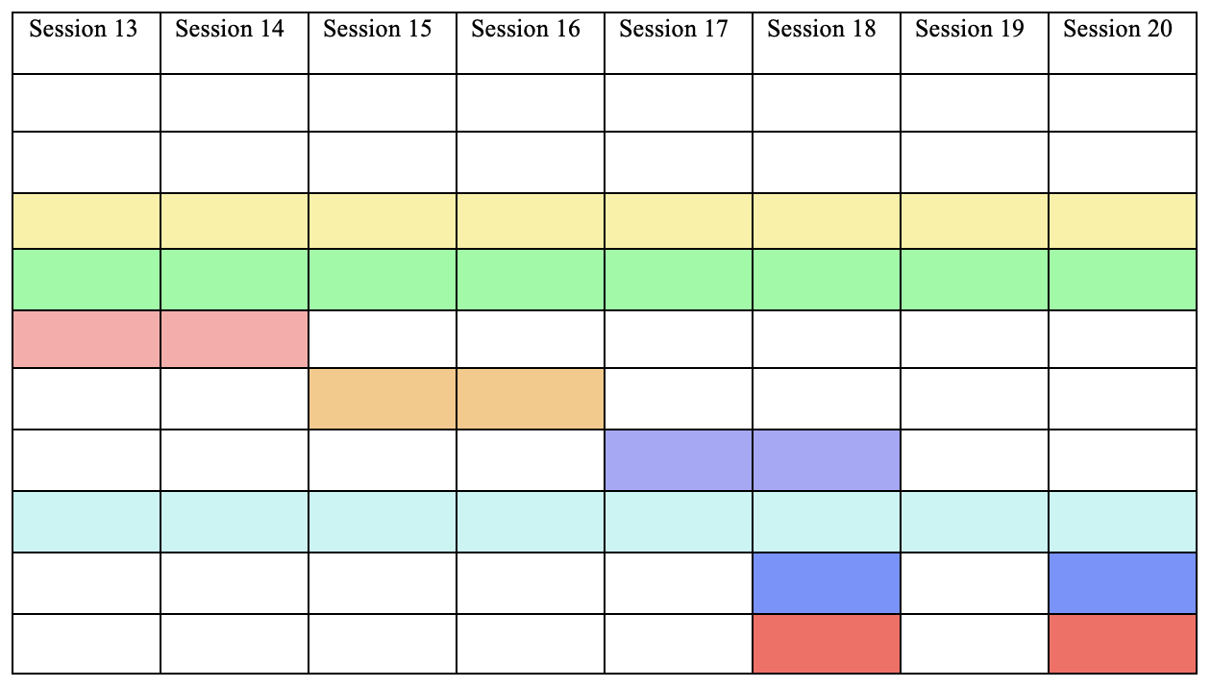

References

Allen, G., Audickas, L., Loft, P., & Bellis, A. (2018, November 9). Knife crime in England and Wales. House of Commons Library. https://researchbriefings.parliament.uk/ResearchBriefing/Summary/SN04304#fullreport

Augimeri, L. K., Koegl, C. J., Levene, K. S., & Webster, C. D. (2005). Early Assessment Risk Lists for Boys and Girls. In T. Grisso, G. Vincent, & D. Seagrave (Eds.), Mental health screening and assessment in juvenile justice (pp. 295–310). The Guilford Press. https://doi.org/10.4324/9781315518374-15

Blattman, C., Chaskel, S., Jamison, J. C., & Sheridan, M. (2022). Cognitive Behavior Therapy Reduces Crime and Violence Over 10 Years: Experimental Evidence. American Economic Review: Insights, 5(4): 527-45. https://doi.org/10.31235/osf.io/q85ux

Bonta, J., & Andrews, D. A. (2007). Risk-need-responsivity model for offender assessment and rehabilitation. Rehabilitation, 6(1), 1-22. https://www.securitepublique.gc.ca/cnt/rsrcs/pblctns/rsk-nd-rspnsvty/rsk-nd-rspnsvty-eng.pdf

Borum, R., Lodewijks, H., Bartel, P. A., & Forth, A. E. (2010). Structured Assessment of Violence Risk in Youth (SAVRY). In R. K. Otto & K. S. Douglas (Eds.), Handbook of violence risk assessment (pp. 63–79). Routledge.

British Psychological Society (2021, December). Code of Ethics and Conduct. https://doi.org/10.53841/bpsrep.2021.inf94

Brogan, L., Emily Haney-Caron, NeMoyer, A., & DeMatteo, D. (2015). Applying the Risk-Needs-Responsivity (RNR) Model to Juvenile Justice. Criminal Justice Review, 40(3), 277-302. https://doi.org/10.1177/0734016814567312

Harding, S. (2020). Getting to the point? Reframing narratives on knife crime. Youth Justice, 20(1-2), 31-49. https://doi.org/10.1177/1473225419893781

Haylock, S., Boshari, T., Alexander, E.C. (2020). Risk factors associated with knife-crime in United Kingdom among young people aged 10–24 years: a systematic review. BMC Public Health, 20, 14-51. https://doi.org/10.1186/s12889-020-09498-4

Hollin, C. R. (2019). What is cognitive behavioral therapy (CBT) with offenders? In D. L. L. Polaschek, A. Day, & C. R. Hollin (Eds.), The Wiley international handbook of correctional psychology (pp. 623–636). Wiley Blackwell. https://doi.org/10.1002/9781119139980.ch39

Office for National Statistics. (2022, October 27). Crime in England and Wales: year ending March 2022. https://www.ons.gov.uk/peoplepopulationandcommunity/crimeandjustice/bulletins/crimeinenglandandwales/yearendingmarch2022

