Susan Beer
2007542
M4X02037 – Academic Essay Task

The Anderson shelter against living in a war you cannot see

This essay will compare and contrast the Coronavirus war currently faced in present/ contemporary society against World War 2. It will investigate the similarities and differences between the two wars and the feelings that have accompanied them. I am passionate about this area of research as my father was an air raid warden and fire fighter. Although both wars are different in nature, one unseen and one causing massive physical destruction, the emotions felt by the people trapped within them are arguably the same and I will be examining the effects on the lives of people living through these wars.

Despite the 75 years between the two wars both have catastrophically changed the nature of society and the way people live. Infringements were made upon the freedoms that people felt, rules and constrictions put in place to keep people safe. During World War 2 however these rules saw people brought together within air raid shelters and a new sense of community developed as a result of needing each other and relying upon strangers. The war we are currently facing is not only an unseen war in terms of being a virus contained within the person and hospitals, but the rules that have accompanied it have kept people apart, confined within their own homes. “First Minister Mark Drakeford urged people in Wales to go out just once a day to shop for basic food and to exercise close to home” (BBCNews, 2020).

The need for community is very present however this has taken the form of social networking over computers as people seek the same connections made during World War 2. The feelings of fear, isolation, loneliness and mental health generated by both wars make people want to come together to form a united front and this is one of the biggest differences faced between these wars.

Both wars have affected the way that people connect with each other on a physical and emotional level but the major difference is that the Covid-19 war can only be seen through hospital and news reports detailing the number of deaths. In World War 2 physical destruction was visible through damaged buildings, houses and people; armies were a physical and visible presence making the war they were fighting something they could see in front of them daily. It is arguable that this difference has a massive impact on understanding and acceptance of the situation which changes a person’s perspective enabling them to face it on an emotional level. The difficulty with the Covid-19 war is that without being able to see it, this understanding has not been created, so mistrust has been created with many.

Both the coronavirus pandemic and the second world war are both wars however very different most noticeably through the nature of community created during World War 2 and the separation and isolation caused by the coronavirus pandemic. The nature of community spirit in World War 2 can be partly attributed to the use of air raid shelters. During World War Two children and families were dependent upon the use of Anderson shelters or the underground shelters to protect them from the bombings. The Anderson shelter was buried 4ft deep in the ground in back gardens. “Six feet tall, 6.5 feet long, and 4.5 feet wide, the corrugated metal shelters were a snug fit for a family of six. They were buried four feet under owners’ yards, their arched roofs covered with a layer of soil”(Arbuckle, 2015).
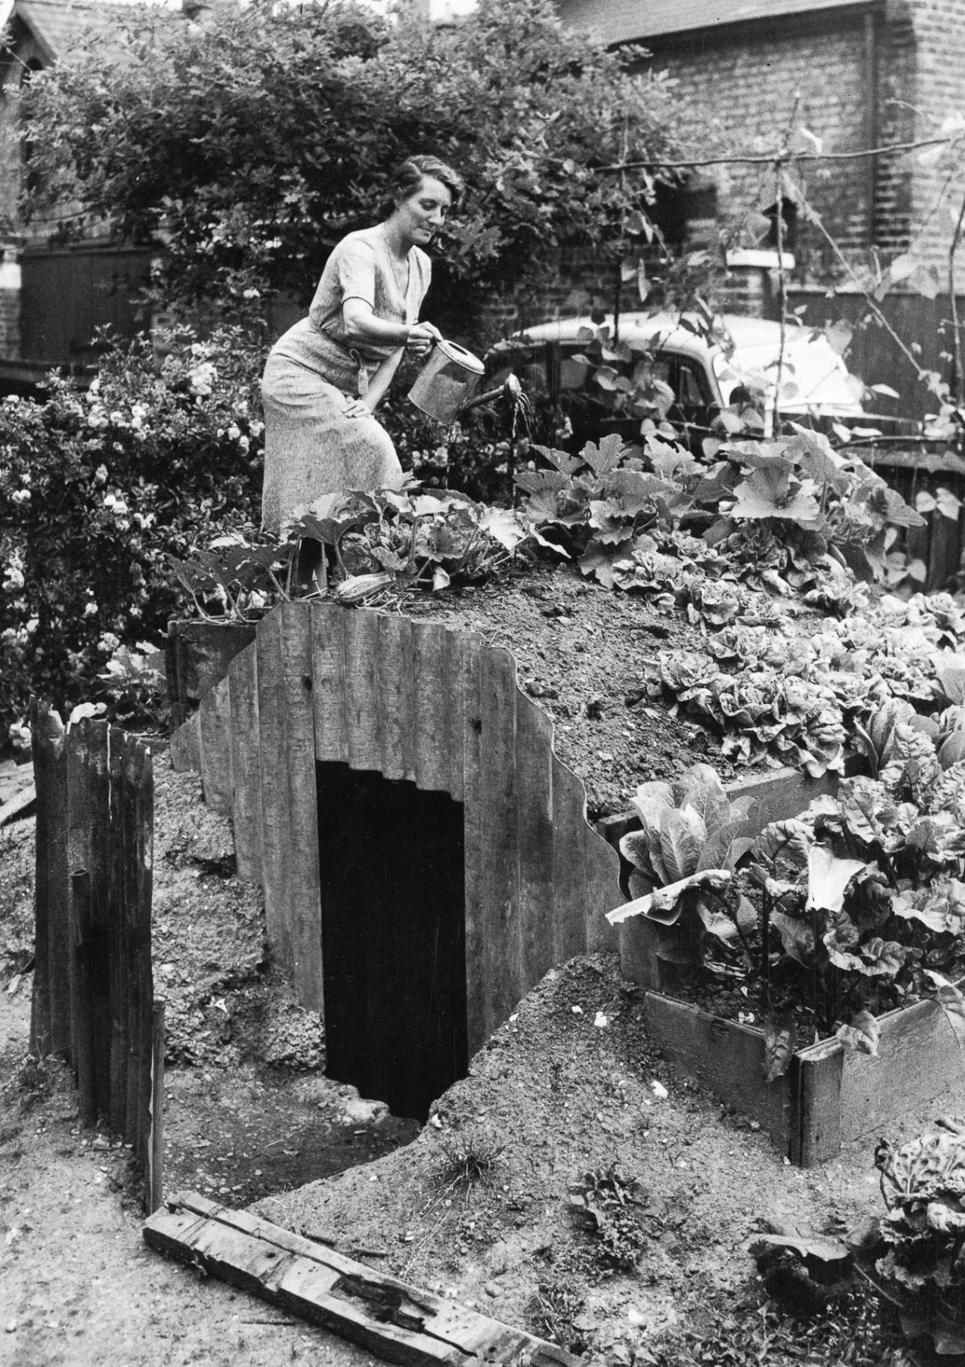
Fig.1: A South London resident waters the vegetables planted
on the roof of her Anderson shelter.

Almost 3 million Anderson shelters were erected across the UK during the Blitz, a period of continuous bombing that took place (findmypast, 2020). “Many chose to incorporate the shelters into their gardens, planting vegetables and flowers on top of them. Residents even held competitions for prettiest shelter” (Arbuckle, 2015). This brought communities together through a common cause: despite the Anderson shelter being a necessity not a luxury the people rallied to make this a resource that they could cherish and be proud of. Through planting vegetables and plants on top this became a food source and the competitions for prettiest brought people together.
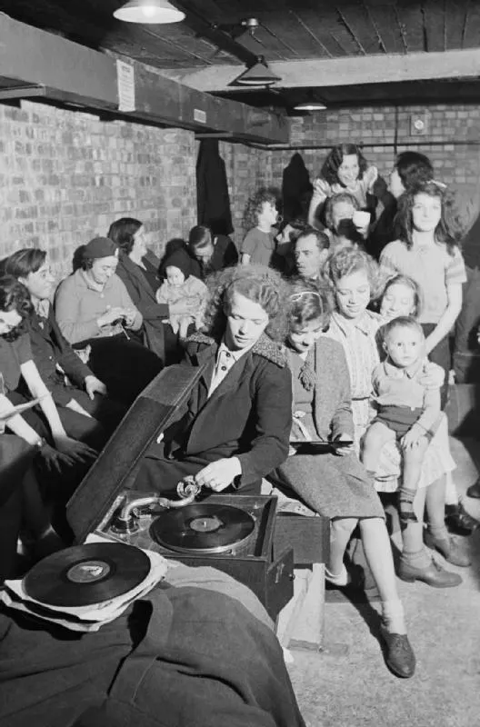
Fig.2: Public air raid shelters could be crowded, uncomfortable and loud. Fortunately, with a little perseverance, fun could be had despite the threat from bombs above. Here, a young woman works a gramophone, putting the needle into place to start a new record.

Underground shelters furthermore helped to forge a sense of community spirit. If people were caught outside their home during an air raid they would go to a public shelter. “A public shelter could range from trenches dug in a local park to brick blockhouses on the corner of the street” (findmypast, 2020). This became an important method of keeping people safe but also bringing them together through difficult times of fear, anxiety and stress. Groups of people from different places and backgrounds could all be sheltering together, bonding over a common cause and finding strength within each other.

Within the coronavirus pandemic gardens have proved to be a community resource also enabling people to join over a common interest during a desperate time. Through social media and over garden fences people are sharing gardening tips and photos to provide inspiration to others and this is the only way people can communicate, due to the isolation of lockdown. “A new report from the National Garden Scheme emphasises the vital role that gardens and outdoor spaces played – and continue to play – in the physical and mental health and wellbeing of the nation during lockdown” (ngs.org.uk, 2020). As people aren’t allowed to meet now, the garden is a place where they can exercise without limitation making it a source of therapy. This has been especially important for those who have been furloughed or those who have become unemployed during the pandemic, which counts for a large percentage. Many of those on furlough or now unemployed have worked for their whole lives and are now unsure what to do; the garden has become an area of focus, refuge and their only connection to other people aiding their mental health. Gardening within both wars has successfully brought people back together providing both a sense of security due to food production and a sense of belonging to something. Within the twenty-first century the population has become increasingly isolated due to the introduction of digital technology and social media making it less important to see people. The pandemic and enforced lockdowns arguably have created a sense of isolation which has in turn forged a sense of community bringing people together through common interests and in ways not seen before the pandemic; many people before did not know who their neighbours were and now are friends. “Coronavirus is bringing communities together – with a quarter of adults saying it has seen them talk to neighbours they previously had no relationship with” (swnsdigital, 2020).

Both wars, through the devastation and death, have brought a greater sense of community to society with people understanding and needing each other more. This has been shown within the coronavirus with the introduction of the ‘clap for the NHS’ whereby neighbours alike would join in the street on a Thursday at 8pm to clap in solidarity. “At 20:00 on the first Thursday of lockdown, a tradition began that would involve millions of people up and down the country - Clap for Carers” (BBCNews, 2020). In addition food banks and local shoppers were put in place to help those in need. “Others have started to donate to a foodbank (13 per cent), volunteered for a charity or local group in need (10 per cent) or shopped from a small or local business instead of going to a large chain (28 per cent)” (swnsdigital, 2020). Food was an act of solidarity within world war two also, at a time when rations were also in place. The Anderson shelters were covered with vegetables with neighbours often sharing resources and shelters were made more bearable through sharing food. “Longley’s mum did her best to make things more bearable for her and her siblings: ‘She would get a tin of broken biscuits from Woolworths to eat. And she would take a few bottles of milk’” (Arbuckle, 2015). Although both times of great stress, anxiety and fear when mental health has arguably been at its worse, the kindness of others has been a common theme through both.

World War Two and the Coronavirus have been very similar, sharing common themes of solidarity between people and the need for communication and shelter. Within world war two people were united within shelters whether Anderson, Morrison or underground and this forged a community spirit. Similarly in the coronavirus pandemic people have sought the company of others engaging in social media zoom chats and conversations over the garden fence. The garden has proved an important theme in both providing an outlet for communication and improving mental health, in addition to being a place to exercise and grow food and flowers. Food has played an important role in both; in world war two people faced extreme deprivation through rationing which resulted in those who were able, growing their own food to provide for their family. In the coronavirus food has been given to deprived families through food banks and those who have faced unemployment or been furloughed. A new wave of gardeners has also been born as many found the need to escape their four walls and have space for themselves; a new hobby in addition to being able to provide for their families. Despite the coronavirus being an unseen war and world war two being seen, two different generations have been brought together and a new understanding shared through the common themes experienced.

List of Illustrations

Figure 1: Fox Photos/ Getty Images (c.1943) A South London resident waters the vegetables planted on the roof of her Anderson shelter [Photo] Available at: https://mashable.com/2015/07/24/wwii-backyard-bunkers/?europe=true (Accessed: 24 February 2021).

Figure 2: FindmyPast (2020) Public air raid shelters could be crowded, uncomfortable and loud. Fortunately, with a little perseverance, fun could be had despite the threat from bombs above. Here, a young woman works a gramophone, putting the needle into place to start a new record. [Photo] Available at: https://www.findmypast.co.uk/blog/history/anderson-and-morrison-air-raid-shelters-and-the-british-public?ds_kid=39700052327871087&gclid=CjwKCAiAp4KCBhB6EiwAxRxbpEPjqP5d0Ui1KeEBNRGMo-MvuNSx8phH9NNB_O2N6fNpNFn0SLwWrBoC3EsQAvD_BwE&gclsrc=aw.ds (Accessed: 24 February 2021).

References

Arbuckle, A.Q. (2015) 1939-1944 Backyard bunkers of the Blitz Available at: https://mashable.com/2015/07/24/wwii-backyard-bunkers/?europe=true (Accessed: 24 February 2021).

BBCNews (2020) Coronavirus: The Story of Wales’ 100 days of lockdown [Website] Available at: https://www.bbc.co.uk/news/uk-wales-53219452 (Accessed: 26 February 2021).

Findmypast (2020) The difference between Anderson and Morrison air raid shelters during the second world war. Available at: https://www.findmypast.co.uk/blog/history/anderson-and-morrison-air-raid-shelters-and-the-british-public?ds_kid=39700052327871087&gclid=CjwKCAiAp4KCBhB6EiwAxRxbpEPjqP5d0Ui1KeEBNRGMo-MvuNSx8phH9NNB_O2N6fNpNFn0SLwWrBoC3EsQAvD_BwE&gclsrc=aw.ds (Accessed: 24 February 2021).

National Open Garden Scheme (2020) New report: Gardens and Coronavirus 2020 [Website] Available at:
https://ngs.org.uk/new-report-gardens-and-coronavirus-2020/ (Accessed: 26 February 2021).

Swnsdigital (2020) Coronavirus is bringing communities together [Website] Available at:
https://www.swnsdigital.com/2020/03/coronavirus-is-bringing-communities-together/ (Accessed: 26 February 2021).

