BMHP5015 – Changemakers: Building your Personal Brand Guidance Paper

Cover page:
Name
Student Number
Module Code
Module Title
Lecturer Name

Main Body : Using the below headings – students will provide a screenshot of their completed unit (see example below) students can also include any notes they have written in relation to the topic. Note – tutors are able to see the activity completion via Moodle VLE.

Introduction – 100 words approx.

Unit 1 – Brand You - 450 words approx.
Topic 1: Ambition is critical (example)
Screenshot of completion:
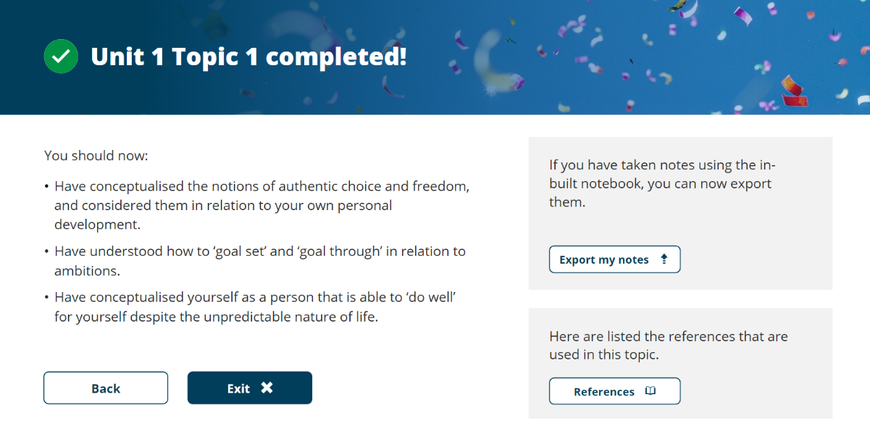

Notes: Here you will add any notes or answers which you have provided in the topic (e.g. during the ‘apply’ or ‘reflect’ tasks) and any references which you have used to support your answers.

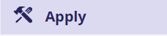

Continuing with the example above you will add in further information for the below headings:

Topic 2: What drives you?
Screenshot of completion:

Topic 3: Boundaryless careers
Screenshot of completion:

Topic 4: Boundaryless skills
Screenshot of completion:

Summary Notes of Unit: 450 words approx.
Here you will provide an overview of the unit including any references or important information.

Unit 2 – It’s a Small World – 450 words approx.
Topic 1: No one is an island
Screenshot of completion:

Topic 2: Variety is the spice of life
Screenshot of completion:

Topic 3: Network society
Screenshot of completion:

Topic 4: Making connections
Tutor led activity –

Summary Notes of Unit: 450 words approx.
You will provide here a summary of the unit which must include a reflection of the activity which your tutor has instructed you to do during session. If you have any accompanying documentation e.g. drawings or pictures you can also input them here.

Unit 3 – Opportunity Knocks
Topic 1: Creating your own luck
Screenshot of completion:

Topic 2: Identifying career opportunities
Screenshot of completion:

Topic 3: Open doors
Tutor led activity –
Here you will input a reflection of the activity which your tutor has instructed you to do
during session. If you have any accompanying documentation e.g. drawings or pictures
you can also input them here.

Topic 4: Me.com
Screenshot of completion:

Summary of the Unit: 450 words approx.

Unit 4 – The pursuit of happiness
Topic 1: Future me
Screenshot of completion:

Topic 2: Passion and perseverance
Screenshot of completion:

Topic 3: Plan, prepare, perform
Screenshot of completion:

Topic 4: Career role models
Screenshot of completion:

Summary of the Unit: 450 words approx.

Conclusion: 100 words approx.

Reference List – at least 8 sources

