Mahmud Akbar
SN-1711691
Knowledge and Information Management
Skills for the Workplace
BMSK 5006
Lecturer – Dr Md Nazmul Hasan

Mid-Term Formative Assessment
Question 1.
Explain why the same set of data can be considered as useful information by some and useless data by others. Further, could this useful information be termed as “Knowledge”? Why?
A supermarket uses barcodes to price their products. It is useful for them as it can be used at the tills to inform the cashiers of the price of the items. The bar codes are of no importance to others.
When applying to renew a British passport, a person is given a unique reference number to contact the Home Office if required. This is only important to them and useless to others.
If the same set of data, has been acquired by some people, only browsed upon but not properly understood, not put into practice or made no difference to them, then they have dismissed this data and it is frivolous and totally useless to them. According to the Harvard Business Review, data is useless without the skills to analyse it (Harris, 2012). This means the two above examples of data are only important for the people concerned, as they can analyse it and transform the data into information. The source of the data is only for a specific subject or purpose; thus, it is of no value to others as it cannot be processed for their needs (Avasarikar and Chordiya, 2007). In some circumstances if the analyst has not properly interpreted the data, this can lead to confusion and the data can be rendered useless.
The information obtained from the data, refined and made relevant to achieving one’s specific need can be perceived as “Knowledge”. When a person has the relevant information, has fully understood it, is capable of using it for their specific purpose and able to take the correct action, then they have acquired the knowledge.
Question 2.
Describe the ways in which “knowledge” differs from “data” and “information.” Justify your answer with a relevant diagram.
It is often recited that “Knowledge is Power”, but knowledge without action is useless. To acquire this capacity, we have to acknowledge certain procedures before it becomes cultivated, scholarly and dynamic.
Knowledge is regarded as to what people know. It is the cultivation of data, the culmination of facts and information which have been acquired to enrich a person’s intelligence. When the combination of data and information is given relevance and significance, it formally becomes knowledge (Thompson and Warren, 2009) This improves a person’s understanding, perceptions and enhances their sense of reasoning and decision making.
Data is the primary stage of the provision and acquirement of sources. As it is in a raw form, it needs to be ascertained and assessed what is relevant and will be beneficial. After this initial filtration, data is integrated into information. Data is obtained by means of sense and observation, analysed and interpreted and utilised to enhance the knowledge. Data is elementary, intrinsic, unsophisticated and unorganised (Thierauf, 1999). Data exists in various forms, such as numbers, sound, symbols, words, images and facts. The source of data can be procured from surveys, timetables, programmes, symbols, hearsay and from the subject of curiosity. Data merely exists, it is there without any relevance on its own.
The gathering of data, refining it, understanding it better and giving it a sense of meaning and purpose, can be defined as information, (Ackoff, 1989). Data that has been analysed, given a structure, has an essence to help to provide a solution to a question or problem.
Information is data that has some significance, informs and makes a difference to the person who has acquired the data, (Davenport and Prusak, 1998).
Data exists in various forms, shapes, sizes and in many places and texts. People will select a set of data, because it is something that has captured their interest or is necessary for their objectives, help them in their initial stage to reach their destination, conclude their research or accomplish their work assignments. They will use these data, filter it, add some meaning to it and utilise it for their purpose and when an outcome is satisfactorily reached, it can be truly termed as productive information. The assimilation and the application of the information can be termed as “Knowledge”. The collection of data, the acquiring of information and the ability to put this into effective practice is knowledge.
Knowledge is the boon, the confidence and the proficiency of know- how, acquired through research, information, experience and intuition. Knowledge must be applied purposefully to sustain and improve competitive performance of a business (Roberts, 2018).
A goldsmith acquires a block of gold, as it is raw material it is just a piece of stone. Like data it is futile. Once the gold has been processed and polished, made into jewellery, it becomes productive and valuable. He then displays the gold jewellery in the shop for customers to browse and buy, which is the information. The knowledge is the fact he knows to display the product in the shop for the customers to purchase. Just an after -thought, gold is very valuable, but knowledge is invaluable, more than its weight in gold.

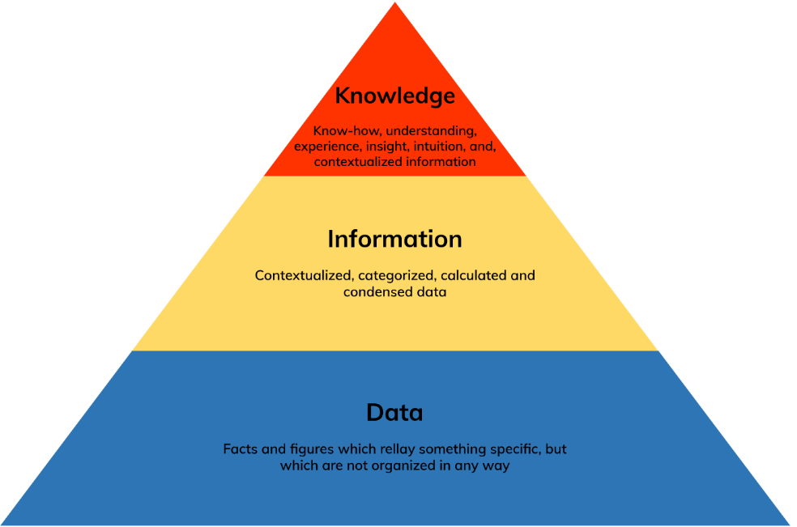

http://www.knowledge-management-tools.net/images/svg/knowledge-pyramid.svg
An analysis of the above diagram is data is unrefined and unstructured. By adding some context, validation and relevance search, data goes into the processing stage.
The collected data is analysed to how relevant it is for the user’s purpose or to their goals, becoming information for them. Information is refined, processed, acquired, put into context, articulated and displayed in an academic form, which can be applied to achieve their objectives or the organisational goals.
Knowledge is the reward of successfully having overcome the first two stages to achieve something meaningful and effective (Skyrme and Amidon, 1997). Knowledge can be articulated, written down, shared and stored systematically.

Question 3.
Does a player in a card game use tacit or explicit knowledge? Explain why. Define and explain the difference between the two.
A card player uses tacit knowledge, they know how to play the game and the enjoyment they experience, but they find it difficult to describe their feelings or the art of participation. Tacit knowledge is the art of know how to the players, so by using this talent, combined with their intuitions and experience, they try to out-wit their opponents. They rely on practice, experience, patience and instinct to make the right decision and win the game. As their knowledge or expertise is very difficult to relate academically or codify, it cannot be described or replicated.
To an extent a novice card player will use a form of explicit knowledge and common sense. A game has some rules and regulations to which the players have to adhere to.
Tacit knowledge is intangible knowledge, acquired from observation, experience and insight. Intangible can be described as vague, abstract, that cannot be assessed or measured because it has no physical substance (Howells, 1996). That is why it is very difficult to write down, describe or share verbally with other people. One can infer tacit knowledge is more distinct and is more in the individuals’ heads. Tacit knowledge is something that enhances with practice, only the possessor can apply it effectively. It cannot be shared, and imitations will have its limitations.
Explicit knowledge is tangible knowledge, something visible, substantial and coherent. It is knowledge that can be acquired from formal education, a designated form of study or training programme and from the experience of having performed a task. It is easy to record, articulate, understand, share and store. The recording and articulation can be classed as the processing, organising, structuring and analysing of data. Once the knowledge has been comprehended, then it can be imparted to benefit the group or organisation. The effectiveness of explicit knowledge depends on the skills of the user. The beauty of explicit knowledge is it can be easily stored for future references.

Question 4.
Consider five decisions you have made today (they could be simple such as taking a turn while driving or even choosing a soda at a convenience store.) In each case determine the data, information or knowledge that were involved in the decision.
Data, information and knowledge in tandem play a vital part into making decisions every day. I would like to investigate five decisions I have made today.
1.The X1 bus leaves every twenty minutes from Coventry to Birmingham. I have to attend the university in Birmingham today. I need to be there by 9.15. As I am travelling by bus from Coventry, I set forth at 8.0 to arrive on time.
The data is the frequency of the bus timetable. The information is what time I need to arrive. The knowledge is I need to catch the 8 o’clock bus to arrive on time.
2.Received a letter from my daughter’s school requesting to make an appointment for parents’ meeting on the 17th of October 2019. As it had to be made online, I used that system to make the appointment.
The data is the letter from the school. The information is the meeting and the date. The knowledge is making the appointment online.
3.I have to make the shopping list for my workplace. I need to check the store and cold room to see what we need to order. I make the list and then have to send it via WhatsApp to the supplier.
The data is the shopping list. The information is checking and making the list. The knowledge is sending the list via WhatsApp.
4.I need to order some change for my workplace. I have checked what is required and phone the bank to place the order, so they will have it ready for me to collect the next day.
The data is the change order. The information is to check and phone the bank. The knowledge is to pick up the change the next day.
5.I need a new phone contract, as my current one expires in two weeks -time. I am looking for a better phone and the best deal.
The data is new phone contract. The information is the current contract expires in two weeks. The knowledge is seeking the best deal.
Question 5.
Now consider how those decisions would have been influenced by the lack of pre-existing data, information or knowledge.
Decisions made with a lack of data would be baseless, made on assumptions and incoherent. Inconclusive and the wrong decision may be made. A lack of information would not support making an effective decision, as there would be no guidelines, deadlines or sufficient knowledge. With a dearth of research, I may acquire the wrong information, spend more time and more money. Without verified data, metrics and a re-evaluation system I would struggle to make a positive decision (Durcevic, 2018).
For the first decision, if I did not know the time to be present at the university, I would not know what time to depart and could have been late. This would have resulted in being marked late and missing vital parts of the lecture.
For the second decision, if I did not know about the timetable, the location and about booking an online appointment, I would have missed the meeting. I would have missed out on vital feedbacks and more importantly let my daughter down.
For the third decision, if I did not make a thorough check, we would have ingredients missing, which would be detrimental into cooking some the dishes and a loss of business.
Fourthly, if I don’t order the correct change, then I would be short-changed and struggle to provide change to the customers. If I make mistakes like not ordering the correct supplies and change, excuse the punt, then the employer may want to change the manager.
Finally, if I am unaware of the expiry of my phone contract, then I would be unable to change to a better offer. This would result in a financial loss to me and also deny me the satisfaction of using a better product.
Question 6.
You have recently invented a new product. Collect demographic data from a sample population, determine how you would use this data, and convert it into information and possibly knowledge for promoting the product.
Eureka! I have finally perfected the “magic mirror”. I have invented a beautiful HD mirror with LED lights. It has a ten times magnifying capability, which provides great clarity for skin and hair examination. It will wonderfully enable ladies to apply makeup perfectly, precisely remove hair and allow to style their hair immaculately. It is also useful for men to get the perfect close shave. With the HD effect it provides a very clear and close-up of your face and body skin. It is essential for the daily skincare and will help to detect any early signs of any skin problems.
The beauty of this product is it is moisture-proof and it has LED lights, which means you can use it in the dark and will always be crystal clear. It comes in three sizes, the large one to put on the wall, medium and the most beautiful one to display on the table and a compact one that can fit into the hand bag.
When a new company is about to launch a new product, it needs to carry out a market survey to collect primary data and evaluate customer reactions. If the company is satisfied with the research, it will use secondary data composed by the government, for example surveys or demographic data (Waters, 1997).
As a small organisation, with limited resources we will have to carefully select the data and ensure it meets the CRAAP criteria, (Currency, Relevance, Authority, Accuracy and Purpose).
This product is universal and useful for all types of people. It will be greatly beneficial to the female population, especially to young ladies aged between eighteen to forty-four years. It is an excellent product, which will greatly enhance and compliment the users’ collection.
Having a great product on board, now is the time to market and sell it. The strategy is to identify the target market and convince them you are providing a superior merchandise to them, (Kotler, 1999). It is essential to recognise the target customers, how and where they obtain information regarding new products.
According to the data analysed from the surveys, there are a few options to advertise the newly invented mirror.
Social media sites such as Facebook and Twitter.
Create your own website and provide information and answers to few key questions.
Email marketing, by sending emails to current and new customers. This can be fast, flexible and cheap. Capture their interest by accentuating on an innovative product, which offers an introductory discount of 20%.
From analysing a few young people, probably the best way to attract their interest and custom is to hire one of these talented people to showcase your product on YouTube. They demonstrate and talk very effectively about the merchandise.
We can advertise by using the conventional methods, in newspapers, posters, leaflets, hosting an open day event and if we are bold enough capture the awareness of the audience at the local city centre. Talk about the beauty of your product, get them to write down their email addresses and put into the box provided. Announce you will be giving away twenty mirrors to the lucky winners picked out from the box.
Next time the user sings mirror, mirror on the wall, I am sure they will get the best reflection of all.

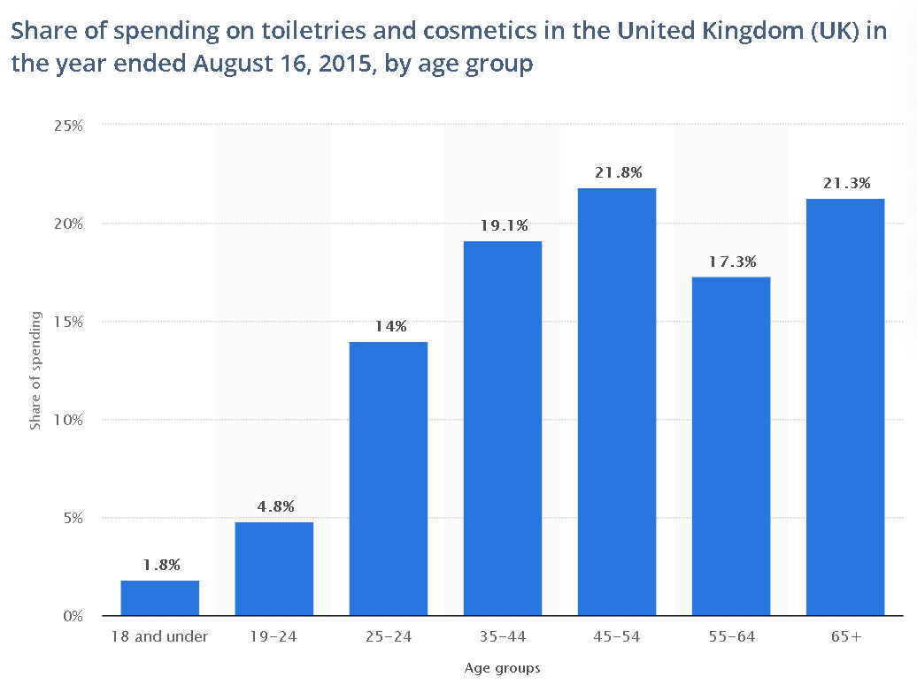
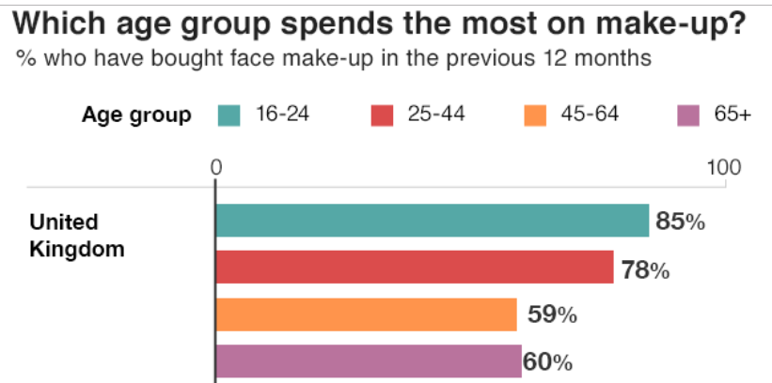
https://www.statista.com/statistics/472626/cosmetics-and-toiletries-spending-share-united-kingdom-uk-by-age/
https://www.statista.com/statistics/713178/makeup-use-frequency-by-age/

End of Term Assessment

Part 1 – Case Study

Q1. Describe how the overall approach adopted by American Airlines incorporated the basic competitive strategies of cost leadership and product differentiation.
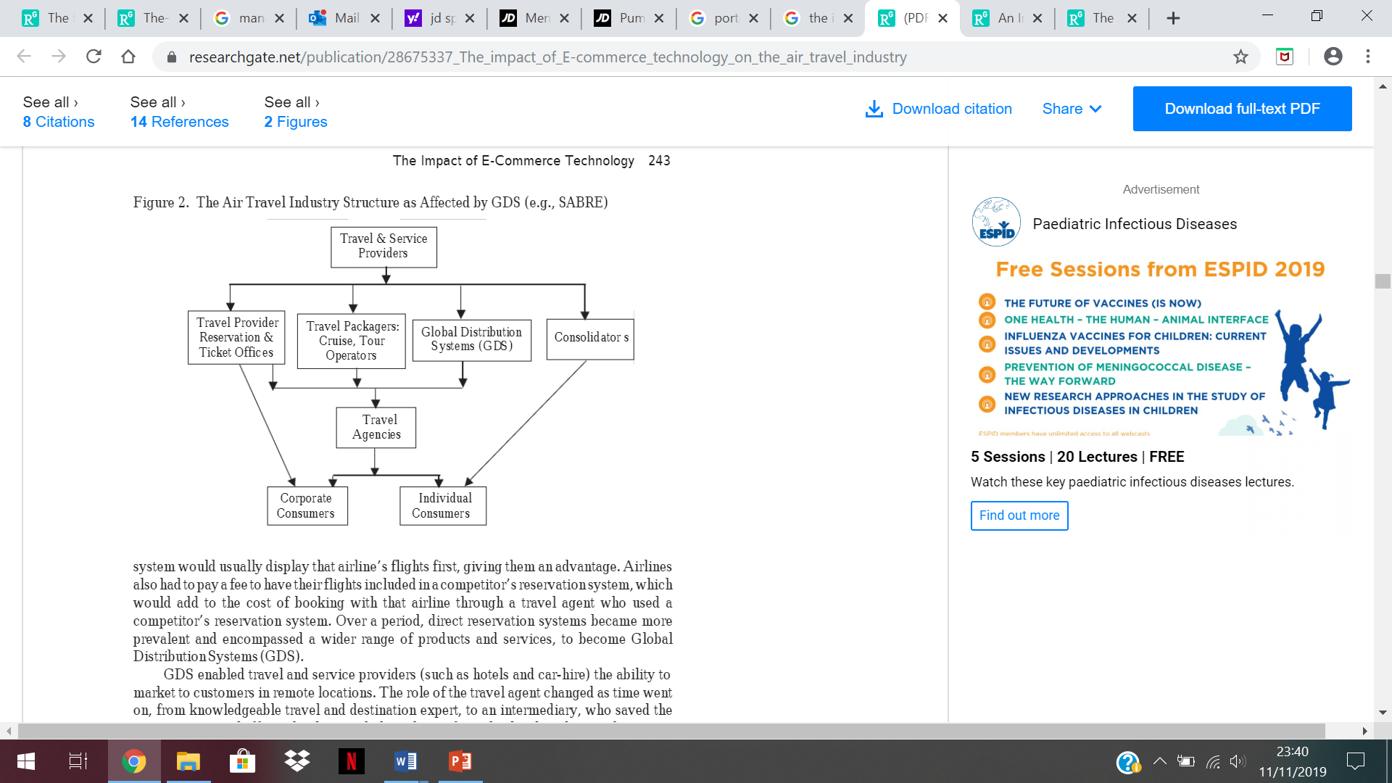
(Gasson, 2003)
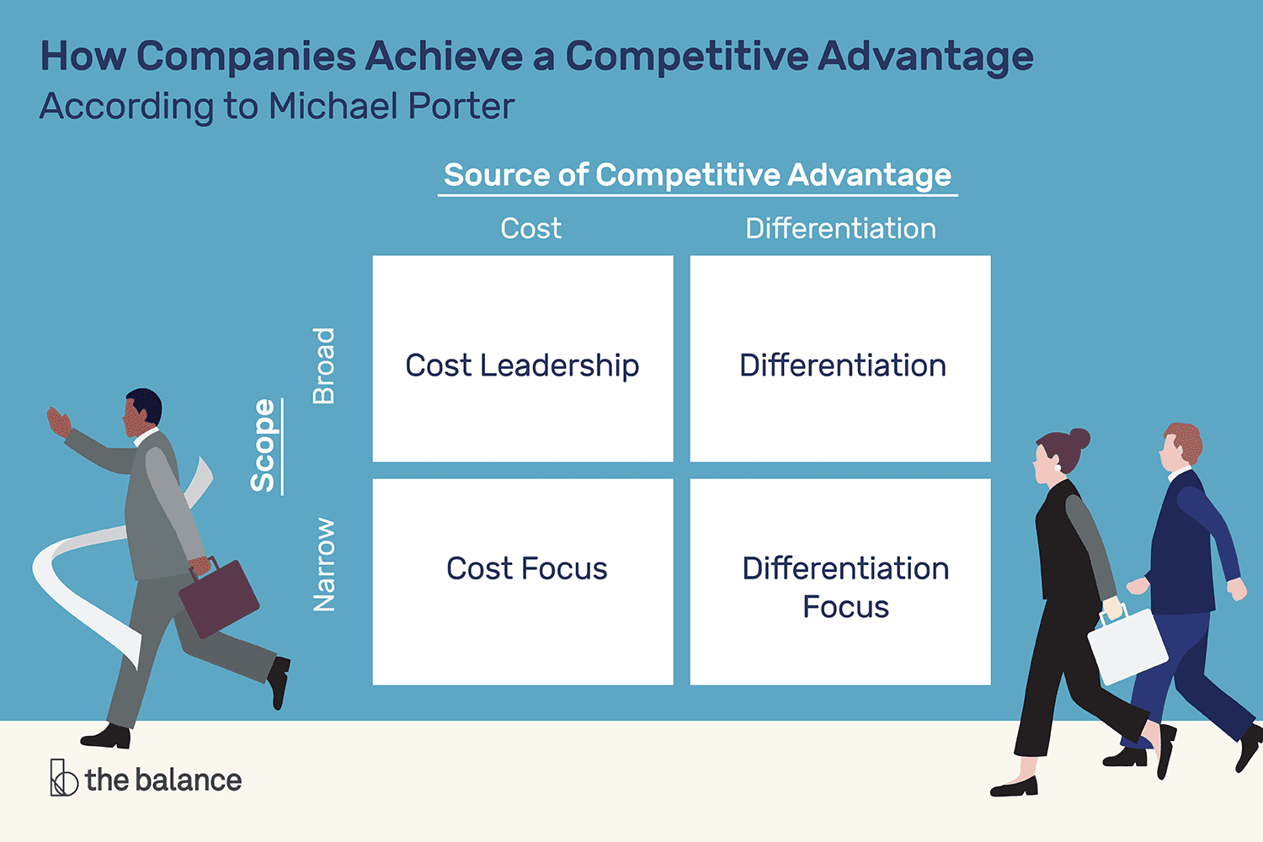

(Amadeo, 2019)

American Airlines believed travellers needed better information and the SABRE system was the best platform to highlight the services they offered. It provided travellers with the latest fares’ and the availability of flights. It encouraged them to use the information from the data and use this knowledge to book their flights at the best prices. This gave American Airlines an opportunity to capture the market for a product, which had a great demand. To achieve their goals, they implemented the basic strategies of cost leadership and product differentiation.

As the SABRE concept was exclusive to American Airlines, this provided them with huge advantage in innovation, cost leadership and product differentiation. Cost leadership means implementing the lowest cost of functioning in the industry to gaining a competitive advantage (Porter, 2007 Mindtools). This is done by creating a superior product and sustaining excellent performances and services. By reducing the costs, this increases sales and the company’s profile (www.capsim.com). As the SABRE System saved thirty per cent on the airlines investment, this was a great boost for the company. This presented American Airlines with a great competitive advantage, they were able to pass on some of the savings to the customers. By charging lower prices, they were able to increase the market shares and still making a substantial profit because of high volume of sales.
When customers are dithering and contemplating, this is the best moment for businesses to fully utilise their innovation and resources to attract them. One of the most vital factors is the product differentiation method used to define the unique qualities of the commodity and service to capture the customer engagement. In cost leadership, price is the dominant factor but for a product to be more appealing to the consumer, other conceptions need to be implemented in tandem to inform and attract the customers. Product differentiation is the marketing strategy of distinguishing an organisation’s product or services from the competitor’s (Kopp, 2019 investopedia.com). It is the method of identifying the company’s unique points of sale and proclaiming why they are superior to the rivals. Products, services or both are different and more appealing from the competitors, a company offering certain products, special features and services, others cannot provide or match.
Cost differentiation defines the benefits of the firm’s product compared to similar ones. It describes how their products or services are different, better and more appealing than one’s competitors. It highlights the company’s credentials, in the form of brand, better promotion and communication and consumer satisfaction. Prior to the flight the AA presented passengers with excellent information, which gave them the knowledge and opportunity to reserve transport for airport transfer, car rentals whilst there and book hotels for their stay. It inspires the customer to select them from other providers or brands and create a competitive advantage for the successful company. American Airlines, ingeniously combined fair pricing and the factors of product differentiation to become the market leaders in their field.
Q2. In what ways did SABRE provide American Airlines with a competitive advantage. Your analysis should refer to concepts related to the strategic use of information systems, for example, entry barriers.
The SABRE system revolutionised the airline reservations and how they functioned commercially. It invented a method for the travel industry to operate online transactions, by using computers connected to a network (www.ibm.com, 2019). As the SABRE System was exclusive to the AA, it gave them great competitive advantages, (www.ibm.com). They offered a service that was easy to order, had exceptional delivery time, provided excellent customer relationship and experiences. They can be classed as market innovators and prominent providers of better options and proficient service on a regular basis (Stair and Reynolds, 2012 www.abebooks.co.uk).
The application of the Porter’s five forces concept will provide a conclusive analysis in to the advantages gained by AA from the SABRE system. In 1985, Michael Porter identified five forces that hugely affect a company’s profits, in their particular business. The framework was devised to investigate the impact of the subsequently mentioned factors on a firms’ profits and progress. The system also allows to evaluate what threats the organisation may encounter in the future.

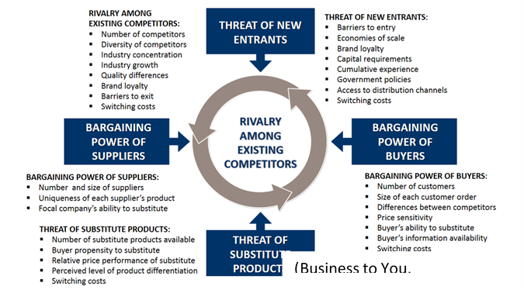
Bargaining power of the buyers
The buyers are the customers, mostly very demanding, wanting the best quality products and services for the minimum price possible. If the customers have the option of similar products and services elsewhere, then that puts a lot of stress on AA to trump them. They may need to give discounts or provide something special to retain the customers. The buyers possess a lot of bargaining power, as they can delay making a quick decision and switch from one airline to another as the penalty is very cheap. This is where the SABRE method was very instrumental in equipping AA with a competitive edge. They had access to the latest information, which enabled them to offer their huge database of customers the best deals, which could be reserved immediately. The buyers had access to lot of information to read, compare and select the best deals. They were well informed about the prowess of the AA’s excellent services, enhanced products and reliability. By catering to the customers’ needs, this increased customer satisfaction, loyalty and reduced defection.
Bargaining Power of Suppliers
Some suppliers, dealing with big companies tend to quote higher prices, and in most cases are able to obtain the contract. These big companies sometimes overlook the possible savings, for the sake of consistency, to save time or the extra workload. Although AA bought materials and food stocks from various suppliers, as to give them the upper-hand in bargaining, sometimes they were not savvy in getting the best deals. The impact of higher supplier- power, can reduce the profitability of the airline, but having the ability to buy in bulk, reduced the costs and offset the company’s bargaining power. This provided AA with a great advantage, as the supplier would be unable to find such a big buyer.
The Threat of New Entrance
As it is very expensive to set up an airline company, the threat of new entrance is very low. A lot of research, resources, investment, and patience is required to get a foothold on the airline industry. It is time consuming and needs to meet the government’s stringent laws and regulations. By setting high entry standards, it discouraged new entrance into the industry.
The Threat of Substitute Products
Sometimes when customers are dissatisfied, they buy a different product, utilise an alternative service or provider. The threat of substitute products was very low as the alternative method of travelling long distances by train, bus or car was impractical and time consuming. In most cases it was not possible to travel using those types of vehicles. By innovating new products and providing improved services AA was able to combat the threats of substitutes. The firm had an excellent customer data base, so it was able to maintain reasonable prices. This offers customers value for money, retains loyalty and safeguards its competitive edge.
The AA offered its customers with excellent choices, which is pivotal in increasing customer satisfaction. For example, the first- class passengers had very comfortable seats, superior service and a good bar facility to enjoy their drinks. Even the economy class passengers received outstanding service and were provided with good entertainment options. The framework below is the closest illustration of the competitive advantage provided by the SABRE system to American Airlines.

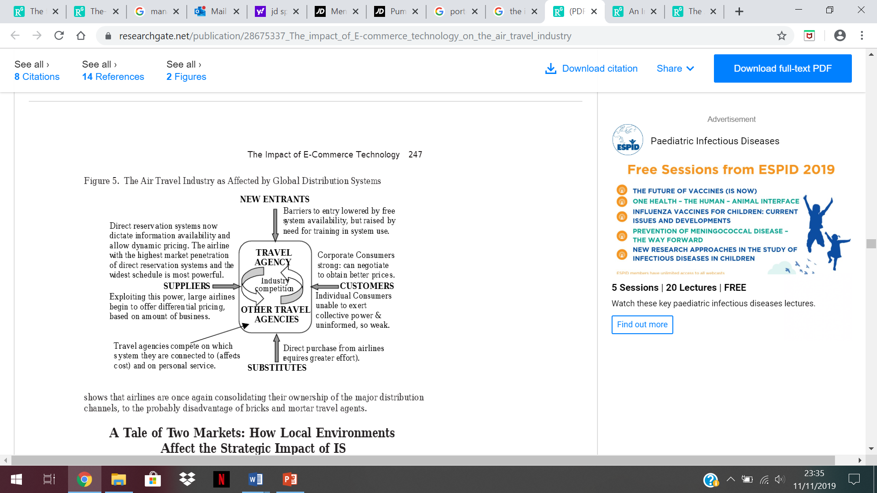
(Gasson, 2003)

Q3. Although SABRE was undoubtedly successful, American Airlines was not able to maintain as competitive advantage beyond the late 1980s. What factors played a part in the erosion of the company’s lead over its competitors and how did the company react?
In any field of competition, all the rivals are determined to beat the champions. During the American Airlines (AA) reign they were the champions in their industry and the competitors were also-rans. Whilst the American Airlines organisation was basking in their glory, some of the competitors were improving and reaching a level field to compete equally with them. Some external and internal factors contributed to the demise of the AA lead over its rivals. Internally, the company was stubborn in its approach to change and had become complacent. Its slow- reaction, reduced the company’s ability to adapt to the changing regulation and modern consumer needs. The complacency factor led the company to not recognising the immediate threats of competitors, and the rivals seized the opportunity to over -take them.
AA, took a strategic risk by not investing, updating their technology and management style. Some of their aeroplanes were quite old, therefore rendered substandard. A lack of innovation made the company stagnant and reduced their influence on the market. The reluctance to modernise and embrace new technology and not applying new marketing techniques, contributed to AA not being able to compete with other organisation’s technological advancements. The agreement with the airline union, was any new employees would receive less wages than the existing workforce (www.nytimes.com). This restricted the airlines to recruiting the very talented people for their company. They had low bargaining power with the union, which meant they could not pay higher wages to attract the employees who would have empowered the organisation. The impact of the competitor’s highly skilled workforce and technological evolutions was huge, reducing the once proud airlines to unformidable opponents.

Part 2 – Information System
Q1. Define an information system.
The advancement in technology has enhanced how businesses operate and their ability to utilise the technology for a smooth functioning and to create a competitive advantage. An information system is software that enables organisations to obtain data, analyse it and apply it to solve problems or enhance operations (https://study.com). The technology will hugely help to improve the company’s productivity and efficiency.
The advent of the Electronic Point of Sales (EPOS) information system has made significant improvements into the way a business operates. The EPOS programme, with functionality to control and manage the business in a simple to use system. It is a computerised network, operated by a main computer, which are connected to several checkout terminals (www.entrepreneur.com, 2019). The business owners or managers can select a customised EPOS software to meet the needs of their business requirements. The technology is also employed by businesses to allow customers to order online and pay for products or services. The information technology system needs to be in alignment with the business’ strategy to achieve the optimal benefits (www.nibusinessinfo.co.uk).
Q2. Describe the categories of computer-based information systems, providing relevant business examples for each category identified;
Computer-based information systems (CBIS) are information systems, which are dependent on the use of computers. The focus is on the implementation of information technology in organisations to enable them to function successfully, supporting activities and business- related decisions. As there are various interests, needs and levels in an organisation, different types of systems are required to
fulfil the demands. The four basic types of computer-based information systems are transaction processing system (TPS), management information system (MIS), decision support systems (DSS) and executive information systems (EIS).
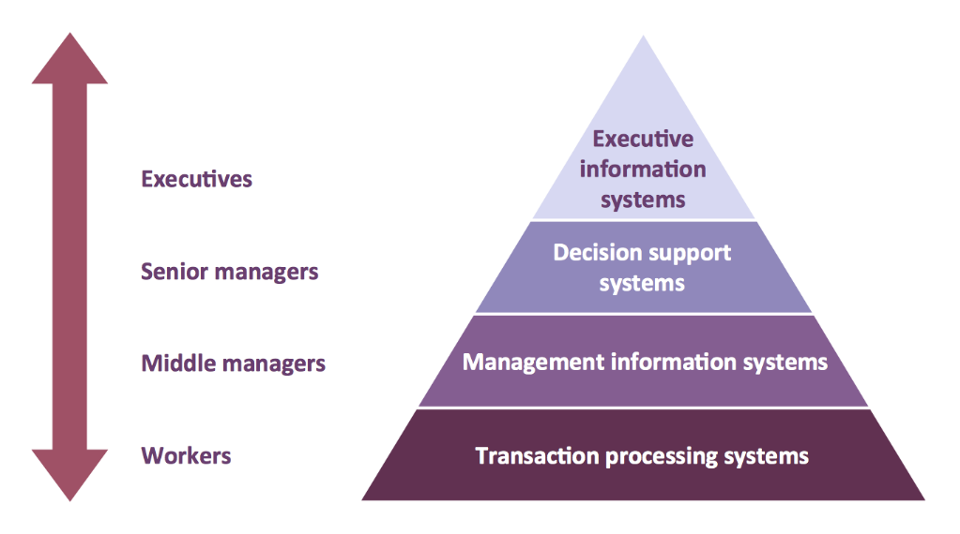
(Concept draw, 2019)
Transactional processing systems are the daily procedures of conducting business. This practice helps to maintain customers’ orders, bills, manage productivity levels and keep track of the inventory. Transactional processing is conducted by computer hardware and software to complete a business deal. This helps to carry out routine activities in buying and selling. As these are basic activities, it is generally performed by the employees at the bottom of the functioning pyramid. The cashier at a shop taking payments from the customers, the administration office at a school maintaining the attendance register or the factory office keeping the employee records and the restaurant waiter taking the customers’ orders.
Management information systems is intended to control the information within a company. It requires hardware and software to enable the MIS to function competently. The software programmes are devised to help managers to maintain employee records, invoicing, quantity of goods in stock, good customer relationships and business analysis. MIS users are usually the middle managers in an organisation, who employ the method to collect information, make appropriate reports, which are sent to senior managers to provide them with the current, accurate and the most relevant information. The purpose of this is to aid the senior level management to proficiently make strategic or long-term organisational planning.
Decision support system (DSS) is a computerised programme, which as the name indicates helps the users to make effective decisions at a higher level in an organisation. This system involves business executives or in some workplaces senior managers, who apply communication technologies, data, knowledge and documents. The managers read, compare and critically analyse the consequences of different decision alternatives and then make the best decision based on their knowledge and experiences. For example, a bank loan manager checks the applicant’s credit score to verify if the person is eligible for a loan.
An executive information system (EIS) is a specialised decision support system that enhances the senior executives’ knowledge and improves their perceptions, to make the best decisions, that will make the organisation stronger and more efficient in the long run. The EIS provides these top- level managers with the comprehensive details within the organisation. As the decision will be made by the most influential people, they will have access to the most detailed internal and external information, which will enable the executives to monitor performances, recognise opportunities and highlight threats or problems.
They will critically analyse the information, garner the specific knowledge and use their expertise and wisdom to make the most beneficial decision for the company. As the executives make strategic decisions, which involves the procedure to develop and further grow the business. They possess the power to do this, so the executives can decide to further establish the company by going international. For example, McDonalds opening restaurants in India or Marks and Spencer’s executive managers deciding to give contracts to a Bangladeshi firm to make shirts for them.
Q3. Explain how computer-based information systems can support managers at each level of an organisation.
Businesses are depending more on computer-based information systems (CBIS) to obtain better information, which will help them to make the best or correct decisions. Although all information acquired, do not have to be computer-based, but eminent writers have verified that computers enhance the processing capabilities and the absorption level of the human minds (Kroenke and Hatch, 1993). CBIS is a tool to assist managers at all levels, by optimising the obtainable information to make the best decisions. With the use of information systems and the appropriate technology, organisations are capable of improving decision making, providing excellent services, sustain high productivity levels and as a result increase profit. The effective application of the knowledge attained from the information can have a significant effect on the managerial structure of an organisation (Chaffey,Bocij,Greasley and Hickie, 2003).
The subsequent pyramid demonstrates how the CBIS can effectively support managers at the various levels of an organisation.
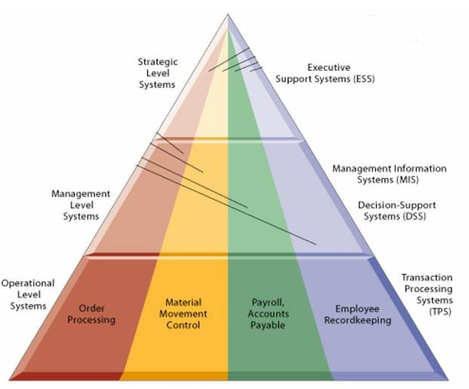
(Researchgate, 2019)

The EPOS system allows the three levels of management to derive the relevant information for their purposes. At the operational level, the employee is able to take the customers’ orders and process the payments. They are allocated certain tasks, which they need to perform on a daily basis. They are only allowed to make low level decisions, which may help them to accomplish their jobs. For example, at a supermarket if there has been a high quantity of baked beans sold, then without waiting for the manager’s instructions, the worker should be able to decide to refill the shelves.
The management level people have the authority to monitor employee attendance, check the inventory level, ensure bills payment, check the daily takings and prepare reports for the senior managers.
The executives make decisions and implement policies that will impact the company in the long-term functioning. These strategists analyse the reports and decide how effectively the business is operating. They will decide if the company needs to launch a new product, improve customer satisfaction, increase the ethical practice of the business, reduce unnecessary expenses and increase profits.

