

Student name: Rebeca Daniela Serban
Student ID: 2331907
Module name: Changemakers: Building your Personal Brand for Sustainable Employment
Module code: BMHP5015
Lecturer name: Caroline Salami

London, 13 April

Contents
Introduction 3
Task 1 – Unit 1: Brand You 4
Sreenshot 2. Week 2 forum – Soft Skills 4
Screenshot 3. Week 2 Forum – Why Self-awareness is essential in Health and social care? 5
Task 2 – Unit 2: It’s a Small World 5
Screenshot 4 Week 3 Forum – Evolution 6
Screenshot 5. Week 3 Forum – Network means 7
Screenshot 6. Week 4 Forum – Network of influence 7
Task 3 – Unit 3: Opportunity Knocks 7
Screenshot 7. Week 5 forum - Why Changing perspective in health in social care is important? 8
Screenshot 8 Week 6 Forum -Open doors , job opportunity 9
Task 4 – Unit 4: The Pursuit of Happiness 9
Screenshot 9 week 7 about to change the mind in positivity still life 10
Screenshot 10 forum week 7 Limiting beliefs 11
Screenshot 11 Forum week 7 about support and strategies 11
Conclusion 11
References 12

Introduction

The main lessons learned from Units 1-4 of the module are compiled in this portfolio, each of which has been crucial in forming my professional identity and personal brand in the health and social care industry. I completed reflection exercises throughout the online activities, which inspired me to delve further into my values, abilities, talents, and long-term goals (Tan, W. 2025). These exercises emphasised the value of self-awareness, self-assurance, and proactive action in creating a meaningful and long-lasting career path. I gained a better knowledge of how opportunity recognition, effective communication, personal branding, and organised career planning support continuous professional development by finishing the weekly activities ( Meshoyrer, et al, 2024)
Every unit presented a unique viewpoint on employability. While Unit 2 stressed the need of forming deep connections and growing my network, Unit 1 concentrated on understanding myself as a developing professional. Unit 4 helped me think more strategically about my future goals and the attributes needed to attain them, while Unit 3 pushed me to identify, assess, and take advantage of new chances. Together, these courses improved my capacity for critical reflection, deliberate planning, and taking responsibility for my own growth. This portfolio shows how these ideas relate to health and social care and how they will help me advance in the field (James, T. et al. 2023)

Task 1 – Unit 1: Brand You
In addition to introducing the idea of personal branding, Unit 1 pushed me to consider my identity as a budding professional in the field of health and social care. Self-determination, or taking responsibility for my education, choices, and long-term professional path, was a major theme. Through the exercises, I realised that self-determination is especially crucial in the health and social care sectors, where professionals need to be driven, accountable, and able to operate autonomously while maintaining high standards of care (Battaglio, et al. 2022). As I thought back on my own experience, I noticed that although I am growing more self-assured in my ability to establish goals and take initiative, I still need to improve my capacity to make judgements without second-guessing myself. I've been able to pinpoint places where I can strengthen my resilience and confidence in my professional judgement thanks to this insight.
The development of soft skills like problem-solving, empathy, teamwork, and communication was another important component of Unit 1. These abilities are crucial in the health and social care sectors, where workers must establish rapport, react tactfully to a range of demands, and work well with coworkers and clients. I discovered through the online exercises that two of my best skills are empathy and communication, especially in circumstances that call for emotional support and active listening. But I also realised that I needed to keep improving my assertiveness and leadership, particularly when it came to supporting service users or participating in team decisions. Knowing my soft talents helped me identify areas for improvement and envision how I may benefit future teams (Lowry, et al. 2025)
The significance of self-awareness, which entails comprehending my capabilities, limitations, values, and behavioural patterns, was also highlighted in Unit 1. After completing the reflection tasks, I was able to identify how my personal values affect how I approach care and deal with difficulties. For instance, I've observed that when faced with ambiguity, I occasionally hesitate to seek for assistance or become extremely judgemental of myself. To ensure safe, moral, and thoughtful practice, it is essential to recognise these inclinations. It also helps me come up with ways to boost my confidence, including asking for feedback more proactively and acknowledging little victories. Ultimately, by challenging me to consider who I am, what I stand for, and how I want to be seen as a future health and social care professional, Unit 1 laid the groundwork for developing my personal brand. The knowledge acquired will direct my continued growth and fortify my professional identity (Scheidt, et al. 2024)

- Screenshot 1. Week 1 Forum – Self determination
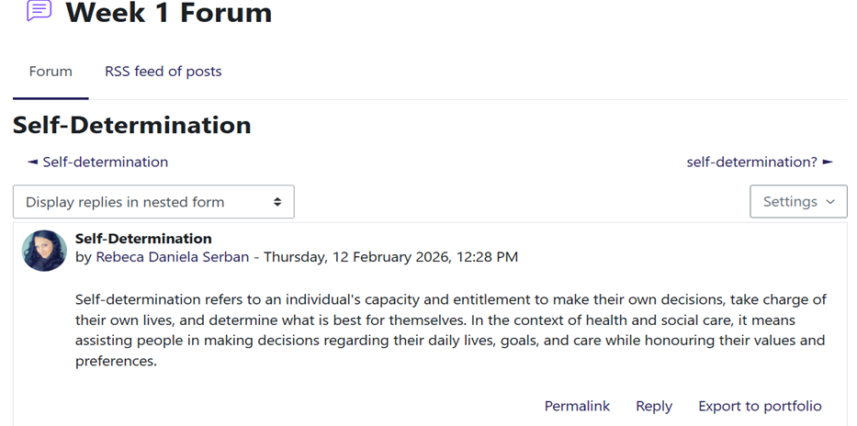

Sreenshot 2. Week 2 forum – Soft Skills

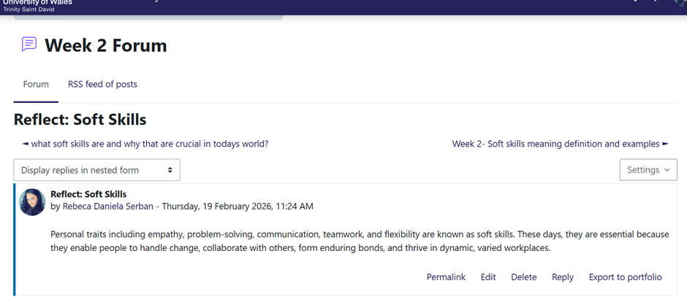

Screenshot 3. Week 2 Forum – Why Self-awareness is essential in Health and social care?
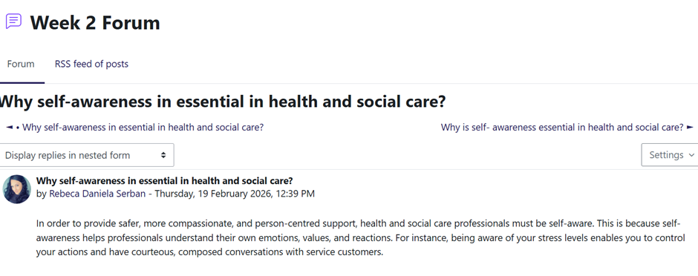

Task 2 – Unit 2: It’s a Small World
Unit 2 examined the value of forming relationships and emphasised the ways in which experiences, surroundings, and relationships support professional development. This unit's main takeaway was that, in order to provide high-quality care, the health and social care sectors are highly intertwined and depend on cooperation, knowledge sharing, and supportive partnerships. This inspired me to consider more carefully how the people in my life affect my growth and how strong connections might mould my professional identity.
One of the most important lessons I learned was that building relationships requires more than just meeting new people; it also entails purposeful engagement, questioning, and being receptive to new ideas. The exercises made it clear to me that developing connections calls for self-assurance, clear communication, and a readiness to push myself. When I thought back on my own actions, I saw that I occasionally hesitate to strike up a discussion in professional settings, which could limit my chances to get new experiences or learn from others. Knowing this has inspired me to communicate with classmates, instructors, and experts more actively since these exchanges can increase my knowledge of the industry (Backhaus, et al. 2024)
Evolution, which alludes to the continuous development of one's personal and professional identity, was another significant element in Unit 2. The unit stressed that growth is shaped by experiences, obstacles, and other people's impact. When I looked back on my trip thus far, I saw that, in comparison to when I started my studies, I had grown more self-assured, organised, and introspective. The comments I've gotten, the connections I've made, and the chances I've taken to hone my abilities have all helped me make this advancement.
Additionally, Unit 2 emphasised the long-term effects of tiny interactions on development. I was introduced to a variety of perspectives and inspired to think more critically about my own experiences by reading and replying to my classmates' forum entries. This reaffirmed the notion that education is a collaborative process and that interacting with others can enhance my comprehension of professional practice (Provenzi, L. et al. 2024)
All things considered, Unit 2 deepened my understanding of how connections and interactions support professional growth. It inspired me to develop relationships that will help me advance in the health and social care industry by being more forthcoming, self-assured, and deliberate. Throughout my career, these realisations will continue to direct my attitude to learning, networking, and teamwork.

Screenshot 4 Week 3 Forum – Evolution
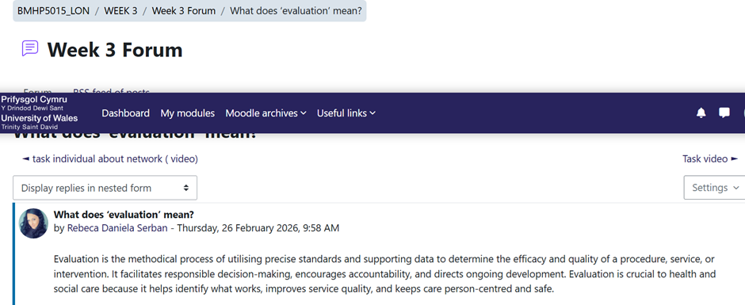

Screenshot 5. Week 3 Forum – Network means

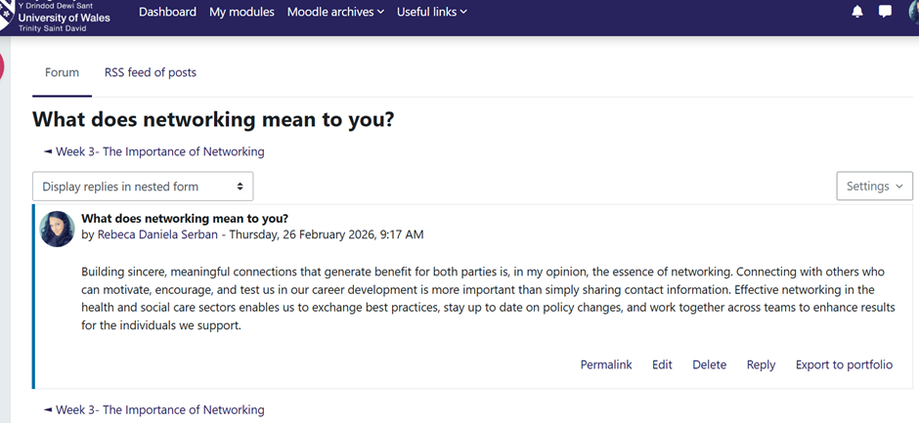

Screenshot 6. Week 4 Forum – Network of influence
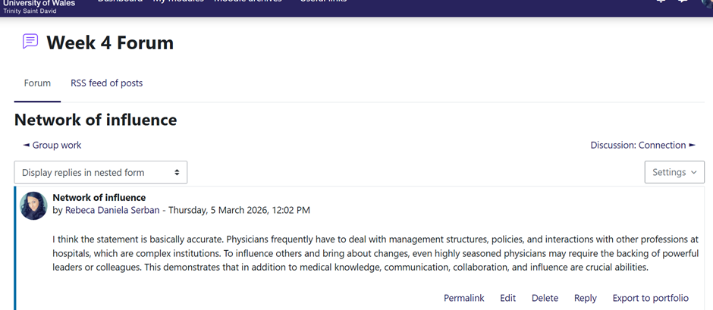

Task 3 – Unit 3: Opportunity Knocks
I was inspired to consider prospects more seriously in Unit 3, especially in relation to my professional growth. My prior belief that opportunities mostly result from formal circumstances or outside occurrences was called into question by Topic 3, Open Doors. Rather, I discovered that possibilities frequently arise from routine behaviours like asking questions, requesting feedback, offering assistance with tasks, or demonstrating initiative. This change in viewpoint made it clear to me that whether or not I recognise and take advantage of these opportunities depends greatly on my attitude, self-assurance, and willingness to venture outside of my comfort zone. Realising this has inspired me to take a more proactive approach to my education and professional growth (Tra, et al.2025)
The importance of reflecting tools in promoting opportunity recognition was also covered in this section. I was able to look more closely at my experiences and spot trends in how I handle difficulties by using models like Gibbs' Reflective Cycle. I became more conscious of circumstances in which I was reluctant to act because of self-doubt or a fear of making mistakes as a result of this methodical reflection. Knowing these obstacles is crucial because it enables me to create ways to get around them, such planning questions ahead of time, asking for clarification when necessary, and seeing errors as teaching moments rather than failures.
In the health and social care sectors, where practitioners must constantly assess their actions to guarantee safe, moral, and person-centred care, reflective practice is especially crucial. Unit 3 reaffirmed that reflection involves more than just looking back; it also involves applying insights to direct future actions. I can more effectively pinpoint my areas of weakness, recognise my strengths, and make well-informed judgements about how to advance in my profession by using reflective techniques.
The notion that opportunities are frequently connected was another important lesson from Unit 3. Over time, small acts like taking part in online activities, participating in debates, or answering criticism might result in bigger chances. This made me realise how important it is to be present, involved, and receptive to new experiences—even if they initially seem insignificant.
All things considered, Unit 3 improved my comprehension of how opportunities are influenced by both outside variables and my own behaviour. It inspired me to take a more proactive, introspective, and self-assured attitude to my growth as a prospective health and social care worker (Shpak, N. et al. 2021)

Screenshot 7. Week 5 forum - Why Changing perspective in health in social care is important?
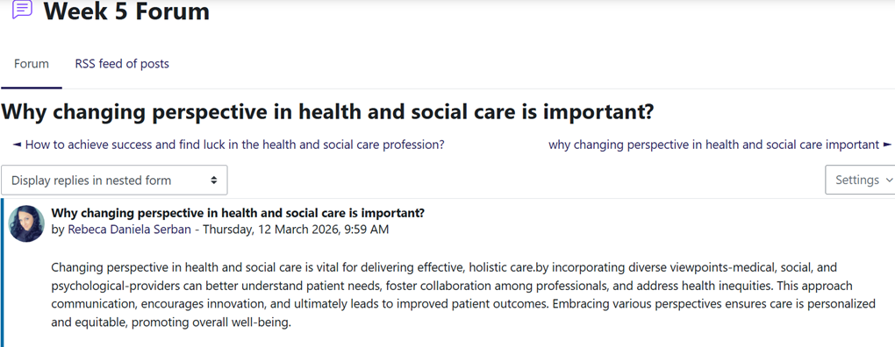

Screenshot 8 Week 6 Forum -Open doors , job opportunity
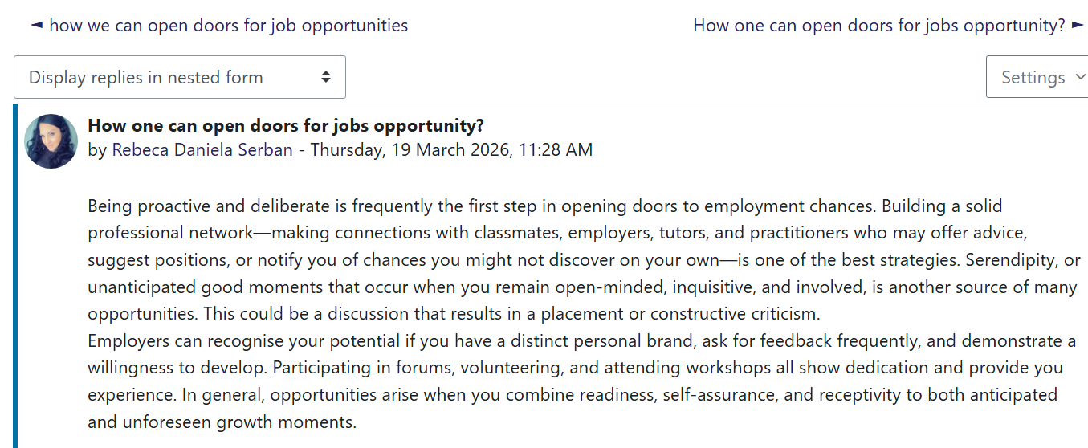

Task 4 – Unit 4: The Pursuit of Happiness
Planning for the future and comprehending the traits needed to accomplish long-term personal and professional goals were the main topics of Unit 4. Preparing for performance was a major issue that inspired me to consider how I portray myself in placements, interviews, and other professional contexts. Through the exercises, I discovered that while sharing my abilities and experiences, preparation, clarity, and confidence are crucial. This made it easier for me to pinpoint my areas for growth, especially in terms of controlling my anxiety and speaking up more. Acknowledging these difficulties has inspired me to hone my interviewing skills, get feedback, and create plans to enhance how I portray myself.
Future planning was another key theme. I was inspired by the unit to consider where I want to go in the next years and what actions I need to take to get there. I was able to divide my long-term goals into smaller, more doable tasks by using tools like SMART goals. This provided me a better sense of direction and made my goals seem more achievable. I also came to understand that planning is a continuous process that calls for ongoing motivation, flexibility, and frequent revision. This is especially true in the health and social care sectors, where career paths might change in response to new opportunities, training requirements, and service demands (Pearce, L. 2026)
The ideas of passion and persistence, which are crucial traits for success in the field, were also covered in Unit 4. Resilience, dedication, and a strong sense of purpose are necessary in the emotionally and physically taxing fields of health and social care. As I thought back on my own experience, I realised that my desire to help others inspires me to continue growing and learning. However, I also admitted that I still need to work on my perseverance, particularly when dealing with obstacles or strange circumstances. Knowing this has inspired me to embrace a growth mentality and see obstacles as chances to improve my abilities.
All things considered, Unit 4 made it clearer to me how crucial planning, preparation, and perseverance are to reaching my professional objectives. It inspired me to take charge of my further growth and to consider my future more deliberately. The knowledge I've learned from this unit will help me advance in the health and social care fields by keeping me motivated, focused, and flexible as I strive to become a competent and self-assured professional (Deady, J. et al. 2023)

Screenshot 9 week 7 about to change the mind in positivity still life

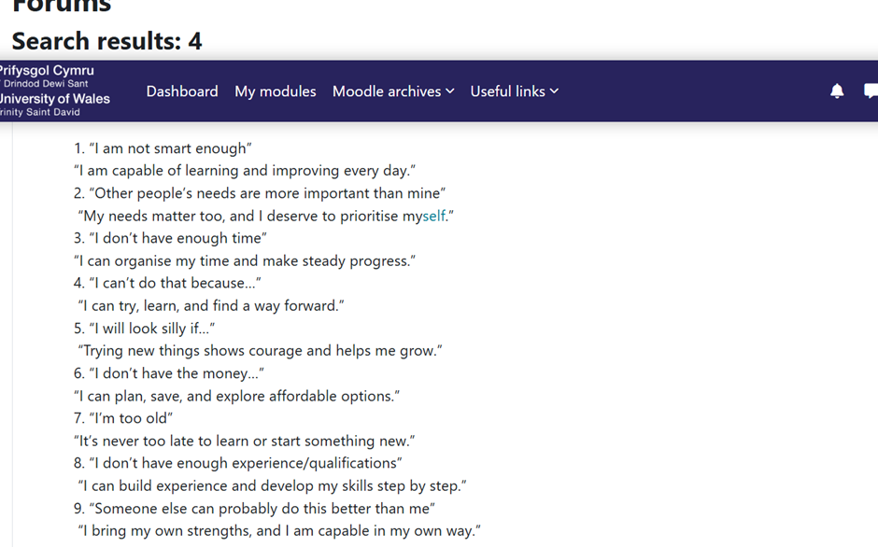

Screenshot 10 forum week 7 Limiting beliefs
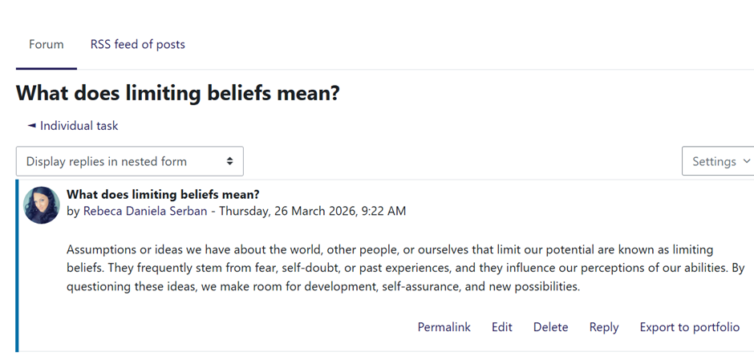

Screenshot 11 Forum week 7 about support and strategies

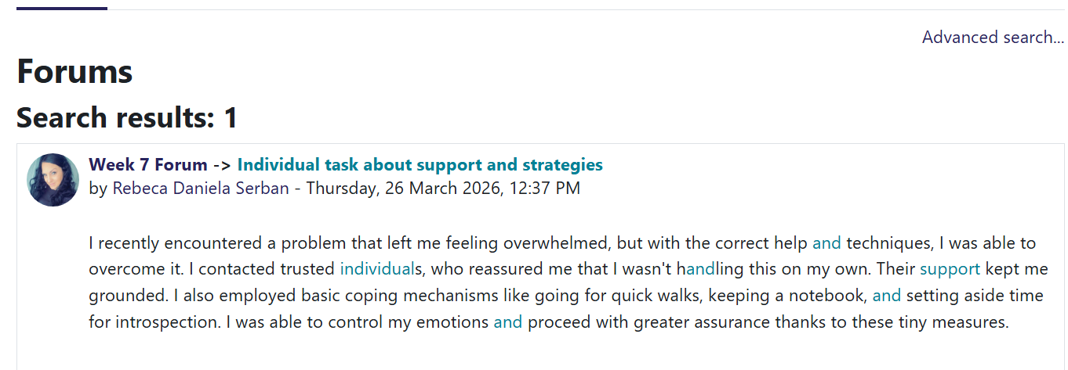

Conclusion
This portfolio has shown how Units 1-4 together enhanced my professional identity, personal brand, and preparedness for a career in the health and social care industry. By participating in the activities, I was able to gain a better grasp of my values, abilities, and areas for development while also realising the significance of introspection and self-awareness in directing my career. I discovered that developing oneself and one's career is a continuous process that calls for deliberate effort, receptivity to criticism, and a proactive attitude toward opportunities.
Any unit offered a unique, complimentary viewpoint. My identity and soft skills were explored in Unit 1, which served as the basis for my personal brand. The importance of networks, connections, and personal development was highlighted in Unit 2. Through reflective practice, Unit 3 improved my capacity to identify and take advantage of opportunities. I was inspired to make strategic plans for the future by Unit 4, which emphasised the significance of long-term goal-setting, planning, and resilience. When taken as a whole, these courses gave me a solid foundation for navigating my growth in a challenging and fast-paced industry (Gains, F. 2004)
I'll keep using these realisations in my future academic endeavours and professional endeavours. I may create a meaningful and long-lasting career path in health and social care by continuing to be introspective, driven, and receptive to new information.

References

- Backhaus, B., Anderson, H. and Bedford, C. (2024) “Communities, connections, and careers: building personal and professional networks through community media work,” Continuum (Mount Lawley, W.A.), 38(1), pp. 124–136. Available at: https://doi.org/10.1080/10304312.2024.2344074.
- Battaglio, R.P., Belle, N. and Cantarelli, P. (2022) “Self-determination theory goes public: experimental evidence on the causal relationship between psychological needs and job satisfaction,” Public management review, 24(9), pp. 1411–1428. Available at: https://doi.org/10.1080/14719037.2021.1900351.
- Deady, J., Behari, N. and Smith, V. (2023) “35 Implementing the allied healthcare professional’s (AHP) support worker competency, education and career development project at great ormond street hospital NHS trust,” Archives of disease in childhood, 108(Suppl 1), pp. A13–A13. Available at: https://doi.org/10.1136/archdischild-2023-gosh.35.
- Gains, F. (2004) “‘Hardware, Software or Network Connection?’ Theorizing Crisis in the UK Next Steps Agencies?,” Public administration (London), 82(3), pp. 547–566. Available at: https://doi.org/10.1111/j.0033-3298.2004.00406.x.
- James, T. et al. (2023) “Reflective Minds, Brighter Futures : Empowering Critical Reflection with a Guided Instructional Model,” Journal of university teaching & learning practice, 20(6), pp. 1–27. Available at: https://doi.org/10.53761/1.20.6.9.
-Lowry, J.H., Rowan, L. and Summers, R. (2025) “Thematic Analysis of Teamwork Experiences in a GIScience Project‐Based Learning Activity,” Transactions in GIS, 29(4). Available at: https://doi.org/10.1111/tgis.70086.
- Meshoyrer, E. and Matlock, T. (2024) “Personal Branding 101: Positioning Oneself for Early Career Success,” IISE Annual Conference. Proceedings, pp. 1–5. Available at: https://doi.org/10.21872/2024IISE_8029.
- Pearce, L. (2026) “How to use SMART goals for study and placements: Guidance on creating SMART goals and how to use them effectively for learning, clinical placements and beyond,” Mental health practice, 29(2). Available at: https://doi.org/10.7748/mhp.29.2.14.s9.
- Provenzi, L. et al. (2024) “Editorial: From social wires to neurobiological connections: a neuropsychobiological focus on parent-child interaction,” Frontiers in behavioral neuroscience, 18, p. 1487555. Available at: https://doi.org/10.3389/fnbeh.2024.1487555.
- Scheidt, S., Loohuis, R. and Henseler, J. (2024) “Top Managers’ Personal Branding in a Corporate World: Strategizing and Overcoming Dualities Along the Career Path,” Corporate reputation review, 27(4), pp. 249–270. Available at: https://doi.org/10.1057/s41299-023-00170-2.
- Shpak, N. et al. (2021) “Simulation of the influence of external factors on the level of use of the regional tourism potential: A practical aspect,” Administrative sciences, 11(3), pp. 1–17. Available at: https://doi.org/10.3390/admsci11030085.
-Tan, W. (2025) “Capitalize on Learning Agility for Career Growth,” Talent Development, 79(1), pp. 64–66.
- Tra, N.N.T., Han, W. and Pill, S. (2025) “Willingness to Communicate, L2 Self-Confidence, and Academic Self-Concept: A Mixed-Methods Study of Vietnamese University Students in the UK,” Behavioral sciences, 15(9), p. 1176. Available at: https://doi.org/10.3390/bs15091176.

