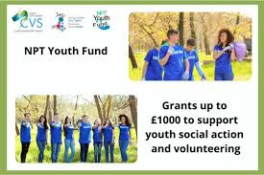
Community Development in Port Talbot, Wales

Youth Sports Community Challenges
• Limited Funding: Insufficient resources hinder sports facilities and event organization. Financial instability affects hiring skilled coaches and equipment. • Participation Fluctuations: Balancing academic, work, and family responsibilities with sports is challenging. Adaptive approaches like flexible schedules and remote training are needed. • Inclusivity: Tailored programming and proactive outreach to underrepresented groups ensure broader participation. • Environmental Challenges: Implementing eco-friendly practices and balancing operational demands with sustainability goals are ongoing challenges. • Social Barriers: Gender stereotypes and cultural biases discourage participation. Advocacy and education are essential for creating an inclusive environment.
Youth Sports Communication for Behavioural Change
Key Communication Channels:
• Social media: Platforms like Facebook, Instagram, and Twitter provide quick updates and success stories.
• Schools and Community Boards: Collaborations with educational institutions ensure direct outreach to students.
• Local Media: Success stories of young athletes are featured in community newsletters and newspapers.
Behavioural Insights:
• Motivations: Youth are driven by recognition, self-improvement, and excellence.
• Addressing Barriers: Flexible scheduling, financial support, and long-term benefits mitigate challenges.
Community development is the process of empowering individuals and groups to improve their community's well-being through specific projects. Port Talbot, Wales—a town historically recognised for its steel industry—has seen a revolutionary shift towards promoting community resilience through innovative programs. One significant project is the emphasis on the youth sports community, which has become a key component of local development efforts.
This presentation focusses on the techniques used to support the young sports community, the impact of these efforts on social and economic integration, and the obstacles faced. With a population of around 29,000 and a sizable number of kids aged 12-25 (Neath Port Talbot County Borough Council, 2023), Port Talbot's dedication to youth sports exemplifies how such efforts can promote health, reduce crime, and boost community vitality.

Develop Strategies
Port Talbot's young sports community grows through cultural, social, economic, political, and environmental factors.
1. Culture Integration:
Participants sense pride and identity in local symbols on sports uniforms and logos.
Annual sports festivals promote the town's traditions and unite the community via music, food, and culture.
2. Social Impact:
Sports reduce criminality and improve social bonds, making communities safer and more cohesive (Olukotun, 2008).
Leadership, discipline, and teamwork help kids grow personally and professionally beyond athletics.
3. Economic Gains:
Local businesses sponsor events, funding and creating jobs.
Visitors to sporting tournaments improve local restaurant, hotel, and shop profits (Hes, 2017).
Opportunities for talented youngsters to play professional sports boost the community's prestige and encourage future generations.
4. Political Support:
Local government investments in sports infrastructure and youth involvement programs are crucial (Head, 2007).
Recent sports facility enhancements and community program funds ensure accessibility and sustainability.
5. Ecological Sustainability:
Recycling and biodegradable materials are included into community events.
Event guests are encouraged to use public transit and bike to avoid carbon emissions (Khwaja, 2004).
These measures boost the youth sports community, ensuring its continuing growth in Port Talbot.

The Youth Sports Community of Port Talbot
Individuals aged 12 to 25 participate in structured sports such as football and rugby. This community is diverse, with members coming from many ethnic, cultural, and socioeconomic origins. It promotes personal development, physical fitness, and social ties.
Key Characteristics of the Youth Sports Community:
Members come from a variety of nationalities, including White British, South Asian, and other minority groups, reflecting Port Talbot's overall multiculturalism.
Unifying Themes: A shared interest in sports generates a sense of belonging, teamwork, and mutual support among members (Dongier et al., 2003).
Cultural Significance: Sports in Port Talbot help to preserve traditions while also promoting multicultural conversation and inclusivity (Stone, 2012).
The community's variety is a strength because it overcomes socioeconomic gaps and allows young people from various backgrounds to work together towards common goals. This inclusivity has entrenched the young sports community as an important part of Port Talbot's overall development strategy.

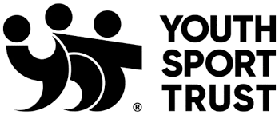
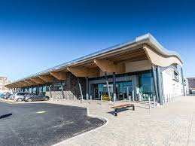
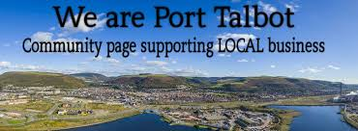
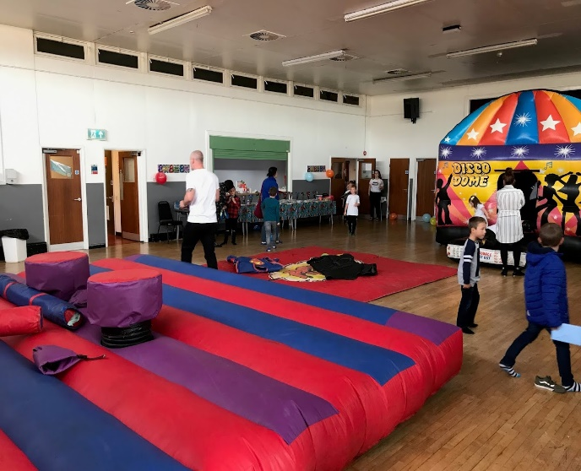
Dongier, P., et al. (2003). Community Driven Development. The World Bank.
Hes, D. (2017). Impact of community engagement on sustainability outcomes.
Khwaja, A. I. (2004). Is increasing community participation always a good thing?
Neath Port Talbot County Borough Council (2023). Community demographics and development.
Olukotun, G. A. (2008). Achieving project sustainability through community participation.
Stone, C. (2012). Community engagement in sustainable development.
Jacob, W. J., et al. (2015). Community engagement in higher education policy reforms and practice.
Conclusion
The youth sports community in Port Talbot exemplifies how targeted programs may promote community development by encouraging social cohesiveness, cultural pride, and economic progress. The community has achieved great success via strategic planning and collaborative efforts, and it now serves as a model for other towns looking to reform themselves.
While financing constraints and inclusion barriers remain, the community's commitment to sustainability and adaptation ensures ongoing growth. Port Talbot's youth sports community may increase its beneficial impact by extending collaborations, utilising technology, and focussing on environmental goals, inspiring a future in which sports unite and uplift communities.

Recommendations for Sustainable Development
To address the identified difficulties and assure the ongoing success of the youth sports community, the following strategies are recommended:
Expand funding:
Seek out relationships with local businesses, non-profits, and national sports organisations.
Investigate government grants and international financing sources for youth and athletic development.
Enhance Inclusivity:
Develop adaptive sports programs for people with disabilities.
Provide culturally sensitive programs to engage varied ethnic communities.
Promote sustainability.
Use energy-efficient solutions in sporting facilities.
Educate participants on sustainable practices and promote long-term environmental stewardship.
Improve Communication:
Use digital tools and platforms to broaden your reach.
Regularly highlight success stories to encourage ongoing participation and community pride.

