Bethan Jane Francis (1802113)
Drink Spiking: A Moral Panic Created by the Media or a Fear for Women in the Night-time Economy

Table of Contents
Table of Figures 1
Introduction 2
Background Literature 2
Aims and Objectives 4
Aims 4
Objectives 4
Research Methods 5
Ethical Considerations and Limitations 6
Resources and Planning 7
Bibliography 8

Table of Figures
Figure 1: Research Onion (Saunders, et al., 2019) 5
Figure 2: Gantt Chart 7

Introduction
This dissertation will look into the night-time economy of the UK, and if drink spiking or spiking has become an epidemic. It will consider if the media has created a moral panic around drink spiking, and if women are more fearful or are taking more precautions when interacting in night-time economy as a result. The researcher will analyse if the media has created a moral panic surrounding the issue of drink spiking or if there is a noticeable increase in spiking crimes. An analysis will also be undertaken regarding if women are taking more precautions as a result of media coverage, and do they feel that they should be keeping themselves safe when interacting in the night-time economy.

Background Literature
Spiking of any form is classified by criminal law under the Sexual Offences Act 2003 Section 61, subtitled Administering a Substance with Intent. It outlines that it is a criminal offence for any person to administer a substance to be taken by another individual when that individual does not consent to taking the substance. Where the individual administering the substance wishes to stupefy or overpower the individual to engage in sexual activity. The aim of this Act is to cover “date-rape drugs” that are administered in any way, such as adding extra alcohol to drinks, adding drugs to drink, or spiking an individual with a needle (UK Government Legislation, 2003). Drink spiking or spiking of any form can carry a maximum of ten years in prison, many preventive measures are offered to those who engage in the night-time economy of how to both prevent and notice spiking, but little is done to stop spiking from happening in the first place (Drink Aware , 2022).
Drink spiking entered public consciousness in the late 1990’s primarily through media coverage that highlighted the dangers of date rape drugs. LeBeau and Mozayani (2001) outline that early information available was simple, it was that an unknown man would target a woman, spike her drink and then when the woman was incapacitated would sexually assault her. Making it a frightening crime which victims could not remember, and where the offender could not be found.
The Home Affairs Committee acknowledges that drink spiking has existed for many years. A 2022 report by the Home Affairs Committee (2022) outlines an increase of spiking incidents across the country that started on October 2021, at this time spiking also gained widespread press coverage. They directly indicate that an increase of incidents could be linked to media coverage. The National Police Chiefs Council outline that between September 2021 and December 2021 there were 1,032 cases of needle injection spiking. They also outline that widespread press coverage happened at the same time, and as a result they have seen an increase in reports. They also indicate that social media reports of this type of crime in students pre-dated this (National Police Chiefs Council , 2022).
Colyer and Weiss (2017) highlight two main academic schools of thought when it comes to drink spiking, the first being that drink spiking is a serious problem and then risk factors are identified so that spiking crimes may be prevented in the future. The second school of thought is that there is no real problem at all, that beliefs about drink spiking persist as a predatory crime narrative. This school of thought acknowledges that drugs play a role in sexual assault encounters, but this is overestimated. Both schools of thought can be seen in Brooks (2014) work where she indicates the media are reporting an increase in this type of offence happening and that it is a crime affecting millions. On the other side Brooks reports on both police and forensic scientists dismissing spiking as an urban myth, or moral panic as an excuse to hide the binge drinking culture that is seen as bad behaviour.
There are also those who see drink spiking as a moral panic that has been created by the media. The idea of moral panics was first introduced by Cohen (2011), he indicates that moral panics are when something such as a group of persons or crime emerges and is deemed as a threat to society. Then it is presented by the media in an easily recognisable form and is often stereotypical. There is then a rapid build-up of concern by the public, that is responded to by authority or opinion makers. The panic that then has been rapidly building up deteriorates and panic resides and this either results in social change or other ways of coping are brought back into public view (Newburn , 2017).
There is academic research where participants have viewed drink spiking as overhyped by the media both intentional and unintentional forms of spiking, with drink spiking being viewed as being “blown out of proportion in terms of media coverage” showing that some are aware that it may not be as much of as risk as other crimes (Sheard , 2011). Sheard’s (2011) academic research also found that women were taking many precautions as “it only takes seconds” to be spiked making it seem like women are aware of what they need to do to keep themselves safe such as only drinking out of bottles and never leaving a drink unattended so that they do not run the risk of being spiked.
The academic sources such as journal articles, books and websites are outdated and focus on how the media has portrayed drink spiking in previous years. No current or previous research focuses on moral panics, there is no current up to date literature on what women are doing to protect themselves or if they still see spiking as an issue when in the night-time economy. Therefore, the researcher has decided to conduct research in this area as there is a lack of academic research and there is also a gap in more recent years.

Aims and Objectives

Aims
The main aim of this research is to both analyse and evaluate the trends in spiking crimes in the night-time economy, and if the statistical crime data aligns with potential increased media coverage. There will then be an evaluation carried out, to see if the increased media coverage on drink spiking has affected how women behave in the night-time economy in relation to precautionary behaviours and safety.

Objectives
Objectives can be seen as the tasks that lay out the main elements of the research questions, these are what will need to be completed in order for the research to be fully complete. They also provide clear guidance and direction to the researcher as to the structure and elements of the research (Hart, 2005). The researcher will use the following objectives to focus on thought the research and refer back to when needed.
- Investigate how the media perceives drink spiking.
- Explore women’s views on the night-time economy and drink spiking in comparison to media perceptions.
- Investigate whether the media has made women more aware of the dangers of the night-time economy i.e., drink spiking, spiking, sexual assault, violent assault, and drug facilitated sexual assault.
- To explore if there is a direct comparison between media articles and drink spiking crime rate statistics, or if the media perceptions are creating a “moral panic”.

Research Methods
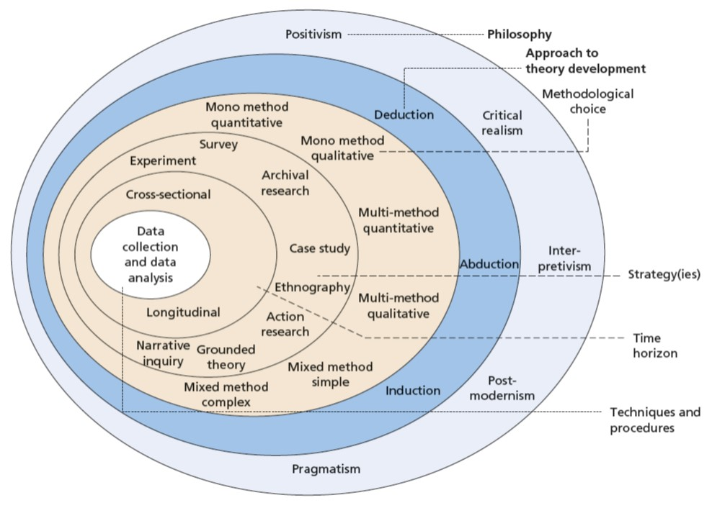
Research is seen as a systematic and methodical way of investigation, with the overall aim to increase knowledge (Collis & Hussey, 2014). A research plan allows the researcher to have a general plan of how to go about answering the objectives of the research as well as clear guidance on what steps to take next, a research method and plan will be produced using Saunders et al (2019) research onion.
Figure 1: Research Onion (Saunders, et al., 2019)

Figure 1 (Saunders, et al., 2019)

Cohen et al (2018) outline that it is clear that different types of research require different research methods, this means that a clear research design will need to be created for each individual research idea. Looking at the research onion by Saunders et al (2019) the research being conducted will be of a cross-sectional time horizon, as the research will only reflect one specific time period as it is being conducted at one specific time.
The research will be of a pragmatism philosophy, as this acknowledges that there are various ways of both interpreting and undertaking research in order to obtain a broader view on the subject area that is being researched. It outlines that there are strengths to both quantitative and qualitative research methods (Johnson & Onwuegbuzie, 2004). Mixed method research is seen to be more credible and to produce more reliable data as it collects both quantitative and qualitative data (Kelemen & Rumens, 2008). Therefore, the research will be of a mixed method approach.
The researcher will first collect secondary data. Secondary data refers to research that already exists, the researcher will be using the University of Wales Trinity Saint David library and the British Newspaper Archives to gain secondary data. The time period will look specifically from October 2021 to the present time of when the secondary research is being carried out. Document secondary data will be used, and this allows the data to be transported across time and space to be used for different research purposes than what they were originally collected for (Symon & Cassell, 2012). Meaning that multiple source secondary data will be used as the researcher will be combing different data sets together to form another set of data (Saunders, et al., 2019). This form of data collection has been picked by the researcher to address the media representation of drink spiking relevant to the research objectives, this research will also form the basis for the research questions.
The researcher will also carry out interviews, these are seen as a purposeful conversation where the interviewer asks concise and ambiguous questions and then by listening to the individual being interviewed points of interest can be further explored (Saunders , et al., 2012). The interview questions will be based off information found in the secondary data, following up on ideas and probing for more information based on what was found out in the secondary information phase of research (Bell & Waters, 2014). These interviews will be aimed at women in order to gain an insight into the night-time economy and drink spiking, as they are seen predominantly as the victims.

Ethical Considerations and Limitations
Ethical considerations must be taken into account, Saunders et al (2019) outlines that ethics is standards and behaviours that guide conduct when conducting research, it relates to the rights of those who become participants within the research as well as those who are affected by the research. Consent will have to be granted from the University of Wales Trinity Saint David prior to carrying out the research and permission must be granted also by an ethics form to make sure the research is within the University’s ethical guidelines ( University of Wales Trinity Saint David, 2017). Each participant will be required to complete a consent form before the interview is conducted, this will all be done so that the research being conducted is in line with the correct codes of ethics.

Resources and Planning
There are many resources that will be needed so that the research can be carried out, this includes access to a suitable computer, access to suitable books, academic journals, and newspaper articles. All of these resources are available to be sourced from the University.
In order to demonstrate the time scale of this project a Gantt chart had been included. Figure 2 below shows the expected time scale of the project and also to help the researcher plan to a tight time frame.
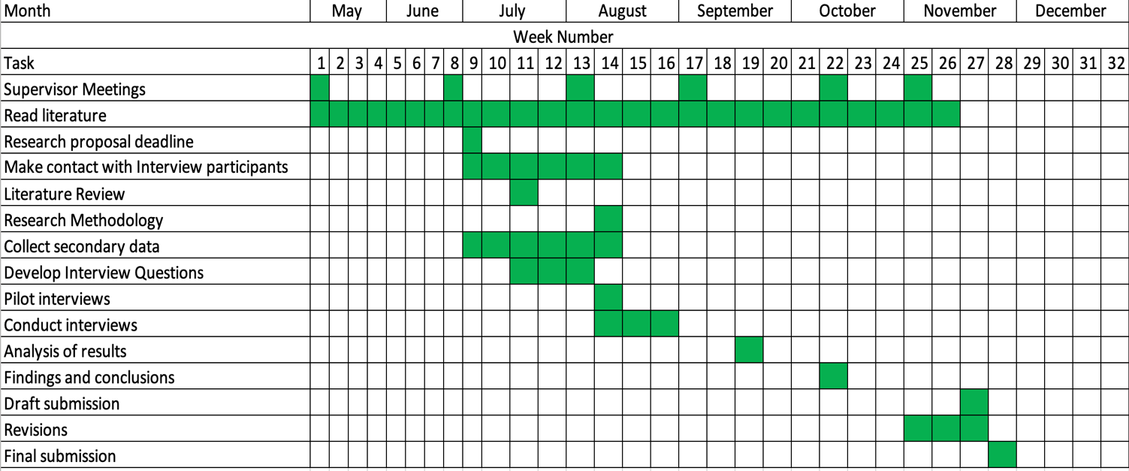
Figure 2: Gantt Chart

Bibliography
University of Wales Trinity Saint David. (2017). Research Ethics & Integrity Code of Practice.
Available at: https://www.uwtsd.ac.uk/media/uwtsd-website/content-assets/documents/research/research-ethics-integrity-code-practice.pdf (Accessed: 18th June 2022).
Bell, J. and Waters, S. (2014). Doing your Research Project a Guide for First-Time Researchers. 6th edn. New York City: McGraw-Hill Education.
Brooks, O. (2014). 'Interpreting Young Woman's Accounts of Drink Spiking: The Need for a Gendered Understanding of the Fear and Reality of Sexual Violence', Sociology , 48(2), pp. 300-316. DOI: 10.1177/0038038512475108
Cohen , L. and Manion, L. and Morrison, K. (2018). Research Methods in Eduction. 8th edn. London: Routledge.
Cohen , S. (2011). Flok Devils and Moral Panics. London: Routledge.
Collis , J. and Hussey, R. (2014). Buisiness Research a Practical Guide for Undergraduate and Postgraduate Students. 4th edn. London: Palgrave Macmillan .
Colyer, C. and Weiss, K. (2017). 'Contextualizig the Drink-Spiking Narrative That "Everyone Knows"',Criminal Justice Review , x(xx), pp. 1-13. DOI: 10.1177/0734016817747011
Drink Aware. (2022). Drink Spiking and Date Rape Drugs.
Available at: https://www.drinkaware.co.uk/advice/staying-safe-while-drinking/drink-spiking-and-date-rape-drugs (Accessed: 14th June 2022).
Hart, C. (2005). Doing your Masters Dissertation. London: SAGE Publications .
Home Affairs Committee. (2022). Spiking Ninth Report of Session 2021-22.
Available at: https://committees.parliament.uk/publications/21969/documents/165662/default/
(Accessed: 14th June 2022).
Johnson, B. and Onwuegbuzie, A. (2004). 'Mixed Methods Research: A Research Paradigm Whose Time Has Come', Educational Researcher, 33(7), pp. 14-26. DOI: 10.3102/0013189X033007014
Kelemen, M. and Rumens, N. (2008). An Introduction to Critical Management Research. London: SAGE.
LeBeau, M. and Mozayani, A. (2001). Drug-Facilitated Sexual Assault A Forensic Handbook. London: Academic Press.
National Police Chiefs Council. (2022). Written evidence submitted by NPCC (SPI0036).
Available at: https://committees.parliament.uk/writtenevidence/42866/pdf/
(Accessed: 14th June 2022).
Newburn , T. (2017). Criminology. 3rd edn. London: Routledge.
Saunders , M. and Lewis, P. and Thornhill, A. (2012). Research Methods for Business Students. 6th edn. London: Pearson.
Saunders, M. and Lewis , P. and Thornhill, A. (2019). Research Methods for Business Students. 8th edn. London: Pearson.
Sheard , L. (2011). ''Anything Could Have Happened': Women, the Night-time Economy, Alcohol and Drink Spiking', Sociology, 45(4), pp. 619-633. DOI: 10.1177/0038038511406596
Symon, G. and Cassell, C. (2012). Qualitative Organizational Research: Core Methods and Current Challenges. London: SAGE.
UK Government Legislation (2003). Sexual Offences Act 2003.
Available at: https://www.legislation.gov.uk/ukpga/2003/42/notes/division/5/1/48
(Accessed: 14th June 2022).

