Perceptual analyses

Arwyn Williams 2116521
BA Product and furniture design
1588 words
Julia Lockheart

Manifesto

1. I am a carpenter.
2. I aim for sustainability in all I do.
3. I create furniture from waste and original pieces.
4. I use traditional carpentry styles.
5. I favour using Japanese carpentry styles and techniques.
6. I attend farming auctions, which are an exciting place for me to be, there are lots of old carpentry tools for me to buy, refurbish and use.
7. I walk through forests and urban areas to make use of storm fallen and dead trees.
8. I aim to use traditional carpentry techniques and original tools

Key Tenets and Principles

Sustainability and Tradition

First and foremost, I am a carpenter and in producing pieces of furniture for the modern world I embrace the history and traditions of my craft in both construction and design. My work is rooted in both western traditions and conventions and Japanese carpentry’s ethos and techniques. For the Japanese carpenter wood and woodworking have both a practical and spiritual dimension which draws upon and in its use of traditional skills honours and celebrates the history of the craft (Brown 2021).

The concepts of individuality and uniqueness is central to my work. My manifesto consciously uses the first person singular as unlike Marx in his Communist Manifesto (Marx 1848) or Marinetti’s “Declaration of Futurism” (Marinetti 1909), I reject the notion of seeking to create a plurality of vision. I therefore consciously do not aim to speak for any general movement or to change the world or the concept of art by polemic. I simply intend to convey my personal and individual style and motivations.

Each of my pieces is unique and I aim to use reclaimed materials and wood retrieved from nature. As such each of my pieces both use and are shaped by the materials themselves. Unlike Rietveld in his Red and Blue Chair I do not use standard timber and reject his concept of designing and producing works with the aim that they can be reproduced for the mass market. I stress the individuality of each of my pieces.

My pieces use traditional techniques and skills I seek to reflect, what Berger describes as “the essential historical experience of our relation to the past,” because “the entire art” (or in this case techniques) “of the past has now become a political issue.” (Berger 1972). The ongoing loss of traditional joinery and furniture making skills being a feature of the modern capitalist economy that promotes non-sustainable disposable consumerism over the sustainable durability of traditionally made and crafted pieces of furniture. I therefore seek to use sustainable and reclaimed materials and avoid where possible using plastics and other

My pieces of work are unique and handmade, using those traditional techniques and natural materials as Benjamin states “the technique of reproduction detaches the reproduced object from the domain of tradition.” (Benjamin 1936). My work retains what Benjamin characterises as the authority of the original and its uniqueness is a political and ecological statement by rejecting the dominance of the mass produced, uniform disposable pieces in which the producer is divorced from its means and method of production. In this way my works embody a rejection of the notion of the value of the piece simply acquiring the transactional quality of a commodity which was criticised by Baudelaire. (Baudelaire 1981: 152-153). My pieces celebrate their own individuality and value of the piece itself with its own identity and link to history.

Summary
In short, I aim to produce individual crafted works that are individually unique and are motivated by concepts of sustainability that celebrates the history and traditions of my craft rejecting the ethos of mass-produced disposability.
Semiotic analysis

Ferdinand de Saussure, used the theory of sign, signified and signifier (Chandler, 2017). The sign in this case is a physical object, the signified which is what the sign portrays such as shape, colour, or texture. Then finally the signifier is what a sign is such as a word, image, or gesture.
I am going to be looking at the work of Hiroshi Sakaguchi who is a traditionally trained Japanese carpenter or ‘Daiku’. He specializes in making anything from traditional Japanese roofing/framing to furniture and garden gates (Ki Arts, 2023). I am going to be analysing one of Sakaguchi’s wooden bathing tubs or ‘Ofuro’. A bath can signify cleanliness or calm/relaxation. Sakaguchi’s ofuro will be analysed using three elements of semiotic analysis. These are material, colour and weight.
These soaking tubs are made from solid Alaskan yellow ceader, with all-traditional techniques. The joinery used are lap joints to join all 4 corners of the tub and the bottom is rebated in (Bullar, 2013). The use of these types of joinery ensures that the wood itself is taking the pressure of the tub full of water. As you can see in the photo these tenon joints look completely different to westerner joints. The reasoning behind this is that this is a traditional Japanese joint so this is what would have been used to assemble a traditional ofuro. This join signifies traditional Japanese woodwork. As well as this, all surfaces of this tub are planned by hand using a traditional pull plane ‘Kanna’ which is pulled towards you rather than pushed like a westerner's hand plane (Odate, 1998) The reason this is constructed in this way is as follows, it is built from solid wood for a few reasons, firstly as it is a traditional material, secondly it is a great insulator keeping the tub warm for longer periods. Finally, the natural scent of the wood is believed to give a calming effect, which links to what a bath signifies.
Being made from ceader the ofuro is usually a cream colour but can vary as the same spices of wood can be many different shades/grains due to where or how it is grown meaning not a single ofuro will have the exact same colour or wood grain. The reasons for not painting it is that firstly it is not what would have been done traditionally also it would take away the beauty which is incredibly important for Japanese master craftsmen as everything is about the beauty and good craftsmanship. The natural colour signifies tradition and natural beauty of the wood.
The weight of the ofuro is also a very important factor as it would be lighter than a cast iron bath but heavier than a modern fiberglass bath. The reason it is constructed from timber is for a few reasons. Firstly the aesthetics, the look of the wooden four is more aesthetically pleasing than if it was cast iron. Another reason is installation and modification. Being made from wood it is going to be lighter/easier to instal and customize as wood is much more forgiving than other materials.
In this example, the bathtub was the sign, signified by the words ‘bath’, ‘tub’ and ‘ofuro’. The signifier ‘ofuro’ also signifies in English-speaking cultures that the object is from a non-English speaking country. The other elements signify the object as being traditional Japanese woodwork.

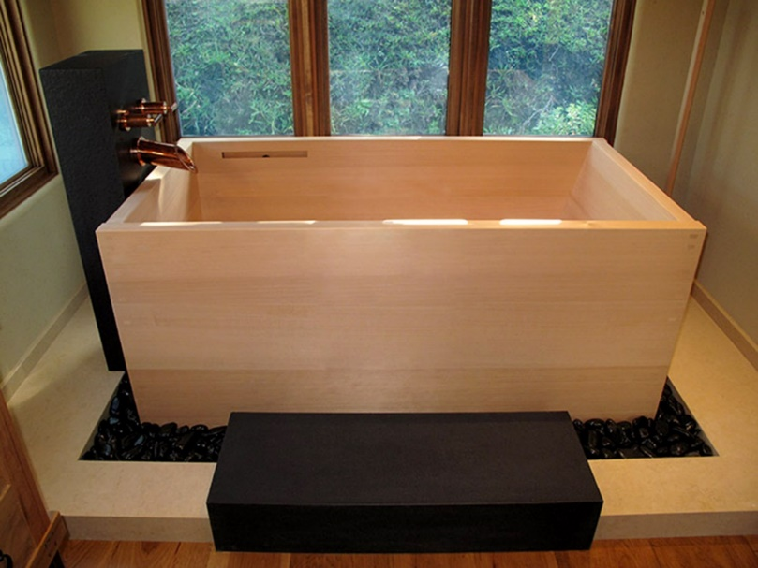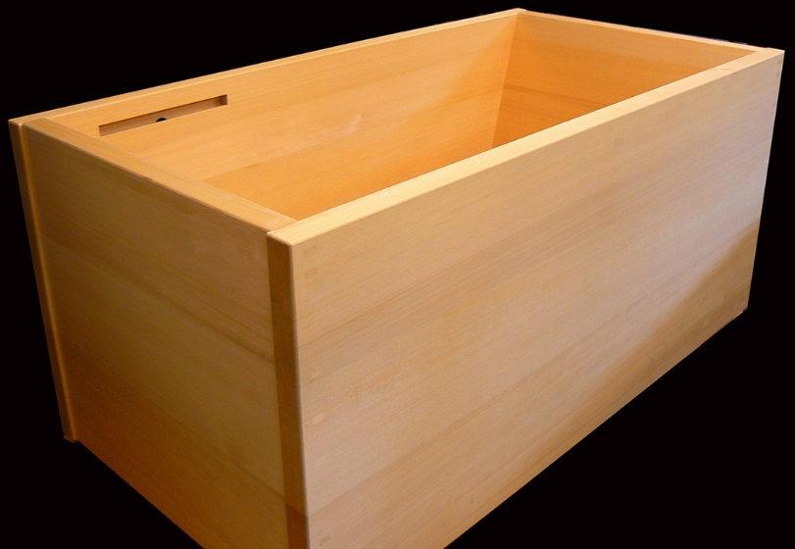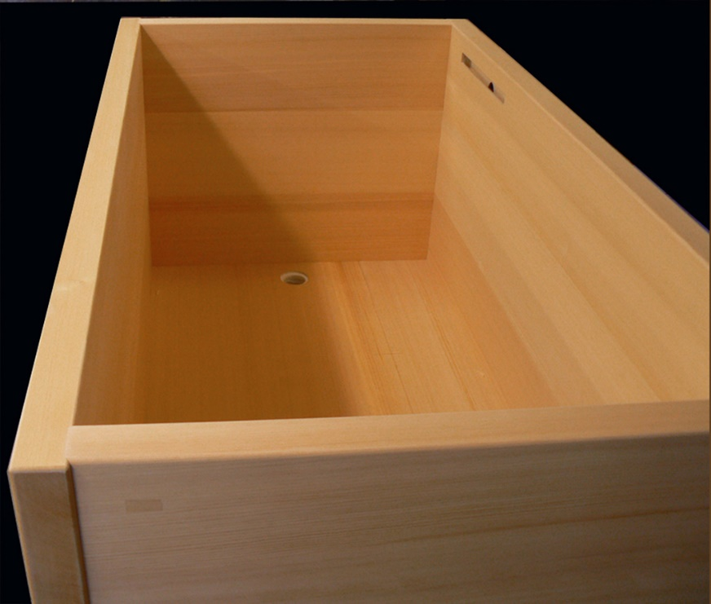
(Fig. 3 Ofuro by Hiroshi Sakaguchi)

Object and shape
Object: Hand plane
Word: Shape
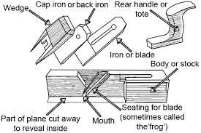
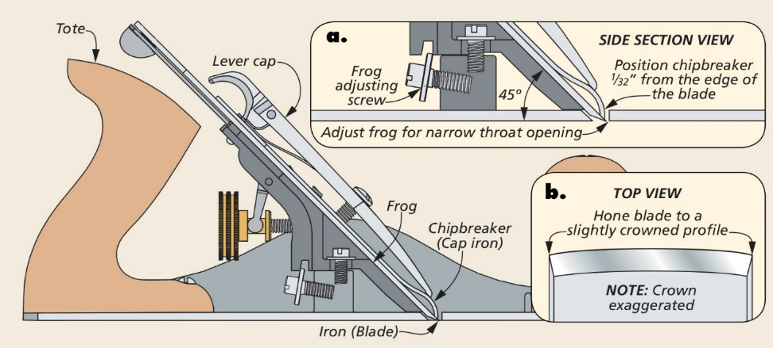
In essence, a hand plane is used for flattening, smoothing, and shaping, but there are hundreds if not thousands of different specialty planes. The first ones originated thousands of years ago. Up until the late 1800s they consisted of a wooden body with a flat sole, sharp metal blade, and a wooden wedge which both sit in an angled mortice in the body of the plane. This could be adjusted with a few light hammer taps to the blade and or the plane body. “Leonard Bailey started making cast iron planes with Stanley in 1869. In the 1870 catalog Stanley offered an impressive line of 28 different sizes and types” (Garrett, 2003). These planes were revolutionary, making the plane’s depth, lateral movements, and whole function considerably simpler, especially for first-time users.
(Fig 4. Cast iron plane) (Fig.5 Wooden plane)

The dictionary definition of shape is as follows “the outward form of someone or something as produced by their outline” (Waite, 2012). What I take from this is that anything and everything that has an outline is some form of shape. However, an artist may say “the name ‘shape’ is given to any area on a surface which can be distinguished visually by a boundary or an edge from the space which lies around it. We humans have an inbuilt ability to perceive, identify, learn and communicate about shapes in our environment” (Martin, 2003).
The main link between the object and the chosen word is the things you can do with a bench plane. In this case, I’m going to look at two different hand planes and their uses. These are the Stanley bailey No4 plane (fig.9) and the No113 Stanley compass plane (fig. 6). The Stanley bailey No4 plane is incredibly versatile, used to hone and smooth down wood to its final dimensions/shape, predominantly used to square up timber. This can be in the form of a square table top, hexagonal beams or posts and anything in between. This plane thrives in making angular shapes. On the other hand, the No113 Stanley compass plane is completely different as it is a specialized tool used for small or large internal and external curves on things like curved furniture. They are even used in the construction of wagon wheels and woolen wheels. This plane has a flexible sole that can be adjusted to the desired curvature required using an adjustable screw. These only scratch the surface of the different kinds of planes available usually with different shaped bottoms for different shapes, textures and sizes to tackle any project you throw at them. For example, I like this workbench by Paul Sellers (Fig 8.) which looks simple, yet used five different types of planes for specific parts of the construction, from flattening to cutting grooves and rounding edges. In conclusion the main link between planes and shape is what you can make using them.

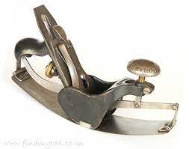
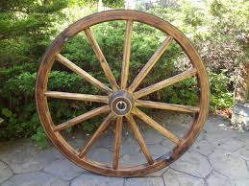

(Fig 6. No 113 compass plane) (Fig 7. Wagon wheel)
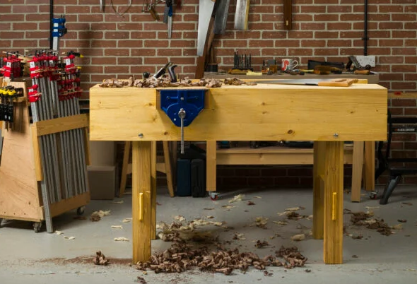
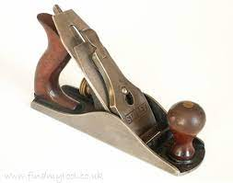

(Fig 8. Rubo workbench) (Fig 9. Stanley Bailey No4)

References (manifesto)

Baudelaire, C P. (1981) Art in Paris 1845-1862: Salons and Other Exhibitions: translated J. Mayne Ithaca NY Cornell University Press.

Benjamin, W. (1936) “The Work of Art in The Age of Mechanical Reproduction”. (https://web.mit.edu/allanmc/www/benjamin.pdf) last accessed 3rd November 2022

Berger J. (1972) “Ways of Seeing” London Penguin Books Limited.

Brown, A. (2021) “The Genius of Japanese Carpentry. Secrets of An Ancient Woodworking Craft”. (Revised edition). NY Tuttle Publishing

Marinetti, T (1909) “Declaration of Futurism” Le Figaro 20th February 1909. Paris Le Figaro

Marx, K and Engels, F. (1848) “The Communist Manifesto” available https://marxists.org/archive/marx/works/download/pdf/Manifesto.pdf last accessed 3rd November 2022.

References (Semiotic Analysis)

Bullar, J. (2013) Complete Guide to Joint-Making, Lewes: GMC Publications

Chandler, D. (2017) Semiotics : the basics, 3rd ed., London: Routledge

KI Arts (2023) Master Carpenter Hiroshi Sakaguchi [online] available at: https://kiarts.com/ [accessed 10.11.2022]

Odate, T. (1998) Japanese Woodworking Tools: Their Tradition, Spirit and Use, Ammanford: Stobart Davies

Reference (object and shape)

Garrett, H. (2003) ‘Cast-Iron Planes’ in The Handplane Book, vol 1, pp.22-23

Waite, M. (2012). “S” Paperback Oxford English Dictionary, Vol 7, pp.665

Martin, W. (2003) ‘The concept of shape’ in Understanding Art A Guide for Teachers, London: Sage

