Contemporary challenges- making a difference.
BMHP4018

E – portfolio

Jodie Anderson – 2500798

Contents page
- Historical issues mind map
- Cause and effect diagram.
- 1400-word essay
- E learning components
- Reference page.

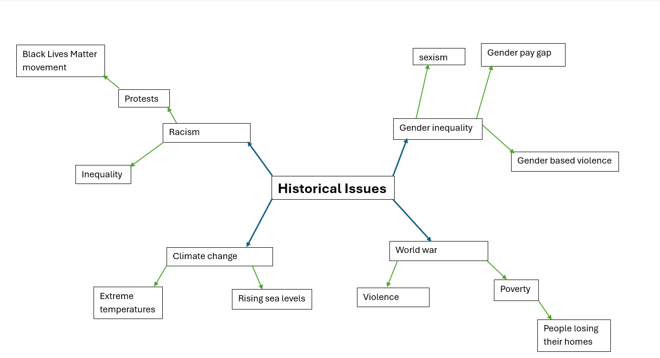

Causes Effects
green house gas emissions rising global temperatures
burning fossil fuels Melting Ice
deforestation Extreme weather
Climate Change
industrial activity Rising sea levels
Pollution Habitat loss
Air pollution biodiversity loss
Gas emissions Threats to human health
Deforestation spread of disease
Loss of forests respiratory problems

Climate change refers to long term shifts in extreme weather conditions; this refers to rising temperatures and more frequent natural disasters. Climate change can be caused by a number of factors but is primarily driven by human behaviours such as burning of fossil fuels. The reasoning that these behaviours contribute to climate change is due to the release of greenhouse gases, these gases include carbon dioxide which results in heat getting trapped within the earth’s atmosphere which results in higher temperatures (IPCC, 2021). Climate change is widely recognised as one of the most significant global challenges in the 21st century, affecting environmental, social, and economic issues worldwide.
This essay evaluates the causes and effects of climate change and its main drivers and impacts. It also links the issues to the sustainable development goals and examines the actions being taken in the United Kingdom and Wales to address the contemporary issue.
Climate change encompasses both global warming and changes in the earths climate system, this includes sea levels and as previously mentioned, extreme weather conditions. According to the intergovernmental panel on climate change, global surface temperatures have increased by approximately 1.1 degrees Celsius above preindustrial levels (IPCC, 2021). Resulting in higher temperatures, storms, and flooding across the globe.
Within the United Kingdom there is already evidence of climate change differences. Within the past few years, the United Kingdom has experienced rising temperatures, increase in heatwaves, increased rainfall and more frequent flooding (Met Office, 2023). In particular Wales faces significant risks, this includes flooding and also impacts on agriculture and biodiversity (Welsh Government, 2022).
There are many different causes that contribute to climate change. However, it is primarily driven by the widespread use of fossil fuels for energy production, this remains as the biggest contributor to greenhouse gas emissions. Due to the burning of coal, natural gas, and oil releases large quantities of carbon dioxide into the atmosphere, which further intensifies the greenhouse effect (Climate Action Wales, 2023). As a result of these conditions, global temperatures continue to rise, the impact that this has on the planet is that it leads to more frequent heatwaves that are becoming more severe, melting polar ice caps which then contributes to rising sea levels. Due to these environmental changes, there is an increased likelihood of extreme weather events, this therefore demonstrates a clear well-established cause and effect relationship between energy consumption and climate instability (Climate Change Committee, 2020).

Another major cause that can contribute to climate change is the use of transport. In particular to this, petrol and diesel vehicles is a huge contributor, In Wales and across the United Kingdom, transport emissions significantly contribute to the overall carbon output (Gov.Wales, 2025). These emissions contribute to global warming and also reduce the air quality, poor air quality can result in respiratory illnesses and other health problems, this is important to understand as it highlights how climate change can also affect human health and not just the environment (Asthma and Lung UK, 2023; GOV.UK, 2019).
A further way climate change is caused is by agriculture and food systems. Livestock farming produces methane, a potent greenhouse gas, due to the cutting of forests and chopping trees for farming reduces the ability for the earth to absorb carbon dioxide (Climate Action Wales, 2023). In addition to this, food waste is also a major issue for the earth’s climate, food waste is responsible for around 8-10% of global greenhouse gas emissions (FAO, 2019). There are consequences to the earth’s climate due to this, this includes, environmental damage, and increased pressure on natural resources. Overall, this shows that choices that we make during our day to day lives linked to food production and consumption can have a significant impact on climate change.
A further way in which climate change can be caused is from the impact of industrial activity and energy – intensive production. However, emissions from industry in Wales have declined in recent years, they still remain a significant contributor (Gov.Wales, 2025). Industrial emissions are a problem for the earth’s climate; this is due to the negative effect it has on air and water pollution; therefore, this damages eco systems and contributes to climate instability.
Finally, inequality and patterns of consumption further make the impacts of climate change worse. Individuals with a higher income produce more goods, travel more and often consume more energy, produce more emissions due to this (Climate Action Wales, 2023; Oxfam, 2020). In contrast to this, individuals with a lower income with a vulnerable community background are more at risk and more likely to experience and suffer the effects of climate change, this includes flooding, poorer air quality, and health problems (Gov.UK, 2019). Furthermore, this shows that climate change is not just an environmental issue but also a social issue, highlighting the importance for fair and inclusive solutions (Oxfam, 2020).
The United Nations 17 sustainable goals were established to address major global challenges, this doesn’t only include climate change, this includes poverty, inequality and environmental degradation. Climate change is linked to the sustainable development goal 13 which is called ‘climate action’, this goal is focused on urgent action that needs to be taken to combat climate action and the impacts (Gov,Wales, 2023). This goal emphasises the need for action against climate change. This includes reducing emissions and learning how to adapt to the changing climate. However, climate change is not an isolated issue and has significant links to other development goals. For example, development goal 3 (Good Health and Well-being), as rising temperatures and air pollution contribute to increased illness in individuals (GOV.UK, 2019). Climate change is also linked to development goal 11 (sustainable cities and communities) this is because the urban more vulnerable areas need to adapt to climate effects such as flooding (UN, 2015). Furthermore, climate change is also linked to goal 12 (responsible consumption and production) this is due to overconsumption contributing to emissions (Climate Action Wales, 2023). This demonstrates that climate change is interconnected with wider sustainability challenges and requires a holistic, coordinated response (UN, 2015).
The UK and Welsh governments have implemented and put different policies in place to address the issue of climate change. The main focus that the government has put in place is on achieving net zero emissions by 2050 (Climate Change Committee, 2020). This target aims to balance the amount of greenhouse gases emitted with those removed from the atmosphere, this ensures that all emissions are reduced to a sustainable level. The commitment to net zero is to reduce environmental damage, meet international climate agreements such as the Paris Agreement, and promote sustainable economic development (Climate Change Committee, 2020; BEIS, 2021). Wales has made measurable progress in reducing emissions, achieving 29% reduction between 2016 and 2023 (Gov.Wales, 2025).
There are many potential solutions linked to climate change that also link to the sustainable development goals. Reducing reliance on fossil fuels and lowering emissions is key to helping climate change, this can be achieved through transitioning to renewable energy sources is key to achieving this, this is linked to development goal 7 (affordable clean energy) and also development goal 13 (climate action) (Climate Change Committee, 2020). Furthermore, developing sustainable transport systems supports development goal 11 (Sustainable Cities and Communities) by reducing urban emissions and improving air quality (Gov.Wales, 2025). Furthermore, addressing waste and consumption is important. By reducing food waste and promoting recycling can reduce greenhouse gas emissions (Climate Action Wales, 2023; FAO, 2019).
In conclusion, climate change issue that needs urgent attention which is driven by factors such as fossil fuel use, transport emissions and consumption. A cause-and-effect analysis demonstrates how climate change is caused and how much of an impact it has on the earth we live on and local environments. This issue is linked to the sustainable development goals; however, it is closely linked to development goal 13 in particular. However, it also affects health inequality and also urban sustainability. The UK and Welsh governments have implemented policies such as net zero targets and emission reduction strategies and targets. However, continued action is necessary to strengthen these efforts and ensure a sustainable future. Addressing climate change requires coordinated action across governments, industries, and individuals.



















References
Asthma + Lung UK (2023) Toxic air could be causing breathlessness in over two million people. Available at: https://www.asthmaandlung.org.uk(Accessed: 27 March 2026).
BEIS (2021) Net Zero Strategy: Build Back Greener. Available at: https://www.gov.uk (Accessed: 27 March 2026).
Climate Action Wales (2023) Carbon emissions. Available at: https://www.climateaction.gov.wales/climate-change/carbon-emissions/ (Accessed: 27 March 2026).
Climate Action Wales (2023) What is climate change? Available at: https://www.climateaction.gov.wales/climate-change/ (Accessed: 27 March 2026).
Climate Change Committee (2020) Net Zero Wales by 2050. Available at: https://www.theccc.org.uk (Accessed: 27 March 2026).
FAO (2019) The State of Food and Agriculture 2019: Moving forward on food loss and waste reduction. Rome: Food and Agriculture Organization.
Oxfam (2020) Confronting carbon inequality. Available at: https://www.oxfam.org (Accessed: 27 March 2026).
The Guardian (2023) Climate crisis could cause 10,000 extra UK deaths a year. Available at: https://www.theguardian.com (Accessed: 27 March 2026).
UK Government (2019) Health matters: air pollution. Available at: https://www.gov.uk/government/publications/health-matters-air-pollution (Accessed: 27 March 2026).
Welsh Government (2023) Well-being of Wales 2023. Available at: https://www.gov.wales (Accessed: 27 March 2026).
Welsh Government (2024) Climate adaptation strategy. Available at: https://www.gov.wales (Accessed: 27 March 2026).
Welsh Government (2025) Well-being of Wales 2025. Available at: https://www.gov.wales (Accessed: 27 March 2026).

