BSc/HND COMPUTING PORTFOLIO — LEVEL 5
ACCA5033 Changemakers: Creativity and Value Creation
CyberGuard Pro
Network Security Tool
Port Scanner and Security Analysis Tool

Module | Changemakers: Creativity and Value Creation
Module Code | ACCA5033
Assignment | Assignment 2: Practical & Professional Development
Lecturer | TBC
Internal Verifier | TBC
Student Name | Tonio George
Student ID | 2312861
Submission | 7th May 2026
Word Count | ~3,500 words

TABLE OF CONTENTS

I. Introduction 1
II. Task 1: Practical Development & Implementation 1
A. Initial User Feedback 1
B. Implementation — CyberGuard Pro 1
1) GUI Layer — main.py 1
2) Scanning Engine — port_scanner.py 1
3) Logging — logger.py 1
4) Multi-threading Architecture 1
III. Task 2: Enterprise & Innovation 1
A. NetSentinel Ltd — Start-up Overview 1
B. PEST Analysis 1
IV. Task 3: Feedback & Reflection 1
A. Post-Development Feedback 1
B. Project Progress Diary 1
C. Skills Development 1
D. Positive Social Impact 1
V. Conclusion 1
VI. References 1
VII. Appendices 1
A. Full Source Code 1
B. Video Demonstration 1
C. Weekly Project Progress Sheets 1
D. CPD Evidence — LinkedIn Learning 1

I. Introduction

Port scanning is one of the most fundamental techniques in network security. It allows administrators to understand what services are running on a system, identify unnecessary exposure, and spot potential entry points before an attacker does [1]. Despite its importance, most professional-grade tools — like Nmap — are command-line based, which puts them out of reach for non-technical users. That gap is exactly what CyberGuard Pro was built to fill.
CyberGuard Pro is a Python desktop application that wraps professional TCP port scanning, service identification, and vulnerability flagging into a clean graphical interface built with tkinter. This report documents the full journey — from collecting user feedback before a line of code was written, through designing and building the tool, to reflecting on what worked, what didn't, and what I'd do differently next time.
All scanning in this report is performed against the loopback address 127.0.0.1. Scanning any external host without written permission from the owner is a criminal offence under the Computer Misuse Act 1990 [3].

II. Task 1: Practical Development & Implementation

A. Initial User Feedback
Before writing any code, I ran a structured feedback session with five people: two computing students, an IT support technician, a small business owner, and someone who takes a personal interest in cybersecurity. The goal was straightforward — find out what they actually wanted from a network security tool, not what I assumed they wanted [2].
I asked four questions covering interface preference, must-have features, ethical concerns, and whether a scan history would be useful. The responses shaped virtually every design decision that followed.

TABLE I — PRE-DEVELOPMENT FEEDBACK SUMMARY
Theme | Feedback | Action Taken
GUI vs CLI | All 5 preferred a GUI over typing commands | GUI-first design adopted throughout
Live progress | IT technician asked for real-time scan feedback | Progress bar and status label added
Risk colours | 3 participants wanted colour-coded severity | RED / ORANGE / GREEN tags implemented
Audit history | 2 participants wanted to review past scans | Audit History tab added via Logger class
Ethical use | 1 participant raised responsible-use concerns | Authorisation disclaimer added at startup

B. Implementation — CyberGuard Pro
CyberGuard Pro is structured across three Python files, each handling a distinct responsibility. Every demonstration in this report uses 127.0.0.1 — scanning external addresses without written authorisation violates the Computer Misuse Act 1990 [3].
TABLE II — MODULE ARCHITECTURE
Module | Responsibility
main.py | GUI layout, threading control, progress bar, and output display
port_scanner.py | TCP socket scanning, banner grabbing, and vulnerability lookup
logger.py | Timestamped scan file writing and audit history retrieval

1) GUI Layer — main.py
The graphical interface is built with Python's tkinter library using the 'clam' theme for a clean, professional look. A ttk.Notebook splits the application into two tabs — Security Audit and Audit History [4]. Figure 1 shows the tool in its ready state before a scan begins.
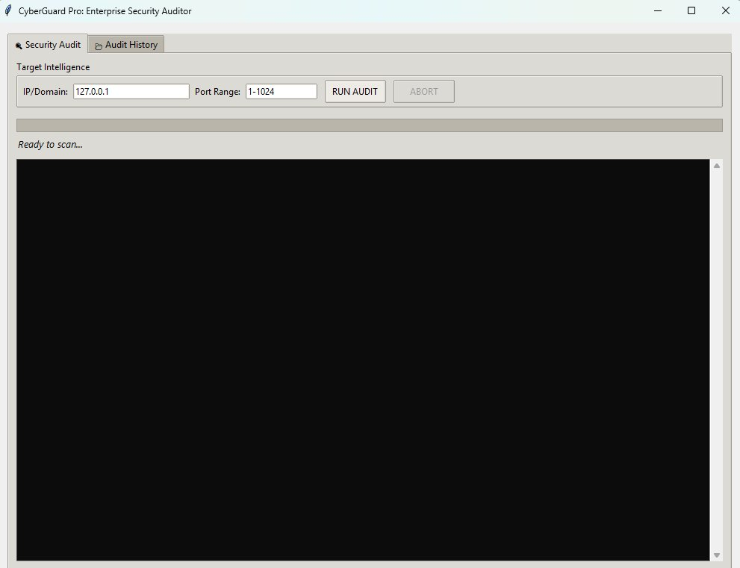
Fig. 1 — CyberGuard Pro: GUI in ready state (Security Audit tab)
Once a scan completes, results are colour-coded by severity — CRITICAL in red for high-risk ports like 445 (SMB/EternalBlue), WARNING in orange for general open services, and INFO in green for standard messages. Figure 2 shows this in action.
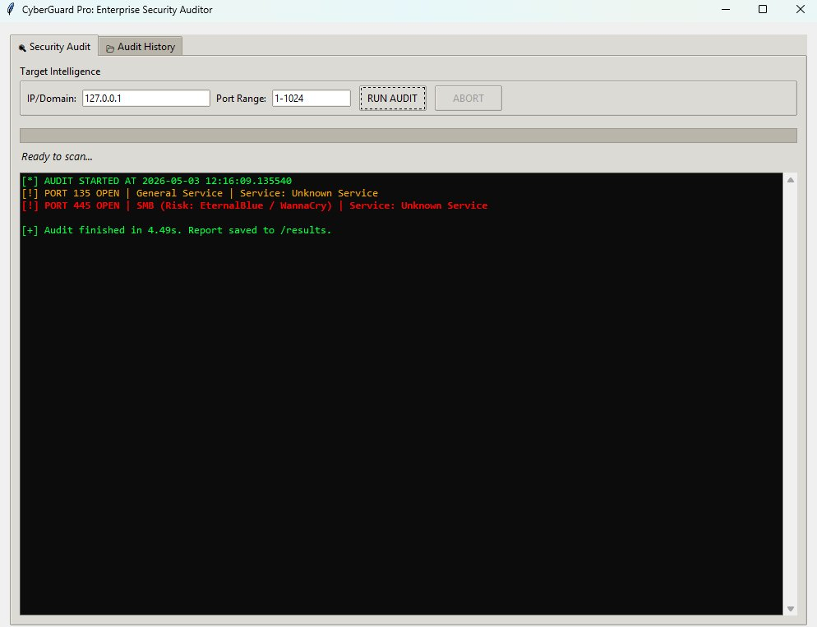
Fig. 2 — Colour-coded scan results: PORT 445 flagged CRITICAL (EternalBlue)

2) Scanning Engine — port_scanner.py
The scanning engine connects to each port using Python's socket library with a 0.4-second timeout. If a port is open, the tool sends a basic HTTP HEAD request and reads up to 512 bytes of the response — a technique called banner grabbing [5]. It then cross-references the port number against a built-in vulnerability dictionary to assign a severity rating.

3) Logging — logger.py
Every scan is saved to a timestamped .txt file in a dedicated results directory. The Logger class creates the directory automatically if it doesn't exist, and a read_logs() method retrieves all past scans for the Audit History tab. Figure 3 shows a list of previous scan files as they appear in the application.
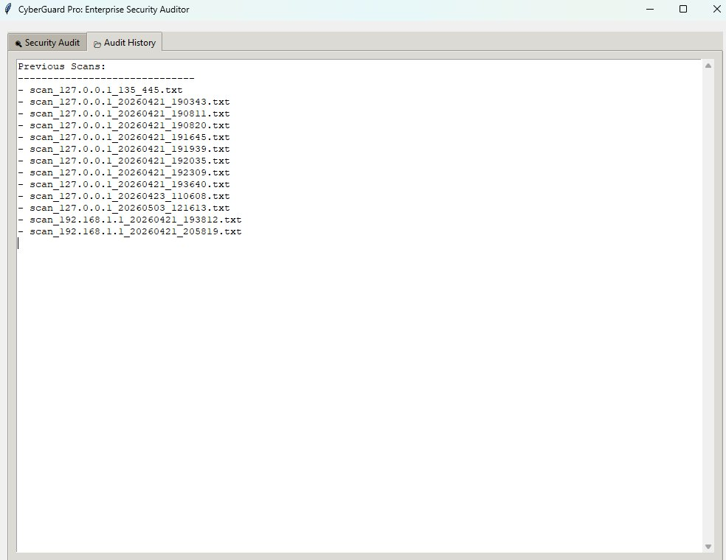
Fig. 3 — Audit History tab showing timestamped scan log files

4) Multi-threading Architecture
CyberGuard Pro scans ports concurrently using a ThreadPoolExecutor with up to 100 worker threads. This is what makes it fast enough to cover ports 1–1024 in under 5 seconds. The key challenge was keeping the GUI responsive during scanning — calling tkinter widget methods directly from background threads causes random crashes. The solution was routing all GUI updates through root.after(0, callback), which queues the update safely on the main thread [4].

III. Task 2: Enterprise & Innovation

A. NetSentinel Ltd — Start-up Overview
The commercial concept behind CyberGuard Pro is NetSentinel Ltd — a UK-registered private company targeting the SME cybersecurity market with a freemium SaaS model. The tagline is simple: "Know your network. Own your security."
TABLE III — COMPANY PROFILE
Field | Detail
Company | NetSentinel Ltd (Private Ltd, England & Wales)
Tagline | "Know your network. Own your security."
Product | NetSentinel Pro — SaaS network audit platform
Target Market | SMEs, IT consultancies, and managed service providers
Revenue Model | Freemium | Pro £29.99/mo | Enterprise white-label
Funding Routes | Innovate UK Smart Grants, NCSC for Startups, angel investors [7]

B. PEST Analysis
TABLE IV — PEST ANALYSIS FOR NETSENTINEL LTD
Factor | Analysis
Political | The UK National Cyber Strategy 2022 commits £2.6bn to cyber resilience [9]. The NIS Regulations 2018 require incident reporting, which increases demand for audit tooling. Post-Brexit procurement also opens more direct government contract routes for UK-founded security firms.
Economic | The global cybersecurity market is projected to exceed $400bn by 2027 [9]. Ransomware attacks are becoming more frequent, pushing even budget-conscious SMEs to invest in prevention. The freemium tier makes NetSentinel accessible when IT budgets are tight.
Social | High-profile breaches affecting the NHS, Capita, and Royal Mail have made business owners significantly more aware of cyber risk [8]. Remote working has expanded attack surfaces across organisations of all sizes. Non-technical decision-makers increasingly want GUI tools — precisely the gap CyberGuard Pro addresses.
Technological | Integrating the NVD CVE API would replace the static vulnerability database with live threat intelligence [6]. AWS Lambda could support cloud-native scheduled scans. AI-based anomaly detection is a realistic roadmap feature. Nmap and OpenVAS remain dominant but lack the polished interface and automated reporting that NetSentinel could offer [11].

Legal & Ethical: Scanning without authorisation is a criminal offence under s.1 of the Computer Misuse Act 1990 [3]. NetSentinel Ltd enforces written authorisation at the application level before any scan is permitted. All scan data must comply with the UK GDPR and the Data Protection Act 2018 [10], particularly on data minimisation, storage limitation, and user access rights.

IV. Task 3: Feedback & Reflection

A. Post-Development Feedback
The same five participants from the initial session came back to see the finished tool. They watched a live scan of 127.0.0.1 across ports 1–1024 and gave their honest assessment of what worked and what they'd want changed.
TABLE V — SUGGESTED IMPROVEMENTS
Suggestion | Source | Priority
PDF export of scan results directly from the GUI | 2 participants | High
Expand vulnerability database to include PostgreSQL, MongoDB, Redis | Security enthusiast | Medium
Add a distinct MEDIUM severity tier between HIGH and LOW | Security enthusiast | Medium
Scan profile presets — Quick Scan and Full Scan options | Computing student | Low

B. Project Progress Diary
TABLE VI — WEEKLY DEVELOPMENT LOG
Week | Completed | Challenges & Lessons
1 | Reviewed the brief, researched Nmap and Angry IP Scanner, set up PyCharm with three-module structure, and initialised the GitHub repository. | Defining scope was harder than expected. I initially planned to include WHOIS and geolocation features, but scaled back once I realised they would jeopardise the core deliverables.
2 | Built the PortScanner class with TCP socket scanning, the vulnerability database, and HIGH/LOW severity classification. Validated against 127.0.0.1. | A PermissionError appeared when scanning ports below 1024 on Linux without root access. Fixed with try/except and a user-facing error message.
3 | Added banner grabbing and integrated the Logger class with auto directory creation and timestamped output files. | Banner grabbing hung on non-HTTP ports until I tightened the timeout to 0.4s. Also accidentally overwrote a day's work — lesson learned: commit at the end of every session.
4 | Built the full tkinter GUI with notebook tabs, progress bar, and colour-tagged terminal output. Connected the GUI to the scanning backend. | Direct tkinter calls from worker threads caused random crashes — easily the most challenging problem of the project. About two days were lost before I found root.after(0, callback) as the correct fix.
5 | Added ThreadPoolExecutor (100 workers), connected the Audit History tab, added the ABORT button, and ran the initial feedback session. | The progress bar overshot its maximum on completion. Fixed by explicitly setting the maximum to the port count before each scan starts.
6 | Post-development feedback session, refined output formatting, authored the full report, and completed final end-to-end testing. | Juggling code polish and report writing in the final week was genuinely stressful. Lesson: keep a running draft updated each week instead of writing the whole report at the end.

Overall Reflection: The threading bug in Week 4 was the defining challenge of this project — and probably the most valuable lesson. I had jumped straight into writing threaded GUI code without first understanding how tkinter handles concurrency, and it cost nearly two full days. If I were starting over, I'd prototype the threading architecture in isolation before touching the GUI. The Week 3 file overwrite reinforced an equally important habit: version control isn't optional. These aren't just technical lessons — they're the kind of thing that separates a functioning developer from a frustrated one.

C. Skills Development
Technical: Writing the socket scanning engine gave me a much more concrete understanding of how TCP connections work than any tutorial had before. Implementing ThreadPoolExecutor and cross-thread GUI updates pushed me to actually understand concurrency rather than just using it. Cybersecurity: Researching EternalBlue and BlueKeep while building the vulnerability database made the abstract concept of "open ports are risky" feel genuinely real [5]. Professional: Running structured feedback sessions before and after development sharpened my ability to translate user input into design decisions — a skill that transfers well beyond this project. The LinkedIn Learning course "Python Theory for Network Engineers" (Appendix D) provided useful theoretical grounding for the network programming elements.

D. Positive Social Impact
The NCSC reported that 32% of UK businesses experienced a cyber attack in 2023, with smaller organisations hit hardest due to limited security budgets and expertise [9]. CyberGuard Pro speaks directly to that problem. By packaging professional-grade port scanning and vulnerability analysis into an accessible GUI, it makes network security auditing achievable for organisations that have no dedicated security team.
There is also genuine educational value here. Students can observe TCP port states, service identification, and risk classification safely in a loopback environment — without touching anything they shouldn't. Released as open source, the tool could contribute meaningfully to the wider security community's shared toolkit [6].

V. Conclusion

This report has documented the full development lifecycle of CyberGuard Pro — from the user feedback that shaped its design, through the Python implementation across three modules, to the enterprise concept and reflections on what I learned along the way.
The tool works. It scans ports concurrently, identifies services, flags known vulnerabilities by severity, and logs every scan with a timestamp. More importantly, it does all of this through an interface that doesn't require the user to know what a command line is. That was the original goal, and it was met.
The technical journey was not smooth — the threading bug in Week 4 alone cost two days — but those difficulties produced the most durable lessons. The NetSentinel Ltd concept demonstrates a credible commercial pathway through a freemium SaaS model, supported by UK government funding mechanisms and a growing market need. And the social impact case is real: any tool that makes professional network security more accessible to under-resourced organisations is a net positive.

VI. References

[1] G. F. Lyon et al., "Nmap Network Scanning: The Official Nmap Project Guide," Insecure.com LLC, 2009.
[2] NCSC, "Small Business Guide: Cyber Security," National Cyber Security Centre, London, 2023. [Online]. Available: https://www.ncsc.gov.uk/collection/small-business-guide
[3] Computer Misuse Act 1990, c. 18. London: HMSO.
[4] F. Lundh, "An Introduction to Tkinter," PythonWare, 2005. [Online]. Available: https://effbot.org/tkinterbook
[5] M. Doyle, "Banner Grabbing Techniques," in Penetration Testing Fundamentals, Indianapolis: Cisco Press, 2018, ch. 4.
[6] NIST, "National Vulnerability Database (NVD)," 2024. [Online]. Available: https://nvd.nist.gov
[7] Innovate UK, "Smart Grants," UK Research and Innovation, 2024. [Online]. Available: https://www.ukri.org/councils/innovate-uk
[8] NCSC, "Cyber Breaches Survey 2023," Dept. for Science, Innovation and Technology, London, 2023. [Online]. Available: https://www.gov.uk/government/statistics/cyber-security-breaches-survey-2023
[9] NCSC, "Annual Review 2023," National Cyber Security Centre, London, 2023. [Online]. Available: https://www.ncsc.gov.uk/annual-review/2023
[10] UK ICO, "Guide to UK GDPR," ICO, 2024. [Online]. Available: https://ico.org.uk/for-organisations/guide-to-data-protection
[11] Anthropic's Claude, private communication, May 2026.

VII. Appendices

A. Full Source Code
Complete source files (main.py, port_scanner.py, logger.py) are submitted separately as code files alongside this report and reproduced in the listings above.

B. Video Demonstration
A screen-recorded demonstration of CyberGuard Pro is available at: https://youtu.be/ZuwScEmViqg
The video shows the full PyCharm environment, the application launching, a live scan of 127.0.0.1 across ports 1–1024, the colour-coded vulnerability output, and the Audit History tab. AI-generated voiceover was produced using ElevenLabs (elevenlabs.io).

C. Weekly Project Progress Sheets
The six weekly progress sheets below document each development sprint — planned activities, outcomes achieved, challenges encountered, and lessons learned. These are consistent with the reflective diary in Section IV-B.
Progress Sheet 1 — Week 1
Student Name | Tonio George
Week | Week 1
Planned Activities | Review the assignment brief; research Nmap and Angry IP Scanner; define scope; set up PyCharm with three-module structure; initialise GitHub repository.
Outcomes Achieved | Brief reviewed; Nmap and Angry IP Scanner evaluated; PyCharm project created with skeleton files; GitHub repo initialised with README.
Challenges & Lessons | Scope was hard to define — initially planned WHOIS and geolocation features. Scaled back after time estimation showed they would compromise core deliverables.
Next Week Plan | Build PortScanner class with TCP socket scanning and vulnerability database.

Progress Sheet 2 — Week 2
Student Name | Tonio George
Week | Week 2
Planned Activities | Implement the PortScanner class with TCP socket scanning, vulnerability database, and severity classification. Validate against 127.0.0.1.
Outcomes Achieved | PortScanner class complete with socket scanning, 0.4s timeout, vuln_db dictionary, and HIGH/LOW classification. Open ports detected on 127.0.0.1 via CLI.
Challenges & Lessons | PermissionError on sub-1024 ports under Linux without root. Resolved with try/except. Lesson: test on the target OS early to catch OS-level constraints.
Next Week Plan | Add banner grabbing and integrate Logger class.

Progress Sheet 3 — Week 3
Student Name | Tonio George
Week | Week 3
Planned Activities | Add banner grabbing (HTTP HEAD + 512-byte receive). Integrate the Logger class with auto directory creation and timestamped output.
Outcomes Achieved | Banner grabbing implemented with timeout and byte cap. Logger class complete with auto-created directory, timestamped files, and read_logs() method.
Challenges & Lessons | Banner grabbing hung on non-HTTP ports. Fixed by tightening the socket timeout. Accidental file overwrite lost a day's work — lesson: commit at the end of every session.
Next Week Plan | Build full tkinter GUI and connect to scanning backend.

Progress Sheet 4 — Week 4
Student Name | Tonio George
Week | Week 4
Planned Activities | Build the full tkinter GUI: notebook tabs, progress bar, colour-tagged ScrolledText output. Connect to scanning backend and run integration testing.
Outcomes Achieved | Full GUI built with both tabs, progress bar, and CRITICAL/WARNING/INFO colour tags. Thread-safe updates via root.after(0, callback) implemented after debugging.
Challenges & Lessons | Direct tkinter calls from worker threads caused crashes — the project's hardest challenge. ~2 days debugging before finding root.after(0, callback). Lesson: understand concurrency before writing threaded GUI code.
Next Week Plan | Implement ThreadPoolExecutor, connect Audit History tab, add ABORT button, collect feedback.

Progress Sheet 5 — Week 5
Student Name | Tonio George
Week | Week 5
Planned Activities | Implement ThreadPoolExecutor (100 workers), connect Audit History tab to Logger, add ABORT button, collect initial user feedback.
Outcomes Achieved | ThreadPoolExecutor(100) integrated. Audit History tab lists all log files. ABORT button halts scan cleanly. Feedback session completed with five participants.
Challenges & Lessons | Progress bar overshot its maximum on scan completion. Fixed by setting progress["maximum"] explicitly before each scan. Lesson: always initialise widget state before async operations.
Next Week Plan | Post-development feedback; refine formatting; author full report; final testing.

Progress Sheet 6 — Week 6
Student Name | Tonio George
Week | Week 6
Planned Activities | Post-development feedback session; refine output formatting; author the complete IEEE-format report; final end-to-end testing.
Outcomes Achieved | Post-development feedback collected. Output formatting refined. IEEE report authored. Successful end-to-end scan of ports 1–1024 completed in 4.49s.
Challenges & Lessons | Balancing final code polish with report writing under deadline pressure was the hardest non-technical challenge. Lesson: maintain a running draft throughout the project.
Next Week Plan | Submit assignment by 7th May 2026.

D. CPD Evidence — LinkedIn Learning
The screenshot below evidences active engagement with the LinkedIn Learning course "Python Theory for Network Engineers" (2022), accessible at: https://www.linkedin.com/learning/python-theory-for-network-engineers-2022. This course supported the Python scripting competencies applied throughout the CyberGuard Pro project.
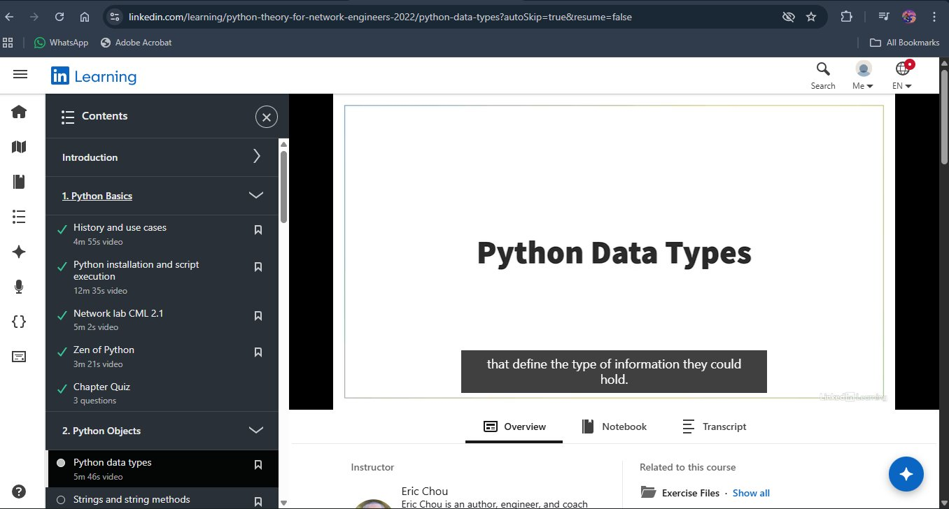
Fig. 4 — LinkedIn Learning: Python Theory for Network Engineers (in progress)

