Rachel Owen- 1801974 (referenced in Harvard) Word count: 3518

Your Lesson Plan (40 minutes teaching)
Class: Year 9
Teaching focus: How did life change for German Jews between 1933-1939?
Anticipated difficulties: Sensitive subject content, students unwilling to participate

Page 1  Timing  (Minutes) | Activity | Objectives | What you will say/do  (e.g. instructions, explanations, talking points) | Grouping | Materials needed
5 | Teach students the topic of the persecution and the use of violence against the Jews | - Engage students with new information  - Build on previous knowledge of who Germany considered enemies  - Censor any sensitive content | - Initial uncertainty over period of time Nazi’s would be in power  - The shift from violence against political opponents  - Putting in action anti-Semitic beliefs | Whole class | Lesson PowerPoint
5 | Teach students the topic of discrimination faced by the Jews | - Engage students with new information  - Censor any sensitive content | Explain methods of discrimination  - Anti-Jewish laws  - Propaganda  - Signs  - School books | Whole class | Lesson PowerPoint
10 | Source analysis  Reflection of source analysis | Use skills in:  - Analysis  - Team work  - Communication | - “Discuss and annotate source A with your tables”  - Indicate a table and ask for their spokesperson to share what they learnt | Tables for task  Whole class for reflection | Source A
Page 2  Timing | Activity | Objectives | What you will say/do  (e.g. instructions, explanations) | Grouping | Materials needed
5 | Teach students the topic of anti-Jewish laws passed between 1933-1939 | - Engage students with new information  - Censor any sensitive content | - Why they were introduced  - The purpose of the laws  - Revoking citizenship | Whole class | Lesson PowerPoint
5 | Students read through the timeline of laws passed between 1933-1939  Pick 5 they think are the most significant and rank them in a pyramid scheme | Use skills in:  - Critical thinking  - Organisation | “I would like you to read through your timelines and choose 5 laws you think had the most impact on Jewish lives. Then jot them down in order of importance” | Individual work | Timeline of laws  Pyramid worksheet
10 | Teach students on the topic of emigration and how it applies to German Jews  Organise push and pull factors on the main whiteboard using personal whiteboards to vote | - Engage students with new information  - Censor any sensitive content  - Use critical thinking skills | Points of interest:  - What is emigration?  - How it applied to the Jews  - Issues they faced  “When I read out a factor, you’re going to show me on your whiteboards whether you think its pull or push” | Whole class | Lesson PowerPoint  Individual Whiteboards, markers, and erasers

Overall Aims  By the end of the lesson, I expect the students will be better able to understand…  1. Nazi intent to exclude German Jews from society during the 1930’s  2. The Nazi’s use of propaganda, violence and anti-Jewish laws to make Jewish life extremely difficult  3. The impact persecution had on German Jews  4. Challenges faced by Jews trying to emigrate from Germany in the 1930’s | Tutor’s signature

The Holocaust is required to be taught in schools by law, in Britain the topic is included in the Key Stage 3 History curriculum. Students in year 9 with an age range of 13-14 years old, will begin learning about the topic as part of their unit on challenges for Britain, Europe and the wider world 1901 to the present day. (Department for Education, 2013, pp.2) Their mature age makes for better engagement with the sensitive material covered, but teachers still have to safeguard against upsetting content in pictures or descriptions of events. At the beginning of the lesson, I would take time to pre-warn students that the subject can be upsetting and if they feel it is too much for them, they need to let me know and other arrangements can be made. At Key Stage 3, pupils should be guided on expanding their chronologically secure knowledge and understanding of British, local and world history, so that it provides a well-informed context for wider learning in their academic career. This topic will relate to the understanding of the Holocaust portion of the unit and expand on the skills set out in the curriculum for critical thinking, communication, numeracy, personal and social education, and career and the world of work. (Welsh Assembly Government, 2008, pp.6-9)
I’ll attempt to follow Jerome Bruner’s social constructivist approach to learning with scaffolding, building on skills that will have been developed in the foundation phase of the student’s academic carrier. (Bartlett and Burton, 2003, pp.30–31) The issue with the Holocaust not being taught until year 9 is there is likely to be little to no knowledge to build on, so a different approach will be needed. However, I would aim to enquire what is already known on the topic from events like Holocaust Memorial Day or other methods of exposure such as films or museum trips. John Dewey’s theory of education and experience will be a focal point for this lesson. Dewey theorised that children learn through experience, if experience is gained through interaction, then learning, is a social process. Keeping this social process in mind, I have organised group and class tasks in addition to some individual tasks for reflection of the student’s own capabilities. I would take a position as overseer of the groups but from a back seat perspective, allowing the students to attempt the task first and intervene when they hit a stand still. Dewey’s educative experience theory would mean learning as a social process makes the teacher apart of the group, leading the activities rather than the dictator role of telling them to do this and only this. (Dewey, 1938, pp.58–59)

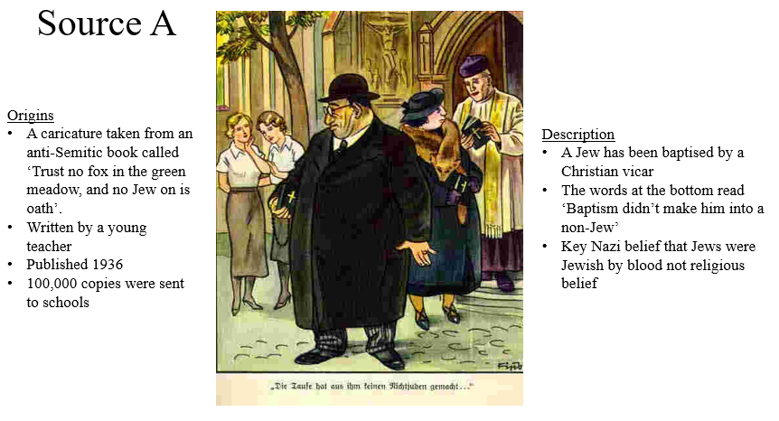

Task one will help to achieve an overall aim of the lesson: ensuring students understand the Nazi’s use of propaganda, violence and anti-Jewish laws to make Jewish life extremely difficult. Task one is source analysis of the above image taken from the lesson PowerPoint, it includes a description of the text at the bottom of the source and the general scene and the publishing information. This task will be conducted as a group activity sorted by table, each student will have their own copy of the source to annotate and the table will appoint a spokes-person to share with the class after five minutes. Students will need to use their historical enquiry skills to critically analyse the source and reach reasoned conclusions on its content. Their communication skills will be required through orally expressing their opinions to their tables followed by their annotations to the class. (Welsh Assembly Government, 2008, pp.6-15) The imposing of group work not only develops their skills but provides the opportunity to learn from each other, then having to share with the class, engages their individual and collective minds. (Palmer-Cooper, Cooper and Liora Bresler, 2010, pp.90–94) Ideally students would link previous knowledge of the German standards for living to new information covered in the lesson on how the Jews were perceived in the public eye. Students would build their global citizenship skills through engaging with the topics of anti-Semitism and discrimination, in addition to their personal and social educational development in recognising and analysing the causes and consequences of the event. (Welsh Assembly Government, 2008, pp.14-15) Learning outcomes would be achievement of a lesson aim to understand the Nazi’s use of propaganda, violence and anti-Jewish laws to make Jewish life extremely difficult. This would be demonstrated across the three areas in literacy; reading and writing levels would be tested through the analytical reading and annotating of the source, it would require interpreting and giving weight to the key issues it represents in a coherent and convincing manner. Oracy skills would be tested through communication amongst the table on individual interpretations or ideas on the source, then collectively agreeing on points to present to the class. Presentation to the class will require clarification and expansion on key points being backed up with evidence from previous knowledge. (Welsh Assembly Government, 2013) Building skills in source analysis and annotation creates a foundation for Bruner’s scaffolding, students considering History at the GCSE level, will likely encounter this source again. Key stage 4 will often involve source-based work in course work and exams. (Bartlett and Burton, 2003, pp.30–31) Anticipated issues with this task mainly revolve around the group work element; students can stray from the topic or take more time choosing a spokes-person rather than analysing the source. I would be walking around the room to ensure students stayed on topic and offer prompts when needed, if the group were having difficulty choosing someone to speak, I would ask a student I believe is capable if they were willing to do it. (Dewey, 1938, pp.58–59) If the pupil responded no, then I would suggest the entire table take a point each, sharing the responsibility. From an ethical perspective, the students could make insensitive comments about the appearance of the Jewish couple in the source, perhaps making remarks about his weight in an impolite manner rather than explaining they are represented as large to signify greediness. To which I would warn the entire class of the importance of being respectful and bullying policies. A similar incident occurred during my observation of a year 9 communications class that were covering the Holocaust, the students were tasked with creating a newspaper article with the title ‘The Rise of the Nazi’s’. One child suggested his description of an image on the front-page would-be Hitler punching a Jewish child in the face, he was warned that he was coming across as offensive and apologised. There is the potential for cross curricular questions relating to Religious Studies, students may not know what a baptism is or the difference between Judaism and Christianity. I would have explanations to these potential questions ready before hand.

Task two will help to achieve two overall aims of the lesson: ensuring students understand the Nazi intent to exclude German Jews from society during the 1930’s and the Nazi’s use of propaganda, violence and anti-Jewish laws to make Jewish life extremely difficult. Task two is an individual task to read and choose five of the laws passed against the Jews between 1933-39 that the student thinks are the most significant, and rank them in a pyramid scheme. I will call on a few students to share their opinions after the task is completed. Students will have their own individual copy of the timeline below and a pyramid scheme worksheet to stick in their exercise books after completing, the task is an individual, critical thinking and organisation piece of work. Students will develop their thinking through reflecting on the key question of what laws would have had the most impact, interpreting each law and then presenting their rationales in the written form of a pyramid scheme. Working with a chronological timeline of events will promote awareness and advancement in number work. Personal and social education will be developed through the sharing of other student’s interpretations, students may be encouraged to question their own rationale or understanding of an alternative interpretation. (Welsh Assembly Government, 2008, pp.14-15) Students should gain an understanding of the exclusion from society the Jews were facing and be able to differentiate between the most impactful laws that they support with evidence. Preparation for the world work will come in being able to identify discrimination and prejudice, this would also link to Donaldson’s four purposes for creating ethically informed citizens. (Donaldson, 2015, pp. 25) (paragraph continues after timeline)

Timeline of anti-Jewish laws
1938
Jan 5th- Jews cannot change their names
Apr 22nd- Jewish-owned businesses cannot change their name
April 26th- Jewish people have to report any property of value
July 11th- Jews are banned from health spas
Aug 17th- Jews with non-Jewish first names have to take additional name: Israel for men and Sara for women
Oct 3rd- Jewish property is taken away and given to non-Jews
Oct 5th- Jews have to hand in their passports to be stamped with a J
Nov 12th- Jews aren’t allowed to own businesses or sell goods
Nov 15th- All Jewish children are banned from school
Nov 29th- Jews are banned from keeping carrier pigeons
Dec 3rd- Jewish driving licenses are revoked
Dec 4th- Jews are banned from cinemas and theatres

1937
Apr 9th- The Mayor of Berlin orders schools not to admit Jewish children until further notice

1936
Apr 3rd- Jews are no longer allowed to be vets
Oct 15th- Jewish teachers are banned from schools
1935
May 21st- Jewish off icers are dismissed form the army
Sep 15th- The Nuremberg Laws; German Jews are no longer citizens. Jewish people are forbidden from marriage or intercourse with non-Jews
Nov 15th- A Jew is defined as anyone with 3 grandparents born into a Jewish community

1933
Apr7th- Restoration of the Professional Civil Service Act dismisses Jews from government jobs
Apr 7th- Jews are banned from entering the legal profession
Apr 25th- Law Against the Overcrowding of German Schools limits the number of Jewish children that can attend school
Apr 25th- Jews are banned from membership in sports clubs
July 14th- Jews living in Germany that were born in other countries are no longer German citizens
Oct 4th- Jews are banned from being editors of newspapers

1939
Feb 21st- Jews are ordered to hand over valuable like gold, silver, diamonds without compensation
Apr 30th- Local authorities can evict Jews from rented houses/flats
Aug 1st- Jews are banned from buying lottery tickets

Learning outcomes would be achievement of the lesson aims: to understand the Nazi intent to exclude German Jews from society during the 1930’s and the Nazi’s use of propaganda, violence and anti-Jewish laws to make Jewish life extremely difficult. This would be demonstrated through the levels of analytical reading and rationalising of information in the timeline. The task will require interpreting and giving weight to the key issues represented in anti-Jewish law in a coherent manner. Oracy skills would be tested in the delivering of a student’s pyramid scheme, they would need to communicate their rationale in a coherent and convincing manner, further clarification and expansion on key points being backed up with evidence will apply. (Welsh Assembly Government, 2013) The timetable resource could be reused for other tasks such as extended writing on the overall impact these anti-Jewish laws had on the German Jews. Foundations for Bruner’s scaffolding are again laid out for the students that wish to pursue History as a GCSE, the timeline can be reused and linked to the Nazi Germany unit in Key Stage 4. (Bartlett and Burton, 2003, pp.30–31) Some anticipated issues may arise from students being indecisive with prioritising the laws, this could potentially be solved by hearing the other student’s interpretations, prompting them to agree or clarify their ideas. The student I call on to share may not want to, in which case I would ask another student, I’d aim for three students to participate overall. To avoid the students feeling uncomfortable about being chosen, I could develop a lolly pop stick system; I would have a pot of lolly sticks on my desk with student’s names on and when a task requires student participation, I pick a stick out at random. This reduces the chance of students feeling like I only ever pick them because I know they will talk and perhaps give some of the shy pupils a chance to participate. The lolly pop system was something I always enjoyed at school, it encouraged random opinions from around the room, gave way for whole class involvement, socially learning and bouncing off each other’s ideas.
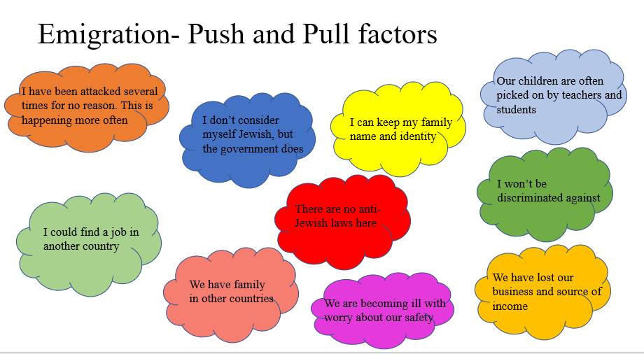

Task three will help to achieve two overall aim of the lesson: ensuring students understand the impact persecution had on German Jews and the challenges faced by Jews trying to emigrate from Germany in the 1930’s. Task three is a class activity using the slide above from the lesson PowerPoint to determine what push and pull factors for emigration would have been for the Jews looking to leave Germany in the 1930’s. Students will have their own individual whiteboards, write push on one side and pull on the other, then show me their answers when I ask. I will then use the lolly pop system to ask students why they have chosen their answer. Students will develop their thinking through reflecting on the push and pull factors on the main classroom board, interpreting each factor and then presenting their rationales on their individual whiteboards. Personal and social education will be developed through the sharing of other student’s interpretations, students can recognise the same lines of thought throughout the classroom. Communication skills will also be needed to orally communicate and expand on those interpretations to the class. (Welsh Assembly Government, 2008, pp.6-15) Whole class participation provides the opportunity to learn from each other, engaging their individual and collective minds. (Palmer-Cooper, Cooper and Liora Bresler, 2010, pp.90–94) Preparation for the world of work will come in being able to identify discrimination and prejudice, identifying key issues relating to emigration would also link to Donaldson’s four purposes for creating ethically informed citizens. (Donaldson, 2015, pp. 25) Learning outcomes would be achievement of the lesson aims: ensuring students understand the impact persecution had on German Jews and the challenges faced by Jews trying to emigrate from Germany in the 1930’s. This would be demonstrated through the reading and interpretation of the key issues of emigration in a coherent manner. Students would need to orally communicate their rationale in a coherent and convincing manner, further clarification and expansion on key push and pull factors being backed up with evidence will apply. (Welsh Assembly Government, 2013) Foundations for Bruner’s scaffolding are laid again through teaching on the topic of emigration. Students will have to take part in a global citizenship challenge as part of their Welsh Baccalaureate in GCSE and A-Level, they will be expected to present on the issue and provide methods for how to tackle it. (Bartlett and Burton, 2003, pp.30–31) The task being carried out as a whole class means the students will lead the conversation and categorise the push and pull factors. I will keep my role as leader of the group in relation to Dewey’s theory, merely prompting who gets to explain their rationale. (Dewey, 1938, pp.58–59) Some anticipated issues could arise in students using their whiteboards for means other than the task set, I would tackle this by first warning the student that the whiteboards are not meant to be used that way and to participate in the task properly. If the behaviour continued, I would remove the whiteboard from the student and their participation in the task would be reduced to verbally communicating their interpretations if selected by the lolly pop stick system.

By the end of the taught session my overall aims of students better understanding:
1. Nazi intent to exclude German Jews from society during the 1930’s
2. The Nazi’s use of propaganda, violence and anti-Jewish laws to make Jewish life extremely difficult
3. The impact persecution had on German Jews
4. Challenges faced by Jews trying to emigrate from Germany in the 1930’s.
Will have hopefully been achieved through a traditional taught session using PowerPoint aid, group activities, class activities, and individual activities. Key stage 3 specific exam board expectation will have been met through the inclusion of developing students thinking, communication, and number skills, advancement of personal and social education, and preparation for the world of work. (Welsh Assembly Government, 2008, pp.6-15) Numerous opportunities to sustain and improve literacy and numeracy skills were provided throughout the lesson. Students would have critically read and analysed evidence and source content, then communicated their interpretations orally or in written form. Students would have had to listen to myself and fellow students share information or interpretations and understand how we arrived at those conclusions through rational thought and understanding of the topic. (Welsh Assembly Government, 2013) In attempts to bring together and solidify the classes knowledge gained from this session, I would have assigned an extended writing homework task. Students would have been asked to write a paragraph bringing together the key points of today’s lesson in relation to the question ‘how and why did the Holocaust happen?’. This task would provide an opportunity for clarification on the topic, development of extended writing skills, use of spelling, punctuation, and grammar correctly, and preparation for Key Stage 4 level literacy frameworks. (Welsh Assembly Government, 2013)

Bibliography
Bartlett, S.G. and Burton, D. (2003). Education studies: essential issues. London: Sage, pp.30–31.
Department for Education (2013). History programmes of study: key stage 3. [online] p. 1-5. Available at: https://assets.publishing.service.gov.uk/government/uploads/system/uploads/attachment_data/file/239075/SECONDARY_national_curriculum_-_History.pdf [Accessed 6 May 2021].
Dewey, J. (1938). Experience and education. New York: Free Press, pp.58–59.
Donaldson, G. (2015). Successful Futures: Independent Review of Curriculum and Assessment Arrangements in Wales. [online] pp.1–124. Available at: https://moodle.uwtsd.ac.uk/pluginfile.php/207620/mod_resource/content/1/150225-successful-futures-en_Redacted.pdf. [Accessed 6 May 2021]
Palmer-Cooper, J.A., Cooper, D.E. and Liora Bresler (2010). Fifty modern thinkers on education: from Piaget to the present. London: Routledge, Taylor & Francis Group, pp.90–94.
Welsh Assembly Government (2008). Yr Adran Plant, Addysg, Dysgu Gydol Oes a Sgiliau Department for Children, Education, Lifelong Learning and Skills Key Stages 2-3 History in the National Curriculum for Wales. [online] p.1-24. Available at: file:///F:/Assignments/Third%20Year/Humanities%20in%20Education%20()/Reading/history-in-the-national-curriculum-for-wales.pdf [Accessed 6 May 2021].
Welsh Assembly Government (2013). National Literacy and Numeracy Framework: Curriculum for Wales 2008 version - speadsheet. [online] Gov.wales. Available at: https://hwb.gov.wales/curriculum-for-wales-2008/national-literacy-and-numeracy-framework-curriculum-for-wales-2008-version/. [Accessed 6 May 2021]

