Lab - Building a Simple Network
Topology
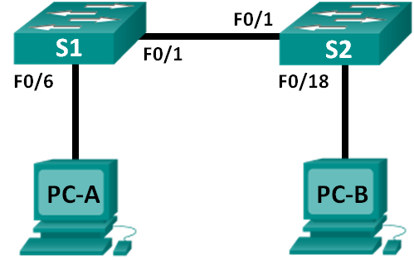
Addressing Table
Device | Interface | IP Address | Subnet Mask
PC-A | NIC | 192.168.1.10 | 255.255.255.0
PC-B | NIC | 192.168.1.11 | 255.255.255.0
Objectives
Part 1: Set Up the Network Topology (Ethernet only)
Part 2: Configure PC Hosts
Part 3: Configure and Verify Basic Switch Settings
Background / Scenario
Networks are constructed of three major components: hosts, switches, and routers. In this lab, you will build a simple network with two hosts and two switches. You will also configure basic settings including hostname, local passwords, and login banner. Use show commands to display the running configuration, IOS version, and interface status. Use the copy command to save device configurations.
You will apply IP addressing for this lab to the PCs to enable communication between these two devices. Use the ping utility to verify connectivity.
Note: The switches used are Cisco Catalyst 2960s with Cisco IOS Release 15.0(2) (lanbasek9 image). Other switches and Cisco IOS versions can be used. Depending on the model and Cisco IOS version, the commands available and output produced might vary from what is shown in the labs.
Note: Make sure that the switches have been erased and have no startup configurations. Refer to Appendix A for the procedure to initialize and reload a switch.
Required Resources
- 2 Switches (Cisco 2960 with Cisco IOS Release 15.0(2) lanbasek9 image or comparable)
- 2 PCs (Windows 7 or 8 with terminal emulation program, such as Tera Term)
- Console cables to configure the Cisco IOS devices via the console ports
- Ethernet cables as shown in the topology
- Set Up the Network Topology (Ethernet only)
In Part 1, you will cable the devices together according to the network topology.
  - Power on the devices.
Power on all devices in the topology. The switches do not have a power switch; they will power on as soon as you plug in the power cord.
  - Connect the two switches.
Connect one end of an Ethernet cable to F0/1 on S1 and the other end of the cable to F0/1 on S2. You should see the lights for F0/1 on both switches turn amber and then green. This indicates that the switches have been connected correctly.
  - Connect the PCs to their respective switches.
    - Connect one end of the second Ethernet cable to the NIC port on PC-A. Connect the other end of the cable to F0/6 on S1. After connecting the PC to the switch, you should see the light for F0/6 turn amber and then green, indicating that PC-A has been connected correctly.
    - Connect one end of the last Ethernet cable to the NIC port on PC-B. Connect the other end of the cable to F0/18 on S2. After connecting the PC to the switch, you should see the light for F0/18 turn amber and then green, indicating that the PC-B has been connected correctly.
  - Visually inspect network connections.
After cabling the network devices, take a moment to carefully verify the connections to minimize the time required to troubleshoot network connectivity issues later.
- Configure PC Hosts
  - Configure static IP address information on the PCs.
    - Click the Windows Start icon and then select Control Panel.
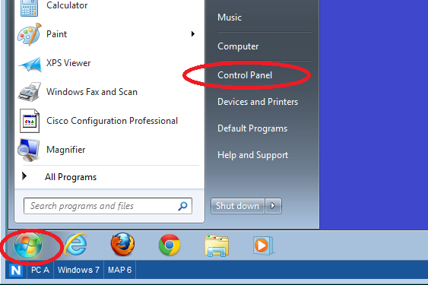
    - In the Network and Internet section, click the View network status and tasks link.
Note: If the Control Panel displays a list of icons, click the drop-down option next to the View by: and change this option to display by Category.
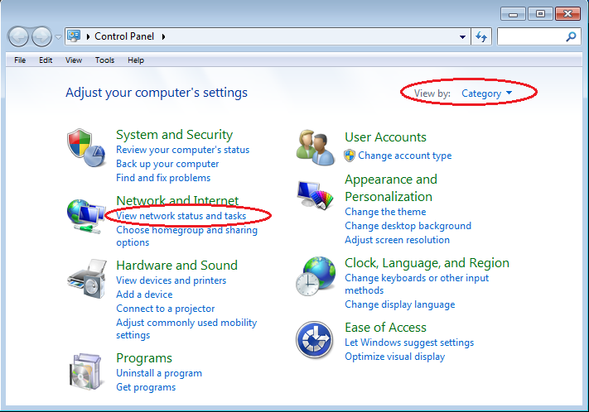
    - In the left pane of the Network and Sharing Center window, click the Change adapter settings link.
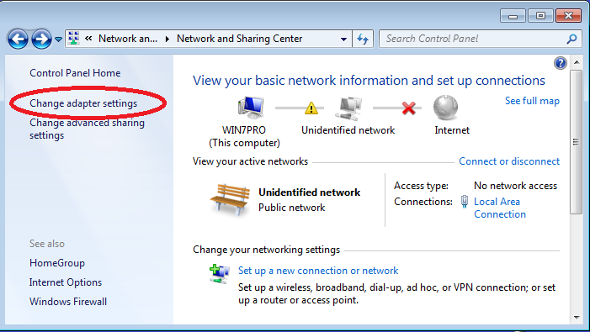

    - The Network Connections window displays the available interfaces on the PC. Right-click the Local Area Connection interface and select Properties.
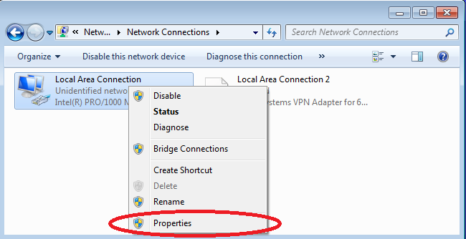
    - Select the Internet Protocol Version 4 (TCP/IPv4) option and then click Properties.
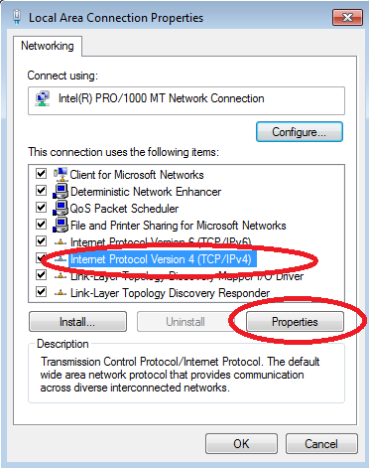
Note: You can also double-click Internet Protocol Version 4 (TCP/IPv4) to display the Properties window.
    - Click the Use the following IP address radio button to manually enter an IP address, subnet mask, and default gateway.
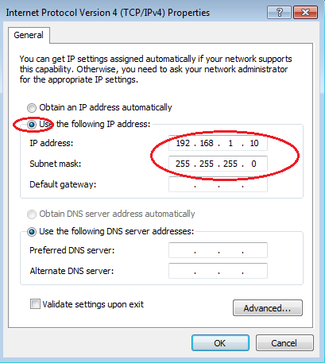
Note: In the above example, the IP address and subnet mask have been entered for PC-A. The default gateway has not been entered, because there is no router attached to the network. Refer to the Addressing Table on page 1 for PC-B’s IP address information.
    - After all the IP information has been entered, click OK. Click OK on the Local Area Connection Properties window to assign the IP address to the LAN adapter.
    - Repeat the previous steps to enter the IP address information for PC-B.
  - Verify PC settings and connectivity.
Use the command prompt (cmd.exe) window to verify the PC settings and connectivity.
    - From PC-A, click the Windows Start icon, type cmd in the Search programs and files box, and then press Enter.
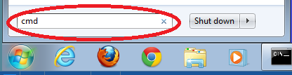

    - The cmd.exe window is where you can enter commands directly to the PC and view the results of those commands. Verify your PC settings by using the ipconfig /all command. This command displays the PC hostname and the IPv4 address information.
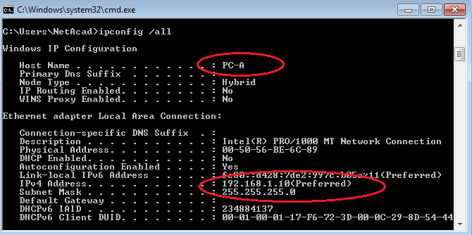
    - Type ping 192.168.1.11 and press Enter.
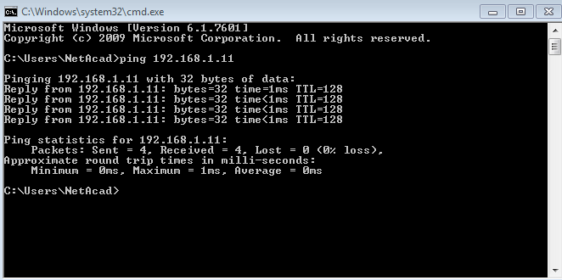
Were the ping results successful? Yes
If not, troubleshoot as necessary.
Note: If you did not get a reply from PC-B, try to ping PC-B again. If you still do not get a reply from PC-B, try to ping PC-A from PC-B. If you are unable to get a reply from the remote PC, then have your instructor help you troubleshoot the problem.
- Configure and Verify Basic Switch Settings
  - Console into the switch.
Using Tera Term, establish a console connection to the switch from PC-A.
  - Enter privileged EXEC mode.
You can access all switch commands in privileged EXEC mode. The privileged EXEC command set includes those commands contained in user EXEC mode, as well as the configure command through which access to the remaining command modes are gained. Enter privileged EXEC mode by entering the enable command.
Switch> enable
Switch#
The prompt changed from Switch> to Switch# which indicates privileged EXEC mode.
  - Enter configuration mode.
Use the configuration terminal command to enter configuration mode.
Switch# configure terminal
Enter configuration commands, one per line. End with CNTL/Z.
Switch(config)#
The prompt changed to reflect global configuration mode.
  - Give the switch a name.
Use the hostname command to change the switch name to S1.
Switch(config)# hostname S1
S1(config)#
  - Prevent unwanted DNS lookups.
To prevent the switch from attempting to translate incorrectly entered commands as though they were hostnames, disable the Domain Name System (DNS) lookup.
S1(config)# no ip domain-lookup
S1(config)#
  - Enter local passwords.
To prevent unauthorized access to the switch, passwords must be configured.
S1(config)# enable secret class
S1(config)# line con 0
S1(config-line)# password cisco
S1(config-line)# login
S1(config-line)# exit
S1(config)#
  - Enter a login MOTD banner.
A login banner, known as the message of the day (MOTD) banner, should be configured to warn anyone accessing the switch that unauthorized access will not be tolerated.
The banner motd command requires the use of delimiters to identify the content of the banner message. The delimiting character can be any character as long as it does not occur in the message. For this reason, symbols, such as the #, are often used.

S1(config)# banner motd #
Enter TEXT message. End with the character '#'.
Unauthorized access is strictly prohibited and prosecuted to the full extent of the law. #
S1(config)# exit
S1#
  - Save the configuration.
Use the copy command to save the running configuration to the startup file on non-volatile random access memory (NVRAM).
S1# copy running-config startup-config
Destination filename [startup-config]? [Enter]
Building configuration...
[OK]
S1#
  - Display the current configuration.
The show running-config command displays the entire running configuration, one page at a time. Use the spacebar to advance paging. The commands configured in Steps 1 – 8 are highlighted below.
S1# show running-config
Building configuration...

Current configuration : 1409 bytes
!
! Last configuration change at 03:49:17 UTC Mon Mar 1 1993
!
version 15.0
no service pad
service timestamps debug datetime msec
service timestamps log datetime msec
no service password-encryption
!
hostname S1
!
boot-start-marker
boot-end-marker
!
enable secret 4 06YFDUHH61wAE/kLkDq9BGho1QM5EnRtoyr8cHAUg.2
!
no aaa new-model
system mtu routing 1500
!
!
no ip domain-lookup
!

<output omitted>

!
banner motd ^C
Unauthorized access is strictly prohibited and prosecuted to the full extent of the law. ^C
!
line con 0
password cisco
login
line vty 0 4
login
line vty 5 15
login
!
end

S1#
  - Display the IOS version and other useful switch information.
Use the show version command to display the IOS version that the switch is running, along with other useful information. Again, you will need to use the spacebar to advance through the displayed information.
S1# show version
Cisco IOS Software, C2960 Software (C2960-LANBASEK9-M), Version 15.0(2)SE, RELEASE SOFTWARE (fc1)
Technical Support: http://www.cisco.com/techsupport
Copyright (c) 1986-2012 by Cisco Systems, Inc.
Compiled Sat 28-Jul-12 00:29 by prod_rel_team

ROM: Bootstrap program is C2960 boot loader
BOOTLDR: C2960 Boot Loader (C2960-HBOOT-M) Version 12.2(53r)SEY3, RELEASE SOFTWARE (fc1)

S1 uptime is 1 hour, 38 minutes
System returned to ROM by power-on
System image file is "flash:/c2960-lanbasek9-mz.150-2.SE.bin"

This product contains cryptographic features and is subject to United
States and local country laws governing import, export, transfer and
use. Delivery of Cisco cryptographic products does not imply
third-party authority to import, export, distribute or use encryption.
Importers, exporters, distributors and users are responsible for
compliance with U.S. and local country laws. By using this product you
agree to comply with applicable laws and regulations. If you are unable
to comply with U.S. and local laws, return this product immediately.

A summary of U.S. laws governing Cisco cryptographic products may be found at:
http://www.cisco.com/wwl/export/crypto/tool/stqrg.html

If you require further assistance please contact us by sending email to
export@cisco.com.

cisco WS-C2960-24TT-L (PowerPC405) processor (revision R0) with 65536K bytes of memory.
Processor board ID FCQ1628Y5LE
Last reset from power-on
1 Virtual Ethernet interface
24 FastEthernet interfaces
2 Gigabit Ethernet interfaces
The password-recovery mechanism is enabled.

64K bytes of flash-simulated non-volatile configuration memory.
Base ethernet MAC Address : 0C:D9:96:E2:3D:00
Motherboard assembly number : 73-12600-06
Power supply part number : 341-0097-03
Motherboard serial number : FCQ16270N5G
Power supply serial number : DCA1616884D
Model revision number : R0
Motherboard revision number : A0
Model number : WS-C2960-24TT-L
System serial number : FCQ1628Y5LE
Top Assembly Part Number : 800-32797-02
Top Assembly Revision Number : A0
Version ID : V11
CLEI Code Number : COM3L00BRF
Hardware Board Revision Number : 0x0A

Switch Ports Model SW Version SW Image
------ ----- ----- ---------- ----------
* 1 26 WS-C2960-24TT-L 15.0(2)SE C2960-LANBASEK9-M

Configuration register is 0xF
S1#
  - Display the status of the connected interfaces on the switch.
To check the status of the connected interfaces, use the show ip interface brief command. Press the spacebar to advance to the end of the list.
S1# show ip interface brief
Interface IP-Address OK? Method Status Protocol
Vlan1 unassigned YES unset up up
FastEthernet0/1 unassigned YES unset up up
FastEthernet0/2 unassigned YES unset down down
FastEthernet0/3 unassigned YES unset down down
FastEthernet0/4 unassigned YES unset down down
FastEthernet0/5 unassigned YES unset down down
FastEthernet0/6 unassigned YES unset up up
FastEthernet0/7 unassigned YES unset down down
FastEthernet0/8 unassigned YES unset down down
FastEthernet0/9 unassigned YES unset down down
FastEthernet0/10 unassigned YES unset down down
FastEthernet0/11 unassigned YES unset down down
FastEthernet0/12 unassigned YES unset down down
FastEthernet0/13 unassigned YES unset down down
FastEthernet0/14 unassigned YES unset down down
FastEthernet0/15 unassigned YES unset down down
FastEthernet0/16 unassigned YES unset down down
FastEthernet0/17 unassigned YES unset down down
FastEthernet0/18 unassigned YES unset down down
FastEthernet0/19 unassigned YES unset down down
FastEthernet0/20 unassigned YES unset down down
FastEthernet0/21 unassigned YES unset down down
FastEthernet0/22 unassigned YES unset down down
FastEthernet0/23 unassigned YES unset down down
FastEthernet0/24 unassigned YES unset down down
GigabitEthernet0/1 unassigned YES unset down down
GigabitEthernet0/2 unassigned YES unset down down
S1#
  - Repeat Steps 1 to 12 to configure switch S2.
The only difference for this step is to change the hostname to S2.
  - Record the interface status for the following interfaces.
Interface | S1 |  | S2
Interface | Status | Protocol | Status | Protocol
F0/1 | Up | Up | Up | Up
F0/6 | Down | Down | Down | Down
F0/18 | Down | Down | Down | Down
VLAN 1 | Down | Down | Down | Down

Why are some FastEthernet ports on the switches are up and others are down?
Up indicates that they are currently in use as a connection, whereas Down indicates that they are available to be used for a connection.
What could prevent a ping from being sent between the PCs?
This could be due to an incorrect IP address being used.
Note: It may be necessary to disable the PC firewall to ping between PCs.
Appendix A: Initializing and Reloading a Switch
  - Connect to the switch.
Console into the switch and enter privileged EXEC mode.
Switch> enable
Switch#
  - Determine if there have been any virtual local-area networks (VLANs) created.
Use the show flash command to determine if any VLANs have been created on the switch.
Switch# show flash

Directory of flash:/

2 -rwx 1919 Mar 1 1993 00:06:33 +00:00 private-config.text
3 -rwx 1632 Mar 1 1993 00:06:33 +00:00 config.text
4 -rwx 13336 Mar 1 1993 00:06:33 +00:00 multiple-fs
5 -rwx 11607161 Mar 1 1993 02:37:06 +00:00 c2960-lanbasek9-mz.150-2.SE.bin
6 -rwx 616 Mar 1 1993 00:07:13 +00:00 vlan.dat

32514048 bytes total (20886528 bytes free)
Switch#
  - Delete the VLAN file.
    - If the vlan.dat file was found in flash, then delete this file.
Switch# delete vlan.dat
Delete filename [vlan.dat]?
You will be prompted to verify the file name. At this point, you can change the file name or just press Enter if you have entered the name correctly.
    - When you are prompted to delete this file, press Enter to confirm the deletion. (Pressing any other key will abort the deletion.)
Delete flash:/vlan.dat? [confirm]
Switch#
  - Erase the startup configuration file.
Use the erase startup-config command to erase the startup configuration file from NVRAM. When you are prompted to remove the configuration file, press Enter to confirm the erase. (Pressing any other key will abort the operation.)
Switch# erase startup-config
Erasing the nvram filesystem will remove all configuration files! Continue? [confirm]
[OK]
Erase of nvram: complete
Switch#
  - Reload the switch.
Reload the switch to remove any old configuration information from memory. When you are prompted to reload the switch, press Enter to proceed with the reload. (Pressing any other key will abort the reload.)
Switch# reload
Proceed with reload? [confirm]
Note: You may receive a prompt to save the running configuration prior to reloading the switch. Type no and press Enter.
System configuration has been modified. Save? [yes/no]: no
  - Bypass the initial configuration dialog.
After the switch reloads, you should see a prompt to enter the initial configuration dialog. Type no at the prompt and press Enter.
Would you like to enter the initial configuration dialog? [yes/no]: no
Switch>

Reflection (Max word count 200):
Write your reflection based on what you learned from this activity. This could include operation of Switch, configs and testing network connectivity.

Reflection of configuration of a Switch using Packet Tracer.

Running through this lab I was able to configure a basic switch configuration using packet tracer. This was done by first enabling the privileged EXEC mode for myself to be able to then enter the configuration mode. This is done with the commands enable first, and then followed by configure terminal. From here I was able to configure the switch name, disable any unwanted DNS lookups and give the switch a password.

After setting up and configuring about the switches in our network, a useful command in the configuration was to show IP address brief. This in short showed exactly what the command says, showing the IP address briefs. This told us the connected interfaces being used along our network, helping us establish which connection we could use as they are available, or which one was currently in use by the network.

Finishing the lab by deleting the VLANs (if any) and also erasing the start-up configuration I found to be extremely useful, this because no unwanted configurations will then be kept on the network when starting up a new network, or someone else uses the same PC for packet tracer.

Lab - Building a Switch and Router Network
Topology

Addressing Table
Device | Interface | IP Address | Subnet Mask | Default Gateway
R1 | G0/0 | 192.168.0.1 | 255.255.255.0 | N/A
R1 | G0/1 | 192.168.1.1 | 255.255.255.0 | N/A
PC-A | NIC | 192.168.1.3 | 255.255.255.0 | 192.168.1.1
PC-B | NIC | 192.168.0.3 | 255.255.255.0 | 192.168.0.1
Objectives
Part 1: Set Up the Topology and Initialize Devices
Part 2: Configure Devices and Verify Connectivity
Part 3: Display Device Information
Background / Scenario
This is a comprehensive lab to review previously covered IOS commands. In this lab, you will cable the equipment as shown in the topology diagram. You will then configure the devices to match the addressing table. After the configurations have been saved, you will verify your configurations by testing for network connectivity.
After the devices have been configured and network connectivity has been verified, you will use IOS commands to retrieve information from the devices to answer questions about your network equipment.
This lab provides minimal assistance with the actual commands necessary to configure the router. Test your knowledge by trying to configure the devices without referring to the content or previous activities.
Note: The routers used with CCNA hands-on labs are Cisco 1941 Integrated Services Routers (ISRs) with Cisco IOS Release 15.2(4)M3 (universalk9 image). The switches used are Cisco Catalyst 2960s with Cisco IOS Release 15.0(2) (lanbasek9 image). Other routers, switches, and Cisco IOS versions can be used. Depending on the model and Cisco IOS version, the commands available and output produced might vary from what is shown in the labs. Refer to the Router Interface Summary Table at the end of this lab for the correct interface identifiers.
Note: Ensure that the routers and switches have been erased and have no startup configurations. Consult with your instructor for the procedure to initialize and reload a router and switch.
Required Resources
- 1 Router (Cisco 1941 with Cisco IOS Release 15.2(4)M3 universal image or comparable)
- 1 Switch (Cisco 2960 with Cisco IOS Release 15.0(2) lanbasek9 image or comparable)
- 2 PCs (Windows 7 or 8 with terminal emulation program, such as Tera Term)
- Console cables to configure the Cisco IOS devices via the console ports
- Ethernet cables as shown in the topology
Note: The Gigabit Ethernet interfaces on Cisco 1941 routers are autosensing and an Ethernet straight-through cable may be used between the router and PC-B. If using another model Cisco router, it may be necessary to use an Ethernet crossover cable.
- Set Up Topology and Initialize Devices
  - Cable the network as shown in the topology.
    - Attach the devices shown in the topology diagram, and cable, as necessary.
    - Power on all the devices in the topology.
  - Initialize and reload the router and switch.
If configuration files were previously saved on the router and switch, initialize and reload these devices back to their basic configurations.
- Configure Devices and Verify Connectivity
In Part 2, you will set up the network topology and configure basic settings, such as the interface IP addresses, device access, and passwords. Refer to the Topology and Addressing Table at the beginning of this lab for device names and address information.
  - Assign static IP information to the PC interfaces.
    - Configure the IP address, subnet mask, and default gateway settings on PC-A.
    - Configure the IP address, subnet mask, and default gateway settings on PC-B.
    - Ping PC-B from a command prompt window on PC-A.
Why were the pings not successful?
The pings were not successful as there is not a configure route between the two PC’s
  - Configure the router.
    - Console into the router and enable privileged EXEC mode.
    - Enter configuration mode.
    - Assign a device name to the router.
    - Disable DNS lookup to prevent the router from attempting to translate incorrectly entered commands as though they were host names.
    - Assign class as the privileged EXEC encrypted password.
    - Assign cisco as the console password and enable login.
    - Assign cisco as the VTY password and enable login.
    - Encrypt the clear text passwords.
    - Create a banner that warns anyone accessing the device that unauthorized access is prohibited.
    - Configure and activate both interfaces on the router.
    - Configure an interface description for each interface indicating which device is connected to it.
    - Save the running configuration to the startup configuration file.
    - Set the clock on the router.
Note: Use the question mark (?) to help with the correct sequence of parameters needed to execute this command.
    - Ping PC-B from a command prompt window on PC-A.
Were the pings successful? Why?
The pings were successful as we have set up correct routing between the two devices.
- Display Device Information
In Part 3, you will use show commands to retrieve information from the router and switch.
  - Retrieve hardware and software information from the network devices.
    - Use the show version command to answer the following questions about the router.
What is the name of the IOS image that the router is running?
Cisco IOS Software, C1900 Software
How much DRAM memory does the router have?
64 bits
How much NVRAM memory does the router have?
255K bytes
How much Flash memory does the router have?
249856K bytes
    - Use the show version command to answer the following questions about the switch.
What is the name of the IOS image that the switch is running?
Cisco IOS Software, C2960 Software
How much dynamic random access memory (DRAM) does the switch have?
21039K bytes
How much nonvolatile random-access memory (NVRAM) does the switch have?
63488K bytes
What is the model number of the switch?
WS-C2960-24TT

  - Display the routing table on the router.
Use the show ip route command on the router to answer the following questions.
What code is used in the routing table to indicate a directly connected network?
L
How many route entries are coded with a C code in the routing table?
2
What interface types are associated to the C coded routes?
Ethernet interfaces
  - Display interface information on the router.
Use the show interface g0/1 to answer the following questions.
What is the operational status of the G0/1 interface?
Connected
What is the Media Access Control (MAC) address of the G0/1 interface?
0000.0C38.4902
How is the Internet address displayed in this command?
Internet address 192.168.1.1/24
  - Display a summary list of the interfaces on the router and switch.
There are several commands that can be used to verify an interface configuration. One of the most useful of these is the show ip interface brief command. The command output displays a summary list of the interfaces on the device and provides immediate feedback to the status of each interface.
    - Enter the show ip interface brief command on the router.
R1# show ip interface brief
Interface IP-Address OK? Method Status Protocol
Embedded-Service-Engine0/0 unassigned YES unset administratively down down
GigabitEthernet0/0 192.168.0.1 YES manual up up
GigabitEthernet0/1 192.168.1.1 YES manual up up
Serial0/0/0 unassigned YES unset administratively down down
Serial0/0/1 unassigned YES unset administratively down down
R1#
    - Enter the show ip interface brief command on the switch.
Switch# show ip interface brief
Interface IP-Address OK? Method Status Protocol
Vlan1 unassigned YES manual up up
FastEthernet0/1 unassigned YES unset down down
FastEthernet0/2 unassigned YES unset down down
FastEthernet0/3 unassigned YES unset down down
FastEthernet0/4 unassigned YES unset down down
FastEthernet0/5 unassigned YES unset up up
FastEthernet0/6 unassigned YES unset up up
FastEthernet0/7 unassigned YES unset down down
FastEthernet0/8 unassigned YES unset down down
FastEthernet0/9 unassigned YES unset down down
FastEthernet0/10 unassigned YES unset down down
FastEthernet0/11 unassigned YES unset down down
FastEthernet0/12 unassigned YES unset down down
FastEthernet0/13 unassigned YES unset down down
FastEthernet0/14 unassigned YES unset down down
FastEthernet0/15 unassigned YES unset down down
FastEthernet0/16 unassigned YES unset down down
FastEthernet0/17 unassigned YES unset down down
FastEthernet0/18 unassigned YES unset down down
FastEthernet0/19 unassigned YES unset down down
FastEthernet0/20 unassigned YES unset down down
FastEthernet0/21 unassigned YES unset down down
FastEthernet0/22 unassigned YES unset down down
FastEthernet0/23 unassigned YES unset down down
FastEthernet0/24 unassigned YES unset down down
GigabitEthernet0/1 unassigned YES unset down down
GigabitEthernet0/2 unassigned YES unset down down
Switch#
Reflection
If the G0/1 interface showed administratively down, what interface configuration command would you use to turn the interface up?
no shutdown
What would happen if you had incorrectly configured interface G0/1 on the router with an IP address of 192.168.1.2?
There wouldn’t be successful data packet movements over the local network.
Explain the operation of a Router and a Switch.
Routers are network devices that are used to connect computer networks, such as a home network, to the internet. A switch connects multiple devices together onto a singular computer network. Routers are used to transfer packets of data along and between networks to allow for communication between nodes. A switch operates at a data link layer of a network and uses MAC addresses to forward along data that is travelling along to the desired destination.



Lab: IPv4, Subnetting, VLSM and IPv6 Addressing

- Understanding IPv4 and IPv6 addressing (word count 1000)
This part of lab worksheet require you research and write a report on “Features of IPv6”. You may discuss but not limited to structure, address types, advanced functionalities and
security.

Report on Understanding and Features of IPv6

- Subnetting and VLSM

NOTE: To complete this part you would need full understanding of Lab 10 to 14.



Using the Network address 172.16.2.0/24, VLSM the network to support the following requirements:
Subnet A: 16 hosts
Subnet B: 2000 hosts
Subnet C: 6 hosts
Subnet D: 500 hosts
Subnet E: 60 hosts
Subnet F: 180 hosts and Serial links between routers

Table 1
Subnet | Network Address | Subnet mask | First Address | Last Address | Broadcast Address
A | 172.16.12.244 | 255.255.255.226 | 172.16.12.245 | 172.16.13.18 | 172.16.13.19
B | 172.16.2.0 | 255.255.248.0 | 172.16.2.1 | 172.16.9.254 | 172.16.9.255
C | 172.16.13.20 | 255.255.255.248 | 172.16.13.21 | 172.16.13.26 | 172.16.13.27
D | 172.16.10.0 | 255.255.254.0 | 172.16.10.1 | 172.16.11.254 | 172.16.11.255
E | 172.16.12.180 | 255.255.255.192 | 172.16.12.180 | 172.16.12.242 | 172.16.12.243
F | 172.16.12.0 | 255.255.255.0 | 172.16.12.1 | 172.16.12.178 | 172.16.12.179
R1 | 172.16.13.28 | 255.255.255.252 | 172.16.13.29 | 172.16.13.30 | 172.16.13.31
R2 | 172.16.13.32 | 255.255.255.252 | 172.16.13.33 | 172.116.13.34 | 172.16.13.35
R3 | 172.16.13.36 | 255.255.255.252 | 172.16.13.37 | 172.16.13.38 | 172.16.13.39

A Report into IPv6 and IPv4 as Network Types

Currently there are two types of networks that we use for allocation of IP addresses, these are IPv4 and IPv6. These names stand for Internet Protocol version 4, and Internet Protocol version 6. The two networks use and share similar characteristics; however, these also do have their own differences. Each one of these networks have their own pros and cons to their use and have their own way of providing service through them.
For example, IPv4 is a 32-bit IP address, as opposed to IPv6 which is a 128-bit IP address. [1] This tells us that there is a limited amount of addresses available for growth into, which can in turn cause issues when it comes to the expansion of the internet. [2, 3] Therefore, we can say switching over to IPv6 can greatly help with the ever-enlarging amount of demand for the internet presently.
IPv6 is the successor to the older IPv4, and because of this feature like security and structure have been investigated form IPv4 and attempted to be improved upon with IPv6, giving more of an incentive to switch over to this IP network.
As discussed above, IPv6 address are longer than IPv4, being 128 bits in length. These addresses have a type and these types are assigned to an interface. [6] This is instead of a node or a host being used. An interface can have more than one IPv6 address type assigned to it at any time.
The three types of IPv6 addresses currently are: Unicast, Anycast and Multicast. A Unicast address is identified as a single interface. Anycast addresses identify a set of interfaces. This means that a packet that is sent to this style of address is delivered to a member of that set of interfaces. Multicast addresses, like anycast addresses, identify with more than one interface, however they are a group of interfaces. So, a packet set to a multicast address is sent to all the interfaces in the group they belong to. [6] Through multicasting addresses being able to communicate with multiple hosts, IPv6 does not require the use of broadcasting as a function anymore. [7]
IPv6 uses an address structure that is made of 128 bits that are divided into eight 16-bit blocks. [10] These blocks are then converted into a 4-digit Hexadecimal numbers separated by colon symbols. Even after the conversion of these 4 blocks into hexadecimal format, the address remains quite long. IPv6 then offered two relatively simple rules to help shorten these long addresses down to help with a quicker address read.
These are as follows:
- Discard leading zeros.
- If two or more of the four blocks contains any consecutive zero, leave out these values and further replace them with a double colon sign.
For devices that make use of internet connections, such as PC’s, laptops, mobiles phones, etc. They need use of an IP based network, so therefore each must be assigned an IP address in order to make use of this function. [6] IPv4 uses Dynamic Host Configuration Protocol as a feature. This requires a server to store a requested host or host’s configuration for use. [6] IPv6 however has a feature called Auto-Configuration and is supported in both stateful and stateless configuration. Auto configuration for IPv6 also supports stateful autoconfiguration, this is where a node can configure an IP based only on the location of the server the node is based. [1, 6, 7]
Another feature that IPv6 utilises is its simplified header. This meaning that the header for IPv6 has been simplified by moving some less important information, and some of the options, to the end of the header. [7] IPv6 headers are also twice as big as the IPv4 headers.
With the more simplified header that IPv6 boasts, faster routing is possible. This due to the information contained in the first part of their simplified header, making routers able to make routing decisions for the path data can take much quicker. [7]
When developing IPv6, its security was included as a mandatory feature. The security that IPv6 utilises is called IPsec (Internet Protocol Security), this was designed to provide IPv6 with a network layer security. [8] IPsec provides data authentication, integrity and confidentiality across the network its implemented. [9] IPsec can be used to do a variety of features, these can be things such as encrypt application layer data, to help protect the network data by setting up a circuit by using IPsec tunnelling so all the data is being sent between the endpoints of the network being encrypted. [9]
IPv6 supports a much more secure name solution called The Secure Neighbour Discovery (SEND). This can enable cryptographic confirmation that a host is who it claims to be at the time of connection. [9] Though, this is not a complete replacement for service layer verification, it offers an improvement on the trust between connections within a network.
The added security that has been developed recently depends entirely on proper design of the network and implementation of the features and applications for the newer IPv6 networks. [9] And, the fact that IPv6 offers a more complex and flexible infrastructure also means there is more of a workload in maintaining and providing the network. [9]
Due to IPv4 being so widely distributed, this makes migration onto IPv6 not simple and a slower process. [11] Much of this IPv6 deployment is being done outside of larger countries like the U.S and Europe. This due to the explosion in the interest and demand of the internet in the modern day, making the requirement of available IPv4 address space of great importance. So, the larger countries have a vast amount of IPv4 addresses left. [11] IPv6 is a major provider of address space and is designed to help expand internet services and security going into the future.

References
[1] Educba (2019) IPv4 vs IPv6 [Online]. Available: https://www.educba.com/ipv4-vs-ipv6/
[2] B. Parr,Mashable UK (2011, Feb. 3) IPv4 & IPv6: A Short Guide [Online.] Available: https://mashable.com/2011/02/03/ipv4-ipv6-guide/?europe=true
[3] E. Durdagi, A. Buldu (2010, Jan. 25) IPV4/IPV6 security and threat comparisons [Online]. Available: https://www.sciencedirect.com/science/article/pii/S187704281000902X
[4] UI Support, Ubiquiti (2019) Intro to Networking - IPv4 Addressing & Subnets [Online]. Available: https://help.ubnt.com/hc/en-us/articles/115005968648-Intro-to-Networking-IPv4-Addressing-Subnets#1
[5] I. Raicu (2003, March. 1) Evaluating IPv4 to IPv6 transition mechanisms [Online]. Available: https://ieeexplore.ieee.org/abstract/document/1191589/authors#authors
[6] Oracle Corporation (2010) System Administration Guide, Volume 3, IPv6 Addressing [Online]. Available: https://docs.oracle.com/cd/E19455-01/806-0916/6ja8539be/index.html
[7] Tutorials Point (2019) IPv6 – Features [Online]. Available: https://www.tutorialspoint.com/ipv6/ipv6_features.htm
[8] D. Holder (2019, Mar. 18) Common misconceptions about IPv6 security [Online]. Available: https://blog.apnic.net/2019/03/18/common-misconceptions-about-ipv6-security/
[9] Geek for Geeks (2019) IP security (IPSec) [Online]. Available: https://www.geeksforgeeks.org/ip-security-ipsec/
[10] Tutorial Point (2019) IPv6 - Address Types & Formats [Online]. Available: https://www.tutorialspoint.com/ipv6/ipv6_address_types.htm
[11] Tutorial Point (2019) IPv6 – Summary [Online]. Available: https://www.tutorialspoint.com/ipv6/ipv6_sum mary.htm

Lab - Accessing Network Devices with SSH
Topology
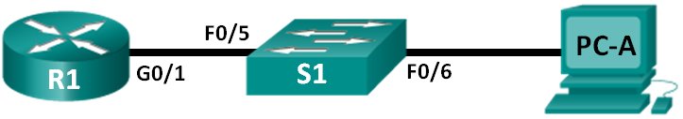
Addressing Table
Device | Interface | IP Address | Subnet Mask | Default Gateway
R1 | G0/1 | 192.168.1.1 | 255.255.255.0 | N/A
S1 | VLAN 1 | 192.168.1.11 | 255.255.255.0 | 192.168.1.1
PC-A | NIC | 192.168.1.3 | 255.255.255.0 | 192.168.1.1
Objectives
Part 1: Configure Basic Device Settings
Part 2: Configure Basic Security Measures on the Router and Switch
Part 3: Configure the Router for SSH Access
Part 4: Configure the Switch for SSH Access
Part 5: SSH from the CLI on the Switch
Background / Scenario
In the past, Telnet was the most common network protocol used to remotely configure network devices. Telnet does not encrypt the information between the client and server. This allows a network sniffer to intercept passwords and configuration information.
Secure Shell (SSH) is a network protocol that establishes a secure terminal emulation connection to a router or other networking device. SSH encrypts all information that passes over the network link and provides authentication of the remote computer. SSH is rapidly replacing Telnet as the remote login tool of choice for network professionals. SSH is most often used to log in to a remote device and execute commands; however, it can also transfer files using the associated Secure FTP (SFTP) or Secure Copy (SCP) protocols.
The network devices that are communicating must be configured to support SSH in order for SSH to function. In this lab, you will enable the SSH server on a router and then connect to that router using a PC with an SSH client installed. On a local network, the connection is normally made using Ethernet and IP.
Note: The routers used with CCNA hands-on labs are Cisco 1941 Integrated Services Routers (ISRs) with Cisco IOS Release 15.2(4)M3 (universalk9 image). The switches used are Cisco Catalyst 2960s with Cisco IOS Release 15.0(2) (lanbasek9 image). Other routers, switches, and Cisco IOS versions can be used. Depending on the model and Cisco IOS version, the commands available and the output produced might vary from what is shown in the labs. Refer to the Router Interface Summary Table at the end of this lab for the correct interface identifiers.
Note: Make sure that the routers and switches have been erased and have no startup configurations. If you are unsure, contact your instructor.
Required Resources
- 1 Router (Cisco 1941 with Cisco IOS Release 15.2(4)M3 universal image or comparable)
- 1 Switch (Cisco 2960 with Cisco IOS Release 15.0(2) lanbasek9 image or comparable)
- 1 PC (Windows 7 or 8 with terminal emulation program, such as Tera Term, and Wireshark installed)
- Console cables to configure the Cisco IOS devices via the console ports
- Ethernet cables as shown in the topology
- Configure Basic Device Settings
In Part 1, you will set up the network topology and configure basic settings, such as the interface IP addresses, device access, and passwords on the router.
  - Cable the network as shown in the topology.
  - Initialize and reload the router and switch.
  - Configure the router.
    - Console into the router and enable privileged EXEC mode.
    - Enter configuration mode.
    - Disable DNS lookup to prevent the router from attempting to translate incorrectly entered commands as though they were host names.
    - Assign class as the privileged EXEC encrypted password.
    - Assign cisco as the console password and enable login.
    - Assign cisco as the VTY password and enable login.
    - Encrypt the plaintext passwords.
    - Create a banner that will warn anyone accessing the device that unauthorized access is prohibited.
    - Configure and activate the G0/1 interface on the router using the information contained in the Addressing Table.
    - Save the running configuration to the startup configuration file.
  - Configure PC-A.
    - Configure PC-A with an IP address and subnet mask.
    - Configure a default gateway for PC-A.
  - Verify network connectivity.
Ping R1 from PC-A. If the ping fails, troubleshoot the connection.

- Configure Basic Security Measures on the Router
  - Encrypt the clear text passwords.
R1(config)# service password-encryption
  - Strengthen passwords.
An administrator should ensure that passwords meet the standard guidelines for strong passwords. These guidelines could include combining letters, numbers and special characters in the password and setting a minimum length.
Note: Best practice guidelines require the use of strong passwords, such as those shown here, in a production environment. However, the other labs in this course use the cisco and class passwords for ease in performing the labs.
    - Change the privileged EXEC encrypted password to meet guidelines.
R1(config)# enable secret Enablep@55
    - Require that a minimum of 10 characters be used for all passwords.
R1(config)# security passwords min-length 10
  - Secure the console and VTY lines.
    - You can set the router to log out of a connection that has been idle for a specified time. If a network administrator was logged into a networking device and was suddenly called away, this command automatically logs the user out after the specified time. The following commands cause the line to log out after five minutes of inactivity.
R1(config)# line console 0
R1(config-line)# exec-timeout 5 0
R1(config-line)# line vty 0 4
R1(config-line)# exec-timeout 5 0
R1(config-line)# exit
R1(config)#
    - The following command impedes brute force login attempts. The router blocks login attempts for 30 seconds if someone fails two attempts within 120 seconds. This timer is set especially low for the purpose of this lab.
R1(config)# login block-for 30 attempts 2 within 120
What does the 2 within 120 mean in the above command?
If we have two failed attempts to log in, within 120 seconds, login access will be blocked for login
What does the block-for 30 mean in the above command?
If the login access is blocked it will wait 30 seconds before allowing attempts at login access again
  - Verify that all unused ports are disabled.
Router ports are disabled by default, but it is always prudent to verify that all unused ports are in an administratively down state. This can be quickly checked by issuing the show ip interface brief command. Any unused ports that are not in an administratively down state should be disabled using the shutdown command in interface configuration mode.
R1# show ip interface brief
Interface IP-Address OK? Method Status Protocol
Embedded-Service-Engine0/0 unassigned YES NVRAM administratively down down
GigabitEthernet0/0 unassigned YES NVRAM administratively down down
GigabitEthernet0/1 192.168.1.1 YES manual up up
Serial0/0/0 unassigned YES NVRAM administratively down down
Serial0/0/1 unassigned YES NVRAM administratively down down

- Configure the Router for SSH Access
Using Telnet to connect to a network device is a security risk because all information is transmitted in a clear text format. SSH encrypts the session data and provides device authentication, which is why SSH is recommended for remote connections. In Part 2, you will configure the router to accept SSH connections over the VTY lines.
  - Configure device authentication.
The device name and domain are used as part of the crypto key when it is generated. Therefore, these names must be entered prior to issuing the crypto key command.
    - Configure the domain for the device.
R1(config)# ip domain-name ccna-lab.com
  - Configure the encryption key method.
R1(config)# crypto key generate rsa modulus 1024
The name for the keys will be: R1.ccna-lab.com

% The key modulus size is 1024 bits
% Generating 1024 bit RSA keys, keys will be non-exportable...
[OK] (elapsed time was 1 seconds)

R1(config)#
*Jan 28 21:09:29.867: %SSH-5-ENABLED: SSH 1.99 has been enabled
  - Configure a local database username.
R1(config)# username admin privilege 15 secret adminpass
Note: A privilege level of 15 gives the user administrator rights.
  - Enable SSH on the VTY lines.
    - Enable Telnet and SSH on the inbound VTY lines using the transport input command.
R1(config)# line vty 0 4
R1(config-line)# transport input telnet ssh
    - Change the login method to use the local database for user verification.
R1(config-line)# login local
R1(config-line)# end
R1#
  - Save the running configuration to the startup configuration file.
R1# copy running-config startup-config
Destination filename [startup-config]?
Building configuration...
[OK]
R1#
  - Establish an SSH connection to the router.
    - Start Tera Term from PC-A.
    - Use Tera Term to telnet to R1.
Does R1 accept the Telnet connection? Explain.
No, it does not connect. This is due to Telnet connections not being encrypted and so not secure.
    - Use Tera Term, establish an SSH session to R1. Use the username admin and password adminpass. You should be able to establish an SSH session with R1.
Does R1 accept the SSH connection?
Yes
    - Intentionally mistype the user and password information to see if login access is blocked after two attempts.
What happened after you failed to login the second time?
No, session was killed.
    - From your console session on the router, issue the show login command to view the login status. In the example below, the show login command was issued within the 30 second login blocking period and shows that the router is in Quiet-Mode. The router will not accept any login attempts for 14 more seconds.
R1# show login
A default login delay of 1 second is applied.
No Quiet-Mode access list has been configured.

Router enabled to watch for login Attacks.
If more than 2 login failures occur in 120 seconds or less,
logins will be disabled for 30 seconds.

Router presently in Quiet-Mode.
Will remain in Quiet-Mode for 14 seconds.
Denying logins from all sources.
R1#
    - After the 30 seconds has expired, SSH to R1 again and login using the SSHadmin username and Admin1p@55 for the password.
After you successfully logged in, what was displayed?
Yes, the message of the day
Enter privileged EXEC mode and use Enablep@55 for the password.
If you mistype this password, are you disconnected from your SSH session after two failed attempts within 120 seconds? Explain.
No, because you are able to still connect to the session with tests, just not have access to enter credentials.
    - Issue the show running-config command at the privileged EXEC prompt to view the security settings you have applied.
- Configure the Switch for SSH Access
In Part 3, you will configure the switch in the topology to accept SSH connections. After the switch has been configured, establish an SSH session using Tera Term.
  - Configure the basic settings on the switch.
    - Console into the switch and enable privileged EXEC mode.
    - Enter configuration mode.
    - Disable DNS lookup to prevent the router from attempting to translate incorrectly entered commands as though they were host names.
    - Assign class as the privileged EXEC encrypted password.
    - Assign cisco as the console password and enable login.
    - Assign cisco as the VTY password and enable login.
    - Encrypt the plain text passwords.
    - Create a banner that will warn anyone accessing the device that unauthorized access is prohibited.
    - Configure and activate the VLAN 1 interface on the switch according to the Addressing Table.
    - Save the running configuration to the startup configuration file.
  - Configure the switch for SSH connectivity.
Use the same commands that you used to configure SSH on the router in Part 2 to configure SSH for the switch.
    - Configure the device name as listed in the Addressing Table.
    - Configure the domain for the device.
S1(config)# ip domain-name ccna-lab.com
    - Configure the encryption key method.
S1(config)# crypto key generate rsa modulus 1024
    - Configure a local database username.
S1(config)# username admin privilege 15 secret adminpass
    - Enable Telnet and SSH on the VTY lines.
S1(config)# line vty 0 15
S1(config-line)# transport input telnet ssh
    - Change the login method to use the local database for user verification.
S1(config-line)# login local
S1(config-line)# end
  - Establish an SSH connection to the switch.
Start Tera Term from PC-A, and then SSH to the SVI interface on S1.
Are you able to establish an SSH session with the switch?
Yes
- SSH From the CLI on the Switch
The SSH client is built into the Cisco IOS and can be run from the CLI. In Part 4, you will SSH to the router from the CLI on the switch.
  - View the parameters available for the Cisco IOS SSH client.
Use the question mark (?) to display the parameter options available with the ssh command.
S1# ssh ?
-c Select encryption algorithm
-l Log in using this user name
-m Select HMAC algorithm
-o Specify options
-p Connect to this port
-v Specify SSH Protocol Version
-vrf Specify vrf name
WORD IP address or hostname of a remote system
  - SSH to R1 from S1.
    - You must use the –l admin option when you SSH to R1. This allows you to log in as user admin. When prompted, enter adminpass for the password.
S1# ssh -l admin 192.168.1.1
Password:
***********************************************
Warning: Unauthorized Access is Prohibited!
***********************************************

R1#
    - You can return to S1 without closing the SSH session to R1 by pressing Ctrl+Shift+6. Release the Ctrl+Shift+6 keys and press x. The switch privileged EXEC prompt displays.
R1#
S1#
    - To return to the SSH session on R1, press Enter on a blank CLI line. You may need to press Enter a second time to see the router CLI prompt.
S1#
[Resuming connection 1 to 192.168.1.1 ... ]

R1#
    - To end the SSH session on R1, type exit at the router prompt.
R1# exit

[Connection to 192.168.1.1 closed by foreign host]
S1#

What versions of SSH are supported from the CLI?
Protocol 1 and 2
How would you provide multiple users, each with their own username, access to a network device?
In the same way that we added a username, as this provides us with username, privilege level and also the ability to enter a password or secret for that.

Reflection (max 800 words):
Write a research report comparing various Encryption standards, e.g AES, SHA, DES, RSA.

A Report into a Variety of Encryption Algorithms
Encryption can help protect a networks information and sensitive data as well as providing for a secure network connection. Modern encryption works by using a complex key to encode data being transferred and then using a complex key to decode data, allowing for secure and safe data trafficking. [1] This prevents unauthorised access to that data being transmitted through the network. The encryption that is uses for this must be based on a standard algorithm or algorithms in order to function properly to effect. [1] There are a significant number of cryptographic algorithms all with their own strong points and weak points to go along with them. Deciding on the best algorithm will also depend on what the demands or requirements of the application you will be using with the algorithm.
A study that was conducted at Limkokwing University to compare and contract different cryptographic algorithms found that each do have their own strengths and weaknesses when it came to look at certain attributes that would be looked for in an encryption algorithm. The study looked at a few certain attributes that each encryption algorithm shared in order to look to compare the different algorithms involved in the study. The paper looks at AES, DES, RSA and Blowfish as encryption algorithms, but also looks at older encryption algorithms to help compare and show difference between them. [2]
AES (Advanced Encryption Standards) is a symmetric block cipher which has been chosen by the U.S government for the purpose of protecting classified information. [4] It is also used worldwide in various software’s and hardware’s to encrypt data. [4] in 1997 AES was starting to be developed by the NIST (National Institute of Standards and Technology). When they developed AES, they wanted the new encryption standard to be block cipher, capable of handling 128 bit blocks, using keys of varying sizes between 128 and 256 bits, and many more advanced encryption standards. [4]
DES (the Data Encryption Standards) is an outdated symmetric-key method of data encryption. [5] This method of encryption uses the same key to encrypt and decrypt a message. This means that both the sender of data and the receiver or that data are required to use the same private key in-order for this to be effective. [5] The DES algorithm was originally designed by researches in the 1970s by IBM and adopted by the U.S government in 1977 as their official Federal Information Process.[5]
RSA algorithm (Rivest-Shamir-Adleman) is the basis of a cryptosystem, this is form of cryptographic algorithm that is used for specifically security services or purposes. This system enables public key encryption and is used to secure sensitive data, mainly over insecure networks. [6]
Blowfish is an encryption algorithm that is used as a replacement for the DES. [7] This type of encryption algorithm uses a private key that also used a variable-length key that varies from 32 bits to 448 bits. [7] This makes this algorithm useful in both domestic and exportable use. Blowfish was originally designed in 1993 and was to be an alternative to the existing encryption algorithm. It was significantly faster than that of the DES algorithm due to the 32-bit instruction processors that were used for this encryption algorithm. [7]
In the study Blowfish was found to have both the fastest encryption time when compared to the other encryption algorithms, and it also has the fastest decryption time too. [2] This make Blowfish valuable for quick efficient use as opposed to maybe AES, that showed a slower encryption time (with smaller file sizes), and a slower decryption time also (again, when looking at smaller file sizes). [2] This can be due to the standard of the encryption and decryption that both of these algorithms use, however both can be applied is their own way, depending on what the application needs.
As previously mentioned in this report, each of these encryption algorithms have their own strengths and weaknesses, and due to this, are used in a variety of different applications and organisations. The study that was previously mentioned looked at these different algorithms and found that the Blowfish algorithm was the best in the case of time and memory according to the criteria of guessing attacks, as blowfish records the shortest time among the different algorithms tested. [2] However, if confidentiality or security is required, then AES is the best to be selected for this purpose. [2]

References
[1] G. Maria (2019, Jul. 8) “4 Common Encryption Methods to Shield Sensitive Data From Prying Eyes” [Online]. Available: https://lab.getapp.com/common-encryption-methods/
[2] M. Nazeh, el al “A Comparison of Cryptographic Algorithms: DES, 3DES, AES, RSA and Blowfish for Guessing Attacks Prevention” Limkokwing University, Kuching, 2018.
[3] CalPoly (2019) “IT Security: Encryption Methods and Recommended Practices.” [Online]. Available: https://security.calpoly.edu/content/encryption-practices
[4] Margaret Rouse (2017, March) “Advanced Encryption Standard (AES)” [Online.] Available: https://searchsecurity.techtarget.com/definition/Advanced-Encryption-Standard
[5] Margret Rouse (2014, Nov.) “Data Encryption Standard (DES)” [Online]. Available: https://searchsecurity.techtarget.com/definition/Data-Encryption-Standard
[6] Margret Rouse (2018, Nov.) “RSA algorithm (Rivest-Shamir-Adleman)” [Online]. Available: https://searchsecurity.techtarget.com/definition/RSA
[7] Margaret Rouse (2005, April) “Blowfish” [Online]. Available: https://searchsecurity.techtarget.com/definition/Blowfish
[8] Z. Hercigonja, D. Gimnazija, V. Croatia “Comparative Analysis of Cryptographic Algorithms” in Book “International Journal of DIGITAL TECHNOLOGY & ECONOMY”, Volume 1, 2016

Lab – Understanding Ethernet Cable Standards
Topology
Addressing Table
Device | Interface | IP Address | Subnet Mask | Default Gateway
PC-A | NIC | 192.168.10.1 | 255.255.255.0 | N/A
PC-B | NIC | 192.168.10.2 | 255.255.255.0 | N/A
Objectives
Part 1: Analyze Ethernet Cabling Standards and Pinouts
Part 2: Build an Ethernet Crossover Cable
Part 3: Test an Ethernet Crossover Cable
Background / Scenario
In this lab, you will build and terminate an Ethernet crossover cable and test it by connecting two PCs together and pinging between them. You will first analyze the Telecommunications Industry Association/Electronic Industries Association (TIA/EIA) 568-A and 568-B standards and how they apply to Ethernet cables. You will then construct an Ethernet crossover cable and test it. Finally, you will use the cable you just constructed to connect two PCs together and test it by pinging between them.
Note: With autosensing capabilities available on many devices, such as the Cisco 1941 Integrated Services Router (ISR) switch, you may see straight-through cables connecting like devices.
Required Resources
- One length of cable, either Category 5 or 5e. Cable length should be 0.6 to 0.9m (2 to 3 ft.)
- 2 RJ-45 connectors
- RJ-45 crimping tool
- Wire cutter
- Wire stripper
- Ethernet cable tester (optional)
- 2 PCs (Windows 7 or 8)
- Analyze Ethernet Cabling Standards and Pinouts
The TIA/EIA has specified unshielded twisted pair (UTP) cabling standards for use in LAN cabling environments. TIA/EIA 568-A and 568-B stipulates the commercial cabling standards for LAN installations; these are the standards most commonly used in LAN cabling for organizations and they determine which color wire is used on each pin.
With a crossover cable, the second and third pairs on the RJ-45 connector at one end of the cable are reversed at the other end, which reverses the send and receive pairs. The cable pinouts are the 568-A standard on one end and the 568-B standard on the other end. Crossover cables are normally used to connect hubs to hubs or switches to switches, but they can also be used to directly connect two hosts to create a simple network.
Reflection:
Write a research report (Max word count 600) on Cat 5e and 6 Ethernet cable standards.
  - Analyze diagrams and tables for the TIA/EIA 568-A standard Ethernet cable.
The following table and diagrams display the color scheme and pinouts, as well as the function of the four pairs of wires used for the 568-A standard.
Note: In LAN installations using 100Base-T (100 Mb/s), only two pairs out of the four are used.
568-A 10/100/1000Base-TX Ethernet
Pin Number | Pair Number | Wire Color | 10Base-T Signal  100Base-TX Signal | 1000Base-T Signal
1 | 2 | White/Green | Transmit | BI_DA+
2 | 2 | Green | Transmit | BI_DA-
3 | 3 | White/Orange | Receive | BI_DB+
4 | 1 | Blue | Not Used | BI_DC+
5 | 1 | White/Blue | Not Used | BI_DC-
6 | 3 | Orange | Receive | BI_DB-
7 | 4 | White/Brown | Not Used | BI_DD+
8 | 4 | Brown | Not Used | BI_DD-

The following diagrams display how the wire color and pinouts align with an RJ-45 jack for the 568-A standard.
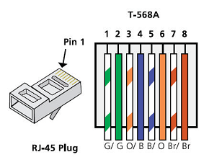
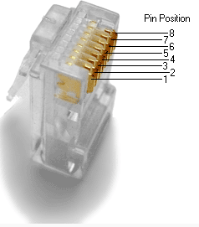
  - Analyze diagrams and tables for the TIA/EIA 568-B standard Ethernet cable.
The following table and diagram display the color scheme and pinouts for the 568-B standard.
568-B 10/100/1000-BaseTX Ethernet
Pin Number | Pair Number | Wire Color | 10Base-T Signal  100Base-TX Signal | 1000Base-T Signal
1 | 2 | White/Orange | Transmit | BI_DA+
2 | 2 | Orange | Transmit | BI_DA-
3 | 3 | White/Green | Receive | BI_DB+
4 | 1 | Blue | Not Used | BI_DC+
5 | 1 | White/Blue | Not Used | BI_DC-
6 | 3 | Green | Receive | BI_DB-
7 | 4 | White/Brown | Not Used | BI_DD+
8 | 4 | Brown | Not Used | BI_DD-
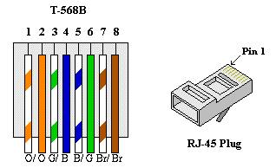

- Build an Ethernet Crossover Cable
A crossover cable has the second and third pairs on the RJ-45 connector at one end, reversed at the other end (refer to the table in Part 1, Step 2). The cable pinouts are the 568-A standard on one end and the 568-B standard on the other end. The two following diagrams illustrate this concept.
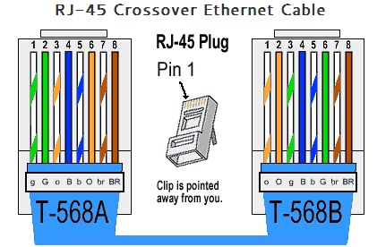
  - Build and terminate a TIA/EIA 568-A cable end.
    - Determine the cable length required. (Your instructor will let you know the cable length you should make.)
Note: If you were making a cable in a production environment, the general guideline is to add another 12 in. (30.48 cm) to the length.
    - Cut off a piece of cable to the desired length and using your wire stripper, remove 5.08 cm (2 in.) of the cable jacket from both ends.
    - Hold the four pairs of twisted cables tightly where the jacket was cut away. Reorganize the cable pairs into the order of the 568-A wiring standard. Refer to the diagrams, if necessary. Take as much care as possible to maintain the twists in the cable; this provides noise cancellation.
    - Flatten, straighten, and line up the wires using your thumb and forefinger.
    - Ensure that the cable wires are still in the correct order for the 568-A standard. Using your wire cutters, trim the four pairs in a straight line to within 1.25 to 1.9 cm (1/2 to 3/4 in.).
    - Place an RJ-45 connector on the end of your cable, with the prong on the underside pointing downward. Firmly insert the wires into the RJ-45 connector. All wires should be seen at the end of the connector in their proper positions. If the wires are not extending to the end of the connector, take the cable out, rearrange the wires as necessary, and reinsert the wires back into the RJ-45 connector.
    - If everything is correct, insert the RJ-45 connector with cable into the crimper. Crimp down hard enough to force the contacts on the RJ-45 connector through the insulation on the wires, thus completing the conducting path. See the following diagram for an example.
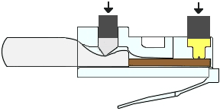
  - Build and terminate a TIA/EIA 568-B cable end.
Repeat steps 1a to 1g using the 568-B color wiring scheme for the other end.
- Test an Ethernet Crossover Cable
  - Test the cable.
Many cable testers will test for length and mapping of wires. If the cable tester has a wire map feature, it verifies which pins on one end of the cable are connected to which pins on the other end.
If your instructor has a cable tester, test the crossover cable for functionality. If it fails, check with your instructor first as to whether you should re-cable the ends and re-test.
  - Connect two PCs together via NICs using your Ethernet crossover cable.
    - Working with a lab partner, set your PC to one of the IP addresses shown in the Addressing Table (see page 1). For example, if your PC is PC-A, your IP address should be set to 192.168.10.1 with a 24-bit subnet mask. You partner’s IP address should be 192.168.10.2. The default gateway address can be left empty.
    - Using the crossover cable you made, connect the two PCs together via their NICs.
    - On the PC-A command prompt, ping the PC-B IP address.
Note: The Windows firewall may have to be temporarily disabled for pings to be successful. If the firewall is disabled, make sure you re-enable it at the conclusion of this lab.
    - Repeat the process and ping from PC-B to PC-A.
Assuming IP addressing and firewall are not issues, your pings should be successful if the cables were properly made.
Reflection
  - Which part of making cables did you find the most difficult?
The hardest part of this lab for making cables was ensuring that the wires were in the correct order when inserting them into the RJ-45 plug, as it was quite a fine process to perform.

  - Why do you have to learn how to make a cable if you can easily buy pre-made cables?
It could be useful to understand how the different ethernet wire configurations work, and how to test if there are issues in connecting and the type of ethernet cable may be required due to this.

A Report into the Cat 5e and Cat 6 Ethernet Cables

There are a variety of ethernet cables that are available, and they are used because of their different make ups and wire configurations, in different ways. Because of the differences in the variety of ethernet cables available and being developed, the cables are grouped into different categories, or “cat”, that are all numbered. [1] In this report the two main ethernet cables that will be discussed are the Cat 5e and the Cat 6 cables. The two cables have both their own pros and cons to them, although they are both able to be used similarly in a network, able to be interchangeable. They are also compatible with each other, and later cables, meaning larger networks will still function properly with a variety of different ethernet cables among it. [1, 2, 3]
The first way that these two cables differ is in their appearance. Cat 5e cables appear to slightly smaller than that of Cat 6 ethernet cables. This is mainly due to the cat 5e having the thinnest sheathing to surround and protect the internal coiled wires. [1] Cat 6 ethernet cables have their own sheathing that allows for protection of the coiled wires also. This protection doesn’t just help protect the wires from damage, but also helps to prevent interference from occurring. Both wires also have shielding for the wires internally as well, which helps prevent things such as crosstalk or noise occurring internally between the wires. [1, 4, 5] To also help improve the resistance to interference, the internal wires are coiled in their pairs. This twisting is however not standardised both between the categories of cables, and between the internal wires themselves. Per cm, in a Cat 5e cable we find there to be roughly 1.5 twists. However, in Cat 6 we find there roughly to be 2 or more twists per cm. [1] This helical path that the wires must take improves the resistance to interference of things such as noise and ping, and from crosstalk. [1]
The two ethernet cables types can handle high quantities of bits per second over them. The later developed cables can obviously hold a higher rate of bits over them, and as we found above, is able to resist interference over them more, making them much more reliable for faster speed connections over a network. [2, 5] Cat 6 cables can provide a 250 MHz performance with 10 Gbps speeds, and this over 55 meters of cabling. The Cat 5e ethernet cables can perform up to 100 MHz of bandwidth and with a speed of up to 1000 Mbps. This, when compared to the Cat 6 cables, does not seem to be much of a comparison, as the methods to produce the Cat 6 cables are more scrutinous when produced. The main difference between these two ethernet cables is to do with the bandwidth that the cables can support, Cat 5e being 100 MHz and Cat 6 being 250 MHz as discussed above. This improvement in bandwidth allows for a greater support in data transfer for larger amounts of data over the line. [6] Another major difference between that of Cat 5e and Cat 6 ethernet cables is that Cat 5e can maintain its bandwidth performance and speed over 100 meters as opposed to Cat 6 at 55 meters. [5]
In general Cat 6 ethernet cables tend to be priced between 10% and 20% higher than that of Cat 5e cables. This is influenced mainly by what goes into the production of the Cat 6 ethernet cables; the length, quality and copper content of the cable as opposed to the Cat 5e production. [6]

References
[1] J. Garrison (2016, Dec. 13) What Kind of Ethernet (Cat5, Cat5e, Cat6, Cat6a) Cable Should I Use? [Online]. Available: https://www.howtogeek.com/70494/what-kind-of-ethernet-cat-5e6a-cable-should-i-use/
[2] Diffen (2019, Nov. 25) Cat5e vs. Cat6 [Online]. Available: https://www.diffen.com/difference/Cat5e_vs_Cat6
[3] Diffen (2019) Diffen: Citation [Online]. Available: https://www.diffen.com/difference/Diffen:Citation
[4] ElectronicsNotes (2019) Ethernet Cable: Types, Performance & Pinout - Cat 5, 5e, 6, 6a, 7, 8 etc [Online]. Available: https://www.electronics-notes.com/articles/connectivity/ethernet-ieee-802-3/cables-types-pinout-cat-5-5e-6.php
[5] Mpercent (2018) What is the difference between Cat 5e vs Cat 6 Ethernet cables [Online]. Available: https://www.ampercent.com/what-is-the-difference-between-cat-5e-vs-cat-6-ethernet-cables/24310/
[6] BlackBox (2019) What’s the Difference between CAT5e and CAT6? [Online]. Available: https://www.blackbox.co.uk/gb-gb/page/43869/Resources/Technical-Resources/Black-Box-Explains/Copper-Cable/Category-5e-And-6

