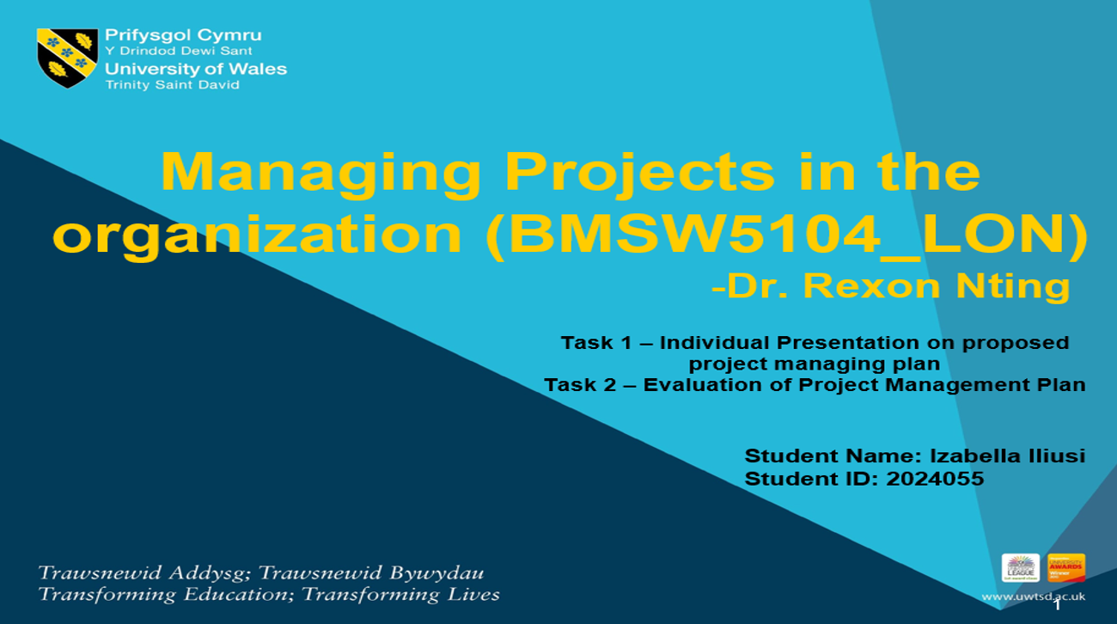

Evaluation of Project Management Plan
Task 2 Report

Executive summary
The office of national statistics has estimated that almost 180,000 people have died throughout the UK due to covid-19. It has been estimated that the GDP of the UK declined by 9.7% in that year. This report will describe the impact of the situation on a popular retail Supermarket in the UK. In order to prevent losses, the supermarket has undertaken a training project to empower its employees. The research has described the background of the project along with the company background. A Stakeholders analysis has been done for this project. Budget and resources have been analysed for this project in this report. Additionally, the risk factors have been analysed as well.

Table of Contents
Task 2: Business Report 4
1. Introduction 4
2. The project description 4
3. Stakeholders analysis 5
3. Work breakdown structure 7
4. Estimation of budget for the project 9
5. Resource analysis for the project 10
6. Outlining the project schedule using the Gantt chart 12
7. Analysis of risk factors associated with the project 12
8. Analysis of risk factors associated with the project 13
9. Conclusion 15
10. References 16

Task 2: Business Report

1. Introduction
‌‌The Covid-19 pandemic hardly hit the UK and its people. Almost 2.3 million people all over the UK have been affected by this virus. The government has announced a lockdown from 23rd march 2020 to prevent the spreading of this virus. Due to that, all the brick-and-mortar stores have been ordered to temporarily suspend their operations. As a result of that, the businesses have experienced a large fall in their sales which is around 30% as compared to the previous year's sales amount. This report has described Morrisons' initiative of empowering their employees and managing the business losses during a covid-19 pandemic. The company needs to train their employees to improve its digital infrastructure and serve its customers in a better manner. This report will describe that initiative in detail. In order to do that, the project background will be presented in the report. Individuals who will be impacted through this project will be analysed. A work breakdown structure will be provided along with the budget and resources required for this project. The project timeline will be prepared to maintain a proper time scale. Additionally, the risk factors associated with the project have been analysed as well by the researcher.

2. The project description
Morrisons is considered one of the fourth largest supermarkets in the UK. Founded by William Mauritius in 1899 the company has more than 490 supermarkets across different areas of England, Scotland and Wales. Currently, the company has an employee strength 1, 10,000 and with that, they are serving the people of the UK through both online and offline platforms (Global Data, 2022). The company has a diverse range of product portfolio that includes bakery items, gift cards, fish and meat, frozen foods, alcoholic and non-alcoholic beverages, vegetables, healthcare and wellness products, medicines, baby products, beauty products, toiletries, cigarettes, garden essentials and many others (Global Data, 2022). The company along with its supply chain produces fresh products that include vegetables, fish, meats and many others. Morrisons currently holds 9.5% of the retail market share in the UK and in order to continuously serve their customers the company has introduced remote working facilities to their employees during the covid-19 pandemic.
It has been reported by ‌Wood (2021), that due to the lockdown process in 2020 the profit percentage of Morrisons has been reduced by 50%. In such a situation it has become necessary for the company to train their employees so that they can effectively handle the operations without being at their office desks. This project has been undertaken by the company to train their employees appropriately and invest in the digital infrastructure so that they can start their millions of customers regularly (Morrisons-corporate, 2022). Apart from that, providing proper training and development facilities to the employees will help the organisation to achieve organic growth in the competitive business market of the UK. Employees with proper training can help to fulfil Morrisons' strategy of serving the customers in a better way, contributing to the community, simplifying the organisation's operations and promoting health and hygiene among the employees.

3. Stakeholders analysis
Investors: The investors are the primary stakeholders, who need to be informed from the very first day of planning a project (Pappas, 2019). In this scenario, the finance department and the board of directors of Morrisons can be considered the investors. Another reason behind considering the stakeholders is, that they will be allocating resources for the project. The project management team needs to make them aware of the project scopes and project progress.
Upper management ‌: The upper level of management is another important stakeholder in this project. In Morrisons, the upper level of management act as the training advocate for their subordinates (Pappas, 2019). The project management team needs to assure them about the positive outcome of the project. Other than that, if they do not find it worthy, the project might get discontinued.
Project managers: The project managers are another key stakeholder of this training project. These individuals handle the development of the training project from start to finish. Their responsibility includes measuring the progress, keeping the budget on track and timely completion of the project (Pappas, 2019). The project manager can take decisions regarding the Outsourcing of the task in the project. Additionally, they work as a link between the investors, developers and the other relevant check holders for managing the employee training project.
Learners: The learners are considered as the stick holders of employee training programs, as these are the people for which the entire program has been designed. Proper implementation of the employee training program will help the employee to develop their skills and their productivity (Dudovskiy, 2013). As a result, they can support Morrisons in the crisis time period like the Covid-19 pandemic. In order to make this entire arrangement successful, these individuals need to be properly engaged (Dudovskiy, 2013). Considering their feedback regarding this project is mandatory as they can provide the best possible feedback in this context.
Instruction designers: These are the experts who are responsible for the successful completion of the project with desired outcomes. These stakeholders contact the investors and understand their vision and expectation of the project. According to Dudovskiy, (2013), they will choose the best model which can successfully mitigate the skill gaps of the employees relating to the employee training project in Morrisons.
Technology experts: As the training program is aimed to improve the digital perception of the employees working in Morrisons, thus considering this technology expert is mandatory for this project (Dudovskiy, 2013). Considering this individual in the project will help the project management team choose the best techniques and tools that can help to make the project successful.

Figure 1: Stakeholders of projects
(Source: Leonard and Ross, 2020)

3. Work breakdown structure
Initiation: The aim of the project initiation stage is to understand and meet the needs of the stakeholders relating to the project. The project management team of Morrisons will also conduct a feasibility test in this stage (Donato, 2021). The company reflects a collaborative strategy and that is why the project management team will incorporate both the internal and the external stakeholders during the initiation stage of this project. It will also help the team to improve the likelihood of both the stakeholders by working on the deliverables of the project.
Planning: The next immediate stage of work down the structure in relation to project management is the planning phase. The project management team in this stage will prepare the budget plan for the employee training program (Donato, 2021). Additionally, create a work breakdown structure and divide the responsibility among the project managers, instructional designers and technology experts. The project scope will be analysed in this stage and the project resources will be collected. The research team will also work on analysing the risks which include the cost risk, schedule risk and performance risk. Additionally, plans will be made to mitigate them.
Execution: In this execution phase the previously made plans will be turned into reality. The project management team primarily delivers the expectation of the project to the learners (Eby, 2018). Necessary knowledge and resources will be provided to them as well. The project manager will continue to track the progress of the project and update the stakeholders about it. The quality assurance team will consider the work orders in the project and the risk handling team will keep a close eye to mitigate the race that might harm the progression of the project.
Monitoring and control: The improvement of the project will be tracked in this stage of the work breakdown structure. The project management team will compare the actual preparation of learners to the expected progression during the planning phase (‌Ketmanto et al., 2018). Apart from that, documents related to the spending, quality checking and time tracking will be observed by the project management team of Morrisons. In case any risk arises the project management team will try to mitigate that by arranging necessary resources like time or budget.
Closure: The activities such as training the employees with proper knowledge and tools have been concluded in the stage the project management team will present the final deliverables to the investors and the upper-level management (Damij and Damij, 2021). The project resources and team members will be released. The project management team will officially close the project depending upon the situation.
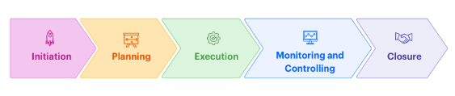
Figure 1: Work Breakdown structure
(Source: Kissflow, 2022)

4. Estimation of budget for the project

Aspects | Budgets (GBP)
Creation of project plan | 1000
Purchase necessary software | 12000
Hire technical experts | 5000
Research a development | 7000
Materialistic resources | 9000
Employee portal | 3000
Payment for the employees | 15000
Other resources | 5000
Total cost | 57000
Table 1: Budget plan for the project
(Source: Author)

5. Resource analysis for the project
Human resources: The human or the individuals of an employee are the most valuable and important resources of a company. The change in perception of the business world has helped them to understand the value of employee engagement and that is why a dedicated department namely human resources have been created in different organisations to carefully handle human resources. According to Morrisons (2022), Morrisons considered that the commitment and the trust of their colleagues have made them successful in the comparative retail market of the UK. Every individual involved in this project from the employees, investors, learners, project management team, technical support and the project managers is considered the human resource of Morrisons (Morrisons, 2022). The human resources by working collaboratively helped Morrison to fulfil their perspective of developing the technological perception of the employees. As a result, they will become able to handle their responsibilities effortlessly while working from home. The handling of the human resource is quite complex because every individual belongs to different backgrounds, cultures and perceptions. That is why the chances of clashes have been enhanced when they start to work together on a project (Actitime, 2021). In order to mitigate that, Morrisons always reflect a diverse and inclusive culture in the workplace, which helps them to establish a trustworthy and supportive work environment with each other.
Material resources: The material resources can be regarded as those tools that the company already offered. On the other hand when material resources are required the company might invest money to purchase them or lease them according to this situation (Actitime, 2021). The software, machines, and tools will be considered as the material resources by the company during this particular project (Actitime, 2021). In addition to that, the communication mediums such as employee portals and feedback equipment will also be used by the project management team in this regard.
Financial resources: Financial resources are an important part of every project regardless of its type, size and deliverables. Morrisons' effective project management team understands the importance of financial resources and that is why they have planned about it during the initiation stage of the project plan. According to Zarghami and Dumrak, (2021), project budget, contingency funds and project grants are considered in the category by Morrisons as financial resources. A project cannot be successful without proper planning of financial resources as it will become unable to pay the human resources, purchase all the other necessary materials and handle the project costs (Zarghami and Dumrak, 2021). Due to these reasons the project management team of Morrisons use budgeting tools which track the cost and custom the hourly rate according to the need of the project.
Time resources: Time is not a renewable resource and that is why consideration of a proper time is done during the initial stage of a project management plan. The project management team of Morrisons has decided on activity milestones within a proper flexible time period (‌Cicala, 2020). Proper time management is also important as it helps to track the performance of the employees after a certain time of delivery of the training. It will help the project managers to understand the areas where the training program needs to be improved (‌Cicala, 2020). It will save a considerable amount of time, money and effort for the project management team and Morrisons.

6. Outlining the project schedule using the Gantt chart
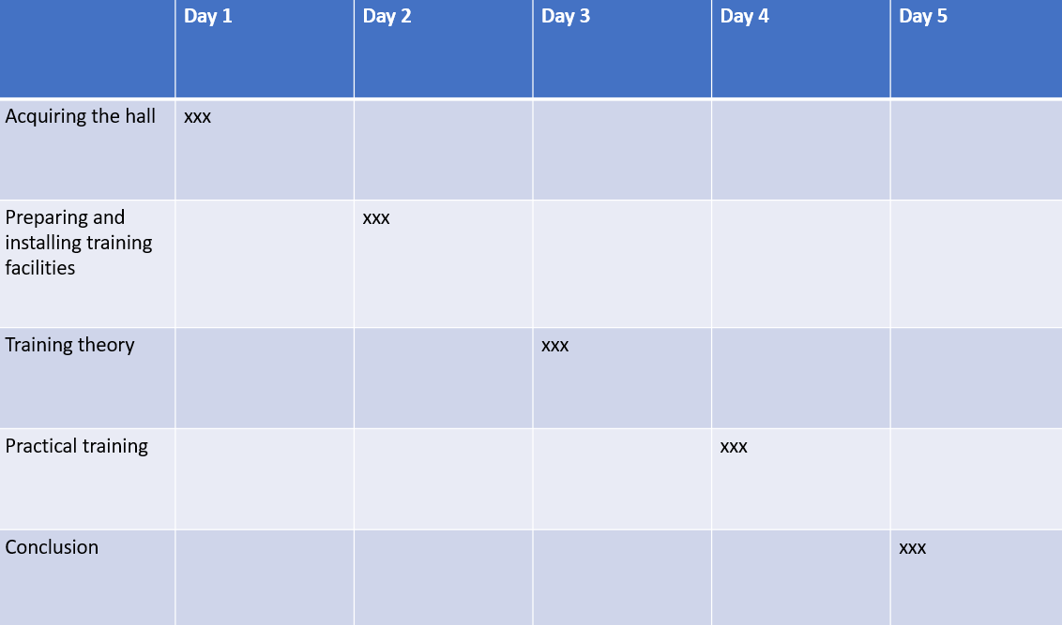Table 1: Project timeline plan
(Source: Author)

7. Analysis of risk factors associated with the project
Situational risk: The initiation of work from the home facility will bring an organisational change to Morrisons. The change if not implemented appropriately can create situational risks such as organisational conflicts, loss of skills and expertise, overwork, work stress and many others (Alve et al., 2021). Apart from that, as the nature of every employee is different, that is why it cannot be expected that every employee will consider the change positively (Alve et al., 2021). The resisting employees may lose their motivation to work and disengage from the shared vision of Morrisons. As a result of that, their performance and the company's productivity will be reduced.
Budget risks: According to Moshtaghian et al., (2020), it has been reported that during the pandemic the profit percentage of the company has been reduced by half. Additionally, the company has invested about 290 million GBP for supporting the communities during the crisis. In such a situation it will not be easy for Morrisons to arrange a training program for their 1, 10,000 employees. The project might not deliver the expected outcomes to the employees due to the lack of budget distribution (‌Moshtaghian et al., 2020). It has been discussed previously that ineffective monetary resources can result in the discontinuation of a project. The project management team needs to consider this.
Time risk: The report published in the popular daily newspapers about the loss of Morrisons clearly reflects that the company is unable to provide effective training to the employees relating to managing the technological infrastructure (Nunes and Abreu, 2020). The company with their project management team if not allocate proper time to design the project effectively. All the initiative and effort of the company will be wasted (Nunes and Abreu, 2020). Other than that, the team needs to allow proper flexibility to the stakeholders of these projects so that they can cope up if they have to face any unwanted situation while compilation of the project.

8. Analysis of risk factors associated with the project
This report has been prepared to help Morrisons with their initiative of training their employees to make them prepared for critical situations like the covid-19 pandemic. In order to do that, the researchers have described the company and the project. The stakeholders of this company have been analysed effectively. Apart from that, in order to finish the project, a work breakdown structure has been provided. The researchers have provided a budget plan and a time plan (Gantt chart) for the project. The resources of this project have been analysed. And the risks associated with the project have been highlighted in this report.

References

Books and journals
Alves, J.L., Ferreira, E.A. and de Nadae, J., (2021). Crisis and risks in engineering project management: A review. Brazilian Journal of Operations & Production Management, 18(4), pp.1-17.
‌Cicala, G., (2020). Managing Project Resources and Assignments. In The Project Managers Guide to Microsoft Project 2019 (pp. 207-264). Apress, Berkeley, CA.
Damij, N. and Damij, T., (2021). An Approach to Optimizing Kanban Board Workflow and Shortening the Project Management Plan. IEEE Transactions on Engineering Management. pp. 201-205.
‌Ketmanto, P.D., Hasibuan, M.A. and Jacob, D.W., (2018). Project Management Plan Design For Developing E-learning Content. International Journal Of Information & System Management. Pp. 150-175.
‌Moshtaghian, F., Golabchi, M. and Noorzai, E., (2020). A framework to dynamic identification of project risks. Smart and Sustainable Built Environment.
Nunes, M. and Abreu, A., (2020). Managing open innovation project risks based on a social network analysis perspective. Sustainability, 12(8), p.3132.
Zarghami, S.A. and Dumrak, J., (2021). Aleatory uncertainty quantification of project resources and its application to project scheduling. Reliability Engineering & System Safety, 211, p.107637.

Websites
Actitime, (2021). What Are Project Resources and How to Manage Them Effectively? Available at: https://www.actitime.com/project-management/project-resources [Accessed 8 July 2022]
Donato. H, (2021). 5 Phases of Project Management Life Cycle You Need to Know. Available at: https://project-management.com/project-management-phases/ [Accessed 8 July 2022]
Dudovskiy. J, (2013). Key Stakeholders in Training Transfer and their Roles. Available at: https://research-methodology.net/key-stakeholders-in-training-transfer-and-their-roles/ [Accessed 8 July 2022]
Eby. K, (2018). Demystifying the 5 Phases of Project Management. Available at: https://www.smartsheet.com/blog/demystifying-5-phases-project-management [Accessed 8 July 2022]
Global Data, (2022). Wm Morrison Supermarkets Plc Company Profile Available at: https://www.globaldata.com/company-profile/Wm-Morrison-Supermarkets-Plc/ [Accessed 8 July 2022]
Kissflow, (2022). 5 Phases of Project Management Process - A Complete Breakdown. Available at: https://kissflow.com/project/five-phases-of-project-management/ [Accessed 8 July 2022]
Leonard. B and Ross. D, (2020). Stakeholder Business Model for a VUCA World Available at: https://finiteeartheconomy.com/stakeholder-business-model-for-a-vuca-world/ [Accessed 8 July 2022]
Morrisons, (2022). People. Available at: https://www.morrisons-corporate.com/morrisons-sustainability/people/ [Accessed 8 July 2022]
Morrisons-corporate, (2022). Strategy. Available at: https://www.morrisons-corporate.com/about-us/strategy/ [Accessed 8 July 2022]
Pappas. C, (2019). The nine main stakeholders to keep in mind in online training Available at: https://www.efrontlearning.com/blog/2019/11/key-stakeholders-in-online-training.html [Accessed 8 July 2022]
‌Wood. Z, (2021). Morrisons profits fall by half in 2020 as costs of Covid pandemic bite. Available at: https://www.theguardian.com/business/2021/mar/11/morrisons-profits-fall-2020-covid [Accessed 8 July 2022]

