Project Portfolio
Project Management
CLCM5003
Project Title: Reopening of Highway Following the West Midlands Flooding
Student Name: Fayza Boukhenifer
Student ID: 2335538

Table of Contents
Part A – Poster 3
Part B – Reflection on Feedback 4
Part C: Project Management Plan 6
1. Introduction 6
2. Project Description 6
3. Scope 7
4. Project Objectives 7
5. Work Breakdown Structure (WBS) 7
6. Iron Triangle 8
7. Quad Chart 10
8. Gantt Chart / Timeline 11
9. Stakeholder Involvement 12
10. Allocation of Resources 12
11. Risk Analysis 13
12. Contingency Plan 14
13. Shelters / Community Support 14
14. Conclusion 15
References 16

Part A – Poster
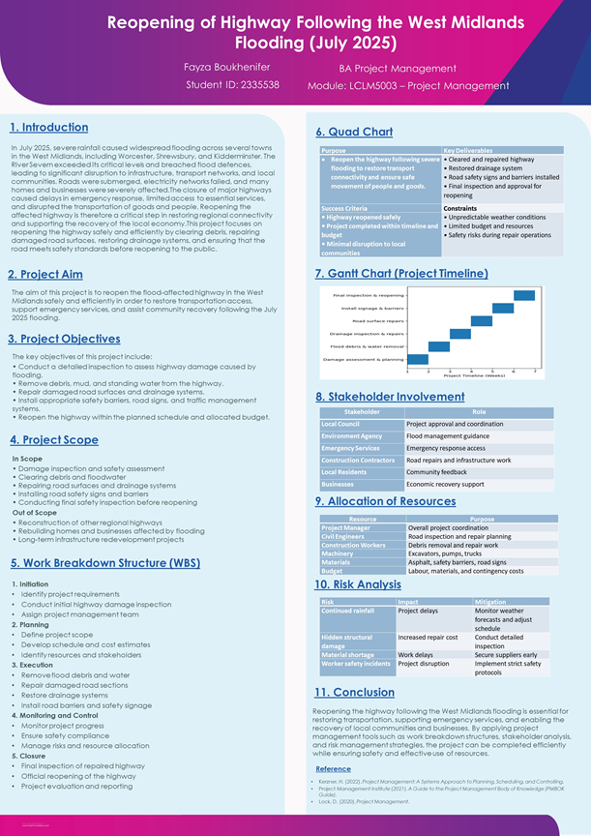

Part B – Reflection on Feedback
The poster presentation was a groundbreaking phase in working on the project portfolio, since it gave me a chance to present the proposed project and get constructive feedback on the project before making the final report. The reopening of a highway after the West Midlands flooding in July 2025 was the centre of attention of the project. The aim of this presentation was to outline the aim of the project, the objectives of the project, the timeline, the risks, as well as the key stakeholders that were going to be involved in the restoration of transport access following the flooding. The review undertaken by the lecturer and peers was useful in not only knowing what the poster has done well, but also what needs to be done to improve it.
This reflection explains what was good in the presentation and how the feedback will be used to refocus the end project management plan. There were a number of things that worked in the poster. First, the selected project topic was precise, topical and directly related to the real-life flood situation given in the assignment brief. Reopening the highway was an important issue that was effectively conveyed, especially regarding the need to reestablish emergency access, support businesses, and aid the local communities in recovering. Moreover, the purpose and objectives of this project were clear, and the audience easily understood the purpose of the proposed work. The poster design was also rational, visually understandable, and the information was arranged in blocks like scope, timeline, stakeholders, and risks. This rendered the content readable. Moreover, the identification of the key stakeholders such as the local council, contractors, emergency services and the residents were an indication of understanding of the people who would be affected by the project (Kerzner, 2022).
The lecturer provided feedback on which there are a few key areas of improvement. Originally, the Work Breakdown Structure needs to be extended in order to demonstrate tasks more specifically at every phase of the project. This will bring responsibilities and activities into perspective. It was also suggested by the lecturer that the Iron Triangle of project management should be mentioned to describe the correlation between time, cost, and scope or quality. It will show the way in which the development in one sphere can influence the others. The other important recommendation was to incorporate contingency planning, which can be in the form of reserve funds, extra labour, or a buffer of additional time to cope with any unexpected delay or extra expenses. Another part that had to be improved is a more detailed and clearer schedule with milestones and the duration of tasks that needed to be completed within the Gantt Chart. Further discussion was also demanded, particularly concerning the risk management, decision-making, and resource control. The lecturer also recommended putting into consideration shelters to be used by the residents who were affected by the flooding due to the immensely broad social impacts of the project. Peer feedback was also helpful. They remarked that the poster was easy to understand and applicable, but more information regarding the project timeline and the costs was needed. Certain peers would also advise the inclusion of more visuals or backing data in order to enhance the presentation. Consequently, the final project plan will be more powerful in terms of WBS, more detailed milestones, contingency budgeting, risk analysis, and support of the stakeholders. In general, the feedback was positive and will be used to considerably reinforce the final report.

Part C: Project Management Plan

1. Introduction
Severe flooding in June 2025 occurred in the West Midlands, as a result of heavy rainfall sustained over a long period due to an unusual cyclonic system of weather that rolled within the Atlantic. Quite a few towns were considered to have been out of control when the River Severn rose to alarming levels and broke through the flood defences that were in place by then, which included Worcester, Shrewsbury and Kidderminster. This flooding caused a lot of damage to infrastructure, transport networks, business outlets and houses. The key road network was flooded or destroyed as the accessibility of emergency services was reduced, goods movement slowed down, and movement was restricted (Too and Weaver, 2014).
Quick and efficient re-use of the highways that have been affected must be supported to help in the recovery of the region. Whether due to the fact that it reinstates road connectivity, it helps emergency response teams manage effectively, helps businesses to reopen and allows residents to have access to essential services once again. Any further economic loss, congestion by alternative roads and increased disruption of the local communities because of the delays in reopening any significant transport routes might occur. This report is aimed at providing a planned project management plan to reopen a flood-ravaged highway in the West Midlands. The report also uses the known project management tools and techniques to make sure the highway is opened efficiently, safely and within the approved time and cost parameters.

2. Project Description
The offered project is going to be called Reopening of Highway Following the West Midlands Flooding (July 2025). The project has been designed to react to the widespread destruction during the flooding that led to making a vital highway unsafe and unreachable. The overriding objective of the project is to get the highway operational in its full capacity as speedily as possible, alongside adherence to the safety and engineering norms. This route needs to be reopened to help in restoring transport connectivity, economic recovery and ease of access to emergency and public services.
The key deliverables of the project include:
- Clearance of debris, mud, and residual floodwater from the highway
- Repair and resurfacing of damaged road sections
- Restoration and testing of drainage systems
- Installation of road safety barriers, signage, and traffic controls
- Final safety inspection and official reopening of the highway

3. Scope
In Scope
- The scope of the project includes all activities directly required to restore the affected highway to safe operational use. These activities include:
- Damage inspection and structural assessment
- Removal of debris, mud, and standing water
- Repair of road surfaces and affected carriageways
- Restoration of drainage infrastructure
- Installation of safety barriers, signs, and temporary traffic systems
- Final inspection, testing, and reopening approval
Out of Scope
- The following activities fall outside the scope of this project:
- Reconstruction of homes or commercial properties damaged by flooding
- Repair or reopening of other regional highways not included in the project boundary
- Long-term regional infrastructure redevelopment or flood defence programmes

4. Project Objectives
- The project aims to achieve the following objectives:
- Reopen the affected highway within an eight-week timeframe
- Ensure all works comply with relevant safety and regulatory standards
- Deliver the project within the approved financial budget
- Minimise disruption to residents, businesses, and road users during implementation

5. Work Breakdown Structure (WBS)
A Work Breakdown Structure (WBS) is a specified project management activity that is used to break down a project into smaller and manageable portions. This will empower the project manager to plan the project, allocate tasks and monitor the project through phases. The highway reopening project had a WBS that was structured into five broad stages, namely initiation, planning, execution, monitoring and control and closure (Burghate, 2018). The initiation stage involves the establishment of the project base by site survey, demurrage analysis, scheduling meetings and acquiring relevant approvals. This is so as to have a clear authority and direction of the project at the initiation. The planning phase would involve the creation of a project schedule, the budget and the identification of potential risks and the arrangement of the procurement activities. Adequate planning is required to have the resources available and set realistic targets.
The execution phase will encompass the actual project implementation, which will involve clearing up the rubble, repairing the road surface and drainage system, and installing safety signs. This stage includes the essential operation processes that are necessary to open the highway (Cerezo-Narváez et al., 2020). The activities of monitoring and control occur during the execution to monitor the progress made, control the expenditure, maintain the standard quality and overcome the emergent problems. Lastly, the closure process involves a final inspection, handover to the appropriate authority and the official opening of the highway.

6. Iron Triangle
Table 1:Constraint Project Application Impact if Changed
Constraint | Project Application | Impact if Changed
Time | The highway must be reopened within an 8-week deadline to restore transport access quickly. | Shortening the schedule may require overtime or extra labour, increasing costs.
Cost | Project costs include labour, construction materials, machinery hire, contractors, and contingency funds. | Reducing the budget may limit resources, delay progress, or reduce quality.
Scope / Quality | The highway must be reopened safely with durable repairs, restored drainage, and compliant safety standards. | Expanding scope or increasing quality standards may require more time and higher costs.

The Iron Triangle is a well-known project management model that illustrates how the three primary project constraints of time, cost, and scope or quality relate to each other. According to the model, when there is a shift in any constraint, it is likely to impact one or both of the other constraints. Consequently, to deliver successful projects, it is necessary to strike an effective balance between these conflicting priorities (Watanabe et al., 2024). In the case of the highway reopening project, time is a very critical issue since the impacted route needs to be opened in less than eight weeks before the transportation connectivity can be restored, and the lives of residents, businesses, and emergency services are not affected as much. Slowdowns would increase traffic on other roads and potentially have a detrimental impact on recovery in the region. Another critical factor is cost, where the project should be within the approved budget yet include labour and machinery, materials, contractors and allowances for contingencies.
The issue of scope and quality is equally important, as the final highway should be safe and durable, as well as meet the engineering and regulatory standards. Rushing to open the road, at the cost of quality, would pose a safety risk or future maintenance problems. On the same note, more upgrades can be added to the scope, which can either raise the cost or the completion time. Project delivery is thus likely to involve trade-offs (Wubuli et al., 2025). As an example, it might be necessary to pay overtime or hire additional labour to accelerate the programme and reduce costs, which might constrain the resources or slow down the procurement. It is therefore imperative that the Iron Triangle is carefully managed in order to bring efficiency and sustainability in meeting the project objectives.

7. Quad Chart
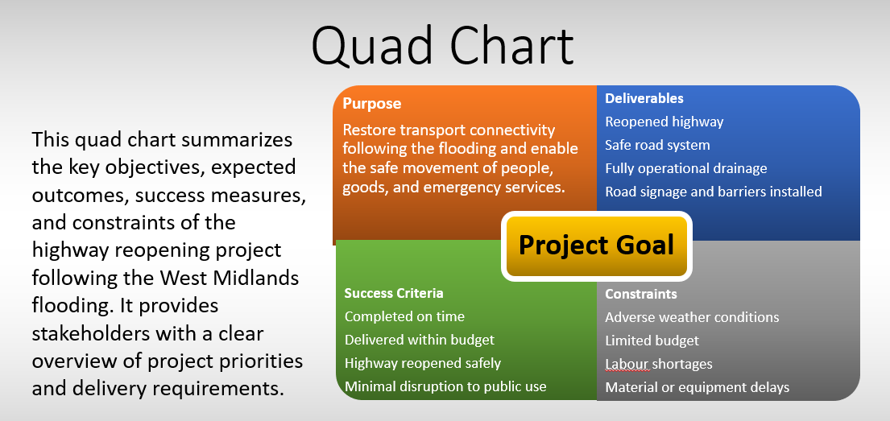
Figure 1: Quad Chart summarising the project purpose, deliverables, success criteria, and key constraints for the highway reopening project following the West Midlands flooding.
The Quad Chart is a small project management tool that is used to summarise the main aspects of the highway reopening project in an understandable and structured manner. It establishes the purpose of the project, anticipated deliverables, criteria of success, and key constraints. In this project, the aim is to resume transport services after the floods. The major deliverables will be the reopened highways, a secure road network, and drainage that is fully operational (Castañeda et al., 2024). Completion of the given work on time, within financial means, and safe reopening of the given work to public use will be its measure of success. Challenges such as unfavourable weather, lack of funds, shortage of labour and Late material or equipment delivery are some of the key constraints.

8. Gantt Chart / Timeline
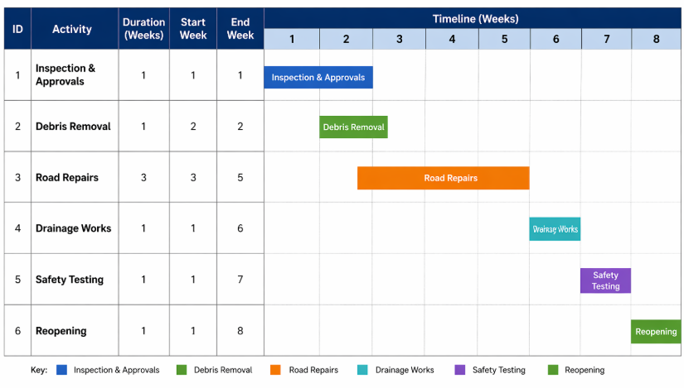
Figure 2: Gantt Chart illustrating the eight-week project schedule, task durations, sequencing, and key milestones for the highway reopening project.
The Gantt Chart of an eight-week highway reopening project is in Figure 1. The chart gives a pictorial plan of the activities and the types of things that should be done, in which the duration of the task, the start date, the end date and the order in which a task can be completed are indicated. This will help the project manager to keep track of the progress and keep the project on time. This project starts in Week 1 by conducting inspections and approvals. At this phase, engineers will determine the amount of damage done by floods, establish that the safety requirements are met, and get permission to do so. During Week 2, the removal process of the debris will be done to clear up the mud, waste products and any other remaining flood water on the highway.
The principal road repair activities will be done in Weeks 3-5. This is the phase that is most time-consuming in the project and involves the resurfacing of the damaged carriageways, structural defect repairs and restoring safety to normal driving conditions. After the road repairs, the drainage works will occur in Week 6 to enhance the water flow mechanisms and minimise the possibility of floods in the future. Week 7 will be dedicated to the final tests and safety checks. All these checks guarantee the meeting of all works done within engineering standards, health and safety rules and operation requirements. The highway will be opened to the public in Week 8. The Gantt Chart is useful as it emphasises the dependencies of tasks, milestones and the deadline by which the whole task should be completed. It also enables identification of delays early enough to enable correction measures to be taken. Thus, the chart will be useful in creating efficient time management and in structuring the successful completion of the project within the scheduled eight weeks.

9. Stakeholder Involvement
The stakeholder input is needed to make the highway reopening project successful. Good communication with the key stakeholders helps in decision-making, enhances communication, and minimises the disturbances in executing a project.
Table 2:Stakeholder analysis identifying the key stakeholders involved in the highway reopening project and their respective roles, interests, and levels of involvement.
Stakeholder | Role / Involvement
Local Council | Provides project approval, regulatory support, and communication with the public.
Emergency Services | Require road access for ambulance, police, and fire response operations.
Contractors | Responsible for carrying out road repairs, drainage works, and site operations.
Environment Agency | Provides advice on flood risk management, drainage, and environmental compliance.
Residents | Affected by road closures, diversions, and reopening outcomes.
Local Businesses | Depend on road access for customers, staff, and deliveries.
These stakeholders should be consulted consistently to make sure that these projects comply with operational, environmental and community needs.

10. Allocation of Resources
It should also be earlier to properly allocate its resources in order to meet the schedule of the project and the budget approved. Human, physical, and financial resources have to be effectively managed in the project lifecycle.
Table 3:Resource allocation plan outlining the key human, physical, and financial resources required for the successful delivery of the highway reopening project.
Resource | Purpose
Project Manager | Oversees planning, coordination, budget, and project delivery.
Civil Engineers | Assess damage, design repairs, and inspect completed works.
Construction Workers | Carry out debris removal, repairs, and installation activities.
Machinery | Includes excavators, pumps, trucks, and road repair equipment.
Materials | Includes asphalt, drainage pipes, barriers, and road signage.
Budget Reserve | Covers unforeseen costs, delays, or additional repair requirements.

11. Risk Analysis
The risk analysis is a vital part of project management as it allows potential risks to be recognised, evaluated and managed before they have a significant impact on the project performance. In the case of the highway reopening project, there are various operational and environmental risks that could affect the results of time, cost, quality and safety.
Table 4:Risk analysis matrix identifying key project risks, their potential impacts on delivery, and proposed mitigation strategies for the highway reopening project.
Risk | Potential Impact | Mitigation Strategy
Continued Rain | Delays to repair activities and unsafe working conditions | Regular weather monitoring and flexible scheduling
Hidden Structural Damage | Increased repair costs and extended completion time | Conduct detailed inspections and engineering surveys
Material Shortage | Delays in construction works and reduced productivity | Secure suppliers early and maintain backup sources
Safety Incident | Work stoppage, injuries, and reputational damage | Apply strict health and safety controls, PPE, and training

Risk management must be managed to be continuously observed during the project life. Proactive mitigation practices can ensure that the chances of delays, overbudgets, and disruption of operations are minimised. This will aid in opening up the highway on time and safely.

12. Contingency Plan
A contingency plan is necessary to address unforeseen events that may disrupt project delivery. Flood recovery projects are exposed to uncertainty, including adverse weather, hidden structural damage, supply delays, and workforce shortages. Therefore, appropriate contingency measures must be established to maintain progress and minimise disruption.
Table 5: Contingency plan outlining reserve measures and corrective actions designed to minimise delays, cost overruns, and disruption during the highway reopening project.
Contingency Measure | Purpose
10–15% Reserve Budget | Covers unexpected repair costs, additional materials, or emergency requirements.
Extra Labour if Delayed | Provides additional workforce capacity to recover lost time and maintain schedule targets.
Backup Suppliers | Ensures continued access to materials and equipment if primary suppliers fail.
One-Week Schedule Buffer | Allows flexibility to absorb delays without significantly affecting final completion.

13. Shelters / Community Support
A community-support aspect is also crucial when it comes to infrastructure recovery projects, especially in the case of flood displacement of people or access prohibitions to vital facilities. Whether in the form of measures to mitigate social inconvenience or in efforts to assist the affected communities throughout the highway closure period, this should be a part of the project.
Table 6: Community support measures identifying actions to assist affected residents, maintain access, and provide communication updates during the highway reopening project.
Support Measure | Purpose
Temporary Shelters for Displaced Residents | Provides short-term accommodation and welfare support for households affected by flooding.
Diversion Routes | Maintains access for residents, emergency services, and businesses while the highway remains closed.
Communication Updates | Provides regular progress reports, closure notices, and safety information to the public.

14. Conclusion
The checkered-open highway is an essential milestone towards enhancing the restoration of the West Midlands, which suffered an outburst of floods in July 2025. Getting this important transport pathway back will enhance access to residents and businesses, as well as emergency services, allowing the region to recover economically and strengthen the community. Further road shutdowns will cause further postponement of inconvenience and negatively impact transport and trade. This report has provided evidence of how the efficient use of project management tools and techniques can aid effective project delivery. By implementing the scope definition, work breakdown structure, scheduling, engagement of the stakeholders, resource allocation, risk management, and contingency planning, it is possible to reopen the highway safely, efficiently, and within agreed time and cost boundaries. Consequently, a timely and sustainable recovery outcome depends on having a structured project management.

References
Burghate, M. (2018). Work Breakdown Structure: Simplifying Project Management. [online] International Journal of Commerce and Management Studies. Available at: https://www.researchgate.net/publication/345762461_Work_Breakdown_Structure_Simplifying_Project_Management.
Castañeda, K., Sánchez, O., Herrera, R.F., Gómez-Cabrera, A. and Mejía, G. (2024). Building Information Modeling Uses and Complementary Technologies in Road Projects: A Systematic Review. Buildings, [online] 14(3), p.563. doi:https://doi.org/10.3390/buildings14030563
Cerezo-Narváez, A., A. Pastor, Otero-Mateo, M. and P. Ballesteros-Pérez (2020). Integration of Cost and Work Breakdown Structures in the Management of Construction Projects. [online] ResearchGate. Available at: https://www.researchgate.net/publication/339353789_Integration_of_Cost_and_Work_Breakdown_Structures_in_the_Management_of_Construction_Projects
Kerzner, H. (2022). Kerzner, H. (2022). Project Managements A Systems Approach to Planning, Scheduling, and Controlling (13th ed.). John Wiley & Sons Publication, Inc. - References - Scientific Research Publishing. [online] Scirp.org. Available at: https://www.scirp.org/reference/referencespapers?referenceid=3874033
Too, E. and Weaver, P. (2014). (PDF) The management of project management: A conceptual framework for project governance. [online] ResearchGate. Available at: https://www.researchgate.net/publication/266620368_The_management_of_project_management_A_conceptual_framework_for_project_governance.
Watanabe, W.C., Shafiq, M., Ali, S., Nawaz, M.J. and Nazeer, S. (2024). The impact of triple constraints on the project success, a moderating role of organizational support. Journal of project management, 9(1), pp.73–84. doi:https://doi.org/10.5267/j.jpm.2023.8.002.
Wubuli, A., Li, F., Cao, S. and Zhang, L. (2025). Timing of Preventive Highway Maintenance: A Study from the Whole Life Cycle Perspective. Sustainability, 17(3), p.1009. doi:https://doi.org/10.3390/su17031009.

