

Course Title: MBA - International Business
Term 3, Group 2

Module Name: Dissertation
Module Code: LCMB7035

Student Name: Hitarth Girishbhai Sorathiya
Student ID: 2506577

Supervisor’s Name: Dr. Jia Miao

Date of submission: 25th September 2026
Word count: 16,422

Localization vs. Standardization in b2b SaaS marketing: evaluating market penetration strategies of European dropshipping platform Avasam as compared to Spocket

Declaration

I declare that this research work is my own original work that has been completed under proper guidance. It is further assured that this paper has not been submitted previously in any other institutions for any other degree, diploma, or qualification. Secondary information that has been used throughout this study from other sources have been duly acknowledged and referenced.

Student signature: Hitarth

Date: 22/09/2026

Name of Supervisor: Dr. Jia Miao
Acknowledgement

I would like to express my sincere gratitude to everyone who supported me throughout the completion of this research project. I am especially thankful to my supervisor for the valuable guidance, constructive feedback, encouragement, and continuous academic support throughout the research process. It is the timely guidance that helped me to complete this study within the stipulated timeframe.

I specifically extend my appreciation to all the participants who generously contributed their time and responses to the survey, making this study possible. Lastly, I would like to thank my family and peers for their constant support, which motivated me to give my full potential and dedication to this research work.

Abstract

This study looks at how localisation and standardisation tactics in business-to-business (B2B) Software-as-a-Service (SaaS) marketing can be effective, with specific reference to the market penetration of Avasam in the United Kingdom, India and China versus Spocket. The study is a strategic issue of how to incorporate global consistency and local market responsiveness in the competitive dropshipping environment. Quantitative research design was followed in the positivist philosophy and through the deductive paradigm. The online questionnaire was used to collect primary quantitative data. A total of 34 purposely chosen respondents were asked to participate in the survey, containing closed-ended questions on dropshipping, digital commerce, and SaaS. Data collected were statistically analysed by estimating percentages, descriptive statistics and cross-tabulation using Microsoft Excel.

The results showed that neither localisation nor standardisation is viewed as a sole sufficient measure towards successful market penetration internationally. Most of the respondents, 61.8% favoured a balanced or hybrid approach, 23.5% favoured standardised global marketing and 8.8% favoured a highly localised approach. Avasam was viewed as relatively more robust in localisation on the regional basis, but Spocket was more robust in the global market presence and universal user acquisition. The average score of Spocket was 3.76 on global market reach and 3.74 on standardised onboarding and platform experience, indicating a better perceived international presence and user-uniform experience. The analysis has found out that Avasam needs to pursue a selective hybrid approach through consistency in its core technology, branding and operational standards and changing marketing, support, supplier relations and communication to the local market conditions. These results aligned with Consumer Behaviour Theory, the Technology Acceptance Model and Supply Chain Management Theory, as these indicate the significance of trust, perceived usefulness, ease of use and supplier reliability in the adoption of SaaS internationally.

Table of Contents
Contents
Chapter 1: Introduction 13
1.1 Background of study 13
1.2 Research problem 15
1.3 Aim and objectives 16
1.4 Research question 17
1.5 Significance of the study 17
1.6 Methodological choice 17
1.7 Research Structure 17
1.8 Summary 18
Chapter 2: Literature review 19
2.1 Introduction 19
2.2 Localisation and standardisation in international marketing: a focus on B2B SaaS marketing 19
2.3 Influence of localisation and standardisation in terms of market penetration 22
2.4 Strategic factors impacting international marketing approaches and best practices for market penetration 24
2.5 Real-Data Factors Influencing Market Penetration 26
2.5 Theoretical framework 28
2.6 Literature gap 30
2.7 Researcher’s discussion 30
2.8 Chapter summary 31
Chapter 3: Methodology 32
3.1 Introduction 32
3.2 Research philosophy 32
3.3 Research approach 33
3.4 Research strategy 33
3.5 Data collection and sampling method 34
3.6 Data analysis methods 34
3.7 Validity and reliability 35
3.8 Limitations of the research 36
3.9 Ethical consideration 36
3.10 Researcher’s evaluation on methodological choices 37
3.11 Chapter summary 37
Chapter 4: Findings and discussion 38
4.1. Introduction 38
4.2 Analysis of primary quantitative findings 39
4.3 Descriptive statistics 52
4.4 Cross-Tabulation Analysis 60
4.5 Discussion of findings 63
4.6 Summary 72
Chapter 5: Conclusion and Recommendations 73
5.1 Introduction 73
5.2 Summary of Key Findings 73
5.3 Conclusion in Relation to the Research Objectives 74
5.4 Recommendations for Avasam 75
5.6 Recommendations for Future Research 76
5.7 Final Conclusion 77
References 78
Appendices 85
Appendix 1: Ethics Form 85
Appendix 2 96
Appendix 3 97
Appendix 4 97
Appendix 5 98
Appendix 6 98
Appendix 7 99
Appendix 8 99
Appendix 9 100
Appendix 10 100
Appendix 11 101
Appendix 12 101
Appendix 13 102
Appendix 14 102
Appendix 15 103
Appendix 16 103
Appendix 17 104
Appendix 18 104
Appendix 19 105
Appendix 20 105
Appendix 21 106
Appendix 22 106
Appendix 23 107
Appendix 24 108
Appendix 25 109
Appendix 26 110
Appendix 27 110
Appendix 28 111
Appendix 29 111
Appendix 30 112

List of Figures

Contents
Chapter 1: Introduction 13
1.1 Background of study 13
1.2 Research problem 15
1.3 Aim and objectives 16
1.4 Research question 17
1.5 Significance of the study 17
1.6 Methodological choice 17
1.7 Research Structure 17
1.8 Summary 18
Chapter 2: Literature review 19
2.1 Introduction 19
2.2 Localisation and standardisation in international marketing: a focus on B2B SaaS marketing 19
2.3 Influence of localisation and standardisation in terms of market penetration 22
2.4 Strategic factors impacting international marketing approaches and best practices for market penetration 24
2.5 Real-Data Factors Influencing Market Penetration 26
2.5 Theoretical framework 28
2.6 Literature gap 30
2.7 Researcher’s discussion 30
2.8 Chapter summary 31
Chapter 3: Methodology 32
3.1 Introduction 32
3.2 Research philosophy 32
3.3 Research approach 33
3.4 Research strategy 33
3.5 Data collection and sampling method 34
3.6 Data analysis methods 34
3.7 Validity and reliability 35
3.8 Limitations of the research 36
3.9 Ethical consideration 36
3.10 Researcher’s evaluation on methodological choices 37
3.11 Chapter summary 37
Chapter 4: Findings and discussion 38
4.1. Introduction 38
4.2 Analysis of primary quantitative findings 39
4.3 Descriptive statistics 52
4.4 Cross-Tabulation Analysis 60
4.5 Discussion of findings 63
4.6 Summary 72
Chapter 5: Conclusion and Recommendations 73
5.1 Introduction 73
5.2 Summary of Key Findings 73
5.3 Conclusion in Relation to the Research Objectives 74
5.4 Recommendations for Avasam 75
5.6 Recommendations for Future Research 76
5.7 Final Conclusion 77
References 78
Appendices 85
Appendix 1: Ethics Form 85
Appendix 2 96
Appendix 3 97
Appendix 4 97
Appendix 5 98
Appendix 6 98
Appendix 7 99
Appendix 8 99
Appendix 9 100
Appendix 10 100
Appendix 11 101
Appendix 12 101
Appendix 13 102
Appendix 14 102
Appendix 15 103
Appendix 16 103
Appendix 17 104
Appendix 18 104
Appendix 19 105
Appendix 20 105
Appendix 21 106
Appendix 22 106
Appendix 23 107
Appendix 24 108
Appendix 25 109
Appendix 26 110
Appendix 27 110
Appendix 28 111
Appendix 29 111
Appendix 30 112

List of Tables

Contents
Chapter 1: Introduction 13
1.1 Background of study 13
1.2 Research problem 15
1.3 Aim and objectives 16
1.4 Research question 17
1.5 Significance of the study 17
1.6 Methodological choice 17
1.7 Research Structure 17
1.8 Summary 18
Chapter 2: Literature review 19
2.1 Introduction 19
2.2 Localisation and standardisation in international marketing: a focus on B2B SaaS marketing 19
2.3 Influence of localisation and standardisation in terms of market penetration 22
2.4 Strategic factors impacting international marketing approaches and best practices for market penetration 24
2.5 Real-Data Factors Influencing Market Penetration 26
2.5 Theoretical framework 28
2.6 Literature gap 30
2.7 Researcher’s discussion 30
2.8 Chapter summary 31
Chapter 3: Methodology 32
3.1 Introduction 32
3.2 Research philosophy 32
3.3 Research approach 33
3.4 Research strategy 33
3.5 Data collection and sampling method 34
3.6 Data analysis methods 34
3.7 Validity and reliability 35
3.8 Limitations of the research 36
3.9 Ethical consideration 36
3.10 Researcher’s evaluation on methodological choices 37
3.11 Chapter summary 37
Chapter 4: Findings and discussion 38
4.1. Introduction 38
4.2 Analysis of primary quantitative findings 39
4.3 Descriptive statistics 52
4.4 Cross-Tabulation Analysis 60
4.5 Discussion of findings 63
4.6 Summary 72
Chapter 5: Conclusion and Recommendations 73
5.1 Introduction 73
5.2 Summary of Key Findings 73
5.3 Conclusion in Relation to the Research Objectives 74
5.4 Recommendations for Avasam 75
5.6 Recommendations for Future Research 76
5.7 Final Conclusion 77
References 78
Appendices 85
Appendix 1: Ethics Form 85
Appendix 2 96
Appendix 3 97
Appendix 4 97
Appendix 5 98
Appendix 6 98
Appendix 7 99
Appendix 8 99
Appendix 9 100
Appendix 10 100
Appendix 11 101
Appendix 12 101
Appendix 13 102
Appendix 14 102
Appendix 15 103
Appendix 16 103
Appendix 17 104
Appendix 18 104
Appendix 19 105
Appendix 20 105
Appendix 21 106
Appendix 22 106
Appendix 23 107
Appendix 24 108
Appendix 25 109
Appendix 26 110
Appendix 27 110
Appendix 28 111
Appendix 29 111
Appendix 30 112

Chapter 1: Introduction

1.1 Background of study
As opposed to the localisation aspect which primarily focuses on the adoptability to meet specific regional needs, standardisation is recognised as the one-size-fits-all business strategy that maintains the same product, price and marketing approach worldwide (Ugwuoju, 2025). However, in the digitised age, the marketing approach has been revolutionised due to the integration of advanced technologies. In this regard, the influential aspect of B2B Software-as-a-Service (SaaS) needs to be considered which allows organisations to utilise cloud-based software in a subscription-based model instead of on-premises systems. The B2B SaaS market also saw an explosive growth in its international expansion possibilities due to the rise of AI (artificial intelligence), cloud computing and platform ecosystems. As per the research data, SaaS is becoming the largest cloud application segment within the B2B market in which global end-user public cloud spending has reached US$723bn by 2025 (Gartner, 2024). However, in a globalised age, while traditional manufacturing companies need to make significant physical investments to enter an international market, SaaS company’s marketing decisions evolved around the standardization to meet local needs (Pereira, 2026).
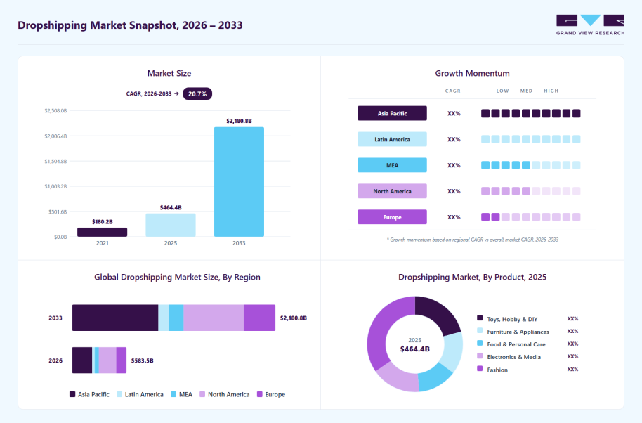

Figure 1.1: Global Dropshipping Market Summary
Source: (Grand View Research, 2026)

As part of this digital economy, dropshipping platforms have become a critical part of B2B SaaS by providing an interconnected digital infrastructure that facilitates inventory management, order fulfilment and logistics. In 2024, the global dropshipping market was worth USD 464.4 billion in 2025 and is projected to grow from USD 583.5 billion in 2026 to USD 2,180.8 billion in 2033 due to the growth of cross-border e-commerce and digital entrepreneurship (Grand View Research, 2026). Despite the high growth of SaaS marketing, a key strategic question is still emerging whether firms should go for standardised marketing (global uniformity and economies of scale) or localised marketing to strengthen the global brand identity. Ugwuoju (2025) added that whilst standardisation can help boost efficiency and build stronger brand recognition across the world, localisation can help increase customer trust, regulatory adherence and cultural acceptance, especially in culturally diverse markets like India and China. To investigate these strategic issues the research will focus on the real-time business scenario of Avasam, which is a UK-based dropshipping platform and focus on supplier verification and marketplace compliance, combined with its localized UK expertise to generate a higher level of trust and service quality (Avasam, 2019).

Within the competitive SaaS market in the UK, Avasam has positioned itself by combining over 200 verified UK and international suppliers, providing automated inventory synchronisation, order management and marketplace integrations, with a late delivery rate of less than 1% and a 2–3-day delivery time for the UK (Matthews, 2019). On the other hand, Spocket is taking a more inclusive approach to international penetration by 1million products, partnership with 80% of US & EU suppliers and a vast range of entrepreneurs worldwide (Spocket, 2026). Thus, through the evaluation and comparison of selected company’s market penetration approach the study will consider that SaaS platforms are increasingly vying in very dynamic international markets where successful market penetration and customer acquisition relies not just on technological ability to perform well but on marketing adaptation as well (Koskela, 2026). However, the findings are also expected to generate practical evidence regarding how the market penetration aspect has been influenced by the international factors within the rapidly evolving B2B SaaS ecosystem.

1.2 Research problem
The B2B SaaS industry is growing at a fast rate in the global business platform, but there is still a confusing approach recognised about the effective marketing strategies to gain market traction especially in the culturally and economically sensitive marketplace (Epa, 2026). While the concepts of localisation and standardisation are well explored in the literature as separate international marketing strategies, there is not enough empirical research to understand how it provides impact on customer acquisition and positioning in B2B SaaS dropshipping platforms. In addition to these, the existing research studies have provided limited focus towards the comparative discussion of cloud-based companies and the marketplace platforms like Avasam and Spocket. This aspect is leaving a significant knowledge gap; as companies with an international SaaS market have to handle global brand consistency, standardisation of technology, regulatory consistency and culturally different customer segments, all of which makes this research more relevant in the current era (Epa, 2026). In addition to these, the differences in culture, language, digital infrastructure, and customer expectations in markets like the United Kingdom, India and China makes marketing adaptation a vital component of market penetration success (Ugwuoju, 2025).

Hence, this study is intended to provide empirical evidence of the effect of localisation and standardisation on the market penetration strategies in these markets. Moreover, the core findings are expected to provide implications for international marketing theory, as well as for managers who aim at sustainable competitive advantage and successful international expansion in the fast-expanding B2B SaaS sector. The concept of localisation and standardisation are thoroughly discussed in the literature as international marketing strategies, but there is still a lack of empirical research to understand the impact of this concept on customer acquisition and positioning in B2B SaaS dropshipping platforms. Besides these, previous research studies have been limited in providing attention on comparison of cloud-based companies and the marketplace platforms, such as Avasam and Spocket. This aspect is creating a huge knowledge gap, particularly in the current time as those companies that go beyond the domestic SaaS market need to be able to manage international brand consistency, technology standardisation, regulatory consistency, and cultural differences with customers.

1.3 Aim and objectives
Aim: The primary aim of this research is to analyse the effectiveness of localisation and standardisation marketing strategies for Avasam’s international market penetration while comparing such with Spocket.
Objectives:
- To analyse perceptions of localisation and standardisation of Avasam in B2B SaaS marketing
- To focus on the perceived influence of these approaches on market penetration of Avasam in the home and host markets
- To compare localisation and standardisation marketing approaches of Avasam with that of Spocket
- To provide actionable recommendations to Avasam for enhancing international marketing approaches and market penetration

1.4 Research question
How does utilisation of localisation versus standardisation in B2B SaaS marketing influence market penetration approaches for Avasam in the UK, India and China, as compared to Spocket?

1.5 Significance of the study
The significance of the study relies on the international marketing and the B2B SaaS literature by exploring the effect of localisation and standardisation strategies on market penetration in the competitive dropshipping industry, thereby aligning with the findings of Lee and Matanda (2026). The insights gathered from the study will be influential to the SaaS platform in the European market aiming for expansion in the international market specifically in India and China. On the academic aspect, this research will add an innovative body of knowledge by applying localisation-standardisation theory to cloud based B2B platforms, in which the field has not been extensively studied empirically. However, the comparative study between Avasam and Spocket will also allow the identification of best international marketing practices, strengths and strategic gaps, facilitating the development of evidence-based recommendations to support the improvement of market penetration and sustainable competitive advantage.

1.6 Methodological choice
In this research, the use of quantitative research design will be used to explore the perception of the respondents on Avasam and Spocket's international marketing strategies. The integration of structured online questionnaires aims to gather primary data by using purposive sampling from targeted participants who are knowledgeable about B2B SaaS and dropship platforms. However, the gathered data will be analysed by using descriptive statistics, percentages, charts and cross tabulation analysis in MS Excel to ensure comparisons between the two companies in the chosen international markets.

1.7 Research Structure
This dissertation is organised into distinct chapters, in which the study introduces the research aim, objectives and question in chapter 1, while Chapter Two critically reviews the relevant literature and theoretical framework regarding the topic. The research methodology section explained in chapter Three. The findings and discussion are represented in Chapter Four while the study is concluded with recommendations, implications, limitations and directions for future research in Chapter Five.

1.8 Summary
This chapter has represented the background, research problem, aim, objectives, research questions along with the methodological choice, scope and significance of the study. It sets the context regarding the importance of evaluating localization/standardisation strategies by comparing with the business initiatives of Spocket and Avasam within the competitive international market. However, the chapter conducted a basis for the literature review which will help to critically analyse the empirical studies and gaps in the literature relevant to the study topic.

Chapter 2: Literature review

2.1 Introduction
The considered debate in relation to localisation and standardisation is still a key issue among international marketing companies, especially for digital platforms like Avasam and Spocket who operate in various countries. For B2B SaaS companies, the challenges are also increased as marketing decisions need to be addressed in various languages, regulations and cultures while managing a consistent brand image. In the dropshipping sector, these considerations are crucial as there are variations in supplier networks, market maturities, and consumer expectations. This chapter aims to review currently available data sources on localisation, standardisation, market penetration, and other relevant concepts to develop a solid foundation for future analysis with Avasam and Spocket.

2.2 Localisation and standardisation in international marketing: a focus on B2B SaaS marketing
The concept of localisation and standardisation are two distinct approaches that contrast each other in international marketing strategies. According to Rashkova et al. (2024), standardisation is the use of consistent marketing approaches, brand positioning, value propositions, and communications in diverse markets. While Okonkwo et al. (2023) identified localisation to be the process of adapting marketing aspects to local cultures, economic, languages, and regulatory demands. Although the debate for being more efficient is lasting for a long-time the context is mainly crucial for digital businesses as technological scalability often forces standardisation, while market diversity requires better adaptations. Both approaches in the international marketing context cannot be considered superior from one another, especially as effectiveness is based on market characteristics, industry conditions and organisational capacities. Eze et al. (2024) argued that standardisation allows companies to gain economies of scale, operational efficiency, and strong brand consistency in wider markets. These advantages can be particularly effective for SaaS businesses as digital products can get replicated and distributed globally with lower marginal costs.
Therefore, through a standardisation approach, a company can maintain proper user experience, reduce content development costs and smooth marketing operations in various countries. In the B2B SaaS context, standardisation is often associated with strong global branding, especially as businesses consider software solutions for their functionality, reliability, and return on investment (Keyholesoftware, 2026). These factors are often universally aligned across markets. Managing a consistent message across platforms and other areas can result in greater credibility and reduce user confusion. Furthermore, standardisation supports efficient resource allocation, especially due to its focus on global marketing in materials, websites, and campaigns, which can then be slightly modified for specific markets (Veracontent, 2023).
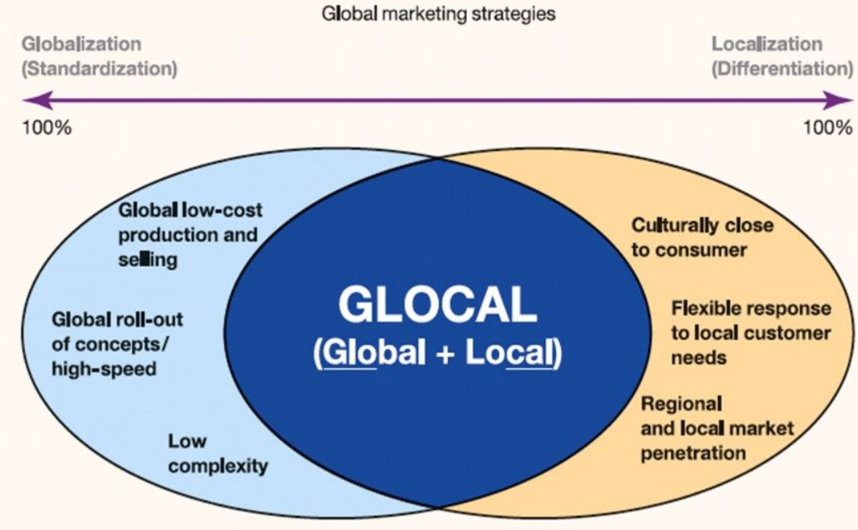

Figure 2.1: Standardisation vs localisation factors
(Source: Chui, 2024)

Although the effectiveness of standardisation is often confused when companies enter a market with high cultural diversity. Localisation, in this case can allow considering factors like consumer expectations, communication styles, behaviours and regulatory environment, as these are often different in different markets (Okonkwo et al., 2023). For example, in markets like India, the payment systems, digital ecosystems, trust-development approaches and language preferences can be highly different compared to Western countries. So, standardised marketing campaigns can fail to align with the local audiences regardless of offering various quality products. Studies have also shed light on the cruciality of localisation in digital contexts, for example, Lin et al. (2023) identified how in the case of international promotional strategies, adapting to local consumer needs and preferences with a focus on market conditions can enhance performance in marketing in international markets. For SaaS providers, localisation can include language and communication channel adaptations, culturally relevant content development, region-based case studies, local consumer support, and even adapting their pricing approaches. However, localisation also has various challenges, potentially including that excess reliance on adaptation can develop brand fragmentation, also complicate strategic coordination and increase operational costs (Song, 2021). Furthermore, different marketing strategies in diverse regions can also hinder brand recognition and develop inconsistency in consumer perspectives. While managing diverse separate campaigns, support systems, and websites will need major financial and managerial inputs. Therefore, for considerably smaller SaaS companies, these can be challenging to meet especially in early international expansion. The rising consensus in terms of these two factors of localisation and standardisation is developing a collaborative global strategy (Sobeih, 2025).

In this context, companies aim to standardise the key brand values, capabilities and product positioning while localisation is done in relation to marketing aspects as per needs in the new market. This perspective considers that international markets provide a complicated perspective that companies need to balance their global efficiency with local responsiveness. The relevance of this analysis is especially crucial in the dropshipping SaaS industry, as platforms like Avasam mainly operate in their domestic market of the UK, showing that it needs less focus on ensuring alignment to various global markets, simplifying the operations (Dave, 2026). On the other hand, platforms like Spocket, which operates at a more international level with 80% of their US & EU suppliers, showcase the need for better communication consistency in terms of technological benefits and analysing each country-based supplier, legal demands and logistics expectations (Spocket, 2026). Therefore, understanding the balance between localisation and standardisation is crucial for analysing international marketing effectively in the B2B SaaS environment.

2.3 Influence of localisation and standardisation in terms of market penetration
The study by Harahap et al. (2025) has shed light on the concept of market penetration, which is a company approaching a new market while acquiring consumers and presence in that target market. For SaaS companies, market penetration is often measured through consumer acquisition, subscription growth, platform adaptations, long-term consumer retention, and market awareness. The relation among standardisation, localisation and market penetration has gained major advancements in terms of academic literatures and is mainly focussed on the company’s success being inflected through how companies adapt their marketing focuses. In home markets, standardisation often provides major advantages, especially for companies like Avasam, which has grown a major presence in the UK market (Dave, 2023). These types of companies often have a larger understanding of the consumer base, including their behaviour, needs, cultural aspects, and competition. Standardised marketing approaches can be beneficial as they are already aligned with market expectations. An extensive level of brand name also reduces the need for extensive adaptations, showing how companies like Avasam can often gain stronger penetration in domestic markets before international expansions. According to Sasaki et al. (2021), the situation is also complicated in the context of host markets, especially when foreign companies enter new countries, they can face issues like cultural distance and lack of brand recognition. These cases increase the importance of localisation due to its capability to reduce uncertainties and increase relevance among potential consumers in the new country. Consumers can showcase better responsiveness to companies that have greater local business context understanding and how the new markets can develop challenges for it. These showcase how various external factors can influence a company’s decisions in market entry.
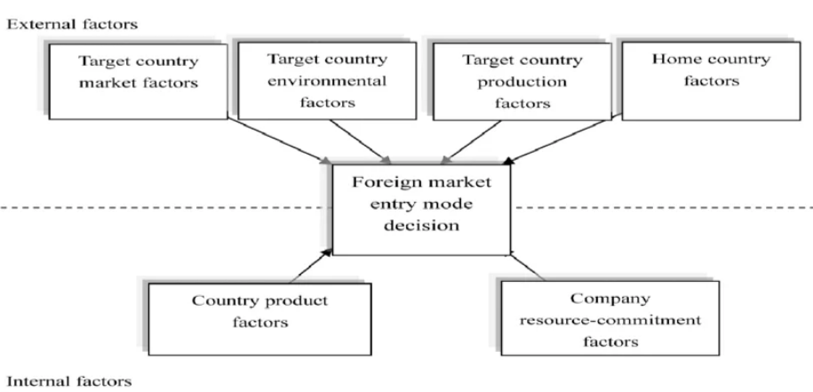

Figure 2.2: Factors impacting market entry mode decisions
(Source: Imiru, 2022)

The importance of localisation is especially crucial in rapidly growing digitalised economies; for example, India has major diversity in terms of languages, cultural aspects, and regional purchasing powers (Mawdsley, 2023). On the other hand, countries like China are mainly operating under diverse digital ecosystems which are influenced through regulations, consumer expectations and platforms. These types of factors can develop barriers for companies like Avasam, which utilises mainly domestic marketing approaches and can focus on expanding in host markets without making proper adjustments. Yet, market penetration is not considered through a single localisation context as standardisation also contributes to expanding trust and credibility of companies in markets. According to the study by Chauhan (2023), it can be identified that in the B2B context of SaaS environments, business consumers often prefer software that provides quality and maintains consistent global standards, especially for reliability and security. These companies often focus on optimising operations, enhancing productivity, and reducing costs. So, a fragmented marketing strategy can raise more concerns among the consumers regarding the company’s professionalisms and develop concerns about operational consistency also. For Avasam, it has developed a major reputation in the UK for its focus on supplier verifications, marketplace integration and automation capabilities (Dave, 2024). The company’s focus is mainly based on the marketplace integrations and develops trust through operational efficiency in a focused market context. Thus, with a major focus on supplier quality and platform reliability, the company has developed a value proposition in relation to professional retailers who are based on dependable fulfillment services.

On the other hand, Spocket has created a more international growth strategy, with a focus on accessing millions of products through a major network and developing relationships with various regions. Based on company disclosures, the company has developed access to over 100,000 online dropshipping retailers while having relations with a wide base of entrepreneurs, reaching regions in North America and Europe (Spocket, 2026). This type of positioning is showing a more global-focused marketing approach that is focused on valuing variety, scale and international accessibilities. These diversities show a wider strategic issue in the international marketing context; companies focusing on focused marketing strategies often gain benefits through local knowledge and strong relationship-developmental approaches. So, companies with global reach can gain better brand visibility and market reach, while also facing major issues in relevancy management in diverse markets. From a localisation perspective, companies operating in various countries need to adapt their market communication approaches, and consumer engagement strategies, as international market consumers can expect local language support and culturally relevant marketing approaches (Sudirjo, 2023). Thus, if a company fails to properly provide these aspects, they can develop risk for declined consumer trust and hinder growth in new markets.

2.4 Strategic factors impacting international marketing approaches and best practices for market penetration
The concept of international marketing effectiveness is based on various influential factors, which are interconnected and lack influence through standardisation and localisation only. These are also relevant in the case of B2B SaaS contexts, making them crucial for understanding, as marketing outcomes are influenced through wider organisational and environmental aspects. In this context, trust development is crucial, as B2B software purchasing includes major financial commitment, and perceived risks (Lee and Matanda, 2026). Thus, consumers often analyse providers in terms of credibility, reputation, and reliability, making trust a key factor, especially in international contexts where consumers may have a lack of data for a foreign company. Furthermore, another key factor is communication relevancy, effective marketing needs proper engagement with consumers so it can efficiently showcase the value propositions in line with local business needs. Decision-makers in different countries can consider software solutions through criteria that are different from one another, so marketing messages that can address locally relevant issues can create better engagement among companies. Udayana et al. (2021) added that regardless of traditionally being considered as an after-sales concept, the factor of consumer support capability can also influence marketing. This is especially as consumers want continuous support in their product usage lifecycle. Local support availability can enhance satisfaction, reduce churn, and enhance consumer relations. Pricing approaches can also become a crucial consideration, as in SaaS-based business models, there is a rising complexity in relation to pricing decisions, especially for subscription-based aspects. Thus, market penetration is not only based on attracting consumers but also on convincing them that the providers can deliver value to them.

In terms of best practices in international market penetrations, these are mainly based on a wider analysis of factors hindering this area. As stated by Eze et al. (2024), localisation and standardisation are not effective or beneficial all by themselves alone, showing how companies need to adopt a more balanced approach that can combine both the benefits of these approaches in a balanced manner to ensure global consistency with selected local adaptations. For example, companies can consider standardisation as the key brand identity while localising communication factors. Product elements and brand values should be adjusted as per market needs, yet the brand should maintain its global identity (Taufiqurrahman et al., 2025). This approach allows for maintaining efficiency at the same level while increasing market relevancy. Prioritisation of market-specific consumer data before expansion can also be beneficial. In contrast to just assuming the similarities in various countries, companies should focus on analysing digital behaviours, cultural needs, regulatory context, and competitiveness in the target market. These insights can support informed decisions for market penetration and reduce risks in this process. Furthermore, companies can focus on investing in local trust-development approaches like testimonials, local success stories, market-based support systems, and others.

In this, local partnerships are most effective to develop a brand presence in internal target markets before full expansion (Ruiz-Coupeau et al., 2019). This is especially for B2B context, as the purchasing decision often involves higher risks as analysed previously. Companies should be focused on analysing KPIs like consumer acquisition costs, conversion rates and others to understand the effectiveness of localisation or standardisation. This will allow them to measure the success in terms of their approaches and make crucial adjustments as per performance to ensure better market penetration through marketing approaches. As analysed, companies have a constant need to adopt flexible pricing and support strategies as per needs (Olivieri and Testa, 2024). While full adaptation can become impractical at the beginning, a more focused approach on adjustments can showcase brand’s commitment to local condition adjustments. These balanced approaches are particularly beneficial for B2B SaaS companies like Avasam and Spocket to expand in economically and culturally diverse markets like the UK, India, and China.

2.5 Real-Data Factors Influencing Market Penetration
One of the greatest shortcomings of studying market penetration solely in terms of theoretical abstractions is that international expansion has an eventual outcome that can be measured in terms of business. Harahap et al. (2025) related the level of market penetration to the rising level of competitiveness and the presence of customers. In SaaS, the indicators of interest can be customer acquisition, conversion rates, subscription growth, retention, customer acquisition cost, churn, active users and brand awareness, which are more directly related to visible evidence in the company.

2.5.1 Supplier network
The supplier presence has a direct impact on the appeal of a dropshipping marketplace. A platform that has trustworthy suppliers can offer more product selection and minimise the risk of fulfilment. Avasam focuses on verified suppliers in the UK and now encourages entry into hundreds of UK dropshipping suppliers that are carefully vetted (Dave, 2023; Dave, 2024). Spocket, on its part, encourages a wider global network of suppliers and declares that they may receive access to massive retailer pools. The contrast is used to demonstrate different penetration strategies, reflecting the fact that Avasam focuses on the quality and reliability of local suppliers, whereas Spocket focuses more on the size of the international network and its availability.
2.5.2 Pricing and subscription structure
SaaS is a product that is directly affected by pricing since the consumers will assess benefits that are likely to be generated against the recurring expenditure. Avasam now offers a free plan with Starter, Advanced, Business and Guru plans. Its UK Starter option is promoted at £24.99 plus VAT monthly prior to annual-payment deals, and increasingly greater plans add sourcing ability, support and account-management features (Ruiz-Coupeau et al., 2019). This tiered pricing can lower the entry barriers and can monetise the more valuable users. Nevertheless, globalization might entail taking into account the purchasing power, currencies, taxation, and local readiness to pay. Consequently, the perceived value of the same nominal pricing strategy used in the UK, India and China might not result in a similar perceived value.
2.5.3 Technology integrations
The other measurable factor is integration capability. A merchant who already has payments with Shopify, WooCommerce or any other marketplace experiences reduced switching and adoption costs when a dropshipping platform can be connected to its infrastructure. Avasam now provides integrations with such platforms as Shopify, WooCommerce, BigCommerce, Wix, Amazon, eBay and OnBuy (Dave, 2024). Spocket is also compatible with Shopify, BigCommerce, Wix, WooCommerce and other e-commerce apps (Shaw et al., 2026). These resemblances denote that technology might not offer enough differentiation on its own. The competitive advantage may thus change to the quality of suppliers, customer service, prices, localisation and performance of fulfilment.
2.5.4 Automation and inventory synchronisation
Automation offers an important B2B value proposition since retailers have to handle potentially huge amounts of inventory and order data. Avasam automatically moves orders, payment and shipping data and synchronises inventory with a regularity of around 30 minutes. Spocket also allows store integration and fulfilment of orders. As stated by Shaw et al. (2026), automation decreases administrative effort and can thus enhance perceived usefulness, which relates directly to the Technology Acceptance Model as will be discussed later.
2.5.5 Trust and supplier verification
Trust is a significant market penetration variable since retailers are relying on suppliers that they may never see (Yue, 2022). Avasam highlights supplier validation and inventory located in the UK as key components of its offer. Spocket also undertakes supplier vetting and mandates suppliers to manage their own inventory and to comply with product, pricing and fulfilment criteria.

2.5 Theoretical framework
This study has been supported through three key theoretical contexts including Consumer Behaviour theory, the technology Acceptance Model (TAM) and the Supply Chain Management theory. These theories aim to provide a detailed framework to understand how localisation and standardisation approaches can influence marketing effectiveness and market penetration in the B2B SaaS dropshipping context.
The Consumer behaviour concept is based on how individuals and companies make purchasing decisions as per various external and internal influencing factors (Shaw et al., 2026). In the business context, decisions for purchasing are impacted through aspects like trust, culture, value, risk consideration, and experiences. The theory is relevant in this research context as localisation and standardisation strategies directly influence how potential consumers consider a SaaS platform. To better understand this, an example can be considered in which localised marketing messages can enhance trust and relevancy through showing how local business conditions are managed. Contrarily, it is argued that the standardisation approach focuses on enhancing perceptions of professionalism and consistency in image (Yue, 2022). In international markets like China and India, cultural expectations and communication preferences are highly different from the UK. Therefore, this theory supports shedding light on how different marketing approaches can develop various levels of consumer engagement in diverse markets. This research will align with this theory via linking marketing adaptation decisions with consumer perceptions and purchasing intentions.

The Technology Acceptance Model (TAM) shows a different approach in marketing adaptations through two separate bases of technological adaptation including perceived ease of use and perceived usefulness of that technology (Zaineldeen et al., 2020). Based on the theory, users can be more focused on adapting a technology if they consider that it can enhance their performance and can be used without complications. This theory is also relevant in the B2B SaaS platform context, as their success is based mainly on business users accepting and integrating technology in daily operations. Olivieri and Testa (2024) added that marketing approaches often influence these considerations before even usage is done. For instance, localised marketing can showcase the platform's usefulness through approaches and business cases or region-specific examples, while standardisation is mainly focused on focusing marketing may focus on universal benefits and functionality. TAM, therefore, provides a better understanding in relation to how international marketing approaches can influence software adaptations. It supports this research through explaining how localisation and standardisation can impact these perceived values and use acceptance in various markets.

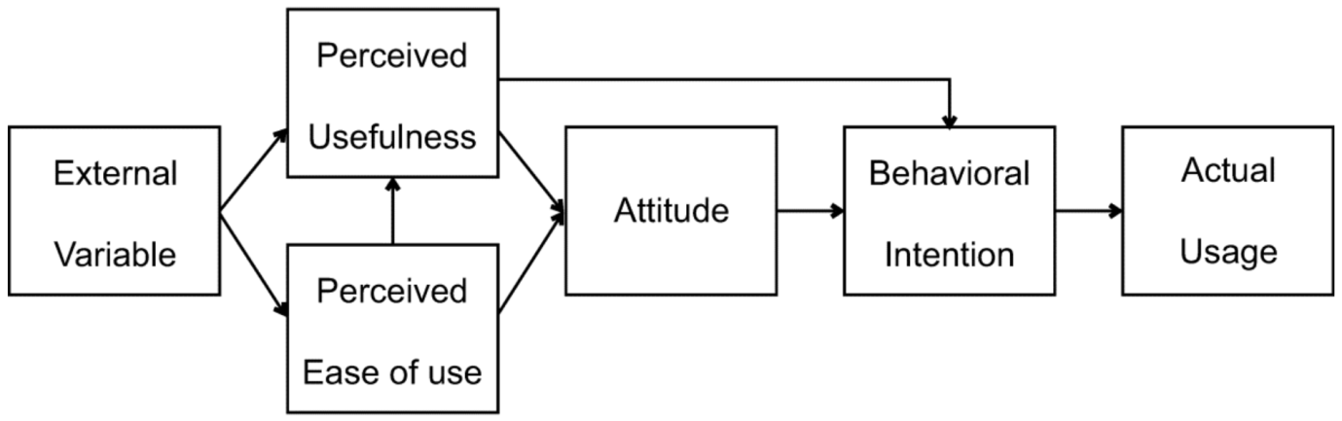

Figure 2.3: technology acceptance model overview
(Source: Park and Park, 2020)

The Supply Chain Management Theory is based on the coordination of logistics, data flows and suppliers that eventually leads to value creation and gaining competitive advantages (Ralston et al., 2023). Regardless of often being aligned with operational management, this theory is highly relevant to dropshipping platforms as their business models are often based on effective supplier-retailer collaboration. In terms of operational benefits, this concept can contribute to aspects like fulfilment efficiency, supplier relationship management, automation capabilities, and inventory alignments. The effects, although they can be diverse and based on various market demands, are especially evident considering how business requirements and local supply chains are different (Park and Park, 2020). Therefore, this theory supports this study through combining marketing communications with operational value propositions developed through dropshipping SaaS platforms.

2.6 Literature gap
According to the analysis done earlier, it can be identified that current literature mainly provides a detailed analysis of localisation and standardisation in an international marketing context. There are also studies done on SaaS internationalisation, market penetration, and digital platform expansions approaches. Yet, the analyses highlighted a gap in terms of research shedding light on how these concepts are interacting in the B2B dropshipping context. Most of the analyses identified traditional consumer markets or wider technological industries without a focus on dropshipping platforms properly. With more analysis, another gap can be identified in existing studies regarding comparative research including localisation and standardisation approaches in home and host markets. Although research has considered the cruciality of adaptation in an international context, the lack of proper studies on how these approaches influence the perceived market penetration in home and host countries like the UK, India, and China collaboratively. Furthermore, there is also a major lack of academic research focusing on Avasam and Spocket analysis; thus, this study contributes to these gaps through analysing the perceptions of international marketing approaches in specialised B2B SaaS context and creating better in-depth understanding of dropshipping platform expansions.

2.7 Researcher’s discussion
Based on the critical review of existing literature, it can be argued that effectiveness of localisation along with standardisation are mainly dependent on market context, consumer expectations and organisational objectives. Analysed studies have shown that both strategies are superior compared to each other, as both of them provide proper advantages while also having limitations. In relation to the complete analysis of different literatures, a balanced approach is more beneficial especially for B2B SaaS companies which operate in various international markets. While standardisation is providing brand consistency, operational efficiency and cost reduction, localisation contributes to better market relevance through focusing on linguistic, cultural and regulatory differences. The comparison among Avasam and Spocket is also showing these differences, like Avasam’s strong focus on the UK market allows it to benefit from a standardised approach, while Spocket’s wider international presence needs better adaptation to diverse markets. Hence, this research considers that effective market penetration can be done when companies maintain key global brand value while adapting on a selective basis as per consumer need, marketing communication and strategies to engage with them, especially in culturally diverse markets like India and China.

2.8 Chapter summary
This above chapter has shed light on various existing databases in relation to localisation, standardisation, international B2B SaaS marketing, market penetration and strategic expansion approaches. Through the discussion, it can be identified that localisation or standardisation cannot ensure international success by themselves, showing the need for a balanced approach. The chapter also sheds light on factors that impact market penetration in home and host countries while analysing potential perspectives in relation to SaaS platforms like Avasam and Spocket. Furthermore, while the gaps in existing literature were considered, the theoretical perspective based on Consumer Behaviour theory, TAM and Supply Chain management theory has also supported this study’s development to fill those gaps.

Chapter 3: Methodology

3.1 Introduction
This chapter sheds light on the chosen methodology selected for this research while justifying it through available academic databases. The main purpose of the methodology selection is based on analysing how localization and standardisation influence the market penetration approaches among B2B SaaS marketing for Avasam in the UK, India and China while comparing with Spocket. The chapter showcases the philosophical considerations, research approach, strategy, sampling and methods for collecting and analysing primary data. There has also been focus given towards approaches to enhance study reliability and validity while considering potential limitations and ethical safeguarding principles. These methods are beneficial to answer the research question and meet the study objectives through seamless, transparent and strict quality analysis.

3.2 Research philosophy
The study is supported through a positivist research philosophy that mainly focuses on the fact that knowledge can be developed via observable patterns. Ali (2024) added that reality is objective and knowledge can be developed through measurable responses. The choice is beneficial and suitable for this research as the study aimed to evaluate the perceptions of localisation and standardisation through numerical data from survey participants. In contrast to analysing personal narratives at an in-depth level, the study focused on identifying common tendencies among individuals who are familiar with digital marketing, dropshipping, and SaaS platforms. This positivist focus also supports the use of structured question, statistical analysis, and comparison across market variables. It is also well-aligned with the study as the focus was also on considering if participial marketing approaches are considered more effective for market penetration. It has allowed increasing the research consistency, reducing researcher influence on the results, promoting a systematic analysis of gained data and allows better generalisations (Park et al., 2019). However, the perceptions are based on a subjective manner, the positivist base allowed to convert them into measurable indicators that can be compared among respondent groups. Through adapting this philosophical base, this research has focused on developing structured findings that are transparent and suitable for analysing international marketing decisions, especially involving Avasam in its home market and selected host markets, while managing analytical clarity through the complete analysis process.

3.3 Research approach
In terms of research approach, the study adopted a deductive research approach as the study started with an existing theoretical assumption and then analysed if participant responses support or contrast the perspectives. According to Mohammed (2024), the deductive approach is beneficial as it aligns with scientific investigation in which the analysis is done based on previous studies and existing theoretical bases while relating to the topic area that eventually allowed for testing through empirical data. Concepts from consumer behaviours, supply chain management, and technology acceptance provided a solid base of understanding of the international marketing decision among dropshipping platforms. The survey findings also supported real-time perceptions based on localisation, standardisation, and market penetration in contrast to creating new theories. This approach is, therefore, beneficial for the study. This method helped to clearly define the questions and analysed measurable data from respondents with relevant understandings. Deduction also supported comparison among Avasam and Spocket through technological analysis that assessed in relation to observed response patterns.

3.4 Research strategy
The research strategy was chosen as a survey strategy, which are commonly utilized in quantitative research as they allow information to be collected from various and wider groups of participants in a consistent approach (Ghanad, 2023). This strategy was suitable for analysing the perception of standardisation, localisation and market penetration. The use of a survey also supported comparison among perspectives and allowed the results to be summarised through descriptive statistics. The online survey format had been a practical choice for this research as the participants were located in various regions, this allowed them to complete the questionnaire at their comfort and convenience. This structured questionnaire was also beneficial as it allowed the study to quantify and analyse data by systematically structuring them in categories related to home and host countries (Ranganathan and Caduff, 2023).

3.5 Data collection and sampling method
For this study, primary quantitative data was collected through an online questionnaire via Google Forms. This approach was beneficial as it allowed contacting a wide variety of participants in diverse locations in a short amount of time, which is aligned with the study’s limited resource and time barriers (Manggaberani and Darlis, 2024). The prepared online questionnaire is focused on 2 sections, including 1: Screening & Demographic and 2: Contextual questions. The total number of questions are 12, with some multiple choice and Likert scale-based questions. The Likert-scale measurements ensured to evaluate participant perceptions for standardisation, localisation, market penetration and comparative positioning of Sprocket and Avasam. While the Likert scale format ensures responses to shed light on levels of agreement efficiently.

This study also ensured to provide participants with a participant information sheet, disclosing the purpose of the study, the voluntary nature of participation, data safeguarding approaches and other relevant rights. The purposive sampling technique was utilised to only focus on gathering participants who have relevant knowledge and understanding regarding the study, this allowed for better findings generation from data analysis (Tajik et al., 2025). The 34 chosen participant group mainly include the ones related to online selling, digital marketers, entrepreneurs, and individuals using or familiar with Avasam and Spocket. The entire process of data collection has, however, not considered any personally identifiable information like addresses, names, phone numbers, and others. This has ensured that the obtained responses remain anonymous and focused on participant perceptions only. All data collection will be done after gaining ethical approval from the university only. This selected method is cost efficient, allows for wider accessibility and better suitability through aligning with standardised perceptions based on international marketing decisions in home and host countries.

3.6 Data analysis methods
The collected survey data was then analysed through quantitative approaches that are suitable for this study. All the questionnaire results from the survey were transferred to Microsoft Excel for organising, coding and cleaning (Ucla, 2026). Responses were ensured to be complete and are relevant to the questions before conducting descriptive statistics analysis. The frequencies, percentages and response distributions were calculated for each question to shed light on patterns in responses. The Key analytical method chosen was cross-tabulation, which allowed understanding the relations among variables in a systematic manner through tables (Geeksforgeeks, 2026). For example, the perception of localisation was able to be compared with perspectives on market penetration, while focus on attitudes for standardisation was able to be analysed in relation to perceived effectiveness in various markets.

These types of comparisons supported this study to identify particular response categories that were often more frequent and whether any notable differences developed in respondent groups. To make the findings clear and easy to understand, visual representations, like charts and graphs, have been used. These have shed light on the tables that ensured clear findings representations. This analysis approach ensured convenient identification of trends and contradictions in perspectives through a pattern-based approach and aligned with research objectives. Analysed data was then compared with the existing literature findings on international marketing, SaaS adaptations, standardisation and localisation to understand if the practical perceptions align with previous academic understanding. The analysis remained focused on answering the pre-determined research questions to avoid potential general claims. The findings were able to provide a better understanding of the considered relationships and tendencies among participants while supporting the study with a structured basis for developing findings.

3.7 Validity and reliability
Validity and reliability are crucial for any study to ensure that the findings are credible and dependable (William, 2024). The study has undertaken various approaches in both contexts like content validity has been supported through questionnaire design in relation to research objectives and concepts identified in the literature review. This helped ensure that the questions properly met the concepts regarding standardisation, localisation, and market penetration and related marketing perceptions. Furthermore, in terms of reliability, it was ensured through the use of a standardised questionnaire developed similarly for every participant. The development ensured proper consistent word choices and simple modes of analysis to reduce unnecessary variations and gain justified responses from everyone. Furthermore, transparency in document sampling, collection and analysis also ensured the methodological choices were consistent.

3.8 Limitations of the research
Regardless of the beneficial sides and outcomes, the research also has various limitations that need to be considered in future similar research. For example, the limitations of sample size with 34 participants are strictly hindering the findings and their generalizability capability for globally relevant entities. The selection criteria through purposive sampling also raised concerns for the responses not being representative enough for every individual involved in international e-commerce or SaaS businesses. As inspired by the findings of Hadan et al. (2024), the survey method often develops issues. This is based on the fact that self-reported data can lead to issues like personal bias, analytical diversities or misunderstandings leading to social-desirability bias. Furthermore, the keen focus on perceptions and not organisational measures is also resulting in conclusions reflecting the participant opinions in contrast to the business outcomes. Finally, the geographical focus on the UK, China and India also hinders wider generalizability to other markets with cultural and economic diversities.

3.9 Ethical consideration
Ethical consideration is a key supportive pillar for any research, especially due to the nature of this study involving human participants (Nii Laryeafio and Ogbewe, 2023). This study followed the university ethical requirements and data protection regulations for ensuring a consistent research process. It was also ensured to not start data collection before gaining proper university approval through an ethical proposal. A participant information sheet was provided to each of the respondents that ensured they had all crucial and necessary information regarding the purpose of the research, their rights, data management approaches, and voluntary nature. These have ensured transparency in the process. The participation was ensured to be voluntary, allowing respondents to withdraw at any stage before submission if they feel so. Furthermore, it is ensured to provide everyone with a participant consent form. This has allowed gaining consent before survey conducting, thereby ensuring that all the participants have been willing to participate and share their perspectives on this context (Shepherd et al., 2024). No personal identifiable data was collected to ensure anonymity of the study, while the collected data was securely stored in university-approved OneDrive storage systems that have passwords to protect data from unauthorized access. The study did not include vulnerable groups or any financial incentives to ensure another layer of ethical alignment to make the findings more reliable and justifiable in future qualitative and quantitative studies.

3.10 Researcher’s evaluation on methodological choices
According to the researcher’s opinion, methodological choices adapted for this study are especially crucial and well-aligned to address the pre-defined research aim and objectives. The positivist philosophy and deductive approach provided a structured framework for analysing the participant perception through more in-depth measurable data, while the survey strategy allows for efficient data collection from the entities only familiar to the dropshipping or and SaaS platform context. Regardless of the fact that qualitative methods like interviews could have developed better insights for pergola experiences and motivations, this method had limited the capability to compare responses in a systematic manner across wider participants. Therefore, the selected methods are considered beneficial for providing reliable and objective-based findings, aligned with the study's allocated time and resources.

3.11 Chapter summary
This chapter has shed light on the methodological choices adapted for analysing the perceptions of localisation and standardisation in B2B SaaS marketing, with a focus on Avasam and Spocket. The discussion showcases how positivist philosophy, a deductive approach and a survey strategy are guiding the study. The focus on detailed questionnaire-based data collection through a sample selected by purposive sampling allowed the collection of relevant data that can be analysed with quantitative analysis methods. Validity, reliability, and ethical safeguarding approaches also supported better showcasing the limitations of the methods. The methodological choices that developed a structured approach to address the research objectives and eventually meet the aim, aligning with the scope and context of the research.

Chapter 4: Findings and discussion

4.1. Introduction
This chapter has analysed the findings from the survey conducted. This has been according to the key research aim of analysing the effectiveness of localisation and standardisation marketing approaches for Avasam’s international market penetration with a particular comparative focus on Spocket’s approaches. This chapter has shed light on the survey findings through providing an initial analysis of it to better understand the perceptions of the surveyed individuals. Analysed data has then been interpreted in a critical manner through comparison with available literatures. This is so as to develop a more in-depth understanding of the topic while meeting the objectives and key aim of this research.

4.2 Analysis of primary quantitative findings
1) Consent of the respondents
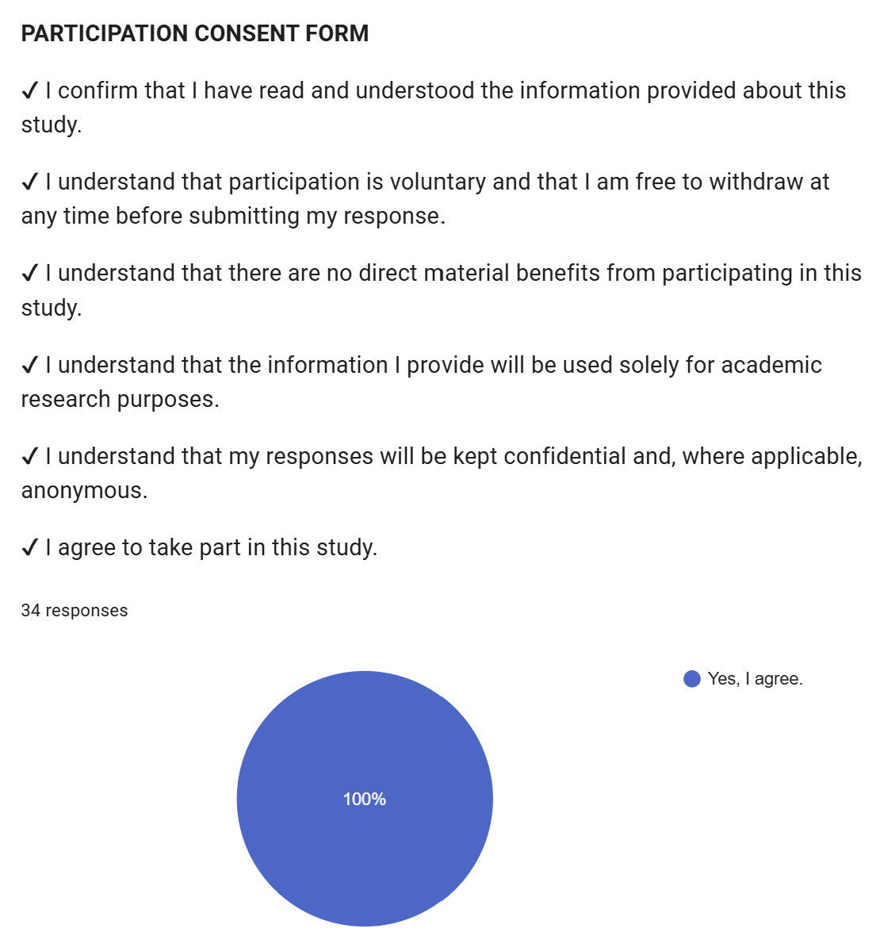

Figure 4.1: Consent of the respondents
(Source: obtained using Google form)
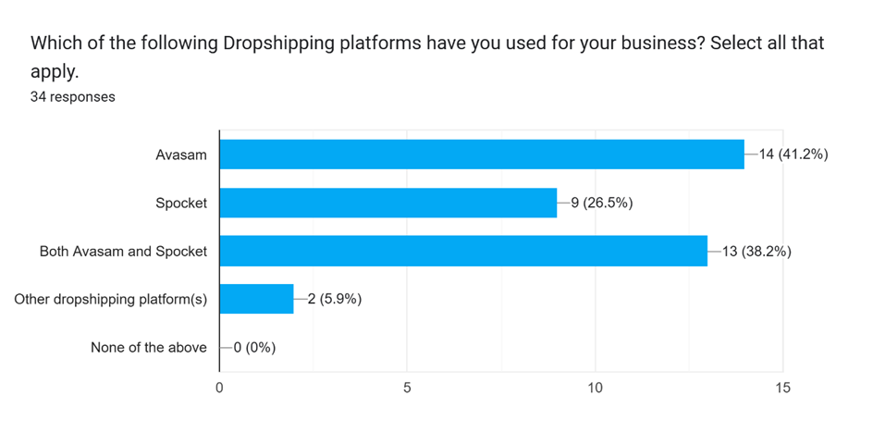

Figure 4.2: Dropshipping platform usage for business
(Source: extracted from the survey)

After gathering consent from all chosen participants, this survey question focused on analysing the most chosen or popular dropshipping platforms among the consumers in their businesses. Above responses showed that as a single platform, Avasam is chosen by 41.2%, while Spocket is chosen by only 26.5%. This shows the greater popularity of Avasam as a dropshipping platform among consumers. However, results also shed light on a trend in which a considerable portion (38.2%) chose Avasam and Spocket both as preferred Dropshipping platforms. While no one chose “none of the above,” 5.9% chose other dropshipping platforms, showing how as a platform for dropshipping, Avasam and Spocket had a greater consumer base.

2) Location of primary business
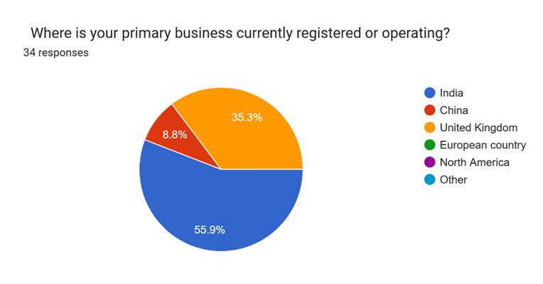

Figure 4.3: Location of primary business
(Source: extracted from the survey)
This survey question analysed the current registered or operating business location of the survey respondents which provides a potential overview of how the dropshipping platforms are covering various regions for them. Based on initial understanding, over half of respondents (55.9%) reported their business to be registered or operating in India, while another major portion (35.3%) chose the United Kingdom, which was identified as a key operating region for Avasam. The remaining respondents (8.8%) chose China as the region of operation, and none chose European countries, North America or others. These results, therefore, enhanced validity of the primary operating regions of the businesses and their preferred Dropshipping platforms.

3) Time of usage of the Dropshipping/SaaS platforms
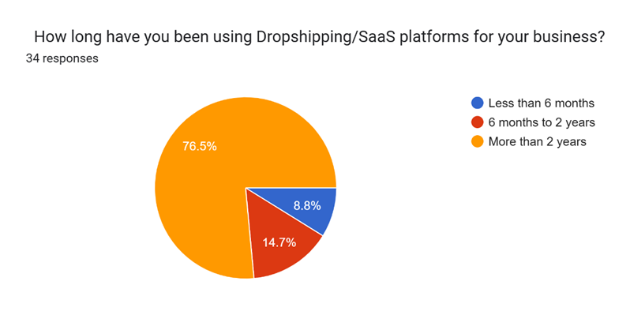

Figure 4.4: Time of usage of the Dropshipping/SaaS platforms
(Source: extracted from the survey)
This question has allowed better understanding of consumers' preferences of these dropshipping platforms, as it identified the timeline of usage of a particular platform in their business. A significant portion (76.5%) reported that they have been using them for over 2 years, potentially showing how dropshipping has become a key and popular choice for consumers and businesses in their operations over a long time. However, 14.7% chose 6 months to 2 years, and 8.8% chose less than 6 months, highlighting a potential gap in these markets for dropshipping usage and maybe a need for better knowledge development regarding these platforms and their benefits.

4) Role in the business
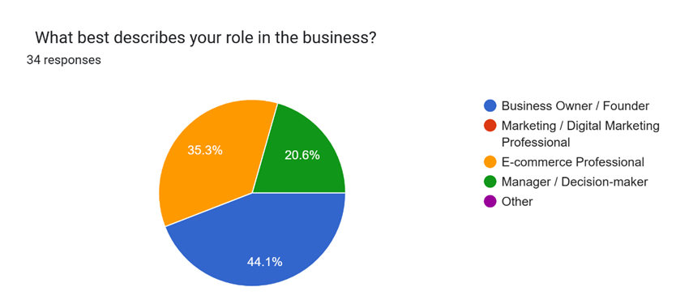

Figure 4.5: Role in the business
(Source: extracted from the survey)
To create a deeper understanding of the job roles of individuals related to dropshipping in businesses, this survey required their responses regarding the roles they are currently in. Nearly half (44.1%) responded to be business owners or founders, creating an understanding of how dropshipping is most relevant or well-known to these job roles. However, E-commerce professionals and Manager/ Decision-makers also accounted for 35.2%, and 20.6%, respectively, creating a diverse consideration of relevant job roles in the dropshipping context. No participants chose Marketing/Digital marketing professional or ‘Other’ options. This showed lack of involvement of these roles in the dropshipping context, particularly in the chosen regions where the respondents’ businesses are currently operating.

5) Dropshipping platform used for market types
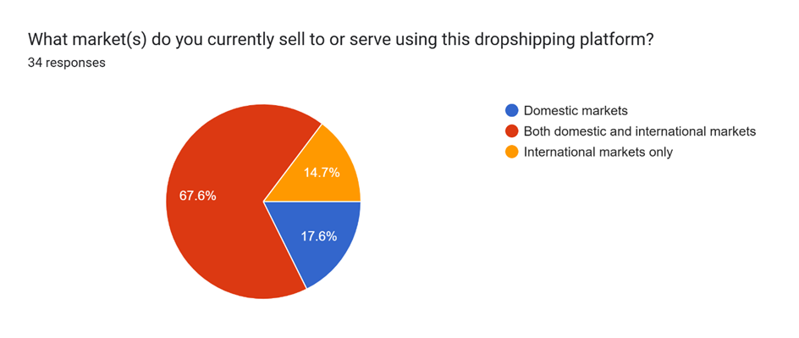

Figure 4.6: Dropshipping platform used for market types
(Source: extracted from the survey)
This question is mainly focused on analysing the markets that the respondents currently serve or sell to through dropshipping platforms. With this analysis, it is evident that the choice of both domestic and international markets is the primary choice for these businesses, as it accounted for more than half (67.6%) of the responses. These findings showcased that dropshipping platforms have developed major opportunities for businesses to operate in domestic and international markets as well, providing their major potential. Although, there have been some exceptions, as 14.7% chose international markets and 17.6% chose domestic markets only. This, in turn, indicated a lack of understanding of capabilities of these dropshipping platforms or personal preferences of these businesses, needing more detailed analysis of opportunities provided through the platforms.

6) Channels for discovering Avasam or Spocket
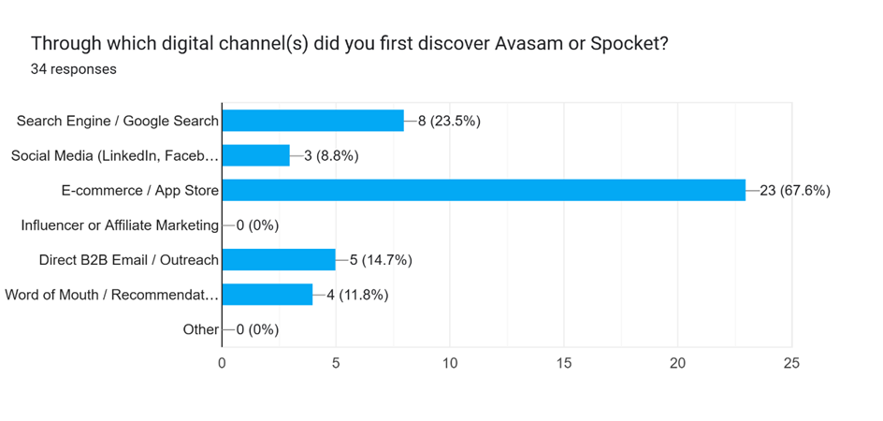

Figure 4.7: Channels for discovering Avasam or Spocket
(Source: extracted from the survey)
This question provides a solid understanding of the channel of discovery for the dropshipping platforms among the survey respondents. Based on the survey responses, it is seen that 67.6% chose “E-commerce/App store” as the digital channel they discovered Avasam or Spocket with, while 8 individuals (23.5%) reported the channel to be “Search engine/ Google Search”. Furthermore, there was the presence of other popular digital channels too which, although not significantly used as E-commerce or search engine, got considerable portions or choice. 14.7% chose “Direct B2B Email/outreach”, 11.8% chose Word of mouth or recommendations, while 8.8% chose social media as key digital channels that helped them discover Avasam or Spocket. However, no one chose influencers, affiliate marketing, or other options. This has, therefore, shown how Avasam and Spocket are mainly recognised through E-commerce and Search engine, becoming potentially their key marketing approaches in the global dropshipping market.

7) Agreement with statements on Avasam
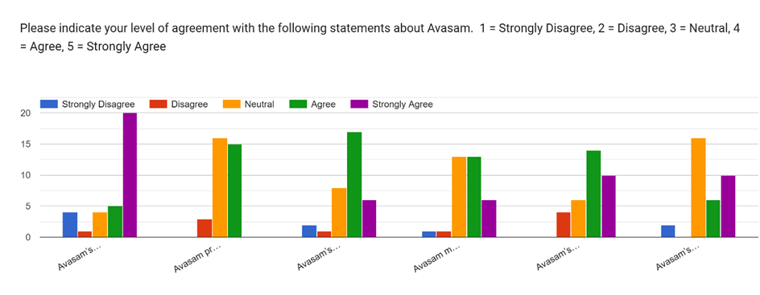

Figure 4.8: Agreement with statements on Avasam
(Source: extracted from the survey)
This question provided a more in-depth and critical understanding regarding the dropshipping platforms and how consumers consider them. For example, for “Avasam’s marketing materials are tailored to the UK/European market.” The majority of the participants reported ‘strongly agree’ while minimal portions showed disagreement. This mainly highlights how Avasam is primarily focused on UK/European markets for their marketing approaches, yet the small portion of neutral and disagreement still creates the need for better analysis.
Respondents showed no strong agreement or disagreement at all for “Avasam provides features that support UK/European tax, currency and compliance requirements.” with nearly similar portions of “agree” and “neutral” and minority choosing “disagree”. The primary result is hence showing a positive yet controversial understanding of Avasam’s features, as although there is a high number of agreements, there are considerably higher amounts of “neutral” responses for this statement. For “Avasam’s customer support and onboarding reflect local business needs,” a majority of respondents chose “Agree,” with little portion choosing “strongly agree”. It highlights how Avasam focuses to meet the local demands and requirements for the best potential regional adaptability.
A considerable portion of “neutral” and negative responses still develops a potential gap in this understanding and may indicate gaps in the company’s adaptability approaches. Regarding “Avasam maintains a consistent platform interface and core features across markets,” the initial analysis highlighted mostly positive responses, with minimal disagreements, however, the neutrality developed the need for better in-depth analysis of Avasam’s consistency. Furthermore, Avasam’s branding and messaging being consistent in different markets showed higher positives with minor disagreements or neutral responses. This reflected the possibility of Avasam using a consistent brand image across diverse global market operations to position them as a brand with consistent quality of services. This is also reflected through the statement on “Avasam’s standardized global approach makes the platform easier to recognize and adopt,” as the majority of respondents chose “strongly agree” or “agree,” showing the standardized approach undertaken by Avasam. Although a majority of neutral responses indicated wider gaps in understanding.
8) Beneficial marketing approach for Avasam’s growth
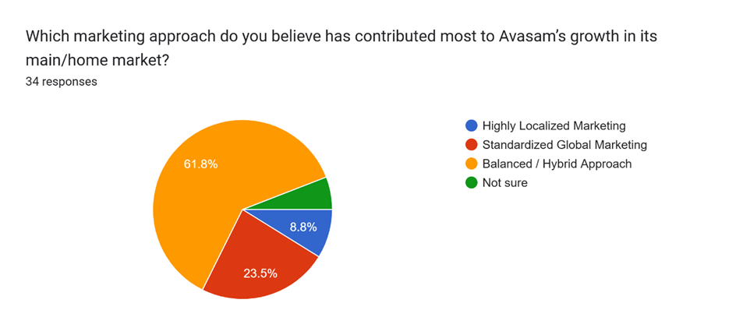

Figure 4.9: Beneficial marketing approach for Avasam’s growth
(Source: extracted from the survey)
This question focused on analysing the key marketing approaches that respondents believed mostly contributed to Avasam’s growth in the main and home market. Through the responses, a balanced or hybrid approach proved to be most beneficial for the brand as over half (61.8%) reported it, creating an important understanding for Avasam’s global success as a dropshipping platform. 23.5% believed a standardised global marketing contributed to their success and 8.8% reported Avasam’s growth due to highly localised marketing, with a minor portion being “not sure”. These results highlighted the potential controversies regarding which approach was key for Avasam’s success, thereby developing requirements for comparative analysis with existing studies.
9) Concept of Avasam’s current positioning for international market entry
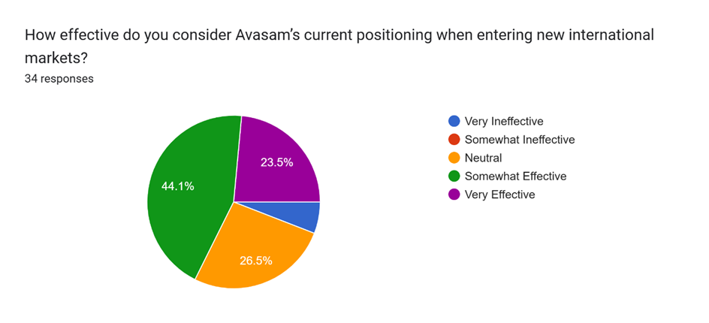

Figure 4.10: Concept of Avasam’s current positioning for international market entry
(Source: extracted from the survey)
In terms of the effectiveness of Avasam’s positioning to enter new international markets, the survey responses showed different perspectives that create potential confusion. For example, nearly half (44.1%) of the respondents reported its positioning to be somewhat effective, which almost showcases that the company needs to work on its positioning approaches to enhance market entry. Although 23.5% reported it to be “very effective,” there is still a small portion of “Very ineffective” responses and even another 26.5% responding “Neutral”. Hence, the initial analysis revealed a lack of an effective positioning approach by Avasam for its international growth.

10) Perceptions on Avasam and Spocket comparison
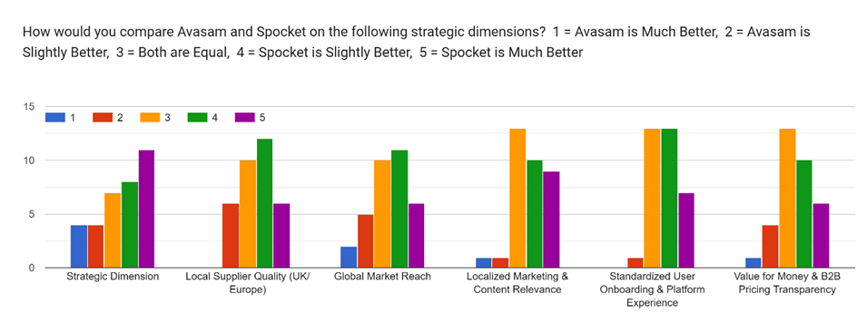

Figure 4.11: Perceptions on Avasam and Spocket comparison
(Source: extracted from the survey)
Through this comparative analysis of Avasam and Spocket, a greater analytical understanding has been gained in strategic dimensions, supplier quality, value for money, and other aspects. In the strategic dimension context, the responses were mainly inclined towards Spocket being much or slightly better than Avasam, while a considerable portion of 3 (referring both are equal) responses still slightly position Avasam as a considerate dropshipping brand. For “Local supplier quality (UK/Europe)”, Spocket was shown to be the preferred brand as a significant portion reported 4 (Spocket is slightly better). However, there are also high numbers for 3 and 2, which also shows Avasam’s potential focus on local supplier qualities. The option for “global market reach” also got more 4 and 5 responses, with lower 1 and 2 responses, highlighting Spocket’s excellence in this category. The response rate for 3 is also high, making Avasam competitive with Spocket in this aspect.
In “Localized Marketing & Content Relevance,” Avasam got really low responses as 1 and 2 were minimal; although 4 and 5 were higher, the significant portion of 3 may show that Avasam and Spocket have similar localisation focuses. Responses on standardized user onboarding experience revealed similar trends with Spocket receiving greater preference, yet ‘3’ is also high, providing insights on how Avasam can be equally good as Spocket, yet detailed analysis is required. Finally, for “Value for Money & B2B Pricing Transparency”, although ‘3’ is higher than others, the higher portions of 4 and 5, as compared to 1 and 2. This conclusively reflected that Spocket has proven to be a better value-for-money brand with effective transparency.
11) Platforms being globally standardised or regionally localised
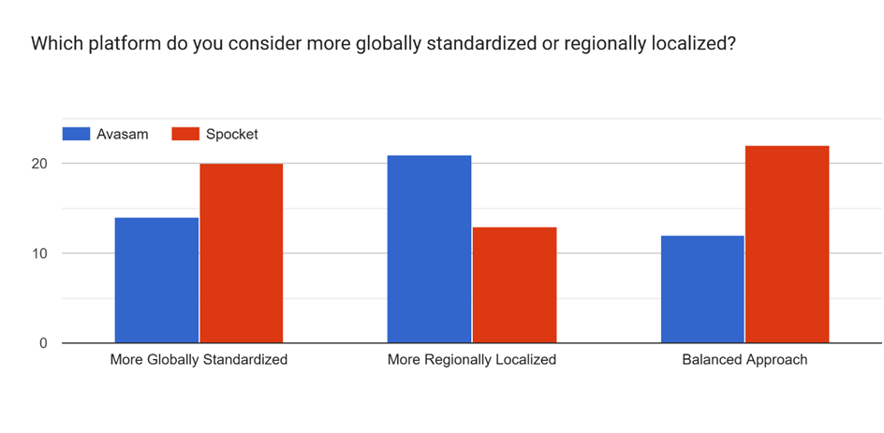

Figure 4.12: Platforms being globally standardised or regionally localised
(Source: extracted from the survey)
Through this survey analysis, Spocket was shown to be more globally standardised with higher responses, while Avasam was reported to be more regionally localised. However, for “balanced approach", obtained responses showed Spocket to be more effective in managing a hybrid standardisation and localisation approach, while lower responses for Avasam showed a gap in terms of its hybrid approach.

12) Effectiveness of promotional and content marketing approaches
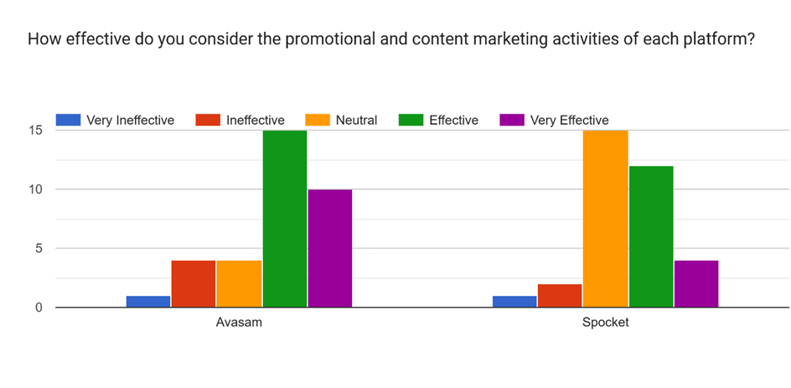

Figure 4.13: Effectiveness of promotional and content marketing approaches
(Source: extracted from the survey)
For promotional and content marketing approaches, Avasam received more “effective” responses compared to Spocket. This is also a similar case for “very effective” responses, as Avasam proved to have better promotional and content marketing approaches. Although responses highlighted that Spocket got significantly higher neutral responses. This means that they lack clear showcasing of effective promotional activities for consumers, creating this controversial perspective.

4.3 Descriptive statistics
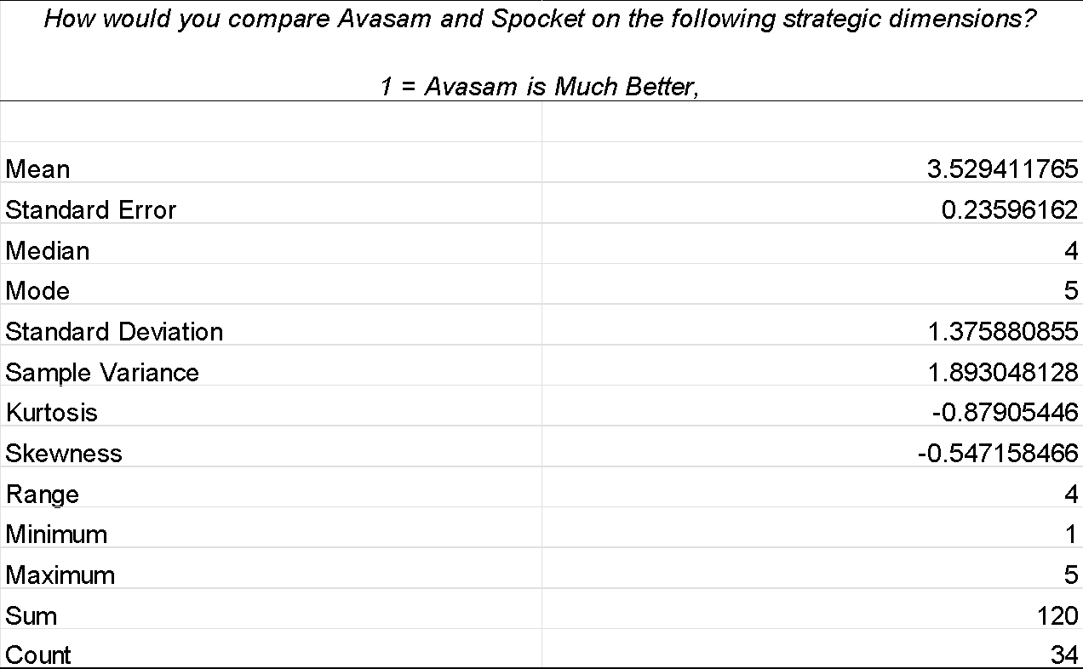

Table 4.1: Comparing Avasam and Spocket in terms of Strategic Dimension
(Source: calculated in MS Excel)
The average result of 3.53 showed that Spocket was rated by the respondents as a bit more superior than Avasam on the dimension of strategy. This tendency is supported by the median of 4 and the mode of 5 accounts for a common strong preference to Spocket. Nevertheless, the standard deviation is 1.38. These altogether showed that there is a significant difference in perceptions of the respondents.
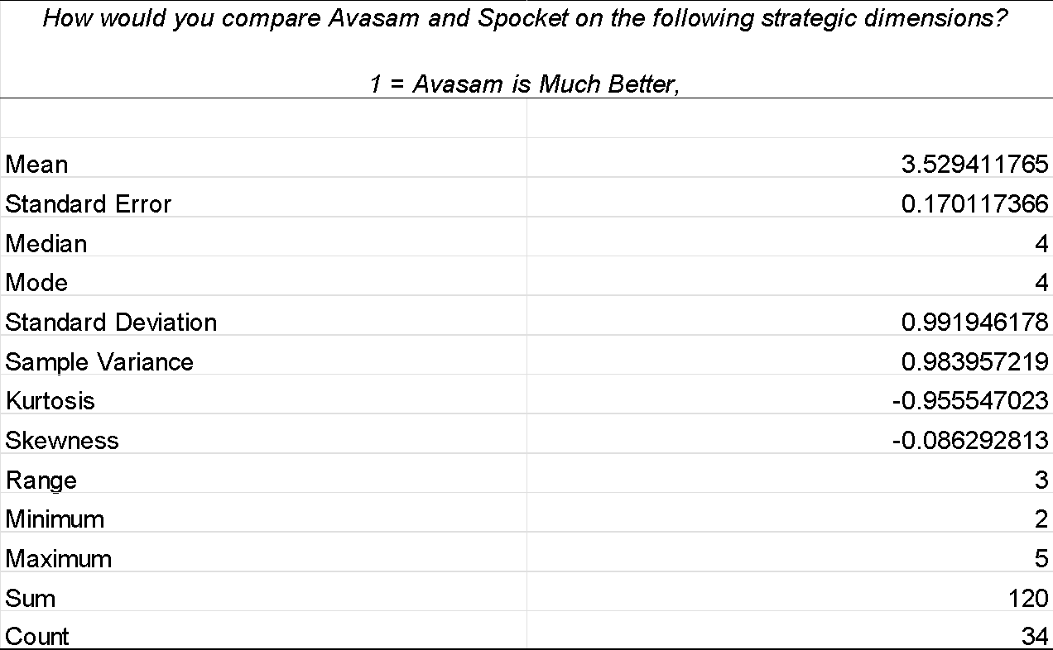

Table 4.2: Comparing Avasam and Spocket in terms of Local Supplier Quality
(Source: calculated in MS Excel)
The average of 3.53 means that the respondents have a rather positive view of Spocket being slightly higher than Avasam in the quality of local suppliers (UK/Europe). The median and mode 4 support this preference. The standard deviation of 0.99 indicates a moderate variation and skewness is close to zero implying a fairly balanced distribution of responses.
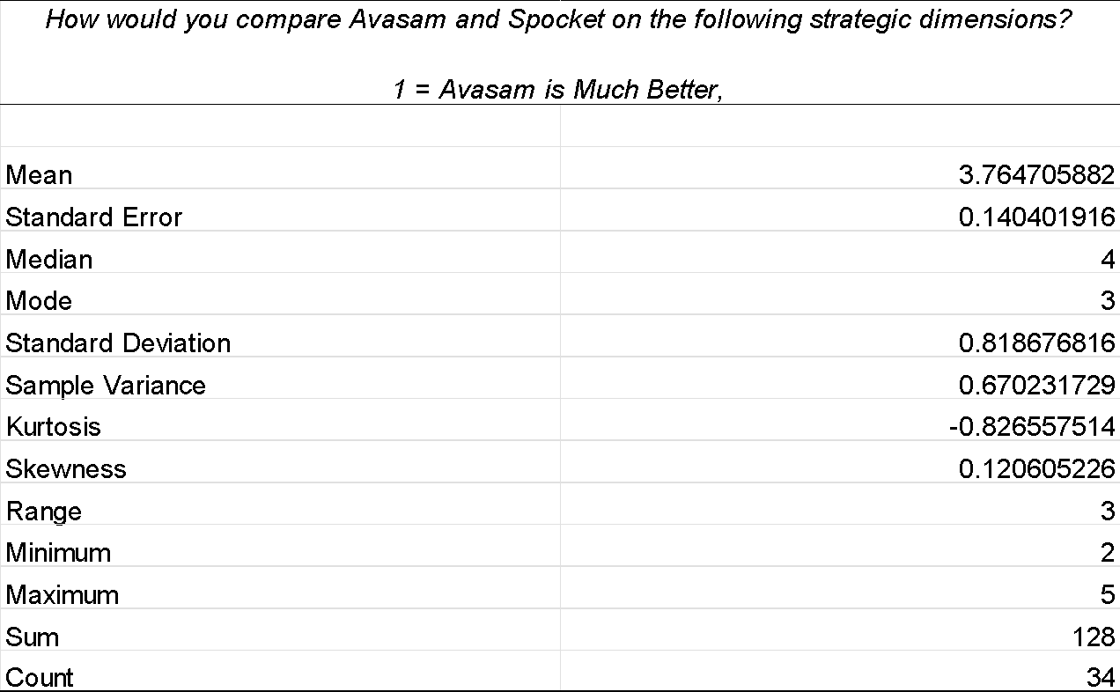

Table 4.3: Comparing Avasam and Spocket in terms of Global Market Reach
(Source: calculated in MS Excel)
The overall mean of 3.76 shows that the respondents saw Spocket as a bit superior to Avasam in standardized user onboarding and platform experience. This tendency is supported by a median of 4. The standard deviation of 0.82 shows that there were relatively similar responses, whereas the skewness is minimal, indicating that there is a balanced distribution around the mean.
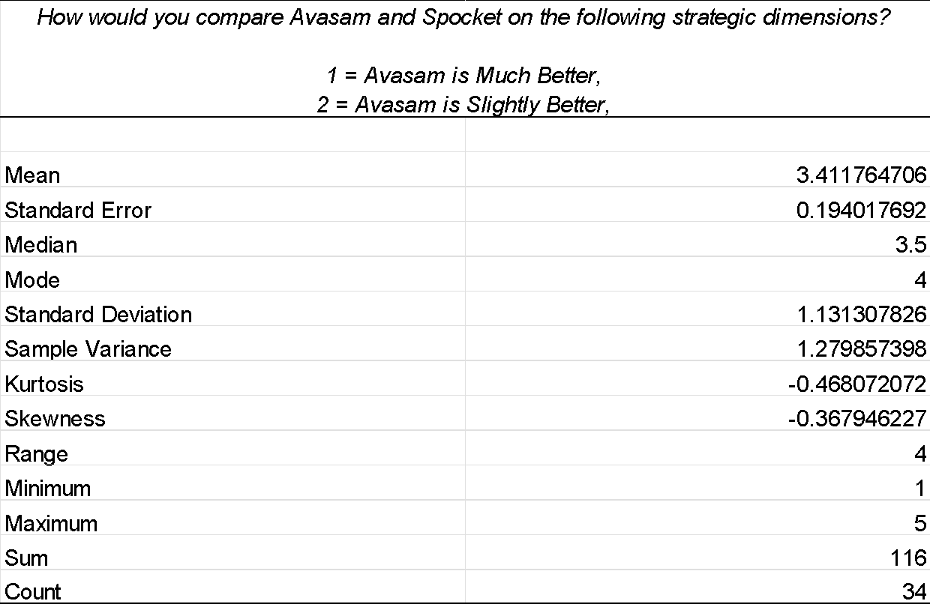

Table 4.4: Comparing Avasam and Spocket in terms of Localized Marketing and Content Relevance
(Source: calculated in MS Excel)
The average of 3.41 shows that there is a minor general inclination towards Spocket from the perspective of value and price transparency in the business to business. However, the median of 3.41 and mode of 4 indicate that most of the respondents viewed the two platforms as equal. The standard deviation of 1.13 shows that there is a moderate variation in the perceptions of respondents in the sample.
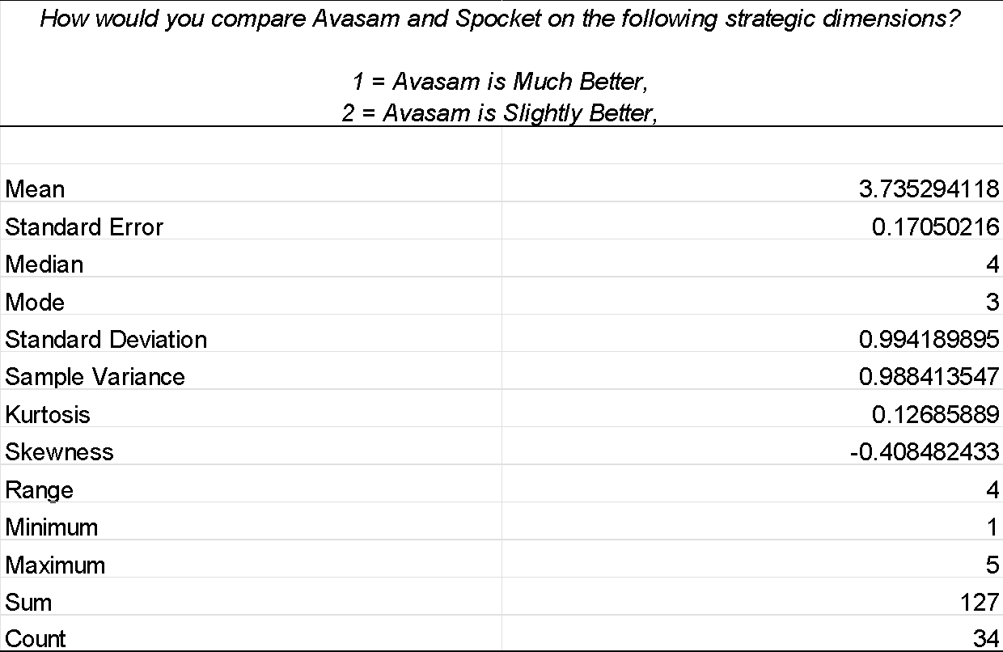

Table 4.5: Comparing Avasam and Spocket in terms of Standardized User Onboarding & Platform Experience
(Source: calculated in MS Excel)
The average of the scores 3.74 shows that the respondents rated Spocket as a bit superior to Avasam in localized marketing and content relevance. This is preferred by the median of 4, but the mode of 3 shows that many considered them equally. The standard deviation of 0.99 implies that there is moderate variation in perceptions.
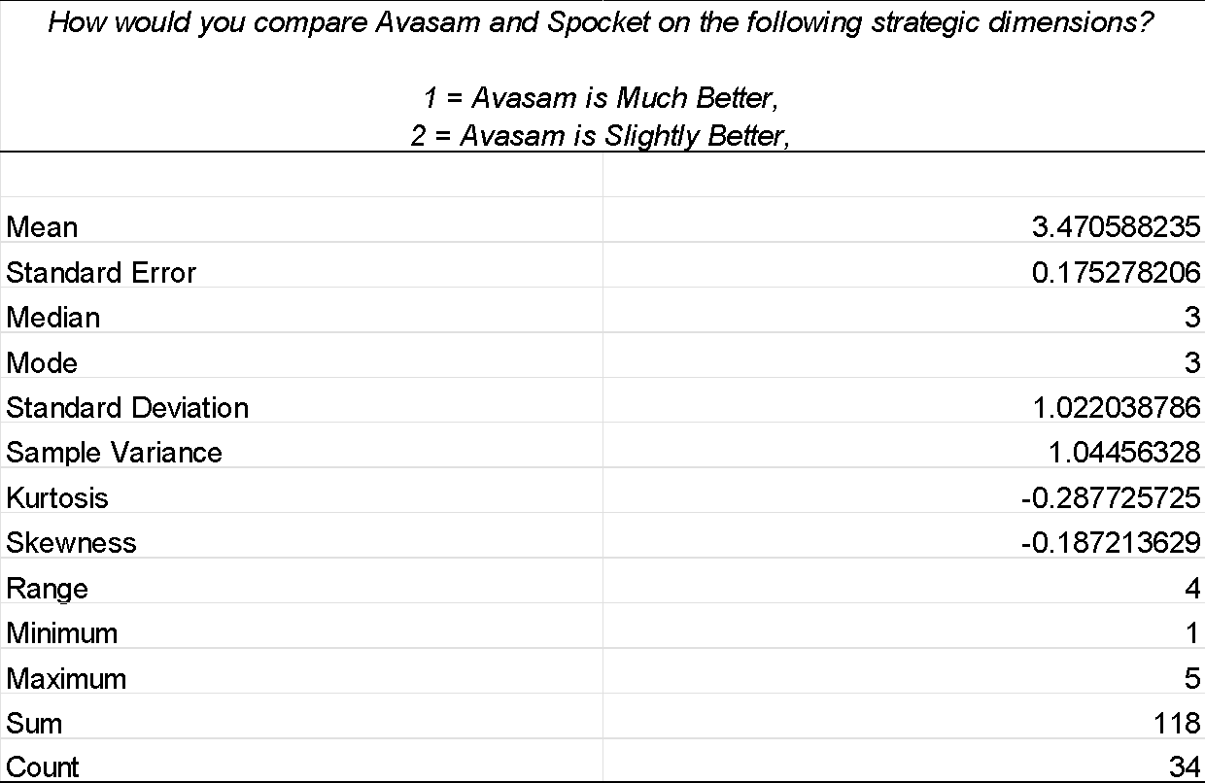

Table 4.6: Comparing Avasam and Spocket in terms of Value for Money
(Source: calculated in MS Excel)
The overall intention of respondents towards Spocket in terms of global market presence was not so high, as it was evidenced by the mean score of 3.41. This is reinforced by the median of 3.5 and mode of 4. The standard deviation of 1.13 is a sign of moderate variation and it implies that respondents had slightly different perceptions with regards to the global coverage by the platforms.

Table 4.7: Summary of Comparative Descriptive Statistics
Strategic dimension | Mean | Median | Mode | SD | Quantitative interpretation
Strategic dimension | 3.53 | 4.00 | 5 | 1.38 | Moderate tendency toward Spocket
Local supplier quality | 3.53 | 4.00 | 4 | 0.99 | Moderate tendency toward Spocket
Global market reach | 3.76 | 4.00 | 3 | 0.82 | Strongest comparative tendency toward Spocket
Localised marketing/content relevance | 3.41 | 3.50 | 4 | 1.13 | Weakest Spocket advantage
Standardised onboarding/platform experience | 3.74 | 4.00 | 3 | 0.99 | Relatively strong tendency toward Spocket
Value for money/pricing transparency | 3.47 | 3.00 | 3 | 1.02 | Slight-to-moderate tendency toward Spocket
Strategic dimension – Mean = 3.53
The average of 3.53 is 0.53 above the midpoint of 3 which is neutral. This implies that there is a moderate inclination towards respondents rating Spocket better on the overall strategic dimension. This interpretation is supported by the median of 4, but the standard deviation of 1.38 proves a lot of variation in the opinions of respondents. Notably, this difference cannot be said to be a statistically significant difference, since no significance test was performed. Rather, it shows that the respondents did not evaluate the strategic position in a similar manner.
Local quality of suppliers- Mean = 3.53
Another measure was local supplier quality with an average of 3.53, indicating that there was once again an inclination towards Spocket. The average was however only slightly higher than the equality value of 3. The mean and median were equal to 4, and the SD was about 0.99, which is less dispersion compared to the overall strategic dimension. Therefore, there was a slight tendency of respondents to view Spocket in local supplier quality more positively, but the outcome does not imply the superiority.
Global market penetration- Mean = 3.76
The highest mean score of 3.76 was reached at global market reach. It scores 0.76 higher than the midpoint and thus indicates the highest comparative tendency towards Spocket of the six dimensions.
The SD of about 0.82, which is the smallest of the dimensions, also implies the relative agreement of the respondents. This finding is significant in market penetration since global recognition, availability of suppliers and cross-market may affect the appeal of a dropshipping platform. In this sample, Spocket was thus seen to have the more obvious advantage of having global reach.
Localised marketing and content relevance- Mean = 3.41
The lowest mean was 3.41, which was captured by localised marketing and content relevance. Even though it is still above the neutral midpoint thus leaning slightly towards Spocket, the gap between equality and that is just 0.41. This implies that the two platforms were seen to be more localised matched than global market coverage or standardised onboarding. This finding also aligns with the independent cross-tabulation whereby Avasam was given greater credit on localisation to the region. Thus, the data on localisation is comparatively positive to Avasam in comparison with the other comparative dimensions.
Standardised user onboarding and platform experience - Mean = 3.74
With an average score of 3.74, it was the second highest of the six dimensions and it was only 0.02 points below global market reach. The respondents were thus more likely to have a positive view of Spocket in the standardised onboarding and platform experience. Nevertheless, the mode of 3 reveals that there were a significant proportion of respondents that also considered the platforms as equal. In the TAM perspective, this aspect is of specific interest as the consistent onboarding and platform experience can affect the perceived ease of use and eventually technology acceptance.
Value-money and B2B pricing transparency- Mean = 3.47
Value for money created an average score of about 3.47, which was just 0.47 above equality. The median was 3 as was the mode, indicating that the two platforms were equal. As a result, the numerical average suggests a slight inclination towards Spocket, but the outcome does not imply a significant difference in perceived value or transparency in pricing in B2B.

4.4 Cross-Tabulation Analysis
4.4.1 Business Location and Preferred Marketing Approach for Avasam
Business Location | Balanced/ Hybrid | Highly Localised | Standardised Global | Not Sure | Total
India | 11 | 1 | 6 | 1 | 19
United Kingdom | 7 | 2 | 2 | 1 | 12
China | 3 | 0 | 0 | 0 | 3
Total | 21 | 3 | 8 | 2 | 34

Table 4.7: cross-tabulation on business location and marketing approach for Avasam
(Source: calculated in MS Excel)
The cross-tabulation reveals that the balanced/hybrid strategy was the most frequently taken, as 21 out of 34 respondents (61.8%). This was the preference in all three markets where there were 11 Indian respondents, seven UK and all three respondents in China. Comparatively more Indian respondents were drawn to standardised global marketing. Altogether, the results indicated that global consistency and local adaptation, which are selected, are viewed as more suitable to Avasam as compared to localisation or standardisation.
4.4.2 Business Location and Effectiveness of Avasam’s International Positioning
Business Location | Very Effective | Somewhat Effective | Neutral | Very Ineffective | Total
India | 4 | 8 | 5 | 2 | 19
United Kingdom | 2 | 6 | 4 | 0 | 12
China | 2 | 1 | 0 | 0 | 3
Total | 8 | 15 | 9 | 2 | 34

Table 4.8: cross-tabulation on business location and effectiveness of Avasam’s international positioning
(Source: calculated in MS Excel)
The findings suggest that 15 participants (44.1) believed that international positioning of Avasam was partially effective and eight (23.5) believed that it was very effective. Indian respondents had more mixed perceptions with five neutral responses and two very ineffective responses. In UK responses, there was a focus on somewhat effective and neutral. Thus, even though Avasam has a perceived international potential, the results indicate that the positioning could be further adapted to the specifics of the market, especially in more significant host markets. This corroborates the trends that have already been found in the current Chapter 4 analysis.
4.4.3 Business Location and Perception of Global Standardisation
Business Location | Avasam | Spocket | Total
India | 9 | 10 | 19
United Kingdom | 5 | 7 | 12
China | 0 | 3 | 3
Total | 14 | 20 | 34

Table 4.9: cross-tabulation on business location and perception of global standardisation
(Source: calculated in MS Excel)
In terms of global standardisation, 20 respondents (58.8%) chose Spocket, and 14 (41.2%) chose Avasam. The Spocket had a bit more support among the Indian and the UK respondents and was chosen by the three Chinese respondents. These findings indicate that Spocket is in a better perceived global-standardisation stance, and the international identity of Avasam seems to be less established in the sampled markets.
4.4.4 Business Location and Perception of Regional Localisation
Business Location | Avasam | Spocket | Total
India | 12 | 7 | 19
United Kingdom | 6 | 6 | 12
China | 3 | 0 | 3
Total | 21 | 13 | 34

Table 4.10: cross-tabulation on business location and perception of regional localisation
(Source: calculated in MS Excel)
An alternative trend was regional localisation. Avasam was voted by 21 respondents (61.8%), and 13 (38.2) by Spocket. This contrast was especially evident among the Indian respondents with 12 of them choosing Avasam and seven choosing Spocket. Avasam was also the choice of all the three Chinese respondents. UK respondents were split in two equal parts. Therefore, Avasam seems to have a greater perceived regional-localisation stance in comparison to Spocket.
4.4.5 Business Location and Perception of a Balanced Approach
Business Location | Avasam | Spocket | Total
India | 6 | 13 | 19
United Kingdom | 6 | 6 | 12
China | 0 | 3 | 3
Total | 12 | 22 | 34

Table 4.11: cross-tabulation on business location and perception of a balanced approach
(Source: calculated in MS Excel)
In the balanced approach, 22 respondents (64.7% chose Spocket, 12 (35.3% chose Avasam. The distinction was most pronounced among Indian respondents, as 13 of them recognized Spocket, and six realized Avasam. The respondents were as divided as at the same time all Chinese respondents chose Spocket. The importance of this finding especially indicates that even though Avasam is viewed as stronger in terms of localisation in the region, Spocket is viewed as more effective in terms of integrating localisation with global standardisation.

4.5 Discussion of findings
These findings indicate that neither localisation nor standardisation in isolation were felt to be adequate to enable Avasam to penetrate the future market despite the marketing approach perceived to have contributed to Avasam’s growth in its main/home market. However, the survey findings also offer robust support regarding the perception that Avasam and Spocket have different yet increasingly similar international marketing roles. Through the use of comparison questions within the study, the findings provide clear evidence whether each platform is more globally standardised, regionally localised or balanced. In this aspect, the evidence suggests a more nuanced division where Avasam has a greater regional localization focus (61.8%), while Spocket has a greater global reach and is perceived as more more balanced internationally. This highlights the importance of international consistency with specific local adaption, rather than just as a globally standardised platform (Rashkova et al., 2024). The most convincing one is that the majority of 61.8% wanted a hybrid strategy, whereas 23.5% wanted standardisation and 8.8% wanted high localisation. These numerical preferences are showing an in-depth strategic reliability as modern B2B users consider standardisation and localisation as not options,and consider them as mutually reinforcing support systems. For platforms like Avasam, which refers to the fact that operational efficiency gained from global-level consistency needs to be combined with focused regional responsiveness for ensuring competitive advantage in the international markets. Moreover, 61.8% also found Avasam stronger with regional localisation against 38.2% who chose Spocket.
Consumer Behaviour Theory can be used to interpret these findings. Trust, perceived value, cultural relevance, risk and prior experience can guide business purchasing decisions, as explained in the 2nd chapter. Localised marketing could thus enhance the levels of relevance that a prospective user will see a SaaS platform as having to their business environment. This reduced its keen focus on a single approach and aligned with findings of Sobeih, (2025), regarding that current SaaS companies are increasing their global consistency while also focusing on selective market adaptation to enhance marketing effectiveness in international markets. The survey findings supported this finding, as 61.8% responded that there is a balance in localisation and standardisation that contributed to Avasam's growth.
TAM suggests that the perceived usefulness and the perceived ease of use are the key factors that affect technology acceptance. This theoretical approach is more specific to the results on platform experience and global standardisation. One of the highest scores in the comparison was the mean of standardised onboarding/platform experience of Spocket (3.74). The highest mean of 3.76 of global reach was only 0.02 less than its own. Moreover, 58.8% of the respondents recognised Spocket as the more globally standardised platform. Based on the findings by Okonkwo et al. (2023), localisation is an approach of adapting marketing activities as per local cultural, economic, and regulatory needs. As analysed, most respondents considered Avasam’s response and efforts to be crucial for generating relevant outcomes according to its key operating markets through customised communication and support. In B2B SaaS context, these perceptions can majorly influence the purchasing decisions through perceived trust and potential relevancy.
The Consumer Behavior Theory is considered that focuses on how purchasing approaches are impacted through external influential forces like trust, cultural demands, and even value generated (Shaw et al., 2026). This positive perception regarding Avasam’s localised support and communication thus supports the fact that users consider the platform as more aligned with business needs. Yet, the findings also show that respondents consider limitations of Avasam's localisation approaches, mainly as responses regarding support for European and UK tax, currency, and compliance needs developed major levels of neutrality compared to other statements. While agreement remained comparatively higher than disagreement, the neutral response remained higher, potentially showing uncertainty for the adaptation capability. Therefore, this aspect is seen as the significant uncertainty, because it can lower trust in the platform's adoption in new markets due to perceived regulatory adaptation gaps. This is a crucial vulnerability as in the SaaS context, unresolved regulatory hindrances can directly impact through financial risk for business users. Hence, until localised compliance aspects are properly streamlined, platforms risk hindering their in-depth market penetration outside of the home jurisdictions, regardless of how strong their average brand messaging can be. Song (2021) highlighted that localisation is often challenging to implement properly due to operational complications and resource needs, partially supporting the analysis of Avasam. Therefore, the findings show that users consider localisation efforts yet are often not convinced regarding the adaptation focus provided through the platform. Besides localisation context, respondents also related Avasam to major standardisations, as most of the participants agreed on the fact that Avasam ensures a consistent platform interface and key features in various operating markets, while similar levels of positive responses were recorded regarding brand messaging and consistency levels. This aligns with the findings of Rashkova et al. (2024) that standardization can be considered as the management of consistent brand positioning, communication, and value propositions in diverse global markets. The positive responses also support findings of Eze et al. (2024) who argued that standardisation contributes to operational efficiency, reduced confusion among consumers, and enhanced brand consistency.
The analysis becomes more supported as responses regarding platform recognition were also considered. The findings showed respondents majorly agreeing with the fact that Avasam's standardised global approach is a key factor that allows the platform to become easy to adapt. These are potentially in line with literature referring to standardisation approaches to support credibility and loyalty via consistent user experiences (Veracontent, 2023). In the B2B SaaS context, reliability and predictability are often key focuses for businesses for technological solutions, making consistency critical. Hence, respondents mainly related Avasam’s standardisation approaches to operational reliability and professionalism. The findings also showed that perceptions of standardisation and localisation are diverse across markets, as consumers in different markets can have various perceptions that may not be always similar to each other or even in other markets. The survey responses showed that a total of 55.9% of respondents were currently operating in India, 35.3% operated in the UK, while 8.8% operated in China. This distribution is relevant to the existing studies also, as it was shown that countries like India are mainly characterised through major language, cultural, and regulatory differences from the Western markets (Mawdsley, 2023). Therefore, strong support for a balanced approach can be identified as a critical approach that focuses on both standardisation and localisation and does not consider them separately, as they might not address the needs in these diverse markets separately. This also aligns with the findings of existing literature on how international SaaS companies should focus on standardising key product or service offerings while adapting some consumer-based approaches to local market needs (Taufiqurrahman et al., 2025). Thus, the findings showed that respondents consider Avasam as a dropshipping company balancing localisation and standardisation and not just focused on a single approach. This directly contributes to the literature gap identified previously via providing key empirical evidence from B2B Dropshipping SaaS aspects. However, the ideas highlight that localisation is only valuable if it serves a specific market difference instead of just an increased level of adaptation. In this context, if the platform's functionality is predictable, it can reduce the perception of complexity for business users; in other words, 'standardization' can be advantageous for various reasons beyond merely maintaining consistency (Taufiqurrahman et al., 2025). This is crucial as the majority of the existing previous studies were identified to be analysing this area of research at a minimal level, lacking crucial details.
The findings also supported the second objective regarding the perceived influence of localisation and standardisation on market penetration for Avasam. Localisation and standardisation influence market penetration through various and related aspects. While the concept of localisation is shown to enhance trust and market relevance, standardisation contributes to higher recognition, credibility, and adaptation ease. These aligned with the analysis of Harahap et al. (2025) who argued that market penetration in SaaS context is influenced through consumer awareness, acquisition, retention, and long-term platform usage. The survey found market penetration as a visible context in the survey demographics aspects, especially, Avasam was selected as a preferred dropshipping platform by 41.2% of respondents, while Avasam and Spocket were both used by 38.2% of respondents. These highlight the platform's higher market presence while showing that Avasam gained major visibility in the target market. The analysis showed that 76.5% of the respondents had utilised dropshipping platforms for over 2 years, also highlighting that responses gained in the survey were mainly from experienced users and not just recent adopters. Therefore, Avasam’s perception in relation to market position can be considered as relevant and informed. In the Home market context, the findings mainly supported existing literature for benefits gained through standardisation. The literature argued that Avasam has established a strong presence in the UK market, eventually reducing the need for extensive adaptation in the region (Dave, 2026). This argument is reflected in survey findings also, in which the respondents mainly agreed with Avasam managing consistent branding, platform functionality, and messaging. The literature also supports that companies in familiar markets often have a greater understanding of market needs and thus can benefit through standardised approaches. Therefore, the findings show that respondents consider Avasam’s consistency to contribute positively to its continued penetration in established markets like the UK.
Although the influence of localization is still prominent, especially in relation to host markets, the literature shows that foreign market entry is often challenged through factors like diverse consumer expectations, low brand familiarity, and even cultural distances (Sasaki et al., 2021). The survey is aligned with these findings as, regardless of 23.5% reporting Avasam's positioning for entering new markets is very effective, a significant portion (44.1%) consider it slightly effective, and a considerable 26.5% remained neutral in this statement. This suggests a possible disconnection between recognition and local market acceptance and shows that global visibility does not always equate to successful market penetration. Furthermore, the responses suggest that respondents consider the platform's international potential yet also consider the potential limitations that may hinder the brand to enter foreign markets in a more in-depth manner. The analysis is highly relevant as most respondents were based outside of the home market of Avasam. With 55.9% operating in India and 8.8% in China, the findings showed perceptions from markets identified in the literature that need better adaptation capabilities for diverse language preferences, regulations and digital systems compared to the UK (Mawdsley, 2023). Therefore, the moderate analysis of Avasam’s international positioning shows that respondents consider extra efforts in localisation for enhancements of host market penetration practices. Thus, it evaluated the diversity of the respondents, since varied regulatory and cultural expectations may not be sufficiently addressed by a single multinational marketing strategy. The findings also show that localisation contributes to market penetration through increased trust and relevance among users, while positive perceptions of localised onboarding and consumer support are aligned with arguments of Udayana et al. (2021) who showed that communication relevance and support capacities are crucial approaches for increasing consumer engagement. From the Consumer Behavior theory perspective, these adaptations are crucial to reduce the potential risks and therefore improve purchase confidence that will support adapting in new markets. Respondents also considered Avasam’s standardised platform interface and branding positively showing how consistency is crucial across markets. This highlights the fact that standardisation also influences market penetration via technology acceptance. Hence, the findings collaboratively are showing that market penetration is gained through a collaborative focus on local relevancy and global consistency management.
In this aspect, the evidence suggests a more nuanced division where Avasam has a greater regional localization focus (61.8%), while Spocket has a greater global reach and is perceived as more balanced internationally. This aspect demonstrates that Sprocket has international consistency with specific local adaption, rather than just as a globally standardised platform. The findings also highlight that international expansion of a business necessitates striking a strong balance between market relevance and the operational consistency required for scaling. This is strongly aligned with the research of Rashkova et al. (2024), which developed the concept of standardization considering consistent brand positioning, communication and value proposition. Regarding the critical standpoint, the outcome suggests a rethinking of the way Avasam has grown domestically, given a mere standardisation-based view. While standardisation can be seen as beneficial in established domestic markets as companies have increased knowledge about consumers' expectations and the competition, only 23.5% of the respondents said that Avasam's growth was due to standardised global marketing. On the other hand, the significantly higher 61.8% opting for hybrid suggests that respondents believe that the success of Avasam is due to the combination of consistency and market relevance. This interpretation is especially crucial for Avasam as their competitive pitch relates to supplier validation, marketplace integration and fulfilment reliability. Standardised technological and operational capabilities can therefore lead to consistency and efficiency, and locally relevant supplier links and communication with the market can boost perceived value and trust. However, the findings also strengthen that high standardisation can generate efficiency on the inside and localisation can add value to customers on the outside in order to cope with the competitive nature of international business context.
It further made a consistency with the argument proposed in the literature review: that there was no evidence that either standardisation or localisation is superior in general in which effective combination between the global consistency and accurate adaptation of localisation could be influential in creating greater strategic effectiveness. However, it also supports the argument of Okonkwo et al. (2023) and Taufiqurrahman et al. (2025) on the ground that for maintaining a global identity in the competitive marketplace, it is essential to relate localisation to marketing adaption with cultural, linguistic, economic and regulatory conditions. Thus, the survey findings have bolstered the thesis that the effectiveness of the two methods is dependent on the situation rather than considering it as a universal aspect.
Furthermore, the finding can also be explained in terms of the theory of the study. As per the Consumer Behaviour Theory, the inclination for a combination method implies that customers might appreciate the consistency and neighborhood relevance of a B2B SaaS platform. In terms of the Technology Acceptance Model (TAM), the constant maintenance of platform functionality and platform ease of use can help customer perceived usefulness and ease of use, while a localised look of selected customer-facing components can help increase perceived ease of use and usefulness within specific markets (Zaineldeen et al., 2020). This indicates that if users do not feel that the platform is relevant to their own market context, then its consistency alone might not be enough to ensure adoption. The concept of Supply Chain Management Theory also supports this notion since Avasam's Supplier Quality and Fulfilment capability aspects are operational elements that must be dependable and responsive to the market-specific requirements. The survey findings suggest that Avasam does not need to give up its existing strengths by standardizing or over-localizing its operations for further internationalization. However, the standardisation of Avasam is not seen the same across all dimensions. The statement Avasam's standardised global approach makes the platform easier to recognise and adopt garnered half of the positive responses while half respondents were neutral. In this aspect, Zaineldeen et al. (2020) suggest that the perceived usefulness and perceived ease of use in the context of technology acceptance. While a common platform might be expected to decrease complexity and boost ease of adoption, the high neutral proportion suggests that survey participants are not yet confident that Avasam's standardisation is directly applicable to ease of adoption. Thus, the evidence suggests a selective hybrid approach, where technology, standards and brand attributes will stay the same, while communication, supply chains and a limited number of market-related activities are geared towards specific international markets. In this context, the findings suggest that the strategic question is not whether to follow one or the other, but rather what to keep consistent and what to leave local. However, the perceived benefit of Spocket regarding the global reach suggests that Avasam's local supplier strength needs to be matched by their ability to supply internationally.
This aspect is also supported by the survey findings in which 61.8% of respondents stated that the approach they believe will be most helpful to Avasam's growth is a balanced approach whereas only 23.5% saying standardised global marketing is the approach they will find most beneficial and 8.8% emphasised the highly localised marketing. So the findings are justifying that Avasam needs to harmonise its basic technological foundations, platform capabilities along with the brand identity, security and its fundamental value proposition, by empowering effective communication, pricing presentation and market-specific promotional campaigns. This is influential to comply with the diverse marketplace and grab the attraction of the consumers. It also supports findings of Sobeih (2025) and Taufiqurrahman et al. (2025), which stated regarding the current international marketing debate that has been shifting from a rigid to a hybrid strategy. Thus, the findings emphasize the belief that global consistency and local responsiveness can coexist within the complex platform. Due to the identification of a strategic gap by the comparison with Spocke, this aspect is significant as the data shows a vast range of the respondents believed that Spocket was more standardised worldwide while 41.2% believed that Avasam is more standardised worldwide. On the other hand, 35.3% response towards the balanced approach of Avasam highlights that the company is less effective on integrating localisation with global scalability in which the organisation should build on its current local market knowledge as a base and not just localisation itself (Taufiqurrahman et al., 2025).
Further findings also highlight the importance of enhancing localisation of the brand in the specific markets of India and China while maintaining global identity. This is imperative as 55.9% of respondents were based in India, 35.3% in the UK and 8.8% in China. Therefore, the evaluation of selected literature reveals that there are significant differences in the purchasing behaviour of individual languages, cultures and regions in India, and distinct platforms, regulatory conditions and consumer expectations in the digital environment of China. This aspect is significant in this context, because the availability of a platform is not the only factor to consider, customers must also be convinced that the service is suited to their local business market.
Therefore, the organisation should concentrate towards the localised landing pages, local case studies, regional examples, culturally appropriate messaging, locally accessible customer service and maintain the same visual identity and technological offer. It also can help to lower the perceived risk of fulfilment and enhance the sense of trust, turning adaptation into an operational capability and not just a marketing exercise. This initiative is also complementing the research of Lin et al. (2023) who discovered that the adjustment of promotions of the SaaS providers in accordance with the needs of consumers and the market circumstances in the country can result in better performance in international marketing. It is also an embodiment of Consumer Behaviour Theory as the business customers evaluate trust, perceived value, risk and relevance before they accept a B2B SaaS solution (Shaw et al., 2026). In addition to these, the findings also emphasised the importance of local supplier ecosystems and supply-chain localisation. Regarding the findings, it has been found that Spocket is seen as having a better advantage over the whole world than Avasam, as a vast range of respondents rated the organisation as slightly or much better compared to Avasam. According to the theory of Supply Chain Management, two key points in dropshipping are supplier coordination and information sharing, as well as fulfilment and reliability. In this aspect, one of the accurate approaches would be more localised partnerships with suppliers, careful selection and verification in globalising the business platform especially in India and China by maintaining the quality of the services. This means supplier localisation is not just an operational choice but can directly affect the likelihood of reliability, trust and adoption of the platform. Furthermore, it also can help build a differentiated proposition. However, local partnerships can also enhance the responsiveness of the fulfillment and increase customer confidence (Ruiz-Coupeau et al., 2019). Therefore, the literature also highlights the partnerships as a valuable instrument for creating presence in foreign target markets in order to eliminate uncertainty in the fulfilment process and enhance Avasam's credibility and responsiveness in new markets.
The finding also emphasises the significance of focusing towards the digital channels in order to grab the attention of targeted consumers. According to the survey, 67.6% of the respondents found Avasam or Spocket through e-commerce/app stores whereas only 23.5% via Google/search engines. The findings also empowered the power of word of mouth and social media for effective marketing. This evaluation suggests that Avasam should focus on visibility and search-engine optimisation, B2B content marketing and targeted digital acquisition for further success in internationalisation. This is influential to the market where awareness is a prerequisite for acquisition and adoption, in which digital visibility plays an important role in customer acquisition and international market entry. In this aspect, Harahap et al. (2025) suggested that customer presence and competitiveness are relevant penetration dimensions while it also pointed to acquisition, conversion, subscription growth and retention as relevant dimensions for SaaS. This aspect should be controlled by the data-driven internationalisation control system, which will help to decide if the penetration is improved by localisation or not. Moreover, relevant evidence suggests that Avasam's competitive advantage in the future should not be based on its localization or standardisation. Combinely, the evidence indicates that neither of these approaches by itself accounts for international penetration, but they can efficiently work together when implemented in conjunction with one another. While localisation is already recognised as a strategic advantage to the brand, it needs to integrate a phased hybrid strategy in order to maintain its worldwide consistency.

4.6 Summary
This chapter introduced, discussed and critically analysed the empirical results of the study with regards to localisation and standardisation in Avasam's B2B SaaS marketing and Spocket. The analysis further revealed important trends in respondents' current marketing effectiveness, market positioning, supplier quality and international market penetration in order to highlight the favour of a balanced/hybrid approach whereas the vast range of respondents stating it was most useful to Avasam's home-market development. Further chapter has also shown that localisation enhances the market relevance and supplier credibility whereas effective standardisation contributes to technical uniformity and efficiency.

Chapter 5: Conclusion and Recommendations

5.1 Introduction
This chapter wraps up the localisation and standardisation in marketing of B2B SaaS and how they affect market penetration of Avasam over Spocket. The study was meant to determine the success of these two international marketing strategies by Avasam in the UK, India and China. The survey particularly looked at the perception of localisation and standardisation, its perceived impact on market penetration, the relative positioning of Avasam and Spocket and the strategic initiatives which can enhance the international expansion of Avasam.

5.2 Summary of Key Findings
The inclination towards a balanced international marketing strategy is one of the most significant results. Of the 34 respondents 61.8% of the respondents chose a balanced or hybrid approach as the strategy that would most suitably assist Avasam to grow. Comparatively, 23.5% favoured standardised world marketing and a mere 8.8% favoured a high localisation strategy. The hybrid strategy was also popular among the geographical groups: 11 respondents of India, seven of the UK and all three Chinese respondents chose this strategy. This indicates that respondents tended to view market penetration as one that needed to be consistent and responsive and not to be in between two diametrically opposite strategies. Hence, this findings is critical as it mostly agrees with the perspectives developed by Eze et al. (2024), showcasing that current B2B SaaS platforms can not mainly focus on the solid standardisation or complete localisation. The key reason for this hybrid approach is mainly based on the dual requirement for dropshipping platforms to ensure technological and operational efficiency in various regions while ensuring localised consumer trust, eventually aligning with Consumer Behavior Theory discussed earlier. Especially as claimed by Shaw et al., (2026), who identified cultural relevancy is a major factor to include purchasing choice for international e-commerce contexts. The results however found various competitive advantages between Avasam and Spocket. Avasam seemed to have a relatively greater localisation position in the region, 61.8% of the respondents said that Avasam was more localised in the region than 38.2% of respondents said Spocket was. It can be attributed to the fact that Avasam is focused on the supplier verification, integration of markets, reliability of fulfilment and its UK orientation. The results are directly aligned with Sobeih (2025) and Taufiqurrahman et al., (2025), who identified that modern digital platforms need to adapt a hybrid approach as per new market trends.
Spock on the other hand tended to be perceived more favourably in areas that were related to international level and congruency. The mean of the global market reach was 3.76 which is the greatest comparative inclination towards Spocket whereas standardised onboarding and platform experience had a mean of 3.74. The result of the global reach was also relatively low standard deviation of about 0.82 showing more agreement amongst the respondents. These findings suggest that the respondents would relate Spocket with a wider global coverage and a more uniform platform experience. Lee and Matanda (2026), further shed light on global digital platforms scaling and need for consistency in reliability and perceived user risk minimisations, therefore potentially showing a similar base of undertanding. The variance of some other dimensions was not as significant. Localised marketing and content relevance registered an average of 3.41, and the value of money and B2B pricing transparency registered about 3.47. Both were the relative mid-points higher than the neutral but showed only slight tendencies towards Spocket. Specifically, both the median and mode of value of money were 3 meaning that most of the respondents viewed the platforms as relatively similar in this respect. The findings also align with Okonkwo et al. (2023) regarding the fact that regional customisation is crucial to develop trust with users. The findings eventually align with Consumer behavior theory as the role of cultural relevance is high in purchasing decisions (Shaw et al., 2026).

5.3 Conclusion in Relation to the Research Objectives
The initial aim was to study the perceptions of the localisation and standardisation of Avasam in B2B SaaS marketing. The results indicate that the strategies were recognised as valuable by the respondents. Localisation was found to be specifically relevant to the communication, supplier relations, market relevance, and support, meanwhile the standardisation was linked to the same technology, branding and platform experience. This distinction is shedding light on the key Technology Acceptance Model that consistent management of functionality and ease of use can result in surprising consumer alignment, and localised focus can support in creating customer-facing usefulness in particular markets (Zaineldeen et al., 2020). The second target involved the perceived impact of these strategies on penetrating the market. The evidence suggests that localisation may contribute to market penetration through increased trust, relevance and responsiveness especially in host market penetration. The findings hence support Sasaki et al. (2021)’s findings that managing cultural distance through localised approaches can support foreign entrants overcome the barriers related to lack of initial brand familiarity. The standardisation appears to play a role in the form of identifiable branding, technological standardisation and simplification. Thus, the findings indicate that the interaction between local relevance and global consistency influences the market penetration and not either of the factors. These are directly covering the gap in empirical research regarding Consumer behavior theory and the technology Acceptance Model (TAM), as it supports analysis of Okonkwo et al., (2023), and even Zaineldeen et al., (2020), that considers ease of use and local cultural alignment being crucial as user adaptation drivers. The third aim was to make a comparison between Avasam and Spocket. The comparison suggests that there are various strategic merits and not absolute merit. The localisation in regional was seen to be relatively stronger in Avasam, compared to Spocket that had greater perceived global coverage and standardised onboarding. This refers to the fact that Avasam can gain some insights on the international scalability of Spocket without compromising on its localisation and supplier-quality advantages.

5.4 Recommendations for Avasam
Based on these findings, the main suggestion is that Avasam should endeavor to adopt a selective hybrid or a global localized or local marketing approach. Its basic SaaS platform, brand name, security, automation and its important technology functionality are expected to be almost standardised. These components can give uniformity, effectiveness and familiar overseas worth proposals (Nii Laryeafio and Ogbewe, 2023).
In the case of India, localisation might focus on market-relevant pricing messages, local business case studies, proper communication channels and content that depict the Indian e-commerce business needs. Instead of developing a completely different platform, Avasam might test market-specific case studies and support materials, as well as localised landing pages. In the case of China, growth would demand more focus on language, domestic digital ecosystem, regulatory demands and appropriate domestic alliances (Okonkwo et al., 2023). These recommendations need to be considered as the ones to be tested in the market since the research involved only three respondents who are in operation in China.
Avasam must also enhance its global network of suppliers without compromising on its focus on supplier verification. The results suggest that a competitive advantage of Spocket which is especially noticeable is its global presence. Avasam may require extending verified supplier relationships in the strategically selected host market rather than focusing on the size of the network. This would allow the company to have its perceived strength in supplier quality and have more availability internationally (Ralston et al., 2023). On the other hand, another key suggestion is that of platform experience and onboarding. The average score of Spocket is 3.74 which is an indication of a relative strength in standardised onboarding. Avasam could potentially benefit from making registration, supplier discovery, store integration, order management and help resources simple and similar in all countries. This standardised experience can then be overlaid with selected localisation, such as language, examples and support information.
5.5 Limitations of methodology
Regardless of providing a structured comparative analysis, this study is facing various methodological limitations, especially the sample size of 34 participants who hindered the generalisability of the findings to wider global B2B SaaS market context. The use of purposive sampling, while being effective to target knowledgeable e-commerce professionals, has developed potential bias, making the perspective not wider representative for digital entrepreneurs in the UK, India and China regions. Furthermore, the basis on self-reported data in the survey developed risks for subjective bias or diverse interpretations for localisation and standardisation constructs. The major focus on India and the UK reduced representation capability from China, which eventually hindered cross-regional comparisons. Finally, the research measured perceived market penetrations, limiting the focus on actual longitudinal financial KPIs like revenue growth or even consumer acquisition costs, hence the findings are showcasing participant attitudes and not the audited business performance metrics.

5.6 Recommendations for Future Research
Future studies are hence suggested to utilize a bigger and a more geographically balanced sample; which would be inclusive of UK, India and China. Quantitative surveys with interviews with merchants, suppliers, digital marketers and platform managers could be mixed in a design. As stated by Rashkova et al. (2024), it might be possible in future to incorporate the real business KPIs to determine whether localisation does bring about quantifiable changes in acquisition, conversion and retention. Longitudinal research would be especially beneficial as the market penetration is a process that occurs over time and not at a point. Additional comparative research of more dropshipping SaaS solution providers might also help to find out whether the trends revealed between Avasam and Spocket are generalized (Sasaki et al., 2021).

5.7 Final Conclusion
Overall, this study’s findings indicate how the data is consistent with the analysis that localisation-standardisation decision is not a binary choice for Avasam. The strongest support of the survey was on a hybrid approach as 61.8% of the respondents believed in a balanced approach. Avasam was identified to have useful capabilities in localisation and supplier-related abilities, while Spocket has a better perceived global coverage and platform standardisation.

References
Ali, I.M., (2024). A guide for positivist research paradigm: From philosophy to methodology. Idealogy Journal, 9(2). https://idealogyjournal.com/ojs/index.php/idealogy/article/download/596/380
Avasam, (2019). ‘What is the Avasam Verified Supplier Programme?’, Avasam, 2 April. Available at: https://www.avasam.com/what-is-the-avasam-verified-supplier-programme/
Chauhan, S., (2023). SaaS Growth Drivers Framework A Comprehensive Analysis. Available at: https://www.researchgate.net/publication/392512431_SaaS_Growth_Drivers_Framework_A_Comprehensive_Analysis
Chui, J., (2024). Globalization vs Localization? Available at: https://www.linkedin.com/posts/joechui_globalization-vs-localization-many-mncs-activity-7124004580077539328-YWA_
Dave, J., (2023). Avasam And Its Journey So Far: Embrace The Ongoing Celebration. Available at: https://www.avasam.com/avasam-and-its-journey-so-far-embrace-the-ongoing-celebration/
Dave, J., (2024). Dropshipping’s Future: Synergy Of Something Different Wholesale & Avasam Enterprise. Available at: https://www.avasam.com/dropshippings-future-synergy-of-something-different-wholesale-avasam-enterprise/
Dave, J., (2026). Avasam – future of e-commerce drop-shipping. Available at: https://www.avasam.com/avasam-future-of-e-commerce-drop-shipping/
Epa, U., (2026). Sustainable business model innovation and market entry strategies of Finnish born-digital SaaS startups in international B2B markets. https://lutpub.lut.fi/bitstream/handle/10024/172435/Mastersthesis_Epa_Udara.pdf?sequence=1

Eze, F.J., Inyang, I.B. and James, E.E., (2024). Standardization versus adaptation of marketing mix in international markets: A systematic literature review. World Journal of Advanced Research and Reviews, 22(2), pp.1192-1212. https://www.researchgate.net/profile/Edim-James/publication/380727873_Standardization_versus_adaptation_of_marketing_mix_in_international_markets_A_systematic_literature_review/links/664baa9b479366623a00cd09/Standardization-versus-adaptation-of-marketing-mix-in-international-markets-A-systematic-literature-review.pdf
Gartner, (2024). ‘Gartner forecasts worldwide public cloud end-user spending to total $723 billion in 2025’, Gartner Newsroom, 19 November. Available at: https://www.gartner.com/en/newsroom/press-releases/2024-11-19-gartner-forecasts-worldwide-public-cloud-end-user-spending-to-total-723-billion-dollars-in-2025
Geeksforgeeks, (2026). Cross-Tabulation. Available at: https://www.geeksforgeeks.org/data-analysis/what-is-cross-tabulation-and-how-does-it-organize-data-in-a-table/
Ghanad, A., (2023). An overview of quantitative research methods. International journal of multidisciplinary research and analysis, 6(08), pp.3794-3803. https://www.academia.edu/download/122595879/52.pdf
Grand View Research, (2026). ‘Dropshipping market size, share, growth and trends report, 2026–2033’. Grand View Research. Available at: https://www.grandviewresearch.com/industry-analysis/dropshipping-market
Hadan, H., Wang, D., Mogavi, R.H., Tu, J., Zhang-Kennedy, L. and Nacke, L.E., (2024). The great AI witch hunt: reviewers perception and (mis) conception of generative AI in research writing. arXiv preprint arXiv:2407.12015. https://reference-global.com/download/article/10.5334/uproc.202.pdf
Harahap, M.A.D., Soemitra, A. and Rahma, T.I.F., (2025). Market penetration strategy by increasing firm competitiveness. Golden Ratio of Marketing and Applied Psychology of Business, 5(1), pp.44-52. https://goldenratio.id/index.php/grmapb/article/download/712/450

Imiru, G.A., (2022). DETERMINANTS OF MULTINATIONAL COMPANIES'CHOICE OF MARKET-ENTRY MODE FOR OPERATING IN ETHIOPIA: AN EMPIRICAL STUDY. European Journal of Management and Marketing Studies, 7(4). https://www.researchgate.net/publication/365133510_DETERMINANTS_OF_MULTINATIONAL_COMPANIES'_CHOICE_OF_MARKET-ENTRY_MODE_FOR_OPERATING_IN_ETHIOPIA_AN_EMPIRICAL_STUDY
Keyholesoftware, (2026). Custom Software Development Cost: 2026 Pricing & Timeline Benchmarks. Available at: https://keyholesoftware.com/cost-custom-software-development/
Koskela, M., (2026). Challenges and Success factors in the international expansion of Software-as-a-Service (SaaS) Companies. https://www.theseus.fi/bitstream/handle/10024/910287/Koskela_Matias.pdf?sequence=2
Lee, H.S. and Matanda, M.J., (2026). From capabilities to performance in AI-driven B2B SaaS: Website interactivity and regional differences under digital transformation. Available at: https://www.sciencedirect.com/science/article/pii/S0019850126000581
Lin, Q., Xiaoyu, L. and Jianqiang, Z., (2023). Global marketing standards and local adaptation: an analysis of the literature. International Journal of Management and Human Science (IJMHS), 7(2), pp.44-57. https://ejournal.lucp.net/index.php/ijmhs/article/download/2196/2460
Manggaberani, A.A. and Darlis, A.M., (2024). The effectiveness of Google Forms in assessing and evaluating online learning outcomes: Meta-analysis study. J. Indones. Sos. Teknol, 5(10), pp.4561-4570. https://pdfs.semanticscholar.org/037e/4146ce98522416c1c483e2d6b097c4bbda86.pdf
Matthews, D., (2019). ‘How to start a DropShipping business [updated for 2022]’, Avasam, 24 December. Available at: https://www.avasam.com/how-to-start-a-dropshipping-business-in-2020/

Mawdsley, E., (2023). Redrawing the body politic: Federalism, regionalism and the creation of new states in India. In Decentring the Indian Nation (pp. 34-54). Routledge. https://www.researchgate.net/publication/36725525_Redrawing_the_Body_Politic_Federalism_Regionalism_and_the_Creation_of_New_States_in_India
Mohammed, S.S., (2024). deductive and inductive research. Available at: https://www.researchgate.net/publication/384971734_deductive_and_inductive_research
Nii Laryeafio, M. and Ogbewe, O.C., (2023). Ethical consideration dilemma: systematic review of ethics in qualitative data collection through interviews. Journal of Ethics in Entrepreneurship and Technology, 3(2), pp.94-110. https://www.emerald.com/jeet/article-pdf/3/2/94/1330691/jeet-09-2022-0014.pdf
Okonkwo, I., Mujinga, J., Namkoisse, E. and Francisco, A., (2023). Localization and global marketing: Adapting digital strategies for diverse audiences. Journal of Digital Marketing and Communication, 3(2), pp.66-80. https://tecnoscientifica.com/journal/jdmc/article/download/311/173
Park, E.S. and Park, M.S., (2020). Factors of the technology acceptance model for construction IT. Available at: https://www.mdpi.com/2076-3417/10/22/8299
Park, Y.S., Konge, L. and Artino Jr, A.R., (2019). The positivism paradigm of research. Available at: https://www.researchgate.net/publication/337693284_The_Positivism_Paradigm_of_Research
Pereira, P., (2026). Global SEO as a Growth Lever: A Framework for International Digital Acquisition in SaaS Products. Available at SSRN 6287858. https://papers.ssrn.com/sol3/Delivery.cfm?abstractid=6287858
Ralston, P.M., Schwieterman, M., Bell, J.E. and Ellram, L.M., (2023). The building blocks of a supply chain management theory: Using factor market rivalry for supply chain theorizing. Journal of Business Logistics, 44(1), pp.141-159. https://onlinelibrary.wiley.com/doi/pdf/10.1111/jbl.12320
Ranganathan, P. and Caduff, C., (2023). Designing and validating a research questionnaire-Part 1. Perspectives in clinical research, 14(3), pp.152-155. https://pmc.ncbi.nlm.nih.gov/articles/PMC10405529/pdf/PCR-14-152.pdf
Rashkova, Y., Moi, L., Marku, E. and Cabiddu, F., (2024). Online integrated marketing communication strategies of international brands: standardization vs. adaptation approaches. Journal of Marketing Communications, 30(7), pp.810-833. https://iris.unica.it/bitstream/11584/354158/7/Rashkova%20et%20al.%202023_post-print_Journal%20of%20Marketing%20Communications.pdf
Ruiz-Coupeau et al., (2019). Impact of Regional Public Agencies on Firms’ Internationalization Processes: Evidence from Case Studies. Available at: https://www.mdpi.com/2071-1050/11/10/2813
Sasaki, I., Nummela, N. and Ravasi, D., (2021). Managing cultural specificity and cultural embeddedness when internationalizing. Journal of International Business Studies, 52(2), pp.245-281. https://ideas.repec.org/a/pal/jintbs/v52y2021i2d10.1057_s41267-020-00330-0.html
Shaw et al., (2026). What factors influenceconsumer behavior?. Available at: https://www.productmarketingalliance.com/what-influences-customer-behavior/
Shepherd, V., Hood, K. and Wood, F., (2024). ‘It’s not making a decision, it’s prompting the discussions’: a qualitative study exploring stakeholders’ views on the acceptability and feasibility of advance research planning (CONSULT-ADVANCE). BMC Medical Ethics, 25(1), p.80. https://link.springer.com/content/pdf/10.1186/s12910-024-01081-5.pdf
Sobeih, S., (2025). International Marketing Strategy Adaptation or Standardisation?. Available at SSRN 5777864. https://papers.ssrn.com/sol3/Delivery.cfm?abstractid=5777864
Song, J., (2021). Global standardization and local adaptation of marketing ---A critical review of the literature. Available at: https://www.researchgate.net/publication/350921095_Global_standardization_and_local_adaptation_of_marketing_---A_critical_review_of_the_literature
Spocket, (2026). Access 100,000+ Online Dropship Retailers Directly With Spocket. Available at: https://www.spocket.co/suppliers
Spocket, (2026). Spocket: best dropshipping suppliers for US + EU products. Available at: https://www.spocket.co/
Spocket, (2026). US & EU Dropshipping AliExpress Dropshipping. Available at: https://www.spocket.co/
Sudirjo, F., (2023). Marketing strategy in improving product competitiveness in the global market. Journal of Contemporary Administration and Management (ADMAN), 1(2), pp.63-69. http://journal.literasisainsnusantara.com/index.php/adman/article/download/24/39
Tajik, O., Golzar, J. and Noor, S., (2025). Purposive sampling. International Journal of Education & Language Studies, pp.1-9. https://www.researchgate.net/publication/391849280_Purposive_Sampling
Taufiqurrahman et al., (2025). Brand Adaptation Strategy in Global Marketing : A Study Qualitative in Multinational Companies. Available at: https://www.researchgate.net/publication/393618280_Brand_Adaptation_Strategy_in_Global_Marketing_A_Study_Qualitative_in_Multinational_Companies
Ucla, (2026). Working with Quantitative Data. Available at: https://libguides.law.ucla.edu/c.php?g=1382972&p=10944918
Udayana, I.B.N., Farida, N., Lukitaningsih, A., Tjahjono, H.K. and Nuryakin, (2021). The important role of customer bonding capability to increase marketing performance in small and medium enterprises. Cogent Business & Management, 8(1), p.1932239. https://www.tandfonline.com/doi/pdf/10.1080/23311975.2021.1932239
Ugwuoju, E.C., (2025). Brand Localization versus Globalization: A Comparative Analysis of Adaptation Strategies in Diverse Markets. https://www.intechopen.com/online-first/1236927
Veracontent, (2023). Global marketing standardization and localization: A helpful guide. Available at: https://veracontent.com/mix/global-marketing-standardization/
William, F.K.A., (2024). Mastering validity and reliability in academic research: Meaning and significance. International Journal of Research Publications, 144(1), pp.287-292. https://www.ijrp.org/paper-detail/6106.pdf
Yue, O., (2022). Conceptual model for effects of the buyer supplier relationship purchasing process and measures of performance in supply chains. Journal of Enterprise and Business Intelligence, 2(3), pp.142-152. https://pdfs.semanticscholar.org/e687/5fdbb61e5d4ae6dfe595bdb38293ce3f6956.pdf
Zaineldeen, S., Hongbo, L., Koffi, A.L. and Hassan, B.M.A., (2020). Technology acceptance model’concepts, contribution, limitation, and adoption in education. Universal Journal of Educational Research, 8(11), pp.5061-5071. https://www.researchgate.net/publication/345004753_Technology_Acceptance_Model'_Concepts_Contribution_Limitation_and_Adoption_in_Education

Appendices

Appendix 1: Ethics Form

APPLICATION FOR ETHICAL APPROVAL

In order for research to result in benefit and minimise risk of harm, it must be conducted ethically.

The University follows the OECD Frascati manual definition of research activity: “creative work undertaken on a systematic basis in order to increase the stock of knowledge, including knowledge of man, culture and society, and the use of this stock of knowledge to devise new applications”. As such this covers activities undertaken by members of staff, postgraduate research students, and both taught postgraduate and undergraduate students working on dissertations/projects.

The individual undertaking the research activity is known as the “principal researcher”.

This form must be completed and approved prior to undertaking any research activity.

SECTION A: About You (Principal Researcher)
1 | Full Name: | HITARTH GIRISHBHAI SORATHIYA
2 | Student Number: | 2506577
3 | Email address: | 2506577@student.uwtsd.ac.uk
4 | Programme of Study: | MBA – INTERNATIONAL BUSINESS
5 | Supervisor: | Dr. Jia Miao

SECTION B: Internal and External Ethical Guidance Materials
 | Please list the core ethical guidance documents that have been referred to during the completion of this form (including any discipline-specific codes of research ethics, location-specific codes of research ethics, and also any specific ethical guidance relating to the proposed methodology). Please tick to confirm that your research proposal adheres to these codes and guidelines. You may add rows to this table if needed.
1 | UWTSD Research Ethics & Integrity Code of Practice
2 | UWTSD Research Data Management Policy
3 |  | ☐
4 |  | ☐

SECTION C: Details of Research Activity
1 | Indicative title: | Localization vs. Standardization in B2B SaaS Marketing: Evaluating Market Penetration Strategies of European Dropshipping Platform Avasam as Compared to Spocket
2 | Proposed start date: | 15 July 2026 | Proposed end date: | 25 September 2026
Introduction to the Research (maximum 300 words in each section)
Ensure that you write for a Non-Specialist Audience when outlining your response to the three points below:
- Purpose of Research Activity
- Proposed Research Question
- Aims of Research Activity
- Objectives of Research Activity
Demonstrate, briefly, how Existing Research has informed the proposed activity and explain
- What the research activity will add to the body of knowledge
- How it addresses an area of importance.
3 | This research will focus on the comparison between localisation and standardisation in B2B SaaS marketing, with a particular focus on Avasam in the United Kingdom and comparing it with Spocket. This study will specifically analyse ways in which marketing adaptation or standardisation can impact the market penetration approach in the home country, the UK, and the selected host markets of India and China. The research will focus on gaining primary quantitative data through an online survey for adults who have their knowledge of e-commerce, dropshipping, digital marketing, SaaS platforms, and experience with Avasam and Spocket.  In the context of international marketing, companies entering foreign markets can often face challenges in decision-making for how and which marketing approaches should be adapted for standardization. Regardless of the lack of information on Avasam, the research aims to provide evidence from survey respondents for their perception of international marketing approaches and their effectiveness. The findings can be supported to enhance the understanding of marketing approaches in an international B2B SaaS context.
4 | Research Question  How does utilisation of localisation versus standardisation in B2B SaaS marketing influence market penetration approaches for Avasam in the UK, India and China, as compared to Spocket?
5 | Aims of Research Activity  The main aim of this research is to analyse the effectiveness of localisation and standardisation marketing strategies for Avasam’s international market penetration while comparing such with Spocket.
6 | Objectives of Research Activity  - To analyse perceptions of localisation and standardisation of Avasam in B2B SaaS marketing  - To focus on the perceived influence of these approaches on market penetration of Avasam in the home and host markets  - To compare localisation and standardisation marketing approaches of Avasam with that of Spocket  - To provide actionable recommendations to Avasam for enhancing international marketing approaches and market penetration
Proposed data collection methods (maximum 600 words)
Provide a brief summary of all the methods that may be used in the research activity to collect data, making it clear what specific techniques may be used. If methods other than those listed in this section are deemed appropriate later, additional ethical approval for those methods will be needed. You do not need to justify the methods here but should instead describe how you intend to collect the data necessary for you to complete your project.
7 | This research will utilise primary quantitative data, which is to be collected through an online questionnaire distributed via Google forms. The Questionnaire will include a set of 10 closed-ended questions based on Likert-scale format. All participants will be questioned regarding their perspective on localisation, standardisation, and the digital marketing effectiveness of dropshipping companies, with a focus on market penetration in B2B SaaS contexts. No interviews, audio/video recordings, focus groups or observations will be done. Responses will be gained anonymously, and data analysis will be done through charts and graphs developed through survey responses to shed light on trends and then discussed with existing literature for better validation.

SECTION D: Scope of Research Activity
 | Will the research activity include: | YES | NO
1 | Use of a questionnaire or similar research instrument? |  | ☐
2 | Use of interviews? | ☐
3 | Use of focus groups? | ☐
4 | Use of participant diaries? | ☐
5 | Use of video or audio recording? | ☐
6 | Use of computer-generated log files? | ☐
7 | Participant observation with their knowledge? | ☐
8 | Participant observation without their knowledge? | ☐
9 | Access to personal or confidential information without the participants’ specific consent? | ☐
10 | Administration of any questions, test stimuli, presentation that may be experienced as physically, mentally or emotionally harmful / offensive? | ☐
11 | Performance of any acts which may cause embarrassment or affect self-esteem? | ☐
12 | Investigation of participants involved in illegal activities? | ☐
13 | Use of procedures that involve deception? | ☐
14 | Administration of any substance, agent or placebo? | ☐
15 | Working with live vertebrate animals? | ☐
16 | Procedures that may have a negative impact on the environment? | ☐
17 | Other primary data collection methods. Please indicate the type of data collection method(s) below. | ☐ | ☐
 | Details of any other primary data collection method:  (this box should expand as you type) | ☐ | ☐

If you have ticked NO to every question then the research activity is (ethically) low risk and you may skip section E and continue to section F.

If YES to any question, then no research activity should be undertaken until full ethical approval has been obtained.

SECTION E: Intended Participants
 | Who are the intended participants: | YES | NO
1 | Students or staff at the University? | ☐
2 | Adults (over the age of 18 and competent to give consent)? |  | ☐
3 | Vulnerable adults? | ☐
4 | Children and Young People under the age of 18?(Consent from Parent, Carer or Guardian will be required) | ☐
5 | Prisoners? | ☐
6 | Young offenders? | ☐
7 | Those who could be considered to have a particularly dependent relationship with the investigator or a gatekeeper? | ☐
8 | People engaged in illegal activities? | ☐
9 | Others. Please indicate the participants below, and specifically any group who may be unable to give consent. | ☐
 | Details of any other participant groups:  Complete this only if your participants cannot give consent. This includes animals  (this box should expand as you type) | ☐

Participant numbers and source
Provide an estimate of the expected number of participants. How will you identify participants and how will they be recruited?
10 | How many participants are expected? | Approximately 50 participants will be sampled.
11 | Who will the participants be? | This research will only select relevant participants with experience or knowledge in dropshipping, SaaS platforms, or a related context. Consent forms will be duly signed by them before conducting the actual survey.
12 | How will you identify the participants? | Participants will be identified through online networks and business-related online communities. All participation will be voluntary and based on a purposive sampling method.

 | Information for participants: | YES | NO | N/A
13 | Will you describe the main research procedures to participants in advance, so that they are informed about what to expect? |  | ☐ | ☐
14 | Will you tell participants that their participation is voluntary? |  | ☐ | ☐
15 | Will you obtain written consent for participation? |  | ☐ | ☐
16 | Will you explain to participants that refusal to participate in the research will not affect their treatment or education (if relevant)? |  | ☐ | ☐
17 | If the research is observational, will you ask participants for their consent to being observed? | ☐ | ☐
18 | Will you tell participants that they may withdraw from the research at any time and for any reason? |  | ☐ | ☐
19 | With questionnaires, will you give participants the option of omitting questions they do not want to answer? |  | ☐ | ☐
20 | Will you tell participants that their data will be treated with full confidentiality and that, if published, it will not be identifiable as theirs? |  | ☐ | ☐
21 | Will you debrief participants at the end of their participation, in a way appropriate to the type of research undertaken? |  | ☐ | ☐
22 | If NOto any of above questions, please give an explanation
You should be able to tick YES for all of these questions. If not, then explain why not in this box.

(this box should expand as you type)

 | Information for participants: | YES | NO | N/A
24 | Will participants be paid? | ☐ |  | ☐
25 | Is specialist electrical or other equipment to be used with participants? | ☐ |  | ☐
26 | Are there any financial or other interests to the investigator or University arising from this study? | ☐ |  | ☐
27 | Will the research activity involve deliberately misleading participants in any way, or the partial or full concealment of the specific study aims? | ☐ |  | ☐
28 | If YES to any question, please provide full details
You should be able to tick NO for most of these questions. For any cases that you have ticked YES then provide details in this box. If you are using cameras/voice recorders to record interviews, then please state that in this box.

(this box should expand as you type)

SECTION F: Anticipated Risks

 | Outline any anticipated risks that may adversely affect any of the participants, the researchers and/or the University, and the steps that will be taken to address them.
1 | Risks to participants  For example: sector-specific health & safety, emotional distress, financial disclosure, physical harm, transfer of personal data, sensitive organisational information. If you have identified in section D that there are no participants, then enter N/A and go skip to question 3.
 | Risk to participants:  Potential risks include minor inconvenience, time consumption, or discomfort when answering any business-related questions. | How you will mitigate the risk to participants:  Participation will be voluntary to ensure they can withdraw at any stage without negative outcomes. No names, contact details, or sensitive data will be collected. Responses will be stored securely.
2 | If research activity may include sensitive, embarrassing or upsetting topics (e.g. sexual activity, drug use) or issues likely to disclose information requiring further action (e.g. criminal activity), give details of the procedures to deal with these issues, including any support/advice (e.g. helpline numbers) to be offered to participants. Note that where applicable, consent procedures should make it clear that if something potentially or actually illegal is discovered in the course of a project, it may need to be disclosed to the proper authorities
 | No sensitive, or embarrassing information will be asked during the survey, as it is not a upsetting topic.
3 | Risks to the investigator  For example: personal health &safety, physical harm, emotional distress, risk of accusation of harm/impropriety, conflict of interest
 | Risk to the investigator:  The researcher may face risks related to data management, accidental disclosures of any data, or criticism of findings and outcomes. | How you will mitigate the risk to the investigator:  The data management process will be strictly followed, and research records will be maintained securely, while the findings will be presented in a transparent and objective manner.
4 | University/institutional risks  For example: adverse publicity, financial loss, data protection
 | Risk to the University:  Potential risks can include data protection breaches or reputational harm due to inadequate research data management. | How you will mitigate the risk to the University:  The study will align with any ethical needs of the university while ensuring data protection regulations, including the Data Protection Act 2018 and UK GDPR, are considered.
5 | Environmental risks  For example: accidental spillage of pollutants, damage to local ecosystems
 | Risk to the environment:  The study includes online data collection only, making sure it has no environmental risks. | How you will mitigate the risk to environment:  Digital distribution and storage will be still utilised for reducing paper consumption.

SECTION G: Feedback, Consent and Confidentiality

If you have identified in section D that there are no participants, then skip this section and continue to section H.

1 | Feedback  What de-briefing and feedback will be provided to participants, how will this be done and when?
 | Participants will be provided with a short debriefing statement at the end of the survey to showcase the purpose of this research. The participants will receive the email address of the researcher who will want more details regarding the study findings.
2 | Informed consent  Describe the arrangements to inform potential participants, before providing consent, of what is involved in participating. Describe the arrangements for participants to provide full consent before data collection begins. If gaining consent in this way is inappropriate, explain how consent will be obtained and recorded in accordance with prevailing data protection legislation.
 | Prior to the survey conducting, participants will be shown an information page to shed light on the purpose of this research, how they will contribute to it, their voluntary nature of their participation, and confidentiality management approaches. Participants will need to give consent through selecting an agreement option and then starting to answer the questions.
3 | Confidentiality / Anonymity  Set out how anonymity of participants and confidentiality will be ensured in any outputs. If anonymity is not being offered, explain why this is the case.
 | No names or identifiable information will be collected. All participant data will be anonymous. Research data will be only stored for the research length and will be deleted after that.

SECTION H: Data Protection and Storage

 | Does the research activity involve personal data (as defined by the General Data Protection Regulation 2016 “GDPR” and the Data Protection Act 2018 “DPA”)? | YES | NO
1 | “Personal data”means any information relating to an identified or identifiable natural person (‘data subject’). An identifiable natural person is one who can be identified, directly or indirectly, in particular by reference to an identifier such as a name, an identification number, location data, an online identifier or to one or more factors specific to the physical, physiological, genetic, mental, economic, cultural or social identity of that natural person. Any video or audio recordings of participants is considered to be personal data. | ☐
 | If YES, provide adscription of the data and explain why this data needs to be collected:
2 | This includes audio/video data of participants but can also include IP addresses and usernames. Names, addresses and emails also count, as do consent forms.  (this box should expand as you type)
 | Does it involve special category data (as defined by the GDPR)? | YES | NO
3 | “Special category data” means sensitive personal data consisting of information as to the data subjects’ –  (a) racial or ethnic origin,  (b) political opinions,  (c) religious beliefs or other beliefs of a similar nature,  (d) membership of a trade union (within the meaning of the Trade Union and Labour Relations (Consolidation) Act 1992),  (e) physical or mental health or condition,  (f) sexual life,  (g) genetics,  (h) biometric data (as used for ID purposes), | ☐
 | If YES, provide a description of the special category data and explain why this data needs to be collected:
4 | What counts as ‘sensitive’ will differ between cultures. Any information on behaviour that is not in accordance with cultural norms would count as sensitive personal data.  (this box should expand as you type)

 | Will data from the research activity (collected data, drafts of the thesis, or materials for publication) be stored in any of the following ways? | YES | NO
☐ | Manual files (i.e. in paper form)? | ☐
6 | University computers? |  | ☐
7 | Private company computers? | ☐
8 | Home or other personal computers? | ☐
9 | Laptop computers/ CDs/ Portable disk-drives/ memory sticks? | ☐
10 | “Cloud” storage or websites? | ☐
11 | Other – specify: |  | ☐
12 | For all stored data, explain the measures in place to ensure the security of the data collected, data confidentiality, including details of backup procedures, password protection, encryption, anonymisation and pseudonymisation:
 | Survey data will be downloaded and stored in an encrypted manner, ensuring it is password-protected and stored in an electronic folder of the university computers. Backup copies will be kept to protect research progress and will be also stored in university approved storage-folders.

 | Data Protection
 | Will the research activity involve any of the following activities: | YES | NO
13 | Electronic transfer of data in any form? | ☐
14 | Sharing of data with others at the University outside of the immediate research team? | ☐
15 | Sharing of data with other organisations? | ☐
16 | Export of data outside the UK or importing of data from outside the UK? | ☐
17 | Use of personal addresses, postcodes, faxes, emails or telephone numbers? | ☐
18 | Publication of data that might allow identification of individuals? | ☐
19 | If YESto any question, please provide full details, explaining how this will be conducted in accordance with the GDPR and Data Protection Act (2018) (and/or any international equivalent):
This includes data such as drafts of your thesis as well as experimental or survey data. An example of suitable text is given below.

(this box should expand as you type)
20 | List all who will have access to the data generated by the research activity:
 | The main researchers and dissertation supervisor
21 | List who will have control of, and act as custodian(s) for, data generated by the research activity:
 | The researcher
22 | Give details of data storage arrangements, including security measures in place to protect the data, where data will be stored, how long for, and in what form.
 | Electronic data will be stored on password-protected and encrypted university-approved storage systems only. All data will be stored until the research completion and after that, if there is any potential identifiable record, will be securely deleted. No third-party access will be granted, or no data will be shared without participant consent.
22 | Confirm that you have read the UWTSD guidance on data management (see https://www.uwtsd.ac.uk/library/research-data-management/)
23 | Confirm that you are aware that you need to keep all data until after your research has completed or the end of your funding

SECTION I: Use of AI tools
Use of generative AI and other AI-based tools  There are a number of ethical issues relating to the use of generative AI and other AI-based tools, including data security, output bias, and output errors. In general you should assume that any generative AI or other AI-based tool that you pay to use is more secure and accurate than one which is free to use.  Will the research use AI tools to do any of the following: |  | YES | NO | N/A
1 | Capture data? | ☐ |  | ☐
2 | Generate and/or edit text? | ☐ |  | ☐
3 | Generate graphics? | ☐ |  | ☐
4 | Generate video? | ☐ |  | ☐
5 | Generate sound/music? | ☐ |  | ☐
6 | Generate code? | ☐ |  | ☐
7 | Generate synthetic data? | ☐ |  | ☐
8 | Analyse data? | ☐ |  | ☐
9 | Analyse personal or sensitive data? | ☐ |  | ☐
10 | Classify data? | ☐ |  | ☐
11 | Do you intend to use the free version of any AI tools? | ☐ |  | ☐
If you have answered YES to any of questions O1-O11, please provide justification detailing why this is necessary for the research.
12 | State which AI tool or tools you will be using, and where they are based (or store their data – you may need to check their webpages or user agreement for this). If you are planning to use Copilot then say if you’re using the UWTSD version of it or the public version. You should also show how you are complying with current UWTSD guidance/policy of the use of AI.  (this box should expand as you type)

SECTION J: Declaration
The information which I have provided is correct and complete to the best of my knowledge. I have attempted to identify any risks and issues related to the research activity and acknowledge my obligations and the rights of the participants.

In submitting this application I hereby confirm that I undertake to ensure that the above named research activity will meet the University’s Research Ethics and Integrity Code of Practice which is published on the website: https://www.uwtsd.ac.uk/research/research-ethics/
 | 1 | Signature of applicant: | HITARTH | Date: 22/09/2026
2 |  | Supervisor: | Dr. Jia Miao |  | Date: 22/09/2026
3 |  | Signature: | Jia |  | Date: 22/09/2026

Appendix 2

Figure 1.1: Global Dropshipping Market Summary
Source: (Grand View Research, 2026)

Appendix 3

Figure 2.1: Standardisation vs localisation factors
(Source: Chui, 2024)

Appendix 4

Figure 2.2: Factors impacting market entry mode decisions
(Source: Imiru, 2022)

Appendix 5

Figure 2.3: technology acceptance model overview
(Source: Park and Park, 2020)

Appendix 6

Figure 4.1: Consent of the respondents
(Source: obtained using Google form)

Appendix 7

Figure 4.2: Dropshipping platform usage for business
(Source: extracted from the survey)

Appendix 8

Figure 4.3: Location of primary business
(Source: extracted from the survey)

Appendix 9

Figure 4.4: Time of usage of the Dropshipping/SaaS platforms
(Source: extracted from the survey)

Appendix 10

Figure 4.5: Role in the business
(Source: extracted from the survey)

Appendix 11

Figure 4.6: Dropshipping platform used for market types
(Source: extracted from the survey)

Appendix 12

Figure 4.7: Channels for discovering Avasam or Spocket
(Source: extracted from the survey)

Appendix 13

Figure 4.8: Agreement with statements on Avasam
(Source: extracted from the survey)

Appendix 14

Figure 4.9: Beneficial marketing approach for Avasam’s growth
(Source: extracted from the survey)

Appendix 15

Figure 4.10: Concept of Avasam’s current positioning for international market entry
(Source: extracted from the survey)

Appendix 16

Figure 4.11: Perceptions on Avasam and Spocket comparison
(Source: extracted from the survey)

Appendix 17

Figure 4.12: Platforms being globally standardised or regionally localised
(Source: extracted from the survey)

Appendix 18

Figure 4.13: Effectiveness of promotional and content marketing approaches
(Source: extracted from the survey)

Appendix 19

Table 4.1: Comparing Avasam and Spocket in terms of Strategic Dimension
(Source: calculated in MS Excel)

Appendix 20

Table 4.2: Comparing Avasam and Spocket in terms of Local Supplier Quality
(Source: calculated in MS Excel)

Appendix 21

Table 4.3: Comparing Avasam and Spocket in terms of Global Market Reach
(Source: calculated in MS Excel)

Appendix 22

Table 4.4: Comparing Avasam and Spocket in terms of Localized Marketing and Content Relevance
(Source: calculated in MS Excel)

Appendix 23

Table 4.5: Comparing Avasam and Spocket in terms of Standardized User Onboarding & Platform Experience
(Source: calculated in MS Excel)

Appendix 24

Table 4.6: Comparing Avasam and Spocket in terms of Value for Money
(Source: calculated in MS Excel)

Appendix 25
Strategic dimension | Mean | Median | Mode | SD | Quantitative interpretation
Strategic dimension | 3.53 | 4.00 | 5 | 1.38 | Moderate tendency toward Spocket
Local supplier quality | 3.53 | 4.00 | 4 | 0.99 | Moderate tendency toward Spocket
Global market reach | 3.76 | 4.00 | 3 | 0.82 | Strongest comparative tendency toward Spocket
Localised marketing/content relevance | 3.41 | 3.50 | 4 | 1.13 | Weakest Spocket advantage
Standardised onboarding/platform experience | 3.74 | 4.00 | 3 | 0.99 | Relatively strong tendency toward Spocket
Value for money/pricing transparency | 3.47 | 3.00 | 3 | 1.02 | Slight-to-moderate tendency toward Spocket

Table 4.7: Summary of Comparative Descriptive Statistics

Appendix 26
Business Location | Balanced/ Hybrid | Highly Localised | Standardised Global | Not Sure | Total
India | 11 | 1 | 6 | 1 | 19
United Kingdom | 7 | 2 | 2 | 1 | 12
China | 3 | 0 | 0 | 0 | 3
Total | 21 | 3 | 8 | 2 | 34

Table 4.7: cross-tabulation on business location and marketing approach for Avasam
(Source: calculated in MS Excel)

Appendix 27
Business Location | Very Effective | Somewhat Effective | Neutral | Very Ineffective | Total
India | 4 | 8 | 5 | 2 | 19
United Kingdom | 2 | 6 | 4 | 0 | 12
China | 2 | 1 | 0 | 0 | 3
Total | 8 | 15 | 9 | 2 | 34

Table 4.8: cross-tabulation on business location and effectiveness of Avasam’s international positioning
(Source: calculated in MS Excel)

Appendix 28
Business Location | Avasam | Spocket | Total
India | 9 | 10 | 19
United Kingdom | 5 | 7 | 12
China | 0 | 3 | 3
Total | 14 | 20 | 34

Table 4.9: cross-tabulation on business location and perception of global standardisation
(Source: calculated in MS Excel)

Appendix 29
Business Location | Avasam | Spocket | Total
India | 12 | 7 | 19
United Kingdom | 6 | 6 | 12
China | 3 | 0 | 3
Total | 21 | 13 | 34

Table 4.10: cross-tabulation on business location and perception of regional localisation
(Source: calculated in MS Excel)

Appendix 30
Business Location | Avasam | Spocket | Total
India | 6 | 13 | 19
United Kingdom | 6 | 6 | 12
China | 0 | 3 | 3
Total | 12 | 22 | 34

Table 4.11: cross-tabulation on business location and perception of a balanced approach
(Source: calculated in MS Excel)

