Sasha White
1806323
Event Strategy Planning REport
Swansea Fringe Festival

Contents

Introduction 2

Planning Process 2

Staffing 3

Suppliers, Stakeholders and Costings 3-4

Contingency Plan 4

Event Evaluation 4-5

Introduction

The Swansea Fringe Festival is an annual event, which aims to bring a variety of arts including comedy, poetry and music to the Swansea area. This event typically lasts four days, this year between the 3rd-6th of October, across various locations such as the ‘No Sign Wine Bar’ and the ‘Elysium Gallery’ and features over 200 acts, catering to a variety of audiences, with 2019 having an estimated 2500 attendees across the four days. In addition to this, the fringe festival also has a mixture of free and ticketed events. Attendees, whom want to attend the whole festival can purchase their tickets online, and then pick up a wristband at the event. Those who just want to attend singular events, can pay on the door of the venue.
In terms of how the event programming is broken down (see appendix 1), the venues will host one of the events, with the opportunity for multiple performance to occur during that event, such as on the Friday the Elysium has a event named the ‘Demimonde’ which runs from 9pm-12am and hosts four separate performers. However, it’s not just within separate events, as there are simultaneous events across all the venues across the weekend.

Planning Process
When it comes to the planning stages of the event, the first way to breakdown the stages would be a Gantt chart (see appendix 2 ). A Gantt chart shows “major tasks and when they need to be completed” (O’Toole, et al, 2002). As seen in the chart, there are around 12 weeks for planning and then the day of the event for all the last-minute activities such as the venue decorating and setting up. The chart shows that most activities regarding performing and venues happen at the beginning of the time scale. This allows there to be changes which aren’t happening last minute such as if a performer is unable to make the event, there is a larger time frame to find an alternative. In addition to this, with the venues and performers confirmed earlier in the planning process, this feeds into the marketing and programme design which is more towards the middle of the planning process. This is because the marketing can use the performers to draw a larger number of attendees, as well as being able to use the venues websites and social media in order to promote the event. Furthermore, the programme being produced earlier means that this can be sent out early to attendees and put in key places in order to again draw in attendees. Also due to this event having tickets sold on the door, its important to confirm the ticket sales early, so that there can be the discussion to how many additional tickets can be made available on the door of the events, reducing the health and safety risk that could have been posed from overcrowding.
In terms of the running order (see appendix 3), this is the order of the first event day, which will be in conjunction with the technical running order (see appendix 4). The running order breaks down the whole of the Friday of the event, into who is performing and when. The technical running order shows what is needed, in terms of resources and how much time is needed per event. Focusing on one of the events within the festival, this running order shows that there are six different performances which happen within a five-hour time slot. These are broken down into roughly 45-minute performances, which all should require the same or similar resources due to them being bands whom are playing in the same venue. There is a five-minute gap between performances which allows for a change of equipment and the next performer to get ready also

Staffing
In terms of the staffing for the event, there will be a mixture of paid and volunteer staff. As there will be venues used, these will be staffed with the normal workers for the event. This makes both the paying and managing easier. This is because, the payment could be partly subsidised by the venue. For example, if the event was happening at the ‘No Sign Wine Bar’, the venue could make money by selling drinks whilst the event is happening and so the money made could subsidise the wages, however the event will also try and pay the staff for working for the event. In terms of how the management of said staff will be easier, using the staff that already work at the venue means that the venue will be able to monitor this, on the events behalf. This means that there will be certain expectations of the staff as they will be within their own workplace, which means that they will most likely represent the event in a positive way, boosting the event reputation. These staff members could also be incentivised to work for the event with tickets to the events or free entry the following year.
For other staff, volunteers would be the best way to staff the event, especially because this event is currently completely volunteer run. This is due to them most likely being passionate enough to give up their time meaning, again they will represent the event in a positive way. In terms of how they will be managed, the best way could be to hire through an agency or through a direct link via the event website, which is something already advertised by the event via their website (see appendix 5 ) . This means that you become aware of who is turning up and they can then be monitored via a sign in sheet (see appendix 6) . One way to ensure that these casual staff turn up, could be incentivisation such as a free event, or free tickets to the next fringe.

Stakeholders, Suppliers and Resources
In terms of whom the stakeholders are, these would be Swansea Bid, Sin City, the Swansea Council and the Swansea International Festival. Stakeholders are essential to this event, as it is run purely by volunteers . This means that a large portion of budget is going to be generated by sponsorships, in addition to further marketing from the businesses which could increase attendee figures. On the other side, this also benefits the businesses such as “Not only are the attendees of the event potential new clients and customers, so are your fellow sponsors and vendors!” (Rowe, C, 2014). Regarding how that relates to this event, one of the sponsors is the Swansea International Festival, which is a separate festival taking place after the fringe. This means that, they could benefit from this sponsorship, as there could be new business connections made with potential vendors who could then provide their services for the international event. In addition to this, the attendees from the fringe festival, could also be interested in attended this international festival.
The suppliers of the events would be the venues. This is because they will be providing a space in which the event can occur. The venue may also provide refreshments to guests as they have the facilities in addition to promotional material for their business, however this could also be something that would be outsources, so there could be additional food suppliers present. The other suppliers would be those whom are providing the equipment such as sound, lights, and staging for the live performances. Added suppliers could be providers of accommodation for acts, who are travelling. Furthermore, there will be those providing the programmes and wristbands for the event.
In terms of resources, the biggest priority would be any and all technical equipment including the staging. This is due to the fringe festival being performance focused and the technical equipment will enhance the performance. Another resource to consider is the food and drinks that will need to be provided. These could be provided by the venues that the events are being held in, in addition to allowing other small businesses provide food in order to give them exposure too. A further resource will be wristbands which can be personalised to the event and can be obtained online. A further resource would be sign posting around Swansea and printed programmes with maps. This allows those who are new to the area find their way around as well as being used for advertisement for the festival. Extra resources to consider could be accommodation for those performing or somewhere for them to park vehicles if they travel.

Contingency Planning
In terms of how to plan for any problems that may arise during the event, its best to have a contingency plan. One of the ways that this is achieved is using a risk assessment (see appendix 7) and in turn an accidental reporting chart (see appendix 8). These allow for any potential problems identified prior to the event happening, are dealt with. The risk assessment allows any risks to be identified and then minimised before the event happens and the accidental reporting chart allows any problem that happens to be taken care of in a quick manner which will reduce the scale of impact that a potential disaster would have. These will also help with future events in order to see what could have been learnt and then applied to future events.
Furthermore, a contingency plan (see appendix 9), which focuses on larger scale problems which could occur is also made. These are larger scale problems which are not avoidable unlike the risks which have been earlier detailed. An example is during some of the outdoor aspects of the fringe festival, there could be a change in weather which would deem these unable to go on. One of the ways in which this could be overcome is through having a potential venue which these outdoor events could be moved to, or to change the programme so that instead of outdoor events happening, the attendees are able to go to events that are inside and avoid the bad weather.

Evaluation Strategy
When it comes to the evaluation of the event, there are multiple opinions that could be collected to evaluate the success of this event. One of the ways in which evaluation could be collected is through a survey(see appendix 10). This could be sent out after the event to those who brought tickets online and included in the programme at the back, which would allow those who brought tickets at the event to feedback what they thought of the event. This survey gives an indication as to what type of demographic that the event draws, which could help for the future marketing for the next fringe festival, as these could be the attendees marketed to or those who aren’t attending could be the focus of the event. Also, there is a chance to get a rough attendee figure, and what days are more popular than others. The survey also allows those who attended to rank what they thought of the event. Again, this means that those aspects which were not deemed as successful can then be adjusted for the future fringe festival. In addition, there is also the chance for attendees to give suggestions of performers and venues. This means that people may be more likely to attend again the following year if an act that they are particularly interested in will be there again.
Another way in which there could be the feedback, is through having meetings which sponsors, venues, performers, vendors, services and staff will all be invited to in order to feedback what they believe went well and what could be improved on the following year. This means that anything that may have not been noticed by attendees can be noted and then next year could be built on. This also allows these groups such as the sponsors to decided and the in-turn feedback as to whether they want to be apart of the next fringe festival, thus reducing some of the planning process in the next year.

Bibliography/Appendix

Refences
O'Toole, W, et al (2002). Corporate Event Project Management. New York: Wiley. 35.
Rowe, C. (2014). 7 Reasons why your Business Should be Sponsoring an Event. Available: https://www.linkedin.com/pulse/20140413181244-7672789-7-reasons-why-your-business-should-be-sponsoring-an-event/. Last accessed 11th November 2019.
Appendix
Appendix 1- Event Programme, Friday 4th October
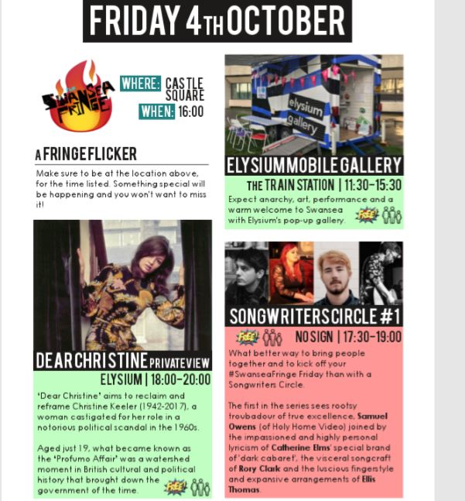
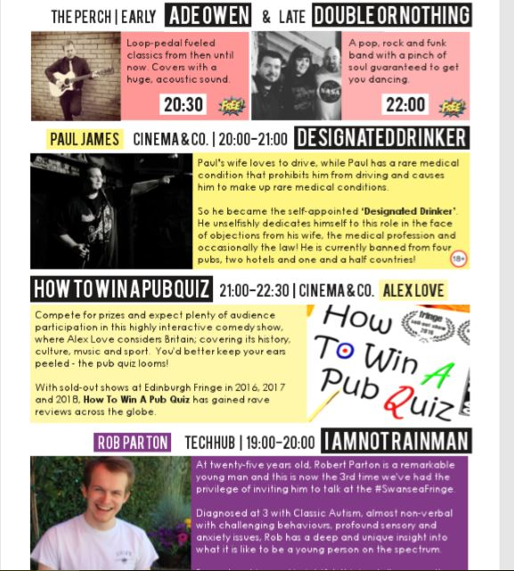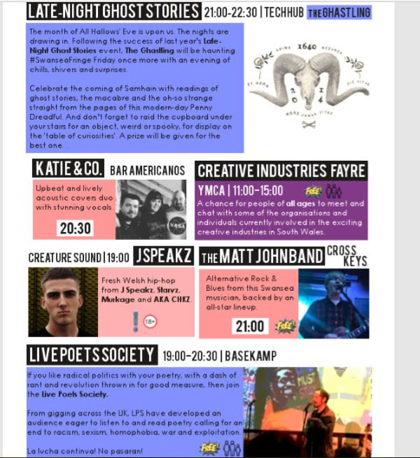

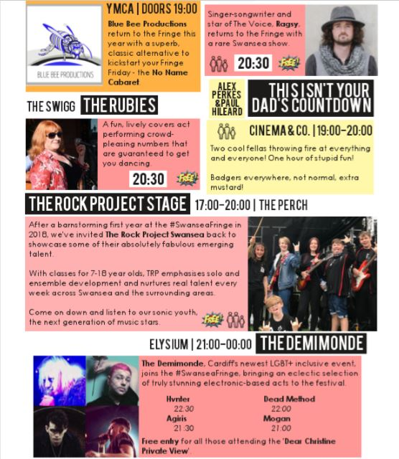

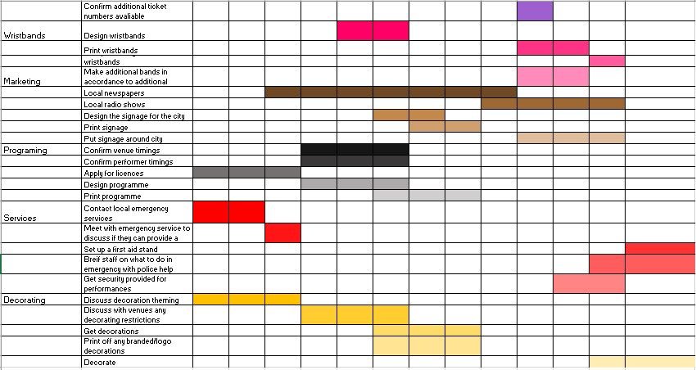
Appendix 2-Gantt Chart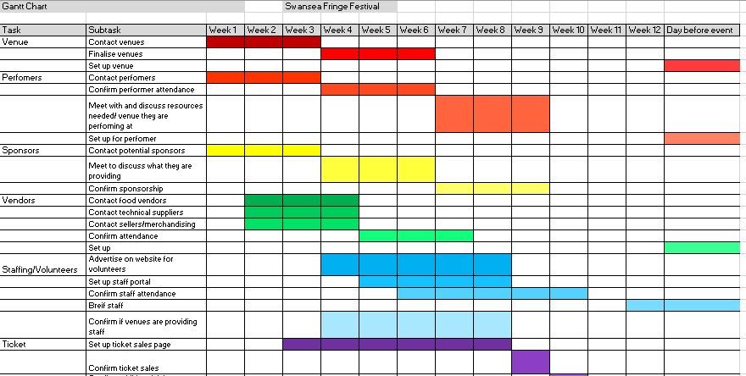

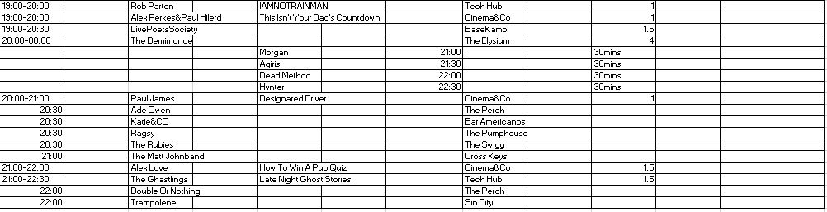
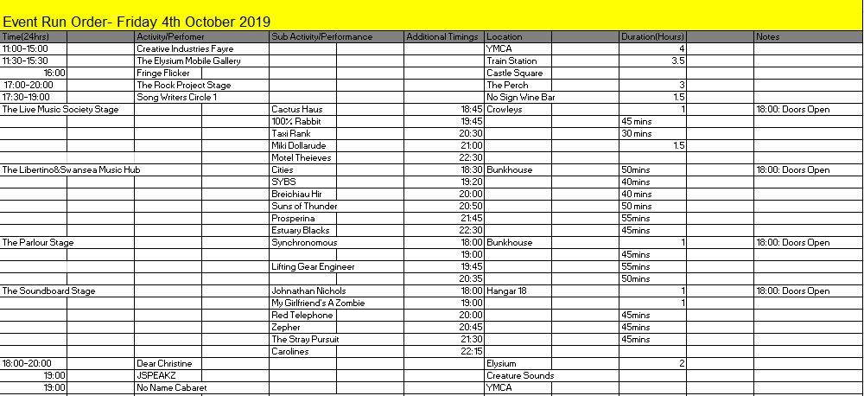
Appendix 3- Running Order

Appendix 4- Technical Running Order 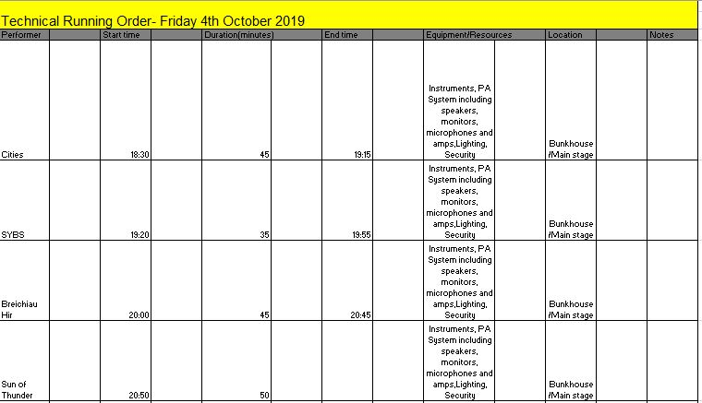
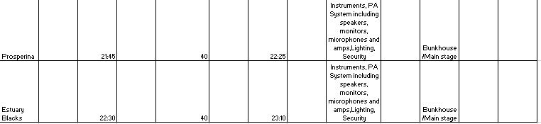

Appendix 5- Volunteering Advert
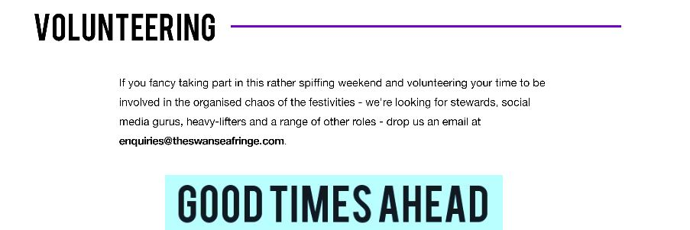

Appendix 6- Staff Sign-In Sheet
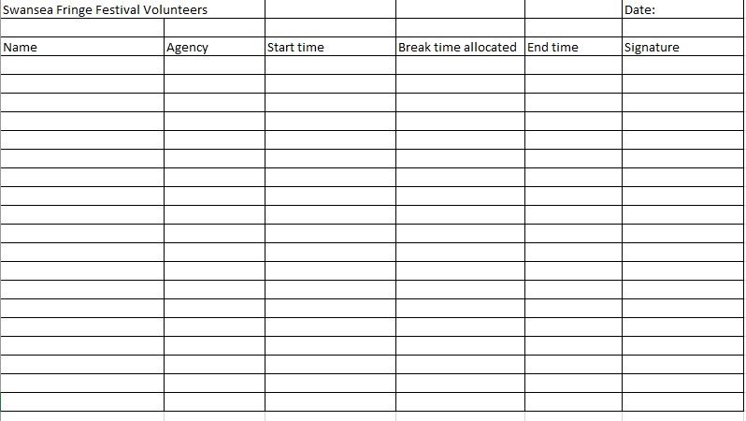

Appendix 7 - Risk Assessment
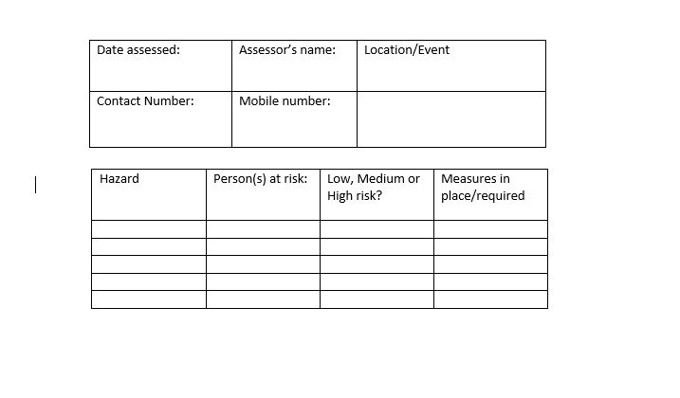
Appendix 8- Accidental Reporting Chart
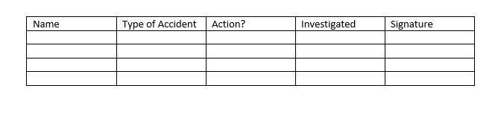
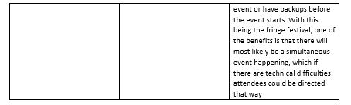
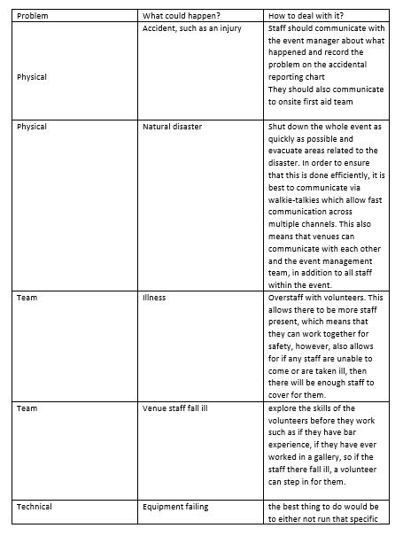
Appendix 9- Contingency Plan
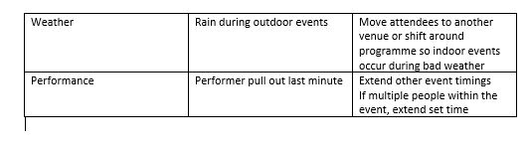
Appendix 10- Evaluation survey


