George Lumsdaine
1809700
Integrated Project
Group 4
Contents
- Introduction
- Design Recommendations
- Distribution of Labour and Resources
- Material Costings with Comparisons
- Summary Project Costings
1.0 Introduction
Both Swansea University and the University Wales Trinity St. David are rapidly growing and therefore there is an increasing demand for additional halls of residence for both home and overseas students. In order to meet this demand and taking into consideration potential constraints such as risk of flooding from river seas, coal authority development high risk, contaminated high and a national flood zone, we have designed a three storey 40 room student accommodation with a ground floor retail space on the SA1 development. My roles for the project were the following.
- Social Factors
- Energy Factors
- Distribution of labour and resources
- Material costings with economic comparisons
- Summary Project costings
2.0 Design Recommendations
The following are some recommendations I have provided that could be implemented into the designs in order for them to meet the social factor and energy requirements that I have researched.
Substructure
For the Substructure, I have recommended the use of CFA piles. I have suggested CFA piles because they suitable for the soil type while also being environmentally and socially friendly. The process of using CFA piles creates faster productivity than bored piles and according to Balfour Beatty ground engineering 2020 they are “ideal for noise and environmentally sensitive sites”. CFA piles have little noise or vibration so cause less disruption to the surrounding area which in the case of SA1 is a built-up area with both residential and education areas.
Superstructure
- Prefabricated Steel Frame
I would recommend the use of a prefabricated steel frame because the SA1 site is becoming a well built-up area and area disturbance is a social factor that must be considered and therefore the reduced construction time and disturbance of the prefabricated steel frame is highly advantageous. Additionally, the reduced construction time means the retail units on the bottom floor can open sooner and therefore create employment sooner rather than later and get a return on their investment sooner. I would also advise a prefabricated steel frame in terms of energy factors, as the controlled environment that the frame is manufactured means there is less wastage and also steel is 100% repeatedly, recyclable and todays steel structures are made from 88% recycled product. Also, Steel structures use long span columns which can allow for large open space areas which can then suit a number of different facilities and layouts. Furthermore, the steel structure offers flexibility as the structure can be modified even years after the completion of construction and while the building is occupied. For example, by removing some of the floor decking and then bracing a single bay, new stairwells can be implemented to the structure and also the steel columns and beams already constructed on the structure can be strengthened by attaching a steel plate to the flanges which can allow for stronger loads and therefore increasing the buildings life span which is an environmental benefit.
- Wind Bracing
Health and safety are a crucial social factor to be considered and in order to protect the building from racking caused by the wind, I would recommend a cross bracing system with the cross bracing to the opposite sides of the service core where the access will be. The bracing to the service core makes it a vertical cantilever anchored to the ground. To transfer wind forces acting on the four faces of the building, at least one of the floors should be framed with horizontal cross bracing which is tied to the vertical bracing of the service core. The action of the vertical cross bracing to the service core and the connected horizontal floor cross bracing to a floor on floor and roof will provide suitable protection for a structure like this. I would recommend this cross-bracing system rather than a system where the cross bracing on the two adjacent sides to the access of the building because it leaves two sides free for access and also more natural lighting which allows the building to be more flexible in its uses and have more freedom to change which increases the buildings life span and also increased natural light is a bonus as a key social factor is natural lighting for comfort and enjoyment of the building.
- Fire Protection
As mentioned on the last point, health and safety is a crucial social factor and as steel can lose its strength in the event of a fire at a temperature of 550°C steel will begin to deform, twist and sag. To offer protection against fire I would recommend that concrete casing is used. Although the concrete has a high mass and increases the deadweight of the frame and also can be quite costly due to on site labour and materials in the formwork and falsework necessary to form and support the wet concrete, I would advise the concrete casing because it offers the greatest level of protection compared to alternatives such as board casings or sprat coatings which can be susceptible to abrasion and knocks and in a student building I would recommend using the highest level of protection.
Interior Fit Out
- Raised Floors
For the bottom floor retail areas, I would advise the use of a deep platform raised floors. The raised floor will be used as a flexible horizontal duct space to conceal services such as electrical cables, ventilation ducting and wet services. The floor is supported on a series of adjustable jacks, usually made from (recyclable) steel, allowing a level surface to be created at varying heights above the structural floor. In this way a void is created through which the services can be passed. Therefore, the wires are concealed rather than being a potential trip hazard. It also allows for an open space area increasing the flexibility of the area, again ensuring a long-life span for the building.
- Suspended Ceilings
I would recommend implementing suspended ceilings as they can offer an attractive finish while being useful for concealing services and also housing equipment such as ventilation grilles, light fittings, fire sprinklers and detectors which again leaves room for the area to be as flexible as possible and have the ability to be used for a number of different facilities meaning there can be numerous different suitors for the rental space.
- Sheet Partitions
I would advise incorporating frame sheet partitions into the designs as they are a demountable form of partitioning which ensures flexibility in their use as they can be taking apart and relocated without damaging which can ensure multiple uses. I would advise the frame sheet partitions as the most suitable option as they have little material wastage, they are easy and quick to fabricate, and they are reusable.
3.0 Distribution of labour and resources on GANTT chart.
The below GANTT Chart indicates the schedule of works for the project while also showing a distribution of labour and resource.

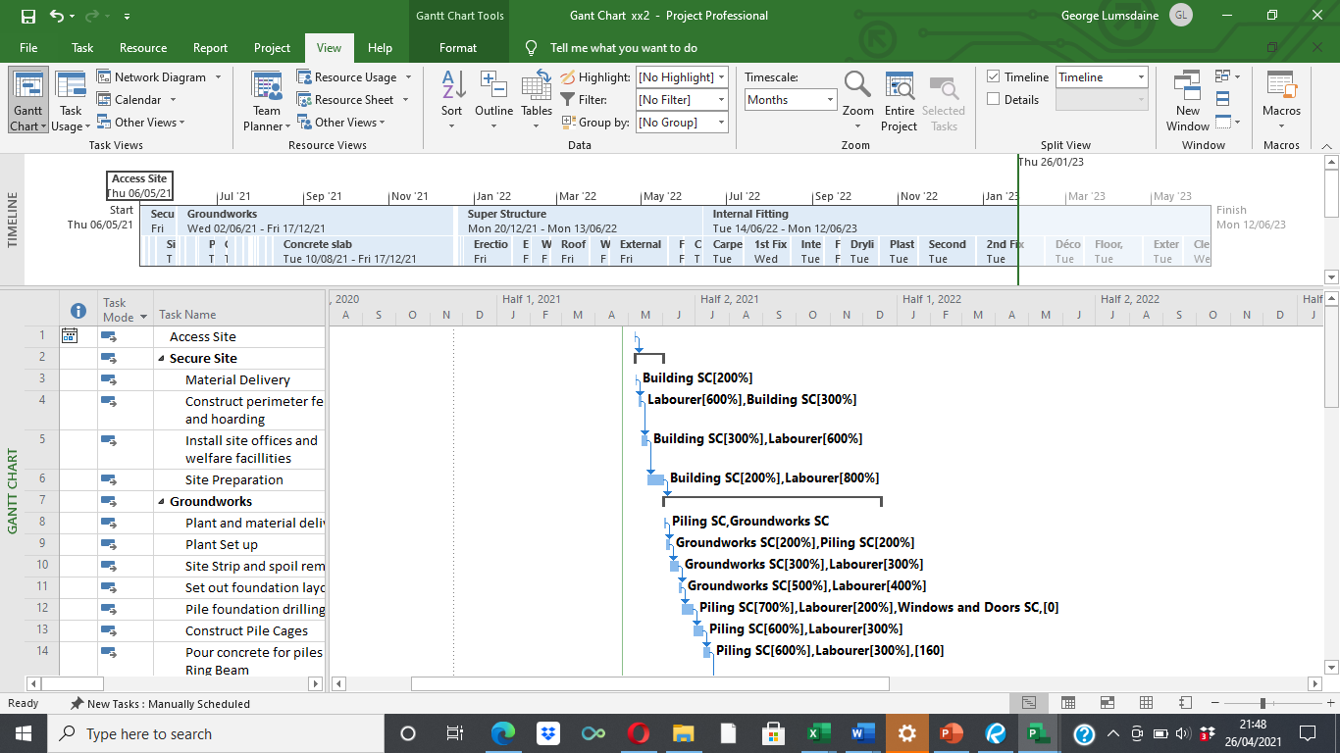
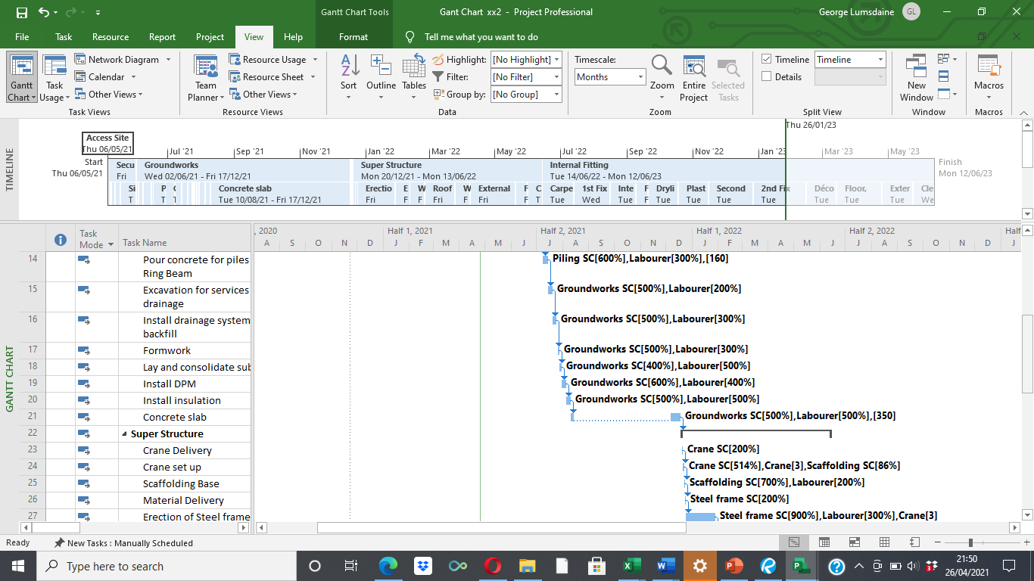

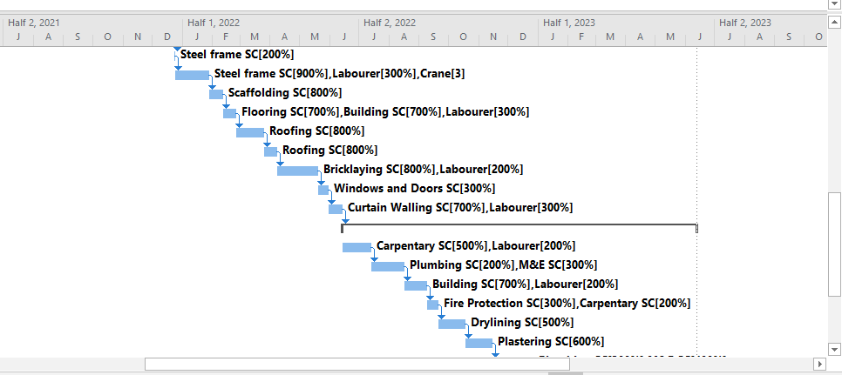

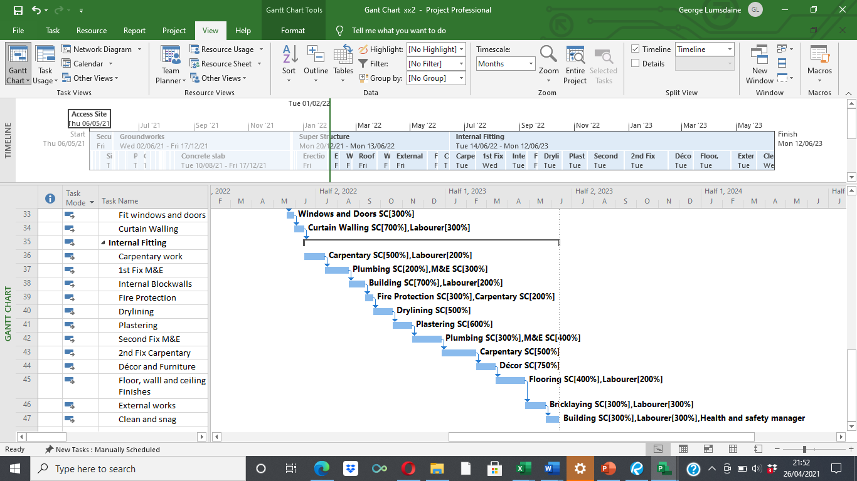

4.0 Material Costings with Comparisons
Using SPONS architects and builders price book 2020 I completed a costing sheet for the proposed structure.

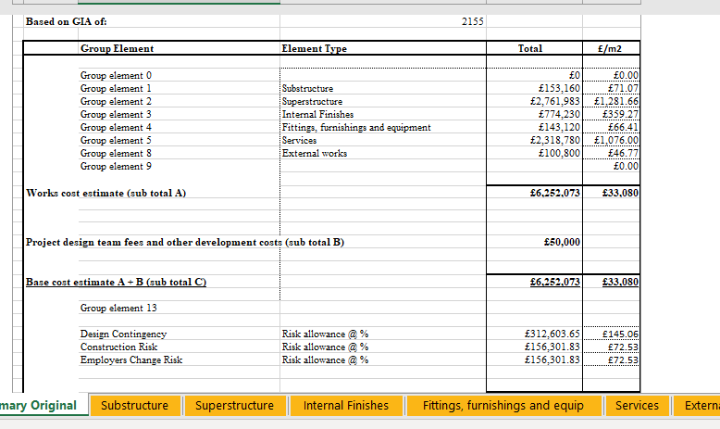

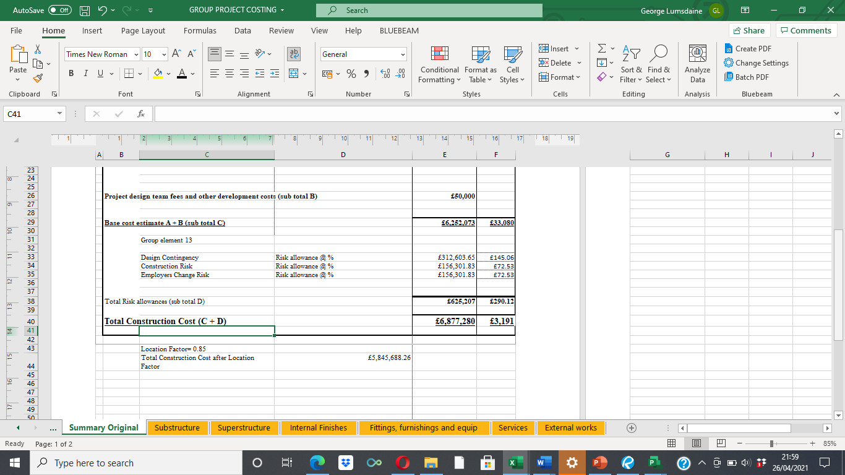
Total construction cost after location factor = £5,845,688.26
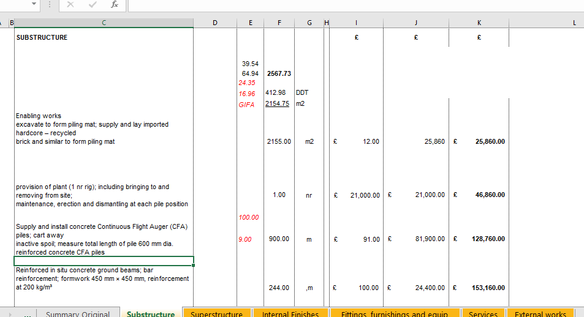

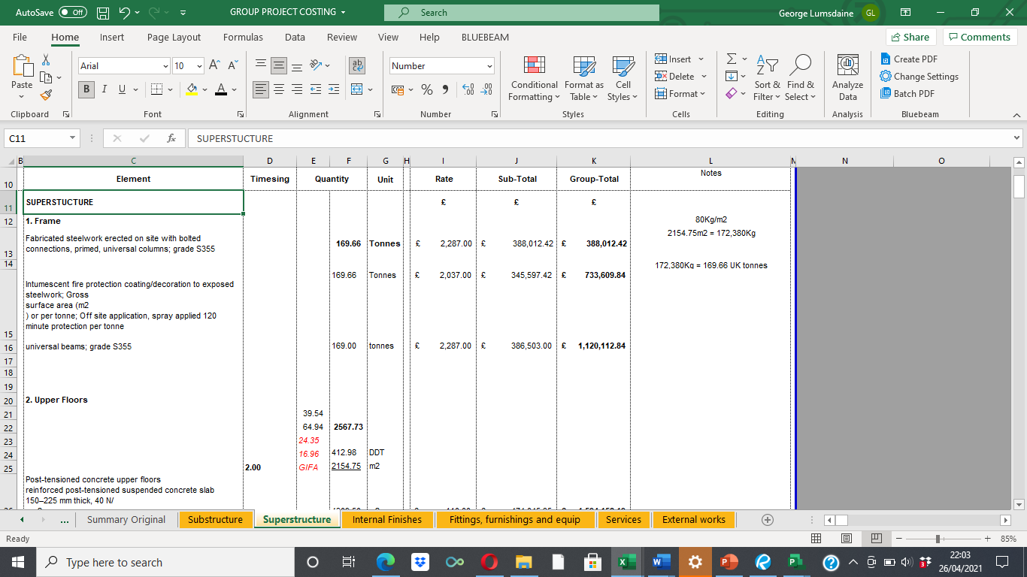
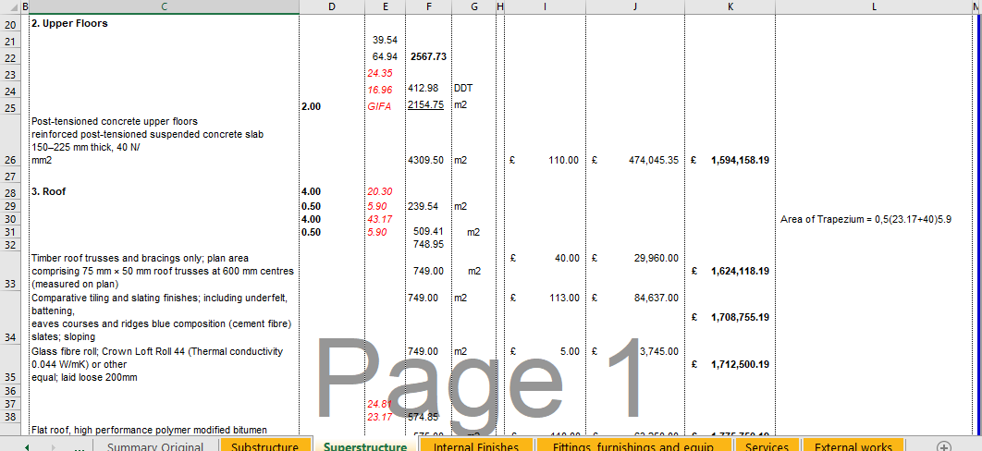

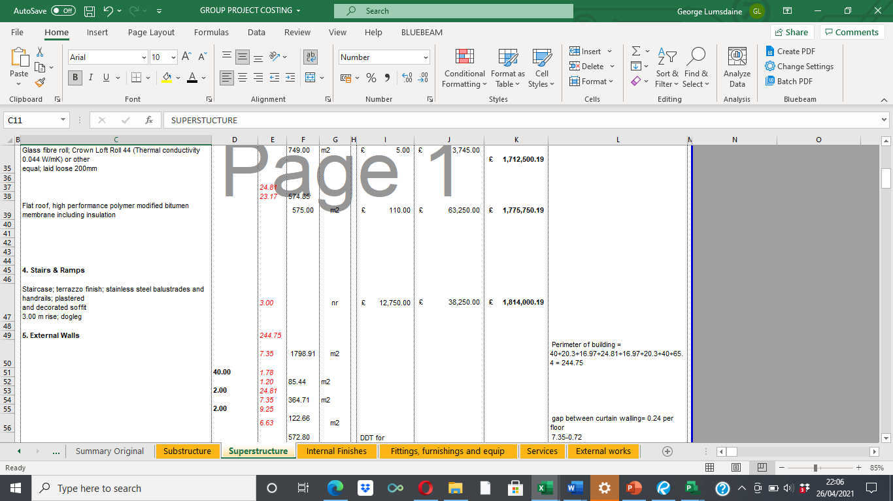

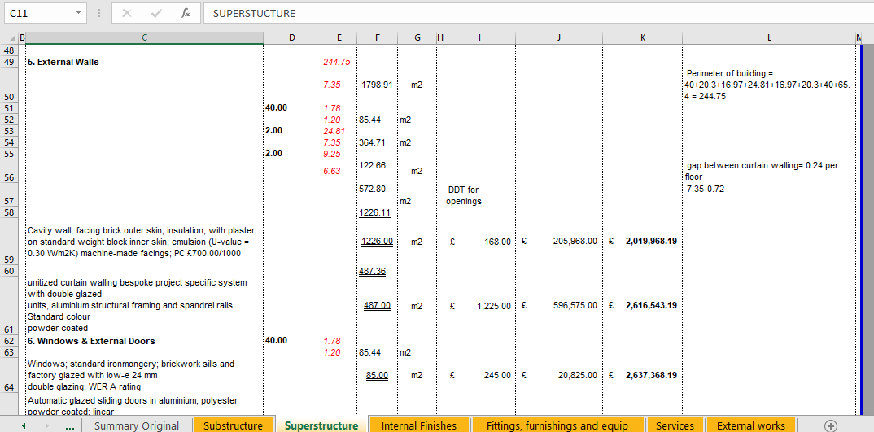
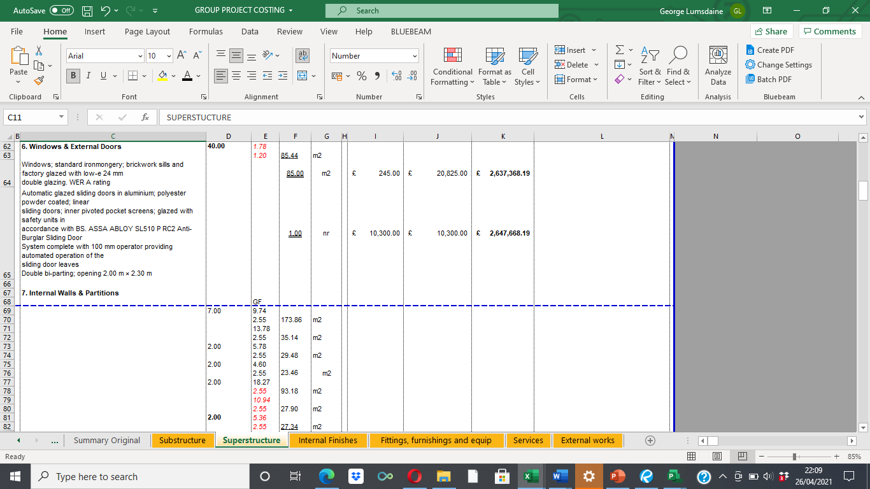
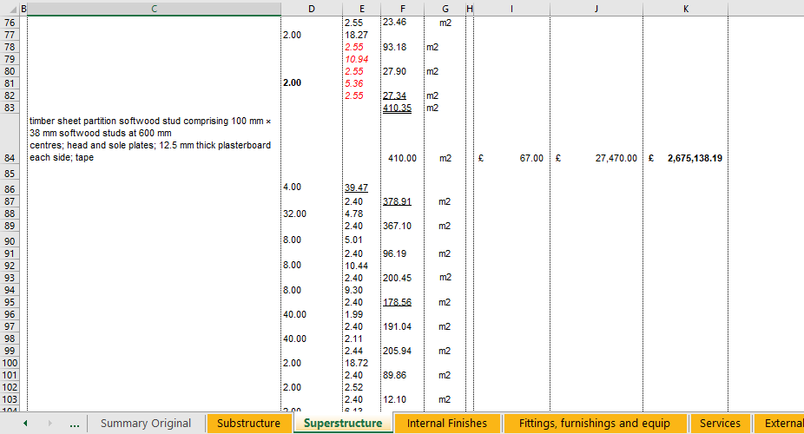
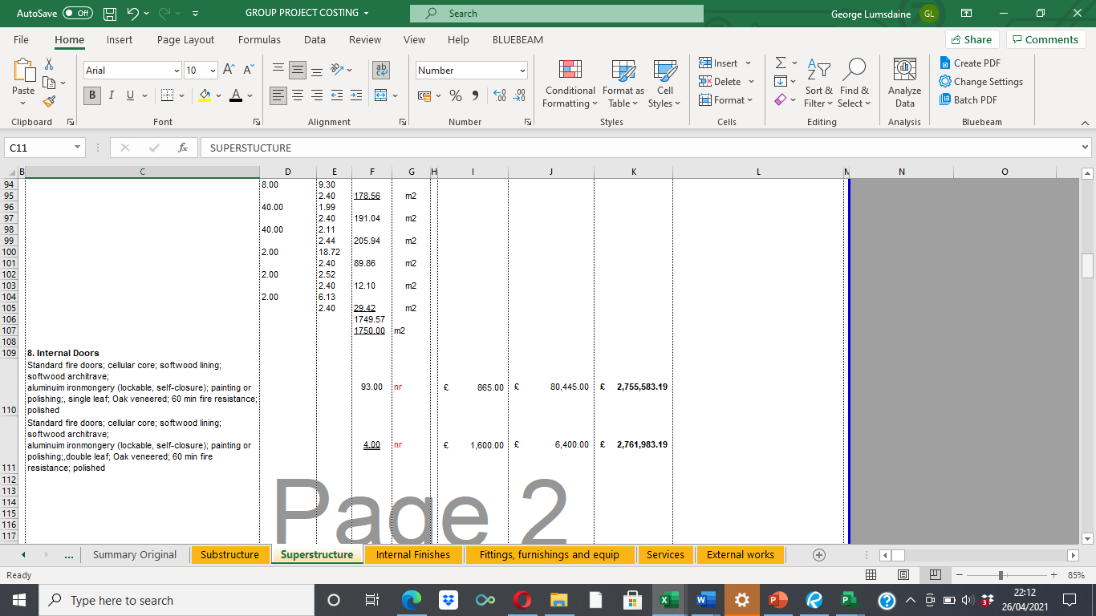
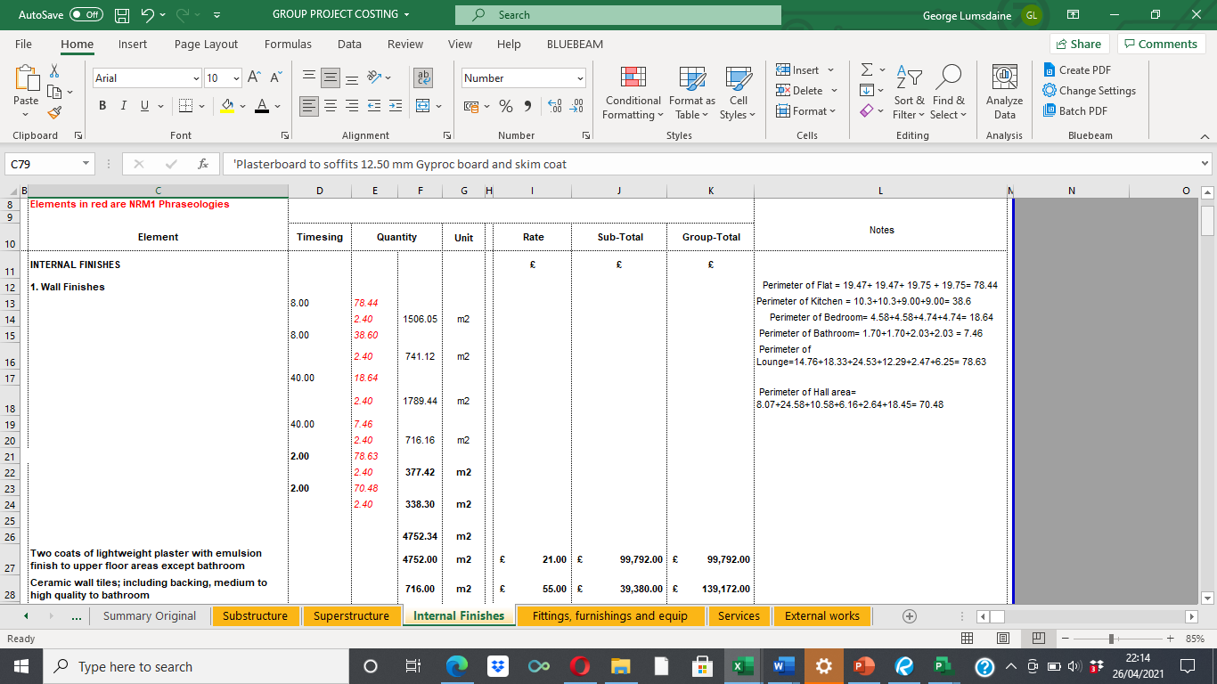
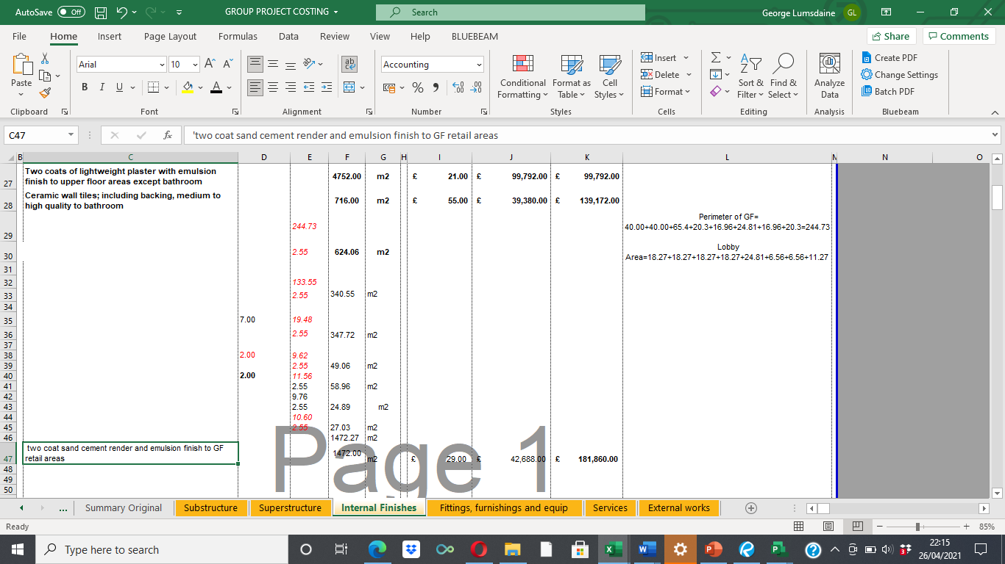
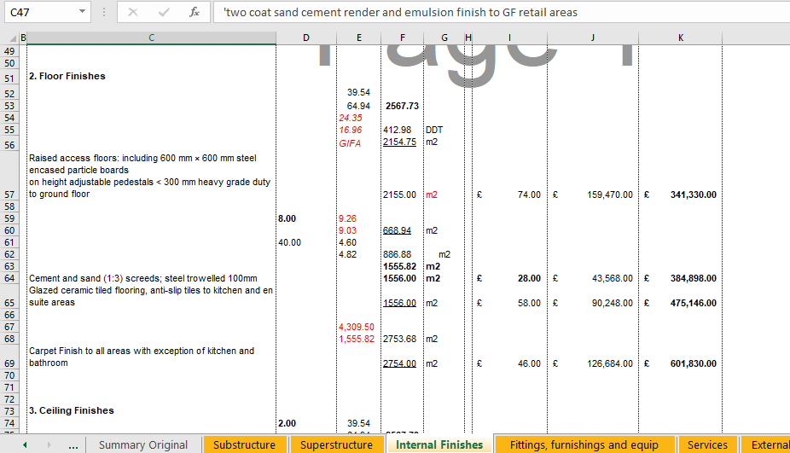
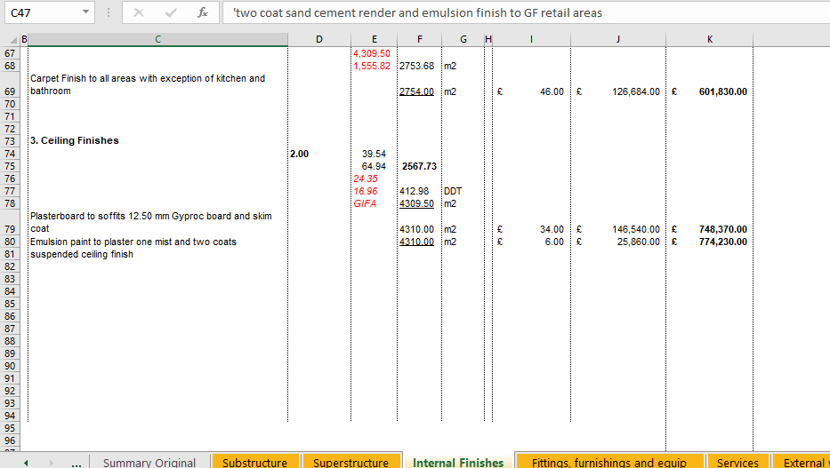
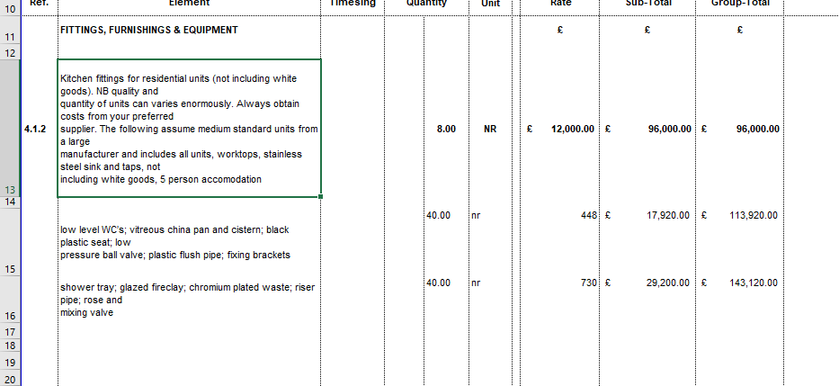
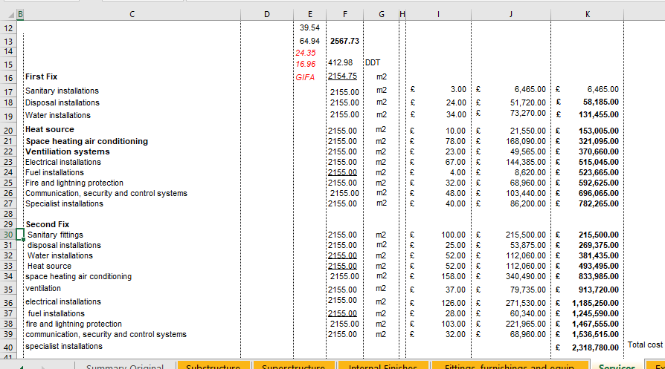
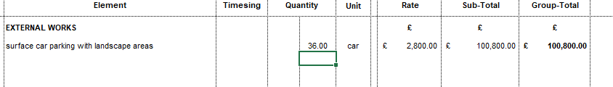

Comparisons
The below screenshots are alternative curtain walling systems and ceiling finishes which would also be available to the client and the impact on the costing they would have.
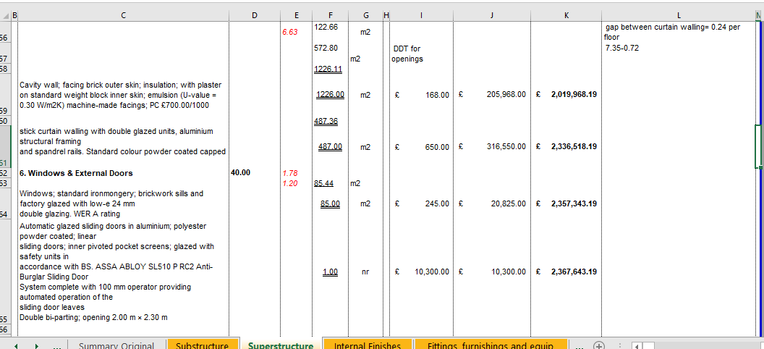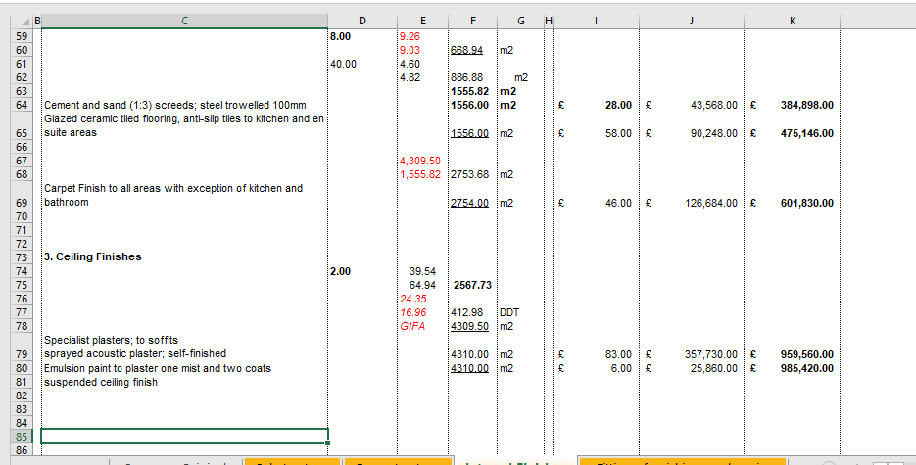
6.0 Summary Project Costings
The below chart demonstrates how the costs are spread across the project.

The below chart indicates the usage of each resource by how many hours they contribute to the project.

