

Assessment 2
Huma Resource Management

Student name: VISHWA PRUDHVI RAJ NETHI
Student ID: 2105235
Module name: HUMAN RESOURCE MANAGEMENT
Module code: LCMB7000
Lecturer name: Gladius Kulothungan

Contents
1.Introduction: 3
2. Developing Human Resource Strategies: 3
2.1 Change Management: 3
2.2 Staff Retention: 4
2.3 Leadership Development: 5
3. The value of each team member and their contribution to the company. Demonstrating through modern HRM and IHRM models. 6
3.1 Change Management: 6
3.2 Staff Retention: 7
3.3 Leadership Development: 8
4. Conclusion: 9
References 10

1.Introduction:
As a HR Director of the company, planning for the future is very important, and setting goals is a big part of that So, these goals must be in line with the company's objectives, vision, and overall strategy. The strategic goals of each company will be different.
To identify whether primary goals have a solid firm foundation, HR should ask the following questions:
• Have the advantages of meeting the goals that were set out and expressed?
• Are the strategic goals relevant to the company's position in the outside world? For example, do they take into account things like competitor positions, the size of the company, and its finances?
• Do the strategic goals take into account the strengths and weaknesses of the organization?
• Are employees across the company aware of how these goals impact them as well as how they add value both individually and collaboratively to the goals that have been set?
•Are the strategic goals realistic and attainable? Unrealistic goals usually lead to disappointment for everyone involved.
•Have deadlines for measuring progress and goals for completed tasks been set?
• Is it possible for the organization to measure the success or failure of its strategic goals in some way?
• Can the strategic goals be connected to the overall strategy of the company?
(Wilkinson, 2011)

Just Eat Limited is a British company that lets you order food online and have it delivered to your home. It was founded in 2001 in the Danish city of Kolding. People who want to order takeout food from independent businesses use this service as a middleman. As per their website, the company is based in London, England. It has operations in 13 countries across Europe, Asia, Oceania, and the United States. Customers can use the platform to find for nearby takeaway restaurants, order and pay online, and pick up or have their food delivered. In this study we will understand few HR strategies we can develop and deploy also demonstrate them connecting to the company. we will also discuss on the HRM and IHRM theories, as I am the HR Director of the company. (Dunne, 2019)

2. Developing Human Resource Strategies:

2.1 Change Management:

Organizational change is a term that refers to the ways a business changes or adjusts a big part of its organisation. This could be about corporate culture, internal processes, technology or infrastructure, business structure, or another important thing.
Just eat Takeaway.com has been very adaptive in terms of change. Since it is a start up which was thriving to become the largest food delivering technology company.
As a HR Director of the company needs to develop ADKAR Change Management Model.
Adaptive or transformational: Change management can be done in two different ways:

Adaptive Changes:
Changes that an organisation makes to its commodities, methods, workflows, and strategies are called adaptive changes. These changes are small and gradual and happen over a long period of time. Adding a new team member to deal with more work or changing the work-from-home policy to get more right kind of people too are examples of adaptive changes.

Transformational changes:
These are bigger in both scale and scope, and they often signal a dramatic and, at times, sudden change from the status quo. Transformational changes include things like introducing a new product or company division, or moving your business to a new country.

Change management is the process of leading an organization's change from the beginning stages of planning and preparation all the way through execution and, finally, to a close down. There are 5 steps to summarize:
- Prepare the Organization for Change.
- Craft a Vision and Plan for Change.
- Implement the Changes.
- Embed Changes Within Company Culture and Practices.
- Review Progress and Analyze Results. (Miller, 2020)

2.2 Staff Retention:
As a HR Director of the company to say a few words on this, Staff Retention is very important for any company and Exit interviews can give you a lot of valuable information about how your employees think about your company and help you figure out if your retention strategies need to be changed.
Just Eat Takeaway.com has always on recruiting since the delivering jobs are dependent on social factors and some times uncontrollable but also easy to find and replace. However, company is always towards retention of staff irrespective of mergers and acquisitions or economy factor.
They will most likely say either one of the reasons listed why they are leaving their job:
- Poor pay and benefits.
- Feeling overworked and/or alone
- Career advancement is limited.
- An important need for decent work balance
- Lack of attention
- Boredom
- With management, I'm not happy.
- Concerns about the direction of the company or its financial health
- Displeasure with the way the company is run
- desire to change things
- At other companies, there are more desirable jobs.
Candidates who have skills that are in demand are likely to be able to find a new job quickly, even though the employment market in some sectors and places is in their favor. Many businesses didn't stop employing during the global epidemic, and a lot of the ones that did are now hiring more people again.
It's important to act quickly if you think your business could lose some of its best employees. Here are 14 things you can do to make your employees happier at work and make it easier for you to keep good employees.
- Onboarding and orientation
- Mentorship programs
- Employee compensation
- Perks
- Wellness offerings
- Communication
- Continuous feedback on performance
- Training and development
- Recognition and rewards systems
- Work-life balance
- Flexible work arrangements
- Effective change management
- An emphasis on teamwork
- Acknowledgement of milestones, big and small. (Half, 2021)

2.3 Leadership Development:
Though I am the HR Director of the company, in order to become a good leader, there are many ways to learn. Larger businesses are more likely to have well-defined programs, but this isn't always the situation with smaller firms.
Develop your company's future leaders doesn't have to be complex and costly. It doesn't have to be hard or expensive to do this. There is a good chance that paying attention to your own employees and growing them is going to be a lot cheaper and faster than training new staff.
When you help your current employees grow, you show that you care about them. People will all be happy about that. It also makes people more likely to trust each other.
Just eat Takeaway.com has always in lime light of acquiring or merging, top management always strives to stand number 1 in every country. Opportunities have been given internally and externally for leadership development.
Here are five things you can do right now to help your leadership team grow:
- Understand training vs. development
- Identify skill gaps and future needs
- Determine who’s best suited for future leadership
- Deliver the necessary training
- Adopt a continuous leadership development mindset. (Insperity, 2021)
This year has shown us that effective Strategic leadership is important for the future that is coming up. There aren't many HR leadership development program in businesses like this one. Some businesses didn't know how to deal with the COVID-19 pandemic. It pushed them into a new future that many weren't ready for. However, it gave us a better idea of the kind of Leaders that is will be required. You should start an HR leadership development program at your company now because now is the best time to do that.
Most HR managers have been able to deal with the pandemic with calm, expertise, and strength. Still, more than majority of C-suite top management still think of HR as a mostly administrative job, even though they play a business strategy role in the process pandemic. A very well HR leadership development program (LDP) can change this. But even more important is that you need an HR LDP to deal with the issues of the jobs of the future. (G, 2021)

3. The value of each team member and their contribution to the company. Demonstrating through modern HRM and IHRM models.

3.1 Change Management:
It has been observed that just eat is now known as Just eat takeaway.com, since February 2020. There have been multiple merges and acquisitions by the company since it was founded. As it is one of the leading startup foods delivering technology company aspiring to become world number one, it is ready to take multiple changes to reach its position by internal changes and making sure the customers are also given the best service. However, stock price also rises high due to such acquisition and merges which benefits the company as they are publicly listed.
Just eat Takeaway has also done technology changes internally by using slack as official communications to send quick and handy updates to employees internally. They have also started using salesforce for business development and maintain a formal and organized record of every employee work and his details.
ADKAR change management model is used to make sure the transition is smooth and all the employees are trained well. Awareness, Speak out for change in your company. Desire, Make the case for change with everyone concerned. Knowledge, give everyone the information they need to participate in the transformation process. Ability, assure that all staff have the necessary skills and training. Reinforcement, just after change is made, keep working with workers and stakeholders to ensure they remain on track. (Hicks, 2021)
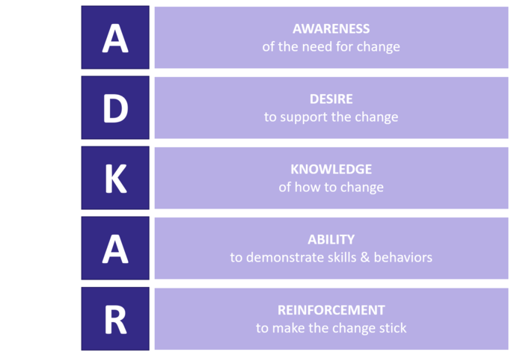
Source: (Creasey, 2019)

By developing such strategies, it benefits the company and it is possible to shift smoothly from one state to another while sustaining employee morale, productivity, as well as the company's image via effective change management. Provides management and employee assistance in the event of a change-related emergency. An effective change management strategy ensures that employees and the public have an accurate perspective of the change. It assists in the development of effective communication methods. Managed change has the potential to reduce resistance to change. Improves employee morale, productivity, and overall work quality. Improves the ability to cooperate, collaborate, and communicate. A well-thought-out approach to change decreases stress and worry while also encouraging employees to remain loyal to the business in question. Employees' willingness to embrace the change has increased. Individuals' personal loss or gain is recognized and handled. Change management is the practice of minimizing disruptive features and highlighting favorable possibilities throughout a change process. (Connelly, 2022)

3.2 Staff Retention:
Staff retention at just eat takeaway.com Improved corporate moral, Job Satisfaction, and improved staff-manager interactions are all benefits of this initiative. The capacity to increase total productivity, which in turn serves to increase profit and growth potential. Improvements in the customer and application experience. Let us consider two instanced occurred recently listed below:
- As Deliveroo's stock price continues to decrease, 2000 Just Eat riders are promoted to full 'employee' status. Just Eat has doubled its objective for promoting riders to full employee status, which includes benefits such as vacation and sick pay. (Kenny, 2021)
- Just East Takeaway's chief executive, Jitse Groen, told BBC World News that the company may continue to use temporary workers or part time workers in certain places if it is feasible to provide them with insurance and "improve the lives of these individuals far more than it is now. In few countries temporary workers or part time workers will be removed or made permanent, in order to replace with employees who are entitled to benefits and workplace safeguards, food delivery business Just Eat aims to phase out the use of gig economy workers within Europe. (Groen, 2020)
By developing such strategies to act on environmental factors and social factors to gain employees trust, it will help the employee to stick long with the company. Such activities will help the workers gain trust in the company and work better.
Frederick Herzberg's popular "Two-Factor theory" explains how employee retention and motivation of employees work together to keep people at their jobs. According to him, there are two types of things that make people more motivated at work. These things either help or hurt employee satisfaction.
Employee-retention-Herzberg’s-two-factor-theory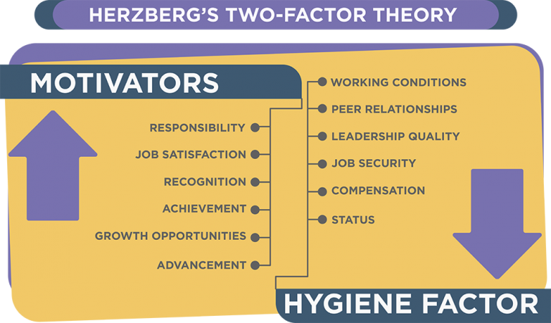Source: (yashgarg4, 2019)
The first factor is called the hygiene factor, and it is about things that help people be motivated at work. A hygiene factor is something that staff expect to be taken care of. Employees aren't happy when these things aren't there. There are some physical needs, like getting a good salary, having a stable job, and having good working conditions. Other things to think about are how good a person is at being a leader and how well they get along with their coworkers.
The second are people who make you want to do something. In his book, Herzberg says that employee motivation is based on the job itself. These things make the employees want to do better. Some of the things that make people want to work are commitment, work satisfaction, appreciation, accomplishment, opportunities for growth, and so on. (Thangjam, 2021)

3.3 Leadership Development:
As a HR Director of the company by developing the steps mentioned in section 2.3 following are the benefits for the employee and also the company. However, just eat takeaway is also tied up with other agencies to hire the right person and also allow the internal team to learn and grow.
- Train future leaders: Leaders are no longer characterized by their meeting contributions or work hours. We’re becoming better at identifying high-potential employees. From 9box processes to comprehensive portraits of our future leaders' competencies, demographics, and personalities. Leadership development training enables organizations to deliberately invest in employees from early career development to senior executive level. In this way, the individual and the firm profit.
- Retain employees: Take your best leader. A supportive friend or mentor. Leadership development program teach all of these abilities. These are the traits that set leaders apart from managers.
- Motivate employees: Employees would like to work for the company that develops their leadership. Regularly recognized as being one of the top three reasons to join a business, training and development is extremely necessary. leadership development program targets diverse and underrepresented youth.
- Boost financial results: A solid plan will boost financial results. Everyone wins, but leadership, executives, and top performers gain the most. Acting quickly and sharing expertise may dramatically improve a company's bottom line.
- Leaders choose better: Making choices is a skill that can be taught. Participants in leadership development program learn to apply self-awareness to identify key aspects, alternatives, and risks.
- Lead with a bold style: A leadership development program may help you enhance your communication skills. Determining how their teammates and colleagues would behave in a crisis is crucial. A great leader can inspire individuals of various ages and cultures.
- Create effective teams: Team leaders may also be developed. A team that goes through leadership development training jointly develops collaboration skills and behaviors. Learning skills may help colleagues beyond the program. Strong leaders lead to better results.
- Prepare your team for growth: Leadership development program offer more than just the skills required today. This encompasses both job and personal skills. connects emerging leaders with seasoned leaders. Active listening skills are a great side benefit of leadership development programs. (Haville, 2021)

The 5-P model of HRM is the best fit to use in developing the leadership development strategy in the company.(Schuler, 1992) came up with the 5-P model of HRM, which shows how HRM works under the five categories:
1. HR philosophy -This is a statement about how the company thinks about its employees, how important they are to the success of the company, and how they're being treated and managed.
2. HR policies - these are guidelines for how to deal with individuals business issues and how to build HR programs and practices that meet the company's long-term goals.
3. HR programs: These are based on HR policies and are coordinated HR efforts that are meant to start and manage organizational change efforts based on strategic business needs.
4. HR practices: These are the things that are done when HR policies are put into place. They cover things like staffing, learning & development, performance management, employee relations, and administration, among other things.
5. HR processes These are the official procedures and strategies for implementing HR strategic goals and policies.
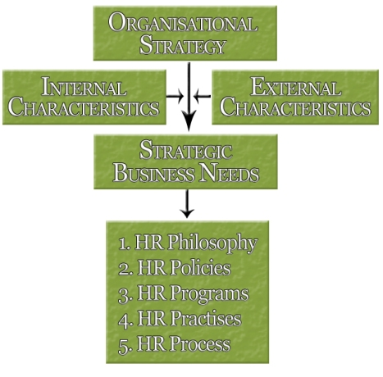
Source: (han08robinson, 2010)

4. Conclusion:
To conclude things we can do to increase employee happiness and make it simpler to retain excellent staff. Developing your organization's future leaders does not have to be complicated or expensive. The last year has shown that the critical nature of strong strategic management for the future. There are few HR leadership development program comparable to this one in corporations. Simply eat Takeaway has also implemented technological advancements inside, including the use of slack for official communications, which allows for rapid and convenient updates to staff.
The ADKAR change management methodology is used to ensure that the transition is seamless and that all workers get enough training. Team makes sure has the ability to lessen employee resistance and boost morale, efficiency, and overall job quality. Additionally, it enhances one's capacity for cooperation, collaboration, and communication. Just Eats’ goal in Europe is to fade out the usage of gig economy employees. Jitse Groen, chief executive of Just East Takeaway, believes the company may continue to utilize temporary or part-time workers in some locations provided it is financially possible to supply them with insurance.
Managers are no longer defined by their contributions to meetings or work hours. Organizations should make purposeful investments in their workers' growth, from early career stages through senior leadership positions. Everyone benefits, but CEOs, leaders, and top performers benefit the most. Training and development are critical components for future leaders. The 5-P model of human resource management is divided into five categories: human resource philosophy, human resource policies, human resource program, human resource practices, and human resource processes. Strong leaders foster the development of good teams, and good teams produce superior outcomes.

References
Connelly, M. ( 2022, January 18). what-is-change-managemen. Retrieved from https://www.change-management-coach.com: https://www.change-management-coach.com/what-is-change-management.html
Creasey, T. (2019, june 12). adkar-core-people-side-change. Retrieved from https://www.changepartners.lv/: https://www.changepartners.lv/adkar-core-people-side-change/?lang=en
Dunne, S. (2019, august 27). Just Eat: Building A Business From Inception To IPO. Retrieved from https://www.forbes.com/: https://www.forbes.com/sites/workday/2019/08/27/just-eat-building-a-business-from-inception-to-ipo/?sh=4dd9e8ae41bb
G, R. (2021, March 8). Leadership development. Retrieved from https://www.aihr.com/: https://www.aihr.com/blog/hr-leadership-development-program/
Groen, J. (2020, August 14). Just Eat to stop using gig economy workers. (J. Josephs, Interviewer)
Half, R. (2021, December 14). 14 Effective Employee Retention Strategies. Retrieved from https://www.roberthalf.com/: https://www.roberthalf.com/blog/management-tips/effective-employee-retention-strategies
han08robinson. (2010, Februray 25). https://han08hrm.wordpress.com Blog. Retrieved from https://han08hrm.wordpress.com: https://han08hrm.wordpress.com/2010/02/25/
Haville, S. (2021, March 09). /what-are-the-benefits-of-leadership-development-training. Retrieved from https://www.circl.org/: https://www.circl.org/blog/what-are-the-benefits-of-leadership-development-training
Hicks, K. (2021). Change Management Models. Zendesk, 1-3.
Insperity. (2021, August 31). Business Leadership. Retrieved from https://www.vistage.com/: https://www.vistage.com/research-center/business-leadership/20210831-effective-leadership-development/
Kenny, A. (2021, April 01). As Deliveroo shares fall again, 2000 Just Eat riders move to full ‘employee’ status. (J. Armitage, Interviewer)
Miller, K. (2020, March 19). Change Management. Retrieved from https://online.hbs.edu/: https://online.hbs.edu/blog/post/change-management-process
Schuler, R. S. (1992). Strategic Human Resources Management: Linking the People with the. In R. S. Schuler, Organizational Dynamics (pp. 18-32). online: Elsevier Inc.
Thangjam, T. (2021, December 28). employee-retention-strategies. Retrieved from https://blog.vantagecircle.com: https://blog.vantagecircle.com/employee-retention-strategies/
Wilkinson, M. (2011). The Executive Guide to Facilitating Strategy. global: Leadership Strategies Publishing.
yashgarg4. (2019, October 05). herzbergs-two-factor-theory. Retrieved from https://yashgarg4.blogspot.com: https://yashgarg4.blogspot.com/2019/10/herzbergs-two-factor-theory.html

