Digital Building Survey at the Dylan Thomas Centre

Student: Jac Roberts 2404313
Module: Digital surveying and highway design
Tutor: Hannah Williams
Date: 05/01/2026
PART 1 — SURVEY PLAN
1. Purpose of the Survey

The purpose of this digital building survey is to capture accurate spatial information for a corridor space in the Dylan Thomas Centre (DTC) using 3D laser scanning technology and to evaluate its effectiveness compared to traditional manual measurement techniques. The surveyed area consists of a series of corridor space within the DTC, chosen to provide a realistic context for applying professional surveying methods. The survey aims to extract reliable data on corridor geometry, openings, and height, forming the basis for developing measured drawings.

This project reflects an industry-standard system in which laser scanning is increasingly used for refurbishment planning, architectural design, and building documentation. The specific motivation for this survey is to demonstrate how 3D scanning improves accuracy, reduces field time, and captures complete data sets that remain useful long after the initial visit. The resulting point cloud will support measurement extraction and may be used for future modelling in CAD or BIM software.

The survey is also intended to serve as a teaching opportunity: to experience a structured pre-survey planning process, to carry out real scanning work on-site, and to evaluate the practical challenges encountered. It provides insight into best practices and reinforces the importance of careful planning to ensure efficient scanning, safe working conditions, and high-quality outputs.

2. Survey Area Definition

The survey area covers one connected internal corridor layout of the (DTC) including, entry and exit spaces and selected features such as windows, doors, low-level services, and ceiling details. The goal is to achieve complete spatial coverage with sufficient overlap between scan stations to allow a reliable plan.

The required Level of Detail (LOD) for this survey corresponds to typical architectural survey standards, including:

- Accurate wall-to-wall dimensions

- Full door and window geometry (width, height, reveals)

- Floor-to-ceiling height

- Visible structural or fixed architectural elements

- Significant ceiling features

The deliverables generated from this survey will include:

- A detailed written survey plan

- On-site evidence and execution summary

- Extracted measurements from the processed scans

- A comparative analysis of laser scanning versus traditional manual measurement

3. Site Assessment

A preliminary site assessment was conducted to identify logistical, environmental, and operational factors that could affect the scanning process.

Access and Circulation

The building offers straightforward entry, with a primary access door leading to a main foyer that then leads to the survey space being the 2nd floor of the west wing. Internal circulation is generally good, though some corridors are narrow, requiring careful positioning of the tripod to avoid blocking routes. No special permits were required for entry due to being accompanied by UWTSD staff. Internal doors are operable and allow movement between spaces without obstruction.
Lighting Conditions

Lighting within the building is moderate and variable. Some rooms rely on artificial lighting, while others receive daylight through windows. While lighting does not significantly affect laser scanning performance, darker areas may impact visual references used during registration. It

Environmental Considerations

The internal environment presented minimal weather-related concerns however direct sunlight through glazing can affect scan quality. Reflective surfaces such as glass panes, glossy paint, or mirrors posed potential issues. In several areas, furniture and equipment created partial occlusions, requiring additional scanning angles to capture hidden surfaces.

Proposed Scanning Positions

A preliminary scan layout was planned to ensure comprehensive capture. Estimated positions included:

4-5 stations in the corridor in all 4 corners

1 station near the entry area

Additional stations if occlusions were identified during the scanning day

Scans were planned with overlapping fields of view to improve registration reliability. The tripod height was estimated at 1.4–1.6 metres, suitable for capturing both low and high geometry.

4. Equipment and Methodology
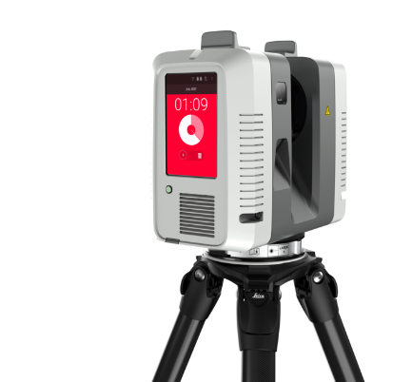
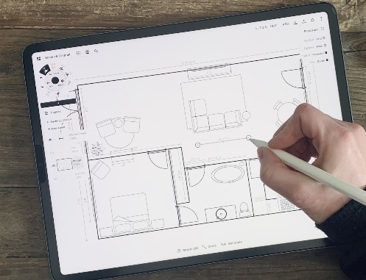
The survey uses a terrestrial laser scanner capable of capturing high-density point cloud data with a typical accuracy range of 2–5 mm, depending on final resolution settings. The scanner was mounted on a stable tripod and operated via touchscreen mobile interface (in our case an iPad Pro).

Resolution and Quality Settings

Standard indoor resolution was selected to balance accuracy with manageable file size. A scanning time of 2–4 minutes per station was anticipated, with medium quality.
Registration Strategy
A targetless method was planned, using cloud-to-cloud alignment. This relies on significant overlap (minimum 30–40%) between successful scans. Visual features such as corners, door frames, and fixed fixtures were expected to assist the automatic alignment process.
Data Handling
Scans were stored directly to the scanner’s internal memory and backed up to a laptop accompanied by a USB stick. File naming conventions followed chronological order to aid registration. The final processed point cloud would be exported to suitable formats for measurement extraction or modelling.

5. Risk Assessment Summary
A simplified risk assessment was prepared to identify potential hazards and appropriate mitigation measures.

Operational Risks
Trip hazards: Tripod legs may obstruct circulation. Mitigation: High-visibility placement, verbal warnings, and careful station choice.
Equipment instability: Knocked or unstable tripod. Mitigation: Firm ground placement; this was not left unattended.
Public interaction: People may walk through the scan path. Mitigation: Pause scanning when necessary; communicate clearly with building users.

Environmental Risks
Reflective or transparent surfaces: These can cause discrepancies in the dataset. Mitigation: Adjust scanning angle; add additional stations.
Restricted spaces: Narrow corridors may limit scanner placement. Mitigation: Use multiple shorter-range scans.

Data Risks
File corruption or loss: Mitigation: Backups to laptop; preview scans before leaving site.

6. Estimated Programme / Timeline
Initial planning and site visit: 30 minutes to 1 hour.
On-site scanning: 45–90 minutes depending on complexity.

Registration and processing: 1–2 hours
Measurement extraction: 30–60 minutes
Final analysis and report writing: 4–6 hours

PART 2 — PRACTICAL SURVEY EXECUTION

The practical component involved visiting the site and conducting the laser scanning survey according to the prepared plan. Upon arrival, the first step was to review the environment and confirm that the planned scanning positions were viable. In general, the survey proceeded as expected, with most pre-planned scanning stations used successfully.

Execution Summary
The scanning equipment was set up at the first position near the entry area to establish an anchor for registration. Subsequent positions were placed strategically around the corridor ensuring sufficient overlap. Several planned positions were adjusted slightly due to people passing through the space. This required short-term pauses in scanning to allow for clear captures.
Lighting levels were adequate, and no significant glare or reflectivity issues were encountered, although one window required positioning adjustment to avoid excessive washout. The scanner performed well, capturing dense point cloud data for each location within the expected time.

Adaptations to the Plan
While the initial plan assumed four positions in the corridor, an additional scan was required due to the shape of the corridor as it corners. This ensured complete wall geometry and improved registration accuracy. Similarly, a narrower corridor than expected required the tripod to be repositioned more frequently to avoid blocking access.
Despite these changes, overall workflow remained close to the original plan.
A few real-world issues arose during the scanning process:
Foot traffic: Movement of people through the space occasionally disrupted scanning.
Obstructions: Wall spacing and shape obscured some scans, requiring additional scans.
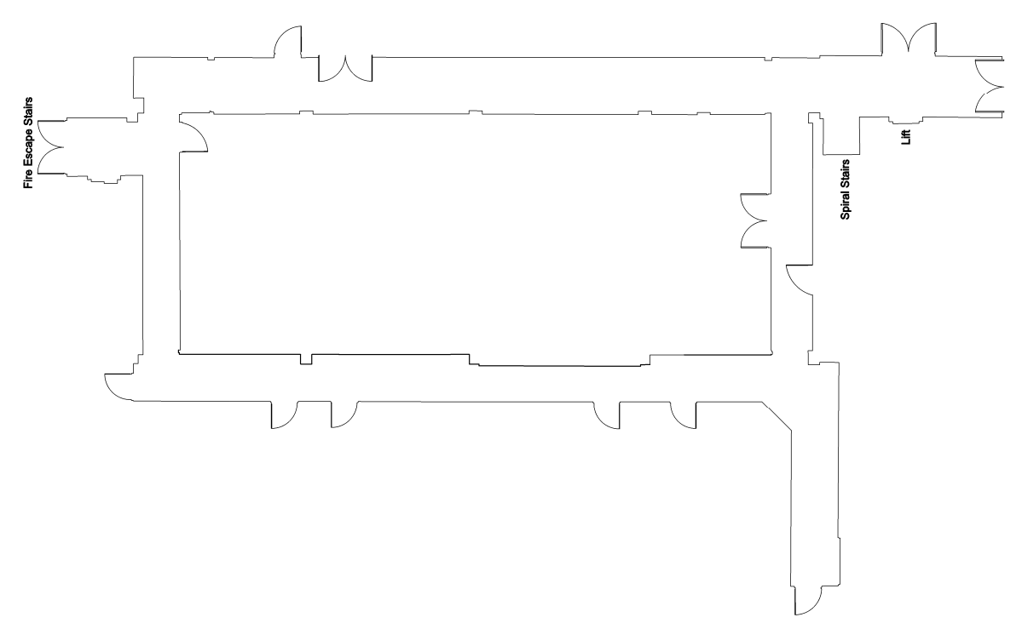
These issues were managed through communication, repositioning the scanner, and performing additional scans where necessary. Despite minor setbacks, the overall dataset was complete and of high quality.

The Image above shows the floor plan scan produced by the laser scanner in the specified DTC corridor. All doorways and features are clearly displayed without interference and allows the final user to easily distinguish the layout of the space.

PART 3 — MEASUREMENT & ANALYSIS

Using the processed paper scans, several key measurements were extracted to evaluate the size and geometry of the surveyed space.

1. Extracted Measurements

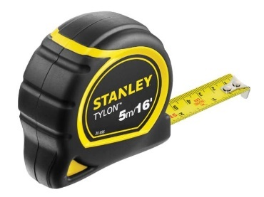
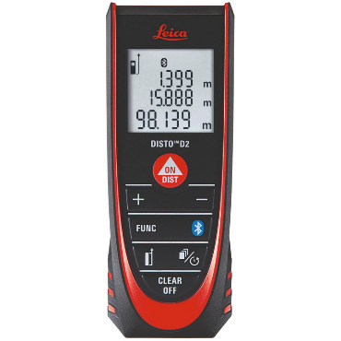
Once we had drawn a rough copy of the corridor layout, we could then take measurements using a traditional tape measure, 30cm rule and laser distance measurer. These were drawn using a pencil and rule.
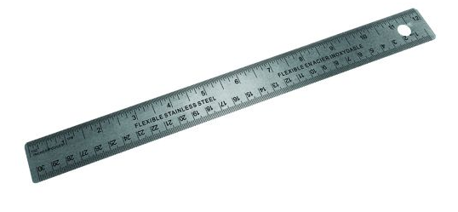



All the measurements are included and produced on the copy bellow.
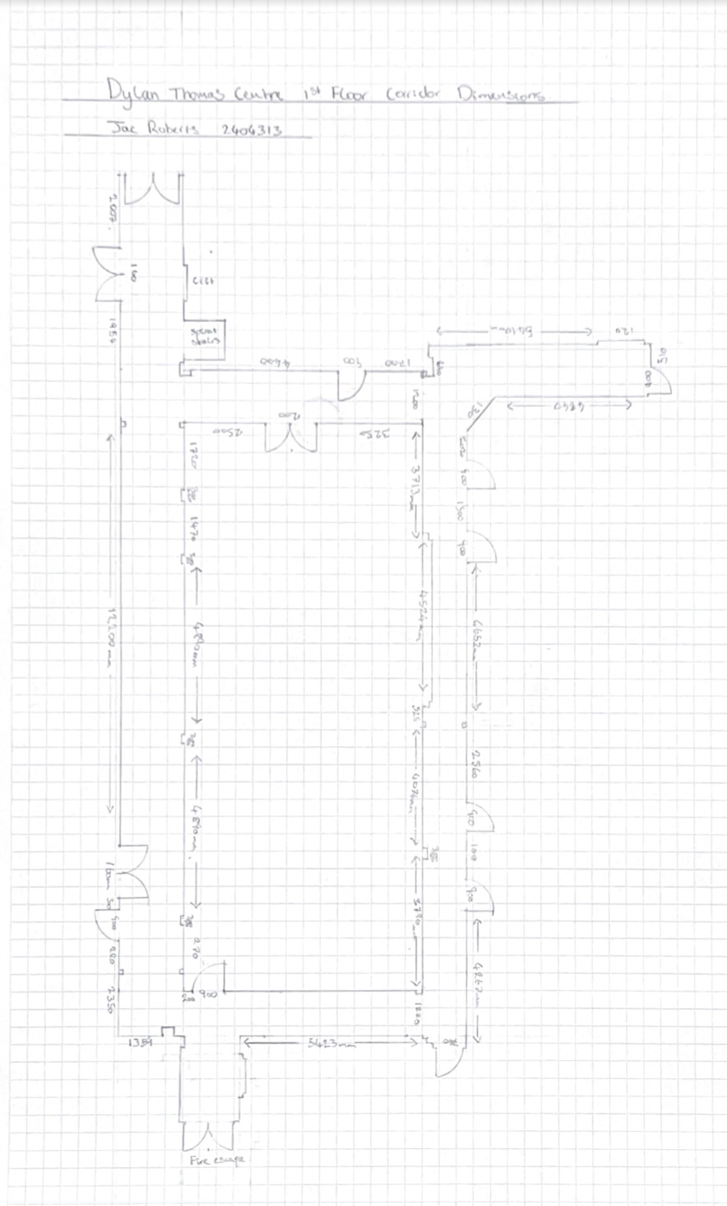
The measurements were taken in millimetres and then drawn in 1:100 scale.

As the drawing is a plan copy the ceiling hight is not included on the drawing.
Ceiling height: 2400 mm

2. Comparison with Manual Measurement

When comparing 3D laser scanning to manual measurement, several clear differences emerge:

Accuracy:
Manual measuring relies a lot on the person carrying it out. Things like how steady the tape is held, how accurately lines are read, and whether measurements are taken straight all affect the result. Small errors can easily occur and build up, especially in rooms that are not perfectly square or contain obstacles. In comparison, laser scanning records many points across the entire space, creating a very accurate digital model. This method provides millimetre-level accuracy and reliable right angles, which are difficult to achieve consistently using manual techniques.

Time Efficiency:
When measuring manually, each dimension must be measured one at a time and often checked more than once to reduce errors. This can take a significant amount of time, particularly in larger rooms or more complex spaces. If something is missed, the site may need to be revisited. Laser scanning greatly reduces the time needed on site, as a full room can be captured in a short period. Although time is required later to process the scan data, the overall process is still more efficient and avoids repeat visits.

Completeness:
Manual measurement usually focuses on main dimensions and often excludes smaller details such as recesses, changes in wall alignment, or irregular features. These details may not seem important at the time but can become issues later in the project. Laser scanning captures the entire space, including walls, ceilings, openings, and unexpected features. This means that additional measurements can be taken later from the digital model without returning to the site.

Overall Assessment:
Overall, laser scanning was found to be more accurate, faster, and more thorough than manual measurement methods. Manual measuring is still useful for simple tasks or quick checks, but it has clear limitations in more complex environments. Digital surveying provides a more reliable and complete dataset, offering long-term benefits by allowing the information to be reused for future drawings, checks, or design changes.

References (Images):

Archiproducts. (2025). RTC360 LT 3D Laser Scanner By Leica Geosystems. [online] Available at: https://www.archiproducts.com/en/products/leica-geosystems/3d-laser-scanner-rtc360-lt_692127?srsltid=AfmBOoo6QxDWNO--NZnSfjV6XKux_Y01ionoloM12143skbNd4z0XWo3 [Accessed 5 Jan. 2026].

Cult Pens (2024). Staedtler Noris Pencil. [online] Cult Pens. Available at: https://cultpens.com/products/staedtler-noris-pencil.

Gstatic.com. (2026). Available at: https://encrypted-tbn0.gstatic.com/images?q=tbn:ANd9GcSDbR9l5CNWkABSXWG08PRmnin8GttlQ3XQog&s [Accessed 5 Jan. 2026].

Screwfix.com. (2025). Stanley Grip Tape 8m Tape Measure Set 2 Pack. [online] Available at: https://www.screwfix.com/p/stanley-grip-tape-8m-tape-measure-set-2-pack/127ky [Accessed 5 Jan. 2026].

Toolstation.com. (2026). Available at: https://cdn.aws.toolstation.com/images/141020-UK/800/AF218.jpg [Accessed 5 Jan. 2026].

TopHatch (2019). How to Create a Floor Plan • Concepts App • Infinite, Flexible Sketching. [online] ConceptsApp. Available at: https://concepts.app/en/tutorials/how-create-floor-plan/.

