Business Inquiry and Research (BMSP5007)
Alexander Hudson
Dr Alex Bell
6th May 2019

Contents
Introduction 3
Procedure 3
Data Presentation and Findings 5
Conclusion 13
References 14

Introduction

The topic that has been selected for this report is the same topic used to within the first report which is the Effects of Technology on Health and Wellbeing. The objective of this report is to collect data from multiple individuals that have used technology, how their lives were lived before the advancement of technology and what particular aspects of their lives have been affected by technology in a positive or negative manner (Ramasamy, 2018). The reason for choosing this area of study is due to noticing the accelerating change of technological uses along with the reliance and dependence of it. To analyse the data for this report, readable tables were created to provide a more in depth analysis on the chosen topic (Foley, 2018).

Procedure

The research methodology used for this report was the quantitative research approach. This research approach consists of using numerical data, enabling the data to be analysed in a systematic and impartial way. The research methodology of using the quantitative approach also enables the opportunity for increased sample sizes, takes less effort and time (Balnaves & Caputi, 2001). Also the researcher doesn’t have to go through the hassle of arranging dates and times for interviews which is used in the qualitative approach. The survey that was used to collect data from 10 individuals was created through the usage of SurveyMonkey (2019). After the completion of setting up the survey, a link was sent to 10 people through social media which would take them straight to the survey questions without the need to log in or provide details to participate. The participants were anonymous so identity is completely taken out of the equation in this research approach meaning that raw anonymous data was left to be analysed. The analysis of the data was conducted through the usage of SPSS which is used for statistical analysis in data (Techopedia, 2019) . The gathered raw data was copied over from SurveyMonkey into an SPSS file. After this, the data was then converted into tables.
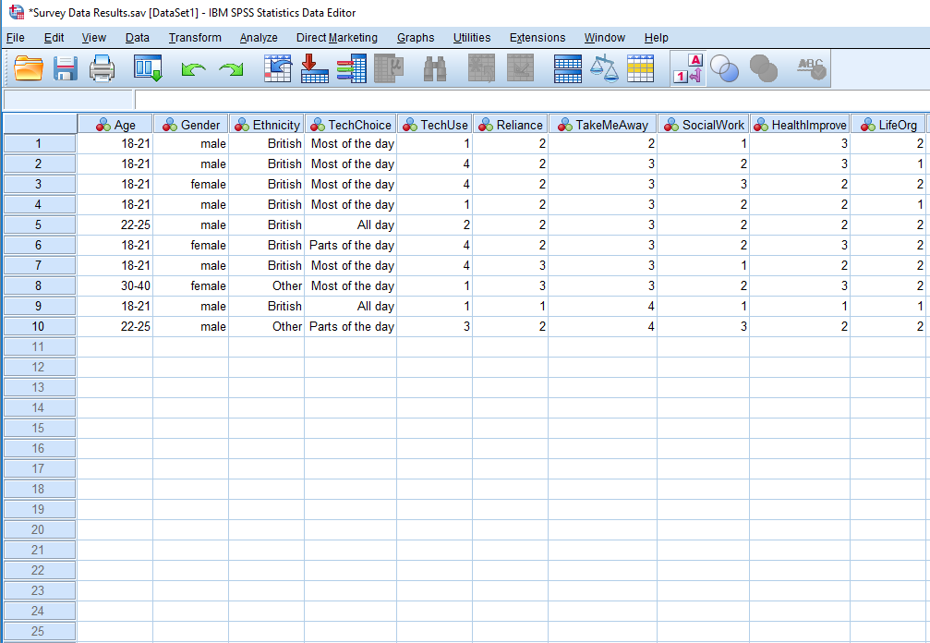

This screenshot shows the process of adding values and labelling them. This was undertaken by firstly converting the data from Survey Monkey into tables as shown to the left.

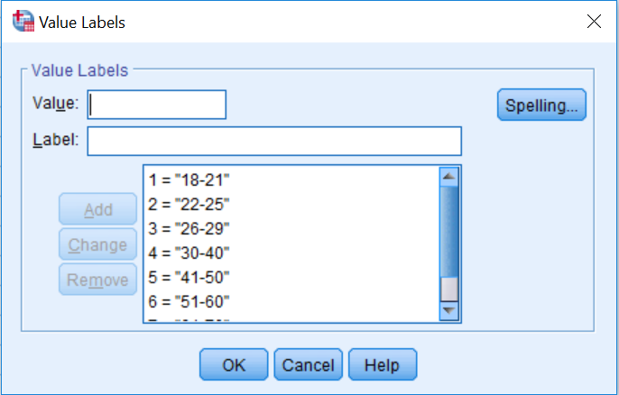
The next step was to add labels to the values. The screenshot shows an example of how it is done. What this does is it labels the data values for cross tabulation.

.
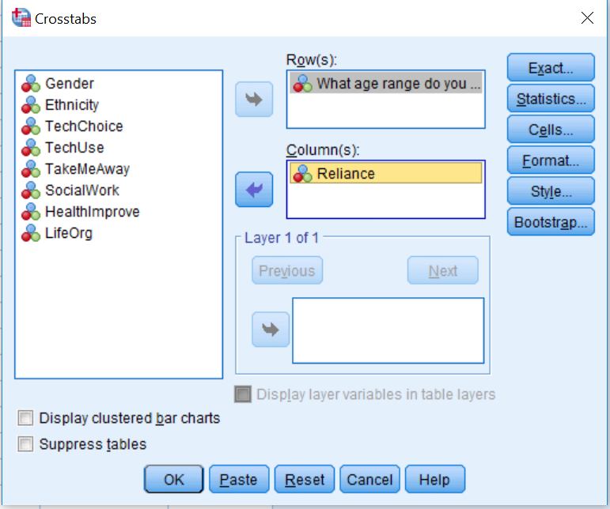
The final step of analysing the data is creating the cross tabulation between whatever data sets you choose. For example, in this screenshot I have chosen to create a cross tabulation between age range and the reliance of digital technology. This is a good example of cross tabulation as it provides a result of which demographic are more reliant on digital technology today.

Data Presentation and Findings
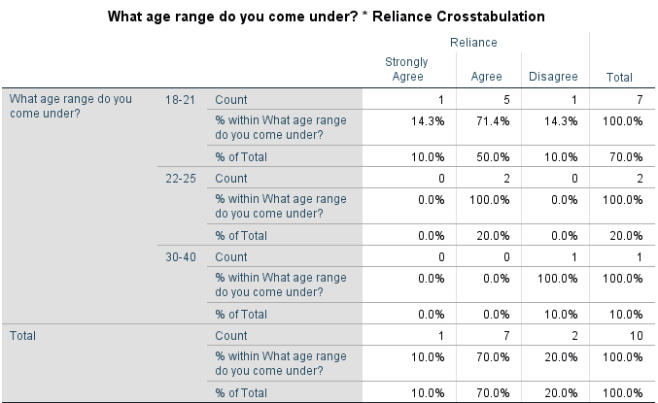

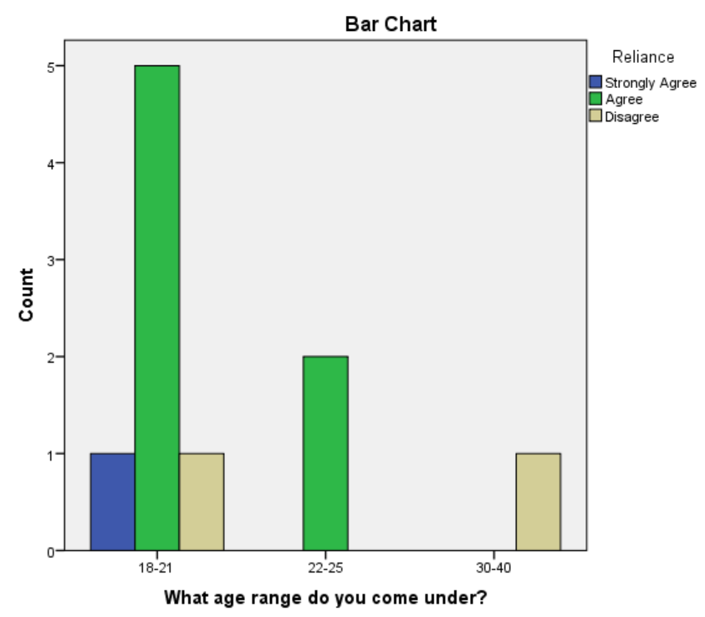
So looking at this, we can see that the younger demographic are more reliant on digital technology than the slightly older demographic. So this is a good example of showing correlation with age determining how reliant individuals are on digital technology. As the older demographic were raised and lived their early life without technology, they have as a result adapted to life without technology so it doesn’t hold much weight in their lives therefore they are less reliant on it.

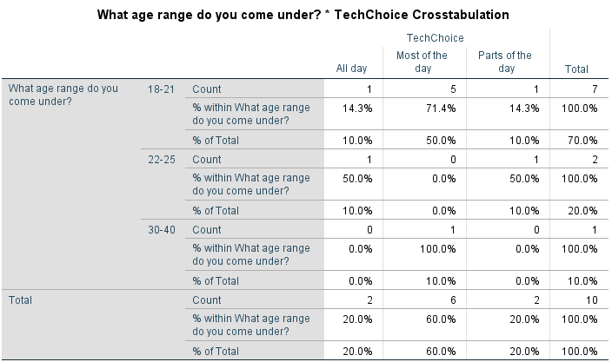

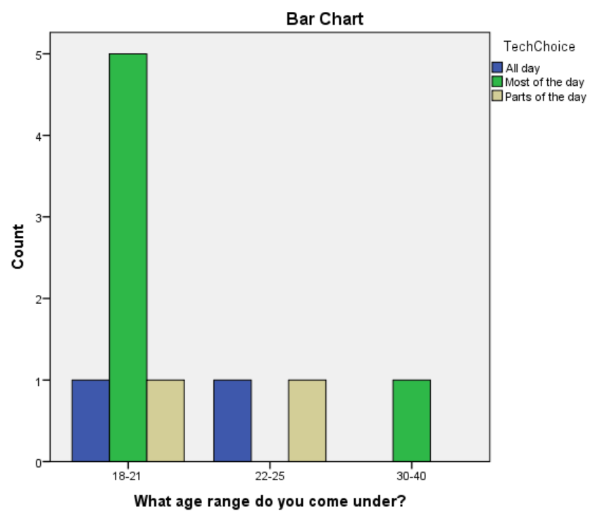
This screenshot shows the Cross tabulation between age and choice of technological uses. So as we can see, the younger demographic spend more of their time using digital technology than the older demographic. But speaking in general terms, all participants use digital technology every day. In this generation, young adults were brought up with minimal technology, but as they grew older, technology became more advanced. Therefore, the younger demographic have adapted to life with technology having an influence on their lives.

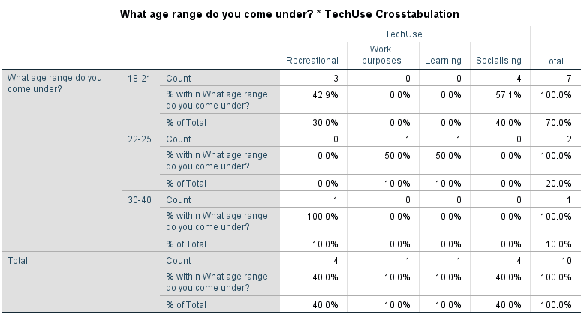

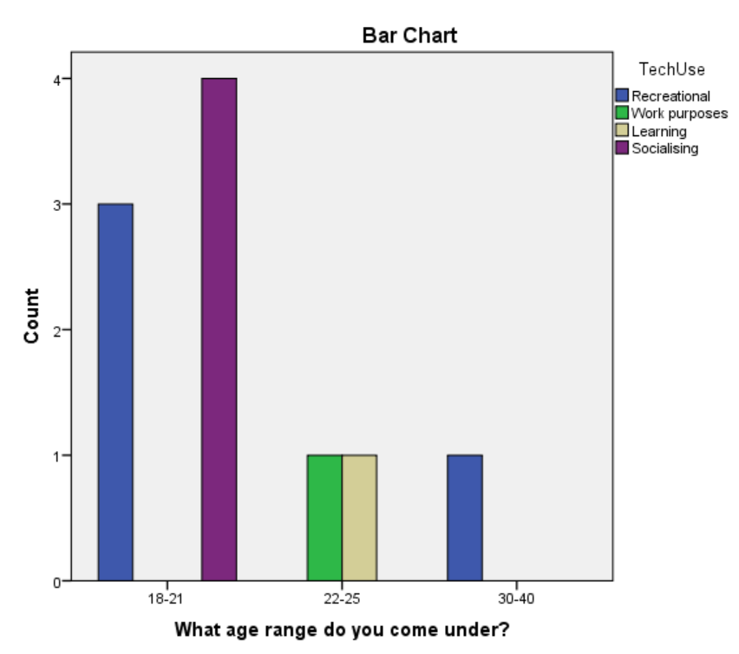
This screenshot shows the cross tabulation of how age can determine what participants use digital technology for. As we can see from this screenshot, the younger demographic mainly use digital technology for recreational and socialising purposes. There are some that use digital technology for work purposes and learning which is for when they are at college or university, however in their free time we can see that they mainly use it for their own personal benefit.

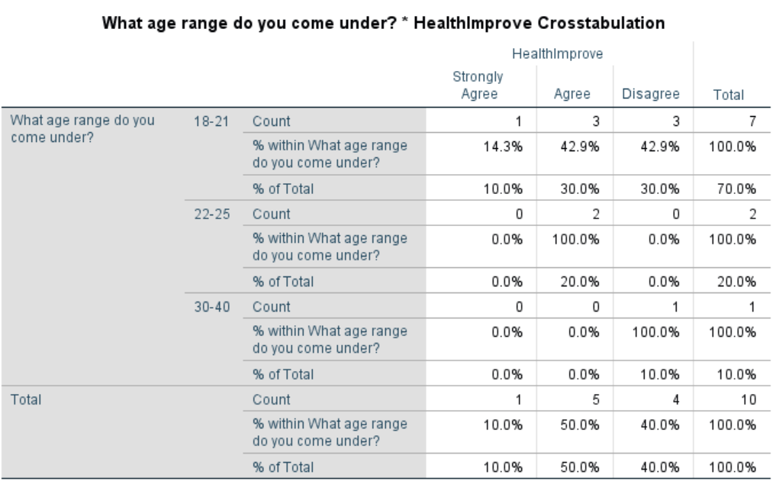

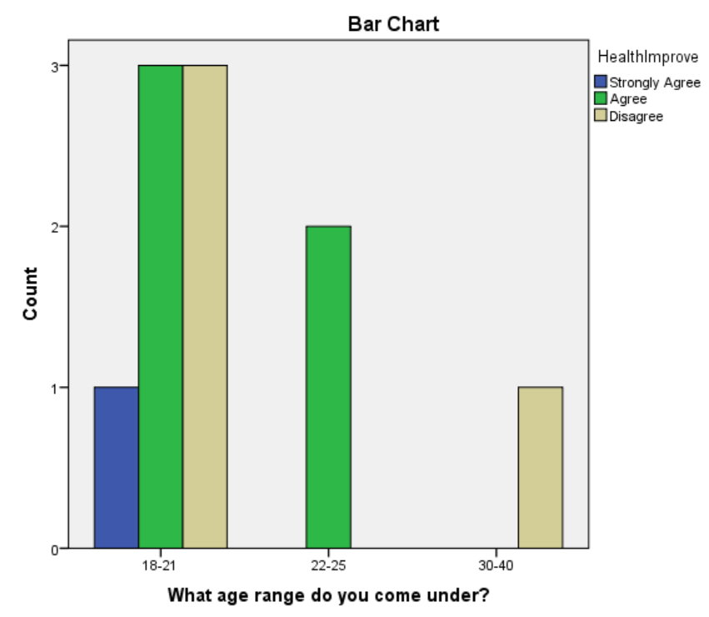
The screenshot above shows the cross tabulation of whether digital technology has improved participants’ lives determined by their age. As we can see the younger demographic has a bit of 50/50 result within 18-21 year olds but the end result provided by 22-25 year olds show that digital technology has improved the lives of a majority of the younger demographic.
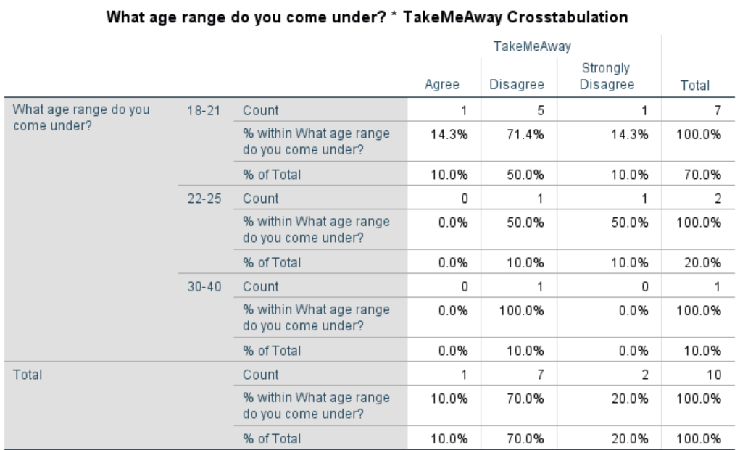

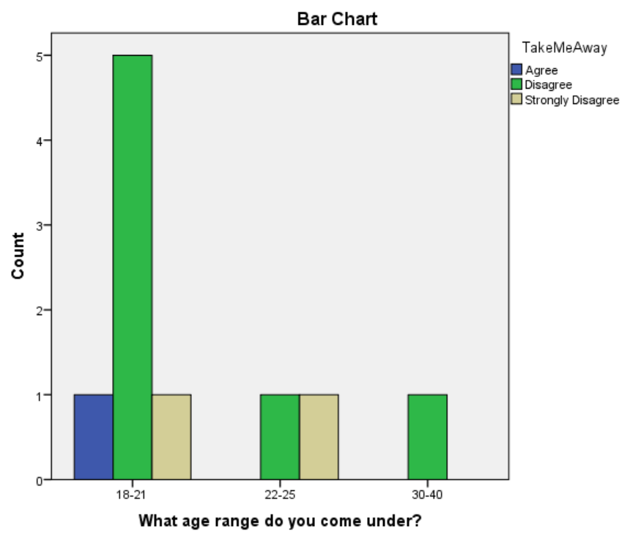
In the screenshot above, we can see the cross tabulation of whether age determines the participants being taken away from social events by digital technology. So by looking at the table, age doesn’t determine at all whether someone gets taken away by digital technology. The younger demographic have expressed this more strongly than the older demographic.

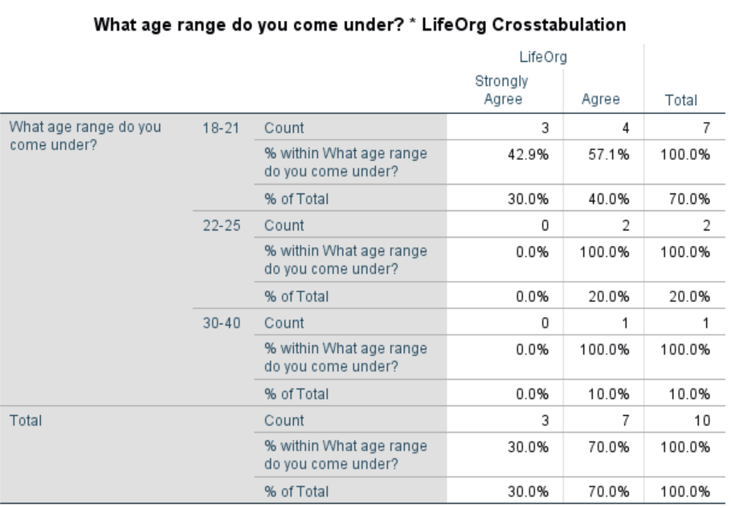

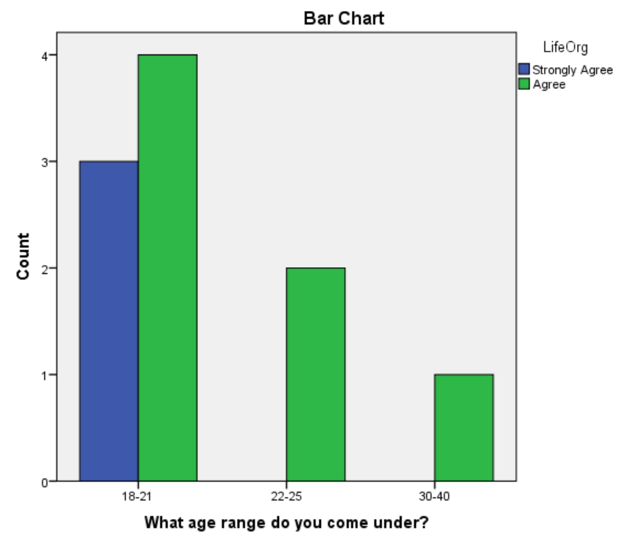
The screenshot above shows the cross tabulation of whether digital technology has helped participants to organise their lives. As we can see from the table, every participant states that digital technology has helped them to organise their lives. This is a good example of how digital technology can be beneficial for society despite the criticisms it receives for having a negative impact according to some people.

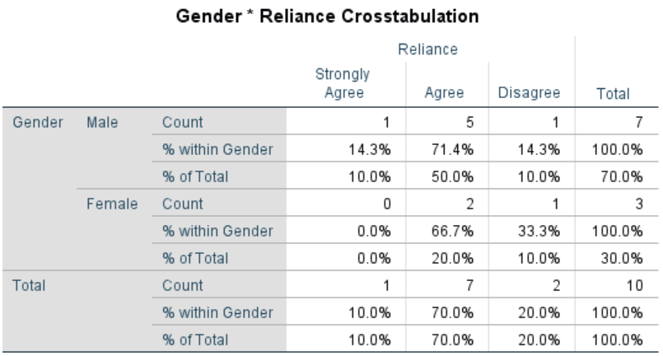

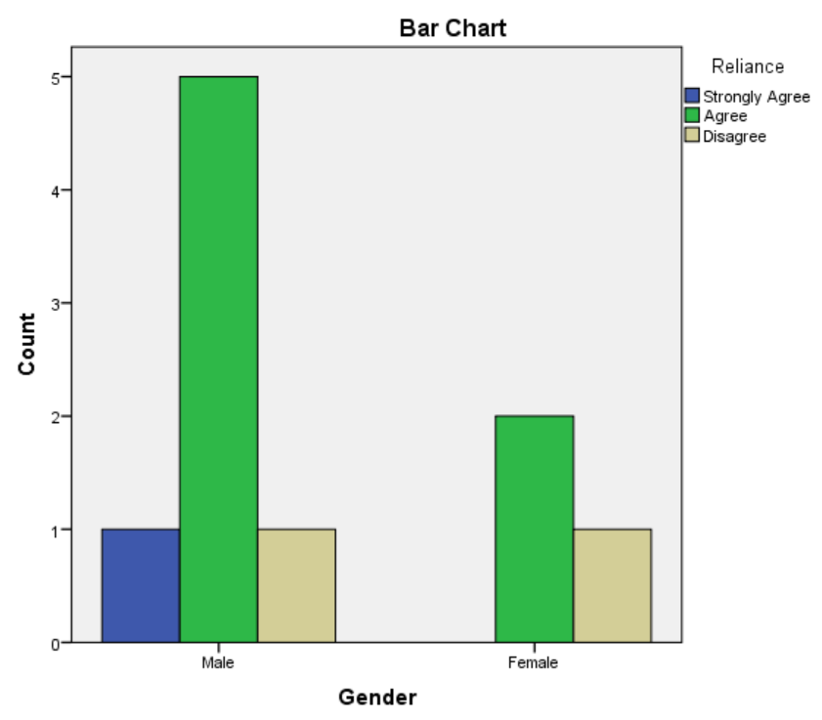
The screenshot above shows the cross tabulation of which gender is more reliant on digital technology than the other. As we can see, the majority of participants that are reliant on digital technology are Male. So this provides an interesting perception in terms of what Males and Females are interested in like for example, men are known for liking sports so this would be a good enough reason for them to use digital technology more often than women.

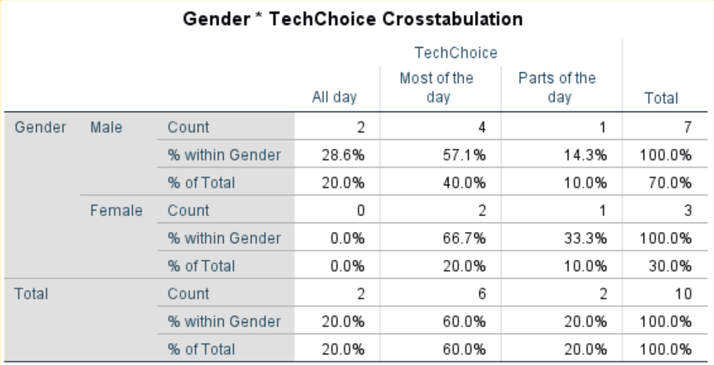

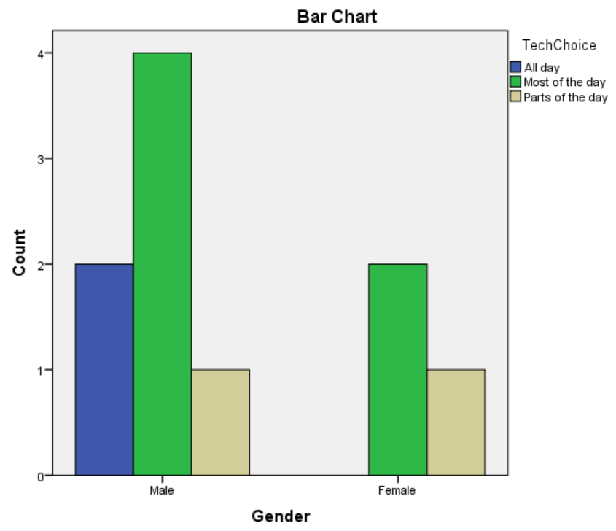
The screenshot above shows the cross tabulation of which gender spends more time with digital technology through their mobile devices. As we can see, the majority of participants that spend more time on their mobile devices are again male. The interpretation I gather from this is the same as the reliance cross tabulation. Men may spend more time on their mobile devices to watch sport broadcasts or games.

Conclusion

To conclude this report, the data gathered and collected from the created survey shows that there are clear connections between the demographical data. Age, gender, reliance and tech choice are the main findings from these connections. The key connection exists between participants’ age and their reliance on digital technology as well as their time spent on using digital technology. The same connections exists between participants’ gender with reliance and tech choice. Through these, the data pointed out a clear result for who is more affected by digital technology. To reflect on the quantitative research methodology as a whole, as always there are some strengths and weaknesses that need to be discussed. The strengths of using this research methodology include the simplicity of creating a survey and handing it out to multiple participants instead of arranging interviews. It was also much more appropriate creating cross tabulation tables as a method of analysing the data for any connections and gathering some clear results.
However, the weaknesses of this research methodology include not being able to delve deeper into the choices made by participants due to anonymity. Another weakness is that the data sample is too small to determine whether the results are highly accurate or indeed carry any meaning. However despite all this, the SPSS tables were very useful of showing a good raw data in a format that can be easily read thus making the connections more clear. During the reflection of this research methodology, I realised that it doesn’t really answer the main question of my research. I think this is mainly because my research topic is a topic that can’t really be explored with this research methodology to provide accurate, clear data.

If I were to undertake this study a second time, I would send surveys out to a larger number of participants in generally and to the older demographic to collect more accurate data. I would also add more questions to follow up on the more important questions to get a clearer result. At the start of this task, I wasn’t 100% sure what answers to expect so I asked question that I thought were most relevant at the time, but looking back now I feel like I could have asked more questions to follow up on the essential questions.

References
Balnaves, M., & Caputi, P. (2001). Introduction to Quantitative Research Methods: An Investigative Approach. SAGE.
Foley, B. (2018, March 1). How Cross Tabulation Makes Your Data More Actionable . Retrieved from Surveygizmo: https://www.surveygizmo.com/resources/blog/cross-tabulation/
Ramasamy, A. K. (2018, May 11). How Is Your Well-Being Affected By Technology? Retrieved from Leaderonomics.com: https://leaderonomics.com/functional/well-being-affected-by-technology
Techopedia. (2019). Statistical Package for the Social Sciences (SPSS). Retrieved from Techopedia: https://www.techopedia.com/definition/12401/statistical-package-for-the-social-sciences-spss
SurveyMonkey (2019) Available at https://www.surveymonkey.com/ (Accessed 02 May 2019)

