
Component 1: Design and Implementation of a Relational Database System
Introduction to Web and Database Concepts - ACCA4023

Sadhana Jha

November 1, 2025
UNIVERSITY OF WALES TRINITY SAINT DAVID

Contents
Scenario Analysis 2
Entity Relationship Diagram (ERD) 2
1. List of attributes and their descriptions 2
2. List of relationships and their meaning. 2
3. ER diagram: 2
Normalization 2
Sample Data Population 2
Query Development 2
Testing and Validation 3
Design Decisions and Future Work 3
1. Design Decisions: 3
2. Future Work: 3
References: 3

1 . Introduction
Medi link pharmacy is the rapid growing business that have manual method to manage their medicine supplies,suppliers customer details pretty much everything.the manual process can be hard to maintain and likely have errors and mistakes.which negatively effects day to day work.
This project is to design and implement Microsoft access data base system to make all the operation automatic.the data base will improve daily operations and management decision making.

Scenario Analysis
Medilink pharmacy is growing rapidly in medication business but there method of operating is still old.currently they are managing their operations manually which create error and mistakes and make it hard to manage all the data.with the help of Microsoft the data base will be created to help maintain the data smoothly.

Entity Relationship Diagram (ERD)

List of attributes and their descriptions
- The database will include several entities.The Medicine entity will include information about the medicine available at medilink pharmacy such as medicine ID,medicine name ,category,price,stock number,expiry date ,manufacturer date and supplier details.The supplier entity will include supplier name,supplier ID,contact number ,email,and supplier address.The customer entity will include customer ID,name ,address contact number,date of birth.
- The prescription entity will include record of medication given to the patient by the doctor which include prescription ID ,date ,customer ID,doctors name.
- The sales entity will include Sale ID,sale date ,amount and customer ID.These entities are connected through relationships.for example one supplier can supply many medicine,one customer can have more then one prescription.

List of relationships and their meaning.
Supplier and medicine | One to many | One supplier can supply more then one medicine but one medicine is supplied by one supplier
Customer and prescription | One to many | One customer can have more then one prescription but one prescription is belong to one customer
Customer and sales | One to many | One customer can buy many medicine but sale is belong to one customer
Medicine and sales | One to many | One medicine can be sold more then one time

ER diagram:
The structure of database can be represented by using ER diagram. [1]
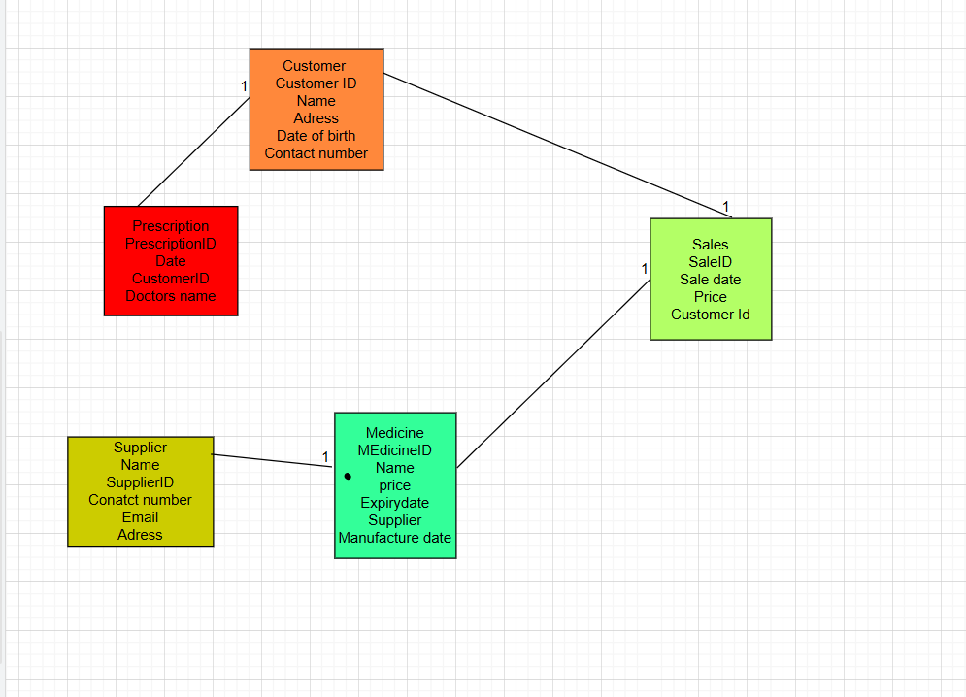

Normalization
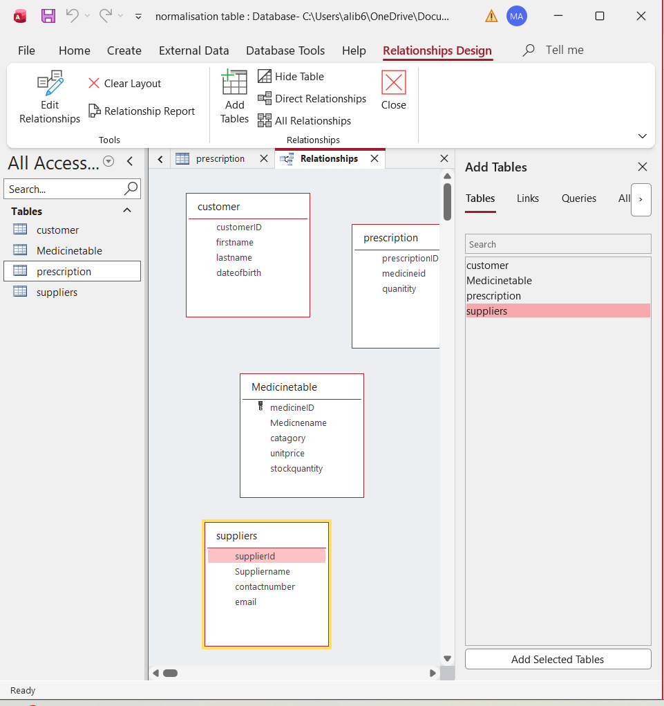

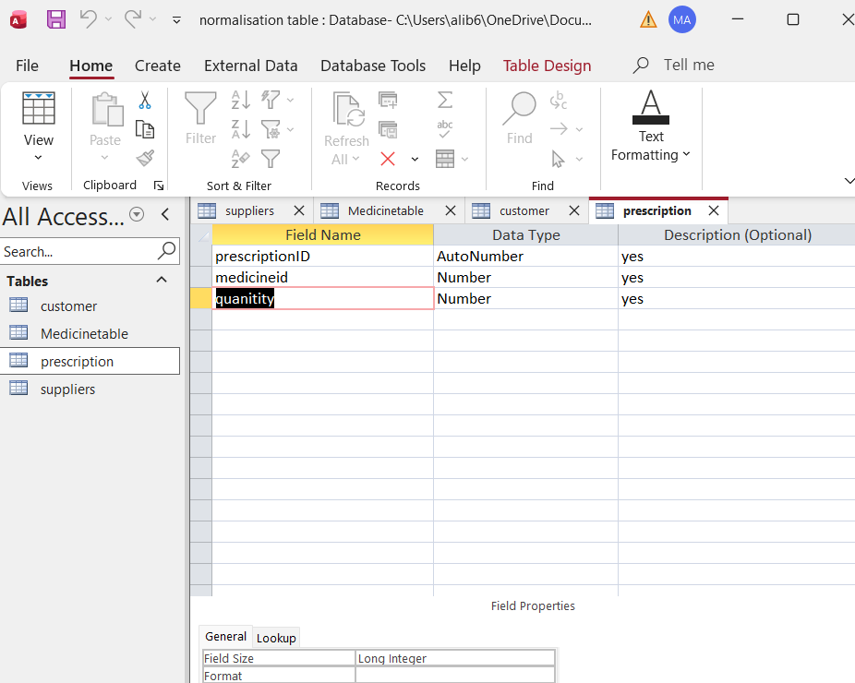
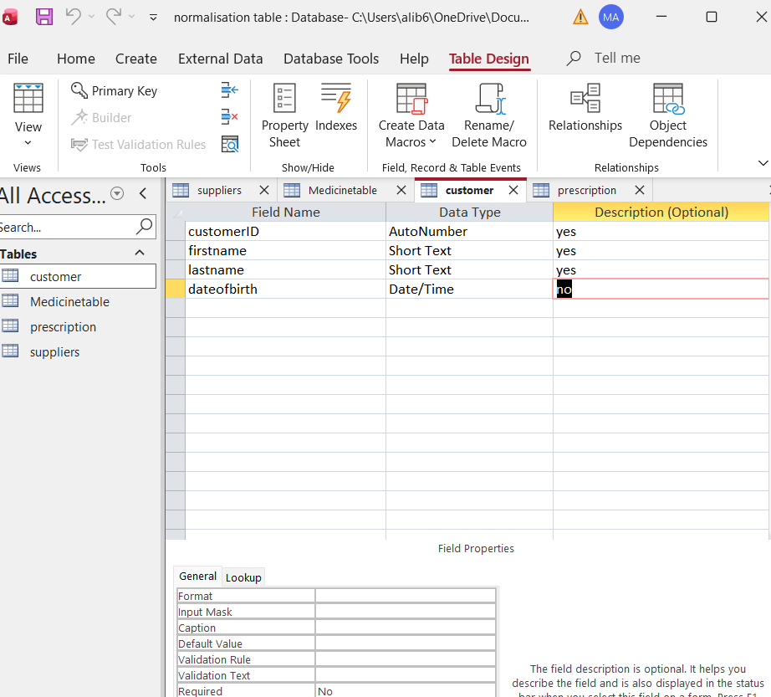
NOW data base is in 3nf
No repeating data
No partial dependencies
Properly linked table
Data integrity enforced

Sample Data Population
Data population is the data we store in tables. [2]
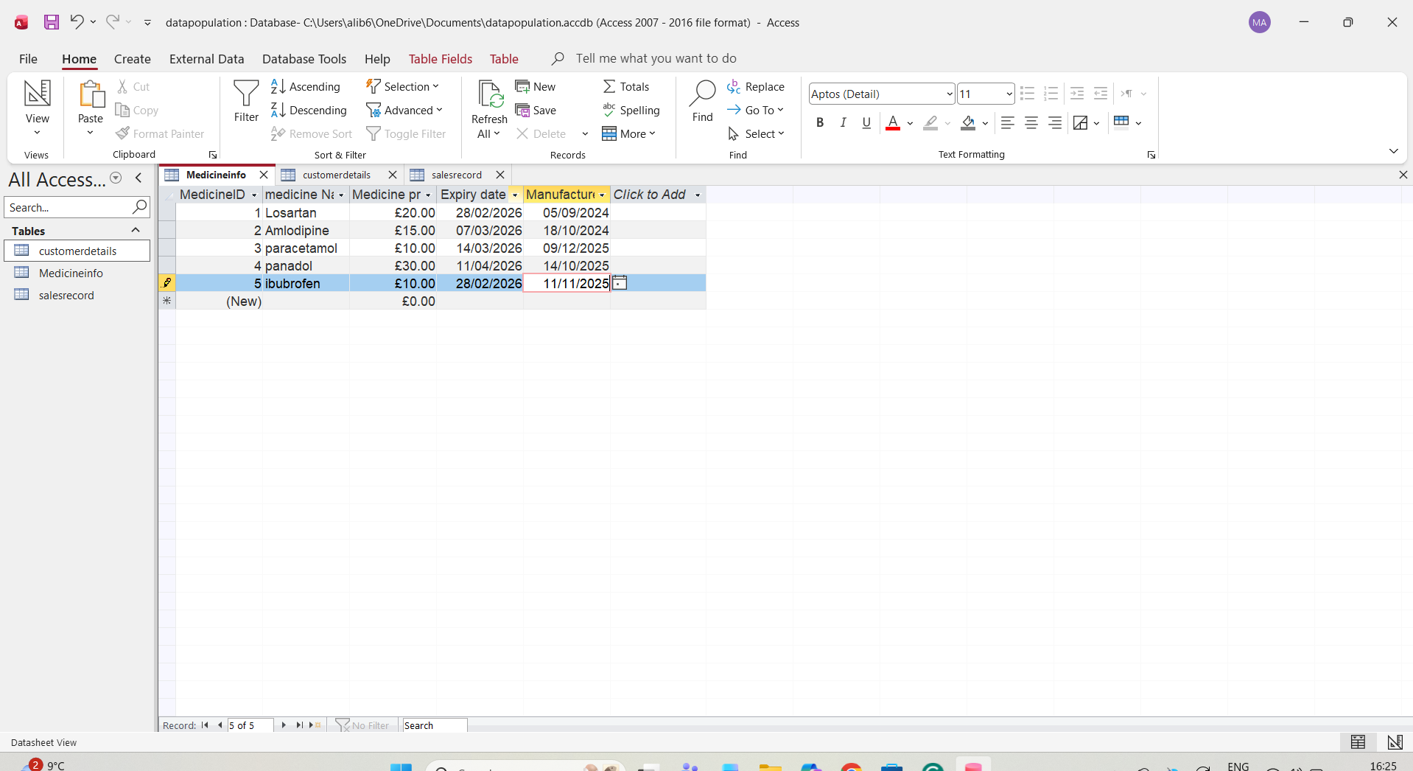
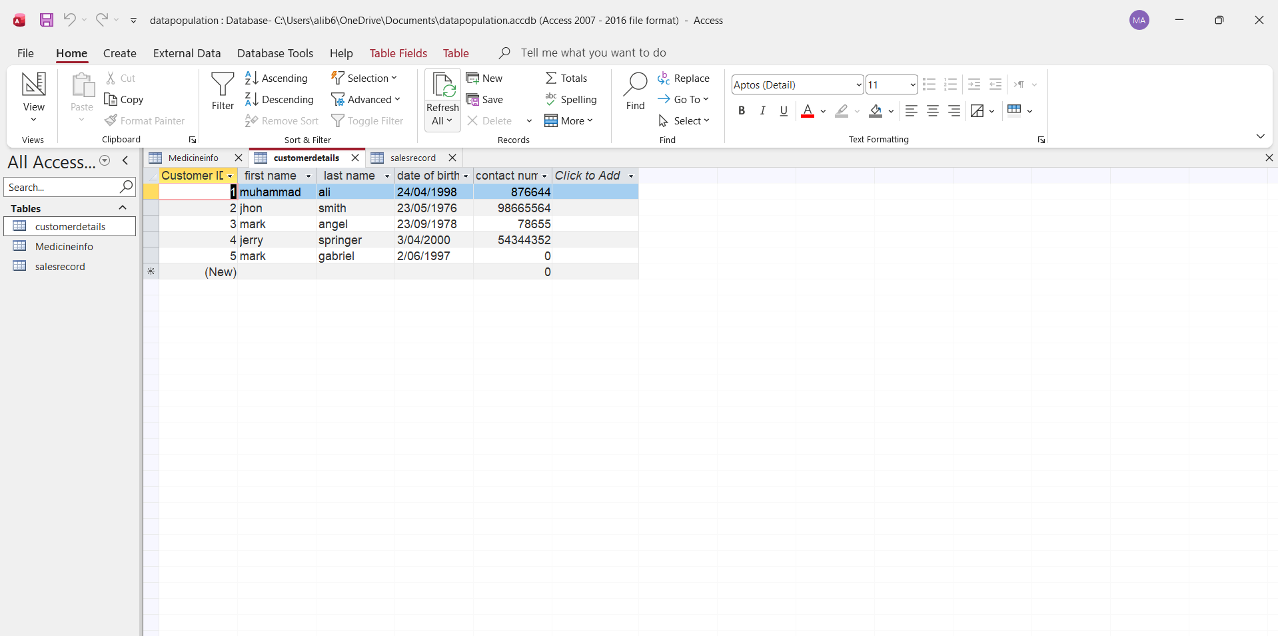
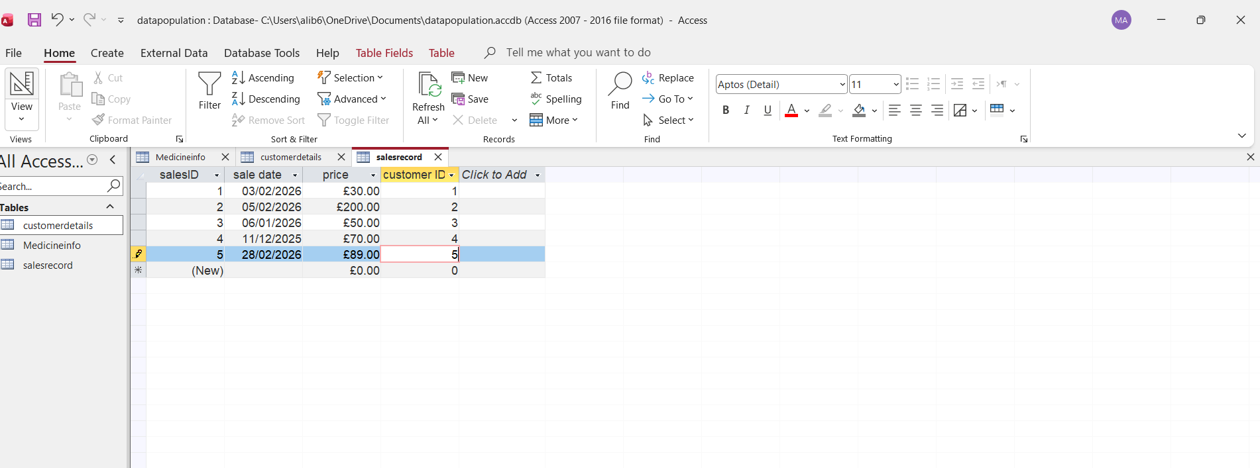
Query Development
First query picture explain how to find all the customers and their details
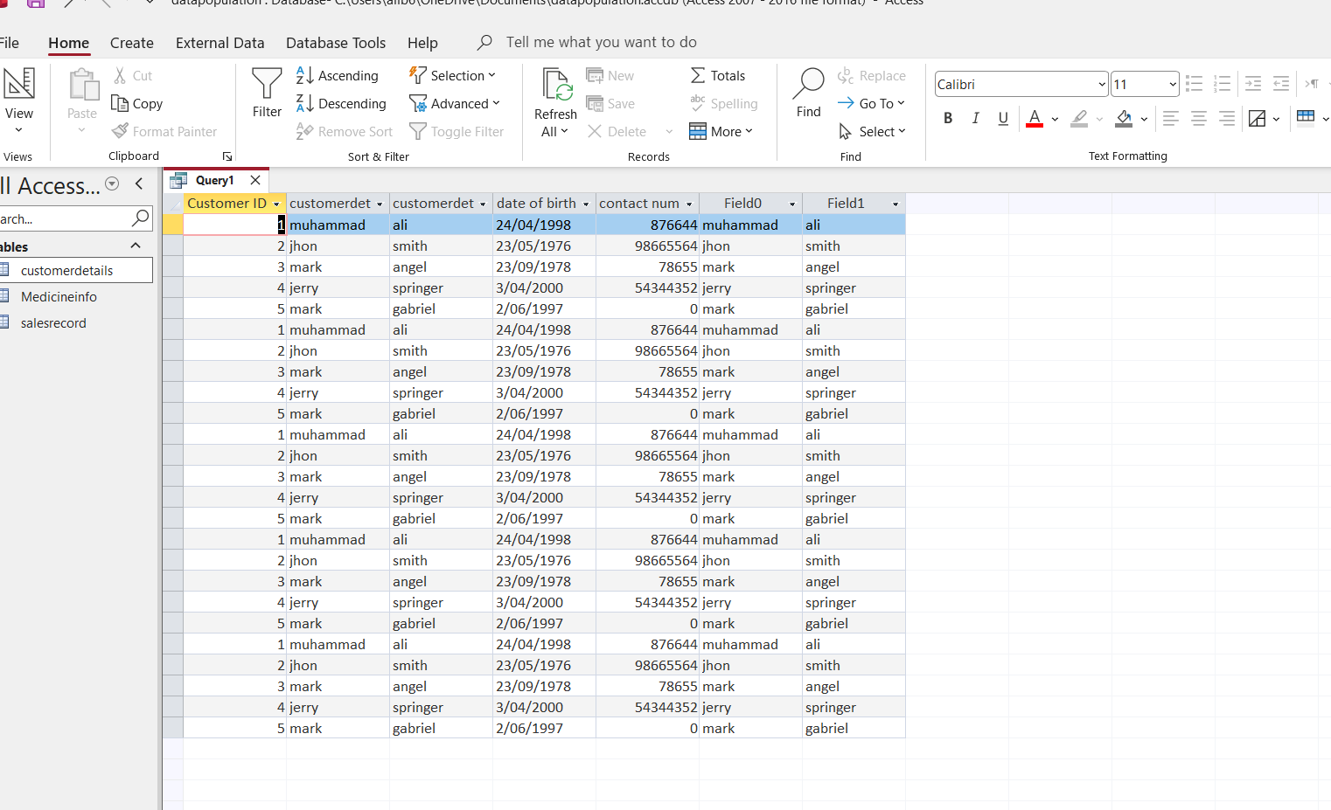
2.in this query we found a specific customer details by using customer ID

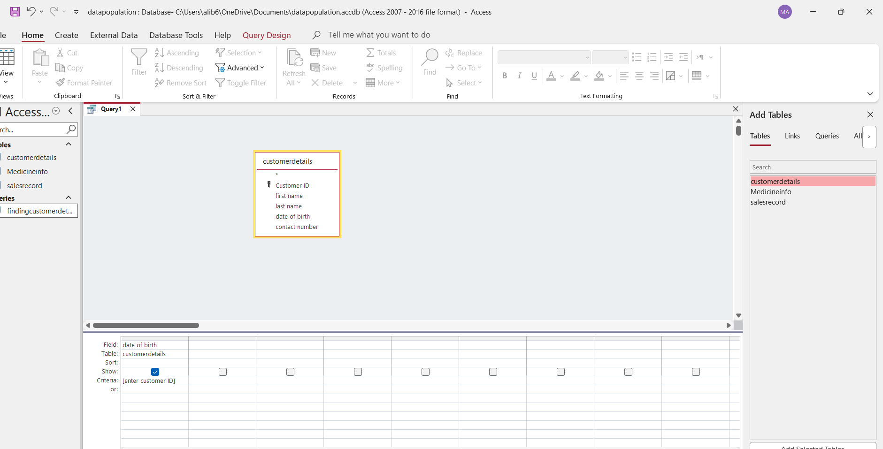
3.we run this query to find customer and sales
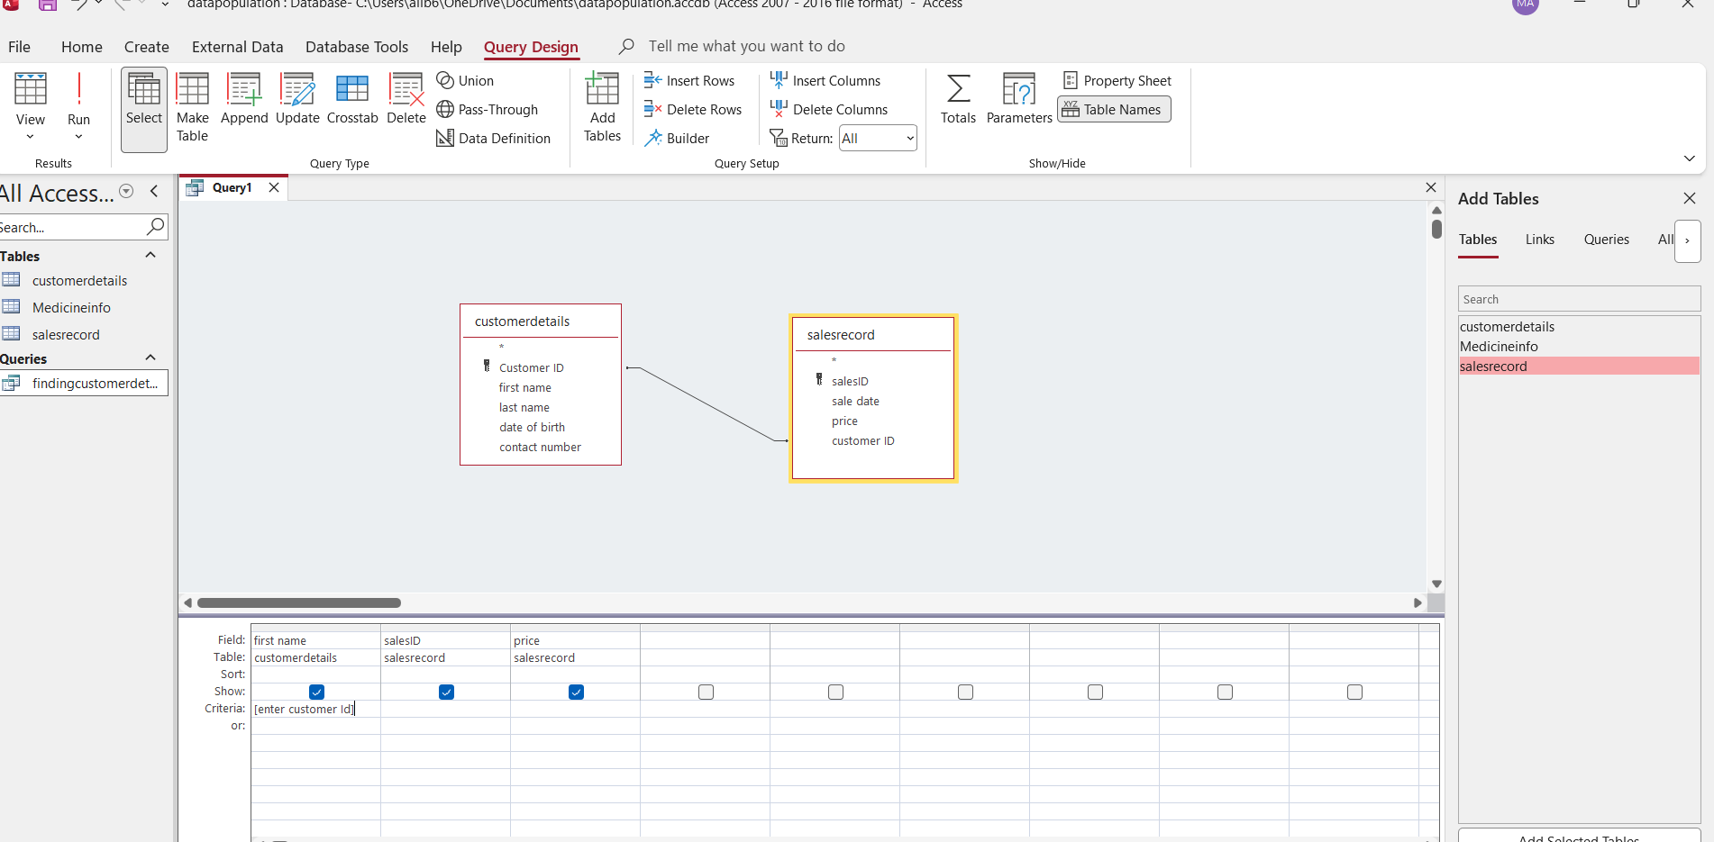
4.this query explain which customer bought medicine at certain price

Testing and Validation

Tried to enter sales record with different data type system rejected it
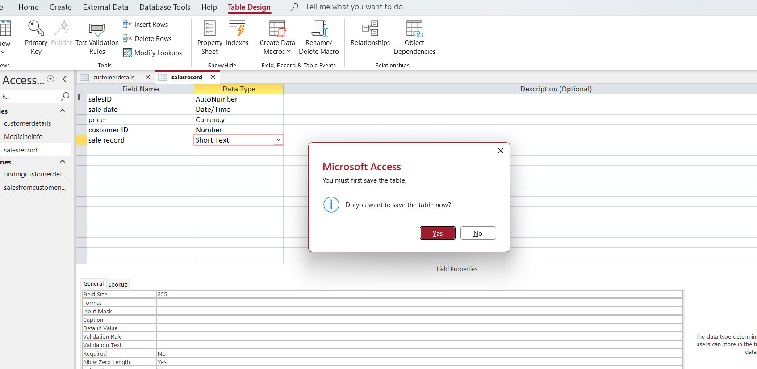
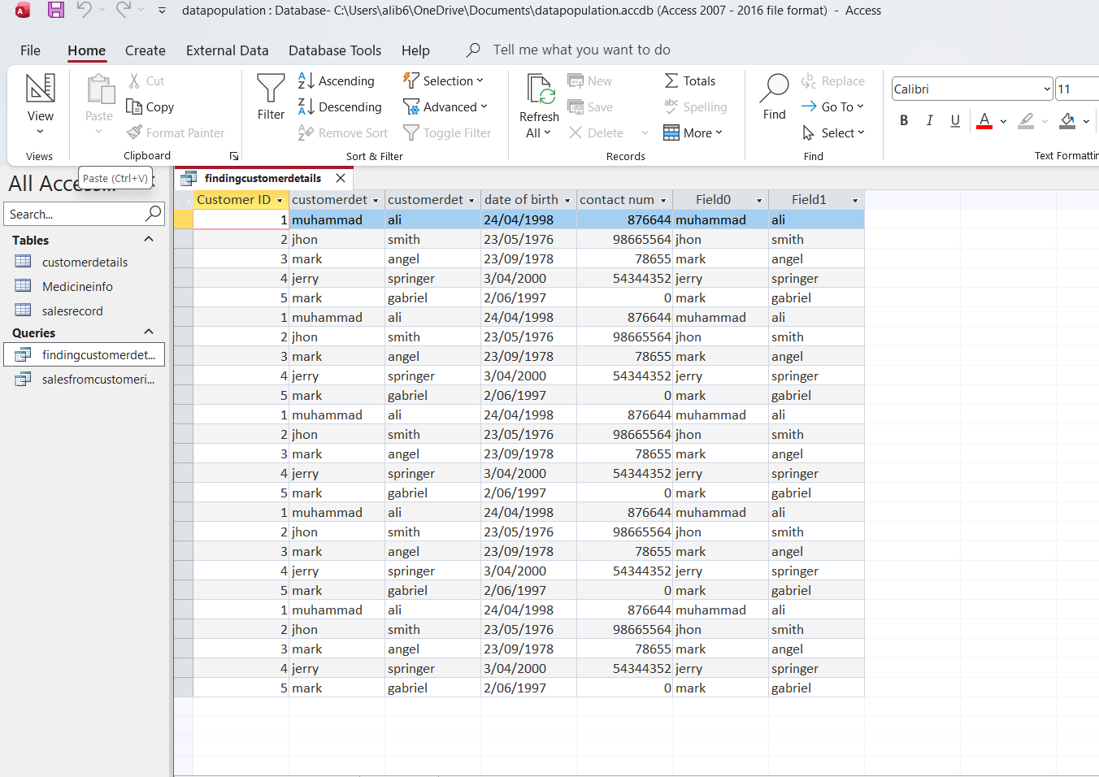
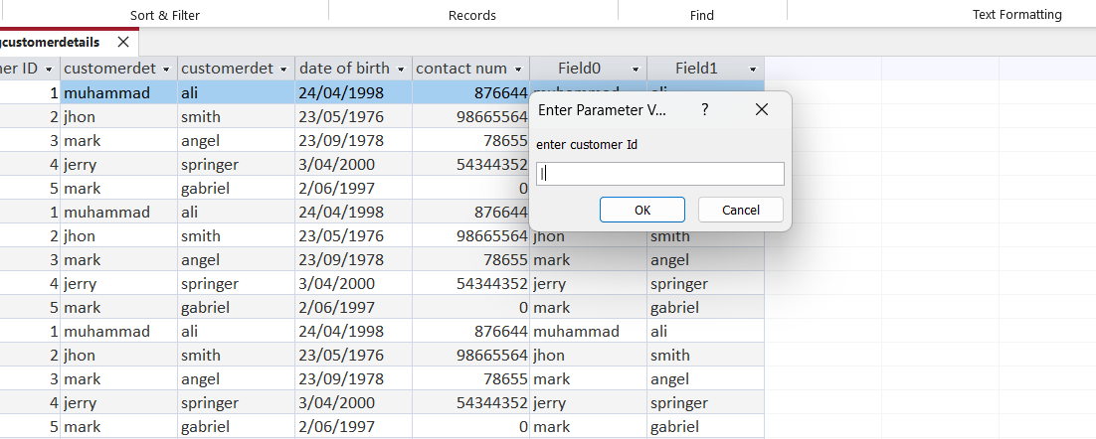
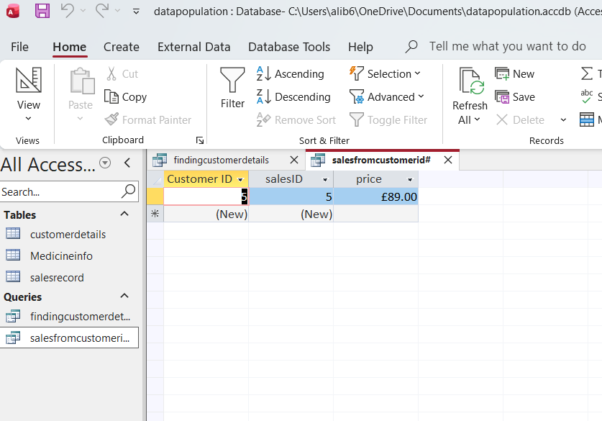

Design Decisions and Future Work
- Design Decisions: the design of MEDILINK pharmacy was based on organized data to work in better way.system is designed in tables form including separate tables for sales,medicine,customers,prescription.All the information is stored in sperate tables rather then repeated in different tables.
Primary key wes set to autonumber to uniquely identify dataforeign key used to link tables.data base was normalized to 3NF to make sure it runs smoothly and ensure integrity.
The main challenge I faced is to choose correct data type which is very important to make sure data is being saved correctly and not mixing or repeating itself.if it chosen wrong it can cause wrong data entry and errors will happen.

- Future Work: in future I would like to implement user login so that only authorise staff can access the data.another feature I would like to add is automatic stock checker to notify when medicine stock is low.

Data Structure Development:
Data structure plays very important role in efficiency of computer programme [3].Data structure development involve creating tables based on Er diagram.we use Microsoft access to convert each entity into its own table.every table is consist of primary key and data type to be uniquely identified.
Foreign keys are used to create relationship between tables to allow data to connect with each other.refrence integrity is to ensure false data cannot be entered into tables.this mean you cannot reference record which does not exist.

References:

List of reference sources in IEEE format

