

Comparison of blended learning approaches with face-to-face instruction in post-16 settings, with an analysis to determine impacts on student outcomes.
Laurence Blake (1806184)

March 14, 2024
UNIVERSITY OF WALES TRINITY SAINT DAVID
ECPT6009


Executive summary
This action research project explores the comparisons between blended learning and face to face tuition.

Results of the

1442 words left

Table of Contents
Executive summary 1
Introduction 3
Review of Literature 3
Methodology. Benefits and limitations of the methodology. 6
Results & Discussion 7
Conclusion. 10
Recommendations 11
References 11
Appendices 13
Appendix A 13
Appendix B 15
Appendix C 16
Appendix D 17
Appendix E 18
Appendix F 19
Appendix G 20

Introduction
To begin with this action research project will demonstrate the comparison between blended learning and face to face instruction within post 16 setting, this action research project will also determine its impact on student outcomes. Face to face instruction is simply where students are in an educational setting, like a classroom and are taught directly by a teacher, and or a lecturer within this live and interactive setting. The purpose of face-to-face instruction is to be in person in the same facility as their teacher or lecturer, whereas blended learning approaches combines face to face interaction with digital activities according to Kintu, Zhu & Kagambe (2017).
As we experience changes evolving within education there has far greater use of blended learning within education, of which has stemmed from the COVID-19 era of where far greater level of blended learning practices were used within this period within education according to the Learning and Teaching Reimagined Report (2020). As education settings return to pre COVID normality, there has been the question raised whether traditional face to face tuition is still required and valued when compared to the current demand of blended learning practice within the modern education setting. Where faculty members have very much preferred blended learning due to the flipped nature and positive impact on student experience and engagement, in contrast there are still educators that prefer the traditional face to face teaching environment (Ali, Khan and Alouraini, 2023). Following the comparison of the different forms of teaching delivery, a review on student outcomes will be reviewed to consider the best overall form of teaching delivery, to support lecturers, students and most importantly to determine the highest quality of student outcomes.

Review of Literature
To commence this section will separate both blended learning and face to face tuition, to determine appropriate benefits and limitations. Once this has been achieved this report will then compare the findings of the research and determining factors will be highlighted within this section. According to QQA (2023) Blended learning often refers to the combination of face-to-face instruction with online resources, allowing for some degree of student control over time, place, and pace of learning. Of which currently is being considered a far preferable choice with wider demographics of students since Covid.
Blended learning educational approaches that integrate traditional classroom teaching with online and digital media (QQA, 2023). While both aim to create a more engaging and flexible learning environment, there are subtle differences in their application. When compared with hybrid learning, on the other hand, typically involves a split between online and in-person sessions, offering a balance that caters to various learning preferences. Both methods are dynamic and adapt to the evolving educational landscape.
In numerous instances, educators exhibit acute awareness of their digital presence, attentiveness, and interactive involvement during online classes, as noted by Singh and Tewari (2021). The disposition towards virtual instruction profoundly influences the educators' self-regulatory aspects: attentiveness, interaction, and active participation. Their proficiency in conducting online courses largely hinges on these self-regulatory measures. There's a scant amount of research delving into how effective learning processes and self-regulation via technology are interconnected.
The shift to digital education has altered the perceived value and the intent to utilize technology within the educational sphere. Such insights became crucial when the COVID-19 pandemic compelled educators to transition to online teaching sans prior training or readiness, necessitating the adoption of various virtual teaching platforms. Educational virtual teaching platforms have been linked towards increasing levels of student satisfaction. Student satisfaction has significantly been increased with the likes of blended learning interactive platforms and multimedia resources to provide that diversified experience to learning. As Vojtesek, J & Hutak (2019), have indicated that blended learning uses and utilises effectively multimedia platforms including videos interactive simulations and educational games to provide that wider access learning experience for students. Some of the examples of particular learning experience software include Mentimeter, Blooket and Vevox.
It has been highly regarded that there are significant benefits associated with blended learning in particularly with regards to creating such a positive impact on performance attitudes in various settings. Research from Yu, Xu & Sukjairungwattana (2022) indicate that even though blended learning has been known to lead two significant academic achievements this is more seen disciplines such as computer science and STEM fields of academia. The effectiveness of blended learning has seen significant learning performance of which has been supported by such studies, more specifically showing an upper medium effect upon student learning performance and outcomes.
As a final benefit suggestion for blended learning, it is clear that it has been linked towards increased flexibility and accessibility for the learning environment. This can include areas such as scheduled flexibility of which there is a schedule provided around their learning commitment which is beneficial for those with additional commitments outside of learning such as family responsibilities care and work. Additionally blended learning also offers within this increased flexibility access to learning resources of which they do not have to be based on campus solely to access the information as students can be remote in order to access it (Kintu, Zhu & Kagambe, 2017). Some platforms and examples of this learning resource access can include Blackboard and Moodle.
Where the benefits have been highlighted it is evident the limitations of blended learning surround some various factors. For example, the design of blended learning delivery plays a significant role towards students’ motivation. Whereas if the course has components and content that are not engaging or appropriately structured, this can significantly impact students’ motivation and have an impact on the student outcomes (Permata & Nanda, 2020).

A further aspect with regards to the limitations of blended learning pays tribute towards technological barriers. Whereas blended learning does require an adequate level of technological infrastructure and requires digital literacy skills for both instructors and learners. With any lack of ICT skills could possess significant challenges for teachers and students for adopting such practises of blended learning especially for those students and teachers within developing countries (Chau, 2022).
As this takes a look at the opposing perspective of face to face instruction, this delivery of education has long been a staple in the higher education sector, traditionally signifying the physical presence of both instructor and student during the learning process. This method of delivery, characterized by direct interaction and immediate feedback, has been synonymous with personal engagement and effective communication within an educational setting.
Historically, the term 'face-to-face' allowed educators to distinguish between learning scenarios where visual contact was possible, such as tutorials, and those where it was not, like telephone conversations. This distinction was crucial in understanding the dynamics of communication styles within the context of educational delivery.
However, with technological advancements and the widespread adoption of videoconferencing tools, the definition of face-to-face communication has evolved. It no longer strictly implies physical proximity but encompasses any situation where participants can see each other, regardless of their location. This shift reflects a broader change in how we perceive presence and engagement in a digitally connected world.
As such, face-to-face now denotes whether communication—and by extension, some aspects of teaching and learning—is occurring in person or remotely. This redefined understanding bridges the gap between traditional in-person interactions and modern remote connectivity, acknowledging that visual contact can be achieved across distances, thereby expanding the possibilities for educational delivery.

Methodology.
As we begin to discuss the methodology of this action research project, a mixed methodology approach has been used. By adopting a mixed methods approach combining both qualitative and quantitative methodologies would provide further depth of detail of which can be utilised to support key findings of this primary research.
According to (Coghlan & Brydon-Miller, 2014), quantitative research methodology is subject to set research techniques to explores approaches towards numerical data, whereas qualitative research on the other hand focuses on gathering data supported by various forms of an individual’s experiences. These methods delve into individuals' interpretations of their own actions, as well as those of others, and the belief systems that underpin such behaviours. Where this has been applied within this actual research project has been using data collection through multiple choice questions of which provide good sample sizes of which correspond to support answering the key research question (McAteer, 2013).
A key point to recognise of the data collection is th at the software Vevox (Vevox, 2024) has been utilised to support the research data collection, of which some of the beneficial features would include maintaining the integrity of the participants anonymity of which safeguards these participants. However, as the participant anonymity is protected which is a benefit, the limitation with the use of Vevox has clearly noticed that due to the anonymous nature the software provides difficulties to identify the key demographic and participant who have made a particular response. From this occurrence, this may result in more of a general perspective, rather than specific research. Therefore, as part of the participation requirement, clear criteria has been made as part of the initial invite to participate, clearly stating that they must be a lecturer, or teacher who has taught in both face to face and blended learning environments.
As per Appendix A, this action research project has managed to capture four participant responses, of which each participant has met the minimum criteria, as stated previously. Respondents were asked exploratory questions with regards to the experiences of their own challenges in face to face and in blended learning, and to delve into their own perspectives with the evidential preference.
A limitation within this action research project and use of this tool must be completely down to the researcher, end of which clear participation requirements need to be clear before engaging in this research.

Results & Discussion
As the data presents itself, each question will be evaluated and related back to the main overarching question. Lecturer perception towards motivation of students compared from blended learning against face-to-face learning is rather varied. As Appendix B would indicate that there are varied responses in association to whether students are perceived more motivated from blended learning opposed to face to face teaching the responses from the participants are rather varied.
As for question two, in Appendix C would emphasise from the lecturers and teachers’ perspective that students appear far less engaged within the blended learning activities when compared to traditional face to face instruction. However, it is interesting to recognise that though from the perspective of the lecturer and or teacher, that shoots appear much less engaged by 50% and the remaining 50% considered the students to be somewhat less engaged when compared to the traditional classroom. Where the participants perception appears that students are far more less engaged during the blended sessions, research from the the perspective of the student, from Kenney and Newcombe (2011) recognised that students have significant positive outcomes with terms of satisfaction performance motivation and knowledge construction within the blended learning environment. Essentially, where the lecturer’s perception of students is less engaged, it is apparent that on the student perspective the outcome appears far more positive and supports students satisfaction.
In relation to question 3
Benefits to blended
- enables flexibility so that students can learn at their own pace and at their own time of which supports autonomy within the learning experience
- regarding a demographic pedagogy mature students may prefer an online environment of which enables them to have a balanced lifestyle towards learning work and family lifestyles
drawbacks to blended
- signifies centre isolation and disconnection from not just the teaching faculty but on a social element, of where students could struggle with self regulation and motivation within these environments
- Students have been seen to struggle to access technology which has been frustrating and disruptive towards other students who have a greater technological capability. This can be link towards great difficulty to manage students on an equal level and difficulty has been seen to ensure that everyone is engaging.
- The teachers ability to have knowledge with the technical hardware and software is paramount to the success of lectures, however if this is not achieved it can have great impact on the value of the education being delivered

As for question 4
benefits for face to face teaching
- Face to face teaching enables the lecturers to establish far more positive relationships oppose to online delivery
- Easier to engage with students within the face to face teaching environment

drawbacks with face to face teaching
- Students will not always show up to face to face sessions, which can impact their attendance and potential outcomes
- Depending on the lecture at hand less technology application could be required of which does not impact the lesson and all the student experience and value

Question 5 regards to how well student concepts are embraced when comparing the delivery styles of face to face and blended delivery
blended delivery
- By using technology effectively can heavily support engagement within the blended learning environment such formats include online quizzes and surveys which encourage feedback and collaboration amongst peers to support the enhancement of blended delivery.

face to face delivery
- With in face to face delivery instructors can observe student reactions and interactions far more directly that way they can do it in more asynchronous and indirect methods of valuation.
- Body language enables the instructor to get a feel for the room and to assess student learning fatigue to justify when brakes can be taken to support the student learning environment
- Students within the face to face delivery a far less prone to evict themselves or walk away from the learning environment when compared to the blended environment. However search effort does determine striking a balance between the level of engagement and enthusiasm set by the lecturer and the students.

question 6 clearly describes that there is a clear landslide in favour of lectures and teachers in belief fat students achieve far better learning outcomes and overall learning outcomes in a face-to-face environment when compared with the blended learning environment. The reasoning behind this decision ensues behind the great levels of engagement of face-to-face teaching compared to blended learning from a participant perspective. Moreover, when compared with the blended learning environment where in cases the use of breakout rooms has resulted in a single student having to complete all the work individually opposed to a complete team or group effort.
A further response included the best form for student engagement is face to face however the future inevitably leans towards blended delivery. We said development of technologies ever growing and its reliance it's very paramount to the success of the student in the modern era, it is difficult to identify students if they require any additional learning support when they are in such blended environments. So is the data suggest that I've students do not have appropriate mechanisms or channels of which to support their learning within the blended learning environment, the student is at a far greater risk of having a lessened quality of learning outcome in the blended learning environment when compared to face-to-face teaching.

Conclusion.
In conclusion, even though and in-depth research report into the different forms of teaching delivery of blended on face-to-face instruction have been reviewed, the appears to be no single victor with regards to which delivery has great levels of student satisfaction and learning outcomes. This report has recognised that both blended learning and face to face tuition have an ordeal of significant opposing it advantages and disadvantages of which creates a stalemate. What this report has recognised is that even though blended delivery might be considered far more flexible within the students work life balance, there's been issues raised with regards to the students in lecture engagement and easy access to withdraw from lectures whenever they seem best fit. Whereas in face-to-face tuition to the flexibility of work life balance is not being recognised, it is apparent that there is a far greater level of support mechanisms and structures to support students who engage within this face-to-face tuition.
Though both forms of delivery have significant and equal advantages and disadvantages, is apparent that it depends on the lens of the individual within these environments off which dictates its success factors. For example, the primary research provided as part of this action research project indicates that students appear far less engaged within the lecture environment, where is secondary research would indicate that students have a far greater level of satisfaction and work life balance. The clear message following this action research project is that both forms of delivery are required for the current learning environment. As strategies of learning delivery and technology continues to evolve, we may begin to see a world we blended learning and blended delivery overtakes face to face delivery in preference, in particular which there will be a far greater demand and requirement for blended delivery, to adopt the same support mechanisms and practices of the kind that a student would receive within face-to-face tuition. Therefore, this topic would need to be reevaluated at a later stage to determine which of these learning styles of delivery would be appropriate for the future of education.

Recommendations
- Ensure the teaching staff have appropriate knowledge of the technology and software required to support far more engaging lecture within both face to face and blended learning environments.
- Consider ethical approaches to support student engagement in and interaction within both modes of delivery to ensure that student outcomes and learning objectives are not compromised.
- Within the blended learning environment consider appropriate strategies of which can provision students who may require additional learning support.

References
Ali, A., Khan, R. M. I., & Alouraini, A. (2023). A Comparative Study on the Impact of Online and Blended Learning. Sage Open, 13(1). https://doi.org/10.1177/21582440231154417
Chau, T (2022) ‘Factors affecting student motivation to English in blended learning’, American Journal of educational research, vol 10(12), pp668-677 DOI: 10.12691/education-10-12-3
Coghlan, D., Brydon-Miller, M. (2014). The SAGE encyclopedia of action research (Vols. 1-2). London, : SAGE Publications Ltd doi: 10.4135/9781446294406
Learning and Teaching Reimagined (2020) Learning and Teaching Reimagined: A new dawn for higher education? Accessed from: Learning and teaching reimagined (jisc.ac.uk)
Kenney, J., & Newcombe, E. (2011). Adopting a blended learning approach: Challenges, encountered and lessons learned in an action research study. Journal of Asynchronous Learning Networks, 15(1), 45–57. Accessed from: ERIC - EJ918218 - Adopting a Blended Learning Approach: Challenges Encountered and Lessons Learned in an Action Research Study, Journal of Asynchronous Learning Networks, 2011-Feb
McAteer, M. (2013). Getting Started on an Action Research Project. In: Action Research in Education, BERA/SAGE Research Methods in Education. London: SAGE Publications Ltd. pp. 45-61 Available at: https://doi.org/10.4135/9781473913967
Permata, I & Nanda, B (2020) ‘Blended learning: Impact on student motivation and understanding’, Advances in Social Science, Education and Humanities Research, Vol 506, pp1-5
Singh, R. and Tewari, A. (2021), ‘Modeling factors affecting online learning adoption: mediating role of attitude’, International Journal of Educational Management, Vol. 35 No. 7, pp. 1405-1420.
Yu Z, XU W & Sukjairungwattana, P (2022) ‘Meta-analyses of differences in blended and traditional learning outcomes and students' attitudes’. Frontiers in Psychology. Vol 13. DOI=10.3389/fpsyg.2022.926947
Vevox (2023). Vevox data. Available from: Vevox - Data
Vojtesek, J & Hutak, J. (2019). Using Multimedia in Blended Learning. Pp. 249-258)10.1007/978-3-030-19807-7_25.

Appendices

Appendix A
Action Research Data:
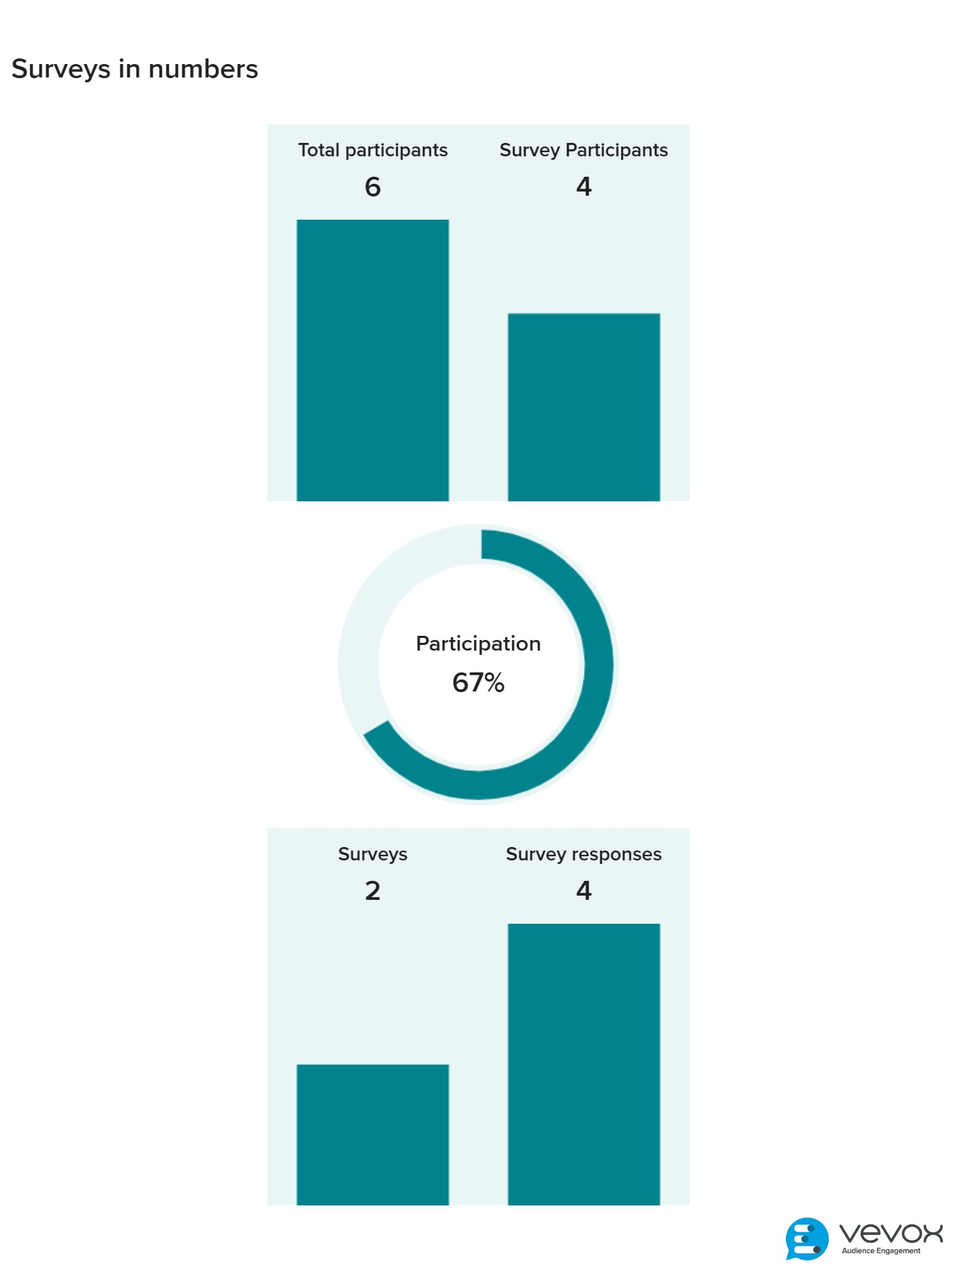

Appendix B
Q1:
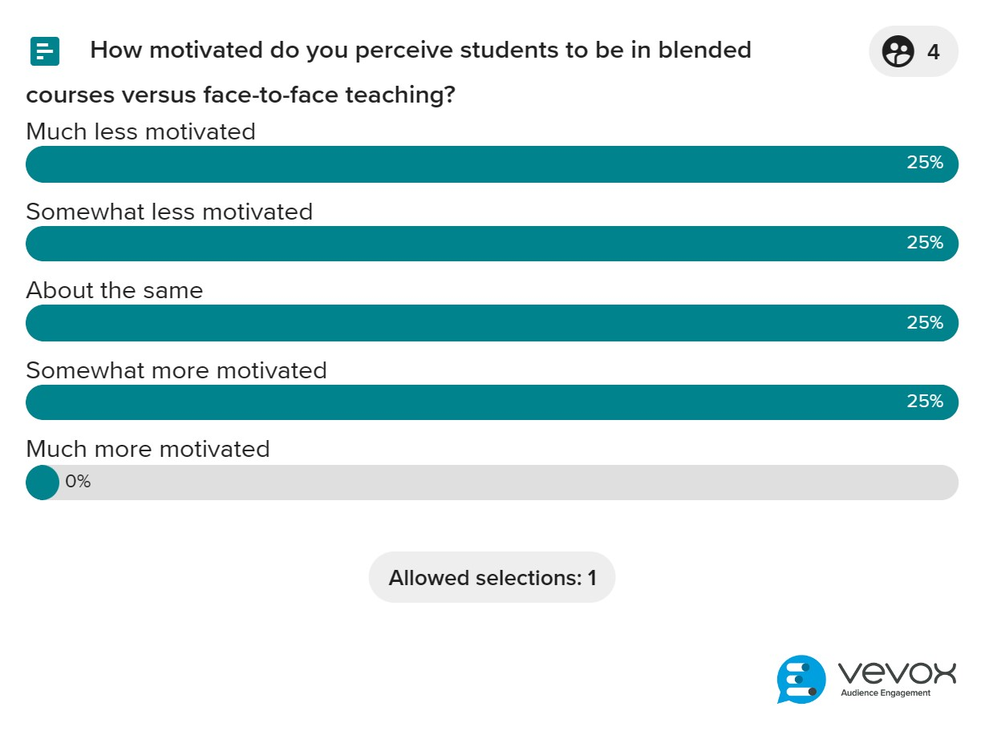

Appendix C
Q2:
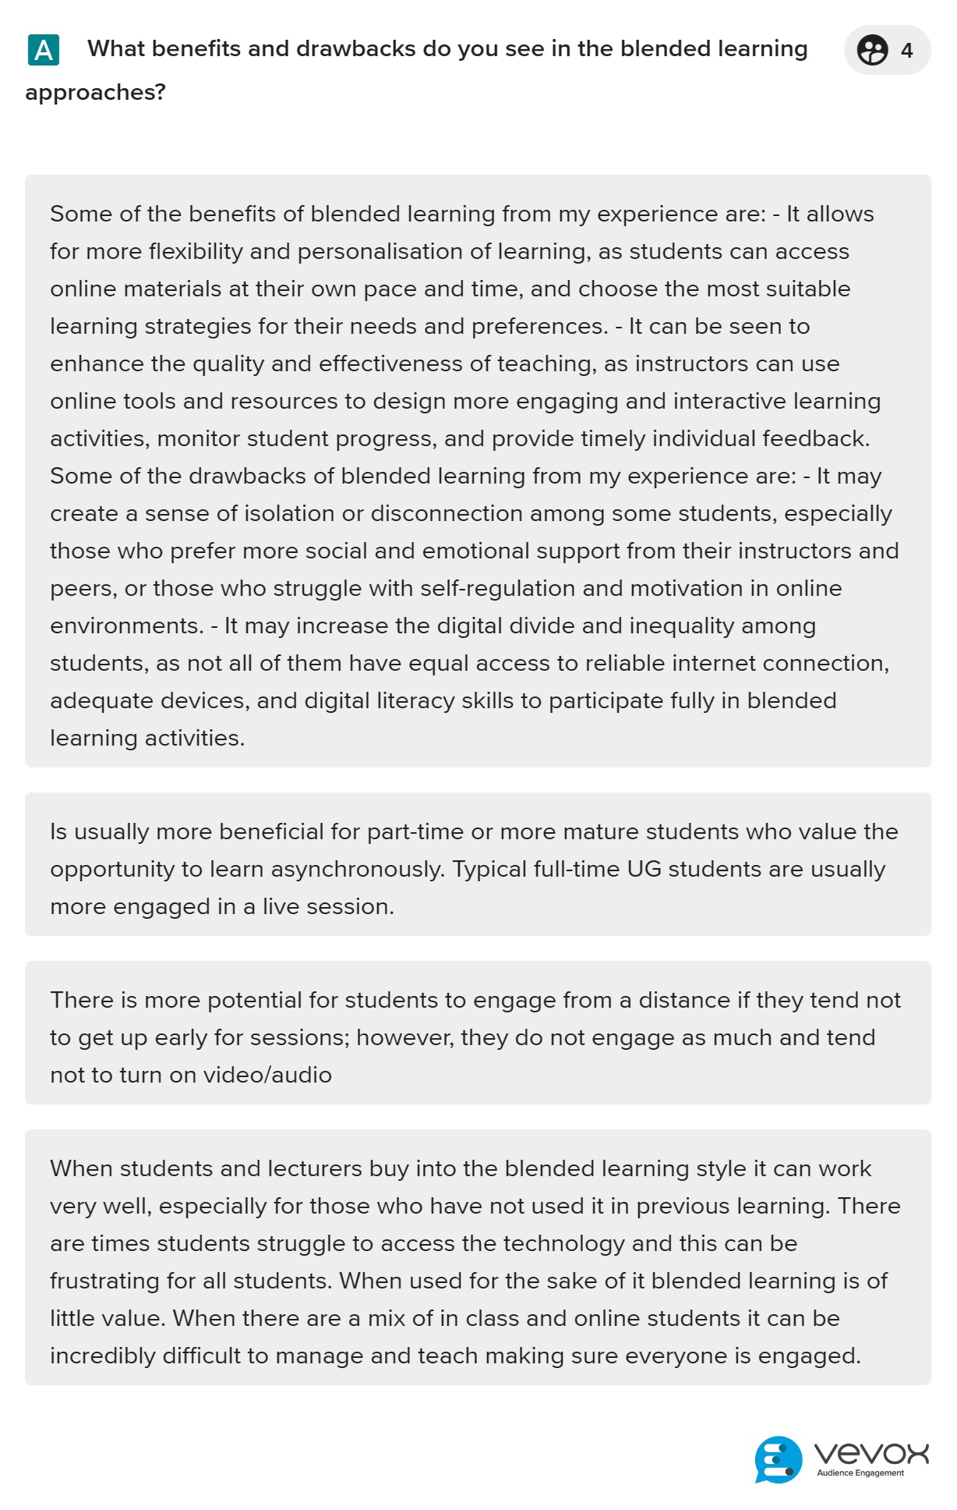

Appendix D
Q3:
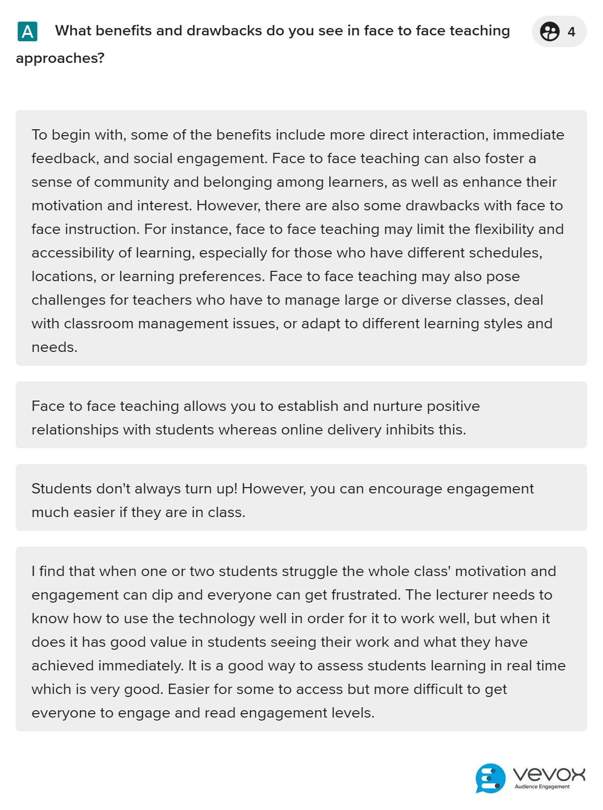

Appendix E
Q4:
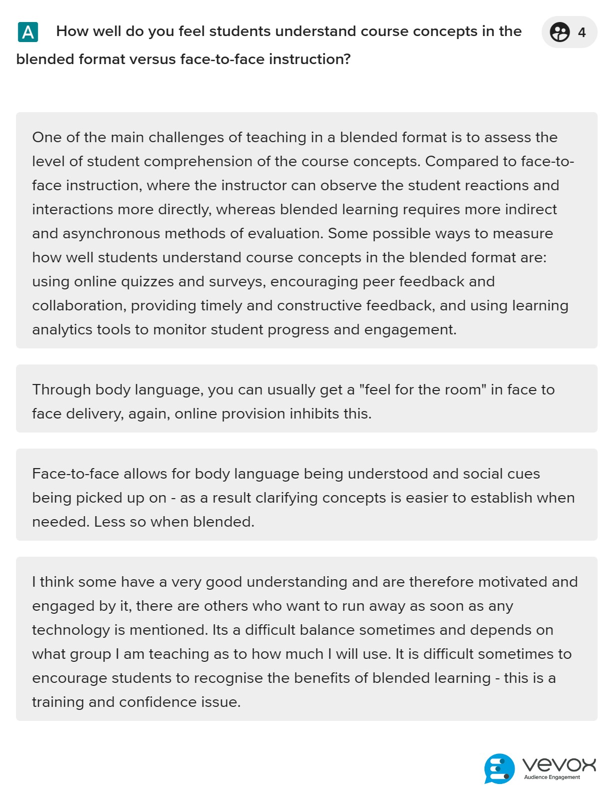

Appendix F
Q5:
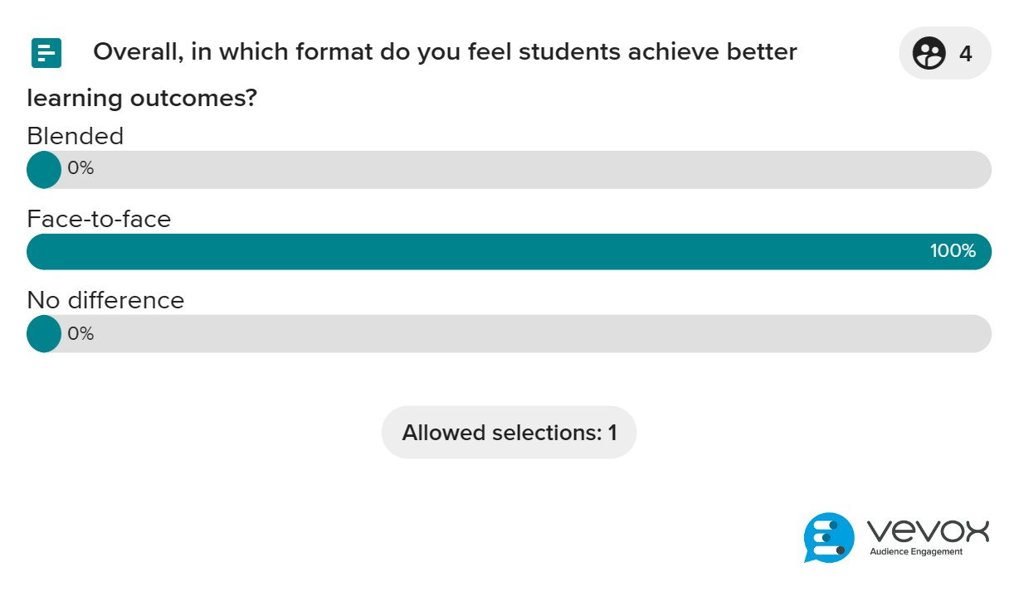

Appendix G
Q6:


