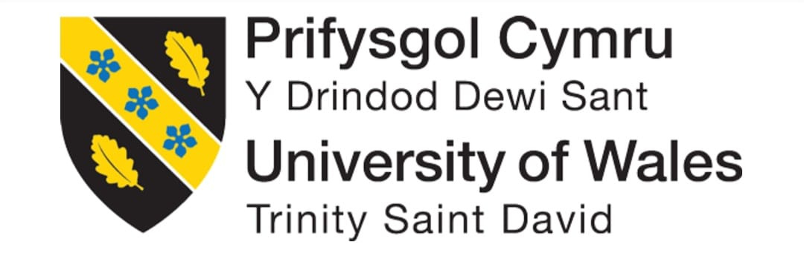

STUDENT NAME: ANNA CHAUSHEVA
STUDENT ID: 2335868
MODULE: ORGANISATIONAL CULTURE
MODULE CODE: LCLM 5005
COMPONENT 1: INDIVIDUAL REPORT
LECTURER NAME: CHRISTOPHER OSBORNE

Table of Contents
1. Introduction 3
2. Organisational Culture at Toyota 3
2.1 Overview of Toyota's Organisational Culture 3
2.2 Application of Schein's Three Levels of Organisational Culture 4
2.3 Application of Handy's Cultural Types 6
2.4 Application of Hofstede's Cultural Dimensions 7
3. Influence of Organisational Culture on Structure and Decision-Making 9
4. Organisational Culture and External Environmental Adaptation 11
5. Organisational Culture as an Enabler or Barrier 12
6. Impact on Organisational Performance and Recommendations 13
7. Conclusion 13
Reference list 15

1. Introduction
The culture of organisations is one of the most critical aspects that influences how organisations conduct their operations, make decisions and achieve their strategic objectives. According to Mullins and Christy (2016), organisational culture refers to the shared values and beliefs and a set of patterns in the work, which affect organisational behaviour, leadership within an organisation, employee motivation and organisational performance. Companies which want to survive in a more global and competitive business environment thus need to create cultures that facilitate innovation, flexibility and sustainability of a competitive advantage.
Toyota Motor Corporation ranks among the largest automobile companies in the world, with a hundred thousand employees or so, with more than 170 countries all over the world. The Toyota Production System (TPS) has enabled the organisation to have an international reputation for quality, operational efficiency and continuous improvement (Morgan and Liker, 2020). Its organisational culture has been at the forefront in making these successes, and therefore it has enabled the company to adapt to technological change, environmental laws and evolving customer expectations.
This report critically discusses and studies the quality of the organisational culture of Toyota in relation to the impact it has on the organisational structure and decision-making process. It further applies the existing organisational culture theories to determine the prevailing organisational culture in Toyota, analyses the way organisational culture ensures that organisations adapt to environmental pressures, critically assesses the way the organisational culture could either be an enabler or a hindrance to future organisational performance and makes evidence-based recommendations that would enhance organisational performance in the future (Fadnavis, Najarzadeh and Badurdeen, 2020).

2. Organisational Culture at Toyota

2.1 Overview of Toyota's Organisational Culture
The Toyota organisational culture has been a journey that has taken decades to evolve, supported by its quality management, operational excellence, and lifelong learning. Rather than focusing solely on financial performance, Toyota espouses an overarching philosophy that prioritises customer value, employee development, and sustainable organisational growth. Toyota Way is an ideology that is incorporated into two major principles of the Toyota Way, namely, continuous improvement (Kaizen) and respect for people (Toyota, 2023). These values influence the behaviour of the workers, the leadership actions, the work practices and the strategic decision-making within the entire organisation.
Continuous improvement is a concept that encourages each employee at any level in an organisation to identify areas of inefficiency, overcome the challenges faced in operations, as well as illuminate them on the ways in which the organisation can be better in its performance (Khan et al., 2019). This endows the employees who have the power to stop production where quality issues are realised, as this is how the organisation invests efforts in instilling the value of accountability and quality rather than deliberately affecting the speed of production. Simultaneously, the value of people promotes team/worker empowerment and/or problem-solving and promotes a work environment where employees are viewed as valuable assets, rather than being desperate workers that the organisation hires to work at its place.
The Toyota culture is, in fact, a strategic organisational strength and not a set of shared values. It promotes the same behaviour in the international operations and maintains high quality of the products, efficiency in operations and customer satisfaction (Hino, 2024).

2.2 Application of Schein's Three Levels of Organisational Culture
Schein's Three Levels of Organisational Culture provides a broad understanding of how to look at the subject of developing organisational culture and its implications for organisational behaviour (Geraghty, 2023). The model consists of artefacts, espoused values and underlying assumptions.
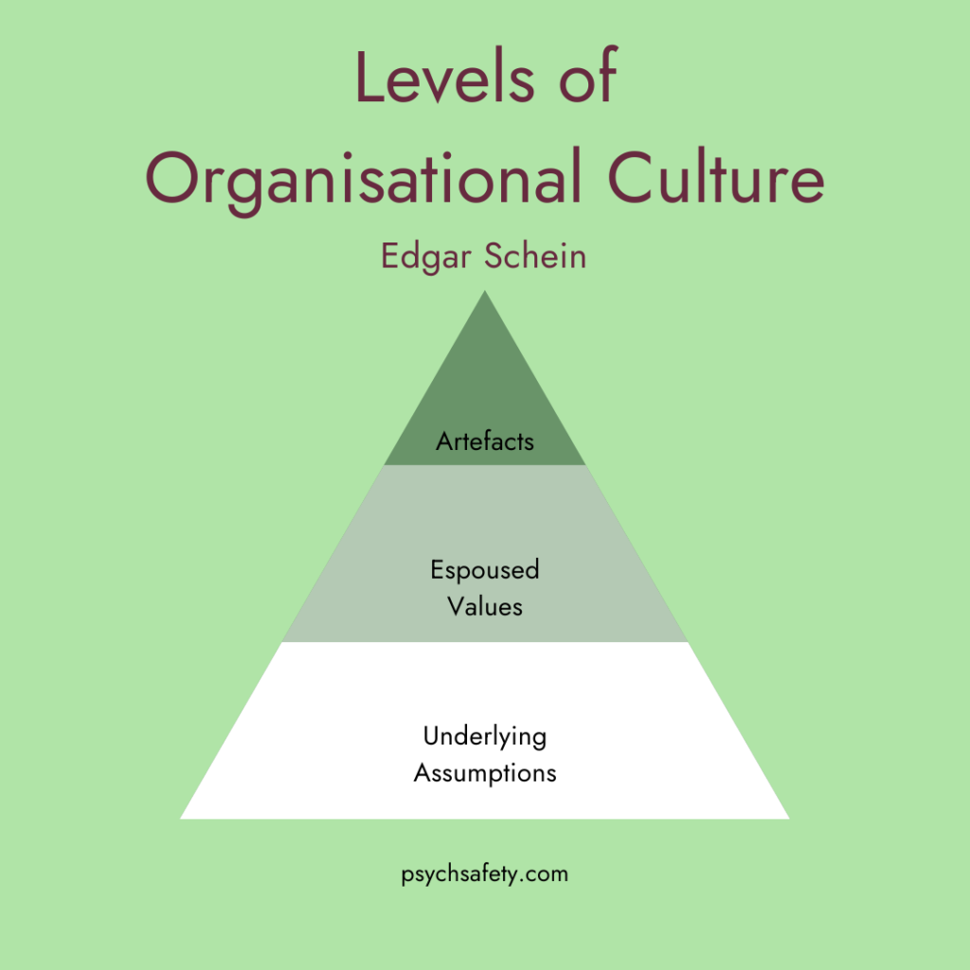
Figure 1: Schein’s Three Levels of Organisational Culture
(Source: Geraghty, 2023)
Toyota exhibits a range of seemingly cultural characteristics at the artefact level. Clearly visible elements of the Toyota culture would involve standardised work patterns, visual control systems, quality circles, staff suggestion plans, as well as the utilisation of lean manufacturing solutions (Nicholas, 2018). Employees meet regularly in teams, and the continuous improvement programs and systematic problem-solving exercises assist in enhancing organisational expectations.
The second level incorporates the values that are lost on paper as postulated by the organisation, and this is the second level, espoused values. Toyota stands out as a strong supporter of customer satisfaction and quality improvement, teamwork, mutual respect, integrity and study all the time. These values are instilled in the leadership development programmes, employee training, employee performance management systems and organisational policies (Akdere and Egan, 2020). These values are not embodied in shoe-shoe form but are constantly imposed in the managerial behaviour and practise in an organisation.
The second is the deepest level, which comprises basic underlying assumptions that unconsciously dictate the organisational behaviour. Toyota assumes that there are operational problems that should not be blamed but should be learned from. The other assumption made is that the level of success of an organisation depends on the building of long-term capabilities of the employees rather than on short-term financial incentives (Wilton, 2022). These assumptions justify the reason why Toyota has never been hesitant in its transformation of the employees with the continuous exchange of knowledge and organic organisational enhancement, even in the introduction of changes in the market.
The scheme by Schein is quite useful in helping know why the organisational culture at Toyota has remained relatively stable despite its business operations in other countries. The only distinction here is that, in the model, the cultural dynamics are primarily focused on the internal factors, and there is not much consideration of the impact of the external change of the environment on the cultural development (Müller and Stephan, 2022).

2.3 Application of Handy's Cultural Types
Handy uses the Cultural Type model to classify organisations into dominant cultural features. Toyota exhibits certain characteristics of the task culture and the role culture, but the former appears to be prevailing in the organisation (Veigas, 2022).
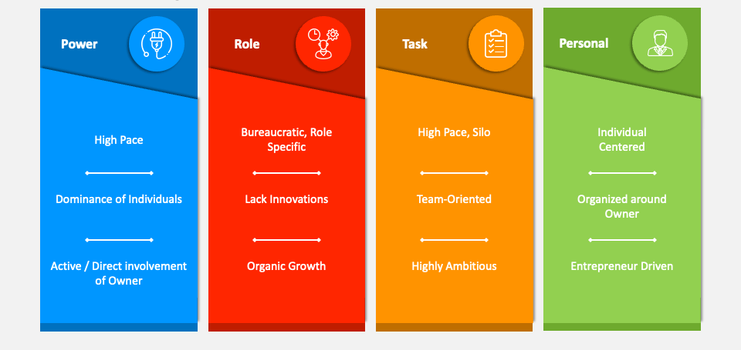
Figure 2: Handy’s Cultural Types
(Source: Veigas, 2022)
Task culture involves cooperation on a teamwork level, expertise and insight in bringing out the objectives of the organisation. These features are reflected in cross-functional teams that exist to improve Toyota, as well as joint production systems and ongoing improvement projects (Bogale and Debela, 2024). There can be a lot of collaboration between employees of different functional areas to improve operational efficacy, solve manufacturing problems, and enable the production of products. They would also decide on information and not command when it comes to quality improvement initiatives.
At the same time, the elements of role culture are also exemplified at Toyota with the highly-developed organisational processes and the existence of official duties and standard working routine. The operations in the manufacturing process are reliant on written procedures, quality standards and clear expectations (shared responsibilities) to ensure that there exist similarities and distinctions that are sought across the entire manufacturing facilities across the whole world (Sankala, 2024).
The combination of both the task culture and role culture enables Toyota to maximise efficiency in its operations and be innovative at all times (Palhau et al., 2024). Nonetheless, being over-reliant on standardised processes may lead to reduced organisational flexibility in cases where urgent need to provide prompt reactions to unexpected marketplace changes.

2.4 Application of Hofstede's Cultural Dimensions
The Hofstede Cultural Dimensions also provide some insight as to the organisational culture within Toyota regarding its nature in Japan and its pervasive worldwide presence (Furuta and Shook, 2021).
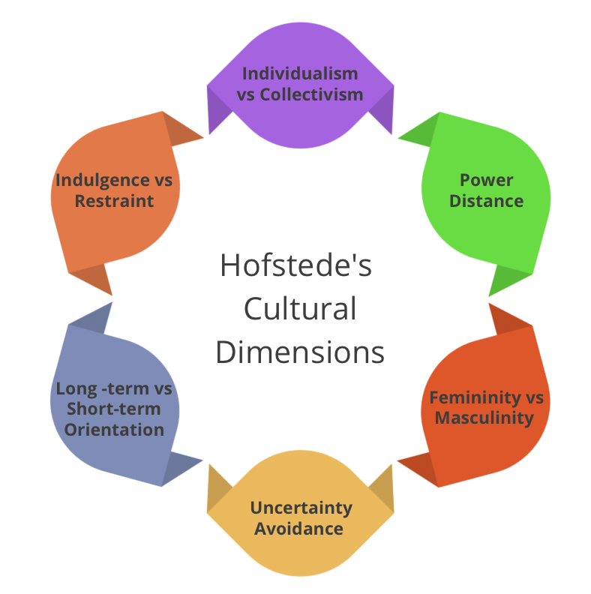
Figure 3: Hofstede’s Cultural Dimensions
(Source: Culture in the workplace, 2024)
Toyota is also exhibiting quite a high degree of collectivism, which encourages collaboration, shared responsibility and organisational identification instead of competition. The employees are also expected to collaborate towards the achievement of the organisational objectives and to establish a mutual solution to organisational issues. This increases collaboration but sometimes may discourage individuals from speaking out about their objections (Scott and Manning, 2022).
The power distance within the organisation is not as high as in most other traditional manufacturing organisations. Although the hierarchical structure remains, there would be an operational level where employees would be advised to identify quality problems and recommend improvement strategies. Enabling production-line employees to halt manufacturing processes is one of the indications of how high a priority is attached to the choice of involving employees in organisational decision-making (Neirotti, 2018).
Toyota is more highly long-term oriented because it has heavily invested in employee development, Research and development, technological innovation and environmental sustainability. The organisation is also always centred on sustainable competitive advantage and organisational resilience instead of focusing on the maximisation of short-term financial benefits.

3. Influence of Organisational Culture on Structure and Decision-Making
Toyota has an organisational culture which influences both the organisational structure and the managerial decision-making. As per the argument of Mullins and Christy (2016), culture will determine how the authority is exercised, how the employees are positioned towards each other and the orientation of strategic and operational decision-making in the whole organisation. The Toyota structure and decision-making processes have the potential to improve the culture of continuous improvement, teamwork and long-term organisational success, rather than working as a separate entity.
There is a hierarchical yet decentralised, cross- functional and participative organisational structure of the Toyota Company. Although there are identified reporting lines, employees at different organisational levels are encouraged to participate in the discovery of the problem and suggest solutions. This is based on the fact that the company is sure that it is not just the top managers who value knowledge, as it will benefit the entire organisation (Liebowitz, 2019). Consequently, operational workers are working on quality enhancement of the manufacturing process, production efficiency and consumer satisfaction.
As demonstrated in the Toyota Production System (TPS), organisational culture has a direct influence on structural design. The manufacturing process is designed in such a way that the co-operative teams are accountable for maintaining quality as well as improving the level of performance (Nohara, 2025). The task of the team leaders is to be a coach who will aid in the process of learning and problem-solving, rather than someone having certain authoritative power. This leadership style makes employees more involved, and a collectively responsible environment is created by it. It will therefore enable vertical and horizontal communication between functions and ease coordination and organisational learning.
One of the most distinctive cultural practices of Toyota is Genchi Genbutsu, or go and see (Vonk and Vasco Freitas Silva, 2024). This precept encourages managers to take into account the decisions which are made in the presence of crowds rather than to rely on decisions made solely on reports or assumptions. Managers are expected to visit the production locations, inquire about the issues in the operation at a one-on-one level, and personally engage the workers before making some important decisions. It improves the quality of decisions made as factual evidence and practical knowledge form the basis of the information integrated into the managerial actions, rather than abstract data.
The process of decision-making in Toyota is also an indicator of the Japanese principle of Nemawashi, which permits the consultation of the responsible parties before the official decision-making. Managers seek consultation with employees, technical professionals and other departments so as to build a consensus during the process rather than coming up with top-down decisions at once (van Beers, van Dun and Wilderom, 2021). The approach may initially appear time-consuming, and it may help improve the implementation process because employees understand the reasons why changes should be conducted and are more dedicated to them. Consensus-building, therefore, reduces resistance and enhances reinforcement of cooperation between functions in an organisation.
In addition, Toyota culture encourages decentralisation in decision-making with regard to operations. Employees at manufacturing lines are directly involved since they are endowed with decision-making powers by being vested with the authority to terminate manufacturing processes whenever they have a quality issue, as portrayed by the Andon system (Hirvonen, 2018). The instant solution of the front-line workers halts the defects along their way through the production process and intensifies the organisational motive towards quality. The practice demonstrates that the organisational culture would make the senior management more responsible in the process of decision-making and make workers more responsive and accountable.
Although these attributes are strong, Toyota has its share of limitations in its cultural decision-making process. During times of rapid environmental change, consensus-building can slow strategic decision-making. The latter was felt through the fact that, as the world was quickly transitioning into electric cars, critics argued that Toyota was slower to switch to electric than other companies because of the established organisational culture of incrementalism and not entirely transformative, disruptive change (Näsman and Ballor, 2024). In equal measure, excessive consultation exercises may slow down the agility of the organisation at a time when immediate action is required, as in a crisis.

4. Organisational Culture and External Environmental Adaptation
In the modern dynamic business environment, organisations must make sure that they stay updated with developments in technology, sustainability, the needs of the global competition, and consumer tastes. Toyota's organisational culture has played a crucial role in ensuring that the organisation has been in a position to respond positively to these environmental forces and yet manage to maintain its value system and operational strength (Hino, 2024).
Kaizen, or continuous improvement, provides Toyota with the capability as an organisation to continue adapting. This also encourages the employees to seek ways of bettering themselves daily instead of taking change as a singular phenomenon. Such a mindset will enable Toyota to be proactive to the new demands of the customers, technology in manufacturing, as well as different regulatory requirements (Hammad et al., 2025). The ability to increase the efficiency of production, reduce waste, and increase product quality in whatever it produces in the global marketplace has been realised by the fact that this company has been undertaking continuous learning.
Another important external factor that has impacted the automotive industry is environmental sustainability. Increasing regulations on the carbon footprint of the atmosphere by the government and consumers' need to have a car that is much greener have also required manufacturers to incur huge amounts of money on technologies that are a lot greener (Pardi, 2022). Toyota's long-term orientation has helped the company to invest heavily in hybrid technology, hydrogen fuel-cell technologies, as well as the manufacturing of carbon-neutral technologies. These decisions reflect a culture which believes in long-term value creation as opposed to short-term monetary gains.
Globalisation has also influenced the Toyota organisational culture. Working under a range of cultural and regulatory environments, organisational consistency and local sensitivity are required. Toyota has maintained the primary aim of respect for people and improvement unceasingly whilst allowing regions where it resides to possess sufficient allowance to respond to local market needs (Hino, 2024). This has been favouring organisational deployment without compromising local creativity completely.
However, certain cultural issues have also been brought out with the external changes that take place in the environment. The rapid growth of battery-only vehicles and digital mobility services has required more strategic change sooner than the tradition of continually enhancing fast in a manner that has been the Toyota tradition (Hino, 2024). Competitors that are making the implementation of more disruptive innovation strategies and are sometimes difficult to predict have sometimes responded more rapidly to changing market conditions. Consequently, Toyota has been delving more into the importance of combining its traditional benefits of maximising efficiency in its manufacturing process with new organisational agility and technological innovation.

5. Organisational Culture as an Enabler or Barrier
Organisational culture may be either resourceful or inhibit organisational effectiveness depending on its fit in terms of internal or external needs. The culture at Toyota is both an enabler and facilitator to a large extent, because it enables continual improvement, employee participation and long-term outlook. Kaizen and Respect for People concepts ensure that employees come up with answers and foster organisational learning through team problem solving and by improving quality (Wiid, 2018). This culture has helped Toyota achieve high operational efficiency, high product quality, and a competitive advantage that has been maintained.
The learning culture also supports the culture of resilience, as Toyota employees are encouraged to identify the exact causes of the problems and implement consistent solutions. One of the practices enhances the organisational capability and assists the organisation to act uniformly in its global business (Gupta et al., 2019).
However, there are also features of the Toyota culture which can be considered as an impediment, nonetheless. Consensus-making and incrementalism have a tendency to slow strategic decision-making at a time when technology is changing at a very rapid rate (Gregory et al., 2018). To exemplify the case scenario, the company was reluctant about its battery-electric vehicles process, something that was condemned due to the rivals moving dynamically into the market. Similarly, the highly standardised processes may tend to limit experimentation and reduce organisational responsiveness.

6. Impact on Organisational Performance and Recommendations
Toyota's organisational culture has significantly improved the performance of the organisation by promoting operational efficiency, quality of products, commitment and lifelong learning among employees. It has reduced wastage as continuous improvement has enhanced the performance of the manufacturing process, and customer satisfaction has also increased (Okpala, Nwamekwe and Ezeanyim, 2024). Employee empowerment has also aided in problem-solving and ideas, which have given Toyota a good global image.
Though these are the strengths, the agility of the organisation is required in the fast-moving automobile industry. The Toyota Company must, hence, build on its current culture but must adapt to new technological/market demands.
Recommendation 1: Enhance strategic agility and innovation.
It should accelerate the strategic decision-making of new technologies at Toyota but maintain a teamwork culture. Cross-functional innovation teams in engineering, software and sustainability functions would help expedite the development of electric vehicles, artificial intelligence and digital mobility solutions, which would enable the company to adapt more effectively in the industry (Achillas and Iosifidou, 2024).
Recommendation 2: Strengthen global leadership and organisational learning.
To improve cross-cultural leadership and knowledge sharing in digital applications, Toyota would do well to allocate an extra investment in cross-cultural leadership development and digital knowledge sharing systems in order to improve coordination among operations across borders (Sahoo et al., 2024). The design of leaders capable of managing multi-cultural teams and the spreading of best practices would result in better organisational learning, innovation and uniformity in overseas subsidiaries.
These recommendations would make Toyota more flexible without interfering with the cultural values on which its successful performance in the long run is based.

7. Conclusion
Toyota has placed the organisational culture at the centre of the organisational structure, decision-making, and long-term performance. The Model of Schein, the Cultural Typologies of Handy and the Cultural Dimensions of Hofstede reveal that the culture is continuously getting better; cooperation and long-term orientation are the primary characteristics of this culture. Although they have facilitated operational excellence and Competitive Advantage, these features may also reduce the responsiveness of organisations to the changing conditions of their industries. The strengths of the Toyota Way could be supported by the capacity to be flexible in strategic terms and be more centred around innovation in order to retain its competitive advantage.

Reference list
Achillas, C. and Iosifidou, P. (2024). Shifting towards Electric Vehicles: A Case Study of Mercedes-Benz from the Perspective of Cross-Functional Teams and Workforce Transformation. World Electric Vehicle Journal, 15(7), p.325.
Akdere, M. and Egan, T. (2020). Transformational Leadership and Human Resource development: Linking Employee learning, Job satisfaction, and Organisational Performance. Human Resource Development Quarterly, 31(4), pp.393–421.
Bogale, A.T. and Debela, K.L. (2024). Organisational culture: A Systematic Review. Cogent Business & Management, 11(1), pp.1–23. doi:https: //doi.org/10.1080/23311975.2024.2340129.
Culture in the workplace (2024). About Prof. Geert Hofstede – Culture In The WorkplaceTM. [online] Culture in the workplace. Available at: https://cultureinworkplace.com/about-prof-geert-hofstede/ [Accessed 16 July 2026].
Fadnavis, S., Najarzadeh, A. and Badurdeen, F. (2020). An Assessment of Organisational Culture Traits Impacting Problem Solving for Lean Transformation. Procedia Manufacturing, 48, pp.31–42. Doi: 10.1016/j.promfg.2020.05.017.
Furuta, N. and Shook, J. (2021). Welcome Problems, Find Success. doi:10.4324/9781003202967.
Geraghty, T. (2023). Edgar Schein’s Three Layers of Organisational Culture. [online] Psych Safety. Available at: https://psychsafety.com/psychological-safety-edgar-scheins-three-layers-of-organisational-culture/ [Accessed 16 July 2026].
Gregory, R.W., Kaganer, E., Henfridsson, O. and Thierry Jean, R. (2018). IT Consumerization and the Transformation of IT Governance. Management Information Systems Quarterly, [online] 42(4), pp.1225–1253. doi:10.25300/MISQ/2018/13703.
Gupta, S., Drave, V.A., Bag, S. and Luo, Z. (2019). Leveraging Smart Supply Chain and Information System Agility for Supply Chain Flexibility. Information Systems Frontiers, [online] 21(3), pp.547–564. doi:10.1007/s10796-019-09901-5.
Hammad, M., Panaousis, M., Ali, H. and Khan, W.A. (2025). Smart Manufacturing in Automotive Industry. Springer Series in Advanced Manufacturing, pp.47–85. doi:10.1007/978-3-032-00214-3_3.
Hino, S. (2024). Inside the Mind of Toyota. doi:10.4324/9781003578826.
Hirvonen, J. (2018). Design and implementation of Andon system for Lean manufacturing. Aaltodoc.aalto.fi. [online] Available at: https://aaltodoc.aalto.fi/items/20840f64-8ef9-4f71-b062-89741b5eef8f [Accessed 16 July 2026].
Khan, S.A., Kaviani, M.A., J. Galli, B. and Ishtiaq, P. (2019). Application of continuous improvement techniques to improve organisation performance. International Journal of Lean Six Sigma, 10(2), pp.542–565. doi:10.1108/ijlss-05-2017-0048.
Liebowitz, J. (2019). Building Organisational Intelligence. CRC Press. doi:10.1201/9780367810689.
Morgan, J. and Liker, J.K. (2020). The Toyota Product Development System. Productivity Press. doi:10.4324/9781482293746.
Mullins, L. and Christy, G. (2016). Management and Organisational Behaviour (11th ed.). Pearson Education Limited.
Müller, L.A. and Stephan, M. (2022). Culture as a Critical Determinant of Dynamic Ambidexterity for Established Car Manufacturers: An International Study. Transforming Mobility – What Next? pp.33–53. doi:10.1007/978-3-658-36430-4_3.
Neirotti, P. (2018). Work intensification and employee involvement in lean production: New light on a classic dilemma. The International Journal of Human Resource Management, 31(15), pp.1–26.
Nicholas, J. (2018). Lean Production for Competitive Advantage. 2nd edition. | Boca Raton: Taylor & Francis, CRC Press, 2018.Productivity Press. doi:10.4324/9781351139083.
Nohara, H. (2025). Toyota Production System and Modern Society. pp.285–321. doi:10.1007/978-981-96-1910-8_7.
Näsman, M. and Ballor, G. (2024). The car industry and climate change: A historical review. Econstor.eu. [online] doi:https: //hdl.handle.net/10419/300154.
Okpala, C., Nwamekwe, C.O. and Ezeanyim, O.C. (2024). The Implementation of Kaizen Principles in Manufacturing Processes: A Pathway to Continuous Improvement. International Journal of Engineering Inventions, 13(7), pp.116–124. doi:https: //hal.science/hal-04669397.
Palhau, M., Sá, J.C., Ávila, P., Dinis-Carvalho, J., Rodrigues, C. and Santos, G. (2024). Toyota Way – the Heart of Toyota Production System and its Impact on Sustainable Company Growth. Quality Innovation Prosperity, [online] 28(3), pp.23–45. doi:10.12776/qip. V 28i3.2073.
Pardi, T. (2022). Heavier, Faster and Less Affordable Cars: The Consequence of EU Regulations for Car Emissions. Social Science Research Network. doi:10.2139/ssrn.4304165.
Sahoo, D.K., Bui, Le V., Samantaray, A., Kumar, A. and Kanwal, P. (2024). Examining the Role of Organisational Learning and Knowledge Sharing in Facilitating Career Transitions and Innovation. Advances in Higher Education and Professional Development, [online] pp.175–200. doi:10.4018/979-8-3693-4163-6.ch007.
Sankala, A. (2024). Strategic Alignment: Evaluating Organisational Processes through the Lens of Global Standardisation. Theseus.fi, [online] 1(1). doi:http: //www.theseus.fi/handle/10024/866516.
Scott, B.A.B. and Manning, M.R. (2022). Designing the collaborative organisation: A framework for how collaborative work, relationships, and behaviours generate collaborative capacity. The Journal of Applied Behavioural Science, [online] 60(1), pp.149–193. doi:10.1177/00218863221106245.
Toyota (2023). Our Vision and Philosophy | Toyota Europe. [online] Toyota EU. Available at: https://www.toyota-europe.com/about-us/toyota-vision-and-philosophy [Accessed 16 July 2026].
van Beers, J.C.A.M., van Dun, D.H. and Wilderom, C.P.M. (2021). Effective hospital-wide lean implementation: Top-down, bottom-up or through co-creative role modelling? International Journal of Lean Six Sigma, 13(1), pp.46–66. doi:10.1108/ijlss-02-2021-0024.
Veigas, E. (2022). Handy’s Model of Organisational Culture. [online] Learnsignal. Available at: https://www.learnsignal.com/blog/handys-model-of-organisational-culture/ [Accessed 16 July 2026].
Vonk, A. and Vasco Freitas Silva (2024). Genchi Genbutsu of the Toyota Way: Finding Local Perspectives. pp.77–88. doi:10.1007/978-3-031-45403-5_5.
Wiid, P. (2018). Kaizen and Education. Agile and Lean Concepts for Teaching and Learning, [online] pp.63–92. doi:10.1007/978-981-13-2751-3_4.
Wilton, N. (2022). An Introduction to Human Resource Management. An Introduction to Human Resource Management, 1(1), pp.1–100.

