

Programme: Master of Business Administration
Module: International Business Concepts
Module code: LCMB7034
Lecturer: Dr Robert Ejike Undeogu

Student name: Md Abdur Roshid
Student ID: 2436449

Word Count: 5197
Submission Deadline: Friday 20/03/2026 by 2pm

Table of Contents
SECTION 1: International Industry/Business Report 1
1.0 Introduction 1
2. Industry and Country Overview (Mexico: automotive vehicles and auto parts) 2
2.1 Mexico country context 2
2.2 Industry definition and value chain 3
2.3 Size, scope, and economic importance (data-driven) 4
2.4 Key firms and competitive positioning (domestic and MNCs) 6
3. Porter’s Diamond Model 8
3.1 Factor conditions 8
3.2 Demand conditions 8
3.3 Related and supporting industries 9
3.4 Firm strategy, structure, and rivalry 9
3.5 Government 10
3.6 Chance 10
3.7 Overall competitiveness judgment 11
4. Foreign MNC case (Nissan in Mexico) 12
4.1 Company profile and Mexico strategy: Nissan 12
4.2 Entry mode and operating model 13
4.3 Market attractiveness (PESTLE) 14
4.4 Industry structure (Porter Five Forces) 18
4.5 Success factors and risks for Nissan in Mexico 19
4.6 Recommendations 21
5.0 Conclusion 22
SECTION 2: Reflective Account (Gibbs) 23
1.0 Description 23
2.0 Feelings 23
3.0 Evaluation 24
4.0 Analysis 24
5.0 Conclusion 25
6.0 Action Plan 25
References 27

List of Tables
Table 1: Mexico light-vehicle production and exports (annual totals or 12-month rolling sums), 2015–2024/2025 (Author) 6
Table 2: Competitive Positioning of Major OEMs in Mexico (2024) (MarkLines , 2025; Promexico Industry, 2025) 7
Table 3: Porter’s Five Forces (Mexico automotive manufacturing) (Author) 18
Table of Figures
Figure 1: Mexico Automotive and Auto Parts Industry: Driving Manufacturing Growth (Reuters, 2025) 2
Figure 2: Mexico’s GDP growth remains positive but volatile (World Bank, 2026) 3
Figure 3: Passenger Vehicles Industry in Mexico (Prodensa, 2025) 4
Figure 4: Annual production volumes (number of vehicles) in Mexico’s automotive industry, 2015–2024 (CEIC Data, 2025) 5
Figure 5: Porter’s Diamond Model of national advantage, Mexico’s automotive manufacturing competitiveness (International Trade Administration, 2026) 9
Figure 6: Mexican Exec Leads Nissan, Strengthening Mexico Auto Ties (International Trade Administration, 2025) 12
Figure 7: Nissan Mexico model balances control and risk (Nissan, 2025) 13
Figure 8: Market attractiveness for Nissan in Mexico, PESTLE analysis (Author) 16

SECTION 1: International Industry/Business Report

1.0 Introduction
The automotive manufacturing industry, which comprises two functional groups, vehicle production and the production of auto parts which has displayed high competitiveness but also a structural weakness. It is also an industry with a high density of footprints of original equipment manufacturers and a strong tier-supplier base; about 79.7 per cent of the vehicle exports out of Mexico are to the United States (International Trade Administration, 2025). This report utilises the production, export, and domestic sales monthly series of INEGI to demonstrate the magnitude of the industry output and the correlations (cycle) (INEGI, 2025). Moreover, the country of Mexico is also ranked globally based on OICA production statistics (OICA, 2026). It includes the evaluation of the institutional and policy risks, in particular, the upcoming joint review of the USMCA, which is scheduled to take place in July 2026 (International Trade Administration, 2026).

2. Industry and Country Overview (Mexico: automotive vehicles and auto parts)

2.1 Mexico country context
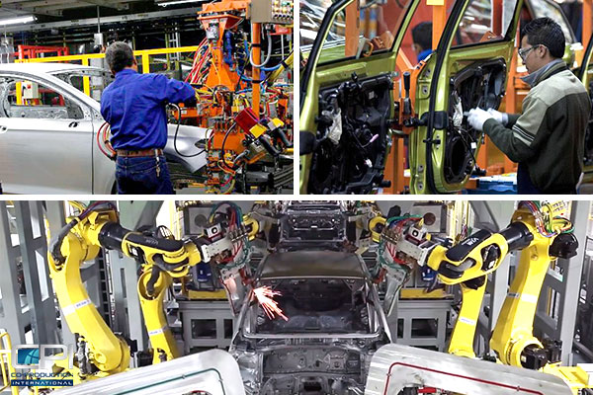
Figure 1: Mexico Automotive and Auto Parts Industry: Driving Manufacturing Growth (Reuters, 2025)

Automobile manufacturing in Mexico can be understood best as an export-style genre that is incorporated into the North American production systems and not an industry that is oriented to centrally planned demand. The trade orientation and the provisions of the USMCA also allow scalability, but, at the same time, expose it to the demand and policy turbulence in the U.S. The macroeconomic environment can be deemed rather sustainable, but not risk-free: GDP grew at the pace of 1.4% in 2024 and had reached around US$1.86 trillion by that time, whereas net inflows to foreign direct investments amounted to about US$45.5 billion in 2024, which means that investors remain interested in it and that nearshoring processes are associated with it despite the continued regulatory and security risks (World Bank, 2026).
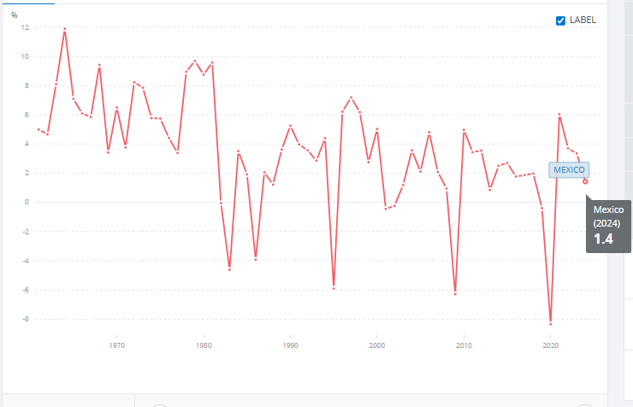
Figure 2: Mexico’s GDP growth remains positive but volatile (World Bank, 2026)
The floating exchange rate system also adds volatility to the cost and revenue of the organisations that receive their export earnings in U.S. dollars and buy inputs in foreign currencies; as a result, the profit margins may change quickly within the model cycles (Reuters, 2025). Logistics are both a source of competitive advantage and a limitation because the model of the export in Mexico is based on reliable road and rail networks that connect industrial units to the borders and the ports; the lead times can be increased or be based on the need to have bigger inventory cushions due to the risk of congestion and insecurity along the correct rail and roadways (ITF, 2015).

2.2 Industry definition and value chain
The Mexican automotive industry is made of original equipment manufacturers (OEMs), which assemble passenger and light truck vehicles, which is backed by a hierarchical structure of suppliers including Tier 1 and Tier 2 stakeholders. Key suppliers such as Nemak (casting and assembly), Metalsa (structural components), and Rassini (suspension and brake components) are suppliers of key components that improve cost-effectiveness, production flexibility, and local content. The suppliers help in smooth integration because they meet the just-in-time delivery requirements of the company, which are essential in the local production as well as the export activities. The ability of the suppliers to localize content, scale quality, and stay abreast with export-oriented programs has enabled the competitive advantage of the value chain (INA, 2025).

2.3 Size, scope, and economic importance (data-driven)

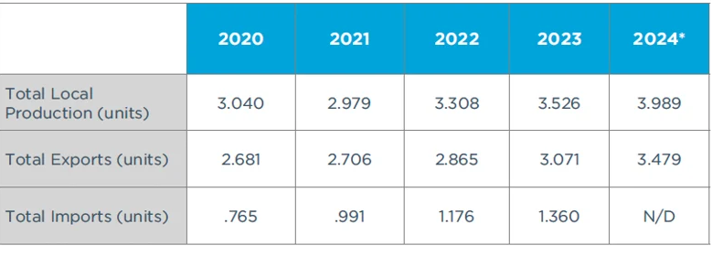
Figure 3: Passenger Vehicles Industry in Mexico (Prodensa, 2025)
Figure 3 shows the pattern in light-vehicle production in Mexico and exports of automotive products to the international market over the last ten years, which suggests a strong growth in this area until the year 2023 and high growth in this index in 2024. During 2024, the overall production of the total of 3,989,403 units was 5.6 percent above that of 2023, and the level of exports recorded 3,479,086 units, also a historic high to demonstrate how the Mexican automotive sector is export-oriented (Prodensa, 2025).
Production, export, and domestic sales of the light-vehicle automotive industry at the firm level are provided monthly by the Administrative Record of the National Institute of Statistics and Geography (INEGI), therefore enabling a data-based examination of the cycle, seasonality, and level of export growth (INEGI, 2025). To be used in international benchmarking, production statistics, which are provided by the International Organisation of Motor Vehicle Manufacturers (OICA), are utilised as a global benchmark that can be used to make international output comparisons (OICA, 2026). Practically, Mexico is in a good position, but as well, it is showing a concentration risk: according to the United States International Trade Authority, Mexico was rated the fifth biggest manufacturer and exporter of light-vehicle automobiles in 2024, and its exports to the United States were about US$104.8 billion, out of which 79.7 percent went to the U.S. (International Trade Administration, 2026). This composition is an indicator of scale and competitiveness, as well as suggesting that a shift within U.S. demand, border frictions, or rules-of-origin adherence can easily flow into the output and supplier utilisation rates of Mexico.
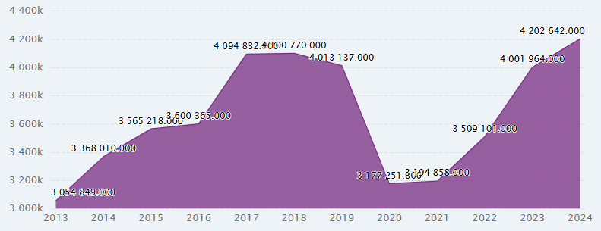
Figure 4: Annual production volumes (number of vehicles) in Mexico’s automotive industry, 2015–2024 (CEIC Data, 2025)
Table 1: Mexico light-vehicle production and exports (annual totals or 12-month rolling sums), 2015–2024/2025 (Author)
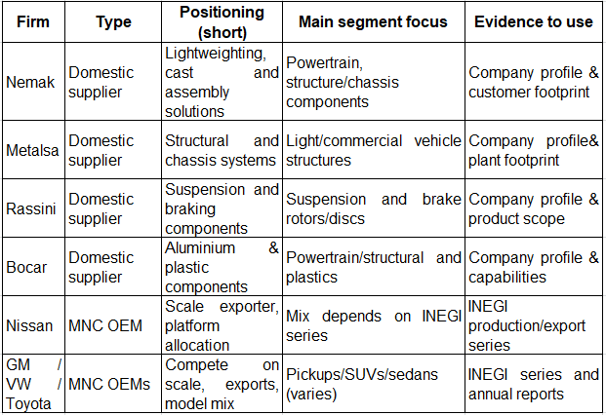

2.4 Key firms and competitive positioning (domestic and MNCs)
The competitive positioning is made through the strategies of global original equipment manufacturers, which include the allocation of platforms, the mix of models, and the route of exports, and through the capabilities of suppliers, which dictate the localisation and cost. The domestic suppliers compete in terms of the engineering depth, the quality accuracy, and the reliability of deliveries, Nemak (casting and assembly solutions across the lightweight materials) (Nemak, 2026), Metalsa (structural products and integrated chassis systems) (Metalsa, 2026), Rassini (suspension and brake parts) (Rassini, 2026), and Bocar (aluminium and plastic ones) (Bocar, 2026). As a contrast, Nissan, GM, Volkswagen, and Toyota OEMs generally compete using scale, platform flexibility, and export preparedness through North American demand cycles. In order to ensure that the approach to data use is evidence-based and not descriptive, one can suggest using the series of firm-level production and export of the INEGI to determine the leaders of output and to show the change in OEM mix in terms of shifting to segments with higher margins. These changes can then be associated with the reliance of the industry on consumer demand and the stability in the trade policy in the U.S. (INEGI, 2025; International Trade Administration, 2025).
Table 2: Competitive Positioning of Major OEMs in Mexico (2024) (MarkLines , 2025; Promexico Industry, 2025)
OEM | 2024 Production (Approx.) | 2024 Export Volume | Primary Model Focus | Competitive Advantage
General Motors | ~842,567 units (highest producer) | ~830,820 vehicles | Trucks, SUVs, crossovers | Scale leadership with the largest production share in Mexico (MarkLines , 2025)
Nissan | ~669,941 units | ~456,866 vehicles | Mix of sedans, SUVs, light trucks | Platform flexibility and diversified model mix (MarkLines , 2025)
Volkswagen | ~382,312 units | ~326,217 vehicles | Passenger cars, hatchbacks | Export-prepared production with consistent export volumes (MarkLines , 2025)
Toyota | Not top producer but significant | ~245,121 vehicles | Pickups (Tacoma) and SUVs | Niche specialization in specific segments (Promexico Industry, 2025)

3. Porter’s Diamond Model

3.1 Factor conditions
The comparative advantage of Mexico is based on the long-term strengths, a high population of suppliers, i.e., Nemak and Metalsa to be named, and the propinquity of the country to the United States. These will have a long-term advantage in terms of cost-effectiveness and scalability, which will strengthen the ability of Mexico to cater to the North American supply chain on a high level. This is even more boosted by the ability of the nation to develop the skilled labor force and the large-scale industrial parks it has developed. A certain degree of contingency, however, like the consistency of trade policy (such as adherence to the United States-Mexico-Canada Agreement) and the consistency of security and logistics, creates weaknesses. Any policy changes or a change in logistics has the potential to rapidly undermine the Mexican competitive edge in the high-volume manufacturing that focuses on exports (U.S. Department of State, 2025).

3.2 Demand conditions
The automotive industry of Mexico has high export penetration performance, as observed via the fact that 79.7 percent of the vehicle export was sent to the United States in the year 2024. The national demand has a relatively small effect on the capacity decisions, which are chiefly used to fluctuate the short-term production schedules. On the other hand, production volumes, as well as the composition of model assortments, are dictated by the external demand, particularly that of the United States. The platform division and investment focus are mostly blind to the domestic requirements and are shaped rather by export demand according to the Instituto Nacional de Estadistica y Geografia (INEGI). As such, a change in policy or supply-demand in the United States will trigger a rapid flow to the production processes and supply-chain dynamics in Mexico (INEGI, 2025; International Trade Administration, 2026).
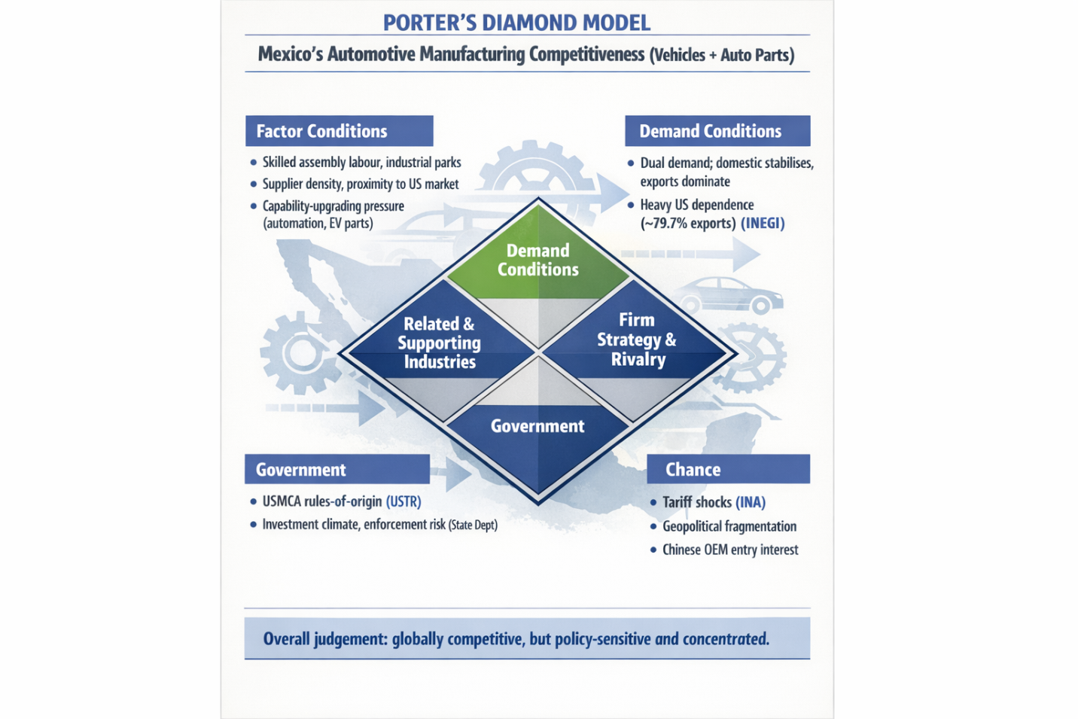
Figure 5: Porter’s Diamond Model of national advantage, Mexico’s automotive manufacturing competitiveness (International Trade Administration, 2026)

3.3 Related and supporting industries
The automotive components sectoral ecosystem in Mexico is a bottleneck of the national competitiveness, where localization, high-quality management, and just-in-time logistics operations largely contribute to the efficiency of their operations. The evidence based on the Industria Nacional de Automotores (INA) in 2025 outlines the depth of the components base in Mexico and, as a result, heightens its manufacturing capabilities. However, logistics reductions are very difficult, especially in respect to border congestion, security, and poor roadway infrastructure. Even though some benefits are inherent in the closeness to the United States geographically, the constant delays at the customs checkpoints and the security threats of the attendants are compelling companies to maintain high stock levels, thus eliminating the time benefits linked to nearshoring and negatively impacting the reliability of the supply chain (U.S. Department of State, 2025).

3.4 Firm strategy, structure, and rivalry
Competition in Mexico does not revolve around the competition of consumers at the domestic level but on the acquisition of global mandates in multinational networks. The INEGI data on manufacturers sheds light on this development, as it relates information on the performance of firms in terms of production and exports and their fluctuation (INEGI, 2025). The structure is similar to the notion of a portfolio competition: original equipment manufacturers are setting up their mix of models (which can be more oriented around higher-margin trucks and SUVs), competing over access to skilled labour, supplier capacity, and slots in the logistics system in a congested ecosystem. At the same time, suppliers vie with each other based on engineering, product quality, and performance of the delivery to retain a place on the international platforms (International Trade Administration, 2025).

3.5 Government
The role of government is decisive because the competitive advantage of Mexico is determined by the existing trade regulations and investor ratings. The trade regime, which is the United States-Mexico-Canada Agreement (USMCA), allows the scale and routing without tariffs in case the rules of origin and compliance criteria are adhered to. At the same time, the investment climate influences the process of prices of regulatory and enforcement risk firms set on the long-term obligations (International Trade Administration, 2026).

3.6 Chance
This business applies an abnormally strong impact of chance factors. The presence of tariff threats can immediately transform the competitiveness of Mexico, as witnessed in the reemergence of tariff politics due to the issue of automobile importation in 2025 (Tourliere, 2025). At the same time, there is an impact of geopolitical fragmentation on market entrants. According to Reuters, BYD and Geely have sought an entry into Mexico by bidding on a car factory, in part to reduce the impact of tariffs and market-access risks (Reuters, 2026).

3.7 Overall competitiveness judgment
The ability to produce on a large scale with its supplier industry and its strategic location near the United States market gives it the ability to serve the international market. This benefit is further bolstered by the high level of competition among international original equipment manufacturers (OEMs) and specific export performance, which is recorded in the monthly statistics of the National Institute of Statistics and Geography (INEGI). However, the competitiveness of Mexico is limited by the concentration risk, which is the over-dependence on the United States market factor, as well as increased policy sensitivity, whereby changes in tariff regimes and enforcement of compliance can swiftly change investment returns. The dynamics also provide a strategic uncertainty in the chances of future entrance into the market and the correspondence of industrial policy as Mexico struggles to balance the benefits of near-shoring with geopolitical factors.

4. Foreign MNC case (Nissan in Mexico)

4.1 Company profile and Mexico strategy: Nissan

To Nissan, rather than Mexico being a local market play, it is a production and export facility in an extremely interconnected North American system. The industrial fundamentals of Mexico are in support of this reasoning. By 2024, Mexico will be one of the most significant manufacturers and exporters of light cars in the world, and most of the cars manufactured by Mexico will be exported to the United States, which will take the central material of market accessibility (International Trade Administration, 2025). The monthly data on Mexico provided by INEGI provides an additional example of how Mexico will be operational, production, exports, and domestic sales of a specific manufacturer being monitored so that Nissan and its competitors could not rely on the presence of domestic demand fluctuations alone but base output optimization on the rise and fall of both export and domestic demand (INEGI, 2025).
Figure 6: Mexican Exec Leads Nissan, Strengthening Mexico Auto Ties (International Trade Administration, 2025)
The new reorganisation of Nissan makes the Mexico strategy more topical and vulnerable. At the end of July 2025, Nissan said that it was planning to move all its production to the Aguascalientes complex in the fiscal year 2025 (ending March 2026) and that it would stop operations at its CIVAC plant in Morelos (Nissan, 2025). Mass media covered this consolidation and associated it with a wider global strategy to minimise capacity and locations, as well as the symbolic significance of CIVAC as the first plant of Nissan to be located outside of Japan and its long manufacturing tradition (Reuters, 2026d). Combined, it means that Nissan is moving to increased capacity, more technology, and greater control of operations at Aguascalientes, even at the cost of reduced geographical redundancy in Mexico (Nissan, 2025; Reuters, 2026d).

4.2 Entry mode and operating model
The model of operation of the Nissan Company in Mexico can be described as a wholly owned system of manufacturing and supply chain to achieve the best results in exports. Such a setup conforms to the general logic of control that informs modern automotive manufacture, whereby quality mechanisms, platform regimen, and standards documentation have to be identical across various markets. This rationale is strengthened by a further consolidation of Aguascalientes to shift the location of production to the location that Nissan presents as preferable in supporting further productivity and competitiveness (Nissan, 2025). The model goes hand in hand with the engagement of Mexico in the trade within the region, where scale and repeatable processes are core factors of cost competitiveness (International Trade Administration, 2026).
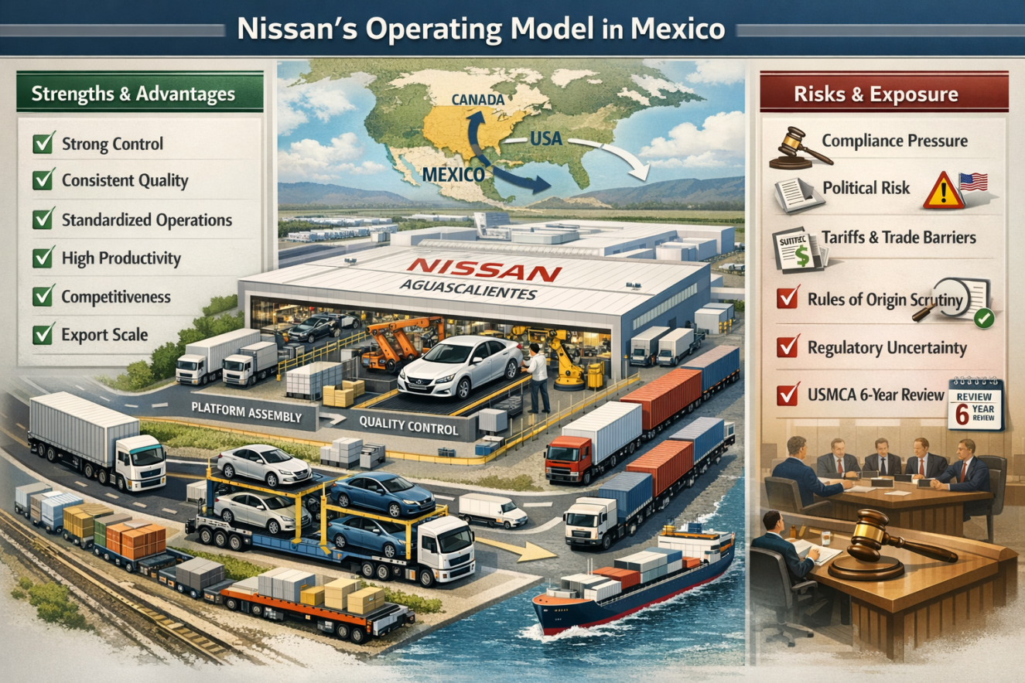
Figure 7: Nissan Mexico model balances control and risk (Nissan, 2025)
On the other hand, exposure is multiplied by the same structure. Heightened control also helps reduce occurrences of coordination failure, but at the same time, it also vests the blame for compliance performance and political risk. Hearings to gather evidence on the practicality of the agreement are already organised by the United States Trade Representative on July 1, 2026, as the first six-year joint review of USMCA is being prepared (U.S. Department of State, 2025). Within this environment, fully owned, export-driven business strategies do not provide Nissan with the same number of buffers in case of the escalation of rules-of-origin enforcement, the threat of tariffs, or a change in the regulatory environment. Whereas the model meets the requirement of having stringent control, it requires stronger risk controls than before, other than having to install better factory efficiency.

4.3 Market attractiveness (PESTLE)
Political
Compliance with the United States-Mexico-Canada Agreement (USMCA) and the stability of Mexico in terms of trade policy are major factors that define Nissan's desirability in Mexico. Future USMCA reviews in July 2026 are associated with some uncertainties, but Nissan has gone ahead to expand its compliance infrastructure through the deployment of advanced rules-of-origin tracking systems and put its suppliers in Mexico through intensive audit exercises (Reuters, 2025). Such steps will ensure that the exports of Nissan remain eligible to receive the duty-free treatment, which will eliminate the threat of introducing tariffs. In addition, Nissan has modified its production operations to reflect the set changes in trade policies, maintaining the flexibility and the ability to quickly adapt to a policy change, which promises the U.S. market cannot be interrupted (United States Trade Representative, 2026).
Economic
Although the investment plan of Nissan has the advantage of Mexico as a country with proximity to the United States market and gains in scale, the concentration within its exports is highly risky as well. In 2024, Mexico exported 79.7 percent of all vehicles to the U.S. (International Trade Administration, 2025). To counter this risk of concentration, Nissan has been able to diversify operations at the plant of Aguascalientes, which maximizes flexibility in the platform in order to adapt to shifts in demand in the United States. However, currency fluctuations that especially include the Mexican peso might hurt the profit margins of Nissan (Reuters, 2026). This can be achieved by hedging on currency risk strategically and enhancing best practices in cost management to ensure that Nissan is able to navigate the volatility in the financial markets all over the world and remain profitable (IMF, 2025).
Legal/regulatory
Mexico holds an attractive investment environment, and thus, the investment environment is still attractive; however, Nissan would be required to comply with strict regulations. In particular, the USMCA regulations on the rule-of-origin require 75% of the vehicle content to be made regional (U.S. Department of State, 2025). Nissan has addressed this by localizing its production to Mexico, where it has a Tier 1 supplier like Metalsa (chassis) and Nemak (casting) to satisfy this demand. The strict rate of adherence to protocols and close partnership with these suppliers makes export business to the United States smooth, minimizing the chances of non-compliance with the laws. Moreover, the compliance with the rules of origin benefits is a competitive advantage because they help Nissan to retain the status of duty-free trade and have a wide range of suppliers (International Trade Administration, 2025).
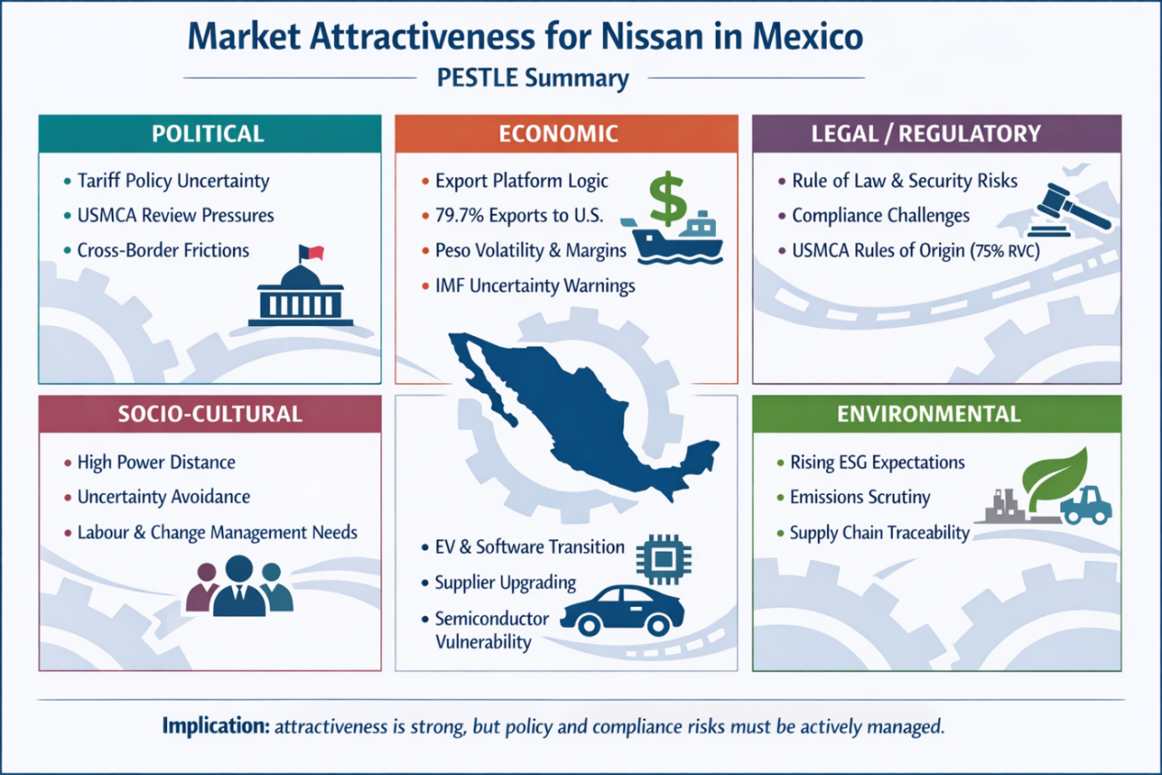
Figure 8: Market attractiveness for Nissan in Mexico, PESTLE analysis (Author)
Socio-cultural
The operations Nissan has conducted in Mexico are based on effective management-labor alignment. With Nissan concentrating its activities in a complex in Aguascalientes, excellent internal communication and trust towards the labor force are of great importance. The change of direction in the CIVAC plant will demand ongoing employee relations in order to avoid productivity loss. The HR processes that have been adopted at Nissan promote a seamless implementation scheme with a focus on open communication and participation of staff in the rearrangement process (Bright and Cortes 2025). The labor stability is also critical because the automotive business in Mexico is slowly shifting to producing vehicles with greater value, such as electric vehicles (EVs) that would need skilled labor and well-developed training.

Technological
Nissan is grappling with the world transition to electric vehicles (EVs), which is coming with its opportunities and threats. In its consolidation efforts in Aguascalientes, Nissan is spending massive amounts on EV manufacturing and the new generation platform technology. This involves modernizing its supply chain and having collaborations with suppliers such as Metalsa and Nemak to get high-quality components to make EVs. The world semiconductor crunch, however, presents a problem because the availability of chips limits the manufacture of vehicles. To reduce this, Nissan has focused on diversification of suppliers and is partnering with Tier 1 suppliers to acquire a stable supply of the key EV parts (Reuters 2026c).
Environmental
Environmental regulations are becoming a significant factor in the entry of Nissan into the market, as well as its brand image. The expectations related to ESG (Environmental, Social, and Governance) are growing all over the world, and Nissan is obliged to follow the requirements of the local and international environmental standards. The firm is positioning its production lines in accordance with the changing environmental laws in Mexico, with clean production and traceability. More so, the pressure on global supply chains is pushing Nissan to engage in sustainable practices, which require all parts that it incorporates in its vehicles to be manufactured according to the principles of sustainable practices. Nissan can exploit the surge in consumer demand for environmentally friendly cars by improving its level of environmental compliance (Lazard 2025).

4.4 Industry structure (Porter Five Forces)
Table 3: Porter’s Five Forces (Mexico automotive manufacturing) (Author)
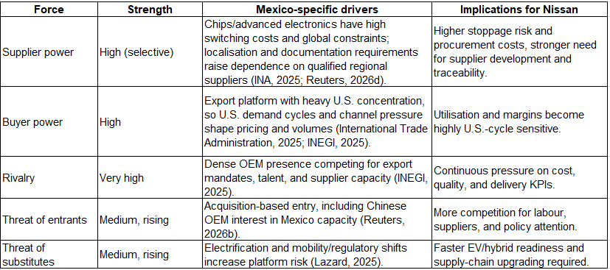
Supplier Power (High - Selective)
Nissan also experiences crucial supplier power because its suppliers (Tier 1 suppliers) (Metalsa and Nemak) provide it with critical components, including chassis and casting. The semiconductor shortage across the world increases the procurement risks (INA, 2025). To counter this, Nissan has been working out long-term agreements with such suppliers and investing in the mechanisms of supply-chain visibility and subsequent continuity in the wake of the external disruption.
Buyer Power (High)
The country market of the United States, which contributes to 79.7 percent of the automotive export of Mexico, has significant control over the volume of production and the model mix of Nissan. In order to adjust, Nissan focuses on the flexibility of platforms and production schedules that are matched with U.S. consumer demand patterns and streamlines its cost base (INEGI, 2025).
Rivalry (Very High)
The high competition of General Motors, Volkswagen, and Toyota motivates Nissan to integrate its production plants in Aguascalientes, thus improving the efficiency of its operations and cost savings (INEGI, 2025). This consolidation is, however, also in effect susceptible to geographical concentration risk.
Threat of Entrants (Medium, Rising)
The threat posed by Chinese OEMs like BYD and Geely increases the risk of Nissan losing size in the market. Nissan can respond to this by focusing on the production of electric vehicles (EVs) and making its platform flexible, which reduces the entry barriers (Reuters, 2026b).
Threat of Substitutes (Medium, Rising)
Switching to electric cars represents an even more topical threat of substitutes. Nissan is responding to this by becoming EV-prepared and updating its platform architecture to be competitive in this growing market and dealing with the risks of semiconductor shortages (Lazard, 2025).

4.5 Success factors and risks for Nissan in Mexico
- USMCA compliance efficacy: Duty-free provision is vulnerable to the delivery of the regional requirement content and submission of the necessary documents, which raises the economic cost of non-compliance (Reuters, 2026a).
- Exposure to tariff and policy shock: The possibility of tariff increases is a major threat to investment planning and pricing options, especially considering the fact that they depend on the demand of the United States (Tourliere, 2025).
- Localisation and local supplier depth: Although Mexico has competitiveness strength in terms of parts ecosystem, Nissan will continue to need to localise to meet its regulatory requirements and reduce government exposure to imports (INA, 2025).
- Risk of concentration of operations post-consolidation: The transfer of the CIVAC production to Aguascalientes by itself could lead to improved efficiency, but it will also result in fewer residents and more vulnerability to various events at one location (Nissan, 2025).
- Labour relations and change management: Organisational restructuring increases labour risk, and it is necessary to maintain clear communication and consistent processes to maintain productivity and employee retention (Reuters, 2025c).
- Security in semiconductor and electronics suppliers: The presence of constraints in the semiconductor industry is likely to disrupt the continuity of its production and increase supplier bargaining power, which makes procurement strategy a vital capability (Reuters, 2025d).

4.6 Recommendations
- Achieve a USMCA compliance advantage instead of staying compliant: It includes the adoption of sophisticated content-tracking systems, high-level procedures in supplier certification, and audit-ready documentation. These projects help eliminate the threat of reneging on the duty-free qualification and make it easy to update the models.
- Reduce the diminished concentration risk by operational robustness: It is essential to strengthen contingency logistics, such as alternative routing, carrier diversification, and buffer strategies of the high-risk components, at the same time bolstering the risk controls at the site level.
- Rapidly modernise its suppliers of electronics and electric-vehicle (EV) components: The speeding up of supplier modernisation along electronics and electric vehicle tracks involves creating joint capability programs with Tier 1 suppliers in Mexico who focus on electronics quality, mitigation of chip risk, and components that are used in electric vehicles. What can be done is making use of the Mexican parts ecosystem and of higher-value localisation that can be provided.
- Manage the stakeholders like a productivity tool: Use an organised worker communication process, open communication in HR and a regular management routine during the transition period to ensure product quality and throughput are not compromised. This becomes particularly urgent in the situation with increased power distance and uncertainty avoidance.

5.0 Conclusion
The automotive sector in Mexico reaches the level of global competitiveness through its concentration of massive assembly plants, a well-developed and well-networked supply chain, and a tight connection with North American markets, in addition to the fact that large volumes of production can be achieved, and export volumes are impressive. Nonetheless, the model creates strategic vulnerabilities; a high level of reliance on demand in the United States makes operational performance excruciatingly sensitive to changes in policy, and the imminent review of the 2026 United States-Mexico Agreement worsens the uncertainty on the matter. Contextually speaking (in the case of Nissan), Mexico serves as an export hub; the centralisation of manufacturing in Aguascalientes will increase the efficiency of operations, but at the same time, the risk will be concentrated in case disruptions in the chain of supply occur in reality. According to the same, the competitive edge is proven to be increasingly based on the move towards cost leadership to compliance and capability orientation as stricter rules-of-origin systems and supply chain supplier improvements increasingly determine market penetration and sustainability. Based on this, the success of Nissan in the Mexican market will depend on how the company positions its trade compliance and logistical resilience as a strategic competency aligned with the productivity imperative. What remains a salient weakness is the fact that data that is publicly available deters being able to gain a granular insight into the profit margin of plants or the terms of the supplier contract, leading to an effect of having to make an indirect estimate of risk.

SECTION 2: Reflective Account (Gibbs)

1.0 Description
The analysis of the Mexican automotive manufacturing industry, which includes vehicles and components, was chosen because of the presence of strong, publicly verifiable data used to justify an evidence-based international business report and because the production industry is also inherently structured by integrating across borders. The monthly data of production, exports, and domestic sales at the manufacturer level prepared by INEGI also enable the researcher to leave the descriptive prose and evaluate the arguments about scale and export dependence empirically based on the time-series evidence (INEGI, 2025). The foreign MNC that was selected as the focal point due to its operations in Mexico is the multinational corporation Nissan, since its activities are both high in scale and currently experiencing a strategic transformation. Namely, the decision by Nissan to implement centralisation in the process of production in the complex of Aguascalientes and yet leave the production of vehicles at CIVAC by the end of the fiscal year 2025 (March 2026) provides a specific contextual framework in which to interpret the response of corporate strategy to the competitive forces and risk (Nissan, 2025). This convergence fits the requirement of the module to appraise the attractiveness and success factor of the market from political, economic, legal, and cultural perspectives.

2.0 Feelings
The main dilemma was to strike a balance between the data-intensive industry and the lack of certainty about the future policy. The ongoing tariff discussions and the USMCA discussion on the review side make the whole environment look like a moving target, with the analysis becoming overly speculative without basing it on any plausible source (United States Trade Representative, 2026). I, too, had a challenge avoiding a reductionist view of Mexico's comparative advantage as a mere amalgam of low cost or nearshoring. These attributes are often put forward in public discourse as self-evident; the existing evidence in the marketplace demonstrates that the competitiveness narrative in Mexico depends on the ability to access the market and the effectiveness of the supply chain (International Trade Administration, 2026). Another complication is due to the lack of data at the firm level; publicly available data rarely reveals plant margins, product-level profitability, or contractual parameters. As a result, the evaluation of Nissan consolidation requires a careful inference based on noticeable factors, patterns of production and exports and declared long-term goals, but not unreasonable conclusions.

3.0 Evaluation
This proved to be best with INEGI as the empirical base. The data set enabled the performance of the OEMs to be compared based on uniform definitions of production, export, and domestic sales and allowed for more decisive statements on the dependence on external demand (INEGI, 2025). Credibility was enhanced through triangulation. I referred to OICA to compare the production among countries globally and the U.S. International Trade Administration to place the sector into perspective, the proportion of exports to the United States (OICA, 2025). The most powerful side of the work was connecting these facts of the industry with the strategic consolidation of Nissan, of which Nissan and Reuters, respectively, report (Nissan, 2025). What also failed to do so well was to integrate parts-industry data on the same granularity as vehicle data. The sources of INA allow the description of ecosystems, yet firm-level items' value added, and the level of localisation are more difficult to measure publicly, which restricts the accuracy of certain supply-chain inferences (INA, 2025).

4.0 Analysis
The cycle of Gibbs compelled me to look at frameworks as a means of decision and not a part to complete. The Diamond created by Porter has assisted in finding the fact that Mexico has a systemic advantage, which is a combination of factor conditions, supporting industries, and rivalry, but it is also politically contingent since sustainable trade rules are essential in competitiveness (International Trade Administration, 2025). After that contingency was converted into the operational implications of Nissan by PESTLE, in particular, political risk (tariffs and USMCA review), economic risk (export concentration and FX volatility), and legal-regulatory risk (investment climate and enforcement uncertainty) (U.S. Department of State, 2025). Five Forces explained the structural high supplier power in semiconductors and electronics, which is important to the resilience and platform strategy of Nissan (Reuters, 2026d). Where I had data that was not complete, I attempted to treat it explicitly. To illustrate, I was not able to measure Nissan's impact on profitability as a result of the consolidation, and instead I concentrated on the observable logic, Nissan's improved utilization and competitiveness statements, and external reporting on the timeframes of plant closure, and identified the resulting concentration risk as a plausible argument as opposed to the measured outcome (Reuters, 2026a).

5.0 Conclusion
This has helped to draw a firmer conclusion that the international business analysis is strongest when it combines superior institutional dynamics at a macro-level with the firm-level strategic decisions using empirical evidence to back its stance, compared to situating the country risk merely as a ticking box. I now consider trade regimes and compliance potential as competitive resources and not a contextual fact, notably in an export platform economy (United States Trade Representative, 2026). Besides, I have come to understand that the so-called nearshoring advantage is not a natural advantage, which should be preserved by relying on reliable logistics, stringent compliance mechanisms, and nonstop technological development.

6.0 Action Plan
I will start previous data retrieval at INEGI in later analyses and build a simple dashboard with production, export, and sales in order to identify the breaks in trends before writing (INEGI, 2025). My search strategy will also be narrowed down by using the structured keywords that include: USMCA automotive rules of origin enforcement, Mexico automotive exports share US, and Nissan Mexico consolidation Aguascalientes CIVAC, which will then filter out low-quality policy articles and focus on mainstream commentary (International Trade Administration, 2025; Nissan, 2025). Lastly, I will strengthen the synthesis stage by ensuring that every Diamond and PESTLE assertion is supported by at least one empirical datum and a source that can be trusted and map out visualisations, trend charts, and firm-comparison tables as soon as possible to ensure that there is no instance of incoherence between the story and the data throughout the work.

References
Bocar (2026) Company. Available at: https://www.bocar.com/company (Accessed: 27 February 2026).
Bright, D.S. and Cortes, A.H. (2025) 6.2 Hofstede’s cultural framework - principles of management, OpenStax. Available at: https://openstax.org/books/principles-management/pages/6-2-hofstedes-cultural-framework (Accessed: 27 February 2026).
CEIC Data (2025) Mexico Motor Vehicle production, Mexico Motor Vehicle Production, 1997 – 2025 | CEIC Data. Available at: https://www.ceicdata.com/en/indicator/mexico/motor-vehicle-production (Accessed: 19 March 2026).
IMF (2025) Mexico: 2025 Article IV consultation-press release; staff report; and statement by the executive director for Mexico, IMF. Available at: https://www.imf.org/en/publications/cr/issues/2025/10/27/mexico-2025-article-iv-consultation-press-release-staff-report-and-statement-by-the-571378 (Accessed: 27 February 2026).
INA (2025) Automotive Industry in mexico - overview, Industria Nacional de Autopartes . Available at: https://ina.com.mx/wp-content/uploads/2024/09/AUTOMOTIVE-INDUSTRY-IN-MEXICO-Overview.pdf (Accessed: 27 February 2026).
Instituto Nacional de Estadística y Geografía (INEGI) (2025) Administrative Registry of the Automotive Industry of Light Vehicles (RAIAVL). Available at: https://www.inegi.org.mx/datosprimarios/iavl/ (Accessed: 27 February 2026).
International Organization of Motor Vehicle Manufacturers (OICA) (2026) Production statistics, International Organization of Motor Vehicle Manufacturers. Available at: https://oica.net/production-statistics/ (Accessed: 27 February 2026).
International Trade Administration (2025) Mexico - Automotive Industry, International Trade Administration. Available at: https://www.trade.gov.http.akamai-trials.com/country-commercial-guides/mexico-automotive-industry (Accessed: 27 February 2026).
International Trade Administration (2026) Mexico - market overview, International Trade Administration | Trade.gov. Available at: https://www.trade.gov/knowledge-product/exporting-mexico-market-overview (Accessed: 27 February 2026).
ITF (2015) Logistics Development Strategies and Performance Measurement Roundtable Report, International Transport Forum (ITF) . Available at: https://www.itf-oecd.org/sites/default/files/docs/logistics-strategy-performance-management.pdf (Accessed: 27 February 2026).
Lazard (2025) Global Automotive Supplier Study 2025, https://www.lazard.com. Available at: https://www.lazard.com/research-insights/global-automotive-supplier-study-2025/ (Accessed: 27 February 2026).
MarkLines (2025) Mexico - automotive production in 2024 by OEM, Vehicle Type, MarkLines Automotive Industry Portal. Available at: https://www.marklines.com/en/statistics/flash_prod/automotive-production-in-mexico-by-month-2024? (Accessed: 19 March 2026).
Metalsa (2026) Drive for a better tomorrow, Metalsa. Available at: https://metalsa.com/ (Accessed: 27 February 2026).
Nemak (2026) Nemak. Available at: https://nemak.com/about-us (Accessed: 27 February 2026).
Nissan (2025) Nissan to integrate vehicle production from Civac Plant to Aguascalientes plant in Mexico, Nissan. Available at: https://global.nissannews.com/en/releases/250730-00-e (Accessed: 27 February 2026).
Office of the United States Trade Representative (2025) USTR seeks public comment on the joint review of USMCA, United States Trade Representative. Available at: https://ustr.gov/about/policy-offices/press-office/press-releases/2025/september/ustr-seeks-public-comment-joint-review-usmca (Accessed: 27 February 2026).
Prodensa (2025) Mexican automotive industry report [updated for 2025], Home. Available at: https://www.prodensa.com/insights/blog/mexican-automotive-industry-report-2024 (Accessed: 19 March 2026).
Promexico Industry (2025) How many vehicles did Mexico Export in 2024 and where were they sent?, Promexico Industry. Available at: https://www.promexicoindustry.com/en/article/how-many-vehicles-did-mexico-export-in-2024-and-where-were-they-sent (Accessed: 19 March 2026).
Rassini (2026) Rassini. Available at: https://www.rassini.com/en/ (Accessed: 27 February 2026).
Reuters (2025) Bank of Mexico, flagging new taxes and tariffs, signals support for rate cut pause | Reuters, Reuters. Available at: https://www.reuters.com/world/americas/bank-mexico-flagging-new-taxes-tariffs-signals-support-rate-cut-pause-2026-01-08/ (Accessed: 27 February 2026).
Reuters (2026a) Automakers hunt high and low for chips as supply crisis worsens | Reuters, Reuters. Available at: https://www.reuters.com/business/autos-transportation/nissan-mercedes-sound-alarm-over-chip-supply-crisis-2025-10-29/ (Accessed: 27 February 2026).
Reuters (2026b) Exclusive: Seeking Mexico Foothold, China’s BYD and Geely bid to buy Car Plant | Reuters, Reuters. Available at: https://www.reuters.com/business/autos-transportation/seeking-mexico-foothold-chinas-byd-geely-bid-buy-car-plant-2026-02-12/ (Accessed: 27 February 2026).
Reuters (2026c) Mexico auto industry warns of complex outlook ahead of USMCA Review | reuters, Reuters. Available at: https://www.reuters.com/business/autos-transportation/mexico-auto-industry-warns-complex-outlook-ahead-usmca-review-2025-10-02/ (Accessed: 27 February 2026).
Reuters (2026d) Nissan to stop production at Civac Plant in Mexico by March 2026, Reuters. Available at: https://www.reuters.com/business/autos-transportation/nissan-stop-production-civac-plant-mexico-by-march-2026-2025-07-30/ (Accessed: 27 February 2026).
Tourliere, M. (2025) Trump’s tariff threat rattles Mexico’s automotive industry, Le Monde.fr. Available at: https://www.lemonde.fr/en/economy/article/2025/04/02/trump-s-tariff-threat-rattles-mexico-s-automotive-industry_6739752_19.html (Accessed: 27 February 2026).
U.S. Department of State (2025) 2025 Investment Climate Statements: Mexico, U.S. Department of State. Available at: https://www.state.gov/reports/2025-investment-climate-statements/mexico (Accessed: 27 February 2026).
United States Trade Representative (2026) Public hearing on the first joint review of the USMCA, United States Trade Representative. Available at: https://ustr.gov/about/policy-offices/press-office/press-releases/2025/december/public-hearing-first-joint-review-usmca (Accessed: 27 February 2026).
World Bank (2025) Mexico , World Bank Open Data. Available at: https://data.worldbank.org/country/mexico (Accessed: 27 February 2026).
World Bank (2026) Foreign direct investment, net inflows (BOP, current US$) - mexico, World Bank Open Data. Available at: https://data.worldbank.org/indicator/BX.KLT.DINV.CD.WD?locations=MX (Accessed: 27 February 2026).

