Rachid Aboulachouaq (2237654)
2237654@student.uwtsd.ac.uk
Word Count: 2402

Changemakers:Value and Creation
ACCA5033

Table of Contents
Task 1 2
Project Scope 2
Proposed Solution 2
Required Technologies/Resources 2
Schedule 3
Constraints 3
Project Timeline Gantt Chart 4
Design Methodology: Agile 4
Requirements Specification (MoSCoW) 5
UML Class Diagram 6
Task 2 6
Nvidia PEST Analysis 7
Nvidia SWOT Analysis 7
Legal and Ethical Considerations 8
LinguaLens 8
Task 3 10
Project Reflection 10
References 11

Task 1

Project Scope
The project aims to design and develop a mobile augmented reality (AR) language learning application to enhance learners’ ability to learn a new language in an engaging manner, as traditional methods provide repetition but fail to provide real world context to words learned.
The proposed solution is to design and implement a mobile application that utilises AR technology to recognise objects through a device camera and display the name of the object in a target language that addresses the identified problem by creating an interesting and engaging pathway to learning language through curiosity and accessibility, as well as creating a link between what is learned and the environment of the user
The scope includes:
- Researching user needs and requirements.
- Designing and developing the AR and language learning systems
- Testing functionality through user trials and feedback.
- Refining the solution based on evaluations.
- Delivering a working prototype and final project report.

Proposed Solution
The solution involves creating an AR based language learning application that will [explain its role and benefit]. The project will use an iterative design and testing approach, incorporating user feedback at each stage to ensure usability and effectiveness.
The proposed solution is to develop a mobile AR application that helps language learners engage with real-world objects to improve vocabulary retention and pronunciation. The app will use object recognition to identify items in the learner’s environment and provide translations, audio pronunciations, and example sentences all in real time. Interactive features, such as pronunciation scoring and progress tracking, will allow learners to practice and keep track of their improvement. A pilot study with a small group of users will be conducted to evaluate usability, engagement, and learning effectiveness, ensuring the app meets both educational and technical goals.

Required Technologies/Resources

Software Development:
- AR Frameworks: ARCore (Android) or cross-platform tools (Unity + Vuforia/AR Foundation) [1]
- Programming: Java/Kotlin (Android)
- Speech Recognition: Google Speech-to-Text API
- Translation/Dictionary: Google Cloud Translation API, offline dictionaries
- Database: SQLite for learner progress tracking

Research Tools:
- Data Collection: Google Forms/MS Forms, OBS/Screen recording (user testing).
- Analysis: SPSS/Excel (quantitative), NVivo (qualitative coding)

Human Resources:
- Project Lead
- Software Developer
- Pilot Study Participants (8–10 language learners)
- Supervisor/Advisor for academic guidance

Schedule
- Weekly check-ins with supervisor for feedback
- Implement Bi-weekly sprints for agile app development
- Pilot sessions scheduled within 1–2 weeks (max 6 participants/day)
- Final 6 weeks reserved for analysis and writing to ensure timely completion

Constraints
- Technical:
  - AR recognition accuracy in different lightings and environments may cause issues
  - Limited access to premium APIs due to budget
  - Mobile device limitations (i.e. camera quality)
  - Lack of design and development standards for AR software may cause issues with compatibility
  - Security and privacy issues with AR software, ensure no negligence in programming and testing is extensive [2]

- Time:
  - Must keep project scope manageable and complete tasks on time
  - Pilot scale only, cannot run a full randomized controlled trial
- Resources:
  - Limited participant pool so must rely on convenience sampling
  - Budget constraints, therefore free/academic versions of software are preferred, potential to obtain Research Council Grant to implement Welsh target language
- Ethical:
  - Informed consent, anonymisation, and data and cyber security must be observed
  - Potential motion sickness/visual fatigue from AR use, ensure participants are aware of right to withdraw

Project Timeline Gantt Chart
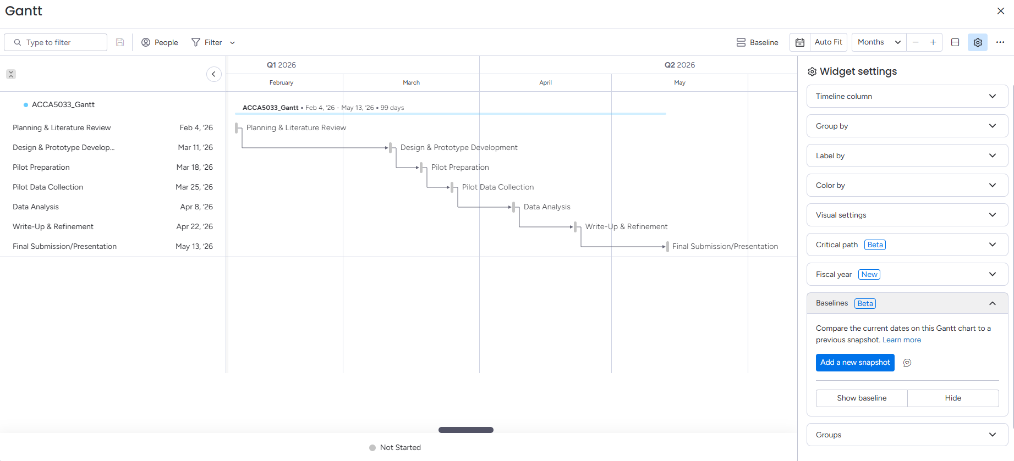
Gantt Chart created with Monday Work Management

Design Methodology: Agile
Agile is chosen because it is flexible, continuous feedback is provided, and iterative improvements can be made, which are essential in both software development and educational research projects. Unlike traditional methods, Agile allows you to build a working prototype quickly (minimum viable product), test it with users, and adapt it based on insights from the collated pilot data. This also places value on feedback from users, which satisfies the chosen research philosophy [3].
The project will adopt an Agile approach by working in short sprints, maintaining a backlog of prioritised tasks, and regularly testing and refining the app. Each sprint will deliver an incremental improvement, such as object recognition, translation etc, with progress reviewed at the end of each cycle. Weekly check-ins with a supervisor will serve as stand-ups, ensuring feedback and to ensure the project is in line with the project goals. Using this iterative method, the app can be developed and improved continuously, while user testing and pilot feedback are integrated directly into the development process [3].

Requirements Specification (MoSCoW)
Must Have:
- The app must recognise real-world objects using the mobile camera

- The app must provide translations of recognised objects in the target language

- The app must provide audio pronunciation for each translated word

- The app must allow users to practice pronunciation and receive real-time feedback

- The app must securely store and track learner progress (words learned, attempts, recall rate)

Should Have:
- The app should allow users to save new words into a personal vocabulary list

- The app should provide example sentences for contextual learning

- The app should allow learners to compare their pronunciation scores over time

- The app should support offline use with a limited local dictionary

Could Have:
- The app could include gamification features (points, levels, customisation).

- The app could support multiple target languages beyond the pilot language.

- The app could include a social learning feature where learners share progress or compete with friends.

- The app could provide adaptive learning paths based on learner performance.

Won’t Have:
- The app won’t include full classroom management features for teachers

- The app won’t offer full integration with third-party learning management systems

- The app won’t support augmented reality headsets

UML Class Diagram
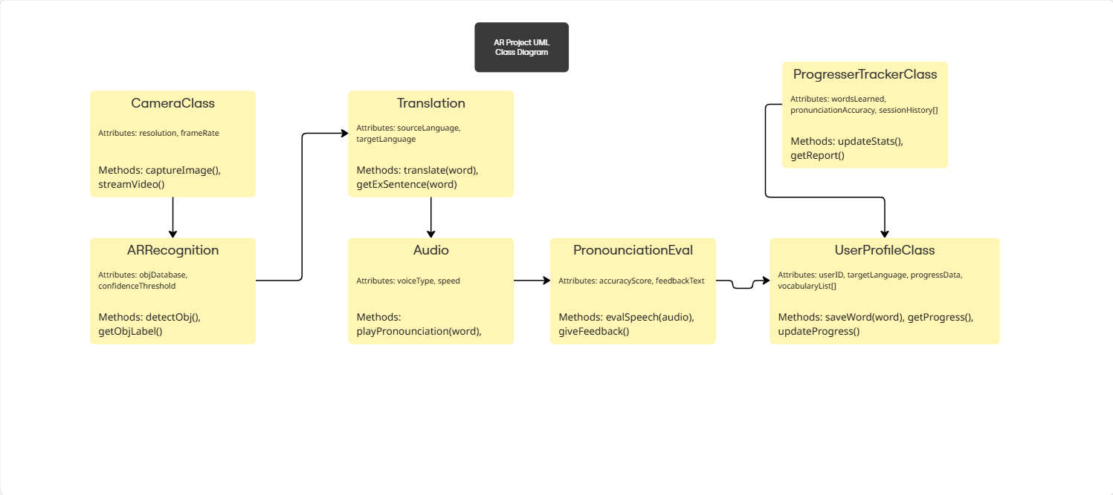
URL: https://miro.com/app/board/uXjVJSpb6u0=/?share_link_id=656646989686

Task 2

Nvidia PEST Analysis
Political
Political factors influence NVIDIA a great deal due to the nature of its products, specifically geo-politics. U.S. export restrictions on advanced AI chips to China have negatively affected NVidias sales, as China is massive market that the business could have taken advantage of. Another consideration is also high tax imposed on the export of Nvidia products due to strained foreign relations [4].
Economic
The economic environment obviously has a great impact on the health of business, and recently Nvidia has experienced an economic boom in the market. With the enormous spike in demand for AI, gaming and microchips, the business has experienced period of growth. However, with interest rates increasing, Nvidia can see Nvidia’s borrowing cost increase as well as a decrease in revenue as people spend more on necessity than luxury [4]. Competition and market saturation is also a real threat to Nvidia.

Environmental/Social
There are conflicting interests in this for the business. A majority of Nvidia sales are from graphical processing units, and with the demand for gaming increasing Nvidia should see a relatively stable period. However, modern games are becoming increasingly more demanding therefore many units can become obsolete with a few months, so constant R&D is need therefore driving up costs. The reputation of Nvidia is also a consideration, with generations and societies becoming increasingly more environmentally aware, the resources used by the company may have a negative impact as well as societal attitude to AI and future regulations on said industry [4].

Technological
Being a tech company, Nvidia is massively impacted by technological progress. As previously mentioned, with tech products demanding increasingly high resources to operate, Nvidia must meet those demands or risk losing sales. Therefore R&D investment is the lifeblood of such a company.

Nvidia SWOT Analysis
Strengths:
Nidia dominates the GPU and AI market as a powerhouse thanks to its advanced hardware, software and brand rep. Its financial stability, strong brand, and R&D investments maintain its position as a market leader across gaming, data centres, and AI [5].
Weaknesses
The company’s reliance on a set of revenue streams, particularly data centres and cloud providers, makes it vulnerable to demand shifts [5].
Opportunities:
There are big opportunities in emerging AI markets, such as edge computing and industrial applications. NVIDIA also has the chance to expand vertically into industries such as healthcare, finance, and manufacturing, while international expansion in emerging economies could drive further growth, making them a conglomerate [5].
Threats:
NVIDIA faces geopolitical risks, particularly U.S - China tensions and export controls that could cut off markets. Rivals such as AMD and Intel, alongside other cloud providers, are developing their own AI chips, intensifying competition. Legal challenges, antitrust scrutiny, and the threat of future technological disruption, like quantum computing, further compound these risks.

Legal and Ethical Considerations
NVIDIA has had to deal with some complex legal and ethical issues. The company has also been sued and fined in the past for not being clear about how much money it made from crypto-related sales [7]. Other issue, such as its collaboration with Hippocratic AI has sparked debate about moral and legal concerns, as they develop AI powered ‘health agents’ which could potentially create job losses as well as save lives by lowering strain on the health care system [6]. Regulators are now keeping a close eye on NVIDIA’s growing power in the chip market, and there are also ongoing debates about the ethics of how AI should be developed and controlled.

LinguaLens
The name of the company is LinguaLens, an augmented reality-based learning company.
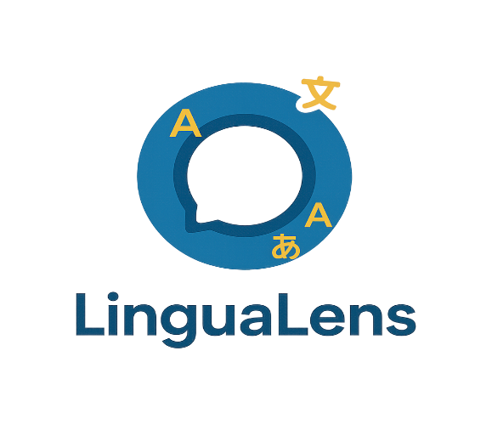
Logo created with GIMP

Business Type
The legal classification of the company will be a Private Limited Company (Ltd). This will be to maintain control of the business and to make it easier to receive investments. A key aspect of this is that it limits personal liability, protecting founders form debt and other legal claims therefore it is the most practical choice for a start-up.

Business Strategy
The business strategy for LinguaLens is based on differentiation through technology, specifically AR, and user experience. The app will target language learners such as students and travellers, as well as institutions looking for innovative teaching tools. Unlike traditional flashcard-based apps, LinguaLens offers a more immersive learning experience by combining AR object recognition, translations, and audio pronunciation with contextual practice, making word retention faster and more engaging.
The strategy will begin with the launch of a mobile MVP (minimum viable product) aimed at early adopters, followed by partnerships with local educational institutions to establish a foundation and generate licensing opportunities. Over time, the business will expand by offering multiple language packs, gamified features, and potential integration with AR glasses, ensuring both consumer appeal and long-term growth in the industry.

Funding
There are several ways for the business to secure start-up funding.
Government Grants & Innovation Funds:
- Educational technology and AI/AR projects are often eligible for local or national innovation grants. This may be feasible if the pilot target language is Welsh, due to Welsh Government goals, as well as UK Research Council grants
Angel Investors
- Investors may be interested in the early stages of the company and AR solutions. They can also provide mentorship and industry connections. LinguaLens can list itself on the UK Angel Investment Network to attempt to make some connections with investors.
Crowdfunding
- There are many platforms offering crowdfunding, such as Kickstarter or GoFundMe to raise funds while building community interest in the ideas. Early access could be provided to sponsors, which could also provide feedback and testing for the product
Strategic Partnerships
- Collaboration with schools, universities, or language institutes/organisations for pilot programs could generate funding, interest and credibility for the product. This could also open up another avenue for a B2B service to provide AR-based learning tools and resources.
Initial funding can come from government grants and crowdfunding, once confidence in the product growths, the company can aim to secure other forms of funding through partnerships with institutions as well as everyday users.

Task 3

Project Reflection
While completing this project, the scope of my research, as well as that of the module, has made the barriers to such things seem smaller. By actually planning the project, the goals seem attainable. Therefore, I will make use of this and do more research into application development. AR frameworks such as ARCore SDK are quite accessible and free to use, and there are many courses online that can be used to learn more about AR development. By also taking on a personal project for practice, this could be added to my personal portfolio, which could influence the business image.
Also, planning a pilot study and project proposal has increased my confidence in my management and planning skills in terms of workload and AGILE working, which I hope to continue to improve in my personal and professional life.
The project definitely seems viable, and the potential for growth in other areas of the industry is impressive. The best way to learn a language is through full immersion, and sometimes classroom learning and personal motivation is not enough for some people so the implementation of being able to visually and realistically associate a word is much more effective. As such, the application can help to bring interest to languages such as Welsh for the locality, and for travelers that are already throwing themselves into the world, the application should hopefully streamline their immersion. For example, ordering a coffee would become very easy, and the experience of successful interactions will accelerate language retention
There were a couple of challenges that I thought were particularly tough. Since the project is being developed with limited resources and under deadlines, there is a risk that the app may not reach full functionality or may contain bugs. To reduce this, I will focus on an MVP that delivers only the most essential features. Using Agile sprints, tasks can be broken into smaller, manageable goals, and open-source libraries or pre-built APIs can be integrated to save time. This approach should keep the project realistic within the available time and resources.
The other point was market saturation. In market already dominated by well-known apps like Duolingo and Memrise, if users do not see the unique value, use may remain low. To overcome this, the company must clearly emphasise its unique selling point of learning vocabulary in real-world contexts using AR. Offering a free version to trial, combined with partnerships with local schools and universities for pilot programs, will help to increase visibility, build trust, and increase user numbers.
To conclude, this project is an AR-based language learning app that helps users build vocabulary by linking words to real-world objects with translation and pronunciation practice. Despite challenges such as limited resources and competition, a lean MVP and agile development approach make the project somewhat achievable. With its unique focus on immersive, contextual learning, LinguaLens has strong potential.

References
[1] T. Boswijk. "What Technology Is Used For AR Development?" https://vrowl.io. https://vrowl.io/what-technology-is-used-for-ar-development/
[2] The App Solutions. "Augmented Reality Issues – What You Need to Know." https://theappsolutions.com. https://theappsolutions.com/blog/development/augmented-reality-challenges/
[3] M. Merkow, Secure, Resilient, and Agile Software Development, 1st Ed. Auerbach Publications, 2019. doi: 10.1201/9781003025399[Online]. Available: https://doi.org/10.1201/9781003025399
[4] PESTLE Analysis Team. "Nvidia PESTLE Analysis: Powering Prosperity in Gaming." https://pestleanalysis.com. https://pestleanalysis.com/nvidia-pestle-analysis/
[5] D. Pereira. "NVIDIA SWOT Analysis." https://businessmodelanalyst.com. https://businessmodelanalyst.com/nvidia-swot-analysis/?srsltid=AfmBOopdrd8t_RtR4ZiS0lRVXhyND0xKkfJUk4VRf3Am_9UcK-VXqGND
[6] K. Nathan, "The Ethical and Legal Implications of Nvidia’s ‘$9 Nurses," American Journal of Biomedical Science & Research, vol. 22, no. 3, pp.408–409, May 18 2024. doi: 10.34297/AJBSR.2024.22.002962. Available: https://biomedgrid.com/pdf/AJBSR.MS.ID.002962.pdf
[7] "Nvidia's Legal Battle Over Crypto Sales Transparency Intensifies." https://spectrum-search.com. https://spectrum-search.com/insights/nvidias-legal-battle-over-crypto-sales-transparency-intensifies#:~:text=The%20legal%20challenge%20against%20Nvidia,GPUs)%20intended%20for%20crypto%20miners.

