
MASTER OF BUSINESS ADMINISTRATION

STRATEGIC MANAGEMENT(LCMB7003)A

ASSESSMENT COMPONENT - INDIVIDUAL REPORT

STRATEGIC ANALYSIS AND SUSTAINABLE TRANSFORMATION OF SHELL PLC: A COMPREHENSIVE EVALUATION OF COMPETITIVE ADVANTAGE IN THE GLOBAL ENERGY INDUSTRY

- NAME= MAHIPALSINH RANVIRSINH GOHIL
- STUDENT ID= 2510635
- LECTURER= DR. ANDRY RAKOTOVOLOLONA
- WORD COUNT= 5000

Executive Summary

This is a strategic analysis report of Shell Plc along the internal strengths, external environment and long-term strategic direction. Some of the most significant strategic models, including PESTEL, Porters Five Forces, VRIO, and the Balanced Scorecard are employed in the paper in a review of a situation that Shell finds itself in within the global energy market. As per analysis derived from discussions of this report, Shell is in good financial position, which earned it significant earnings and cash flows in 2025 on its operations that will see it operate within over 70 countries.
However, dependency on the fossil fuel and the increasing regulatory and environmental requirements are significant threats to the company. Opportunities and strategy imperatives are the rising demand to use renewable energy and the digital transformation. The report finds that Shell should concentrate on the investment in low-carbon technologies, enhance operation efficiency with the help of digital innovation, and augment the risk management practices. A less defensive, more flexible strategy would enable Shell to retain its competitive advantage and achieve its long-term growth in the shifting environment of the energy sector. On the whole, the balanced scorecard exposes that the approach used at Shell is changing into performance measured by balancing components of sustainability, innovation and flexibility, unlike the scale and financial power.

Table of Contents

Section 1: Report 5
1. Organisational Context and Overview 5
1.1 Organisational Context 5
1.2 Industrial overview 5
2. External and Internal Environment Analysis 6
2.1 External Environment – PESTEL Analysis 6
2.2 Industry Analysis (Porter’s Five Forces) 7
2.3 Critical Success Factors and Strategic Challenges 8
2.4 Internal Analysis 9
2.5 VRIO Framework 10
3. CSR and Sustainability Objectives 12
4. Comprehensive and Holistic View (Balanced Scorecard) 13
4.1 Financial Perspective 14
4.2 Customer Perspective 15
4.3 Internal Business Processes 16
4.4 Learning and Growth 16
5. Strategic Choices and Implementation 16
5.1 Business-Level Strategies 16
5.2 Corporate-Level Strategies 17
5.3 Strategy Recommendations 17
5.4 Change Management 18
6. Strategic Evaluation and Recommendation 19
6.1 SWOT Analysis 19
6.2 Strategy Evaluation Tools 20
6.3 Recommendations 20
Section 2: Reflective Analysis 21
7. Conclusion 23
References 24

Section 1: Report

1. Organisational Context and Overview

1.1 Organisational Context
This report emphasizes on the external and internal environment of one of the renowned multinational oil and gas companies in London, Shell Plc. This company officially came into action in 1907. During the time of formation, it was a merger between the Royal Dutch Petroleum Company and The Shell Transport and Trading Company, UK. With time, “delivering more value with less emissions” has become the main strategy of Shell Plc (Shell, 2026a). This reflects its motto of becoming a net-zero emissions business by 2050. This organisation is focused on leveraging its global footprint, and improving its innovation and technology capabilities, which has been possible because of the immense trust people have put on this brand. Shell has positioned itself to be an investment case and the first “partner of choice”. Its vision is to be “the world's leading integrated energy company – delivering impact at scale, connecting energy and people, matching supply to demand” (Shell, 2026a).
With its wide range of activities of oil and gas exploration, production of fuels and lubricants, and constant research and development (R&D), Shell has served 1 million+ commercial and industrial customers (Shell, 202b). Not only this, but it has extended its portfolio by offering lower-carbon energy solutions, which includes hydrogen and carbon capture and storage, electric-vehicle charging, and biofuels.

1.2 Industrial overview
Shell Plc operates in the UK oil and gas industry, which majorly focuses on the energy sector. In 2024, there has been 62.9 million tonnes of oil and gas production, which began in the 70s (Gov UK, 2025). This was, however, 8.8% and 10.3% lower as compared to 2023. Additionally, a total of 158,400 people were found to be directly employed in the energy sector, with a total investment of 8.9% (Gov UK, 2025). Its Lubricant section has been ranked as the leading global supplier for 19 consecutive years. As per one of the recent reports of the United Nations, it is likely for the global population to increase to more than 10 billion (Shell, 2026c). Under such circumstances, it is essential for Shell to find out how the excessive demand for energy can be met at the cost of less carbon emissions. Some of the key players in this market include BP, Melrose Industries (MRO), and Woodside Energy Group (WDS).

2. External and Internal Environment Analysis

2.1 External Environment – PESTEL Analysis
Factor | Key Numerical Figures
Political | 2050 (net-zero target year), 2030 (reduction of carbon intensity 20% target).
Economic | 323 billion (revenue 2025)
Social | 10 billion (estimated world population), 1 million+ (commercial clients served).
Technological | 20% (cost reduction via AI and digitalisation)
Environmental | 20% (reduction of carbon by 2030), 2050 (zero net emissions).
Legal | In-house (compliance standard) 70+ (countries of operation regulatory frameworks), ISO/IEC 17025 (compliance standard).
Table 1: PESTEL Analysis
Shell Plc is engaged in a very complex external environment, which is characterized by political, economic, social, technological, environmental, and legal elements forming a joint influence on the strategic priorities of the company. These statistics are not only pointing at the conditions, but also strategic pressures that have to be addressed with active measures. On the political front, the 2030 carbon cut and 2050 Net-Zero Goal have collectively shown a rise in the regulation intensity, which directly limits the activities of Shell with regard to fossil fuels, as well as hastens its strategy of transition. As Tyce et al. (2025) note, these policy environments are never indifferent as they actively transform the competitive dynamics. There is also a risk of geopolitical instability that leads to supply risk and Shell has to diversify geographically in its 70+ countries of operation. This poses a strategic conflict as to whether to remain profitable or invest in energy transition over the long-term.
The social aspect of the global population projected to be more than 10 billion means that there will be an increase in the energy demand, but the global demand will have to be supported by growing pressure on sustainability in the society. As pointed out by Dongo and Relvas (2025), this two-way demand pressures such companies as Shell to both increase the supply and to also minimize the rate of emissions, which puts a strategic strain on development instead of offering easy growth. The 20% reduction that digitalisation has the capability to achieve in cost is not just an efficiency improvement but a competitive requirement. This pressure is enhanced by the environmental factors, which states that the 2050 net-zero target needs to be fundamentally altered, as opposed to being changed gradually. Compliance of ISO/IEC 17025 and various regulatory systems in all the operating countries add complexity and compliance expenses to operational costs of Shell. According to Haque (2025), regulatory adherence is more of a strategy capability, and not a pre-requisite requirement. On the whole, this analysis demonstrates that the environment of Shell is not only dynamic but structurally changing and needs constant adjustments, innovation, and realignment of strategies.

2.2 Industry Analysis (Porter’s Five Forces)
Force | Key Numerical Figures
Competitive Rivalry | 1.8million (barrels of oil equivalent per day), 70 plus (countries of operation)
Threat of New Entrants | 1-10 billion (average investment in projects), 10-15 years (average project life cycle).
Bargaining Power of Suppliers | 15% (potential reduction in logistics cost), 100 and above (significant suppliers in the world).
Bargaining Power of Buyers | 1 million+ (business clientele), more than 20% (renewable customer adoption tendencies increasing).
Threat of Substitutes | 20% (AI efficiency impact), 2030 & 2050 (energy transition milestones)
Table 2: Porter’s Five Forces Analysis
The oil and gas industry is typified by stiff competition, large amounts of capital outlay, and volatile market dynamics. The Five Forces are used by Porter to emphasise the competitive environment of Shell. The competition is intense because of the presence of leading international competitors, including BP and ExxonMobil. The large-scale competition is indicated by Shell producing about 1.8 million barrels of oil equivalent per day by 2025 (Annual Report, 2025). It is fighting based on its cost effectiveness, innovation and sustainability, and the turn to renewable energy makes the competition even stronger. New entrants have a low threat because of the entry barriers being multi-billion-dollar, advanced technology and stringent regulations. Established companies, such as Shell, have economies of scale and large infrastructure.
The power of suppliers is moderate because the industry relies on specialised suppliers. According to Pervukhin et al. (2025), supply chain optimisation can save logistics expenses up to 15%, which means that the optimal approach towards managing suppliers is critical. The growing awareness of the environment and alternative energy sources is contributing to the growing buyer power. The risk of substitutes is also high, which is facilitated by the rapid development of renewable energy. This transition is being hastened by the use of circular economy models, which helped Shell to be able to continue operating (Alsuhaibany, 2025).

2.3 Critical Success Factors and Strategic Challenges
The ability of Shell to make sure that it possesses competitive advantage depends on several success factors. The technological innovation plays a key role in the improvement of efficiency and cost minimization. New technologies (AI, machine learning, digital platforms) enhance the work in the field of operations and help in decision-making (Bruzzone et al. 2025). The more firms are able to streamline their operations and reduce the costs, the more possibilities of remain being competitive. With digitalization, capabilities of sustainability service chains have become significant in maximizing performance of the oil and gas industry (Mehdiabadi et al. 2025). The concept of Shell to focus on renewable energy and carbon reducing programs is a manifestation of its sustainability.
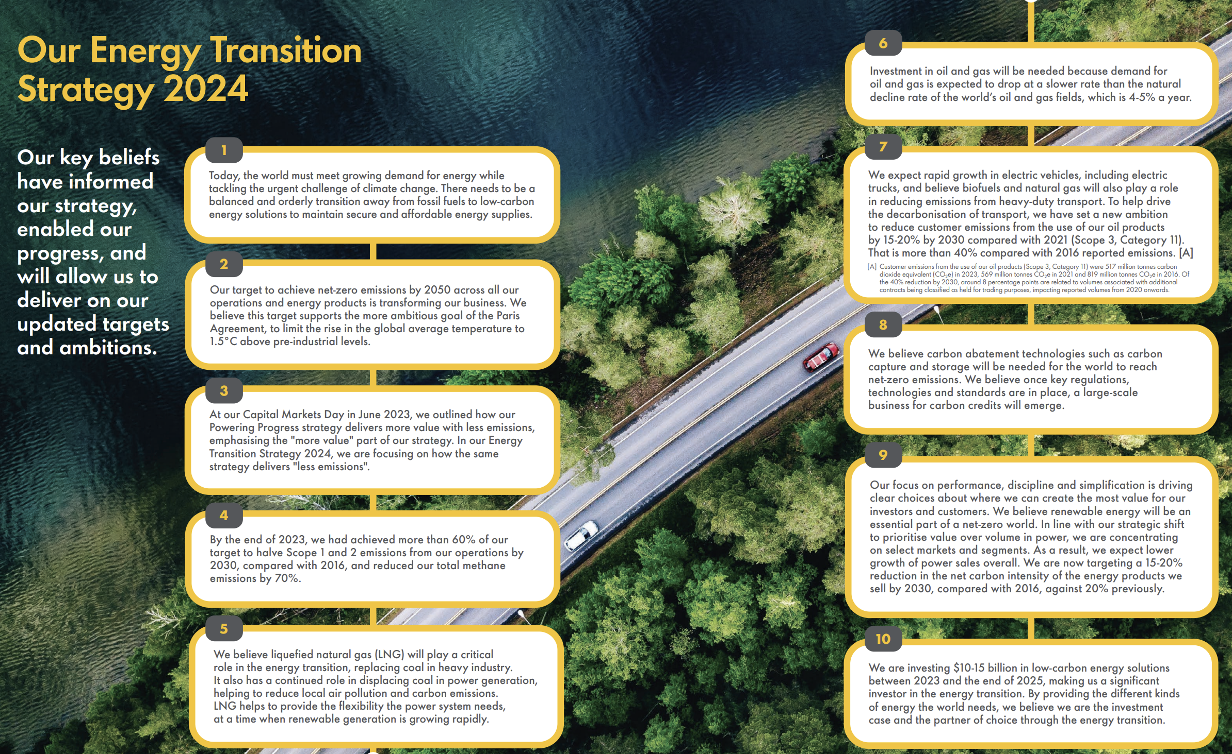
Figure 1: journey of Shell Plc towards net zero
(Source: Shell, 2024)
As evident from figure 1, Shell has achieved 60% of its target to reduce Scope 1 and 2 emissions in 2023 itself (Shell, 2024). Despite such strengths, Shell has several strategic challenges. The switchover to renewable energy can be costly and, therefore, it can have a short-term impact on profitability. The stability and safety of multifaceted supply chains is extremely relevant, particularly in dangerous environments such as offshore drilling. Cybersecurity is also faced with a huge threat. Because of the emergence of digitalisation, oil and gas companies are susceptible to additional cyber threats. Quansah (2025) provides an interesting approach to understanding securing digital supply chains as a significant factor to securing critical infrastructure and continuity of operations.

2.4 Internal Analysis
The internal environment of Shell is defined by the great resources and abilities that help in achieving the strategic objectives. With more than 93,000 employees all over the globe, the company offers a diverse, skilled labour force with the potential to promote innovation and operational efficiency (Yahoo Finance, 2025). One of the internal capabilities is financial strength. In 2025, Shell produced cash of about $54 billion, which made a large amount of money to invest in renewable energy and digital transformation programs (Stock Titan, 2025). This financial ability enables the company to undertake long-term strategic objectives as well as remain stable. Another significant strength is the technological capabilities wherein machine learning and simulation modelling will help Shell to become more productive and have a competitive advantage. Human capital is important to the performance of organisations. As Edonomokumor et al. (2025) showed, transformational leadership enhances employee innovation and minimises turnover, which leads to better performance and innovation. Investment in employee development and leadership training by Shell is in favour of its long-term growth.

2.5 VRIO Framework
Resource / Capability | Value (V) | Rarity (R) | Imitability (I) | Organisation (O) | Key Numerical Figures
Financial Strength | Yes | Yes | No | Yes | $54 billion (cash flow), $28 billion (earnings)
Global Operations | Yes | Yes | No | Yes | 70+ (countries), 1 million+ (customers)
Production Capacity | Yes | Yes | No | Yes | 1.8 million (barrels/day)
Technological Capabilities | Yes | Moderate | Moderate | Yes | 20% (efficiency improvement via AI)
Supply Chain Efficiency | Yes | Moderate | Yes | Yes | 15% (cost optimisation potential)
Workforce & Human Capital | Yes | Moderate | Yes | Yes | 93,000+ (employees)
Table 3: VRIO Analysis
The VRIO analysis brings out that the competitive advantage possessed by Shell is not homogenous with all its resources, but its sustainability and strategic influence are not homogenous. The financial power portrayed a good value and organisational strength that allowed investing in energy transition projects at large scale (Stock Titan, 2025). Nonetheless, as precious and well-structured, financial resources are not completely uncommon, and other large competitors have the same resources. The scale benefits and complexity of the infrastructure are value and relatively scarce as 70 or more countries of operation and a production capacity of 1.8 million barrels per day are uncommon. These are short term hard to copy, and generate a temporary competitive advantage. Conversely, technological capabilities that provide up to 20% in terms of efficiency are worthwhile but only moderately uncommon since digital technologies can be embraced by competitors in the long run (Póvoas et al., 2025). The supply chain, which can be optimised by 15% of the cost, and employee of more than 93,000 workers offer operational support, but are mostly replicable to prevent long-term differentiation. Mehdiabadi et al. (2025) argued that sustainability of the oil and gas industry is slowly becoming reliant on the adoption of innovation and service chain capabilities. On the whole, the ability to grow large and constantly innovate is an enduring competitive edge, which Shell can leverage as opposed to having resources that others have.

3. CSR and Sustainability Objectives
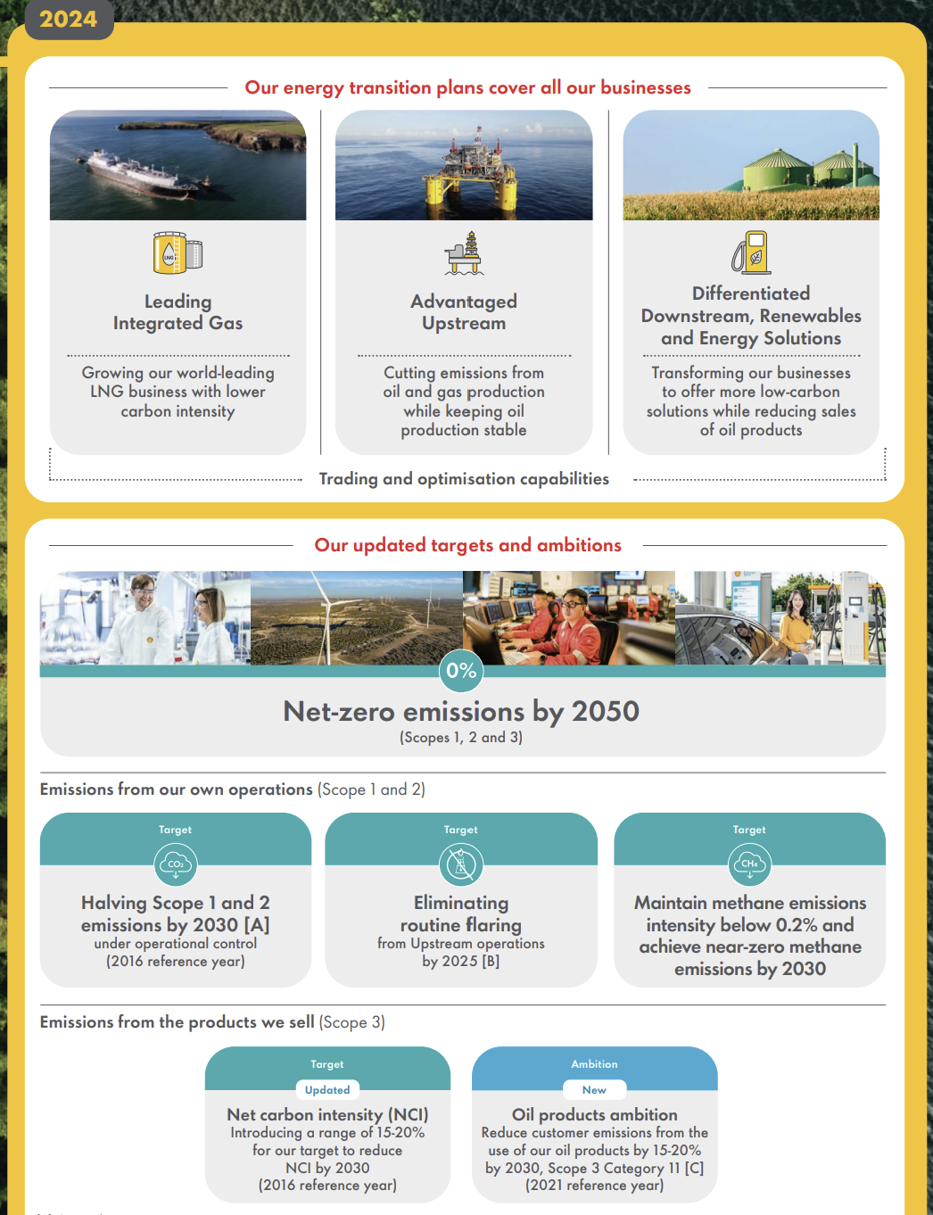
Figure 2: 2024’s Energy Transition Strategy of Shell
(Source: Shell, 2024)
The Shell corporate social responsibility (CSR) approach involves minimisation of carbon emissions, increased investment into renewable energy and increased transparency of environmental action reporting. In 2030, the company has a clear target in that it will have reduced its net carbon intensity by 20%, since it is the overall objective of the company in its attempt to go to a low-carbon energy future (Annual Report, 2025). Such a goal aligns with the global climate agenda and is indicative of the way Shell tackles the societal issue of environmental problems without inevitably losing its market share. The increased investment into the renewable energy solutions is one of the key aspects of Shell sustainability strategy. Figure 2 has proved that Shell has succeeded to become a leading LNG business that has the lowest carbon intensity (Shell, 2024). The company has expanded its product range in the hydrogen power, charging technology of electric vehicles, and biofuels as a way of not relying on conventional fossil fuels.
Oyerogba et al. (2025) noted that proper corporate governance leads to better carbon emission disclosures that in turn build accountability and trust between the stakeholders. Shell has tried to focus more on transparency and reporting and this makes it appear to be a responsible energy provider. Despite these efforts, a significant issue of attempting to balance between the sustainability objectives and the financial results exists. Switching to renewable energy will imply high outlay of capital and this could affect the profitability in the immediate future. In his regard, the digital transformation will play an important role in assisting in maintaining the initiatives. Al-Hajri et al. (2025) are convinced that digital technologies have a positive effect, such as improving the efficiency of operations, wasting, and resource management, which positively contributes to the support of environmental goals. Overall, CSR and sustainability goals of Shell are an indication of the strategic shift to the cleaner energy and financial sustainability. However, the long-term sustainability objectives will demand the presence of constant innovations and appropriate governance.

4. Comprehensive and Holistic View (Balanced Scorecard)
The balanced scorecard offers a holistic model to measure the performance of Shell due to its ability to incorporate both financial and non-financial aspects. It helps the organisation to align its strategic goals with operations in four major perspectives which are financial, customer, internal processes and learning and growth.
Perspective | Objectives | KPIs (Numerical) | Targets / Figures | Initiatives (Numerical)
Financial | Profitability & growth | $28 billion (earnings), $42.9 billion cash flow from operating activities | 2030 and 2050 (long-term carbon emission reduction targets) | $10+ billion (annual investment range)
Customer | Customer satisfaction & expansion | 1 million+ (customers), 70+ (countries) | 10 billion (future demand population) | 100,000+ (EV charging points target range)
Internal Processes | Efficiency & operations | 1.8 million (barrels/day), 15% (cost optimisation) | 88,000 (EV charging points) | 24/7 (operational uptime target)
Learning & Growth | Innovation & workforce development | 93,000+ (employees), 20% (AI impact) | 2030 (digital transformation milestones) | 1000+ (training hours annually per unit estimate)
Table 4: Balanced Scorecard

4.1 Financial Perspective
The strength and the strategic pressure can be identified in the financial performance of Shell. In 2025, the company has high liquidity to invest heavily (LSE, 2025). But these numbers also point out a strategic quandary that they provide money to long-term initiatives with low carbon and sustain shareholder returns. A financial commitment to capital spending in the form of spends that exceeded $10 billion a year indicates a slow but steady shift towards renewable energy (Shell, 2026a). as evident from figure 3, Shell has witnessed income of $18.1 billion and cash flow of $42.9 billion from operating activities as of 2025 (Shell, 2026). However, financial capability of the effort is still limited through the existing reliance on oil and gas. Nuraini and Cahyadi (2025) added that the governance and capital structure of oil and gas companies have a strong impact on financial performance. This implies that Shell financial strategy needs to justify the balance between the risk and returns and the sustainability commitment.
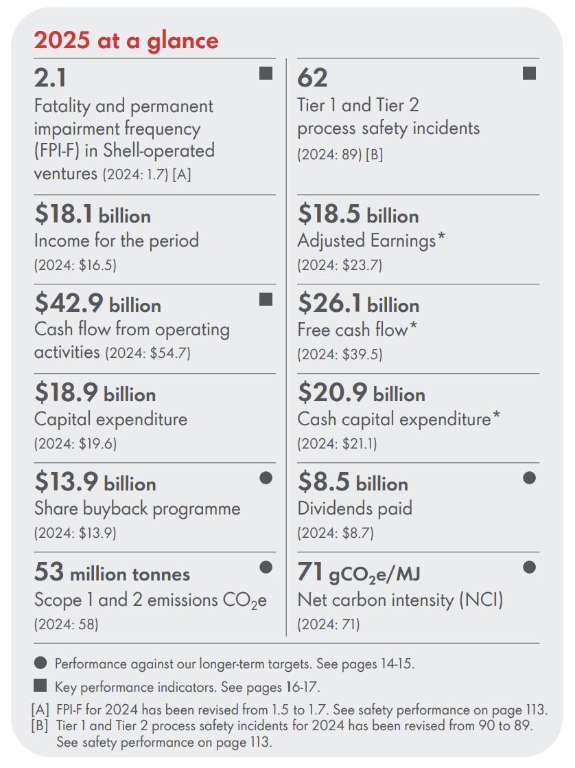
Figure 3: Financial performance of Shell in 2025
(Source: Shell, 2026)

4.2 Customer Perspective
The customer strategy of Shell represents the transition to value-driven sustainable solutions provided to the customers instead of energy supply in volumes. The scale of serving more than 1 million customers is good, yet it is the actual strategic transformation that is to meet the emerging consumer expectations. The fact that the company is expanding to 100,000+ EV charging points shows that it is entering into new energy ecosystems (Shell, 2024). This however is not entirely a demand-based transition but influenced by society and regulatory pressures. According to Dongo and Relvas (2025), energy companies need to align the customer experiences offered by the firm with the sustainability objectives, which means that customer value should start being re-invented by Shell as something beyond selling fuel.

4.3 Internal Business Processes
The internal processes at Shell are undergoing transformation to digitally integrated systems that were initially efficiency-oriented processes. Its level of production of 1.8 million barrels per day is an indicator of the level of operation. With this, it has owned 88,000 electric vehicle charge points in 2025, which was 73,000 in 2024 (Shell, 2026). According to Stoianova et al. (2025), decision support systems contribute to the efficiency of strategic planning and resource distribution, which implies that the work of Shell becomes more data-driven. Yet, dependence on sophisticated supply chain creates weaknesses, and to get 15% cost optimisation potential, the ongoing process innovation and risk management are essential.

4.4 Learning and Growth
The long-term competitiveness of Shell is reliant on its human capital and innovation capabilities development. It has provision of assessing maturity of several opportunities. Post-investment reviews are performed to extract learnings for implementation in future opportunities, which also flourishes delivery predictability (Shell, 2026). can be seen as the strategic direction toward the knowledge-based competitiveness. Edonomokumor et al. (2025) point out that the transformational leadership style is more effective in improving employee creativity and minimizing employee turnover, which supports the significance of the internal capability building.

5. Strategic Choices and Implementation
Strategic decisions made by Shell indicate a shift in its organisational structure, with a focus on its more advanced and diversified energies and sustainability aspects (Shell, 2026c). Nevertheless, the process of transformation is not always linear because the company will have to save the current revenue base at the same time as investing in development areas.

5.1 Business-Level Strategies
Shell practices a hybrid strategy of cost leadership and differentiation at the business level, which causes inherent strategic conflict. Large volume operations, integrated supply chains and economies of scale drive cost leadership where Shell manages to lead with competitive pricing in a fluctuating market. Nevertheless, this strength is increasingly being questioned by the increase in the cost of operation and regulation. The main way of differentiation is achieved by investing in renewable energy, low-carbon fuels, and electric mobility infrastructure. This is an indication of a change in the mode of competition which is product based to a value-based competition which is focused on sustainability. Digital technologies can also boost efficiency and innovation (Povovas et al. 2025). Cost leadership and differentiation however could be used together thus blurring strategic direction. Mehdiabadi et al. (2025) stated that sustainable competitive advantage in oil and gas industry is about combining both innovation and operational efficiency meaning that Shell needs to be keen on aligning both strategies as opposed to pursuing them in isolation.

5.2 Corporate-Level Strategies
At the business unit level, Shell is undertaking the process of diversification and internationalization, which entails high level of risk and uncertainty. The strategic move to other energy renewable sources like hydrogen, wind, and biofuels shows that the company is responding to a waning trend in fossil fuels. But even these markets are still in the maturity phase and involve high risk of capital outlay that will be met with questionable returns. The internationalisation strategy enables Shell to diversify risk, reach new markets, but also expose it to geopolitical risks, and regulatory uncertainty. Digital transformation is also more powerful in supporting corporate strategy as it allows making data-driven decisions and making operations more integrated. According to Al-Hajri et al. (2025), the digital transformation is necessary to ensure the alignment of sustainability and operational performance, meaning that the corporate strategy of Shell is getting more and more reliant on technology.

5.3 Strategy Recommendations
Shell needs a more specific approach to transition towards to improve the long-term competitiveness and not a widespread hybrid strategy. The investment in renewable energy also needs to be increased. Although, it should be allocated to the sector of the high growth hydrogen and electric mobility so that it could yield the greatest returns. Also, Shell ought to speed up the process of digital transformation to enhance efficiency and lower the cost of operation. The approach of applying artificial intelligence and data analytics will optimize decision-making and aid innovation. One of the primary factors of efficiency and competitiveness of the energy industry is digitalisation (Povivas et al. 2025). It should also take strategic partnerships to mitigate the risk and pick up on innovation. Distribution should be increased in collaboration with technology companies and renewable energy suppliers to improve the ability to enter the market and decrease the burden of capital. To balance both the financial stability and long-term sustainability, it is advisable to have a phased transition approach.

5.4 Change Management
These strategic decisions would require effective change management. The shift to renewable energy will be accompanied by a huge organisational change, including cultural change, workforce re-skilling, and changes in structure. A significant obstacle is resistance to change especially in an organisation that has always operated on fossil fuel. Bondi et al. (2025) highlight the need to focus on strategic communication to align the expectations of the stakeholders and promote change. This will need transparent communication and effective leadership in order to win trust and cause less opposition. Also, Egila et al. (2025) emphasise the role of organisational culture and risk management in achieving operational reliability in the context of change. All in all, the strategic execution of Shell is reliant on the capacity to strike a balance between change and stability whereby innovation, efficiency and organisational alignment are realised in tandem.

6. Strategic Evaluation and Recommendation
An analysis of the current approach of Shell has shown the strengths and weaknesses and the region where the company can improve on its strategic positioning. One of the strategic tools that may be used to analyse its competitive position and prospects is the SWOT analysis and the Ansoff Matrix.

6.1 SWOT Analysis
Strengths | Weaknesses
- Global presence in 70+ countries enables diversification and market reach.  - Shell’s energy transition is profitable, which follows the Carbon Management Framework (CMF)  - This aligns with its GHG reduction commitments (Shell, 2026) | - Heavy reliance on fossil fuels with $323 billion revenue increases the risk  - High capital requirements of $10+ billion for transition projects impact short-term returns  - Business of 2024 caused net loss of $7,364 million (Shell, 2026)  - The long-term 2050 transition timeline creates uncertainty in achieving sustainability goals.
Opportunities | Threats
- Rising demand from a 10 billion global population increases energy needs (Dongo and Relvas, 2025)  - Expansion of 100,000+ EV charging points supports clean energy growth.  - Digitalisation offering efficiency gains | - Strict environmental regulations by 2030 raise compliance costs.  - Supply chain inefficiencies can increase costs by up to 15%.  - Renewable competitors growing over 20% threaten market share.
Table 5: SWOT Analysis
The financial stability, the international character, and the integrated business model of Shell are its strengths. Its CM, which embed carbon emission reduction considerations into core management processes, has turned out to be beneficial for Shell to accelerate the energy transition profitably (Shell, 2026). The business is supported by diversification and mitigation of risk, operating in 70+ countries with more than 1 million customers. Nevertheless, Shell is still immensely reliant on fossil fuels, and a significant part of its $323 billion revenue is based on oil and gas (Macro Trends, 2025). Switching to renewable energy would entail multi-billion-dollar investments, which would impact short-term returns. Through increased energy demand in the world, opportunities emerge since the population is now over 10 billion. The EV charging and hydrogen investments contribute to the future development. Among the threats, there are regulatory pressures and inefficiencies in the supply chain, which may raise the costs by up to 15% (Pervukhin et al., 2025).

6.2 Strategy Evaluation Tools
Ansoff Matrix gives insight into the strategic direction of Shell especially the emphasis it has on diversification and developing the market. Renewable energy expansion is a diversification approach since the firm is shifting to new product lines, including hydrogen, biofuels and renewable electricity. Simultaneously, the development of the market is seen through Shell trying to spread out in the emerging economies with the growing demand for energy. This two-pronged strategy can enable Shell to lose dependence on the conventional markets as it tries to venture into new areas of revenue. Yet diversification also brings on some risks such as expensive investment and rising new technologies. This is why proper allocation of resources and planning must be carried out to be successful.

6.3 Recommendations
Shell needs to invest more in renewable energy so as to become less dependent on fossil fuels to meet the sustainability targets. Making the digital transformation, involving AI and data analytics, more rapid can enhance efficiency and decision-making, and the potential benefits include up to 20% (Povas et al., 2025). It is also important to strengthen cybersecurity since the vulnerability of systems can result in the loss of money (Ebelogu et al., 2025). The strategies will promote competitiveness in the long term and sustainable growth.

Section 2: Reflective Analysis
This part is an introspective of the way I conducted my research, analysis and writing of the strategic management report of Shell Plc in Gibbs reflective cycle. This model provides me with a methodical system within which I could critically examine my experience in learning and be aware of the areas that I could improve in the future.
Description
In this assignment, I have conducted a comprehensive strategic analysis of Shell Plc through the application of some theoretical models, which consist of the PESTEL, Porters Five Forces, VRIO, SWOT, and the Balanced Scorecard. It was achieved through gathering data in the form of scholarly materials, company reports as well as financial reports so as to achieve a well-supported analysis. I additionally examined CSR activities, strategic decisions, and overall competitive advantage of Shell in the energy industry of the world. The assignment motivated and educated me that I need to integrate theory and business in practice in the world of business. I had to be capable of ensuring that all the sections of the report were being logically connected and supported with the help of the relevant data and the scholarly literature. As Ocampo et al. (2025) argue, reflective practices help students to connect theory and practice, and this method of learning seemed very reasonable to me when I was completing the assignment.
Feelings
It was very hectic and I was on the first level and was lost in the intricacies of the assignment. The oil and gas business is quite dynamic and the numerous facets of the business required a lot of effort to understand the various facets of the business. I even did not know how to be efficient when working with different strategic models and whether I selected the most suitable data to demonstrate my arguments. However, my level of confidence in the work on the report increased as well. I was introduced to financial analysis and application of strategic models. Decoding information and connecting ideas of different concepts enabled me to get a more decisive conception of the subject. As stated by Beldar (2025), reflective learning will raise the degree of confidence and problem-solving skills as it occurred to me during the assignment.
Evaluation
Reflecting back on my work, I can state that one of my performance strengths was the ability to be able to integrate theory and practice. My points were more valid and the analysis was more acceptable given the fact that numerical data were utilized. I was also able to give a systematic and rational report, which responded to the major requirements of the assignment. However, the restrictions were also present. It was also not easy to keep track of a considerable amount of information and there were occasions when I was not able to be consistent concerning different sections. The other fact is that I was not good at critically evaluating certain ideas as well as just describing them. Praveena et al. (2025) note that reflective practices enhance the skills of analytical thinking and critical thinking that Analysis.
The experience allowed me to discover how critical thinking and systematic analysis are useful in strategic management. By applying a number of frameworks, I was able to gain additional information on the effects of internal and external factors in the strategy of an organisation. I have come to learn that strategic models are not the imaginary tools but practical theoretical approaches of analysing actual business scenarios. Besides that, I got introduced to the importance of evidence-based decision-making. The use of financial data and academic source allowed me to prove my arguments. Wang (2025) believes that the reflective cycle that was created by Gibbs makes the process of learning more profound as it makes an individual critically evaluate his or her experiences. During this process, I was capable of identifying the gaps in my knowledge particularly on the relationship between theoretical frameworks and practical application. The other lesson acquired was the importance of time management. I also learnt that planning is quite critical whenever dealing with difficult tasks. One should take time to properly conduct research, analyse and revise so that he could produce quality work.
Conclusion
In most cases, the assignment became an excellent learning experience that enhanced my research, analytical, and problem-solving skills. I had a better understanding of the concepts of strategic management and its usage in the real life. My abilities in data analysis and formulation of sound arguments also evolved. According to Jocz and Fitzhugh (2025), reflective practice plays a role in the continuous learning and professional development. This reflection has helped me to be more aware about my strengths and weaknesses that will help me improve in my next academic and professional tasks.
Action Plan
I will have a more systematic approach to dealing with my work in the future. In order to ensure that all the phases of the assignment are accomplished successfully, I will begin by creating a clear plan and schedule. My time management will be improved to help me deal with a lot of information. The other area of strengths I wish to work on is the skill of critical thinking, which I would develop through a reading of more academic literature and scepticism towards other opinions. I will also strive to improve my abilities associated with the synthesis of information and the ability to present it in the clear and concise manner. I will also continue to expand my knowledge related to the strategic frameworks, and their application. Regular training and self-evaluation will help me to polish my analytical skills and improve the quality of my work. The reflective cycle developed by Gibbs will also be my permanent tool of continual improvement in my daily work with an assurance that I will learn each time and apply these lessons in the next work.

7. Conclusion
It can be concluded from above discussions that strategically, Shell Plc is operating in the dynamic and competitive international energy environment because of the regulatory pressure, the establishment of technologies, and the transition to sustainable energy. It is also seen that Shell is a company that has superior financial position, international presence and technology, which guarantee high level of sustained competitive advantage. However, the reality that it cannot prevent the use of the fossil fuels poses huge strategic issues in respect to the growing environmental pressure and the market revolution. The strategic models have been an eye-opener on strengths and external forces, especially the PESTEL, VRIO and the Balanced Scorecard. It is revealed in the analysis that the diversification into renewable energy and the digital transformation will turn out to be the key factors of the long-term success. Overall, resiliency, investment in innovation and strategic change management would also contribute to Shell becoming more competent in its sustainability activity and capable of attaining sustainable development even in the rogue environment of energy conditions.

References
Al-Hajri, A., Hamouda, A.M. and Abdella, G.M., 2025. Sustainability-based strategic framework for digital transformation in the oil and gas industry. IEEE Access. https://ieeexplore.ieee.org/abstract/document/10915590/
Alsuhaibany, Y., 2025. Digital innovation and circular economy: a nexus for sustainable oil and gas sector transformation in Saudi Arabia. Sustainability, 17(3), p.1325. https://www.mdpi.com/2071-1050/17/3/1325
Annual Report, 2025. Shell Plc Annual Report 2025. Available at: https://www.shell.com/investors/results-and-reporting/annual-report-archive/_jcr_content/root/main/section_812377294/tabs/tab_copy_copy/text.multi.stream/1773292272508/5e49e127579b77081f032b6088b348694aac0d14/shell-annual-report-2025.pdf [Accessed on: 21 March 2026]
Beldar, P.R., 2025. Case Study: Enhancing Learning in C Programming Through Gibbs Reflective Cycle. Journal of Engineering Education Transformations, pp.61-68. https://www.journaleet.in/index.php/jeet/article/view/2013
Bondi, T., Burbano, V.C. and Dell'Acqua, F., 2025. When (not) to talk politics in business: Experimental evidence. Strategic Management Journal, 46(5), pp.1105-1119. https://sms.onlinelibrary.wiley.com/doi/abs/10.1002/smj.3684
Bruzzone, A.G., Sinelshchikov, K., Gotelli, M., Monaci, F., Sina, X., Ghisi, F., Cirillo, L. and Giovannetti, A., 2025. Machine learning and simulation modeling large offshore and production plants to improve engineering and construction. Procedia Computer Science, 253, pp.3318-3324. https://www.sciencedirect.com/science/article/pii/S1877050925003990
Dongo, D.F. and Relvas, S., 2025. Evaluating the role of the oil and gas industry in energy transition in oil-producing countries: A systematic literature review. Energy Research & Social Science, 120, p.103905. https://www.sciencedirect.com/science/article/pii/S2214629624004961
Ebelogu, C.U., Prasad, R., Bisallah, H.I., Hammawa, B.M. and Musa, I., 2025. Investigation of cybersecurity vulnerabilities and mitigation strategies in Nigeria's oil and gas industry. ABUAD Journal of Engineering Research and Development (AJERD), 8(1), pp.140-150. http://journals.abuad.edu.ng/ajerd/article/view/1025
Edonomokumor, T., Arhinful, R., Mensah, L. and Obeng, H.A., 2025. The mediating role of creative behavior in the relationship between transformational leadership and turnover intention. Future business journal, 11(1), p.139. https://link.springer.com/article/10.1186/s43093-025-00563-1
Egila, A.E., Kamal, M.M., Kumar Mangla, S., Rich, N. and Tjahjono, B., 2025. Highly reliable organisations and sustainability risk management: safety cultures in the Nigerian oil and gas supply chain sector. Business Strategy and the Environment, 34(2), pp.2680-2701. https://onlinelibrary.wiley.com/doi/abs/10.1002/bse.4091
Gov UK. (2025). UK ENERGY IN BRIEF 2025. Available at: https://assets.publishing.service.gov.uk/media/688890c3a11f859994409132/UK_Energy_in_Brief_2025.pdf [Accessed on 08 March 2026].
Haque, E.A., 2025. Quantitative Analysis Of Mechanical Testing And Valve Performance In The Oil And Gas Sector: Ensuring Compliance With ISO/IEC 17025 In Global Industrial Infrastructure. ASRC Procedia: Global Perspectives in Science and Scholarship, 1(01), pp.1424-1457. https://global.asrcconference.com/index.php/asrc/article/view/75
Jocz, J. and Fitzhugh, G., 2025. Through the Looking Glass: Building Reflective Practice into Data Collection with Public Librarians. Visitor Studies, 28(1), pp.142-155. https://www.tandfonline.com/doi/abs/10.1080/10645578.2025.2500245
LSE, 2025. Shell Plc 4th Quarter 2025 and Full Year Unaudited Results. Available at: https://www.londonstockexchange.com/news-article/SHEL/shell-plc-4th-quarter-2025-and-full-year-unaudited-results/17447293 [Accessed on: 31 March 2026]
Macro Trends, 2025. Shell Revenue 2012-2025 | SHEL. Available at: https://www.macrotrends.net/stocks/charts/SHEL/shell/revenue [Accessed on: 31 March 2026]
Mehdiabadi, A., Sadeghi, A., Yazdi, A.K. and Tan, Y., 2025. Sustainability service chain capabilities in the oil and gas industry: A fuzzy hybrid approach SWARA-MABAC. Spectrum of operational research, 2(1), pp.114-134. http://sor-journal.org/index.php/sor/article/view/12
Nuraini, A. and Cahyadi, I.P., 2025. Influence good corporate governance, capital structure, and company size on financial performance of oil and gas companies. Jurnal Ilmiah Akuntansi Kesatuan, 13(1), pp.43-52. https://jurnal.ibik.ac.id/index.php/jiakes/article/view/3109
Ocampo, F.A., McIntyre, B.G., Massey, D. and Saunders, R., 2025. Nursing student reflections on a research internship: A reflective discussion following the Gibbs' reflective cycle. Nurse education today, 145, p.106481. https://www.sciencedirect.com/science/article/pii/S0260691724003915
Oyerogba, E.O., Olugbenro, S.K., Omojola, S.O., Wright, O., Aregbesola, O.D., Akinsola, T.O. and Amu, I., 2025. The roles of ownership structure on carbon emission disclosure quality of the listed oil and gas companies in Nigeria. International Journal of Energy Economics and Policy, 15(1), pp.25-35. https://savearchive.zbw.eu/bitstream/11159/703141/1/1920707069_0.pdf
Pervukhin, D.A., Davardoost, H., Gasimov, E. and Hawezy, A.L.J., 2025. Optimizing multimodal logistics in petroleum supply chains using linear goal programming: A case study on South Pars gas field development. https://www.researchgate.net/profile/Hadi-Davardoost/publication/388938578_Optimizing_Multimodal_Logistics_in_Petroleum_Supply_Chains_Using_Linear_Goal_Programming_A_Case_Study_on_South_Pars_Gas_Field_Development/links/67ad99004c479b26c9def43a/Optimizing-Multimodal-Logistics-in-Petroleum-Supply-Chains-Using-Linear-Goal-Programming-A-Case-Study-on-South-Pars-Gas-Field-Development.pdf
Póvoas, M.D.S., Moreira, J.F., Neto, S.V.M., Carvalho, C.A.D.S., Cezario, B.S., Guedes, A.L.A. and Lima, G.B.A., 2025. Artificial intelligence in the oil and gas industry: Applications, challenges, and future directions. Applied Sciences, 15(14), p.7918. https://www.mdpi.com/2076-3417/15/14/7918
Praveena, K.S., Juslin, F., Patil, C.M. and Bhargavi, K., 2025. Using gibb's reflective model approach for enhancing project-based learning among students through reflective assessment. Journal of Engineering Education Transformations, pp.148-155. https://journaleet.in/index.php/jeet/article/view/2071
Quansah, S., 2025. Securing Oil & Gas Digital Supply Chains: A Vendor Risk Management Framework for IoT and Cyber-Physical Systems. Journal of Artificial Intelligence General science (JAIGS) ISSN, pp.3006-4023. https://www.researchgate.net/profile/Samuel-Quansah-6/publication/394920365_Securing_Oil_Gas_Digital_Supply_Chains_A_Vendor_Risk_Management_Framework_for_IoT_and_Cyber-Physical_Systems/links/68abc7646327cf7b63d92452/Securing-Oil-Gas-Digital-Supply-Chains-A-Vendor-Risk-Management-Framework-for-IoT-and-Cyber-Physical-Systems.pdf
Shell. (2026a). Our strategy. Available at: https://www.shell.com/what-we-do/our-strategy.html [Accessed on 05 March 2026].
Shell. (2026b). What we do? Available at: https://www.shell.com/what-we-do.html [Accessed on 08 March 2026].
Shell. (2026c). Our business at a glance. Available at: https://www.shell.com/careers/about-careers-at-shell/our-business-at-a-glance.html [Accessed on 08 March 2026].
Shell. 2024. Energy Transition Strategy 2024. Available at: https://www.shell.com/sustainability/climate/shell-energy-transition-strategy/_jcr_content/root/main/section_321304972/promo_copy_copy/links/item0.stream/1726832326846/2c3f9065f2886e789ac196789f137dbca49473e8/shell-energy-transition-strategy-2024.pdf [Accessed on: 20 March 2026]
Shell. 2026. Shell plc / Annual Report and Accounts. Available at: https://www.shell.com/investors/results-and-reporting/annual-report/_jcr_content/root/main/section/promo/links/item0.stream/1774544186011/5727c329a58b5eb7a54442c0a03f562a5aef1159/shell-annual-report-2025-interactive.pdf [Accessed on: 18 March 2026]
Stock Titan, 2025. Shell 2025 results: cash returns and emissions cuts. Available at: https://www.stocktitan.net/sec-filings/SHEL/6-k-shell-plc-current-report-foreign-issuer-7e7909793630.html [Accessed on: 31 March 2026]
Stoianova, A.D., Trofimets, V.Y., Stoianova, O.V. and Matrokhina, K.V., 2025. Structural model of decision support system for sustainable development of oil and gas companies. https://www.researchgate.net/profile/O-Stoianova/publication/387894766_Structural_Model_of_Decision_Support_System_for_Sustainable_Development_of_Oil_and_Gas_Companies/links/6781139979d6d00f5f607d11/Structural-Model-of-Decision-Support-System-for-Sustainable-Development-of-Oil-and-Gas-Companies.pdf
Sun, X. and Wang, Y., 2025. Spatio-temporal characteristics and analysis of influencing factors of inclusive green growth in China’s oil and gas resource industry. Ecological Indicators, 170, p.112982. https://www.sciencedirect.com/science/article/pii/S1470160X24014390
Tyce, M., Abdulai, A.G. and Asante, K.P., 2025. Confronting shifting energy landscapes and contested domestic politics: Ghana's national oil company and the global energy transition. Energy Research & Social Science, 119, p.103901. https://www.sciencedirect.com/science/article/pii/S2214629624004924
Wang, D., 2025. Practice and Exploration of a Clinical Nursing Student Teaching Model Based on the Combination of Flipped Classroom, MOOCs, and Gibbs’ Reflective Cycle: A Case Study of The First Affiliated Hospital of Anhui Medical University. Pacific International Journal, 8(4), pp.176-184. https://www.rclss.com/pij/article/view/866
Yahoo Finance, 2025. Shell plc publishes fourth quarter 2025 press release. Available at: https://uk.finance.yahoo.com/news/shell-plc-publishes-fourth-quarter-070100277.html [Accessed on: 27 March 2026]

