Jonathan’s Assignment Feedback:

Highlight = something done well
Highlight = something to improve upon/ skill to learn
Highlight = important to be aware of
Engagement with Literature 11/15
Knowledge and Understanding 19/25
Cognitive and Intellectual Skills 11/15
Practical Skills 18/25
Transferable Skills for Life and Professional Practice 14/20

Areas of Strength
You have shown a strong level of knowledge and understanding of all the key study skills, particularly within the quiz components (referencing, academic writing, AI, and critical thinking) of the portfolio, where you have received high marks. This indicates that you have an appreciation of their importance in future assessments.

Within your AI quiz and forum post, you show very good level of critical thinking; for example, your forum post dissects both extracts and you present logical reasoning of why extract 2 was written by AI. This will prove to be very important when it comes to using AI in your studies.
Your academic planner and well-being checklist demonstrate very good transferable skills, particularly for current and future studies, and employment as you can effectively manage your time, problem-solve, and help maintain positive well-being.

Areas for Development
There are components of your portfolio that did not make use of the application of theory; for instance, within your wellbeing checklist, you could have utilised Maslow's hierarchy of needs to illustrate that without meeting physiological needs, physical/psychological safety, and developing a sense of belonging, individuals cannot potentially reach their potential or goals.
Moreover, it was unfortunate to see that you did not showcase your integration and networking skills within your networking task. Showcasing accessing services outside of the lecture room can be very important for a student's journey, and in the future, should you ever need support outside the classroom, there are services available to support you.

Moving Forward:
In future assignments, try and showcase how theory can be utilised to address a challenge as a solution or how it attempts to explain a particular situation/context or a phenomenon. This will strengthen your understanding of the applicability of theory and bridge the divide between theory and practice.

Continue to apply all the academic study skills within your current and future assignments, as these will serve you well.
Overall comments:
You have been a model student since joining us Sydney, and it is great to see you supporting other students within your cohort and providing reassurances and guidance: this is invaluable to other students.

Corey’s Assignment Feedback:

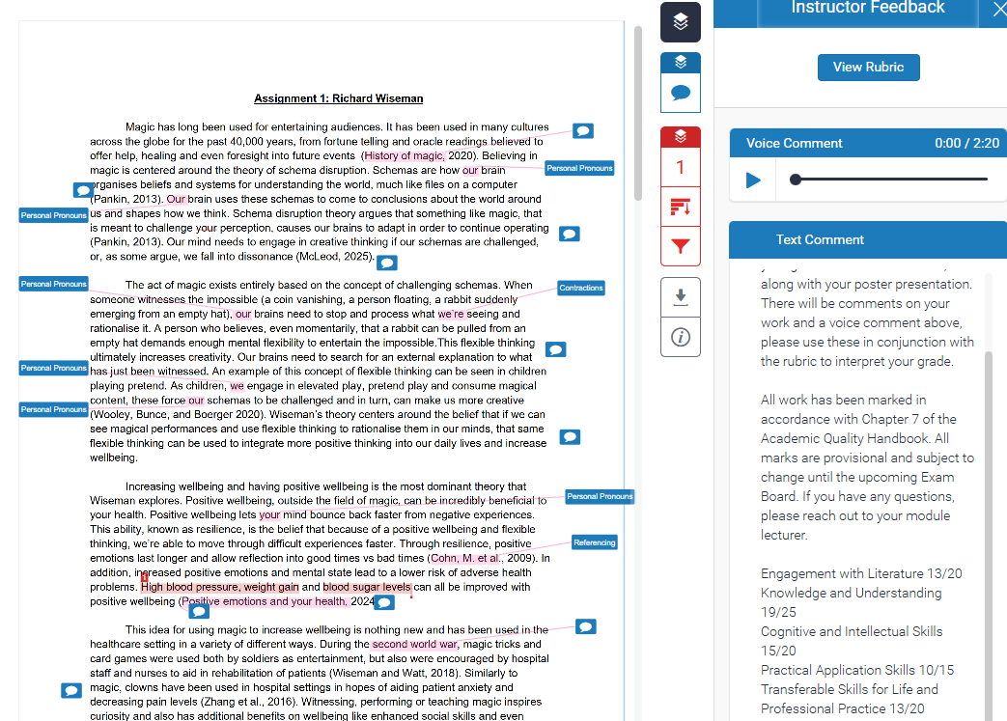
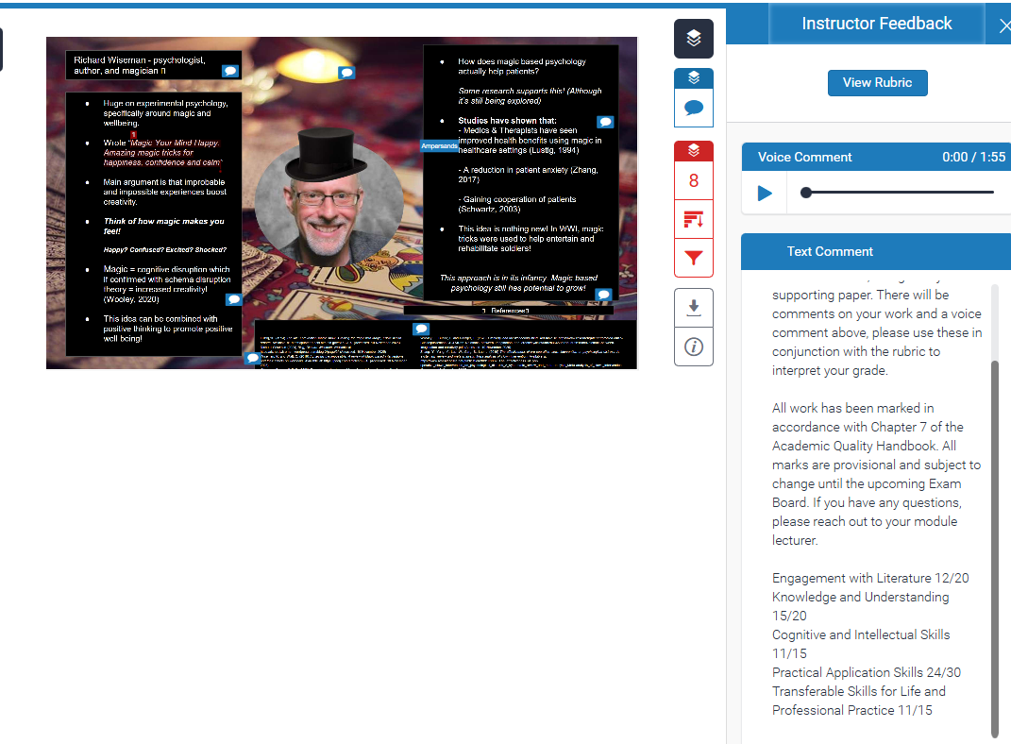

- Don’t use personal pronouns
- Strong knowledge of lecture materials
- Good engagement with complex ideas
- Minor referencing problems
- A few irrelevant points here and there.
- Good inclusion of complex ideas
- Good engagement with ideas not taught in class.
- Need to expand upon reference materials.
- Stop using contractions.

