BSc health and Social Care
Living with Care: The Older Person
Student Name: Petea kaye Davis
Student ID: 1911491
Module code BMHP6009-BIRM
Lecturer Joanne Davies
Assignment Title written Assignment Essay

People above the age of sixty-five are considered to reach old age. However, it is unnecessary as the rate of ageing biologically varies from person to person. Moreover, the Health of individuals also plays an active role in ageing, as an individual above 70 may seem healthier than someone aged 60 (Piper et al.,2019). At the same time, Stuckler et al. (2017) identified that the utilisation of advanced health care services in the United Kingdom has helped increase the number of older people by making it easy for them to survive in society. The availability of quality healthcare services for older individuals has further contributed to the rising older population. Additionally, this rate will likely speed up more in the coming twenty years.
According to the report issued by UK Parliament (2022) in the year 2019, almost one-fifth (19%) or 12.3 million of the population of the UK was based on people above 65. Moreover, the report stated that due to the increasing number of older individuals, 23% of the rise in the population was recorded, whereas a 6% increment in the whole population was observed. However, the house of the common library further discussed that this figure is predicted to reach up to 24% of the entire population by the year 2043 or around 17.4 million individuals. Whereas it is estimated that 8% of the population of people above 75 in 2018 is likely to increase up to 13% by 2043, the population above 85 can increase from 2 to 4% by that time. Therefore, NHS.UK (2022) claimed that the responsibilities of the National Health Services (NHS) furtherincrease with the increasing number of older adults, and they should be prepared for challenges as they will have to provide great social and healthcare facilities to a large number of people.
The Health and Social Care (HSC) also needs to prepare for the growing population of older adults as they need more medical and social assistance than other generations (Health UK, 2022). Furthermore, they need to restructure their policies and effectively build them to meet the older population's needs. Additionally, they can also design effective strategies by finding replacements in the form of assistive technologies for care services provided at the hospital to make room for more people and refraining from any unnecessary stay of the patients in the nursing health care sector. Henderson et al. (2022) also declared that HSC must be able to adopt such techniques through their utilisation. The long-term hospital stay of the older patient may be avoided, and they will be recovered rapidly from diseases along with getting a good quality of services from the healthcare service providers. Moreover, Kaehne et al. (2017) pinpointed that it is more appropriate for HSC to maintain a sense of balance between services which are community-based and also comes under local health economies and hospitals.
The World Health Organisation (WHO, 2022) discussed that ageing comes with several health issues for older individuals, including diabetes, dementia, arthritis, chronic obstructive diseases, and many issues related to mental health such as depression, dissociation or dissociative disorder and many others. They further explained that older adults face all these issues at once. Moreover, older people experience many complex health conditions generally known as geriatric syndromes, which emerge due to many factors, including urinary incontinence, frailty, pressure ulcers and delirium. Khoja et al. (2020) defined that the occurrence of these in some cases is due to genetics, but mostly it is due to the social and physical environment of the individual. Moreover, personal features of an individual, including ethnicity, socioeconomic status and sex, the environment around the home, communities and neighbourhood, also contribute to how an individual ages. Therefore, the social and physical environment can affect an individual's ageing directly in the form of opportunities, health behaviour and decisions that a person has made in life. Moreover, most non-communicable diseases can be prevented through regular physical activities, a balanced diet, and abstaining from tobacco usage, and mental and physical capacity can be further improved.
Baker et al. (2017) addressed that ageing has serious effects on an individual's musculoskeletal system as the bones present in the human body continuously undergo bone formation and absorption, which is generally known as remoulding. However, increasing age alters the balance between absorption and formation, resulting in bone loss. Therefore, bones turn more fragile than dense, further changing the characteristics of cartilage by reducing the water content and its capacity to captivate shock. Jetha et al. (2018) highlighted that cartilage further undergoes a degenerative development contributing to the formation of arthritis. Consequently, the connective tissues in the body and ligaments turn less flexible, and their elasticity is also affected with increasing age due to the alterations occurring in the musculoskeletal system; joints produce less motion with rising age due to the breaking down of cartilage, and they become painful and inflamed. Therefore, arthritis is considered one of the unavoidable results of ageing that can be founded, especially in old-aged people. Katz et al. (2020) claimed that the ratio of arthritis is high in people under 65 years of age compared with other age groups. A report by Statista (2022a) showed the frequency of arthritis in individuals who are above 50 in age from the year 2018 to 2019 in England. The statistics further showed that most individuals diagnosed with arthritis are women as this disease was recorded at around 56% in women between 75 to 79 years of age and 40% in men of identical age group, as shown in Fig 1 (Statista, 2022a).
.
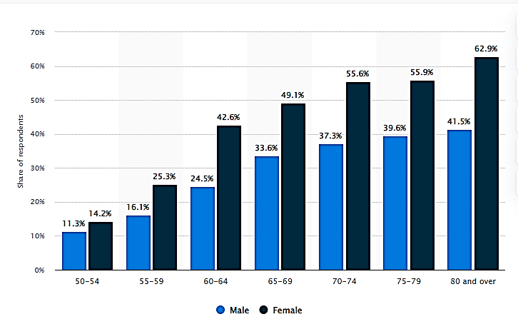
Figure 1. England: Arthritis Among Over the 50s in 2018/19, by Gender and Age
Source: (Statista, 2022a)
On the other hand, Age UK (2022), arthritis comes with several risks and challenges for both the individual suffering from this disease and the health care provider. The patients going through this disease suffer from extreme pain, even from the slight movement of the bones, and their old age contrite more to their miserable situation. At the same time, Bartlett et al. (2018) discussed that the disease is a major cause of mobility loss, ultimately damaging a feeling of independence. Furthermore, his study further elaborated that numerous older adults who go through arthritis are also reported to suffer from mental diseases, including depression which destroys the mental peace of an individual and has severe consequences on the physical health of an adult person. Another report by Statista (2022b) mentioned that individuals who are suffering from arthritis have their lives greatly impacted by this disease, as over a fifth of arthritis sufferers in the year 2018 had to leave their workplace or job to its severe effects as shown in Fig 2 (Statista, 2022b)
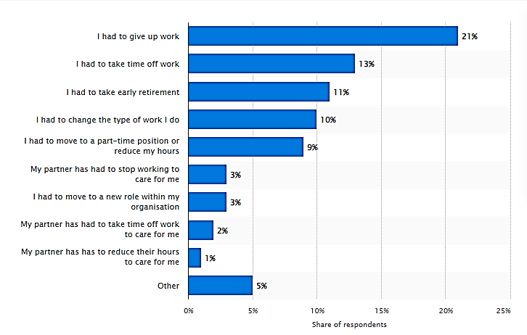
Figure 2. Impact on Working Life for Arthritis Sufferers in Great Britain in 2018
Source: (Statista, 2022)
Zgibor et al. (2017) addressed that to reduce the effects of arthritis on older individuals; it is necessary to implement the interventions presented to fight this disease effectively. Additionally, physical activity is proved to be a working solution that aids in relieving the patients going through arthritis by decreasing bone stiffness, which forbids older adults from performing any daily life activity. Therefore, to increase the quality of life for the old aged people who face such issues and suffer from different chronic conditions, interventions such as self-management education and physical activity should be adopted. Nair et al. (2017) further explained that self-management education includes available online programs for the awareness of virtual support, getting training from the healthcare professional vis video conference, email support, phone conference and many others. However, the influence of the National Health Services (NHS) is majorly acknowledged for refining the health care services and fetching the best disparities in the practices of health services for older people in the treatment of arthritis.
Tarrant (2019) elaborated that the different theories related to ageing, particularly known as theories of ageing, assist various researchers in proficiently understanding the concept of body changes that a human may experience with rising age as their body goes through numerous biochemical reactions causing damage and promoting ageing. In contrast, Routray (2017) the purpose of utilising these theories in the nursing practice is to clearly comprehend the impacts of surroundings on older adults' health by visualising them interfacing with their surroundings in a mental, emotional, spiritual, social and physical manner. Therefore, the main goal of using these ageing theories is to understand the severity of the pain elders may go through with passing time along with their changed response to life, including social activities happening in their surroundings.
The disengagement theory of ageing is discussed by Zaidi and Howse (2017), who stated that this theory was presented in the year 1961 by Elaine Cumming and Warren Earl Henry and built theory on older individual’s disinterestedness in society which became the major reason for self-isolation and led to many psychological issues, depression is most common of them. The theory elaborated that individuals, with passing time, individuals become less active in societal activities, and one of the main reasons for this happening is watching the death of people from similar age groups due to various causes such as diseases and low quality of healthcare, frailty and many others. Furthermore, Zhang and Lin (2022) emphasised that after isolating themselves from their surroundings, older individuals start to wait for their own death call. Therefore, key factors of this theory will help the healthcare givers to know about the facts related to the mental dilemma of older adults and their sentiments which can aid in improving their mental health by boosting them to have good interactions with others they are surrounded by with. It is also one of the service givers' responsibilities to help improve the patients and contribute to their rapid recovery by engaging them with social activities. Socially active older patients are more likely to improve earlier than the others.
On the contrary, Scott-Warren and Maguire (2017) discussed the activity theory of ageing, which was introduced by Robert J. Havinghust, the role an individual carries in the social effects of the self-concept of an individual. Moreover, the theory further discussed the psychological factors which have the main influence on the way older people think. Asiamah (2017) pinpointed that it is important for older people to stay active in society and show their concern regarding its issues because their happiness is directly linked to their social interactions and their social role. Therefore activity theory relates the satisfaction of older individuals with their activity. Besides activity theory, another socioemotional selectivity theory can be implemented in healthcare practices, which psychologist Laura Carstensen proposed. Carstensen. and Hershfield (2021) added that the theory discusses the difference in goals of individuals with respect to their age, including short-term or long-term goals. Moreover, old people have short-term goals based on emotions, whereas young people have goals concerning their careers. Older adults are emotionally sensitive; therefore, health service providers are responsible for taking their psychological and emotional health along with physical health by dealing with empathy and compassion.
Lebrasseur et al. (2021) elaborated on the serious impacts of the pandemic on older individuals. They stated that the precautions against this deadly virus, including self-isolation and protective measures, were mandatory for everyone to stay protected, especially the older people at great risk of death due to COVID-19. These precautions helped them safety against this virus, but they were the main cause of intensifying the issues already existing in older adults, including loneliness, excessive worrying, and age discrimination. Cunha et al. (2020) added that they further result in self-isolation, assumptions about the bad effects of social distancing on daily activities, cognitive decline for older people, and mental health. Furthermore, age discrimination is increased by the pandemic in older individuals by badly affecting information access, funding of informal care providers, and healthcare services.
In contrast, Grolli et al. (2021) declared that despite having several older individuals online, the majority are still unaware of how technology is utilised and require more assistance for assessing and accessing a piece of information. Moreover, the vulnerable older people have no access to web resources or the needed digital knowledge and skills to utilise them efficiently. Therefore vulnerable population is unable to have access to digital technology. Whereas. Asiamah (2017) further contributed that fear is another factor which plays a vital role in deteriorating the health of older adults as their high fear of being in contact with the deadly virus intensifies the overall anxiety, which is one of the severe mental health issues and is known to badly impact the quality life of older people. Additionally, along with physical and mental impacts, the pandemic has influenced the emotional state of older adults by excessive loneliness and less social interaction, as older individuals are more sensitive to emotions. Therefore, it is true that short-term or long-term impacts of the pandemic have more sensitively affected older individuals compared to other age groups.
During COVID-19, people of all ages were exposed to the fatal virus and needed urgent medical assistance. Therefore, the social care policies were restructured or reformed and indicated the transformed call for the government's action. According to BBC News (2022), the prime minister had discussed some new plans to deal with urgent medical conditions, but even those were not practically taken place until 2021. Levita et al. (2020) highlighted that in England, to receive a social healthcare service, an individual needs to have a high level of requirement for such services from their local authority or have savings of less than £23,250. Moreover, it is higher for wale as an individual receiving healthcare facilities should have assets of £24,000 or less than this figure for non-residential services and £50,000 for residential care services. The number of older individuals who require social healthcare facilities has intensified, but very few are considered eligible for services in their homes or healthcare sectors.
Moreover, Sepúlveda-Loyola et al. (2020) discussed that people in England, around 1.5 million, who need medical assistance to perform their daily activities and have no access to it. According to Foster and Harker (2022),the government of the UK allocated £5.4 billion in funds for the support of adult social and healthcare for the next three years, from 2022 to 2025. Moreover, the report was published in December 2021 and mentioned that £3.6 billion would be utilisedto fund reforms to the ways people pay for social care services, and £1.7 billion will help in supporting the wider reform in the division.
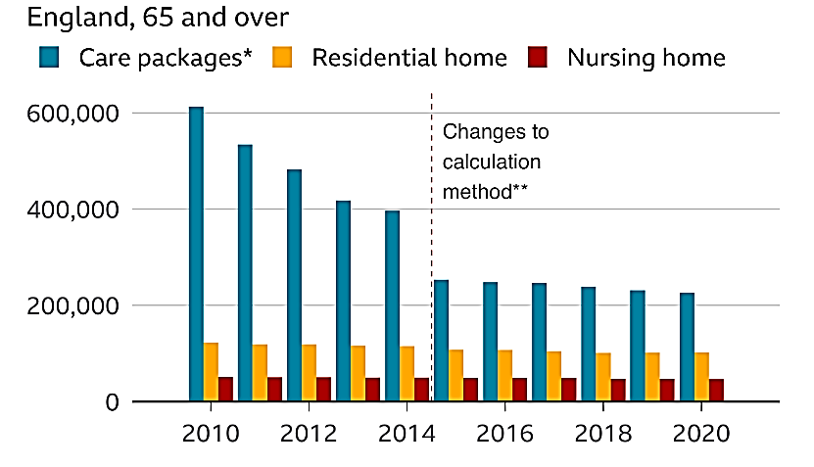
Figure 3. Number of People Receiving Long-Term Help from Councils
Source: (BBC News, 2022)
The above graph showed that in comparison to 2010 where more than 600,000 people used to take help from the local authorities have decreased to fewer above 200,000 and this stats is maintained from many years indicating that despite the increasing population of old age people, only some of them get help from the councils as shown in Fig 3 (BBC News, 2022).On the other hand, Li and Mutchler (2020) defined that the fees paid by local authorities are majorly dependent on the location of the individual or on the place they live. However, the quality of healthcare facilities for those people receiving the care was a big question when in 2020, almost a third of COVID-19 deaths were reported from the care homes due to issues with Personal Protective Equipment (PPE) and sickness of staff. Therefore, this puts further pressure on the system of health care sectors across the UK. Consequently, the pandemic had devastating or shocking effects on the quality of healthcare facilities. However, the government of the UK had adopted several approaches to deal with issues raised by the pandemic by providing personal protective equipment PPE for older people at that time and finding every way to provide them with care through digital technology. They further made policies for implementing social distancing mandatory for older adults to stay home.
Older adults have a significant role in society and can play a vital role in their activities. Therefore, health care service providers are accountable for treating them with care and improving their service to facilitate them better. However, policies made by the various organisation, including WHO, and HSC, should adopt modern approaches in their healthcare plans, such as virtual care and utilisation of digital technology to save time and facilitate many patients simultaneously. These organisations further need to increase their financial structure and provide services to each person in need of healthcare to improve the quality of healthcare for older individuals.

References

Journal
Asiamah, N., 2017. Social engagement and physical activity: Commentary on why the activity and disengagement theories of ageing may both be valid. Cogent Medicine, 4(1), p.1289664.
Baker, N.A., Barbour, K.E., Helmick, C.G., Zack, M. and Al Snih, S., 2017. Arthritis and cognitive impairment in older adults. Rheumatology international, 37(6), pp.955-961.
Bartlett, D.B., Willis, L.H., Slentz, C.A., Hoselton, A., Kelly, L., Huebner, J.L., Kraus, V.B., Moss, J., Muehlbauer, M.J., Spielmann, G. and Kraus, W.E., 2018. Ten weeks of high-intensity interval walk training is associated with reduced disease activity and improved innate immune function in older adults with rheumatoid arthritis: a pilot study. Arthritis research & therapy, 20(1), pp.1-15.
Cunha, L.L., Perazzio, S.F., Azzi, J., Cravedi, P. and Riella, L.V., 2020. Remodeling of the immune response with aging: immunosenescence and its potential impact on COVID-19 immune response. Frontiers in immunology, p.1748.
Grolli, R.E., Mingoti, M.E.D., Bertollo, A.G., Luzardo, A.R., Quevedo, J., Réus, G.Z. and Ignácio, Z.M., 2021. Impact of COVID-19 in the mental health in elderly: psychological and biological updates. Molecular Neurobiology, 58(5), pp.1905-1916.
Henderson, L., Bain, H., Allan, E. and Kennedy, C., 2022. A multi-case study of the experiences, needs and relationships of people who access and provide Health and Social Care (HSC). INTERNATIONAL COLLABORATION for COMMUNITY HEALTH NURSING RESEARCH in cooperation with Linnaeus University.
Jetha, A., Bowring, J., Tucker, S., Connelly, C.E., Martin Ginis, K.A., Proulx, L. and Gignac, M.A., 2018. Transitions that matter: life course differences in the employment of adults with arthritis. Disability and rehabilitation, 40(26), pp.3127-3135.
Kaehne, A., Birrell, D., Miller, R. and Petch, A., 2017. Bringing integration home: Policy on health and social care integration in the four nations of the UK. Journal of Integrated Care.
Katz, P., Andonian, B.J. and Huffman, K.M., 2020. Benefits and promotion of physical activity in rheumatoid arthritis. Current opinion in rheumatology, 32(3), pp.307-314.
Khoja, S.S., Patterson, C.G., Goodpaster, B.H., Delitto, A. and Piva, S.R., 2020. Skeletal muscle fat in individuals with rheumatoid arthritis compared to healthy adults. Experimental Gerontology, 129, p.110768.
Lebrasseur, A., Fortin-Bédard, N., Lettre, J., Raymond, E., Bussières, E.L., Lapierre, N., Faieta, J., Vincent, C., Duchesne, L., Ouellet, M.C. and Gagnon, E. 2021. Impact of the COVID-19 pandemic on older adults: rapid review. JMIR aging, 4(2), p.e26474.
Levita, L., Miller, J.G., Hartman, T.K., Murphy, J., Shevlin, M., McBride, O., McKay, R., Mason, L., Martinez, A.P., Stocks, T.V. and Bennett, K.M., 2020. Report1: Impact of Covid-19 on young people aged 13-24 in the UK-preliminary findings.
Li, Y. and Mutchler, J.E., 2020. Older adults and the economic impact of the COVID-19 pandemic. Journal of Aging & Social Policy, 32(4-5), pp.477-487.
Nair, R., Schweizer, M.L. and Singh, N., 2017. Septic arthritis and prosthetic joint infections in older adults. Infectious Disease Clinics, 31(4), pp.715-729.
Piper, M., Forrester, A. and Shaw, J., 2019. Prison healthcare services: the need for political courage. The British Journal of Psychiatry, 215(4), pp.579-581.
Routray, S., 2017. Forceful" Social Ageing" through Economic Disengagement in India. Indian Journal of Gerontology, 31(3).
Scott-Warren, V. and Maguire, S., 2017. Physiology of ageing. Anaesthesia& Intensive Care Medicine, 18(1), pp.52-54.
Sepúlveda-Loyola, W., Rodríguez-Sánchez, I., Pérez-Rodríguez, P., Ganz, F., Torralba, R., Oliveira, D.V. and Rodríguez-Mañas, L., 2020. Impact of social isolation due to COVID-19 on health in older people: mental and physical effects and recommendations. The journal of nutrition, health & aging, 24(9), pp.938-947.
Stuckler, D., Reeves, A., Loopstra, R., Karanikolos, M. and McKee, M., 2017. Austerity and health: the impact in the UK and Europe. European journal of public health, 27(suppl_4), pp.18-21.
Tarrant, A., 2019. “Maturing” theories of ageing masculinities and the diverse identity work of older men in later life. In Routledge International Handbook of Masculinity Studies (pp. 192-200). Routledge.
Zaidi, A. and Howse, K., 2017. The policy discourse of active ageing: some reflections. Journal of Population Ageing, 10(1), pp.1-10.
Zgibor, J.C., Ye, L., Boudreau, R.M., Conroy, M.B., Vander Bilt, J., Rodgers, E.A., Schlenk, E.A., Jacob, M.E., Brandenstein, J., Albert, S.M. and Newman, A.B., 2017. Community-based healthy aging interventions for older adults with arthritis and multimorbidity. Journal of community health, 42(2), pp.390-399.
Zhang, X. and Lin, H., 2022. Disengagement Theory. In Encyclopedia of Gerontology and Population Aging (pp. 1471-1476). Cham: Springer International Publishing.

Website
Age UK 2022. [online] Age UK. Available at: https://www.ageuk.org.uk/information-advice/health-wellbeing/conditions-illnesses/arthritis/ [Accessed 13 July 2022].
BBC News 2022. Social care: What are the challenges facing the system?. [online] BBC News. Available at: <https://www.bbc.com/news/health-50377846> [Accessed 16 July 2022].
Health UK 2022. Community care | Department of Health. [online] Health. Available at: <https://www.health-ni.gov.uk/articles/community-care> [Accessed 15 July 2022].
NHS.UK 2022. Arthritis. [online] nhs.uk. Available at: https://www.nhs.uk/conditions/arthritis/ [Accessed 13 July 2022].
Statista 2022a. England: Arthritis among older people 2018/19 | Statista. [online] Statista. Available at: https://www.statista.com/statistics/983315/england-arthritis-among-older-people/ [Accessed 13 July 2022].
Statista 2022b. Impact of arthritis on working life in Great Britain 2018 | Statista. [online] Statista. Available at: https://www.statista.com/statistics/937083/impact-of-arthritis-on-working-life-in-great-britain/ [Accessed 13 July 2022].
UK Parliament 2022. [online] House of common library. Available at: https://commonslibrary.parliament.uk/research-briefings/cbp-9239/#:~:text=The%20UK's%20ageing%20population,or%20around%2012.3%20million%20people. [Accessed 13 July 2022].
WHO 2022. Ageing and health. [online] Who.int. Available at: <https://www.who.int/news-room/fact-sheets/detail/ageing-and-health#:~:text=Common%20conditions%20in%20older%20age,conditions%20at%20the%20same%20time.> [Accessed 15 July 2022].
Foster and Harker2022. Adult Social Care Funding (England). [online] House of Commons Library. Available at: https://commonslibrary.parliament.uk/research-briefings/cbp-7903/ [Accessed 16 Jul. 2022].
‌

