
Skills for the Workplace
Module Assignment Submission
Student Name: | Sophia Taher
Student Number: | 2016413
Module No: | BMSK4007
Module Title: | Digital Skills and Personal Branding

Statement of Confirmation of Authenticity
By the act of making this submission, the student declares that this is the work of the student named above. The work has not, in whole or in part, been knowingly presented elsewhere for assessment, or where assessment has been built on a previous assessment, this has been identified. Where materials have been used from other sources it has been properly acknowledged. If this statement is untrue, the student acknowledges that an assessment offence has been committed.
Attention is drawn to the plagiarism and unfair practice policies of both the University and of ILM.
Permission for ILM to use this script
ILM uses learners’ submissions – on an anonymous basis – for assessment standardisation. By submitting, both the centre and the learner agree that ILM may use this script on condition that identifying information is removed. However, if you are unwilling to allow ILM use this script, please refuse by ticking the box: □

Table of Contents
What has been the impact of 21st Century Technologies on the modern workplace? 3
Evaluate the appropriate use of modern technologies and social media in the workplace generally 4
Explore the use of modern technologies and social media in own workplace 5
How can Personal branding help YOU? 8
Your LinkedIn Profile to promote your Personal Brand 9
Evaluate the value of other social media platforms to enhance networking and career prospects 10
Examine the impact of Personal Branding on your own employability 11
Discuss personal and professional security and safety online. 11
References 14
Appendix 1 7
Appendix 2 8

Introduction
In this assignment I will be looking at the impact of modern technologies on the workplace the introduction of social medias has allowed the workplace to improve in many ways. You present yourself on social medias in different ways. It is important to know your personal brand when creating social media profiles. Additionally, when creating online profiles, you need to remain safe and secure to protect yourself from hackers’ scanners and viruses.

What has been the impact of 21st Century Technologies on the modern workplace?

Technology has been very impactful over the last few decades, continuing to grow and develop throughout. The creation of the internet was a worldwide phenomenon. It gave the globe universal access to all the information they could ever need. When looking before the internet, you can see how impactful it was. People would need to go to libraries and find the information by looking through endless amounts of books. In the twenty-first century we can access the internet instantly and receive answers in seconds. When looking at the modern workplace, you can see how the introduction of the internet has played a huge role in the development of the office. People can now use the internet to search for information, video chat and connect with colleagues. The internet has given the modern workplace flexibility, increased communication, and the ability to search for information quickly.
We also now have laptops, printers, and scanners. These have been upgraded from typewriters and fax machines. Similarly, to the internet, these upgrades have allowed the modern workplace to be faster. This is because we can print things and scan from our computers, and it then instantly prints. This is contrasted to the typewriter, where each page would have to be written and then printed.
Additionally, technology has allowed the workplace to develop its social side. When looking at the use of fax machines, they are very archaic and slow. We now have emails and telephones to communicate instantly in the office.
iCloud storage is also used in the workplace. It enables you to store information online and access information from any device. Companies can now readily access important information through the Cloud. They now only have downloaded their desired documents to have them on in their possession.
Technology has transformed the way people work. Staff are now able to work from home, applicants can train for jobs online, and communication has been made easier. Technology has allowed the modern workplace to grow and develop through the twenty-first century.

Evaluate the appropriate use of modern technologies and social media in the workplace generally

Companies can use Facebook or twitter to market themselves. By using these sites, companies can target their audience and gain more publicity. This is a strength of social medias. They are accessible to everybody. Therefore, allowing companies to know which application would be best to promote themselves on. For instance, you may want to advertise clothing brands or music on Twitter and Instagram for the younger generation, whilst advertising events and political things on Facebook for the older generation. However, this could be a negative. Social media companies have continuously exploited their users by selling their information to third parties, so that these large companies have access to whom they should promote their products to. This is a huge GDPR breach and has caused many of the public to protest and speak out against the use of certain social medias.
Many organisations praise the introduction of social medias, specifically those with the option to use video chat. This is because it allows communication between colleagues, resulting in a free flowing, happy working environment. Working relationships can be made easier through the introduction of video chat apps, such as Teams and Zoom. The creation of video chatting sites has been prominent throughout 2020 with the global pandemic. Video chatting has ensured that companies are able to communicate and work at home. This is a huge strength of social media. We can communicate at all hours of the day and in any location.
Companies can also use webchat through social media to support customers this will help relieve pressure on phone lines and can be quicker with an instant response. It is also useful that customers who have used the company can leave reviews and recommendations on a social media platform. This then can help attract potential customers allowing the business to get more custom. This would not have been possible without the introduction of the internet, again showing its strengths.
The advantage of using social media in the workplace means that it is a very low-cost platform with hardly little to no fees to use this allows the workplace to advertise and recruit potential employees quickly and effectively. It is also useful that customers who have used the company can leave reviews and recommendations on a social media platform. This then can help attract potential customers allowing the business to get more custom.
In terms of negative impacts, social medias and technologies are not always reliable. They are very intermittent and do not always work. This can be seen using Wi-Fi and the internet. In the workplace, when Wi-Fi fails it can be hard for employees to access the applications, they need to to perform their job.
Another negative of technology is how much it costs. Although social medias are free, companies do need to set all their employees up with equipment, such as laptops etc. This can have a huge financial impact on companies, specifically during 2020. More people than ever were working from home and so companies needed to correctly be equipped their employees with things for them to work from home. Although in the long run this has been very beneficial, companies would have still had been at a financial loss which would have been intensified throughout the Global Pandemic of 2020.
Moreover, it seems there are more positive than negatives of technologies and social media. As with everything, they have their downfalls, but are very beneficial for companies and the modern workplace. They allow office areas to work smoother and for employees, as well as customers, to easily access to correct information they need.

Explore the use of modern technologies and social media in own workplace

I am currently working in the food industry at Mezza Luna. Restaurants heavily rely on social media to promote their businesses. Mezza Luna are on Facebook and Instagram, where we upload photos of the food cooked to promote ourselves and attract new customers.
Additionally, the use of technology and applications allows customers to be connected to the restaurant, as they can leave reviews, order food, and check our opening hours. Two main platforms that Mezza Luna use are Deliveroo and Just Eat. We can deliver the food to our customers doors. Fast food has been a highlight of the twenty-first century, and so for my company to be doing this shows how modern we are. Customers can simply download the app and order food straight to their door. Deliveroo has an app that notifies customers in real time so they can see and track where their food is. It also gives an ETA as to how long it will take for their food to arrive. This provides an efficient time effective service. Without this technology, people would need to leave their homes and businesses would not have a second option. The use of fast-food apps has helped many restaurants remain open during the Global Pandemic of 2020.
We also use social media such as Instagram and Facebook to promote the business by offering monthly giveaways and any promotions which would increase the company’s sale revenue. 2020 has been a very unpredictable year with a world-wide pandemic COVID-19. This has caused a massive impact on the food industry people are unable to go to work because of current lockdowns and social distancing measures, guidelines. Alluding to my earlier point, by promoting food online and offering monthly giveaways we have been able to remain open and supply the public with food.
To recap social media is a big part of the food industry without it company’s would find it difficult to survive and it is heavily relied upon for revenue streams.
We use various technologies in my workplace, also. We have a cash register to store cash. Without this we would not be able to take payments and have a safe place to keep any money we receive. Throughout the years, cash payments have evolved to card payments. Using debit and credit cards are much more user friendly than cash and are used more regularly by the public. Due to this, restaurants have had to purchase card machines. However, recently debit cards have been made “contactless,” so the customer does not need to use their pin code and risk fraud, they can simply tap their card on the reader to pay their bills. This has made purchasing a lot easier, which has allowed the food business to boom. People can also have their debit cards on their phones, so if they forget their card, they will always have a way to pay. This not only protects the customer, but the businesses. There is more than one way to pay nowadays, so the restaurant would not be out of pocket and can ensure they receive their money.
An important technology we have is a telephone. This allows customers to contact us and make bookings, order food, or ask us any questions. Without the introduction of phones in the 1990’s, we wouldn’t have this universal freedom. Customers would walk, or drive, to the restaurant they would like to go to, to only realise it was closed. The use of a telephone in my work allows us to build relationships with customers and enable them to freely ask questions whenever they please.
One technology we could do with in my workplace is an interactive board where the chefs can then put which orders have been completed. Currently we only have a bell, which cannot always be heard by the waitresses if they are talking to customers. By having a board, I would be able to see whose food is ready rather than wasting time and, possibly, making the food go cold.
Furthermore, my workplace uses an array of social medias and technologies which all help us to work better and leads to a more fluid working environment.

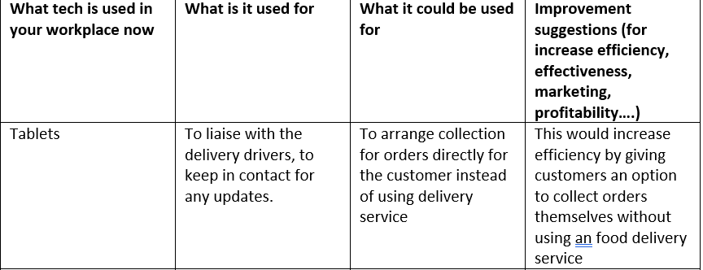

How can personal branding help YOU?

Personal branding is a representation of who you are (Rangarajan, 2017). Personal branding can be your image, skills, behaviour, reputation, beliefs and/or values. Having a positive personal branding can help you in all aspects of your life, from personal relationships to professional job interviews. First impressions also contribute to your personal branding, when in a work environment a positive first impression can be highly beneficial. You can create a positive first impression using your clothes, attitude, and the way you hold yourself. When in a job interview it is important to dress smart, be punctual and to be polite to have the best chance at being successful.
It is important to understand your own personal brand, once you understand your own brand then you can present yourself appropriately to a specific audience e.g Interviewer or new friendship group.

My LinkedIn profile



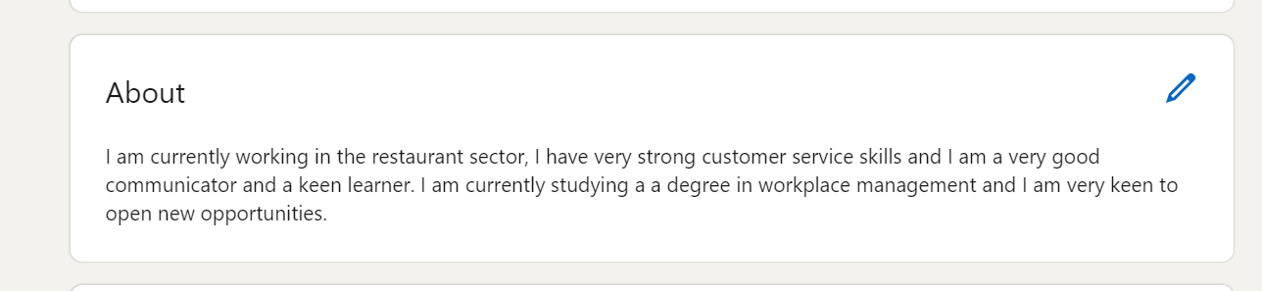

Here is my LinkedIn profile I have decided to not use a background photo as I want my page to be clear and concise. I have used a photograph of myself because it is a clear photograph of me, and I look happy and approachable.
I have put the fact that I am a waitress as that is my current employment. My about information is a clear snippet of how I want to be portrayed. Giving potential employers an overall idea of my current experience and goals.

Evaluate the value of other social media platforms to enhance networking and career prospects

In the modern world it is important to have a social presence online to enhance your future career prospects. Social media is often used to reconnect with family and friends however in recent years it has become more of a social platform for employers to search for potential employees. By doing this it allows employers to search and vet prospective applicants.
Social media applications such as Twitter and Facebook create new opportunities for firms to improve their internal operations and to collaborate in new ways with their customers, business partners, and suppliers. (Culnan et al, 2010) This can be beneficial as everything can be done online and help companies run smoothly and successfully.
LinkedIn is another social media site which is specifically designed for career and professional people to connect It allows you to create a profile and showcase your life, skills, and achievements. This can be very useful with potential employers finding perfect candidates for a specific role.
Instagram is also a very popular site which is used to share photos and videos and to also engage with others. This can be useful as it is a simple site to navigate and you can contact others instantly. This is not very useful for searching for work directly however it can be more useful for influencers or companies to showcase their products or advertise their services giving them a wider audience.

Examine the impact of Personal Branding on your own employability

My personal branding can have a positive or a negative impact on my employability depending on how I present myself, for example if I were to turn up late to an interview or post offensive things on my social media pages then this may have a negative impact because the employer will have a bad impression and will be less likely to want to employ me (Minor-Cooley & Parks-Yancy, 2020).
On the other hand, if I have a well-presented social platform then my employability will be positively impacted. On social platforms like LinkedIn employers can scout people that they think will fit well into their business, if I use positive personal branding to create a high-quality LinkedIn profile then I am far more likely to attract employers (Labrecque, 2011).

Discuss personal and professional security and safety online.

It is very importing to keep personal information safe and secure online, this can be done by using secure passwords. Scamming is becoming more and more popular over the years, so it is important to be vigilant, Encryption is an effective way to keep your data safe because it makes it harder for hackers to access it (LaRose et al, 2008).
When in a work environment its important to ensure that clients and customers can trust that you will handle their personal data fairly and responsibly. Once the data has been collected it needs to be stored correctly, password protected and encrypt.
Conclusion
To conclude, I have found out a lot of technology is used in workplaces. These are constantly improving and changing looking at specific workplaces, you can see why there was a drastic need for the increase in technology in the 21st century. To make you more employable you need to be aware of your personal brand. your personal brand is not your qualifications, but how you present yourself as a person. Finally, I found that you always need to be safe online and have measure in place to prevent any security breaches.

References

Culnan. M, McHugh. P, Zubillaga. J (2010) How Large U.S. Companies Can Use Twitter and Other Social Media to Gain Business Value

Labrecque. L, Markos. E, Milne. G (2011) ‘Online Personal Branding: Processes, Challenges, and Implications’ Vol 25 37-50. Elsevire.

LaRose. R, Rifon. N, Enbody. R (2008) ‘Promotion Personal Responsibility For Internet’ Association for Computing Machinery, New York.
Minor-Cooley. D, Parks-Yancy. R (2020) ‘The Power of the Brand: Personal Branding and Its Effect on Job Seeking Attributes’ Journal of Internet Commerce, 19:3, 241-261
Rangarajan. D, Gelb. B, Vandaveer. A (2017) ‘Strategic Personal Branding – and How it Pays off’ Business Horizons 657-666

Appendix 1

Appendix 2

