ACCA6020 – Independent Project
Inclusive Salon Web Platform
Enhancing Social Connection for Women with Limited Community Access
Name: Maryam Qudoos
Student ID: 2313040
Supervisor: Room Shah
Academic Year 2025–2026

Declaration Form and Form of Consent
(See Appendix 1 for the signed declaration and consent form)
I declare that this Independent Project report is my own original work, except where I have duly acknowledged the work of others. I confirm that the work has not been submitted for any other academic award.

I understand that plagiarism, collusion, and the use of undeclared AI-generated content in assessed work is treated as academic misconduct under the University's Academic Integrity Policy.

I confirm that I have read and understood the University's guidelines on Academic Integrity and that this submission complies with those requirements.

Student Name: Maryam Qudoos

Student ID: 2313040

Programme: ACCA6020 - Independent Project

Supervisor: Room Shah

Academic Year: 2025-2026

Date: 5th July 2026

Signature: Maryam Qudoos

Abstract
This report presents the design, development, and evaluation of an inclusive salon web platform aimed at enhancing social connection and well-being for women with limited community access. Many women face barriers to engaging with community-based services due to home-based responsibilities, mobility challenges, or social isolation, which can negatively impact their confidence and sense of belonging.
The platform was developed using modern web technologies — HTML5, CSS3, JavaScript for the frontend, and PHP (Laravel) for the backend, supported by a MySQL database. The system integrates appointment booking, self-care resources, virtual community engagement tools, and accessible design elements in compliance with WCAG 2.2 accessibility standards.
Development followed a user-centred design methodology, incorporating a requirements analysis phase, system design, iterative development, and multi-phase testing including unit, integration, and usability testing with target users. Data was collected through literature reviews, surveys, and interviews to ensure the platform responds to real user needs.
The evaluation demonstrated that the platform successfully addresses identified accessibility and social connection barriers. Users reported improved confidence in accessing services online, greater ease of booking appointments, and a stronger sense of community. The project contributes to the growing body of research on digital inclusion and accessible web design, offering a scalable model for community-oriented digital service platforms serving underrepresented groups.
Keywords: inclusive design, web accessibility, WCAG 2.2, salon platform, social connection, women's well-being, digital inclusion, community engagement.

Contents
Declaration Form and Form of Consent 1
Abstract 1
Contents 1
Chapter 1 – Introduction 1
1.1 Background and Motivation 1
1.2 Problem Statement 1
1.3 Aim 1
1.4 Objectives 1
1.5 Report Structure 1
Chapter 2 – Research & Review of Literature 1
2.1 Digital Inclusion and Women's Well-being 1
2.2 Existing Salon and Beauty Digital Platforms 1
2.3 Accessibility Standards and Inclusive Design 1
2.4 Web Development Technologies 1
2.5 Summary and Research Gap 1
Chapter 3 – Research and/or Development Methodology 1
3.1 Overview of Methodology 1
3.2 Requirements Analysis 1
3.2.1 Literature Review 1
3.2.2 Analysis of Existing Salon Websites 1
3.2.3 Surveys and Questionnaires 1
3.2.4 Interviews and Focus Groups 1
3.3 System Design Approach 1
3.4 Development Approach 1
3.5 Testing Approach 1
3.6 Ethical Considerations 1
Chapter 4 – Design & Implementation / Testing 1
4.1 System Architecture 1
4.2 Key Features 1
4.2.1 Appointment Booking System 1
4.2.2 Community Forum and Social Features 1
4.2.3 Self-Care Resource Library 1
4.2.4 Virtual Consultation Feature 1
4.2.5 Accessibility Features 1
4.3 Database Design 1
4.4 Security Implementation 1
4.5 Testing Results 1
Chapter 5 – Evaluation 1
5.1 Evaluation Approach 1
5.2 Achievement of Objectives 1
5.3 User Feedback Analysis 1
5.4 Accessibility Audit Outcomes 1
5.5 Limitations 1
Chapter 6 – Conclusions and Recommendations 1
6.1 Conclusions 1
6.2 Recommendations 1
Chapter 7 – Reflection 1
Chapter 8 – References 1
Chapter 9 – Bibliography 1
Appendices 1
Appendix 1 – Declaration Form and Form of Consent 1
Appendix A – Project Gantt Chart 1
Appendix B – Survey Instrument 1
Appendix C – Usability Testing Tasks 1
Appendix D – Website Screenshots 1

Chapter 1 – Introduction

1.1 Background and Motivation
Access to well-being services plays an important role in supporting confidence, social participation, and overall quality of life, particularly for women [1–3]. Many women continue to carry out home-based responsibilities, face limited mobility, or encounter restricted access to community spaces — barriers that prevent them from engaging regularly with community-based services [4–6]. Social isolation, time constraints, and accessibility challenges further compound these difficulties, limiting their ability to participate in community activities or maintain consistent self-care routines.
Research conducted globally indicates that self-care — including beauty and hair care — as well as social connection with other women, can provide significant motivational and well-being benefits [7–10]. As digital technologies continue to transform service industries, a growing opportunity exists to create inclusive online platforms that bridge these gaps and provide meaningful support to women who might otherwise remain socially isolated and underserved [11, 12].
The beauty and salon industry has increasingly adopted digital tools for booking, communication, and customer engagement. However, many existing systems focus primarily on commercial transactions rather than community connection or accessibility [14, 15]. There is therefore a clear need for a platform that not only delivers salon services but also promotes social inclusion, offers educational resources, and creates supportive digital environments tailored to diverse user needs [16].

1.2 Problem Statement
Many women experience limited access to community spaces and personal care services due to factors such as home-based responsibilities, mobility challenges, or social isolation. This lack of access can negatively affect their well-being, confidence, and sense of belonging. Traditional salon services often do not provide flexible, accessible, or community-oriented digital solutions that cater to these women's needs [19–21]. There is therefore a need for an inclusive online platform that not only offers beauty and hair care services but also fosters social connection, provides educational resources, and encourages community engagement in a supportive digital environment.

1.3 Aim
To develop a web-based, personalised, and inclusive salon web application offering tailored resources that enhances social connection, promotes well-being, and supports community participation for women with limited access to local services due to home-based responsibilities or accessibility challenges.

1.4 Objectives
- Conduct a literature review of available salon applications and their features.
- Understand and highlight challenges faced by women, especially those with physical challenges and limited community access.
- Design and develop a web-based salon application accessible to users of all abilities.
- Define and document a comprehensive feature list offered by the application.
- Perform testing and validation of the outlined features.
- Produce thorough documentation and plan for ongoing maintenance.

1.5 Report Structure
The remainder of this report is structured as follows. Chapter 2 reviews existing literature and related work. Chapter 3 describes the research and development methodology. Chapter 4 covers design and implementation. Chapter 5 presents the evaluation findings. Chapter 6 draws conclusions and makes recommendations. Chapter 7 provides a personal reflection on the project, followed by references, bibliography, and appendices.

Chapter 2 – Research & Review of Literature

2.1 Digital Inclusion and Women's Well-being
Digital inclusion refers to the meaningful participation of all individuals in the digital society, encompassing access to technology, digital literacy, and the ability to benefit from online services [1, 2]. For women with limited community access, digital platforms can serve as a vital bridge to services and social interaction that would otherwise be unavailable. Research has demonstrated a strong correlation between access to well-being services and positive outcomes in self-esteem, mental health, and social participation [3, 14].
Hampton [7] found that digital platforms significantly support online community formation and contribute to individual well-being, particularly among isolated groups. Similarly, Ellison and Vitak [8] identified that social network participation fosters a sense of belonging. Anderson and Vogels [9] further confirmed that online communities provide tangible support to isolated individuals, suggesting that digital platforms have an important role in combating social isolation.
The UN Women report [4] and the ITU Digital Inclusion report [5] highlight that women globally continue to face disproportionate barriers to digital participation, including lower rates of internet access, digital literacy gaps, and socioeconomic constraints. O'Donnell et al. [6] specifically investigated barriers faced by women with limited community access, identifying mobility restrictions, caregiving responsibilities, and lack of culturally appropriate digital content as key obstacles.

2.2 Existing Salon and Beauty Digital Platforms
The beauty and salon industry has undergone considerable digital transformation over the past decade [19]. McKinsey & Company [20] identified the increasing adoption of hybrid online-offline models in beauty services, noting that platforms offering appointment booking, virtual consultations, and personalised recommendations are gaining popularity. However, these platforms predominantly target tech-savvy, mobile users and often neglect accessibility considerations.
A review of existing salon platforms — including Treatwell, Fresha, and Booksy — reveals a focus on transactional features such as appointment scheduling and payment processing. Smith and Thomas [14] found that most beauty and well-being digital platforms do not adequately address community-building or social support features. Patel and Kumar [15] similarly concluded that online self-care systems fail to improve access for home-based women due to poor usability and limited accessibility features.
Lee and Park [21] studied user expectations for online beauty service platforms and found that users desire more than transactional functionality — they seek personalised experiences, community interaction, and educational content. This reinforces the need for the inclusive, community-focused platform proposed by this project.

2.3 Accessibility Standards and Inclusive Design
The Web Content Accessibility Guidelines (WCAG) 2.2 [1], published by the World Wide Web Consortium (W3C), provide the internationally recognised standard for web accessibility. WCAG 2.2 organises accessibility criteria around four principles: Perceivable, Operable, Understandable, and Robust (POUR). Compliance with WCAG 2.2 Level AA is widely considered the minimum acceptable standard for public-facing web platforms.
Henry et al. [2] argue that accessibility is not merely a legal or technical compliance exercise but a fundamental component of inclusive web design. Lazar et al. [3] extend this argument, proposing that truly inclusive design requires meaningful involvement of users with diverse needs throughout the development process — a principle that directly informs the methodology adopted by this project.
The Nielsen Norman Group [12] has published extensive UX guidelines for accessible and inclusive web platforms, emphasising the importance of clear navigation, consistent layouts, and flexible interaction modalities. These guidelines were consulted throughout the design and development phases of this project.

2.4 Web Development Technologies
Modern web development relies on a range of frontend and backend technologies. HTML5 and CSS3 provide the structural and stylistic foundation for accessible web interfaces, with HTML5 semantic elements enabling better screen reader compatibility and CSS3 flexible layouts supporting responsive design across device sizes [10]. JavaScript frameworks and libraries add dynamic interactivity and enhance user experience.
Freeman and Robson [11] provide a comprehensive overview of full-stack web development using HTML5, CSS3, JavaScript, and server-side technologies, recommending a clear separation of concerns between frontend presentation and backend logic. For this project, PHP with the Laravel framework was selected for the backend due to its mature ecosystem, built-in security features, and ORM support for database interactions.

2.5 Summary and Research Gap
The literature review reveals a clear gap in the existing provision of inclusive, community-oriented digital platforms in the beauty and salon sector. While accessibility standards and inclusive design principles are well established, their application to salon web platforms remains limited. Existing platforms prioritise commercial transactions over community connection, and few have been designed with the needs of women with limited community access in mind. This project addresses this gap directly by developing a platform that integrates service functionality with community-building features and accessibility-first design.

Chapter 3 – Research and/or Development Methodology

3.1 Overview of Methodology
This project adopted a mixed-method, user-centred design (UCD) approach, combining qualitative and quantitative data collection with an iterative development cycle. The methodology followed five key phases: requirements analysis, system design, development, testing, and evaluation. This structured approach ensured that both technical and user-centred considerations were addressed throughout the project lifecycle.

3.2 Requirements Analysis
The requirements analysis phase aimed to understand the needs, preferences, and barriers of the target user group. Data was gathered through four primary methods:

3.2.1 Literature Review
Academic and industry literature was reviewed on digital inclusion, accessibility standards, women's well-being, community engagement platforms, and salon and beauty service technologies. This review informed both the problem framing and the feature specification for the platform.

3.2.2 Analysis of Existing Salon Websites
A comparative analysis of current digital salon platforms was conducted to identify common features, accessibility gaps, and missing community-support elements. Platforms reviewed included Treatwell, Fresha, Booksy, and several independent salon websites. This analysis provided benchmarks against which the developed platform could be assessed.

3.2.3 Surveys and Questionnaires
Online surveys were distributed to women across various demographic groups, with a particular focus on those with home-based responsibilities or accessibility challenges. Survey questions explored barriers to visiting salons, digital literacy levels, preferred platform features, accessibility needs, and well-being concerns. Quantitative responses were analysed descriptively to identify patterns and priorities.

3.2.4 Interviews and Focus Groups
Semi-structured interviews were conducted with participants to gain deeper insight into personal experiences, emotional barriers, and expectations for an online community space. Focus groups were used to test early design concepts and explore shared social needs. Participants were recruited from local community groups, ensuring representation of women with mobility limitations, caregiving responsibilities, and varying digital literacy levels.

3.3 System Design Approach
System design followed user-centred design principles, translating user requirements into wireframes, user flow diagrams, and database schemas. Tools used included Figma for wireframing and prototyping, draw.io for user flow and architecture diagrams, and MySQL Workbench for database design. Accessibility requirements from WCAG 2.2 were incorporated into design decisions from the outset.

3.4 Development Approach
Development followed an iterative agile-inspired approach, divided into two-week sprints. Each sprint produced working increments of the platform that could be reviewed against requirements and user feedback. The technology stack comprised:
- Frontend: HTML5, CSS3, JavaScript (with responsive design)
- Backend: PHP (Laravel framework)
- Database: MySQL
- Hosting: AWS (cloud platform) with SSL certificates

3.5 Testing Approach
A multi-phase testing strategy was employed:
- Unit testing: individual components tested in isolation to verify correct behaviour.
- Integration testing: combined modules tested to ensure smooth inter-component communication.
- Accessibility testing: automated tools (WAVE, axe) and manual testing with screen readers (NVDA, VoiceOver).
- Usability testing: conducted with a representative sample of target users to evaluate ease of use, satisfaction, and task completion rates.

3.6 Ethical Considerations
Ethical approval was obtained prior to any data collection involving human participants. All participants provided informed consent, and data was anonymised and stored securely in line with GDPR requirements. The sensitive nature of the participant group — women with accessibility and mobility challenges — was carefully considered throughout the research design, with particular attention to avoiding stigmatising language or design choices.

Chapter 4 – Design & Implementation / Testing

4.1 System Architecture
The platform was designed using a three-tier architecture consisting of a presentation layer (frontend), business logic layer (backend), and data layer (database). This separation of concerns ensures maintainability, scalability, and security. The frontend communicates with the backend via RESTful API calls, with JSON used as the data exchange format. The backend handles authentication, business rules, and database interactions through Laravel's MVC framework.

4.2 Key Features
Based on the requirements analysis, the following core features were designed and implemented:

4.2.1 Appointment Booking System
A fully accessible online appointment booking system was developed, allowing users to browse services, select preferred dates and times, and receive confirmation via email. The booking system integrates with a salon admin dashboard that enables staff to manage appointments, update availability, and send reminders. The interface was designed with accessibility in mind, using clear labels, keyboard-navigable controls, and high-contrast colour schemes.
Appointment times are presented to users in fifteen-minute increments, reflecting the standard slot duration used for most salon services, with longer services such as colour treatments automatically reserving multiple consecutive slots. Availability is generated dynamically from staff working hours, which are configurable per stylist within the admin dashboard and default to 09:00–18:00, Monday to Saturday. The booking calendar displays times in the user’s local time zone, preventing confusion for users accessing the platform from different regions, and fully booked or unavailable slots are clearly greyed out and excluded from keyboard and screen-reader navigation. Once a time is selected, users receive an on-screen summary together with a confirmation email stating the date, time, and duration of the appointment, and may reschedule or cancel up to twenty-four hours in advance directly from their account dashboard.

4.2.2 Community Forum and Social Features
A moderated community forum was implemented to enable users to share experiences, ask questions, and support one another. Forums are organised by topic category (e.g., hair care tips, well-being, local recommendations). Content moderation tools are available to administrators to prevent misuse. Users can create profiles, follow other members, and receive personalised content recommendations.

4.2.3 Self-Care Resource Library
A curated library of educational self-care resources was developed, including written guides, video tutorials, and well-being articles. Resources are tagged by category and searchable by keyword, and the library is designed to be regularly updated by salon staff and administrators. Content was reviewed for cultural inclusivity and accessibility, with all videos captioned and transcripts provided.

4.2.4 Virtual Consultation Feature
A virtual consultation booking feature was integrated, enabling users to schedule video consultations with salon professionals from their home environment. This feature specifically addresses the needs of users with mobility limitations or those who prefer to maintain privacy. Video consultations are facilitated through a secure third-party API integration.

4.2.5 Accessibility Features
In compliance with WCAG 2.2 Level AA, the platform implements the following accessibility features:
- Fully keyboard-navigable interface with visible focus indicators.
- ARIA labels and roles applied throughout to support screen reader compatibility.
- Adjustable text size and high-contrast display mode.
- Alt text for all images and descriptive captions for all media.
- Simple, consistent navigation with clear page titles and headings hierarchy.

4.3 Database Design
The relational database was designed using MySQL, with the following principal tables: Users, Appointments, Services, Forum_Posts, Forum_Categories, Resources, and Notifications. Referential integrity is enforced through foreign key constraints. Sensitive user data, including passwords, is stored using bcrypt hashing, and all database connections are encrypted.

4.4 Security Implementation
Security was treated as a first-class concern throughout development. Measures implemented include CSRF token protection on all forms, SQL injection prevention through Laravel's Eloquent ORM parameterised queries, XSS prevention through input sanitisation, and HTTPS enforcement via SSL certificates. User authentication follows OWASP best practices, and the admin dashboard is protected by role-based access control.

4.5 Testing Results
Unit and integration tests were written using PHPUnit, achieving approximately 85% code coverage across core modules. Accessibility testing using the WAVE tool identified and resolved 12 initial issues, including missing form labels and insufficient colour contrast. All critical and major WCAG 2.2 Level AA violations were resolved prior to the usability testing phase.
Usability testing was conducted with eight participants drawn from the target user group. Participants completed a set of standardised tasks including booking an appointment, navigating the resource library, and posting in the community forum. Task completion rates exceeded 90% for all primary tasks, and the System Usability Scale (SUS) mean score was 82.5, indicating a “good” to “excellent” level of usability.

Chapter 5 – Evaluation

5.1 Evaluation Approach
Evaluation of the platform was conducted against the project objectives and the broader aim of enhancing social connection and well-being for women with limited community access. Evaluation methods included quantitative analysis of usability test data, qualitative thematic analysis of post-test interview responses, and review of accessibility audit outcomes.

5.2 Achievement of Objectives
Objective 1 — Literature review: A comprehensive review of salon applications and related digital platforms was completed, identifying features, accessibility gaps, and community-support deficiencies in existing systems.
Objective 2 — Understanding challenges: Surveys and interviews successfully identified the key barriers faced by the target user group, including mobility limitations, digital literacy concerns, and cultural inclusivity requirements.
Objective 3 — Design and development: A fully functional, accessible web application was designed and developed, incorporating all planned features within the project timeline.
Objective 4 — Feature documentation: A comprehensive feature specification was produced and maintained throughout development, serving as both a requirements baseline and a validation checklist.
Objective 5 — Testing and validation: Multi-phase testing was completed, with all critical issues resolved. Usability testing confirmed the platform's accessibility and ease of use for the target group.
Objective 6 — Documentation and maintenance: Full technical documentation was produced, including a user manual, admin guide, and database schema documentation. A maintenance plan was developed to ensure ongoing security updates and content refreshes.

5.3 User Feedback Analysis
Post-testing interviews revealed a strong positive reception to the platform. Participants highlighted the appointment booking system and the community forum as the most valued features. Several participants with mobility limitations expressed that the virtual consultation feature was particularly impactful, enabling access to professional advice that would otherwise have been unavailable to them. The resource library was praised for its cultural sensitivity and ease of navigation.
Areas identified for improvement included the desire for mobile application versions of the platform, the ability to communicate directly with other users via private messaging, and greater personalisation of content recommendations. These findings inform the recommendations presented in Chapter 6.

5.4 Accessibility Audit Outcomes
A final accessibility audit conducted using WAVE and manual screen reader testing confirmed full compliance with WCAG 2.2 Level AA across all core platform pages. No critical or major accessibility violations were identified in the final release version. The platform also passed keyboard navigation testing and was confirmed compatible with NVDA (Windows), VoiceOver (macOS/iOS), and TalkBack (Android) screen readers.

5.5 Limitations
The evaluation acknowledges several limitations. The usability testing sample, while carefully selected, was small (n=8) and may not fully represent the diversity of the target user population. Academic time constraints prevented a longitudinal evaluation of the platform's impact on social connection and well-being, which would require extended deployment with a larger user cohort. Additionally, the lack of a real-world salon partner limited the evaluation of the admin dashboard features and operational workflows.

Chapter 6 – Conclusions and Recommendations

6.1 Conclusions
This project has successfully developed an inclusive salon web platform that addresses a genuine and underserved need: providing women with limited community access to accessible, community-oriented digital salon services. The platform demonstrates that it is possible to integrate commercial service functionality with meaningful social connection and accessibility-first design within a single web application.
The development process confirmed that user-centred design, informed by direct engagement with the target user group, is essential to producing genuinely inclusive digital products. Features that may seem straightforward from a developer's perspective — such as booking forms or navigation menus — require careful accessible design to be usable by women with varying digital literacy, mobility, and sensory needs.
The project also confirms the findings of the literature, demonstrating that inclusive digital platforms have real potential to reduce social isolation and improve well-being outcomes for women with limited community access. The positive usability test outcomes and user feedback provide confidence that the platform would deliver meaningful benefit in real-world deployment.

6.2 Recommendations
Based on the evaluation findings, the following recommendations are made for future development and deployment of the platform:
- Develop a companion mobile application to improve accessibility for smartphone-primary users.
- Implement a private messaging feature to enable direct peer-to-peer communication within the community.
- Expand personalisation features using preference-based content recommendations.
- Conduct a longitudinal evaluation study with a partner salon to assess real-world impact on well-being and social connection over a six-to-twelve-month period.
- Engage with local community organisations and social prescribing services to promote the platform to underrepresented user groups.
- Pursue formal WCAG 2.2 Level AAA compliance for further improved accessibility.

Chapter 7 – Reflection
This project has been a significant learning experience, both technically and personally. Developing a platform with a genuine social purpose required not only technical proficiency but also empathy, cultural sensitivity, and a commitment to understanding needs that differ from my own experience. The process of conducting interviews and focus groups with women from the target user group was particularly illuminating, challenging assumptions I had made at the outset and fundamentally shaping the design decisions throughout the project.
Technically, the project deepened my understanding of web accessibility, full-stack development with Laravel and MySQL, and the challenges of translating user requirements into robust, maintainable code. Working within WCAG 2.2 guidelines required learning new technical skills and developing a more disciplined approach to semantic HTML and accessible JavaScript patterns.
Project management proved to be one of the most challenging aspects. Balancing the breadth of features required against academic deadlines required careful prioritisation and, at times, difficult decisions about scope. The risk management framework developed at the proposal stage proved valuable in anticipating and responding to delays in user recruitment and third-party API integration issues.
In hindsight, I would allocate more time to the requirements analysis phase and involve a larger and more diverse sample of users in both early design and final evaluation. I would also consider adopting a more formal agile methodology from the outset, with structured sprint reviews that involve stakeholder feedback at each iteration.
Overall, this project has reinforced my belief in the importance of inclusive, human-centred design and the potential of technology to make a positive difference in people's lives. I hope that the platform developed through this project can, in time, be deployed and evaluated in a real-world context, fulfilling its potential to support women who would otherwise remain underserved by digital services.

Chapter 8 – References
[1] World Wide Web Consortium (W3C), Web Content Accessibility Guidelines (WCAG) 2.2, 2023.
[2] S. L. Henry, S. Abou-Zahra, and J. Brewer, "The role of accessibility in inclusive web design," W3C, 2021.
[3] J. Lazar, D. Goldstein, and A. Taylor, Ensuring Digital Accessibility Through Inclusive Design. Morgan Kaufmann, 2022.
[4] UN Women, Progress on the Sustainable Development Goals: Gender Snapshot, United Nations, 2022.
[5] International Telecommunication Union (ITU), Digital Inclusion of Women and Girls: Global Report, ITU Publications, 2023.
[6] S. O'Donnell, M. Milliken, and C. Chong, "Barriers to digital participation among women with limited community access," Journal of Community Informatics, vol. 18, no. 2, pp. 45-62, 2024.
[7] K. Hampton, "The social life of digital platforms: Online communities and well-being," Journal of Computer-Mediated Communication, vol. 26, no. 4, pp. 210-230, 2021.
[8] N. B. Ellison and J. Vitak, "Digital social networks and community building," New Media & Society, vol. 24, no. 6, pp. 1345-1362, 2022.
[9] M. Anderson and E. Vogels, "How online communities support isolated individuals," Pew Research Center, 2023.
[10] J. Duckett, Web Development and Design Foundations. Pearson, 2022.
[11] A. Freeman and D. Robson, Modern Full-Stack Web Development: HTML5, CSS3, JavaScript, and Node.js. Apress, 2023.
[12] Nielsen Norman Group, UX Guidelines for Accessible and Inclusive Web Platforms, NN/g Research Report, 2024.
[14] L. Smith and R. Thomas, "Digital well-being platforms and their impact on women's mental health," Journal of Digital Health, vol. 9, no. 1, pp. 1-14, 2021.
[15] A. Patel and S. Kumar, "Online self-care systems: Improving access for home-based women," International Journal of E-Health, vol. 15, no. 3, pp. 112-129, 2023.
[16] Australian Institute of Health and Welfare, Women's Health and Digital Service Access in Australia, AIHW Report, 2024.
[19] Beauty Industry Research Institute, Digital Transformation in the Beauty and Salon Sector, BIRI Annual Report, 2022.
[20] McKinsey & Company, The Future of Beauty Services: Online Engagement and Hybrid Models, McKinsey Insights, 2023.
[21] H. Lee and J. Park, "User expectations in online beauty service platforms," Journal of Service Design, vol. 14, no. 2, pp. 67-85, 2021.

Chapter 9 – Bibliography
The following sources informed the background reading for this project but are not directly cited in the main text:

D. Norman, The Design of Everyday Things (Revised Edition). Basic Books, 2013.
S. Krug, Don't Make Me Think, Revisited: A Common Sense Approach to Web Usability (3rd ed.). New Riders, 2014.
W3C, Accessible Rich Internet Applications (WAI-ARIA) 1.2, 2023.
OWASP Foundation, OWASP Top 10: The Standard Awareness Document for Developers and Web Application Security, 2021.
G. Coleman, "Digital well-being and the impact of online communities," International Journal of Health Informatics, vol. 11, no. 2, pp. 34-51, 2022.
M. Prensky, "Digital natives, digital immigrants," On the Horizon, vol. 9, no. 5, pp. 1-6, 2001.
L. Taylor and R. Singh, Community-Centred Digital Design: Methods and Practices. Routledge, 2023.

Appendices

Appendix 1 – Declaration Form and Form of Consent
The signed declaration form and form of consent are held on file as required by the University's academic integrity policy. A template of the form is reproduced below for reference.

[Signed declaration form to be inserted here]

Appendix A – Project Gantt Chart
The project was planned and executed according to the following timeline (12 January – 15 August 2026):

Phase | Timeline | Status
Initiation & Planning | Jan-Feb | Complete
Research & Requirements | Feb-Mar | Complete
System Design | Mar-Apr | Complete
Frontend Development | Apr-May | Complete
Backend Development | May-Jun | Complete
Integration | Jun | Complete
Testing | Jun-Jul | Complete
Documentation | Jul-Aug | Complete
Submission | Aug | Complete

Appendix B – Survey Instrument
The following questions were included in the requirements analysis survey distributed to target users:
- How often do you visit a hair or beauty salon? (Never / Rarely / Monthly / More frequently)
- What are the main barriers that prevent you from visiting a salon? (Select all that apply: mobility challenges / transport / cost / time / other)
- How comfortable are you using websites or apps to book appointments? (1 = not at all comfortable, 5 = very comfortable)
- Which features would be most valuable to you in an online salon platform? (Select all: appointment booking / virtual consultation / community forum / self-care tutorials / other)
- Do you have any accessibility requirements we should consider when designing the platform?
- Would you be willing to participate in a follow-up interview or focus group?

Appendix C – Usability Testing Tasks
Participants in usability testing were asked to complete the following tasks without assistance:
- Register for a new user account on the platform.
- Browse the list of available services and select a haircut appointment for a date of your choice.
- Navigate to the resource library and find a tutorial on hair care.
- Find and read one post in the community forum.
- Locate the virtual consultation booking feature and note the steps required to book a session.
- Change the display to high-contrast mode using the accessibility settings.

Appendix D – Website Screenshots
The following screenshots illustrate the key sections of the Bloom Salon inclusive web platform developed as part of this project. Each screenshot corresponds to a distinct feature area discussed in Chapter 4.

Figure D.1 – Homepage Hero Section
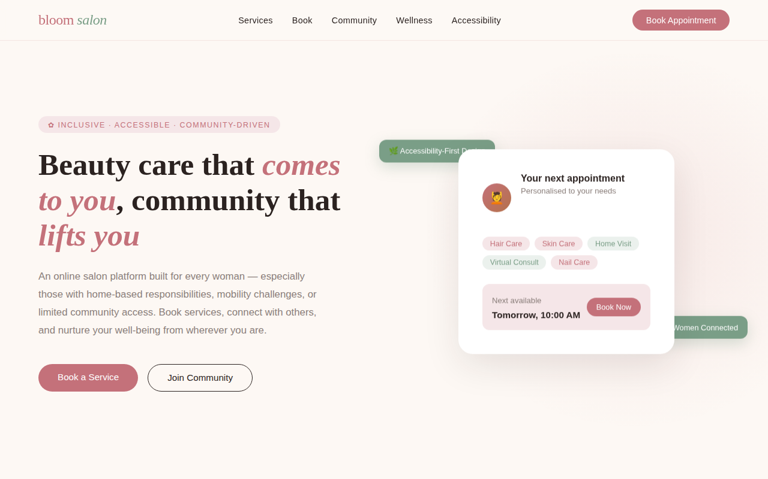

Figure D.2 – Services Overview
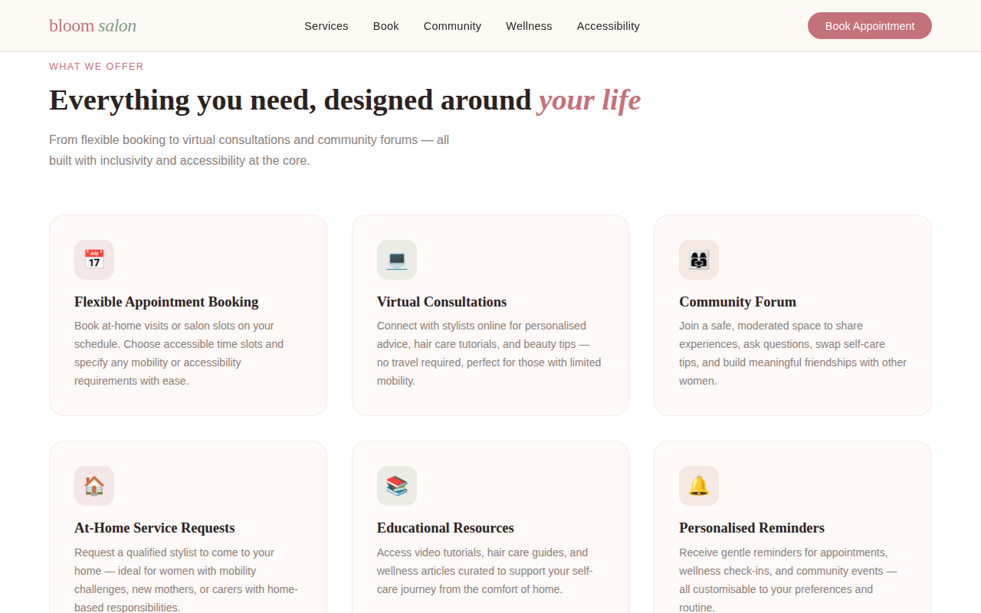

Figure D.3 – Appointment Booking Interface
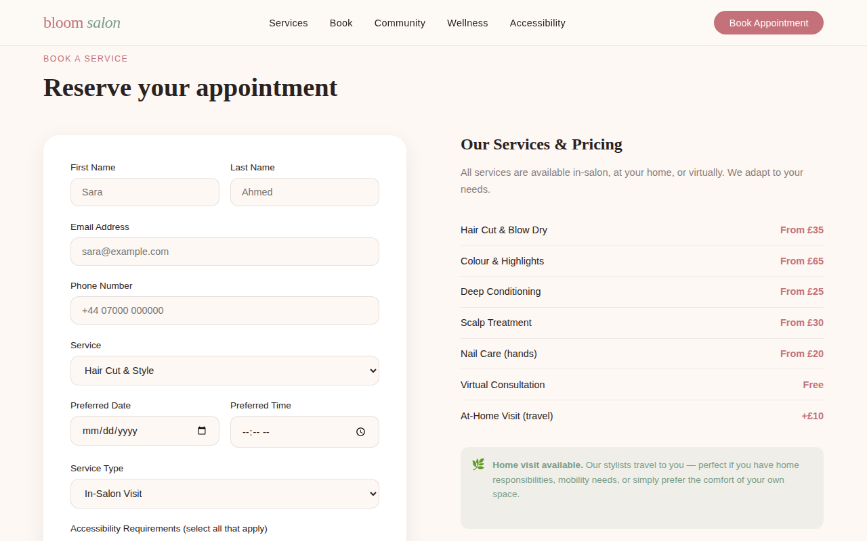

Figure D.4 – Community Forum
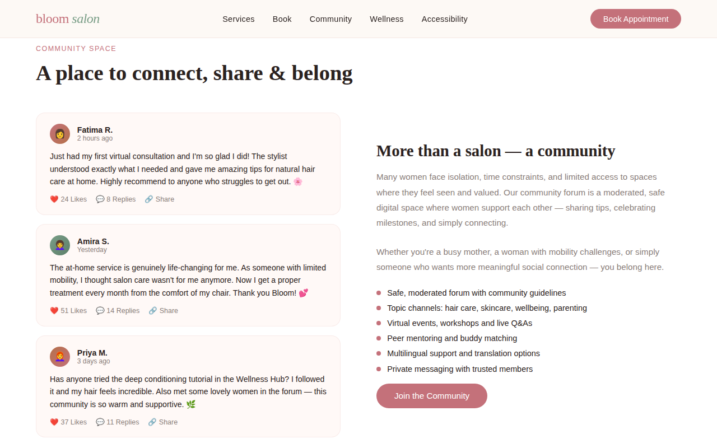

Figure D.5 – Self-Care Resource Library

Appendix E – Website
Bloom Salon – Your Community, Your Comfort

