Project Proposal

An Investigation into Enrolment Systems
For


Prepared by
Oliver Smith (219240)
2017/18

BSc (Hons) in Computing & Information Systems
M2X8630 – Research and Development Methods

Contents
1. Background and Rationale 4
1.1. Introduction 4
1.1.1. Enrolment System Definition 4
1.1.2. Enrolment in Education 4
1.1.3. The Client 5
1.2. Current UK Legislation 6
1.2.1. The Data Protection Act 6
1.2.2. Computer Misuse Act 6
1.2.3. Education and Inspections Act 2006 7
1.2.4. The Human Rights Act 1998 7
1.2.5. Other Legislations 7
1.3. Available methods and tools 8
1.3.1. Data Entry and Collection 8
1.4. Software Used 8
1.4.1. ebs by Tribal 8
1.4.2. UNIT-e 9
1.4.3. Unit 4s Student Management 9
1.4.4. Web Based Enrolment Systems 10
1.5. Rationale 10
2. Aims, Objectives and Deliverables 12
2.1. Aim 12
2.2. Objectives 12
2.3. Deliverables 12
3. Research Methodology 13
3.1. Philosophy 13
3.2. Approach 13
3.3. Strategy 13
3.4. Time Horizon 13
3.5. Data collection method 13
4. Development Methodology 15
4.1. Timeboxing 15
5. Resources 16
5.1. People 16
5.2. Application Packages 16
5.3. Programming Language 16
5.4. Database Product 16
6. Ethical Issues 17
6.2. Ethical considerations for data collection and research tools 17
7. Plan 18
7.1. Research Submissions and Deliverables 18
7.2. Working Time 18
7.3. Research Submissions/deliverables 18
7.4. Work Breakdown and Gantt Chart 19
Bibliography 20

Background and Rationale

Introduction

Enrolment System Definition
Enrolment is defined as “the act of putting yourself or someone else onto the official list of members of a group, course, or college” (1). This meaning, ‘signing up’ someone to an official course, college or group.
A system is then defined as “a set of connected things or devices that operate together” (2). When it comes to the systems, the “things” mentioned in the definition may include processes.
So putting them together, an enrolment system is a way of ‘signing’ yourself or someone to an official course, college or group, through a number of different processes.

Enrolment in Education
Enrolment systems are a very important within the education field, with lower level education. This can be as small as a tutor business. For example, ‘Tutor Club’ in Neath have got a mini enrolment system where students will enrol to their classes. Enrolment is also used in a higher level, such as colleges and universities.

University of Wales Trinity Saint David (UWTSD) has defined their enrolment as the process through which students will agree to attend the university, agree to follow all their rules and regulations, create your student record onto the system (3). If a student fails to enrol, they will not be entitled to (3):
- Gain the qualification
- A student ID card
- Course timetables
- Participate in assessments
- Receive a council tax exemption certificate (where appropriate)
- Receive student finance
- Live in the universities accommodations
- Access university grounds and resources
- Access additional university services and information.

This meaning, enrolling students onto a course is not just for purpose of adding them onto the system. Especially with universities and colleges, failing to enrol will have an effect on their loans and grants from Student Finance. According the Student Finance Wales, if a student applies for a grant or loan, then that student must apply for the course and the university or college must confirm their attendance. When the university or college confirms their attendance, this is when the records are added to their system and sent directly to the student finance company (4).

The Client
NPTC Group of Colleges was formerly known as ‘Neath Port Talbot College’, but in 2013 they had a merger with Coleg Powys (5). Since their merger, they have now got a total of nine campuses and covers 30% of the country’s landmass (5). With the two colleges now being merged, they had two different systems. The college currently uses a system which is causing problems due to it repetitive nature and the lack of organisation. The process of becoming a student at NPTC Group include:

Pre-Enrolment
- Apply for a course
- Attend meeting with course leader – discuss the course, predicated grades etc.

Results
- Receive results to see if you met the entry requirements

Enrolment Day
- Collect a second application form
- Complete the application form, questionnaires provided
- Get exam results checked
- Get advice & guidance
- Go to the enrolment admin centre
- Get your details entered onto the system
- Pay for the course
- Get your picture taken and receive student ID card
There are many processes within this system. The student is made to fill out an application form, to show they are interested in studying at NPTC Group and to show the course they wish to apply for. On the day of enrolment, they have to complete that application form again. However, you have got your own application form, where some of your details are already printed onto the form, to save the student some time. Over the years, there has been many issues with staff not being able to find the students application form, so sometimes they will have to fill it out from scratch.
When you go to get your exams checked, there can be up to a 30 minute waiting time as there are many students enrolling at the same time. Another confusing thing about the enrolment at NPTC Group is the fact that during different years, the building you go to changes. For example, one year the entire enrolment took part in G block. In this block, you would do everything from collecting your application, checking your results and getting your student ID card. In recent years, students are made to collect their application forms from the Nidum Arts Centre, then get their results checked over in D block and then walk around to the library to get their information put onto the system, to pay for their course and then get their photo taken.

Current UK Legislation
As the enrolment system is a way of storing information on students, there are laws that the college must follow.

The Data Protection Act
The Data Protection Act was brought into place, to control how organisations, businesses and government uses your information (6). The college must make sure that all information is:
- Used fairly and lawfully
- Used for limited, specifically stated purposes
- Used in a way that is adequate, relevant and not excessive
- Accurate
- Kept for no longer than is absolutely necessary
- Handled according to peoples data protection rights
- Kept safe and secure
- Not transferred outside the European Economic Area without adequate protection.
The college will hold the following information, if the student agrees to share this information:
- Ethics background
- Religious beliefs
- Health
- Criminal records
Those four pieces of information is classed as ‘sensitive information’ according to GOV.UK, meaning that this information requires stronger legal protection (6).

Computer Misuse Act
The Computer Misuse Act was put in place to make provision for securing computer material against unauthorised access or modification (7). With the Computer Misuse Act, a person will be guilty of an offence if they access secure information that is not authorised for them to see. Any institution that have enrolment systems in place will need to ensure that information is not accessible to the wrong people. NPTC Group would need to make sure that only authorised people will be able to access the data, by storing it securely.

Education and Inspections Act 2006
This is “An Act to make provision about primary, secondary and further education and about training” (8). It is what gives local authorities a strategic role as champion of parents and children, where it sets up the national inspectorate in which it covers education, skills and children’s services (8).

The Human Rights Act 1998
The Human Rights Act is what gives an individual legal protection of their human rights, such as their right to life, or their right to a fair trial (9). According to Article 2 of Protocol 1, everyone has the right to education (10). This will include, that an individual living in the UK has the right to:
- Attend school, college or university
- Get official recognition when studies have been completed, for example, the qualification earned (10).
This Act also protects your rights to a private and family life. This meaning, the college must:
- Respect your sexuality
- The right to be able to make choices yourself
- Respect for private and confidential information, particularly when storing and sharing of information. This gets linked in with the Data Protection Act.
- The right to have confidential and unlimited communication with others
- The right to control how information about your private life is shared, such as photographs.

Other Legislations
      - Higher Education and Research Act 2017 – a recent law, only being brought into place by the Houses of Parliament in 2017. This is now the replacement of the Further and Higher Education Act 1992 and it creates a new regulatory framework for higher education, increase competition and student choice to make sure the student receives the value of their money (11).

Available methods and tools

Data Entry and Collection
Data entry is “the work or process of putting information into a computer database” (12). Tasks include filing, data entry, and special projects in administrative departments (12). However, it computer terms it includes keyboard entry, scanning and voice recognition (13). There are many types of data entry, however, there are two main types that are still used in today’s industries, data entry from hand-written application forms and data entry from online application forms.

Data Entry from hand-written application forms
This is when someone will fill out an application form by paper (13). One of the main disadvantages of this is the fact that there is no validation. There is nothing that makes the applicant fill something in. Even if the field says, it must be filled in, they can still skip it. When an application form needs to be entered onto the system, just like NPTC Groups current enrolment system, there is the risk of poor handwriting. Poor handwriting can have serious effects on the data being held, which could lead to the data being incorrect, making it ‘dirty data’ (14). For example, if a student enters their emergency phone number but their ‘6’ looks like a ‘8’ then that could have a serious effect on the student in the future if something was to go wrong (14).

Data entry from online application forms
This is when someone will fill out an application form through an online application form, normally through a website (14). One of the main disadvantages of this is that the student will need to have an Internet connection. Unlike a paper application form, the college is able to collect data with minimum error. For example, the application form may require the student to enter fields and if the student fails to do this, they will not be able to proceed. It is simpler to analyse the answers given as charts, graphs and reports are able to be produced. It is easier to read the answers overall as there is no concern over whether you can read the answers properly because they will be all typed (14).

Software Used

ebs by Tribal
EBS stands for Education Business System and this is the system that NPTC Group currently uses for their registers. According to an advertising brochure that Tribal hand out to their clients, EBS is there to “manage the entire admissions process” (15). This package offers students to schedule their own interviews and will be reminded when they need to complete something, such as uploading evidence.
Some of the benefits include:
- Tribal offers support services between 9am to 5pm Monday – Friday.
- Training courses are always available and are delivered either on-site or via webinar
- It is a clean package.
- The system is secured by Tribal, so anything that is to go wrong with the package, they will examine it.
- Smart tools such as postcode recognition, third-party payment methods etc.
The limitations include:
- It is an expensive package.
- It is not beneficial to the students as they have to go through repetitive stages.

UNIT-e
UNIT-e is a student management information system, which puts the power of MIS into the hands of the institution, students, staff, parents and other stakeholders (16). This system offers a range of features, from full validation to enabling students to pay online at the point of enrolment. As it is self-serviced for students, it minimises the time of staff to spend on the application process which speeds up the process (16).
Some of the benefits include
- It is a self-enrolment system for students and staff.
- It is a professional software, designed by experts.
- The creators, Capita, have got a helpline.
Some of the limitations include
- It is not just designed for education, so some features may not be relevant to the college.
- It is an expensive package.

Unit 4s Student Management
Before NPTC Group merged in 2013, they used a Student Management System by Unit 4, called QL. Back when the college used this system, it was slow and didn’t keep up with real time. For example, when students updated their email, it would take a whole day for it to update. This was one of the main reasons why they opted to ebs. However, since then Unit 4 have re-developed their student management software (17). Unit 4 now says that they “work with your skilled staff so they can focus on education and research instead of administrations” (17). The systems allow its users to add, create, update and delete student instantly, meaning there will be no more waiting. It allows managements to produce reports that show information such as the growth of students from year to year.
Some of the benefits to this software would be
- The college has already had a close relationship with Unit 4
- A very professional interface and back end.
- It is currently being used by large universities such as University of Essex, Cranfield University, University of Bristol, University of Southampton and University of Cambridge.
- Cloud services are available
Some of the limitations of this software includes
- It is an expensive software to run.
- Need to follow Unit 4s regulations.

Web Based Enrolment Systems
As mentioned, there are many organisations that have their enrolment system online. Although this has many benefits such as, the student does not even have to leave home to enrol, it does have some disadvantages. University of Wales Trinity Saint David (UWTSD) uses this type of enrolment system, as it is on their website (3). When you go click on ‘enrolment’, it asks to user to enter their username and password. For a first time student, this can be confusing as it may not give the student a clear indication on how to actually apply to the University. Some students might find ‘enrolment’ is the same thing as ‘apply’ which will cause confusion.
In order to access this enrolment system, the student will need to have access to the Internet. This may also cause issues if their website goes down, for maintenance or unplanned issues.

Rationale
After reviewing literature on enrolment systems, it has been discovered that self-enrolment is becoming popular in the education industry. After an investigation the meaning of enrolment systems has been defined has adding someone into an official course, college or group. Enrolment systems are used in education for small businesses such as tutors to large businesses such as colleges. When a student officially enrols, they will receive their student ID card and other benefits that students receive.

NPTC Group of Colleges have got an inefficient enrolment system due to its repetitive nature. Students have to complete forms with similar questions multiple times, which is not productive. Part of the system is still paper-based, where students have to fill in forms on paper. After the research, it shows that paper-based systems cause issues because of there have been multiple incidents where staff cannot find students pre-printed forms on enrolment day and when it comes to data entry, handwriting can cause problems.
When it comes to education and handling data, there are legislations in place in which the college needs to follow. When there is any sort of data involved, the Data Protection Act is something that has to be followed. The DPA is all about keeping the data secure and only using it for specific purposes and making sure everyone is aware on what data is being held against them and why. The computer misuse act ties in with this, because the college will need to make sure that material is secured against unauthorised access or modification. After further investigations into the law, it was found that the college has to keep up to the standards of teaching under the “education and inspections act 2006”. A recent law “Higher Education and Research Act 2017” is something the college needs to focus on, to make sure that their courses are up to the standards, to what the student pays in tuition fees. A common law is the human’s right act, which states that the college must respect students and lectures personal lives such as beliefs, religion and sexual orientation. These are some of the laws that have been identified from the research that has been undertaken.

After doing research on the current methods, tools and software that are being used, it has been noticed there is a pattern and a lot of Universities and Colleges have gone down the web based route for self-enrolment. An example enrolment system that is being reviewed at is UWTSD enrolment system, where they have to enter their username and college ID to enrol. This can cause confusion at first, as on the website students may get the words “enrolment” and “apply” mixed up, thinking they mean the same thing. So when that student goes to click on enrol, it will ask them for a username and password, which they may not have which will cause confusion. With the system that is to be developd, the student has to come into college to actually enrol and once they have been given their student ID and password, they can then access the kiosk to start the enrolment. As this is a software application, it does not depend on the Internet to run, so regardless if the Internet is working or not, the student will still be able to enrol. By making the student come into college, it also gives them the chance to view college grounds and seek help and advice in person.

The literature has produced evidence that automated self-service enrolment system is the way forward. It is highly important to get the enrolment stage correct, as this is the official way for a student to participate in a course. All education institutions need to use enrolment systems, to get students onto the courses. As mentioned, the college has issues with its enrolment system, due to the repetitive nature of the system. The system that is being planned to be developed will only mean that the student will have to enter their data once and everything will be done automatically such as bringing up recommended courses.

Aims, Objectives and Deliverables

Aim
To design, develop and implement software that would allow students at NPTC Group to self-enrol onto a course, determined by grades and subject chosen.

Objectives
- To put together a literature review to research and review:
  - Definition of enrolment systems – what is it and what does it do?
  - How enrolment systems are used in education
  - The client and their issues
  - Current UK legislation in regards to education and enrolment
  - Available methods, tools and packages
- Develop a system where a student is able to self-enrol onto a course, determined by grades and subject choice.
- To create a useable interface, that takes the student through the enrolment stage.
- Evaluate the success of using the system.

Deliverables
- Project Proposal
- Project Plan
- Enrolment System
- Project Report
- Exhibition Board

Research Methodology

Philosophy
According to the City University of Seattle, a research philosophy is a “belief about the way in which data about a phenomenon should be gathered, analysed and used” (18). Within the research onion on the philosophy layer, after researching ‘Positivism’ was the philosophy that was selected. Auguste Comte, the father of positive philosophy says that “the only valid knowledge is knowledge gained through the scientific method” (19). The basis of his philosophy is knowing or stating facts through the scientific methods e.g. observations and experiments. As part of the research, it will be proven that the current enrolment system can be improved.

Approach
Inductive research usually aims to explore a new phenomenon, or to look at a previous researched phenomena from a different prospective (20). Mainly, this focuses on creating new knowledge and the researcher will create research problem and then starts creating research questions and will then find data through observations. This approach is use to identify patterns and create a conceptual framework. By using this approach, a theory will be built upon, which is that the enrolment system can be improved.

Strategy
Action research “is a disciplined process of inquiry conducted by and for those taking the action” where the main aim is to “assist the actor in improving or refining their actions” (21). It can be research to solve an immediate problem or a reflective process of progressive problem solving. Weaver (2004) described it as a way where a researcher aims to add to the body of knowledge in an area by applying theory to a problem and then evaluating the results. One of the main reasons why it has been decided to go with action research is because it allows the researcher to be both, participant and researcher. Action research also allows me to make some changes and work practices to improve the present situation.

Time Horizon
The next layer within the ‘research onion’ is time horizon, which “highlights the time horizon over which the researcher undertakes the research” (22). Longitudinal will be used, as this is used when answering questions or addressing problem requires data to be collected for a certain amount of time (22).

Data collection method
Quantitative methods is beneficial to the researcher when meaningful data is being drawn from a large body of qualitative data (23). Quantitative data is measured by numeric terns and can measure things such as percentages and rating scales. For this particular project it will be measured by time ranking scales, prioritising different tasks by a rank number.

Observations are an “exempt observation” or an “observation” that requires consent (24). This is where the researcher will watch interactions of people in a public space. Notes from observations will not include the names of the participants, so it is all anonymous. Observations allow the researcher to watch how the current problem is accruing, which is the reason why this has been opted for.

The main purpose of an interview is to find out what is on someone’s mind that may not be written down (25). These are good for collecting detailed information which allows the researcher to follow up. They are prepared in advance, so the researcher knows what they need to find out and what questions they actually need to ask. The reason why Interviews is a good option is because the researcher will need to interview the users of the enrolment system, to get their take on the current enrolment system and what could be done to make their jobs easier.

Development Methodology

Timeboxing

In timeboxing model, development is done interactively as in the interactive enhancement model. But, in time boxing model, each iteration is done in a timebox of fixed duration. The functionality to be developed is adjusted to fit the duration of the timebox. Each timebox is divided into a sequence of fixed stages where each stage performs clearly defined task that can be done independently. It also requires that the time duration of each stage is approximately equal so that pipelining concept is employed to have the reduction in development time and product releases (26). What makes timeboxing different is that it encourages you to concentrate on time, rather than the actual task. Meaning, if you say you have a task and you say you are going to have it done by a time, then you will have to move on, on the date regardless.
Some of the main reasons why timeboxing has been selected includes:
- It speeds up the development methods as you have time allocated for each task, and that time only.
- It is suited to develop projects with a number of features, in a short amount of time
- It is a simple methodology to use.
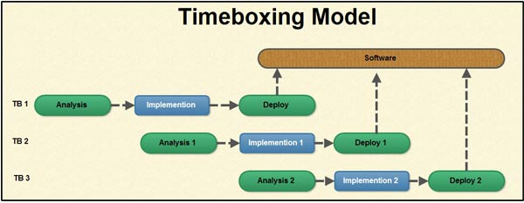

Resources

People
- MIS staff – TBA – To gain more knowledge on the current enrolment system
- Users – TBA – To give feedback on the system
- Project Supervisor – Jeanette Adams – This person will provide help and advice throughout the project.

Application Packages
- Microsoft Word – This will be used to create all of my documentations for the project. Documentations include literature review and user documentation.
- Microsoft Project – This will be used to plan out the project such as all the different tasks the project requires.
- yED – This will be used for diagrams that will need to be created.

Programming Language
The package that will be used for the development of the system is Microsoft Visual studio. Everything that will be needed for the system will be found within the Visual Studio environment, which includes the actual database. For maintenance purposes, Visual Studio will need to be downloaded onto the computer from the 2010 version or newer versions. Visual Studio is a complete set of development tools for C#, Visual C++ and Visual Basic. The programming language that will be used for this specific system will be Visual Basic (VB).

Database Product
Microsoft SQL Server is a relational database management system that will be used for the system. It supports a wide variety of transaction processing, business intelligence and analytics application in corporate IT environments.

Ethical Issues

6.2. Ethical considerations for data collection and research tools
When data is being collected, high ethical standards must be upheld (27). During the project, interviews will need to take place, in order to gain information. When it comes to interviews, the main ethical issues that will need to be put into consideration are:
- Confidentiality – interviews are personal interaction and everything that is recoded will need to remain confidential to protect the participant.
- Consideration on who is reading the data, will they need to sign a confidentiality agreement?
- Could things being said and recorded during the interview be misinterpreted? It is important to take clear and detailed notes (27).
The same things apply to observations. Ethical considerations that will need to be considered are:
- It needs to be considered that the presence of an observer may be threatening and may exert an influence on behaviour.
With regards to data collection and research tools, there are several actions to be taken.
- Anyone who is to be interviews will have clear understanding what the information being given will be used for. They will be informed that they will be used as a reference, of the project.
- Dummy data will be used, so no real student data will be stored, so this will mean for the project no consent forms will need to be signed.

Plan

Research Submissions and Deliverables
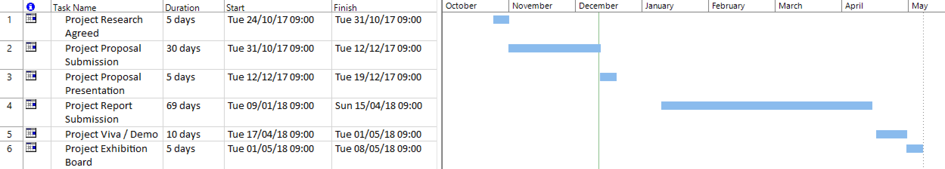

Working Time
Exceptions were added in to allow time away from the project. The holidays that were stated, therefore no work would be done over included:
- Christmas
- Birthday
- Easter
- Bank Holiday
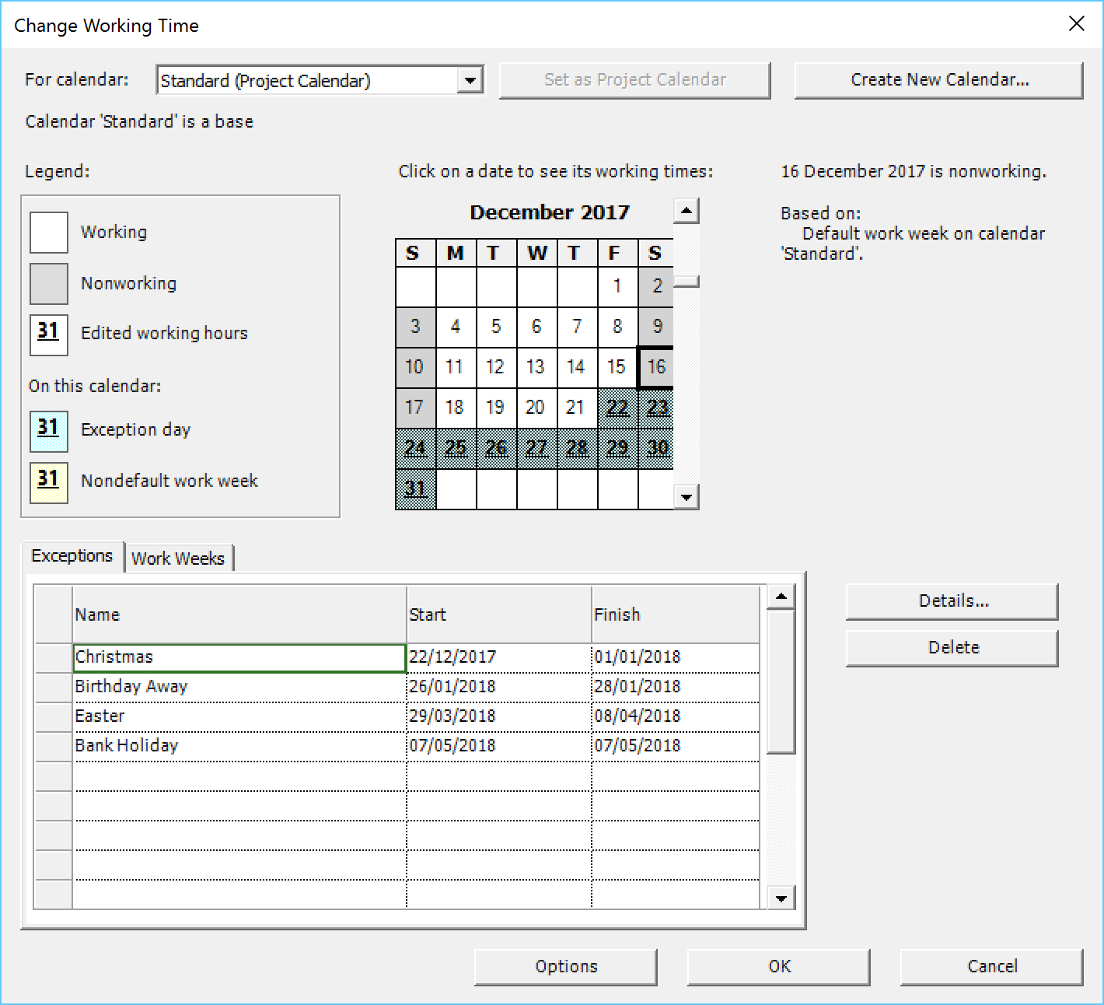

Research Submissions/deliverables
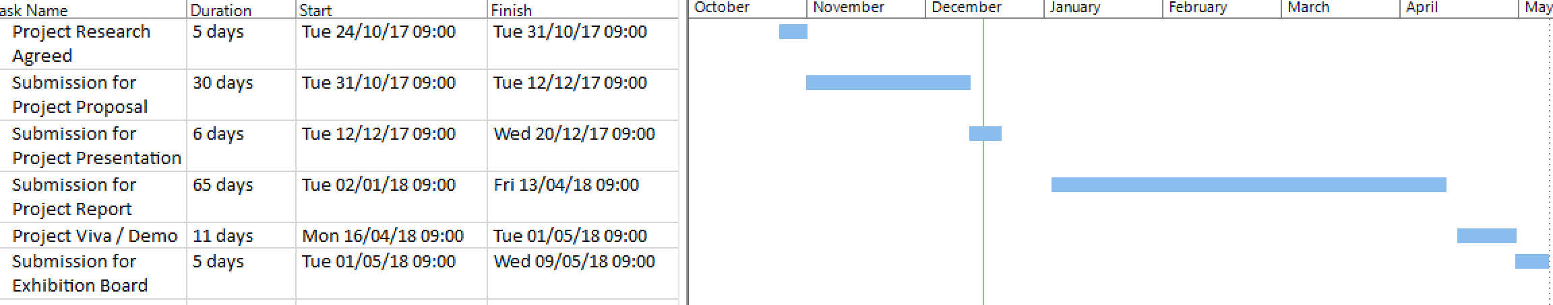

Work Breakdown and Gantt Chart

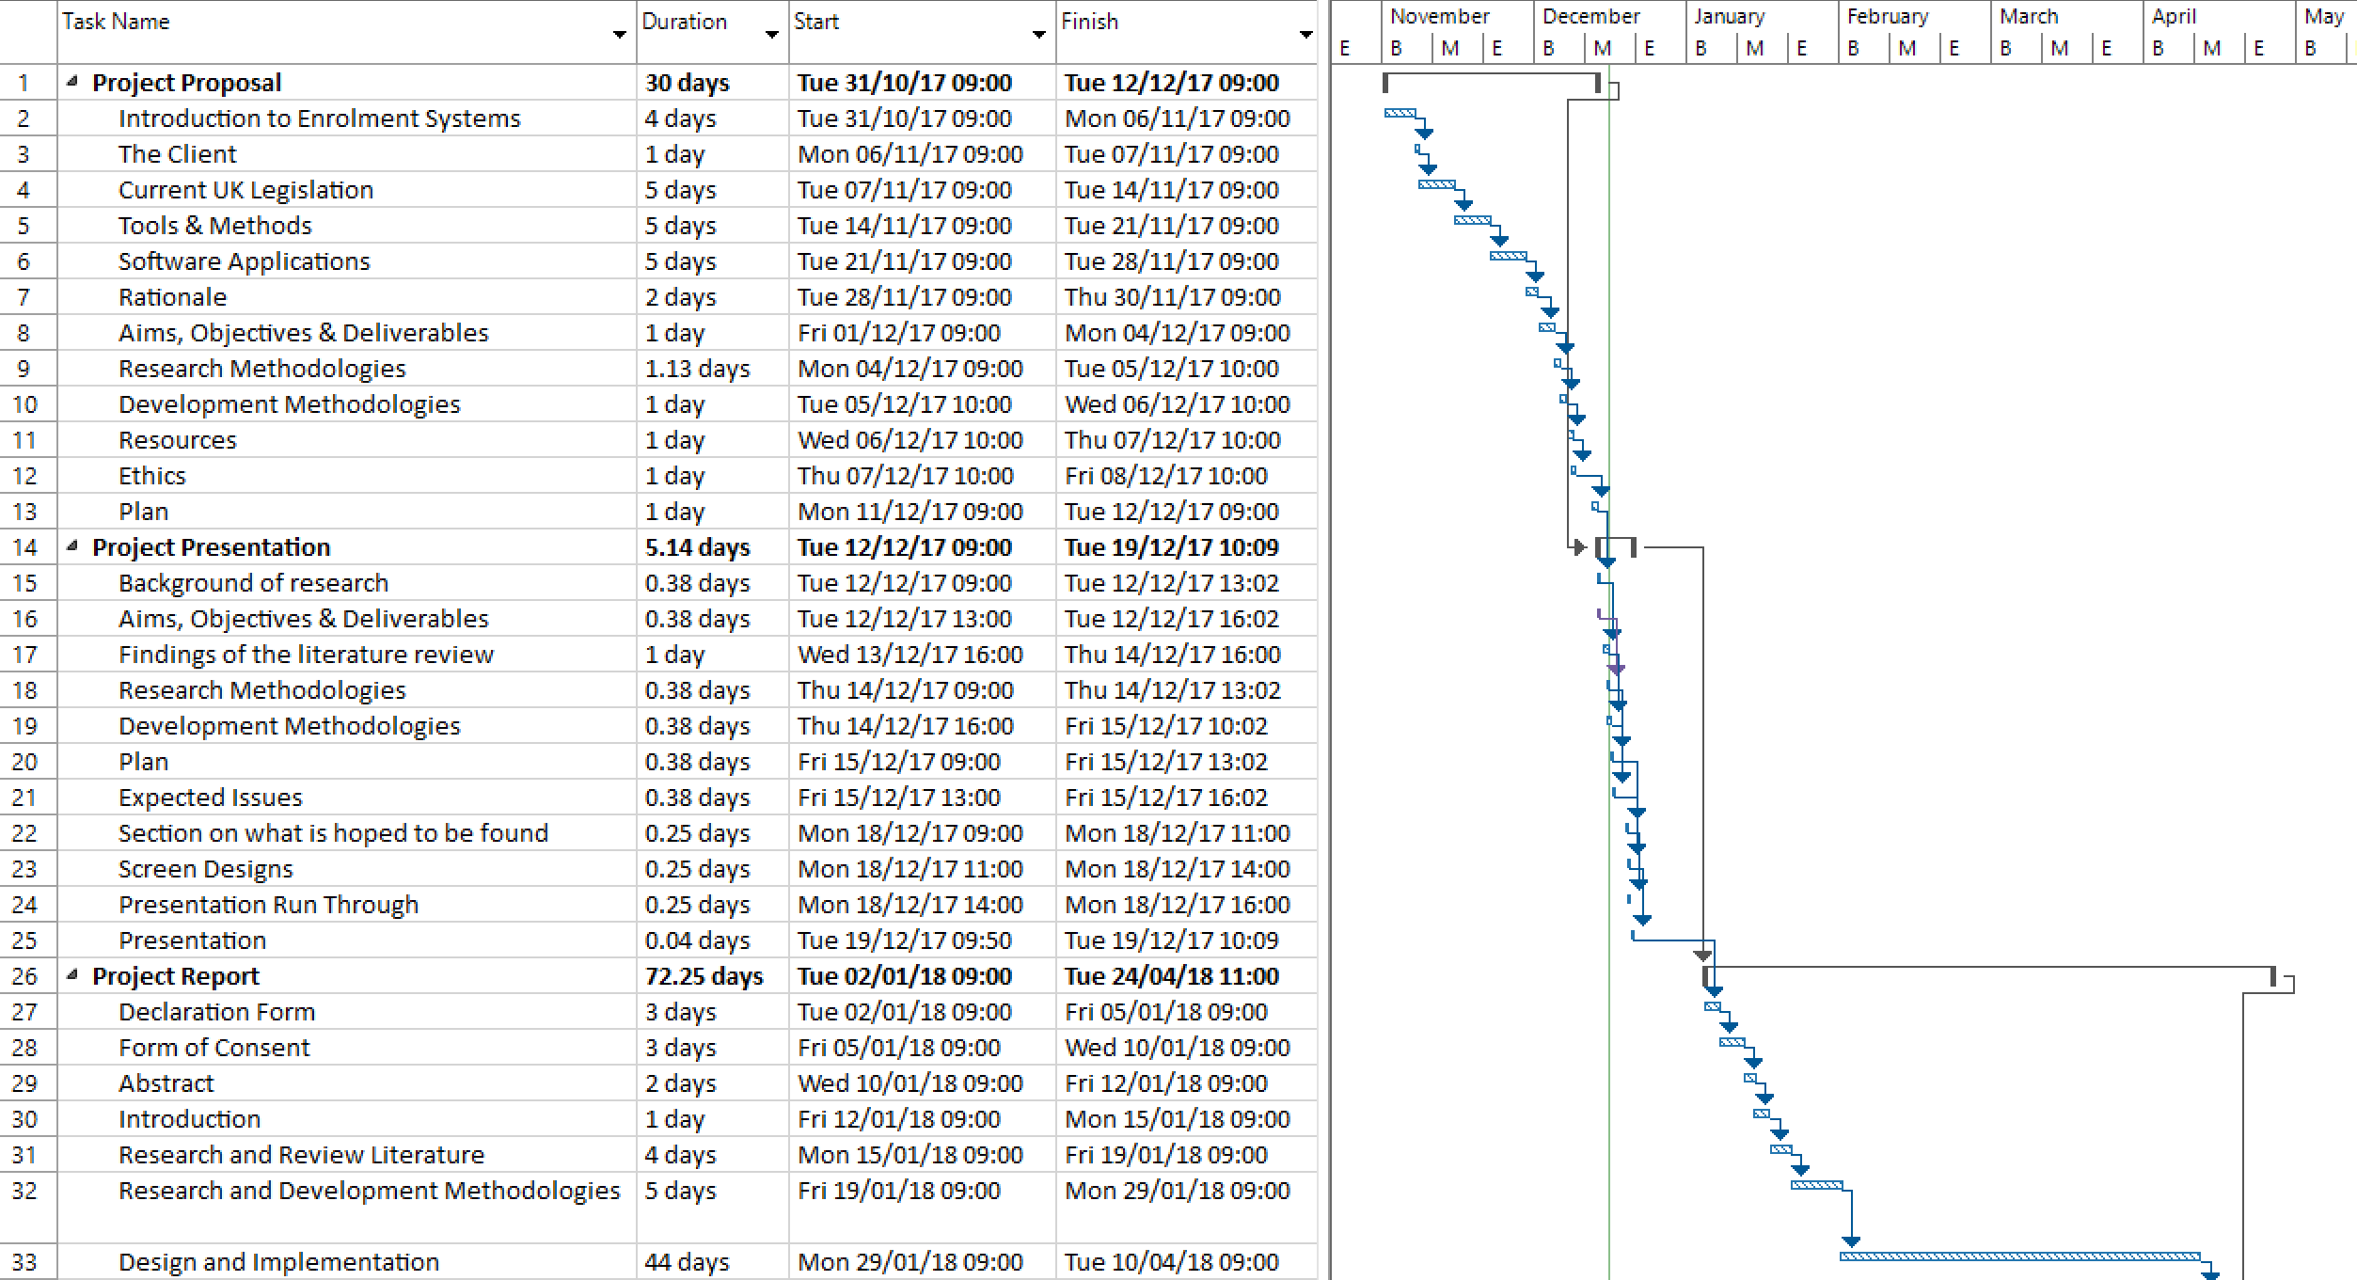
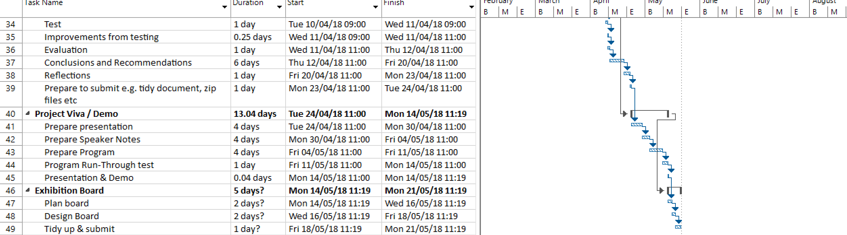
All tasks needed to complete the project are listed above, with start and end times. In order for the project to be completed thoroughly, this time plan will need to be followed. The dates above excludes the ‘exceptions’ that was added and weekends.

Bibliography
1. Camebridge Dictonary. Enrolment. [Online] [Cited: 08 November 2017.] https://dictionary.cambridge.org/dictionary/english/enrolment.
2. Cambridge Dictonary. System. [Online] [Cited: 08 November 2017.] https://dictionary.cambridge.org/dictionary/english/system.
3. University of Wales Trinity Saint David. Enrolment. [Online] [Cited: 21 November 2017.] http://www.uwtsd.ac.uk/registry/enrolment/.
4. Student Finance Wales. How much can you get? [Online] [Cited: 21 November 2017.] http://www.studentfinancewales.co.uk/undergraduate-students/part-time-students/continuing-students/course-grant.aspx#.WhQLNrKLRph.
5. NPTC Group. About Us. [Online] [Cited: 21 November 2017.] https://www.nptcgroup.ac.uk/about-us/.
6. GOV.UK. Data Protection. [Online] [Cited: 21 November 2017.] https://www.gov.uk/data-protection.
7. Legislation.gov.uk. Computer Misuse Act 1990. [Online] [Cited: 21 November 2017.] https://www.legislation.gov.uk/ukpga/1990/18/introduction.
8. —. Education and Inspections Act 2006. [Online] [Cited: 28 November 2017.] https://www.legislation.gov.uk/ukpga/2006/40/introduction.
9. Legislation.co.uk. Human Rights Act 1998. [Online] [Cited: 2017 November 2017.] https://www.legislation.gov.uk/ukpga/1998/42/contents.
10. Mind.org.uk. Human Rights Act 1998. Mind for better mental health. [Online] [Cited: 28 November 2017.] https://www.mind.org.uk/media/1823083/human-rights-act.pdf.
11. Legisilation.gov.uk. Higher Education and Research Act 2017. [Online] [Cited: 28 November 2017.] http://www.legislation.gov.uk/ukpga/2017/29/introduction.
12. Cambridge Dictionary. Data Entry. [Online] [Cited: 14 November 2017.] https://dictionary.cambridge.org/dictionary/english/data-entry?q=Data+Entry.
13. Your Dictonary. Data Entry. [Online] [Cited: 14 November 2017.] http://www.yourdictionary.org/data-entry.
14. Vanderbilt University. The advantages and disadvantages of data entry methofs. Department of Biostatistics. [Online] [Cited: 14 November 2017.] http://biostat.mc.vanderbilt.edu/TPT/SOURCE/Extras/DataManagement/Data%20entry%20methods.pdf.
15. TribalGroup. ebs Empoweing FE and vocational providers to deliver successful outcomes. [Online] [Cited: 28 November 2017.] http://www.tribalgroup.com/media/1221/bro_ebs_v4.pdf.
16. CAPITA. UNIT-e student management information system. [Online] [Cited: 28 November 2017.] http://www.capita-fhe.co.uk/unit-e.
17. Unit 4. Student Management System. [Online] [Cited: 3 December 2017.] http://www.unit4.com/uki/sectors/education.
18. City University of Seattle. Chapter Three: Research Methodology. [Online] [Cited: 28 November 2017.] http://www.is.cityu.edu.hk/staff/isrobert/phd/ch3.pdf.
19. Comte, Auguste. Positive Philosophy. [Online] [Cited: 3 December 2017.] http://philosophy.lander.edu/intro/articles/comte-a.pdf.
20. Spiral. Video lesson plan for: Difference Between Inductive and Deductive Research . [Online] [Cited: 4 December 2017.] https://www.spiral.ac/sharing/w41qw6v/difference-between-inductive-and-deductive-research.
21. ASCD. Guiding School Improvement with Action Research. [Online] [Cited: 4 December 2017.] http://www.ascd.org/publications/books/100047/chapters/What-Is-Action-Research%C2%A2.aspx.
22. Saunders, Mark and Tosey, Paul. The Layers of Research Design. Academia. [Online] [Cited: 5 December 2017.] http://www.academia.edu/4107831/The_Layers_of_Research_Design.
23. Building, Harry Pitt. QUANTITATIVE ANALYSIS APPROACHES TO QUALITATIVE DATA. CuteSeerX. [Online] [Cited: 5 December 2017.] http://citeseerx.ist.psu.edu/viewdoc/download;jsessionid=56A9791D73D3A511040688EE8F87898D?doi=10.1.1.189.3862&rep=rep1&type=pdf.
24. Institutional Review Board for Social & Behavioral Sciences. Observations. [Online] [Cited: 5 December 2017.] http://www.virginia.edu/vpr/irb/sbs/resources_guide_data_method_observe.html.
25. University of Missouri St. Louis. Data Collection Methods. [Online] [Cited: 5 December 2017.] http://www.umsl.edu/~sauterv/analysis/488_f02_papers/data_collexn_files/thePaper.htm.
26. MindTools. Timeboxing. [Online] [Cited: 5 December 2017.] https://www.mindtools.com/pages/article/timeboxing.htm.
27. Danvers, Emily and Desai, Riti. Ethical consideration for data collection and research tools. Cardiff Metropolitan University. [Online] 2008. [Cited: 4 December 2017.] https://study.cardiffmet.ac.uk/AcSkills/Documents/Research/Research_Ethics_elesson/page_22.htm.

